image-width
Tetsuo Honda
Fri, 13 Mar 2026 08:06:37 +0900 9561fdb
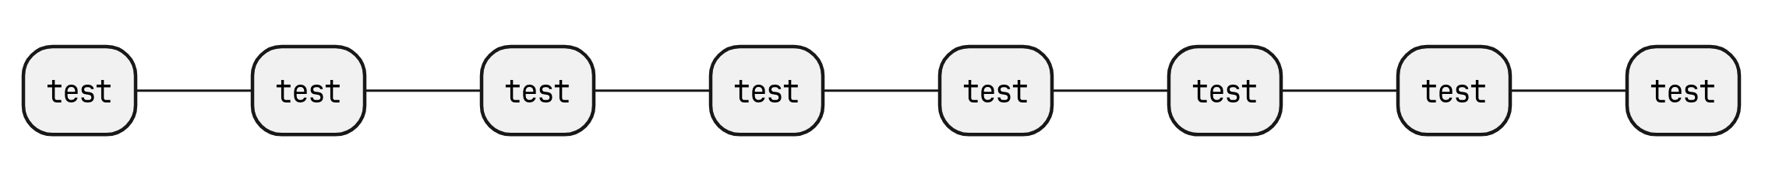
image-width-sample_1
image-width-sample_2
image-width-sample_3

