porter/libsrc/porter/infra/potrSendQueue.c
doxygen and doxybook2
Sat, 14 Mar 2026 08:20:51 +0900
目次

ファイル

porter/libsrc/porter/infra/potrSendQueue.c
非同期送信キューの実装。

作者
c-modernization-kit sample team

バージョン
1.0.0

日付
2026/03/08

インクルード元
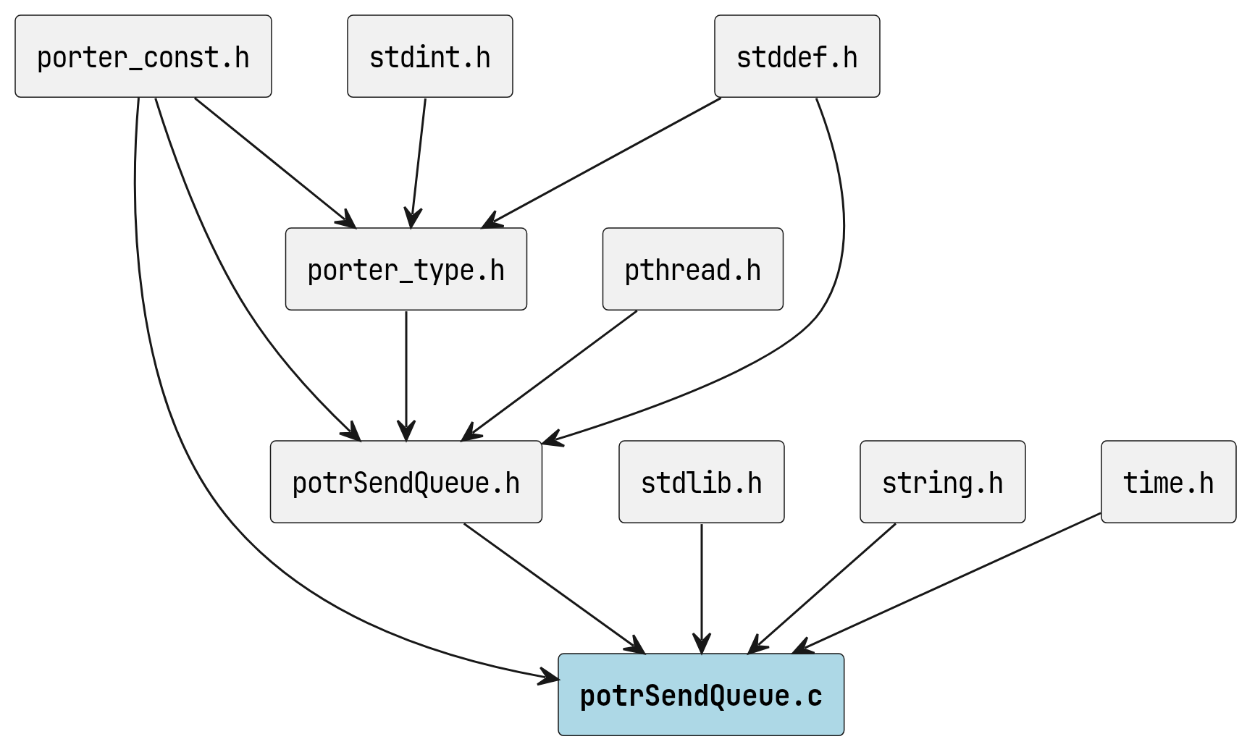
potrSendQueue.c のインクルード元

著作権
Copyright (C) CompanyName, Ltd. 2026. All rights reserved.

関数

potr_send_queue_init
int potr_send_queue_init ( PotrSendQueue *q, size_t depth, uint16_t max_payload )

呼び出し元
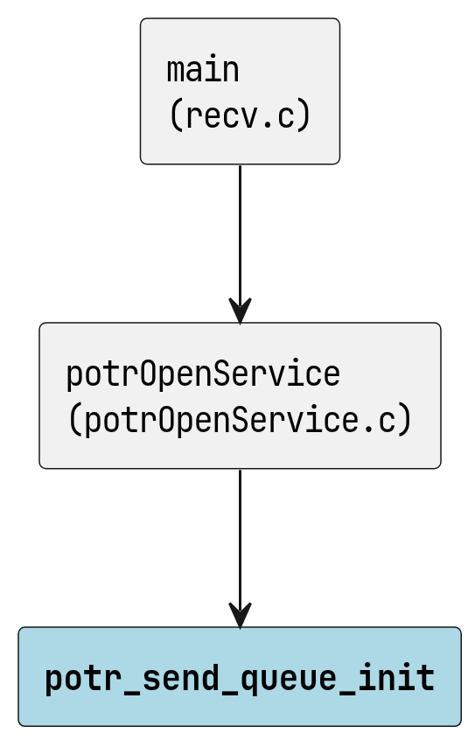
potr_send_queue_init の呼び出し元

potr_send_queue_destroy
void potr_send_queue_destroy ( PotrSendQueue *q )

呼び出し元
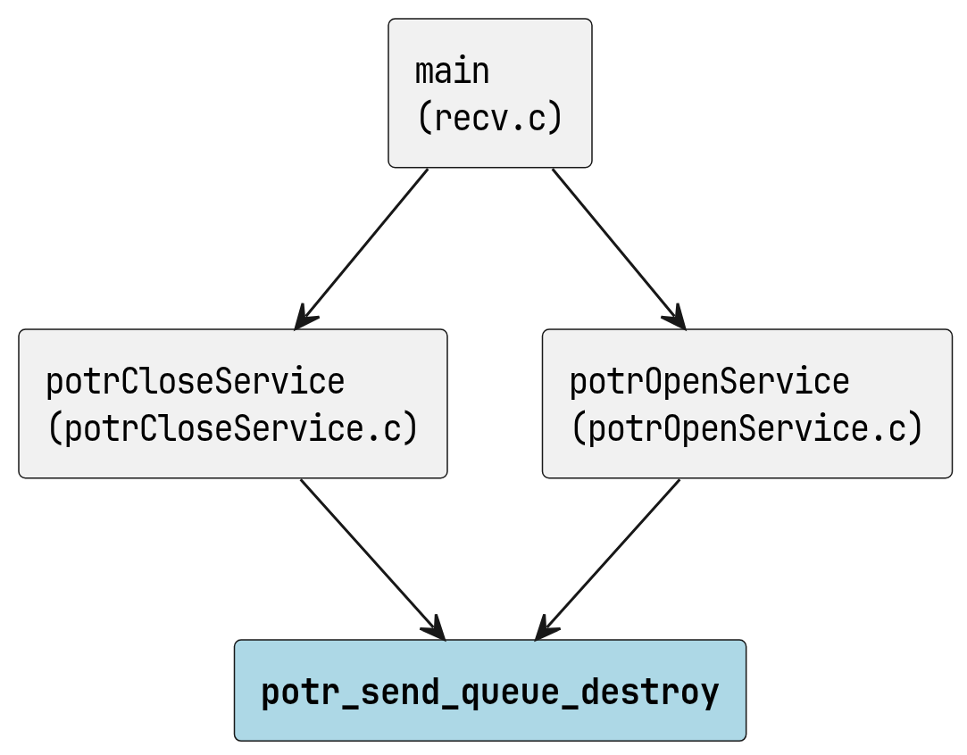
potr_send_queue_destroy の呼び出し元

potr_send_queue_push
int potr_send_queue_push ( PotrSendQueue *q, uint16_t flags, const void *payload, uint16_t payload_len )

potr_send_queue_push_wait
int potr_send_queue_push_wait ( PotrSendQueue *q, uint16_t flags, const void *payload, uint16_t payload_len, volatile int *running )

呼び出し元
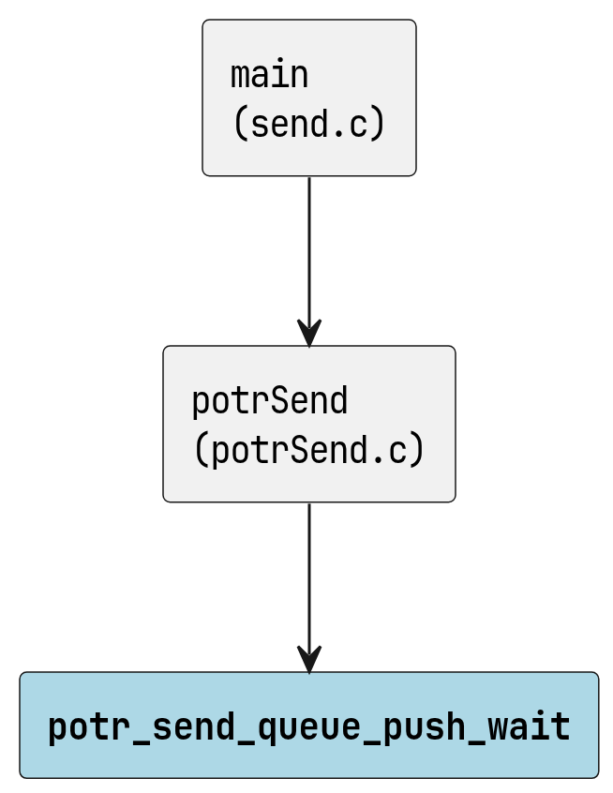
potr_send_queue_push_wait の呼び出し元

potr_send_queue_pop
int potr_send_queue_pop ( PotrSendQueue *q, PotrPayloadElem *out, volatile int *running )

呼び出し元
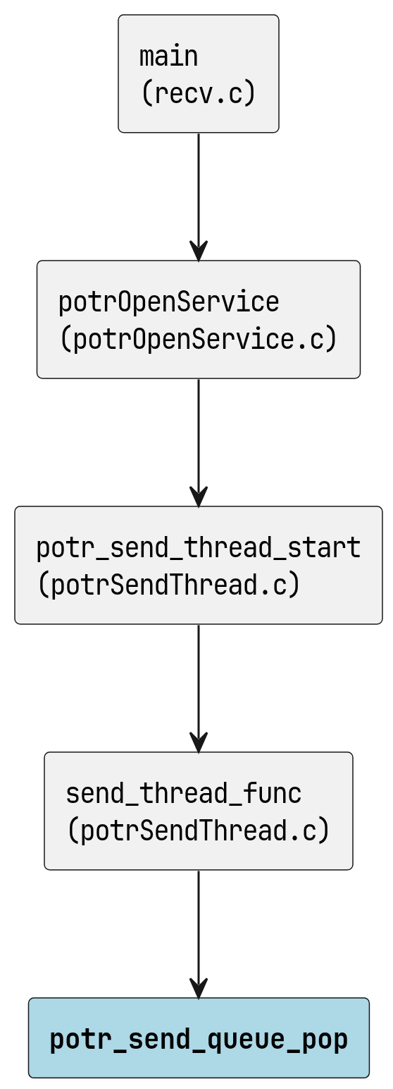
potr_send_queue_pop の呼び出し元

potr_send_queue_peek
int potr_send_queue_peek ( PotrSendQueue *q, PotrPayloadElem *out )

呼び出し元
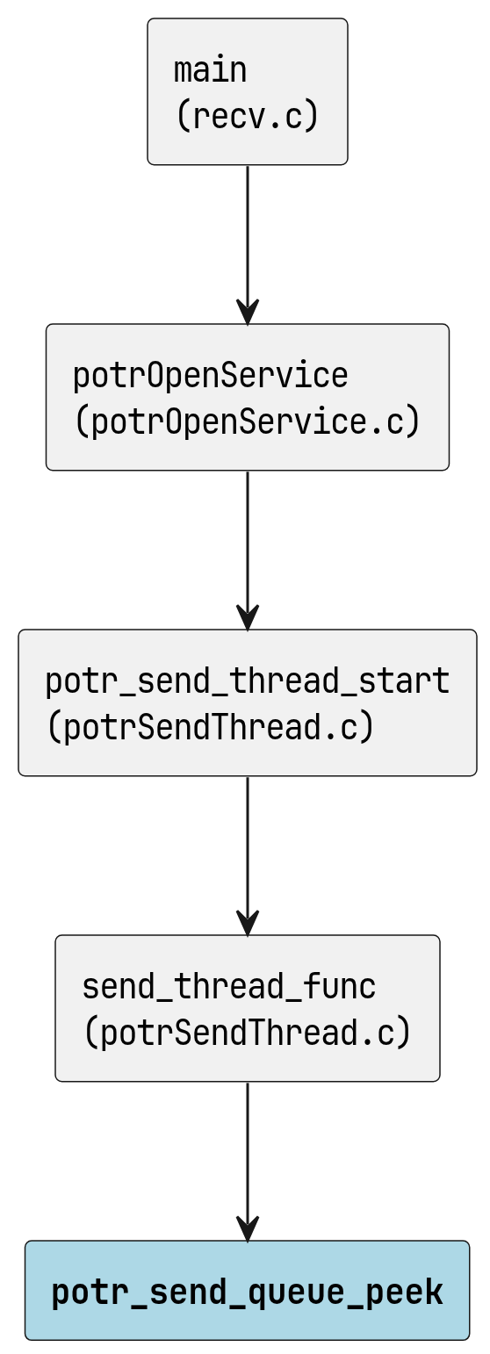
potr_send_queue_peek の呼び出し元

potr_send_queue_peek_timed
int potr_send_queue_peek_timed ( PotrSendQueue *q, PotrPayloadElem *out, uint32_t timeout_ms )

呼び出し元
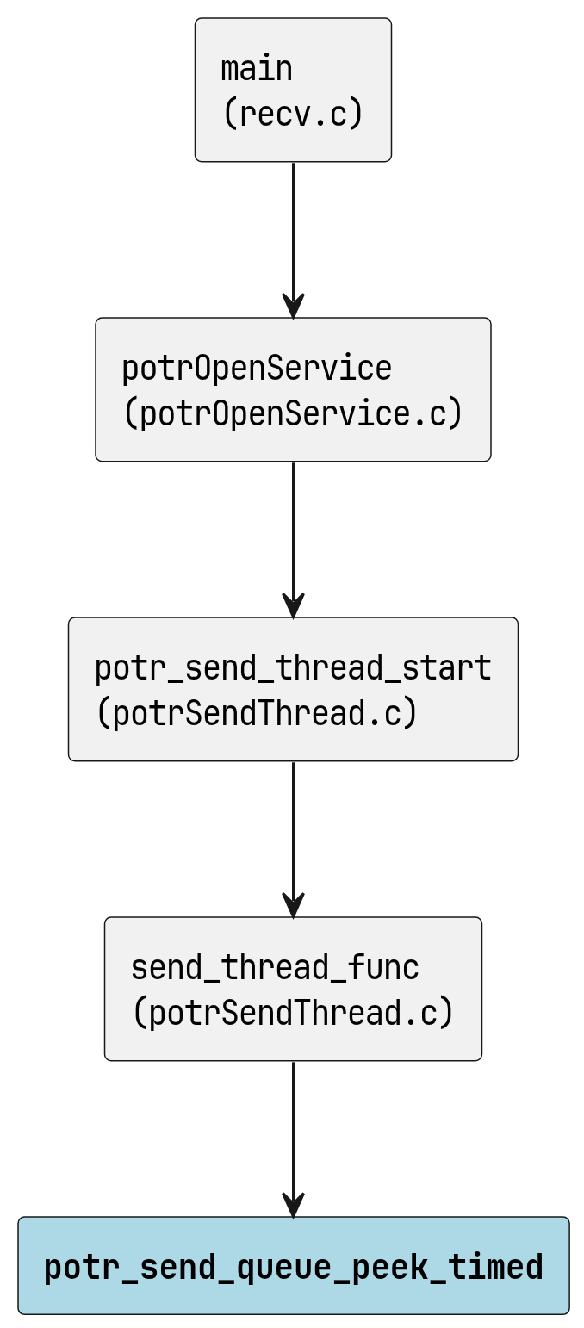
potr_send_queue_peek_timed の呼び出し元

potr_send_queue_try_pop
int potr_send_queue_try_pop ( PotrSendQueue *q, PotrPayloadElem *out )

呼び出し元
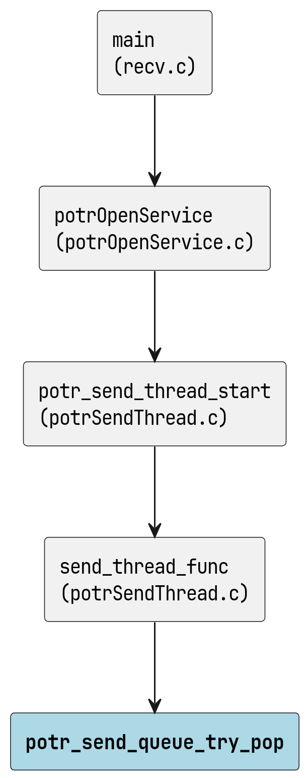
potr_send_queue_try_pop の呼び出し元

potr_send_queue_complete
void potr_send_queue_complete ( PotrSendQueue *q )

呼び出し元
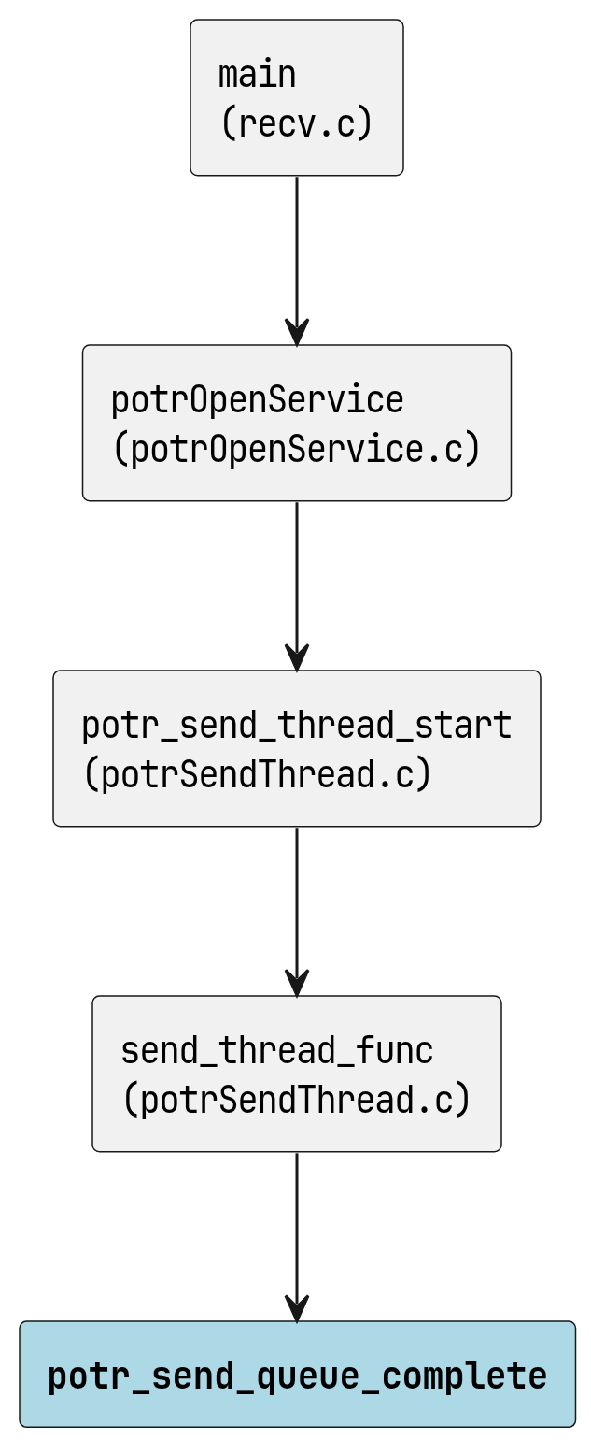
potr_send_queue_complete の呼び出し元

potr_send_queue_wait_drained
void potr_send_queue_wait_drained ( PotrSendQueue *q )

呼び出し元
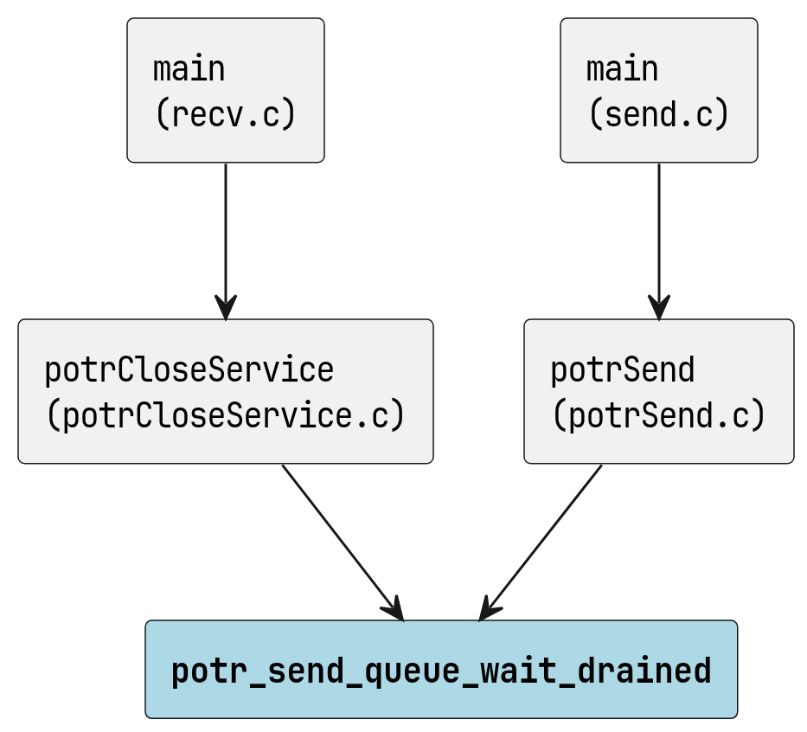
potr_send_queue_wait_drained の呼び出し元

potr_send_queue_shutdown
void potr_send_queue_shutdown ( PotrSendQueue *q )

呼び出し元
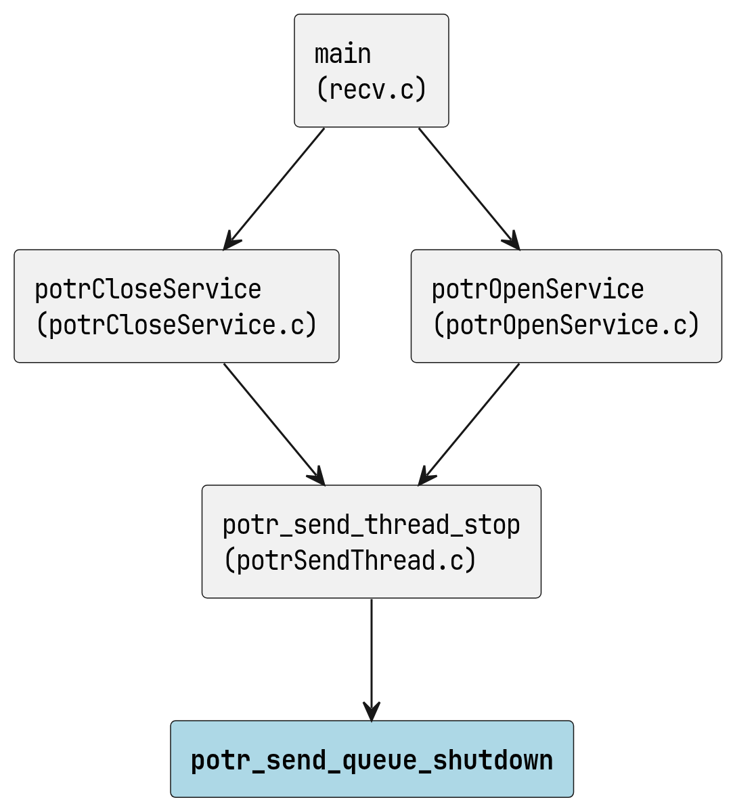
potr_send_queue_shutdown の呼び出し元

定数、マクロ

POTR_MUTEX_INIT
#define POTR_MUTEX_INIT ( m )
pthread_mutex_init((m), NULL)

POTR_MUTEX_LOCK
#define POTR_MUTEX_LOCK ( m )
pthread_mutex_lock(m)

POTR_MUTEX_UNLOCK
#define POTR_MUTEX_UNLOCK ( m )
pthread_mutex_unlock(m)

POTR_MUTEX_DESTROY
#define POTR_MUTEX_DESTROY ( m )
pthread_mutex_destroy(m)

POTR_COND_INIT
#define POTR_COND_INIT ( c )
pthread_cond_init((c), NULL)

POTR_COND_WAIT
#define POTR_COND_WAIT ( c, m )
pthread_cond_wait((c), (m))

POTR_COND_SIGNAL
#define POTR_COND_SIGNAL ( c )
pthread_cond_signal(c)

POTR_COND_BROADCAST
#define POTR_COND_BROADCAST ( c )
pthread_cond_broadcast(c)

POTR_COND_DESTROY
#define POTR_COND_DESTROY ( c )
pthread_cond_destroy(c)

