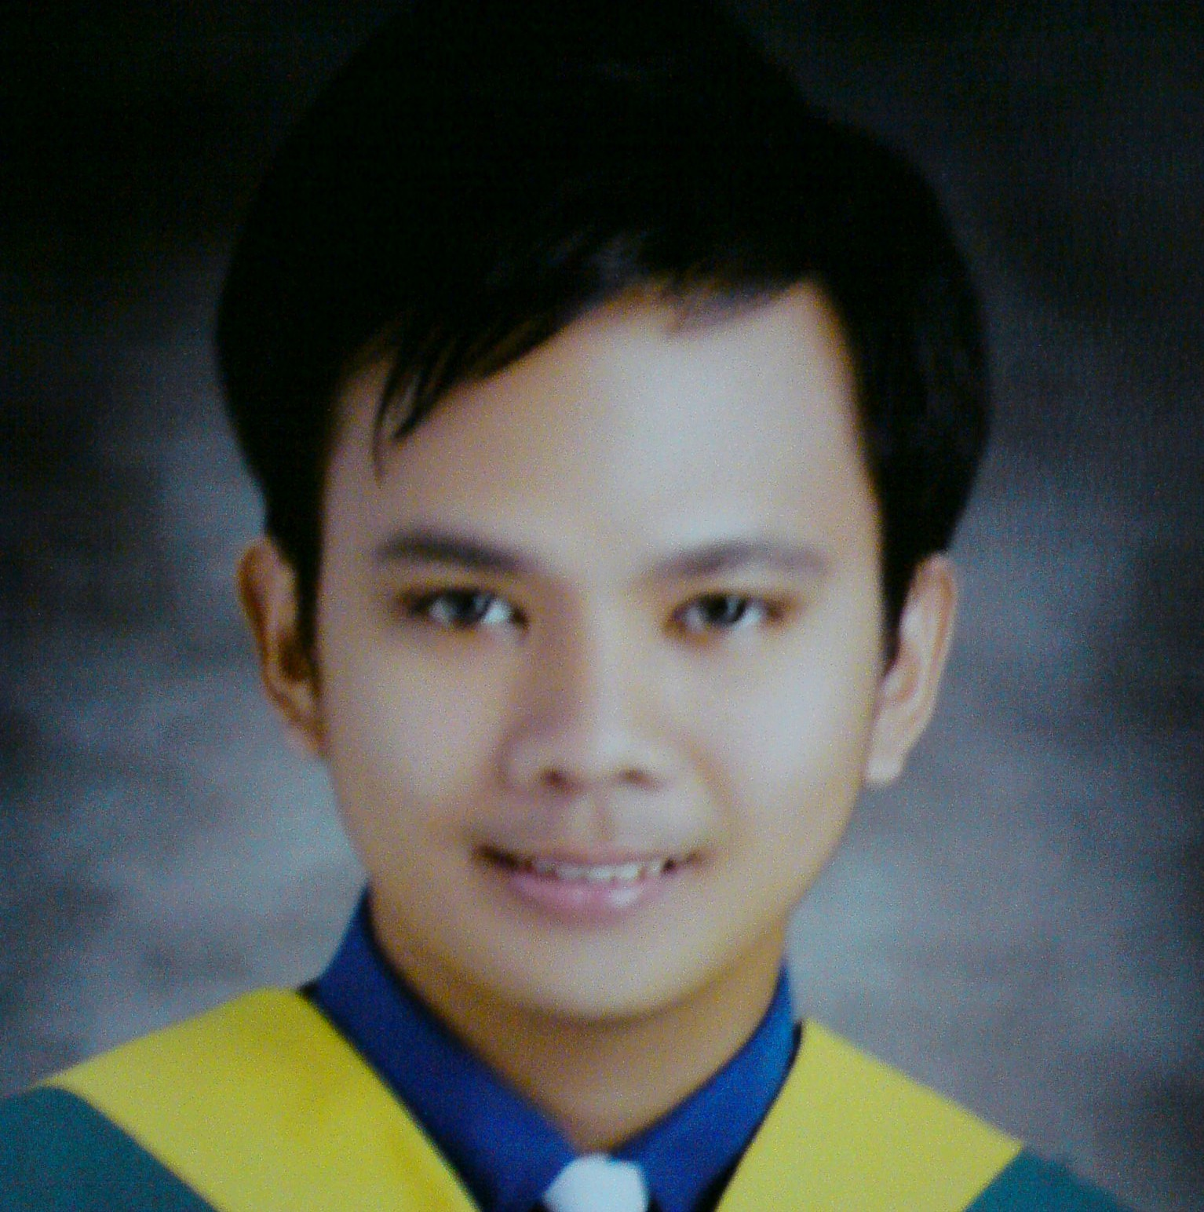
JEFFREY CUEVAS GARCIA,RN
Morroccan Sweet House Bldg.,
Khalidiya St., Abu Dhabi, UAE
Mobile: 050-4386-018
Email: jeffreygarciac@yahoo.com
Seeking a challenging position in the field of nursing where I can enhance my professional and nursing skills. To maximize my capabilities as a nurse in a busy hospital so my skills will be fully utilized.
CAREER PROFILE
- Reliable and Responsible.
- Remain calm and professional throughout critical incidents.
- Strong analytical skills, capable of assessing conditions and implementing appropriate intervention.
- Develop rapport with patients, family, staff and physicians.
- Relate well to people from a variety of cultures.
- Computer literate MS Office/Powerpoint
- Adaptable, assertive and flexible.
PROFESSIONAL EXPERIENCE :
Golden Acres Doctors Hospital, Las Pinas, Philippines
Sept. 1, 2010 to Feb. 7, 2011
Staff Nurse
- Intervenes patient care for up to 12 patients per section.
- Admission and discharging of patients.
- Assess patient’s status and notify physicians for clinical changes.
- Perform tasks according to hospital policies.
- Interact with other medical departments regarding patient care.
- Educating the patient/families on medications, condition and interventions.
- Secure that patient charts are maintained confidential.
Private Duty nurse, Part time job
Dasmarinas, Cavite, 2008 to 2010
- Establishing rapport with the patient
- Monitors patient vital signs, intake and output from time to time
- Giving medications in time as per doctors order
- Provide a nursing care plan for the patient
- Provide nursing skills like NGT feeding, iv insertion, catheterization
- Assist on ambulating & daily care for the patient
SEMINARS AND TRAININGS ATTENDED:
University of Perpetual Help System-DALTA
Bacoor, Cavite. Philippines
- Nurse Enterpreneurship
- Personality Development: Step towards confidence & Transformation
- Cheaper Medicines Act of 2008
- Latest therapy on Psychotherapy
Philippine National Red Cross
Las Pinas City, Philippines
- First Aid Training
- Basic Life Support
Metro South Medical Center
Bacoor, Cavite. Philippines
“Basic IVT Training”
PERSONAL INFORMATION
Date of Birth : January 4, 1990
Place of Birth : DLSU Medical Center, Dasmariñas Cavite
Age : 21 yrs. Old
Nationality : Filipino
Status : Tourist Visa (Feb. 13, 2011 – April 14, 2011)
Passport # : EB1217558

EDUCATIONAL ATTAINMENT:
Course: Bachelor of Science in Nursing Batch 2010
COLLEGE University of Perpetual Help System Molino Campus
Molino III, Bacoor, cavite
HIGH SCHOOL Saint Francis of Assisi College Paliparan Branch
Cuevas Compound Paliparan II, Dasmariñas Cavite
ELEMENTARY Saint Francis of Assisi College Paliparan Branch
Cuevas Compound Paliparan II, Dasmariñas Cavite

I hereby confirmed that the above information is true and correct.

Jeffrey C. Garcia
Applicant

