Attachment A

Explanation of Securitization

Introduction
Securitization takes a commonplace, mundane transaction and makes very strange things happen. This explanation will show that, in the case of a securitized mortgage note, there is no party who has the lawful right to enforce a foreclosure, and the payments alleged to have been in default have, in fact, been paid to the party to whom such payments were due.
Additionally, in the case of a securitized note, there are rules and restrictions that have been imposed upon the purported debtor that are extrinsic to the note and mortgage as executed by the mortgagor and mortgagee, rendering the note and mortgage unenforceable.
This explanation, including its charts, will demonstrate how Securitization is a failed attempt to use a note and a mortgage for purposes for which neither was ever intended,
Securitization consists of a four-way amalgamation. It is partly 1) a refinancing with a pledge of assets, 2) a sale of assets, 3] an issuance and sale of registered securities which can be traded publicly, and 4) the establishment of a trust managed by third party managers. Enacted law and case law apply to each component of Securitization. However, specific enabling legislation to authorize the organization of a Securitization and to harmonize the operation of these diverse components does not exist
Why would anyone issue securities collateralized by mortgages using the structure of a Securitization? Consider the following benefits. Those who engage in this practice are able to...
1. Immediately liquidate an illiquid asset such as a 30-year mortgage.
2. Maximize the amount obtained from a transfer of the mortgages and immediately realize the profits now.
3. Use the liquid funds to enter into new transactions and to earn profits that are immediately realized... again and again (as well as the fees and charges associated with the new transactions, and the profits associated with the new transactions... and so on].
4. Maximize earnings by transferring the assets so that the assets cannot be reached by the creditors of the transferor institution or by the trustee in the event of bankruptcy. (By being "bankruptcy-remote" the value to investors of the illiquid assets is increased and investors are willing to pay more.}
5. Control management of the illiquid asset in the hands of the transferee by appointing managers who earn service fees and may be affiliated with the transferor,
6. Be able to empower the transferor by financially supporting the transferred asset by taking a portion of the first losses experienced, if any, from default, and entering into agreements to redeem or replace mortgages in default and to commit to providing capital contributions, if needed, in order to support the financial condition of the
Transferee (In other words, provide a 100% insured protection against losses).
7. Carry the reserves and contingent liability (for the support provided in paragraph 6 off the balance sheet of the transferor, thereby escaping any reserve requirements imposed upon contingent liabilities that would otherwise be carried on the books.
8. Avoid the effect of double taxation of, first, the trust to which the assets have allegedly been transferred and, second, the investor who receives income from the trust.
9. Insulate the transferor from liability and moves the liability to the investors.
10. Leverage the mortgage transaction by creating a mortgage backed certificate that can be pledged as an asset which can be re-securitized and re-pledged to create a financial pyramid.
11. Create a new financial vehicle so mind numbingly complicated that almost no one understands what is going on.
The obvious benefit of the above #11 is that courts are predisposed to disbelieve the allegation that a securitized note is no longer enforceable. To a reasonable person, the claim that a mortgage note is unenforceable merely because it has been securitized does sound somewhat outlandish. And frankly, the more complex and difficult the securitized arrangement is to explain and perceive, the more likely a judgment in favor of the "lender" will be in litigation.
Simply stated, the vast majority of litigants - and judges - have not been properly informed as to the true nature of this type of transaction. This is said not to insult anyone, Quite to the contrary, this is just to say that the true identity of the real party in interest is able to be obfuscated in the labyrinth of the securitization scheme such that whoever steps forward claiming to be that party and showing documentation appearing to be legitimate is assumed to have standing, and there are too few knowledgeable challengers of that mistaken assumption.
So much more so in the case of the "layman" homeowner. Most homeowners have no idea that the transaction being referred to as a debt and as an obligation that they must pay or be subject to foreclosure, has actually already been paid. And not just once! In cases where a default has been alleged, the securitized note has likely already been satisfied [not just sold and/or assigned) four or five times over.
Securitization is a product of the genius of capitalism. As long as profits continued to be made, all participants did very well from this creative new financial arrangement, and bliss reigned supreme. Then the other shoe dropped.
There is a mortgage default crisis underway in the United States and a credit crisis caused by toxic-assets in the secondary mortgage market. Goldman Sachs estimates that, starting at the end of the last quarter of 2008 through 2014, 13 million foreclosures will occur. The Center for Responsible Lending, based on industry data, predicted 2,4 million foreclosures occurred in 2009, and that there would be a total of 9 million foreclosures between 2009 and 2012. At the end of the first quarter of 2009, more than 2 million houses were in foreclosure, Mortgage Bankers' Ass'n, Nat'1 Delinquency Survey Q109 at 4 (2009) reporting that 3.85% of 44,979,733, or 1.7 million, mortgages being serviced were in foreclosure. Roughly half of these were serviced by national banks or federal thrifts. Over twelve percent of all mortgages had payments past due or were in foreclosure and over 7% were seriously delinquent—either in foreclosure or more than three months delinquent.
These spiraling foreclosures weaken the entire economy and devastate the communities in which they are concentrated. According to The Subprime Lending Crisis: The Economic Impact on Wealth, Property Values and Tax Revenues, and How We Got Here, foreclosed home owners are projected to lose $71 billion due to foreclosure crisis, while neighbors will lose $32 billion, and state and local governments will lose $917 million in property tax revenue.

What is a Securitization? In the mortgage securitization process, collateralized securities are issued by, and receive payments from, mortgages collected in a collateralized mortgage pool. The collateralized mortgage pool is treated as a trust. This trust is organized as a special purpose vehicle ("SPV") and a qualified special purpose entity ("QSPE") which receives special tax treatment. The SPV is organized by the securitizer so that the assets of the SPV are shielded from the creditors of the securitizer and the parties who manage it. This shielding is described as making the assets "bankruptcy remote".
To avoid double taxation of both the trust and the certificate holders, mortgages are held in Real Estate Mortgage Investment Conduits ("REMICS"). To qualify for the single taxable event, all interest in the mortgage is supposed to be transferred forward to the certificate holders.
The legal basis of REMICs was established by the Tax Reform Act of 1986 (100 Stat. 2085, 26 U.S.C.A. §§ 47, 1042J, which eliminated double taxation from these securities. The principal advantage of forming a REMIC for the sale of mortgage-backed securities is that REMlC's are treated as pass-through vehicles for tax purposes helping avoid double-taxation. For instance, in most mortgage-backed securitizations, the owner of a pool of mortgage loans (usually the Sponsor or Master Servicer) sells and transfers such loans to a QSPE, usually a trust, that is designed specifically to qualify as a REMIC, and, simultaneously, the QSPE issues securities that are backed by cash flows generated from the transferred assets to investors in order to pay for the loans along with a certain return. If the special purpose entity, or the assets transferred, qualify as a REMIC, then any income of the QSPE is "passed through" and, therefore, not taxable until the income reaches the holders of the REMIC, also known as beneficiaries of the REMIC trust.
Accordingly, the trustee, the QSPE, and the other parties servicing the trust, have no legal or equitable interest in the securitized mortgages. Therefore, any servicer who alleges that they are, or that they have the right, or have been assigned the right, to claim that they are the agent for the holder of the note for purposes of standing to bring an action of foreclosure, are stating a legal impossibility. Any argument containing such an allegation would be a false assertion. Of course, that is exactly what the servicer of a securitized mortgage that is purported to be in default claims.

The same is the case when a lender makes that same claim. The party shown as "Lender" on the mortgage note was instrumental in the sale and issuance of the certificate, to certificate holders which means they knew that they were not any longer the holder of the note.

The QSPE is a weak repository and is not engaged in active management of the assets. So, a servicing agent is appointed. Moreover, all legal and equitable interest in the mortgages are required by the REMIC to be passed through to the certificate holders. Compliance with the REMIC and insulating the trust assets from creditors of third parties (who create or service the trust) leads to unilateral restructuring of the terms and conditions of the original note and mortgage.
The above fact, and the enormous implications of it, cannot be more emphatically stressed.
A typical mortgage pool consists of anywhere from 2,000 to 5,000 loans. This represents millions of dollars in cash flow payments each month from a servicer (receiving payments from borrowers) to a REMIC (QSPE) with the cash flow "passing through", tax-free, to the trust (REMIC), Those proceeds are not taxed until received as income to the investors. Only the investors have to pay taxes on the payments of mortgage interest received.
The taxes a trust would have to pay on 30, 50, or 100 million dollars per year if this "pass through" taxation benefit didn't exist would be substantial and it would, subsequently, lower the value of the certificates to the investors, the true beneficiaries of these trusts. Worse, what would be the case if a trust that was organized in February 2005 were found to have violated the REMIC guidelines outlined in the Internal Revenue Code? At $4 million per month in cash flow, there would arise over $200 million in income that would now be considered taxable.
It is worth repeating that in order for one of these investment trusts to qualify for the "pass through" tax benefit of a REMIC (in other words, to be able to qualify to be able to be referred to as a REMIC), ALL LEGAL AND EQUITABLE INTEREST IN THE MORTGAGES HELD IN THE NAME OF THE TRUST ARE VESTED IN THE INVESTORS, not in anyone else AT ANY TIME, If legal and/or equitable interest in the mortgages held in the name of the trust are claimed by anyone other than the investors, those that are making those claims are either defrauding the investors, or the homeowners & courts, or both.
So, if the trust, or a servicer, or a trustee, acting on behalf of the trust, is found to have violated the very strict REMIC guidelines (put in place in order to qualify as a REMIC), the "pass through" tax status of the REMIC can be revoked. This, of course, would be the equivalent of financial Armageddon for the trust and its investors,
A REMIC can be structured as an entity (i.e., partnership, corporation, or trust) or simply as a segregated pool of assets, so long as the entity or pool meets certain requirements regarding the composition of assets and the nature of the investors' interests. No tax is imposed at the REMIC level. To qualify as a REMIC, all of the interests in the REMIC must consist of one or more classes of "regular interests" and a single class of "residual interests."

Regular interests can be issued in the form of debt, stock, partnership interests, or trust certificates, or any other form of securities, but must provide the holder the unconditional
right to receive a specified principal amount and interest payments. REMIC regular interests are treated as debt for federal tax purposes. A residual interest in a REMIC, which is any REMIC interest other than a regular interest, is, on the other hand, taxable as an equity interest.
According to Section 860 of the Internal Revenue Code, in order for an investment entity to qualify as a REMIC, all steps in the "contribution" and transfer process (of the notes) must be true and complete sales between the parties and must be accomplished within the three month time limit from the date of "startup" of the entity. Therefore, every transfer of the note(s) must be a true purchase and sale, and, consequently the note must be endorsed from one entity to another. Any mortgage note/asset identified for inclusion in an entity seeking a REMIC status must be sold into the entity within the three-month time period calculated from the official startup day of the REMIC.
Before securitization, the holder of an enforceable note has a financial responsibility for any possible losses that may occur arising from a possible default, which means that holder also, has the authority to take steps to avoid any such losses (the right to foreclose). Securitization, however, effectively severs any such financial responsibility for losses from the authority to incur or avoid those losses.
With securitization the mortgage is converted into something different from what was originally represented to the homeowner. For one thing, since the party making the decision to foreclose does not actually hold any legal or equitable interest in any securitized mortgage, they have not realized any loss or damages resulting from the purported default. Therefore, it also follows that the foreclosing party avoids the liability, which could result if a class of certificate holders claimed wrongful injury resulting from a modification made to achieve an alternate dispute resolution.
Securitization also makes the mortgage and note unalienable. The reason is simple: once certificates have been issued, the note cannot be transferred, sold or conveyed; at least not in the sense that such a transfer, sale, or conveyance should be considered lawful, legal, and legitimate. This is because the securitized note forever changes the nature of that instrument in an irreversible way, much in the same way that individual strawberries and individual bananas can never be extracted, in their "whole" form, from a strawberry banana milkshake once they've been dropped in the blender and the blending takes place.
It might appear that the inability to alienate the note has no adverse consequences for the debtor, but recent history disproves this notion. Several legislative and executive efforts to pursue alternate dispute resolution and to provide financial relief to distressed homeowners have been thwarted by the inability of the United States government to buy securitized mortgages without purchasing most of the certificates issued.
An SPV cannot sell any individual mortgage because individual mortgages are not held individually by the certificate holders; the thousands of mortgages held in the name of the REMIC are owned collectively by the certificate holders. Likewise, the certificate holders cannot sell the mortgages. All the certificate holders have are the securities, each of which can be publicly traded.
The certificate holders are, in no sense, holders of any specific individual note and have no legal or beneficial interest in any specific individual note. The certificate holders do not each hold undivided fractional interests in a note, which added together, total 100%. The certificate holders also are not the assignees of one or more specific installment payments made pursuant to the note.

For the certificate holder, there is no note. A certificate holder does not look to a specific

note for their investment's income payment Instead; the certificate holder holds a security similar to a bond with specific defined payments. The issuer of trust certificates is selling segments of cash flow.

The concept of securitization is brilliant; it began as a simple idea; a way to convert illiquid, long term debt into liquid, tradable short term debt. It cashes out the lender, allowing the lender to make new "loans" while realizing an immediate profit on the notes sold.

The Charts
In order to more easily identify the parties and their relationship to the securitization arrangement, it is useful to view it in diagram form. The parties to a securitization and their relationships to each other, including the duties and obligations one party owes to another party, is referred to on Wall Street as "The Deal". The Deal is created and defined by what functions as a declaration of trust, also known as "the master servicing and pooling agreement", hereafter "pooling agreement".
Chart 1 below shows a Net Asset Trust created to convert long term mortgage debt into short-term, publicly traded securities.

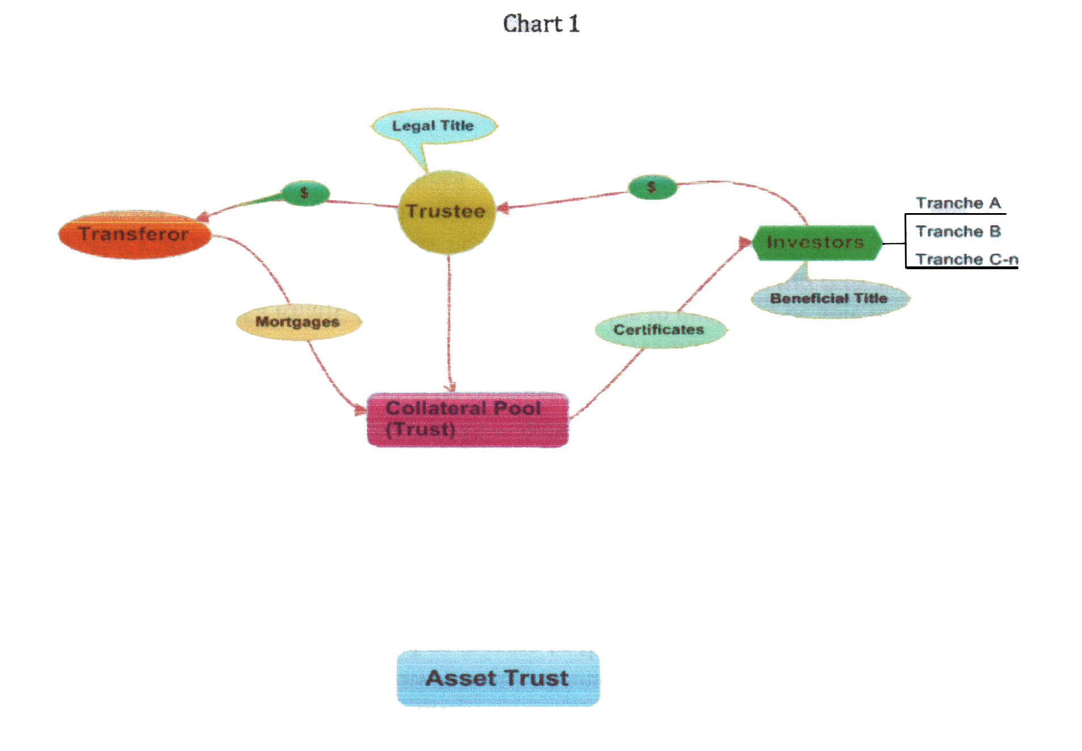

The transferor purchases a portfolio of mortgages and sells them to a trust. The trust purchases
the mortgages. The trustee holds the mortgages and becomes the holder of legal title. The trust

then issues a bond to the investors; debenture-like certificates, the bond issues different classes of certificates, called tranches.
The certificate entitles the certificate purchaser to certain stated, repeated segments of cash flow paid by the trust. The certificate holders do not hold fractional, undivided interest in the mortgages. Instead, each tranche is entitled to an identified, segmented pool of money payable in an order of priority. A senior tranche will get paid before a junior tranche. A junior rate provides a higher promised rate of return because it has a higher risk than a senior tranche. Another tranche exists that pays interest, but does not pay out principal.
The type and variety of tranche that is created, is limited only by the limits of financial ingenuity. Tranches have been created which pay only a portion of principal repaid on the mortgages but no interest.
The investors buy the mortgages from the transferor by paying cash to the trustee who pays the transferor. The investors purchase securities (certificates) which are collateralized by the mortgages held in trust in the collateral pool. Legal title to the mortgages is held by the trustee and beneficial title is owned by the investors.
Only the extremely savvy debtor in this arrangement would know that he should perhaps begin to become concerned upon learning that his mortgage note had been sold to a trust and exchanged for certificates that are issued to unknown beneficiaries (investors) whose certificates were issued under one of many different types of tranches. However, the debtors - the homeowners; the people who provide the income that funds the entire securitization scheme - have no say in the matter because they are never told what will be done with their note. It is never disclosed in the transaction.
So, whereas it would take an extremely savvy person to understand why this arrangement is potentially troublesome to the homeowner whose note has been used in this way, it would take an omniscient homeowner to know that securitization is even going on in the first place. For reasons already stated above, it is not only disingenuous to suggest that securitization does not affect the rights of the debtor, it is downright dishonest.
Nevertheless, for purposes of breaking down the topic into bite-sized pieces: suffice it to say that the trust purchased mortgages and sold certificates. Another way to describe it: the trust bought cattle and wound up selling ground beef.
This then raises questions suitable for a law school examination or law journal article: Are the purchasers of these certificates really beneficial holders of the note, or are they merely purchasers of a contract right to payment from the trust? In other words, is the trustee limited to being the holder of legal title, or does the trustee also hold, the beneficial title? While these may be good questions for an academic exercise, they aren't germane to defending the debtor being sued in foreclosure. The reason is that under either case, the trustee has standing to foreclose.
More germane is the fact is that an asset trust is likely not the type of securitization vehicle to hold a debtor's mortgage. This is because Wail Street decided to improve the "asset trust paradigm". If the Deal could be made safer for, and more lucrative to, the investor, the investor would pay more for the investment. This was accomplished by adding objectives 2-11 to the list already referred to above, shown again below:

1. Immediately liquidate an illiquid asset such as a 30-year mortgage,
2. Maximize the amount obtained from a transfer of the mortgages and immediately realize the profits now.
3. Use the liquid funds to make new loans and earn profits that are immediately realized, again and again (as well as the fees and charges associated with making loans, and the profits associated with liquidating the new loans as quickly as practicable... and so on).
4. Maximize earnings by transferring the assets so that the assets cannot be reached by the creditors of the transferor institution or by the trustee in the event of bankruptcy. (By being "bankruptcy-remote" the value to investors of the illiquid assets is increased and investors are willing to pay more.)
5. Control management of the illiquid asset in the hands of the transferee by appointing managers who earn service fees and may be affiliated with the transferor.
6. Be able to empower the transferor to support the transferred asset by taking a portion of the first losses experienced, if any from default, entering into agreements to redeem or replace mortgages in default and commit to providing capital contributions, if needed, in order to support the financial condition of the transferee.
7. Carry the reserves and contingent liability for the support provided in paragraph 6 off the balance sheet of the transferor, thereby escaping any reserve requirements imposed upon contingent liabilities carried on the books.
8. Avoid the effect of double taxation of, first, the trust to which the assets have allegedly been transferred and, second, the investor who receives income from, the trust.
9. Insulate the transferor from liability and move the liability to the investors.
10. Leverage the mortgage transaction by creating a mortgage backed certificate that can be pledged as an asset which can be re-securitized and re-pledged to create a financial pyramid.
11. Create a new financial vehicle so mind numbingly complicated that almost no one understands what is going on.
The net asset trust structure does not provide the additional 10 benefits of securitization listed above (items 2 through 11). For instance, under the net asset trust, the income received by the collateral pool from the mortgage debtors is taxed and the interest paid to each investor is taxed again.
To achieve the goals listed above, it became necessary to structure the Deal to create a pass through trust and replace the net asset trust. As shown in Chart 2 shown below, the Deal starts off on a straightforward easily charted path. The path of the mortgages identifies the note holder at each stage...

Chart 2

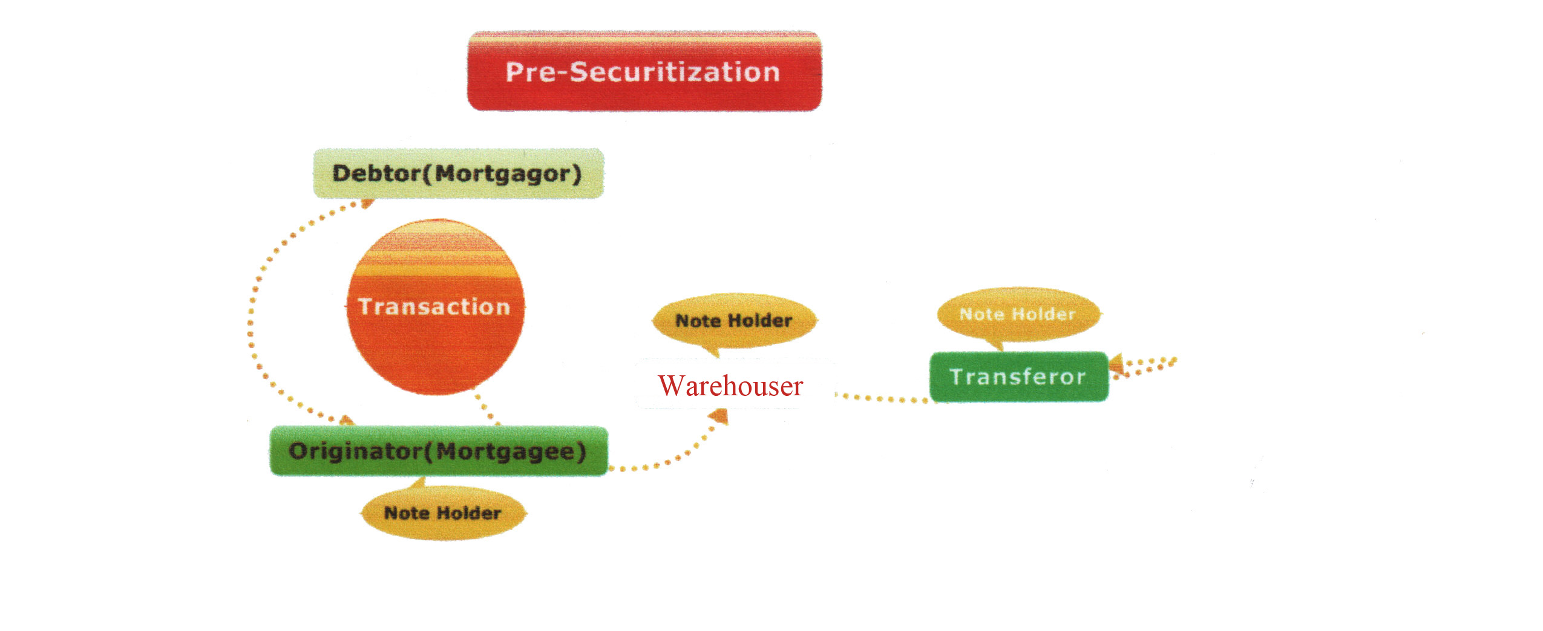

1. ORIGINATOR. The Transaction takes place between the debtor [mortgagor] and the creditor here called the "originator" a.k.a. the mortgagee. The transaction consists of the mortgage note and the mortgage 0r Deed of Trust. The originator becomes the note holder.
2. WAREHOUSER. The originator sells the transaction to the warehouser. The warehouser then becomes the note holder.
3. TRANSFEROR. The warehouser buys the mortgage and also buys other mortgages to assemble a portfolio of mortgages. The portfolio is then sold to the transferor who is the initiating party of the securitization. The transferor, then becomes the note holder. The transferor creates the securitization.

As previously stated, a portfolio for securitization typically contains from 2,000 to 5,000 mortgages.

There are many different structures for securitization but the potential negative impact of Securitization on the debtor is the same. The chart on the following page shows a typical securitization.

Chart 3

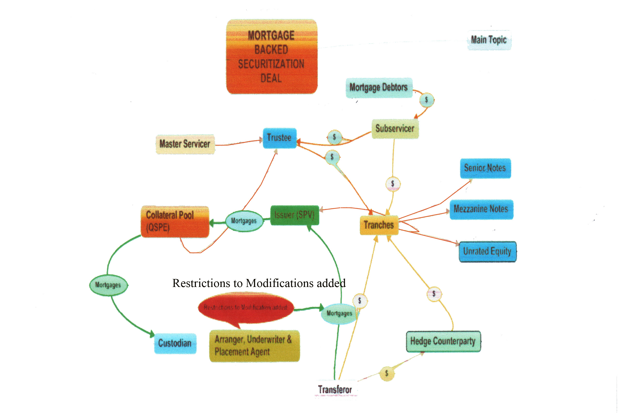

The structure seen above is called the "Deal". The Deal is created through a complex

instrument that, among other things...
1. Serves as a declaration of trust,
2. Identifies the parties who manage the Deal and describes their duties, responsibilities, liabilities and obligations,
3. Defines the different classes of investment securities, and
4. Is called the Master Pooling and Servicing Agreement.
The instrument is filed with the Securities and Exchange Commission and is a public record. This document is the most important source for discovery as it provides the who, the how, the where, and the when of the Deal.
Chart 2 shows the mortgage portfolio in the hands of the transferor who was the note holder,
The Transferor. In the "new and improved" securitization process (shown in Chart 3), the transferor transfers the mortgages to the underwriter. In addition, the transferor may arrange for credit enhancements to be transferred for the benefit and protection of investors. Such enhancements may include liquid assets, other securities, and performing mortgages in excess of the mortgage portfolio being sold, NOTE: the transferor also usually obligates itself to redeem and replace any mortgage in default.
The Underwriter. The underwriter creates the securities and arranges to place the various tranches of securities (different classes of certificates) with investors. The underwriter then transfers the mortgage portfolio and securities to the issuer.
The Issuer. The issuer is organized as a Special Purpose Vehicle (SPV); a passive conduit to the investors. The issuer issues the securities to the investors and collects payment from the investors. The payments from the investors are transferred through the underwriter to the transferor.
The QSPE. The mortgage portfolio is conveyed from the issuer to the collateral pool which is organized as a Qualifying Special Purpose Entity ("QSPE"). As previously stated, what makes the entity "qualified" is strict adherence to a set of rules. Among other things, these rules make the QSPE a passive entity which has no legal or equitable title to the mortgages in the mortgage portfolio and restricts modification of the mortgages in the portfolio,
As a result, the QSPE provides to the investors the benefit of its earnings (paid to it by the mortgage debtors) not being taxed. These earnings flow through the QSPE to the investors. Only the investors are taxed at the individual level.
Custodian. The QSPE transfers the mortgage portfolio to the custodian who acts as a bailee of the assets. The custodian is a mere depository for safekeeping of the mortgages.

Tranches. The investors invest in different classes of securities. Each class is called a tranche. Each tranche is ranked by order of preference in receipt of payment and the segment of cash flow to be received and resembles a bond. The basic stratification by order of priority of payment from highest to lowest is categorized as follows: senior notes, mezzanine notes and unrated equity.

Parties described in the Master Pooling and Servicing Agreement. The Deal establishes a management structure to supervise the investment. The specific parties for a Deal are identified in the master Pooling and Servicing Agreement, which states their duties and obligations, their compensation, and their liability. Typically the managers include: the Master Servicer, the Trustee, the Subservicer, and the Custodian.

Master Servicer. The Master Servicer is in overall charge of the deal and supervises the other managing parties.
Trustee. The day-to-day operations of the collateral pool are administered by the trustee. However, the trustee does very little since the trust must remain passive. The trustee does not have a legal or equitable interest in any mortgage in the portfolio because the trust is a mere passive conduit.
Subservicer. The Subservicer is responsible for dealing with the property owners; collecting monthly payments, keeping accounts and financial records and paying the monthly proceeds to the trustee for distribution to the investors by order of tranche.
The Subservicer may also be responsible for foreclosure in the event a mortgage is in default or some deals call for the appointment of a special subservicer to carry out foreclosure. Usually the subservicer is obligated to make monthly advances to the investors for each mortgage in default. In addition, the subservicer may also have undertaken to redeem or replace any mortgage in default.
Counterparty. Finally, there is a counterparty to make sure that investors get paid on time, the counterparty is like an insurer or guarantor on steroids; a repository of all kinds of financial arrangements to insure payment to the investors. Such financial arrangements include derivatives, credit default swaps and other hedge arrangements.
The term "counterparty" is frequently associated with "counterparty risk" which refers to the risk that the counterparty will become financially unable to make the "claims" to the investors if there are a substantial number of mortgage defaults. The counterparty may guarantee the obligation of the transferor or servicer to redeem or replace mortgages in default. The counterparty may also guarantee the obligation of the subservicer to make monthly payments for mortgages that are said to be in default.
Questions worth asking. We now know that an examination of the Master Servicing and Pooling Agreement filed with the SEC will reveal substantial barriers to a lawful foreclosure. We also know that there are parties involved in this arrangement, as well as insurance products in place, intended to financially "cover" certain "losses" in certain situations, such as an alleged default.
In light of this, there are a few questions the Subservicer and/or the Successor Trustee and/or the foreclosure law firm who claims to have the legal right and authority to conduct a foreclosure, ought to be prepared to answer before the foreclosure goes forward:

1) Have you read, and are you familiar with, the Master Servicing and Pooling Agreement relating to this mortgage that was filed with the SEC?
2) The Servicer, Subservicer, or some other party (counterparty) likely made a payment to the party who allegedly owns the purported debt obligation. This payment, if made, was intended to cover sums that are alleged to be in default Therefore, the party who allegedly owns the purported debt obligation has, by virtue of that payment not been damaged in any way. Therefore, if any sums have thusly been paid, how is it being truly stated that a default has occurred?
3) If the investment trust that ostensibly owns the mortgage obligation is a REMIC, the trustee, the QSPE, and the other parties servicing the trust, have no legal or equitable interest in the securitized mortgages. Therefore, any servicer who alleges that they have the right, or that they have been assigned the right, to claim that they are the agent for the holder of the note for purposes of standing to bring an action of foreclosure, are stating a legal impossibility. In light of this, by what authority can you show that you can administer a lawful foreclosure?
There are many more questions that can and should be asked in such a situation. They all stem from one central fact: a note that has been securitized and submitted to an entity qualifying as a REMIC and organized as a Qualifying Special Purpose Entity, is not enforceable. That is an incontrovertible fact that servicers of securitized mortgages will have to cope with as more and more homeowners discover the truth.

Conclusion
Previously, it was stated that, in order for the investment entity to be a REMIC (in other words, in order for the entity to be able to qualify for the single taxable event as a pass through entity), all-interest in the mortgage is supposed to be transferred forward to the certificate holders.
Well, in fact, such a transfer never occurs. Either that is the case, or the parties who state that they have a right to foreclose on a securitized note are not being truthful when they present themselves as the real party in interest
In any case, they cannot have it both ways. The servicer cannot claim to hold legal and/or equitable interest in the mortgages held in the name of an investment trust that also provides the (REMIC) pass through tax benefit to its investors.
Does the Master Servicing Agreement - made public through its filing with the Securities and Exchange Commission - show that the entity is a REMIC? If so, the note has become unenforceable because the unnamed parties who are receiving the pre-tax income from the entity are the real parties in interest They hold the legal and/or equitable interest in the mortgages held, but they do not have the ability to foreclose on any one individual mortgage because the mortgages held by the REMIC have all been bundled into one big income-producing unit.
The Introduction explains that securitization consists of a four-way amalgamation. It is partly 1) a refinancing with a pledge of assets, 2] a sale of assets, 3] an issuance and

sale of registered securities which can be traded publicly, and 4] the establishment of a trust managed by third party managers,
Also discussed is the fact that enacted law and case law apply to each component of securitization, but that specific enabling legislation to authorize the organization of a securitization, and to harmonize the operation of these diverse components, does not exist. This bears repeating even more explicitly because this is central to the rights of a homeowner facing foreclosure whose underlying mortgage has been securitized: specific enabling legislation to authorize the pass through structure of a trust holding a mortgage portfolio does not exist.

Many unresolved legal issues could be addressed if the Uniform Commercial Code Commissioners added a chapter for securitization. However, that has yet to happen. So as it now stands, a lawful foreclosure cannot occur against a mortgage whose note has been securitized because of the lack of an actual damaged party who has standing to state a claim.

