<https://open.alipay.com/platform/developerIndex.htm>

## 沙箱测试

<https://open.alipay.com/platform/appDaily.htm?tab=info>

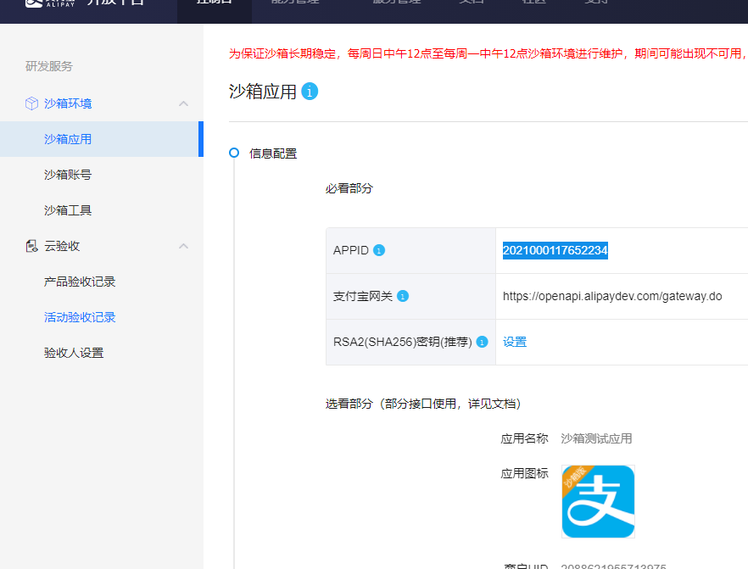

### 生成密钥：

<https://opendocs.alipay.com/open/291/105971#%E5%B7%A5%E5%85%B7%E4%B8%8B%E8%BD%BD>

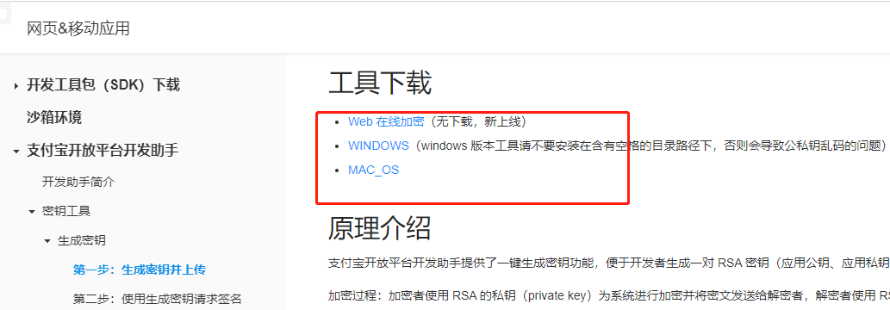

<https://miniu.alipay.com/keytool/create>

