1.Workeod on about_us api in twiki

<http://developerdeepika.com/twiki/appservice/process.php?action=about_us>

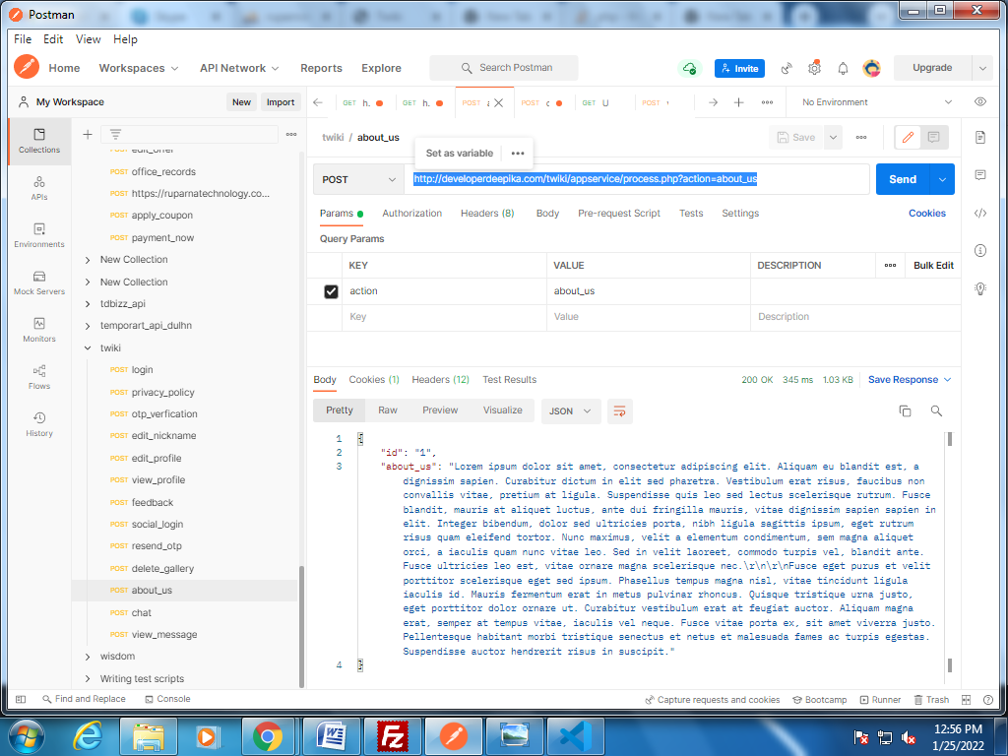

2.Worked on chat api in twiki

<http://developerdeepika.com/twiki/appservice/process.php?action=chat>

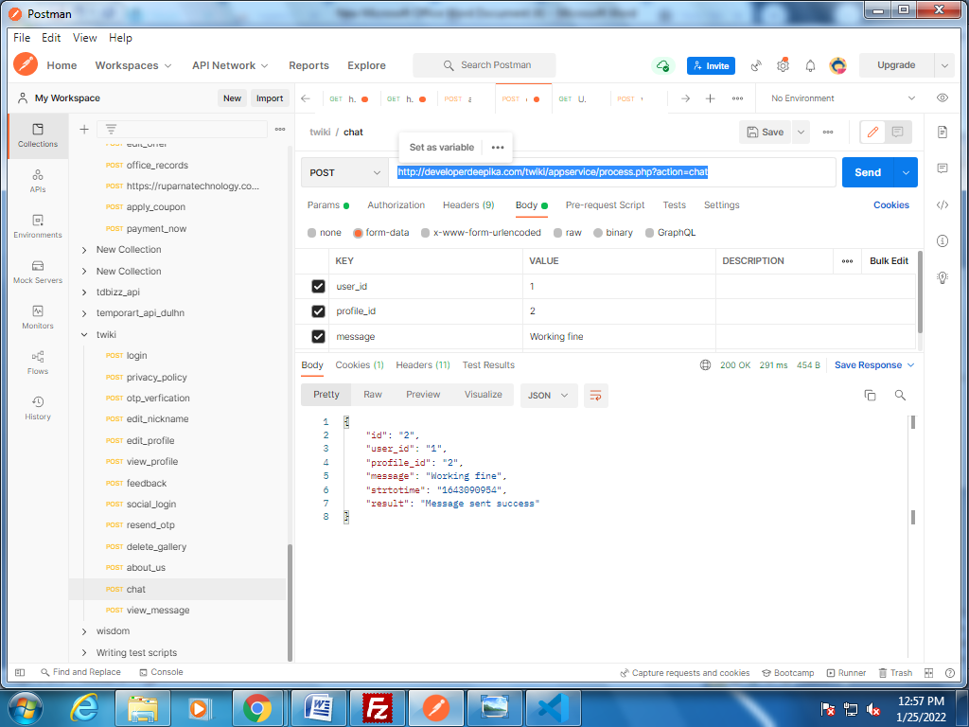

3.Worked on view_message api in twiki

<http://developerdeepika.com/twiki/appservice/process.php?action=view_message>

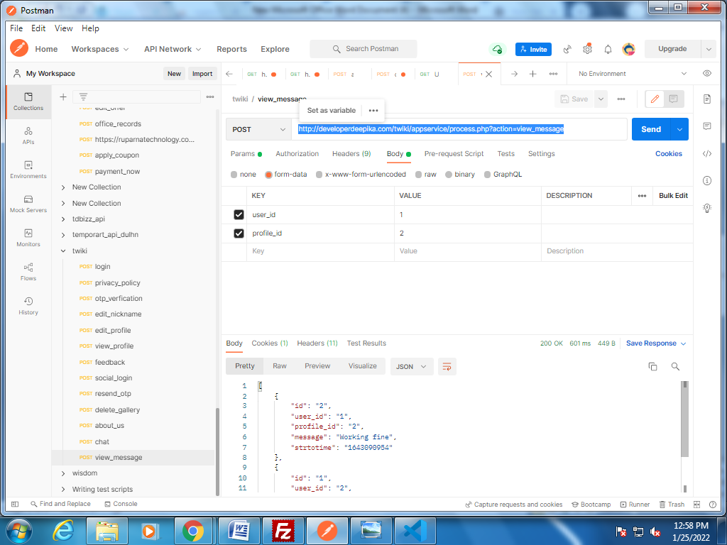

4.Worked on block api in twiki

<http://developerdeepika.com/twiki/appservice/process.php?action=block>

