INTRODUCTION TO JAVA HONEY ARORA

Trainee-JVM

**QUES 1. Write a class with FirstName, LastName & age field. Print First Name, LastName & age using static block, static method & static variable respectively.**

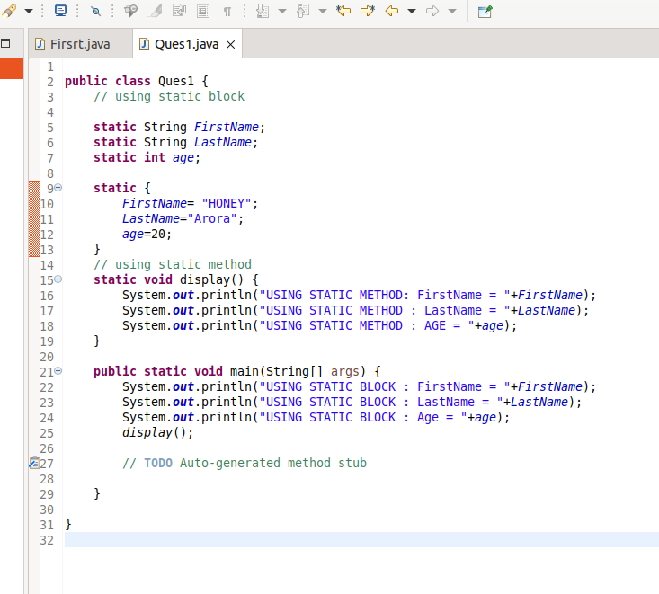

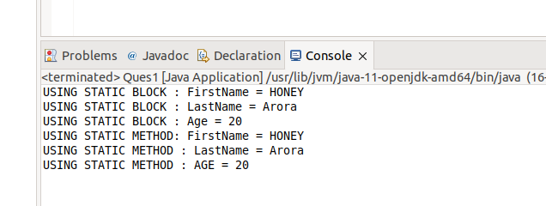

**QUES2. Write a program to read user input until user writes XDONE and then show the entered text by the user on command line**

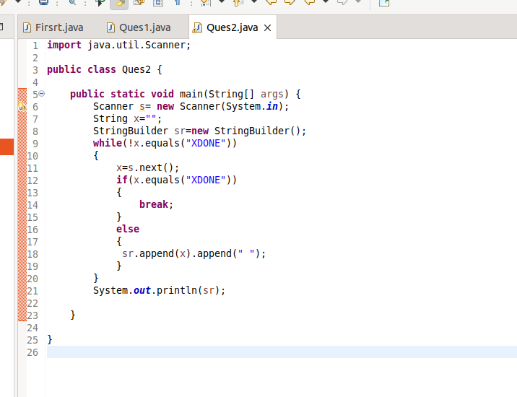

**OUTPUT:**

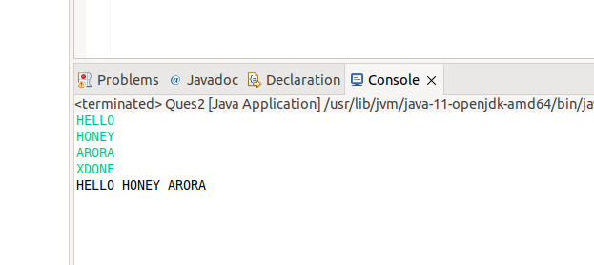

**QUES3. Write a java program to show following menu to the user:**

**\*\*\*\*\*\*\*Menu\*\*\*\*\*\*\***

**1. Calculate Area of Circle**

**2. Calculate Circumference of a Circle**

**3. Exit.**

**Choose an option (1-3):**

**Take radius as user input.**

**Hint: Use the Switch statement to act on the menu. Also area and circumference methods should be static**

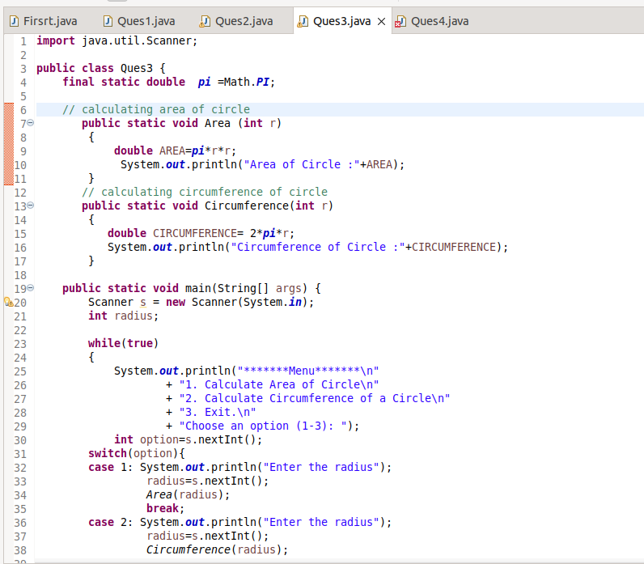

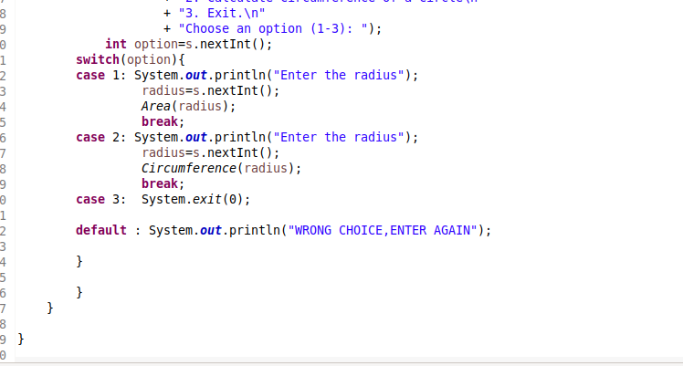

**OUTPUT:**

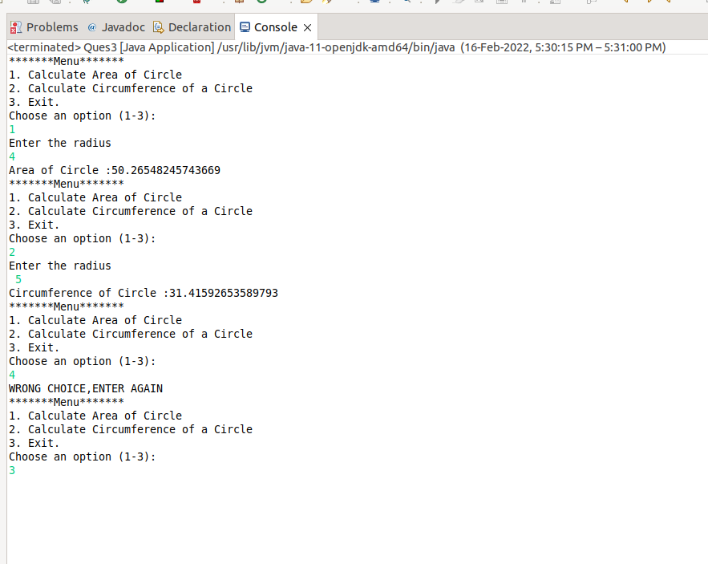

**Ques4 . Create a two dimensional array of integers and display:**

* **sum of all elements of each column**
* **sum of all elements of each row**

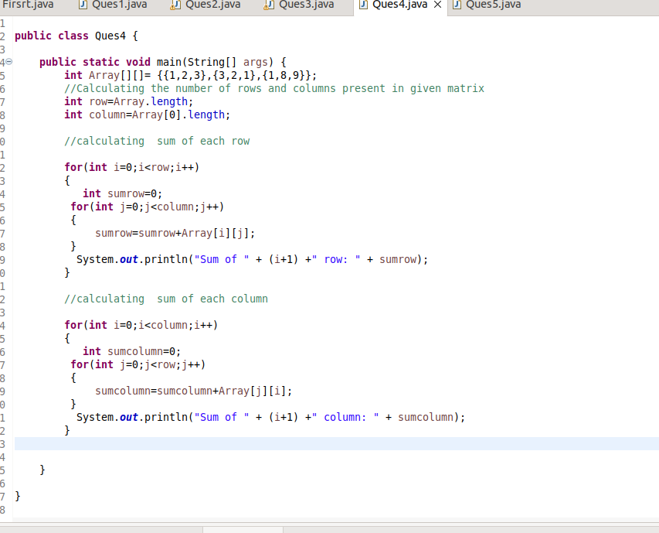

**OUTPUT:**

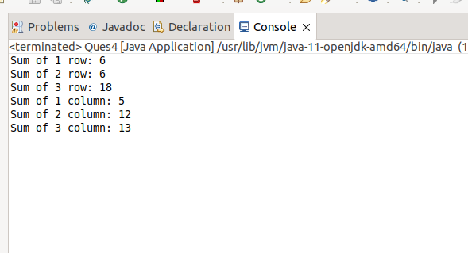

**QUES5. Create a class named Employee with fields firstname,lastname,age and designation.**

**The class should:**

* **have all types of constructors to initialize the object**
* **class should also have setter methods to update a particular field**
* **Override its toString method to display a meaningful message using all these fields.**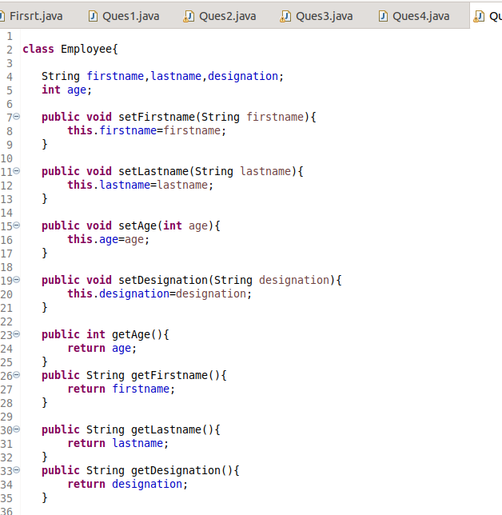

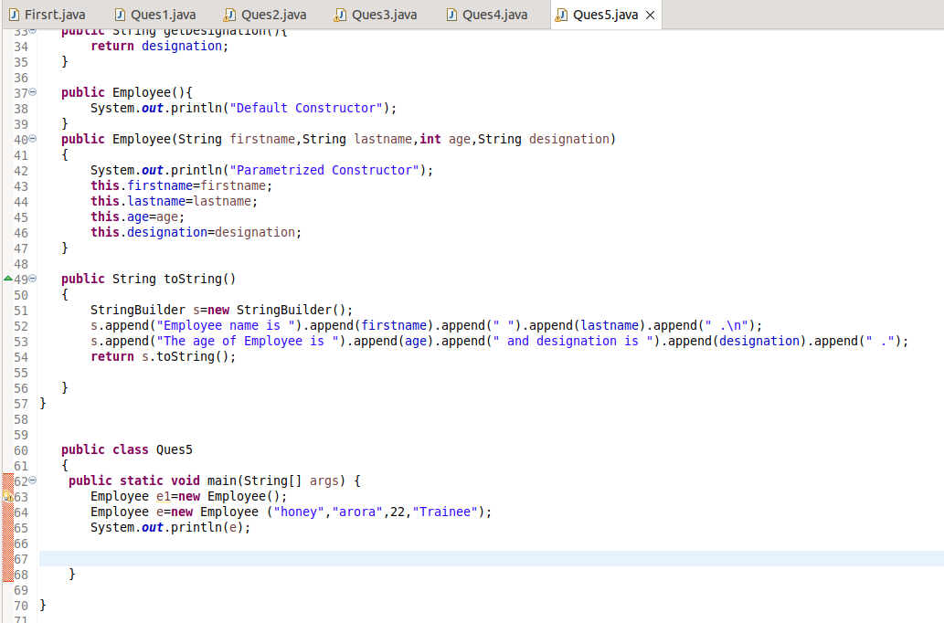

**OUTPUT:**

