INTRODUCTION TO JAVA2 HONEY ARORA

Trainee

**QUES1 . Implement a banking system using java.**

**Create 3 subclass of Bank : SBI,BOI,ICICI**

**All 4 should have following methods:**

* **getDetails which provide their specific details like rateofinterest etc**
* **printDetails of every bank.**
* **Every bank account should have a type (enum): SAVINGS, CURRENT**
* **Implement a feature to deduct the amount from the account. Throw InsufficientAmountException if the amount being deducted is less than the current balance.**
* **Every banking transaction should be saved in a file of each bank's transaction log which would have all details of the transaction like (time of transaction,account number,amount withdrawn, amount before deduction, amount after deduction,transaction status (can also be enum), failure reason if any)**

**BANKING SYSTEM**

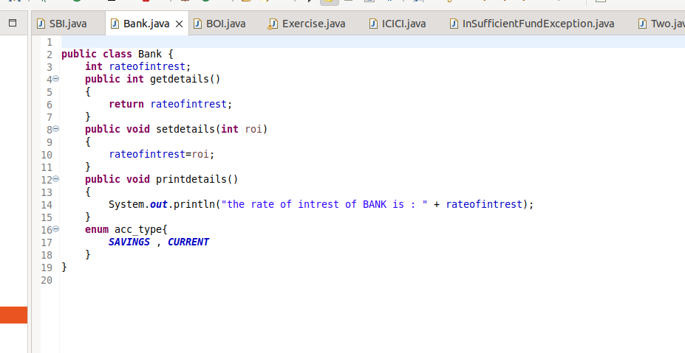

**BOI**

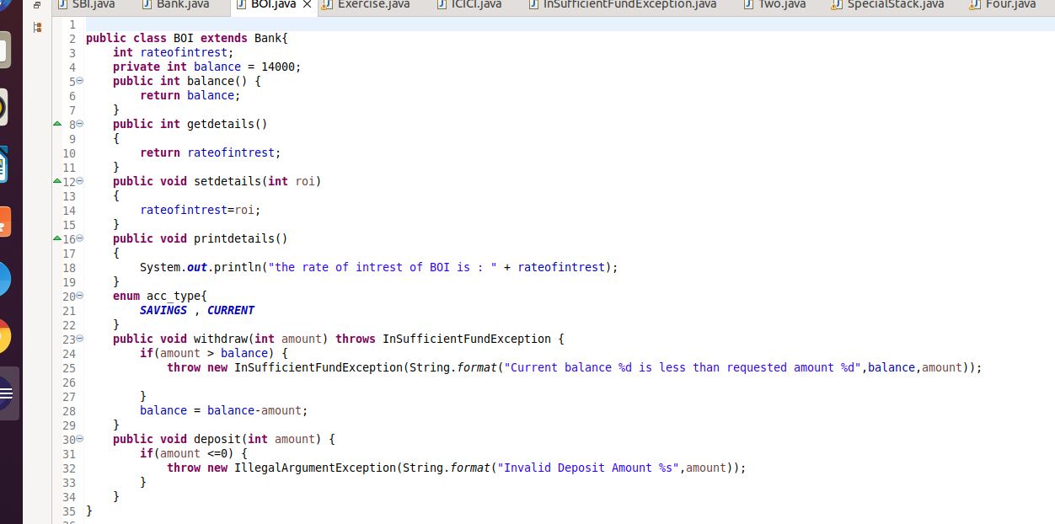

**ICICI**

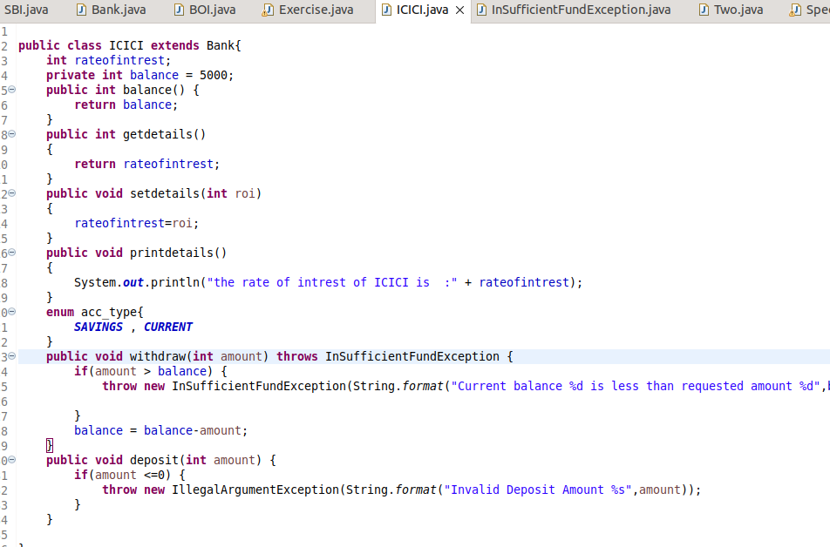

**SBI**

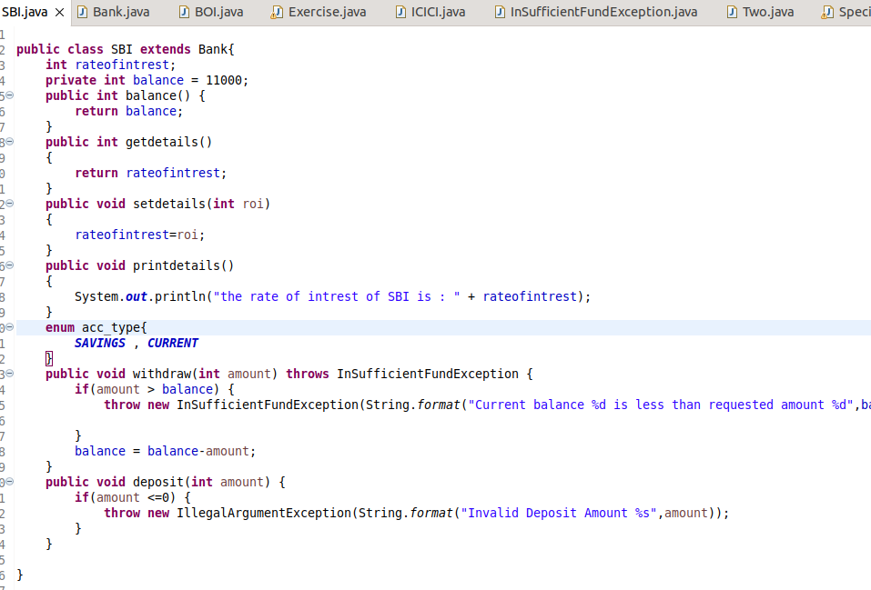

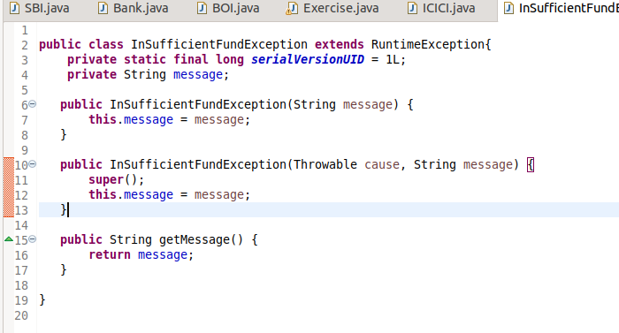

**EXERCISE.JAVA**

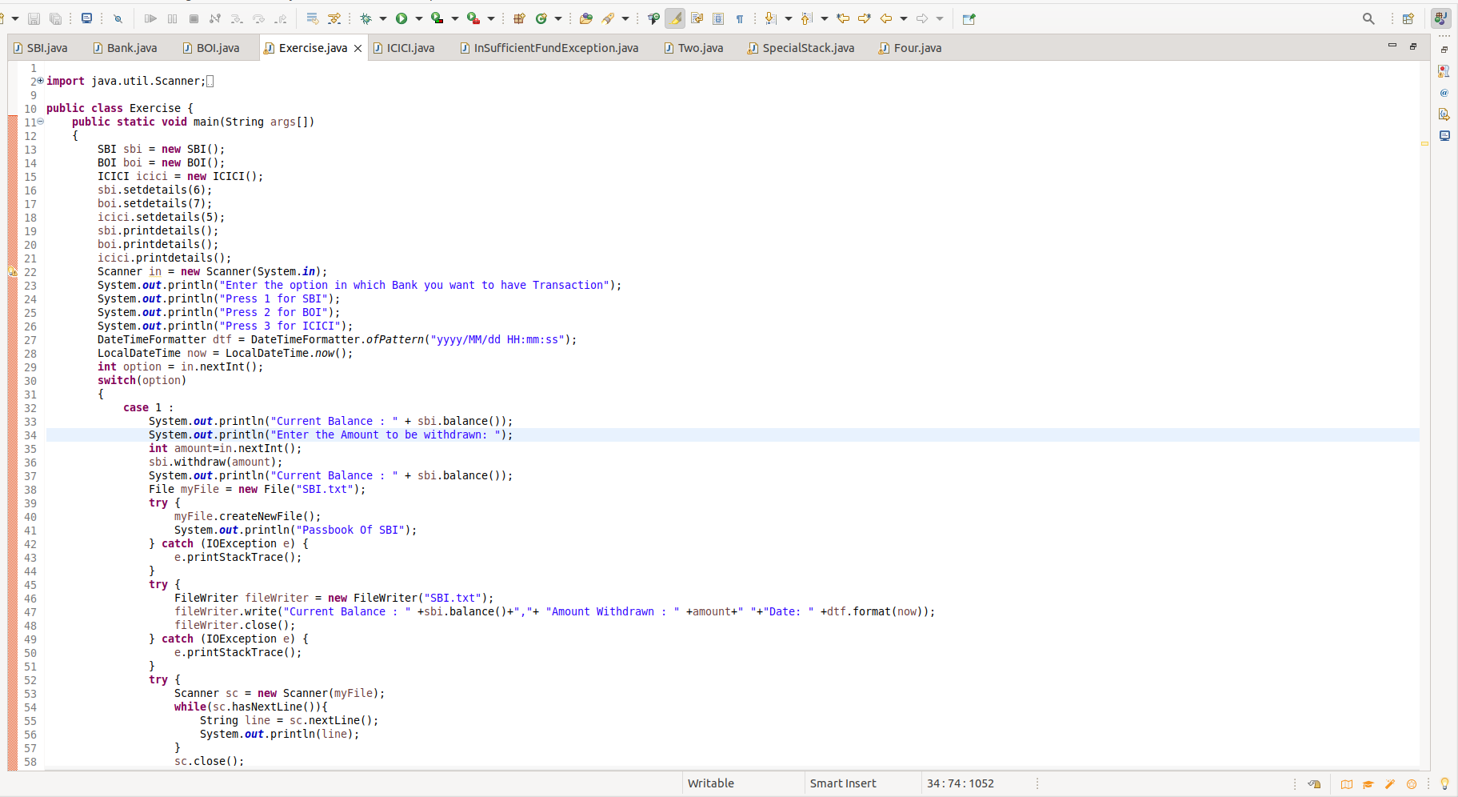

**import java.util.Scanner;**

**import java.time.format.DateTimeFormatter;**

**import java.io.File;**

**import java.io.FileNotFoundException;**

**import java.io.FileWriter;**

**import java.io.IOException;**

**import java.time.LocalDateTime;**

**public class Exercise {**

**public static void main(String args[])**

**{**

**SBI sbi = new SBI();**

**BOI boi = new BOI();**

**ICICI icici = new ICICI();**

**sbi.setdetails(6);**

**boi.setdetails(7);**

**icici.setdetails(5);**

**sbi.printdetails();**

**boi.printdetails();**

**icici.printdetails();**

**Scanner in = new Scanner(System.in);**

**System.out.println("Enter the option in which Bank you want to have Transaction");**

**System.out.println("Press 1 for SBI");**

**System.out.println("Press 2 for BOI");**

**System.out.println("Press 3 for ICICI");**

**DateTimeFormatter dtf = DateTimeFormatter.ofPattern("yyyy/MM/dd HH:mm:ss");**

**LocalDateTime now = LocalDateTime.now();**

**int option = in.nextInt();**

**switch(option)**

**{**

**case 1 :**

**System.out.println("Current Balance : " + sbi.balance());**

**System.out.println("Enter the Amount to be withdrawn: ");**

**int amount=in.nextInt();**

**sbi.withdraw(amount);**

**System.out.println("Current Balance : " + sbi.balance());**

**File myFile = new File("SBI.txt");**

**try {**

**myFile.createNewFile();**

**System.out.println("Passbook Of SBI");**

**} catch (IOException e) {**

**e.printStackTrace();**

**}**

**try {**

**FileWriter fileWriter = new FileWriter("SBI.txt");**

**fileWriter.write("Current Balance : " +sbi.balance()+","+ "Amount Withdrawn : " +amount+" "+"Date: " +dtf.format(now));**

**fileWriter.close();**

**} catch (IOException e) {**

**e.printStackTrace();**

**}**

**try {**

**Scanner sc = new Scanner(myFile);**

**while(sc.hasNextLine()){**

**String line = sc.nextLine();**

**System.out.println(line);**

**}**

**sc.close();**

**} catch (FileNotFoundException e) {**

**e.printStackTrace();**

**}**

**break;**

**case 2:**

**System.out.println("Current Balance : " + boi.balance());**

**System.out.println("Enter the Amount to be withdrawn: ");**

**int amounts=in.nextInt();**

**boi.withdraw(amounts);**

**System.out.println("Current Balance : " + boi.balance());**

**File myFile2 = new File("BOI.txt");**

**try {**

**myFile2.createNewFile();**

**System.out.println("PassBook of BOI");**

**} catch (IOException e) {**

**e.printStackTrace();**

**}**

**try {**

**FileWriter fileWriter = new FileWriter("BOI.txt");**

**fileWriter.write("Current Balance : " +boi.balance()+","+ "Amount Withdrawn : " +amounts+" "+"Date: " +dtf.format(now));**

**fileWriter.close();**

**} catch (IOException e) {**

**e.printStackTrace();**

**}**

**try {**

**Scanner sc = new Scanner(myFile2);**

**while(sc.hasNextLine()){**

**String line = sc.nextLine();**

**System.out.println(line);**

**}**

**sc.close();**

**} catch (FileNotFoundException e) {**

**e.printStackTrace();**

**}**

**break;**

**case 3:**

**System.out.println("Current Balance : " + icici.balance());**

**System.out.println("Enter the Amount to be withdrawn: ");**

**int amountz=in.nextInt();**

**icici.withdraw(amountz);**

**System.out.println("Current Balance : " + icici.balance());**

**File myFile3= new File("ICICI.txt");**

**try {**

**myFile3.createNewFile();**

**System.out.println("Passbook Of ICICI");**

**} catch (IOException e) {**

**e.printStackTrace();**

**}**

**try {**

**FileWriter fileWriter = new FileWriter("ICICI.txt");**

**fileWriter.write("Current Balance : " +icici.balance()+","+ "Amount Withdrawn : " +amountz+" "+"Date: " +dtf.format(now));**

**fileWriter.close();**

**} catch (IOException e) {**

**e.printStackTrace();**

**}**

**try {**

**Scanner sc = new Scanner(myFile3);**

**while(sc.hasNextLine()){**

**String line = sc.nextLine();**

**System.out.println(line);**

**}**

**sc.close();**

**} catch (FileNotFoundException e) {**

**e.printStackTrace();**

**}**

**break;**

**case 4:**

**System.exit(0);**

**default:**

**System.out.println("Enter Valid Input");**

**}**

**}**

**}**

**OUTPUT:**

