JAVA8 EXERCISES HONEY ARORA

Trainee

**QUES1. Write the following a functional interface and implement it using lambda:**

* **First number is greater than second number or not Parameter (int ,int ) Return boolean**

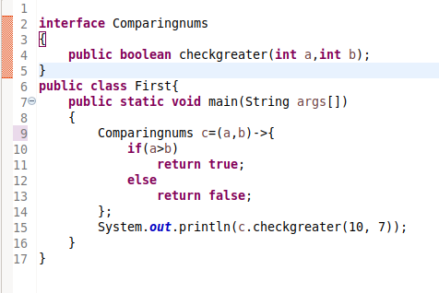

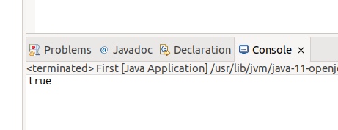

* **Increment the number by 1 and return incremented value Parameter (int) Return int**

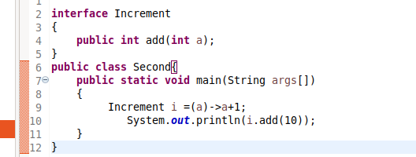

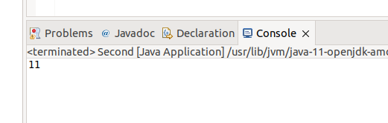

* **Concatenation of 2 string Parameter (String , String ) Return (String)**

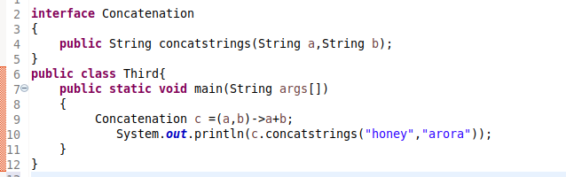

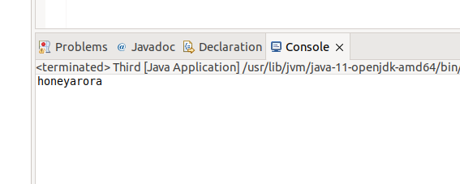

* **Convert a string to uppercase and return . Parameter (String) Return (String)**

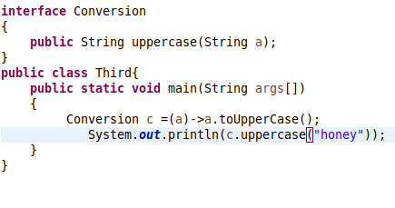

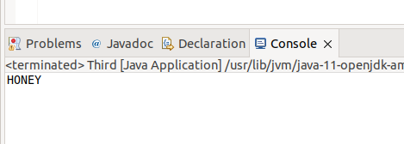

**QUES2.Using (instance) Method reference create and apply add and subtract method and using (Static) Method reference create and apply multiplication method for the functional interface created.**

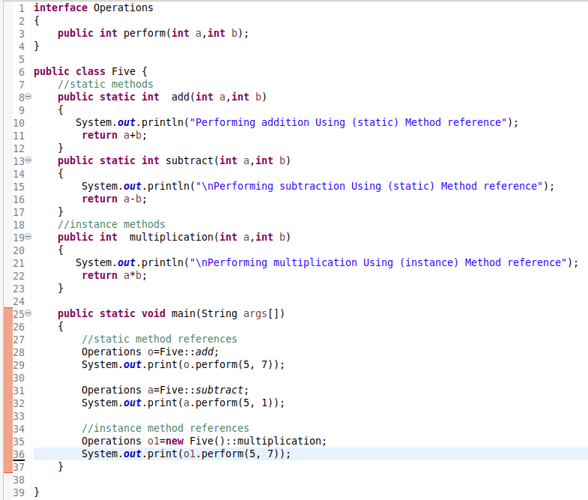

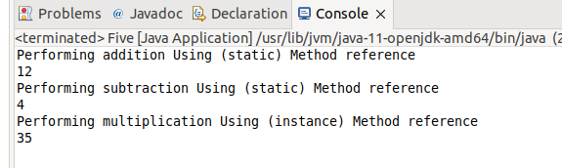

**QUES3. Create a thread using lambda function**

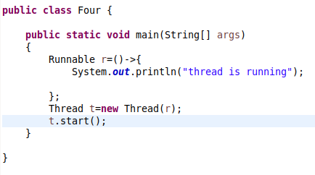

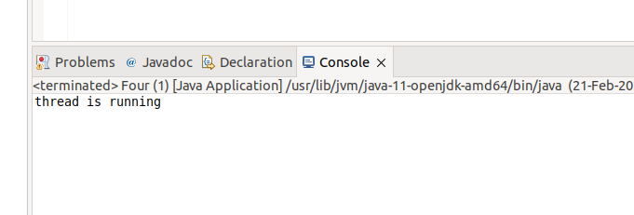

**Ques4. WAP using java 8:**

* **Collect all even numbers from a list using stream**
* **Given a list of objects of following class:**

**class Employee{**

**String fullName;**

**Long salary;**

**String city;**

**}**

**Get a list of all unique firstNames of employees where their salary is less than 5000 and who live in delhi.**

**Note: Full name is concatenation of first name, middle name and last name with single space in between.**

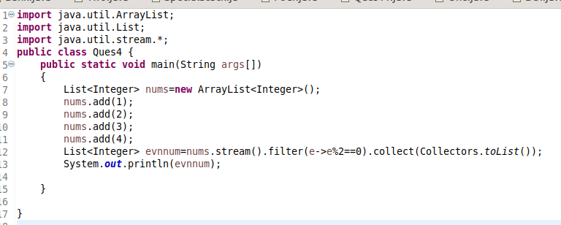

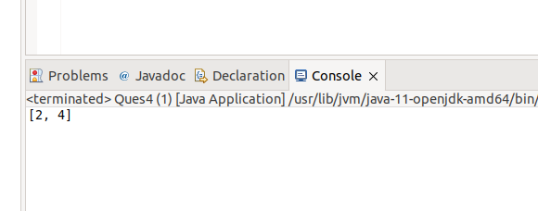

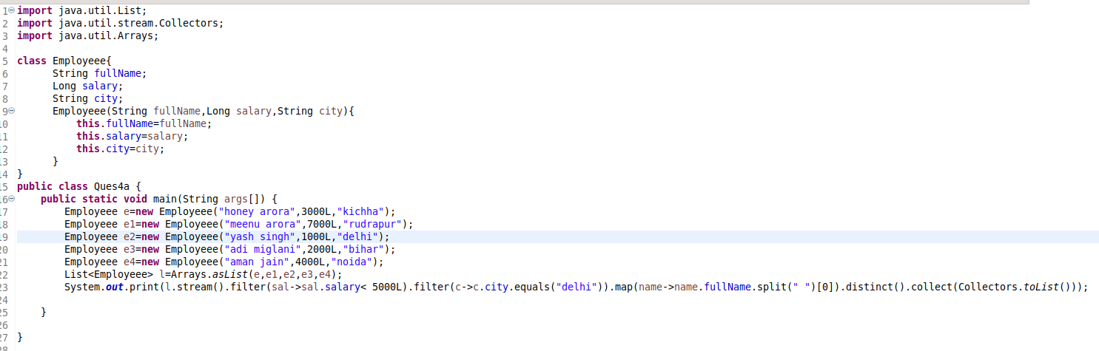

(ALSO PASTED ABOVE CODE BELOW)

import java.util.List;

import java.util.stream.Collectors;

import java.util.Arrays;

class Employeee{

String fullName;

Long salary;

String city;

Employeee(String fullName,Long salary,String city){

this.fullName=fullName;

this.salary=salary;

this.city=city;

}

}

public class Ques4a {

public static void main(String args[]) {

Employeee e=new Employeee("honey arora",3000L,"kichha");

Employeee e1=new Employeee("meenu arora",7000L,"rudrapur");

Employeee e2=new Employeee("yash singh",1000L,"delhi");

Employeee e3=new Employeee("adi miglani",2000L,"bihar");

Employeee e4=new Employeee("aman jain",4000L,"noida");

List<Employeee> l=Arrays.asList(e,e1,e2,e3,e4);

System.out.print(l.stream().filter(sal->sal.salary< 5000L).filter(c->c.city.equals("delhi")).map(name->name.fullName.split(" ")[0]).distinct().collect(Collectors.toList()));

}

}

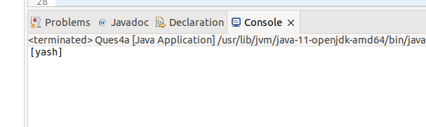

**QUES5. Implement multiple inheritance with the default method inside the interface.**

