**MACHINE LEARNING**

ASSIGNMENT - 5

QUESTION - 1

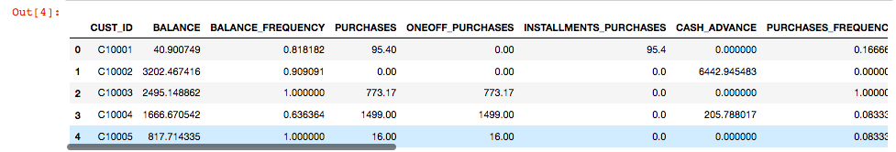

#Over here, By “.head” command it is showing the top 5 rows of the dataset.

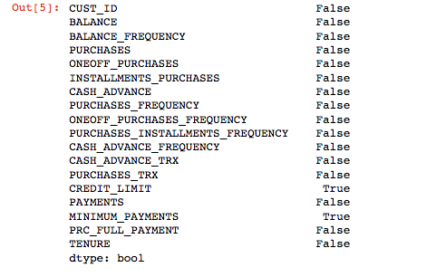

#In this step, The dataset removes all the null values true= null values and false = not null.

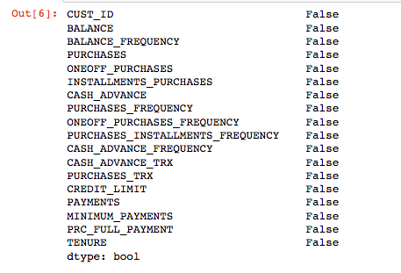

#The null values are replaced with respective mean values .

1. a)

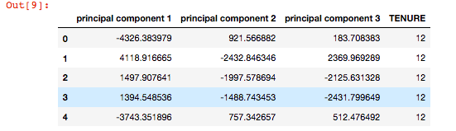

#PCA is applied on CC dataset by using the “.head” command the top 5 rows will be showned.

1 b)

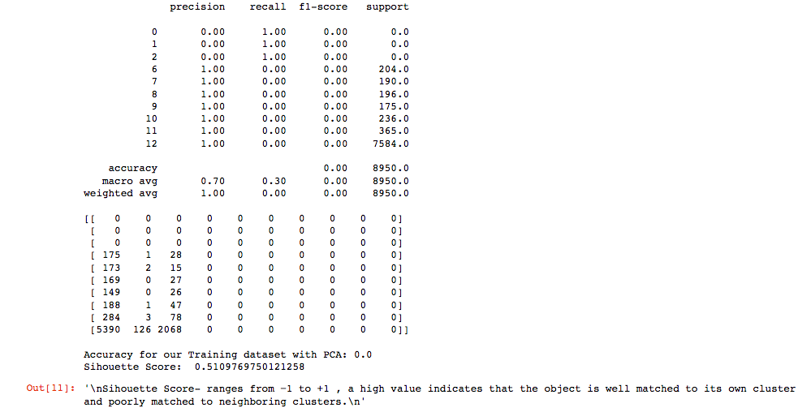

# By applying 3 clusters for K-means on the dataset we calculated the precision, recall, f1-score and sihouette score.

1 c)

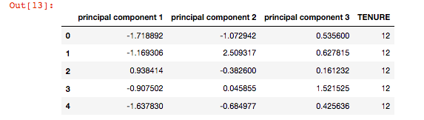

#This dataset shows the applied PCA and Scaling values . overhere, .head command is used so it shows top 5 rows of the dataset.

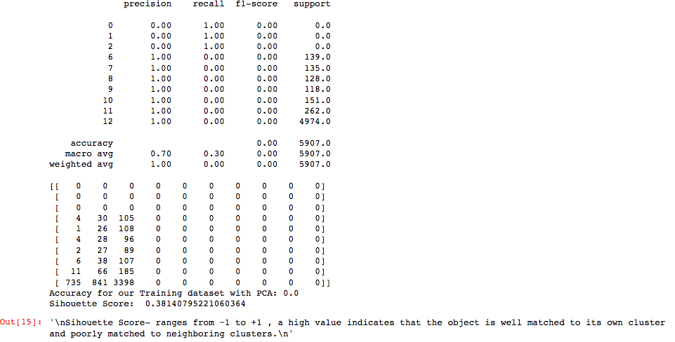

#Overhere, the sihouette score is updated by applying the scaling, PCA. A high value indicates that the object is well matched to its own cluster and poorly matched to neighboring clusters.

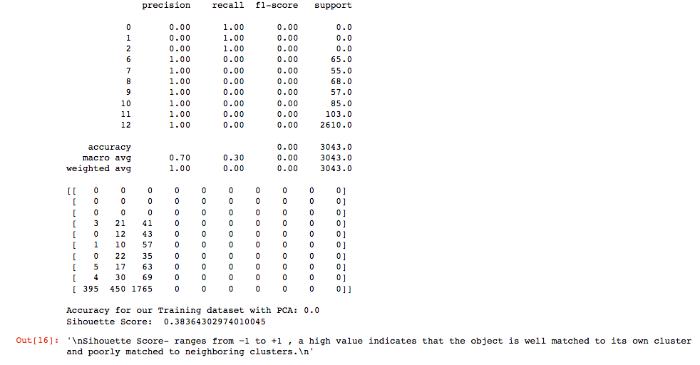

#Predicted the cluster for each data point and this table shows the updated accuracy.

2.

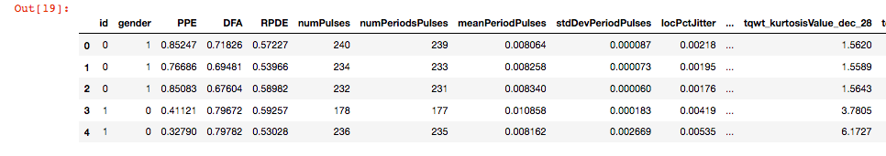

#This table shows up the top 5 rows of the speech features dataset.

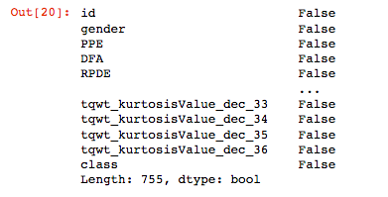

#By using .isnull() command false = not null and true = null values of the dataset.

2 a)

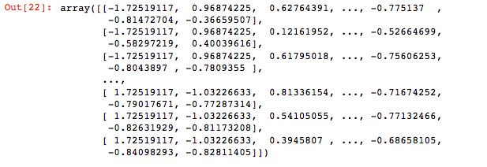

#After dropping out the null values scaling the dataset and it is shown in array format.

2 b)

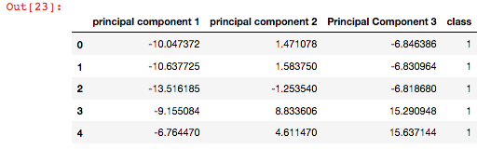

#Applying PCA with 3 clusters classification and by .head command the top 5 rows are shown up.

2 c)

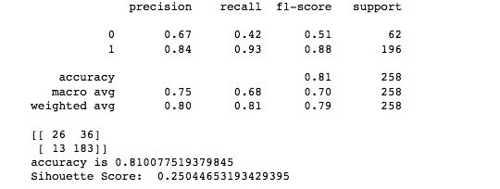

#This is the summary of the classification made by predictions and SVM is applied to this shows up the sihouette score.

3.

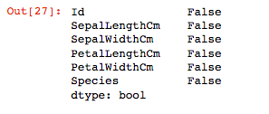

#This shows the not null and null vlaues and the null values are replaced by respective mean values.

Screen Shot 2022-11-08 at 10.46.56 PM

#Applied linear discriminative analysis and reduced dimensionality of data.

4.



#Showing up the difference between PCA and LDA.



#PCA OUTPUT

Screen Shot 2022-11-08 at 10.51.37 PM

#LDA OUTPUT