Machine Learning (Assignment # 1)

**Question 1 :**

.

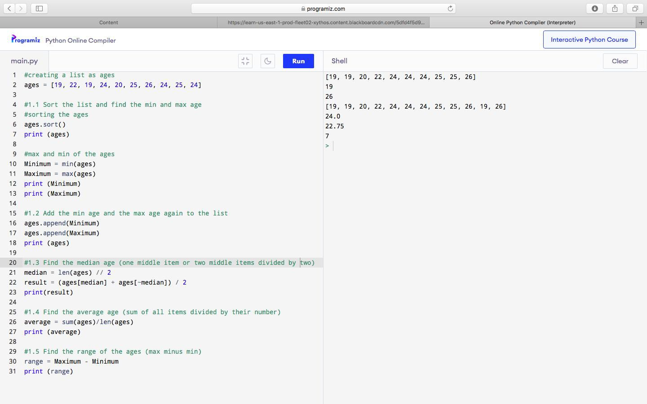

**Question 2 :**

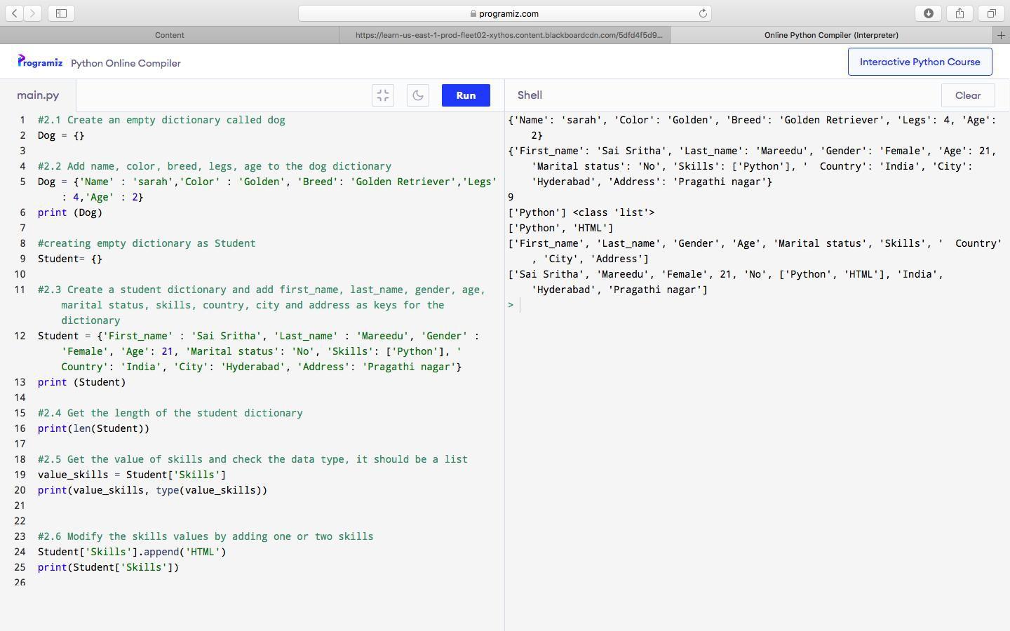

.

**Question 2 :**

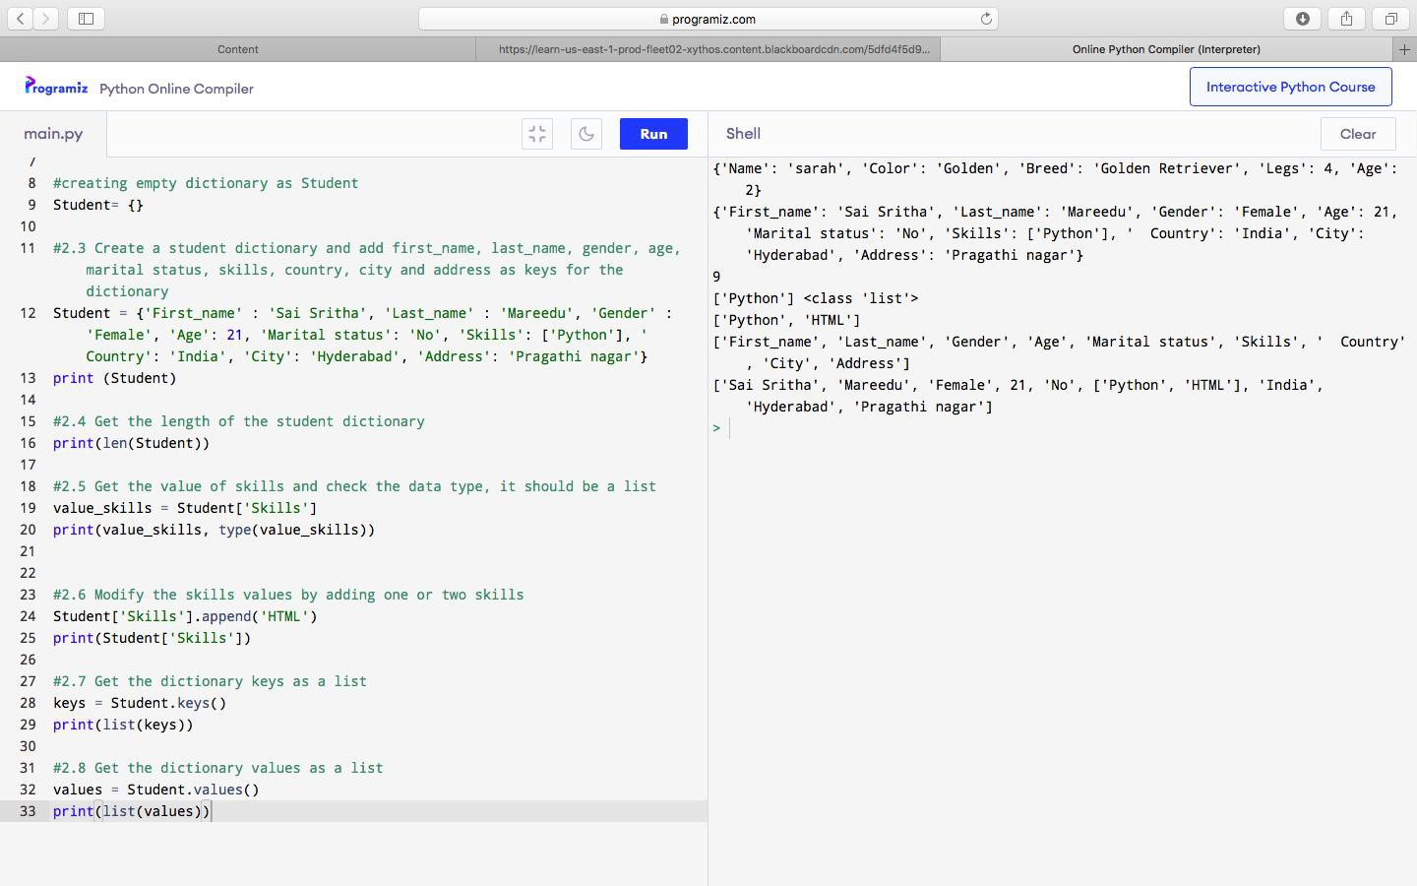

**Question 3 :**

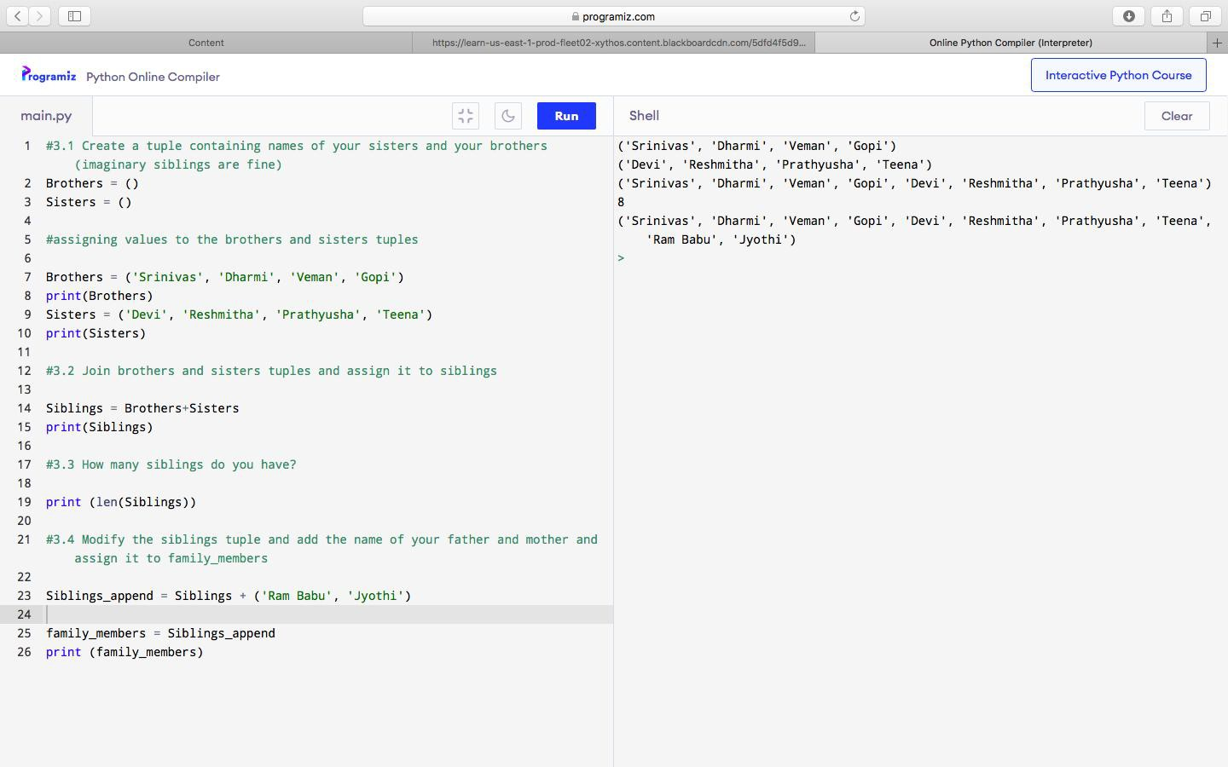

**Question 4 :**

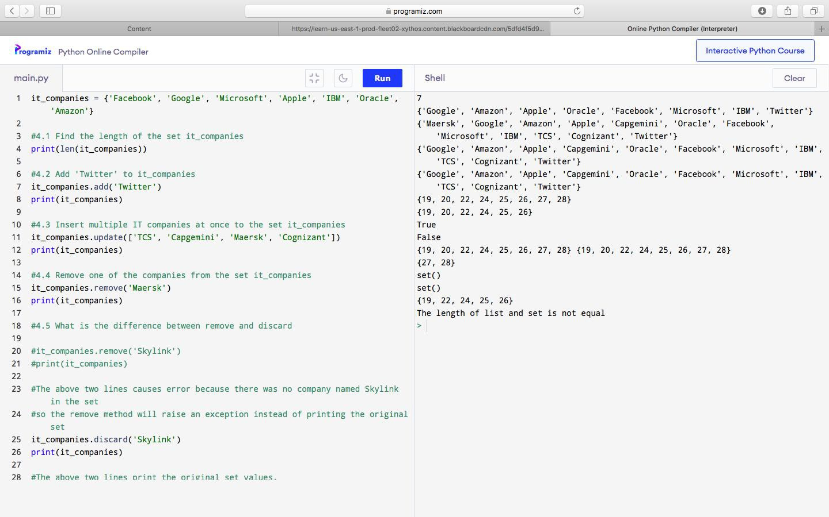

**Question 4 :**

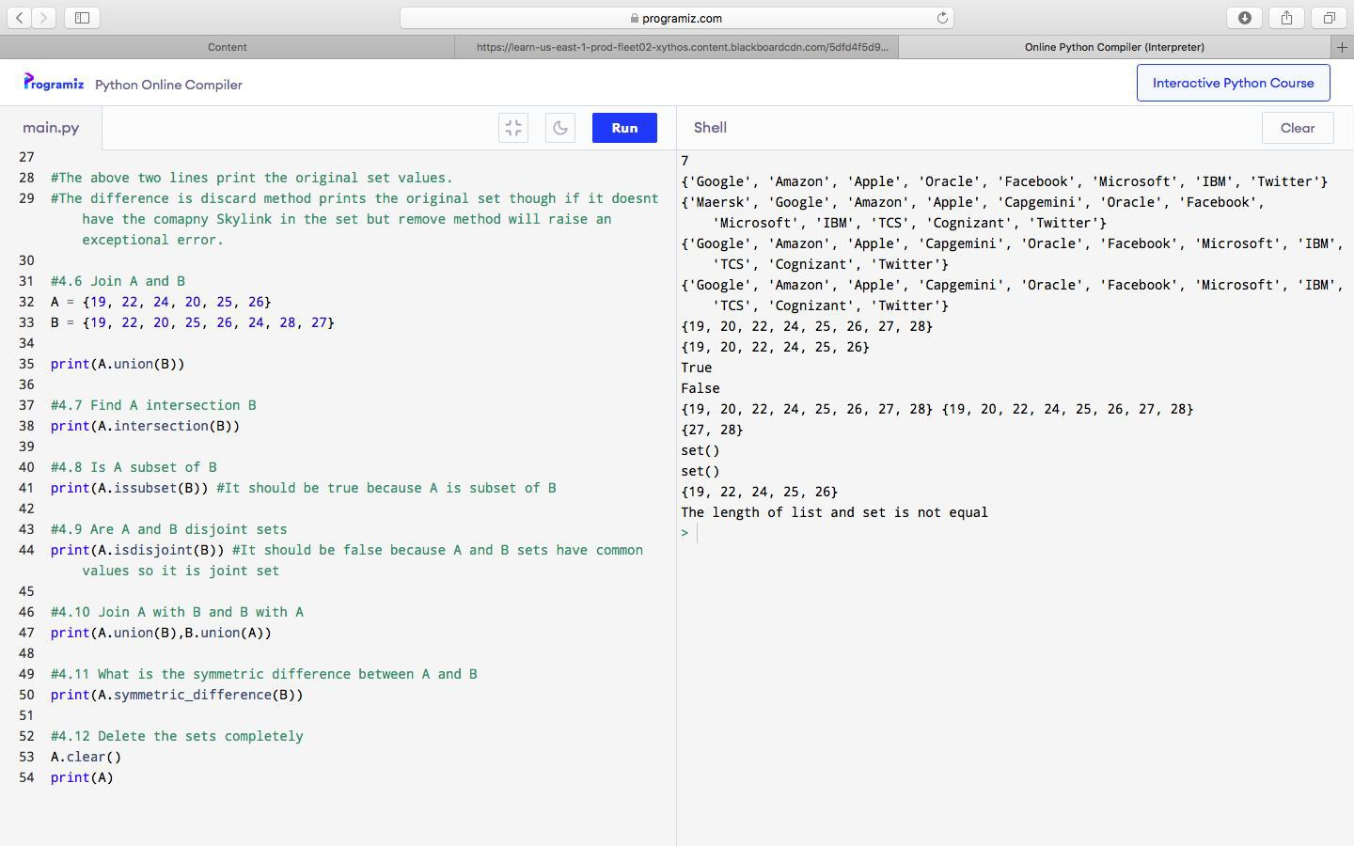

**Question 4 :**

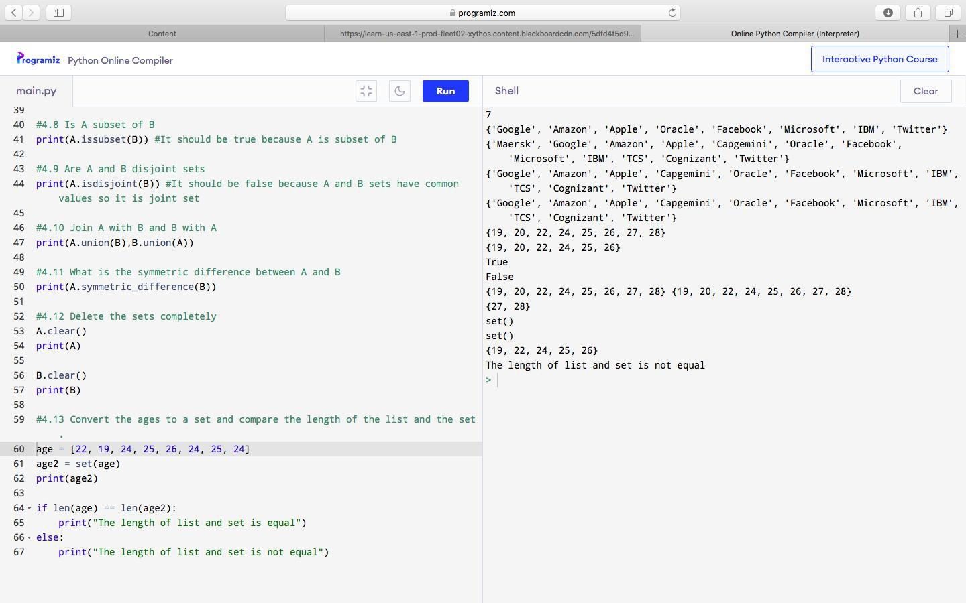

**Question 5 :**

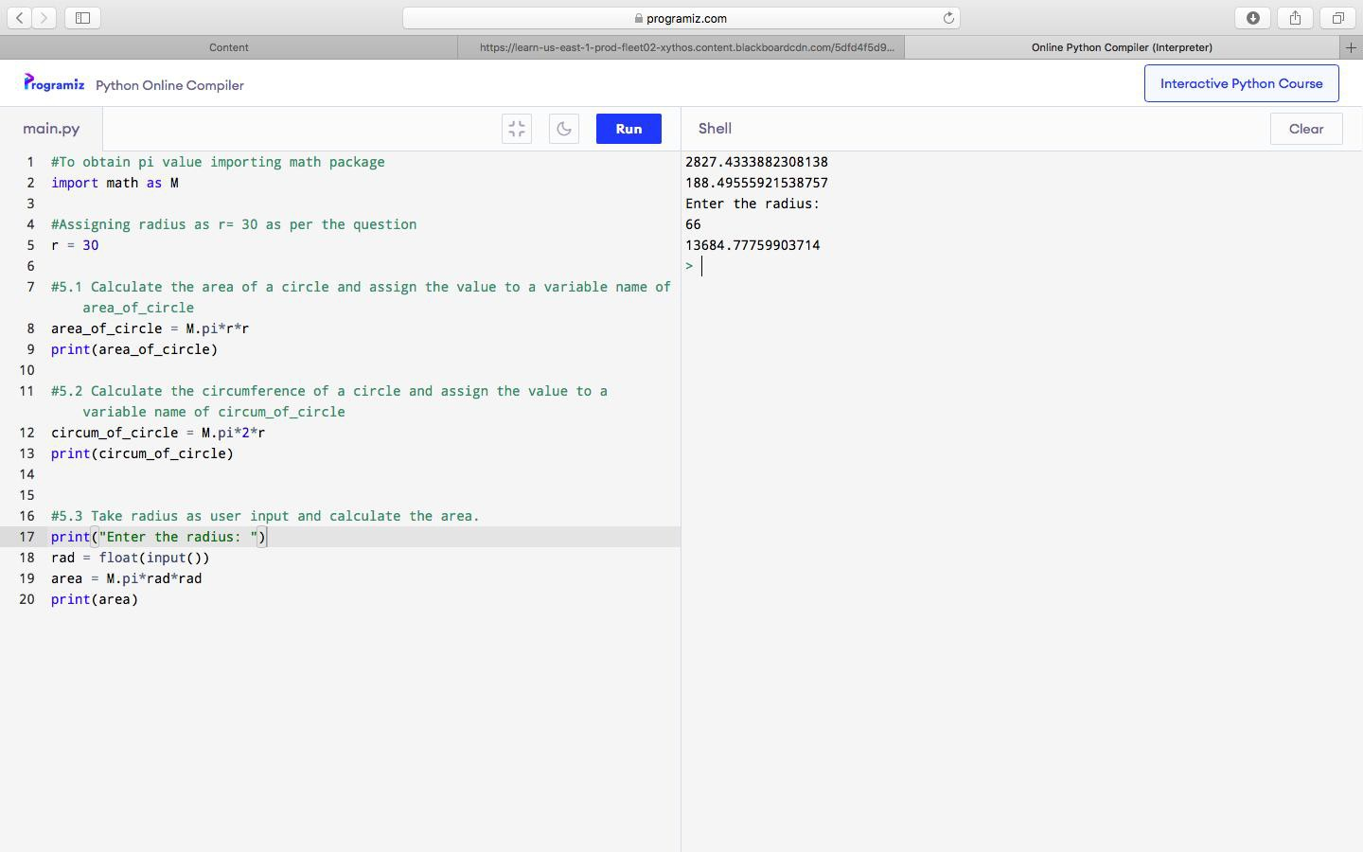

**Question 6 :**

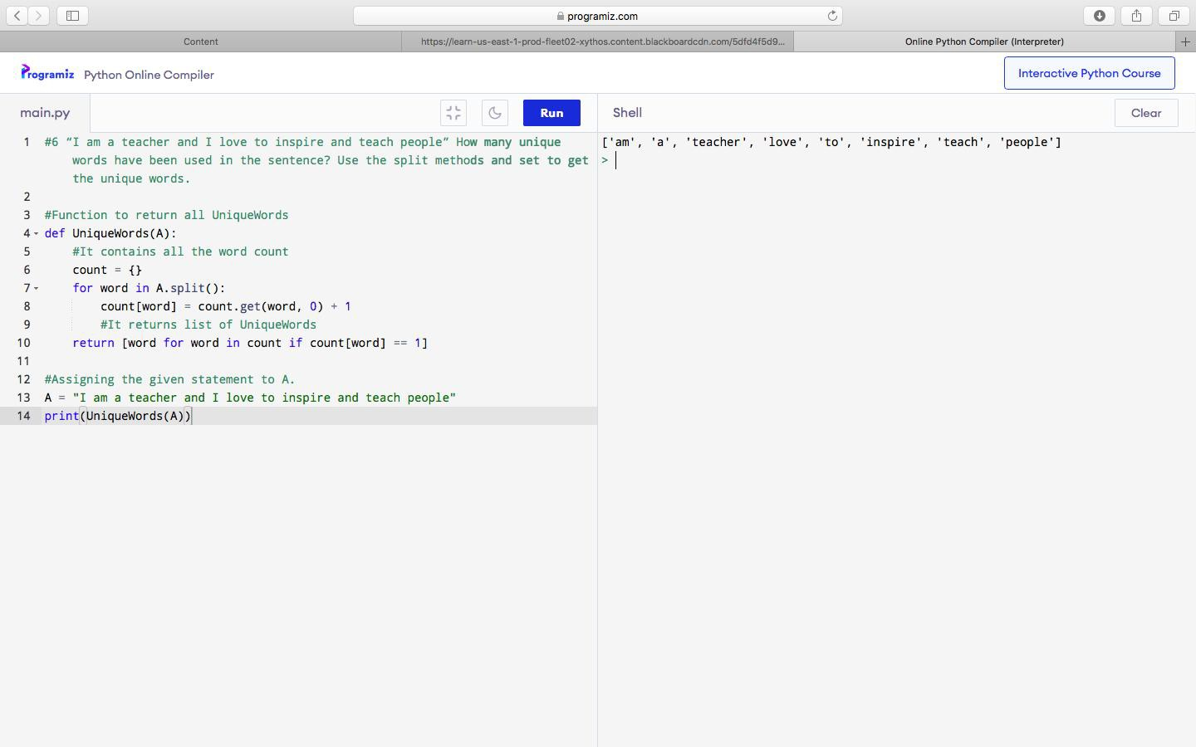

**Question 7 :**

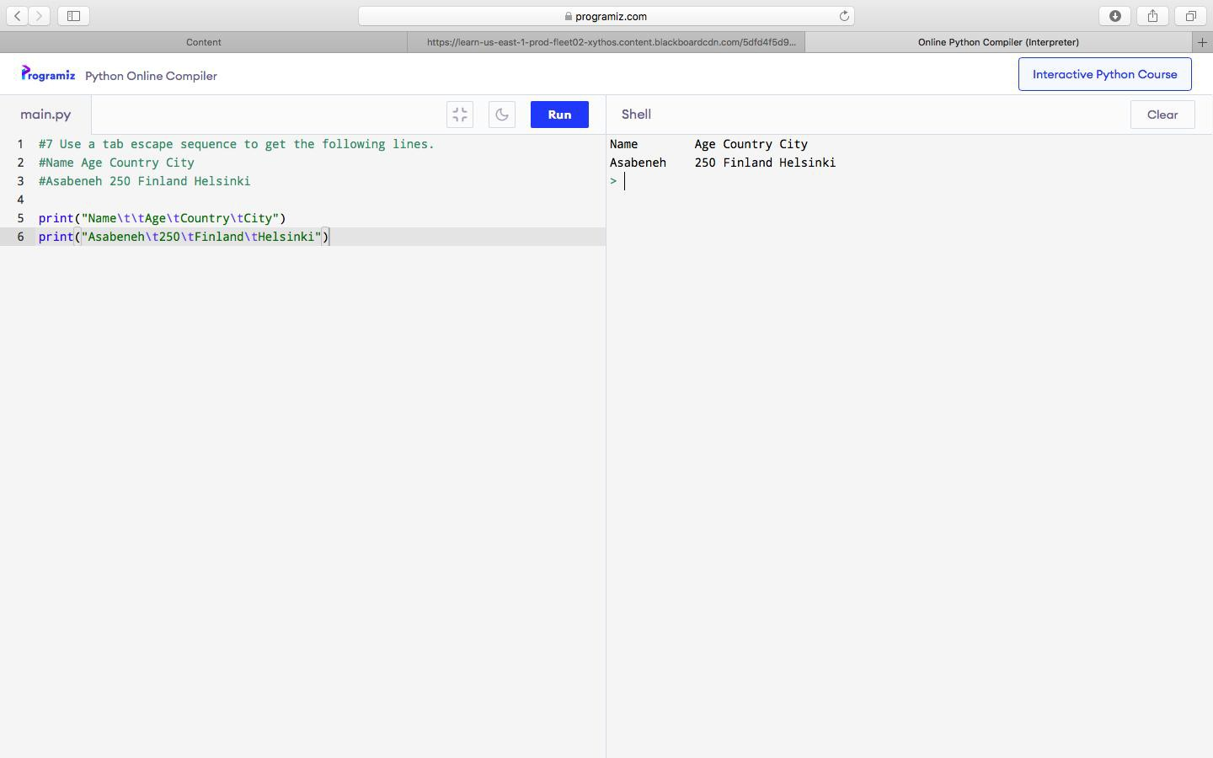

**Question 8 :**

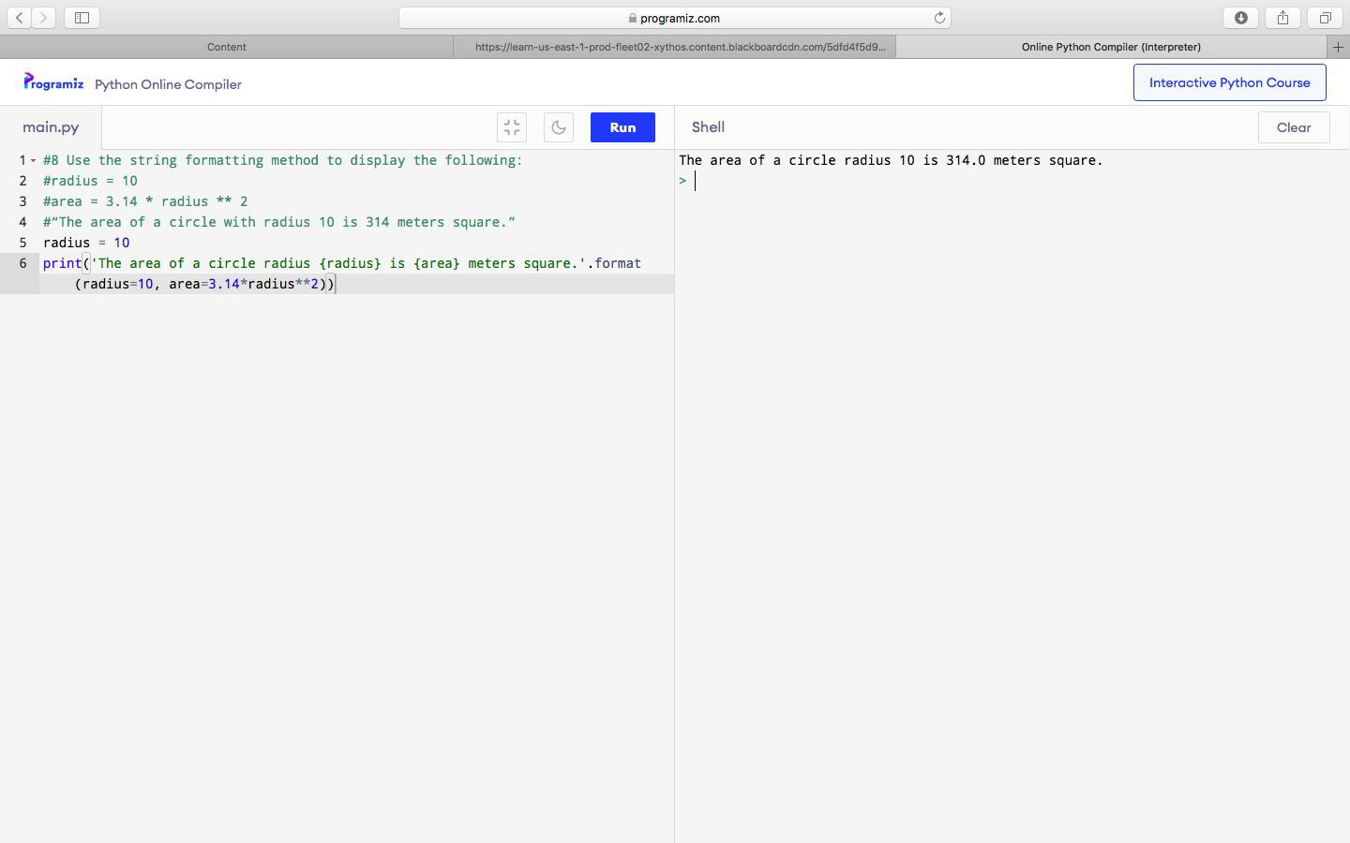

**Question 9 :**

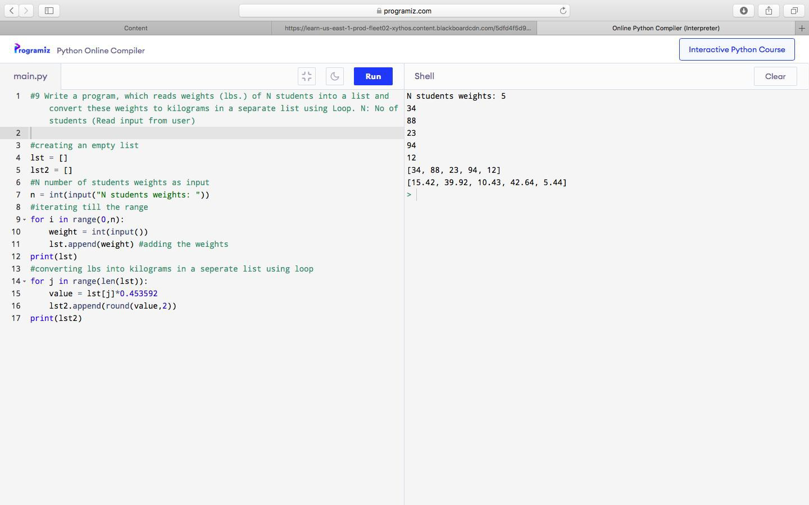

**Question 10 :**

Answer :

Step 1:

Split the given data into train and test sets with 20% of data in the test set.

Make sure that, test set contains data points that represents both the classes uniformly.

Step 2:

Applying KNN algorithm on the training data

Considering K=3

For point at 1, out of three nearest neighbours, 2 are x and one is o, so output=x (incorrect)

For point at 2, out of three nearest neighbours, 2 are x and one is o, so output=x (incorrect)

For point at 3, out of three nearest neighbours, 2 are o and one is x, so output=o (incorrect)

For points at 6, out of three nearest neighbours, 2 are x and one is o, so output=x (correct)

For point at 7, out of three nearest neighbours, 2 are x and one is o, so output=x (incorrect)

For point at 10, out of three nearest neighbours, 1 is x and two are o, so output=o (correct)

For point at 11, out of three nearest neighbours, 2 are o and one is x, so output=o (correct)

Step 3:

Now test the accuracy of the model using test data.

Correct classifications=4 Incorrect classifications=4

Accuracy= 0.5 Sensitivity=2/(2+3)=2/5=0.4 Specificity= 3/3+0=3/3=1