**SEATING ALLOCATIONS SUPPORT FILES**

* First, enable Execution permission of the setting.sh file; by Right click on the setting.sh file. Check “Allow executing file as program” then click on close.

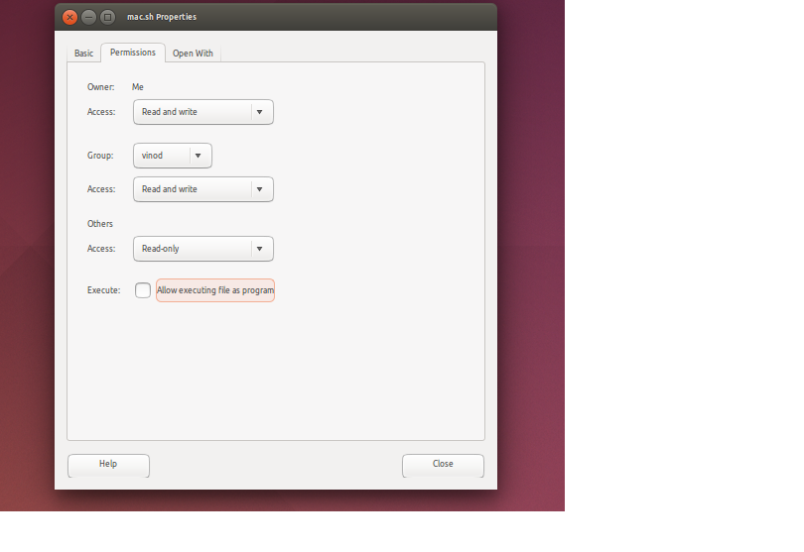

* Now, open Terminal and navigate to the location where files are downloaded.
* Execute setting.sh file from the terminal. E.g.- ./setting.sh