Wireshark Network Analysis
Capturing & Analyzing HTTPS Traffic on Kali Linux
A practical walkthrough of DNS → TCP Handshake → TLS 1.3 encryption

What You Will Learn
This guide walks through capturing and dissecting a real HTTPS connection to Google, from the very first DNS query to the encrypted TLS application data — step by step, packet by packet.
- How DNS resolves a domain name before any connection starts
- How TCP establishes a reliable connection using the 3-way handshake
- How TLS 1.3 negotiates encryption and what each message means
- How to use Wireshark filters to isolate specific protocol streams
- How tcpdump, curl, and nslookup work together in a real workflow

SETUP Tools & Workflow

Tools Used
- Wireshark — visual packet capture and protocol analysis
- tcpdump — command-line capture, saves to .pcap file
- nslookup — triggers and tests DNS resolution
- curl — generates real HTTP/HTTPS traffic

Capture Command
$ sudo tcpdump -i eth0 port 443 -w tls_capture.pcap
$ nslookup google.com
$ curl https://google.com

tcpdump listens on eth0 for all traffic on port 443 (HTTPS) and writes it to a .pcap file. You can then open this file in Wireshark for full visual analysis.

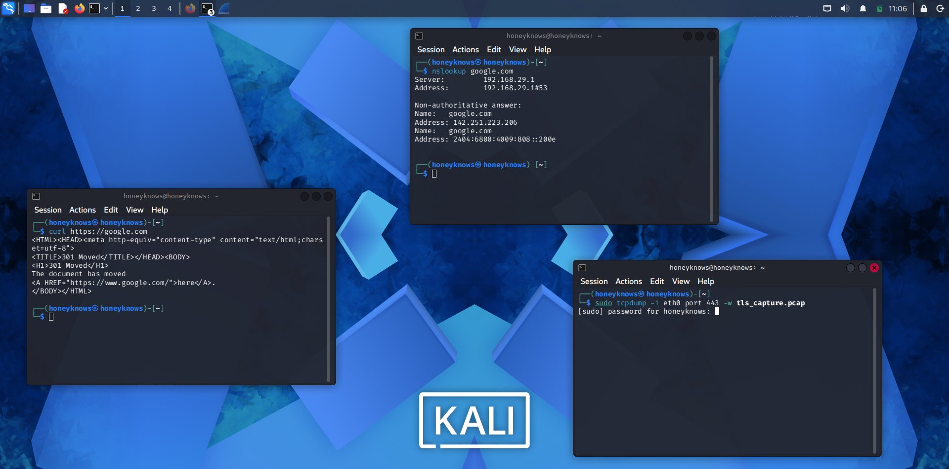
▶ Three terminals: curl triggering traffic, nslookup for DNS, tcpdump capturing to file

STEP 1 DNS Resolution — Live Capture

What Is DNS?
Before any connection is made, your computer needs to translate google.com into an IP address. This is DNS — the phonebook of the internet. Every HTTPS connection starts here.

What You Can See
- Packets 1 & 3 — DNS queries sent from 10.0.2.15 to DNS server 192.168.29.1
- Packet 1 — Type A query — asking for an IPv4 address
- Packet 3 — Type AAAA query — asking for an IPv6 address
- Packets 2 & 4 — DNS responses with resolved IP addresses

Wireshark Filter
dns

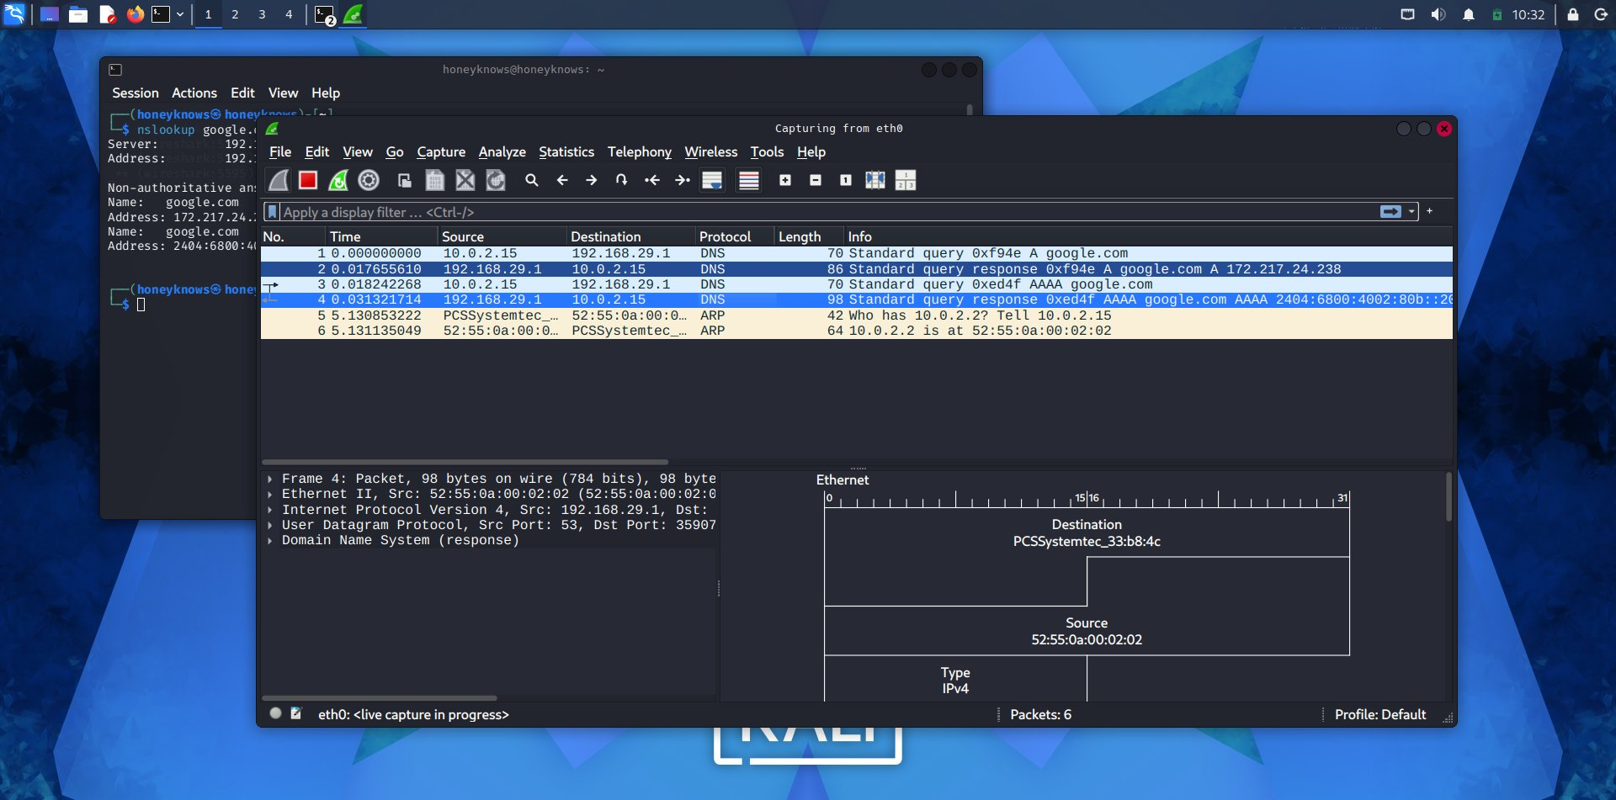
▶ Live DNS capture in Wireshark — nslookup running alongside to trigger the queries

STEP 2 DNS Packet — Deep Inspection

The Protocol Stack
Clicking on any DNS packet reveals the layered structure — each protocol wrapping the next like an envelope inside an envelope.

- Ethernet II — physical MAC addresses (source and destination)
- Internet Protocol v4 — IP addresses, routing information
- UDP — lightweight transport, port 38658 → port 53 (DNS)
- Domain Name System — the actual query payload

Key DNS Fields
- Transaction ID — matches query to response (e.g. 0xf94e)
- Flags: 0x0100 — this is a standard query (not a response)
- Questions: 1 — one domain being looked up
- Answer RRs: 0 — empty because this is the outgoing query

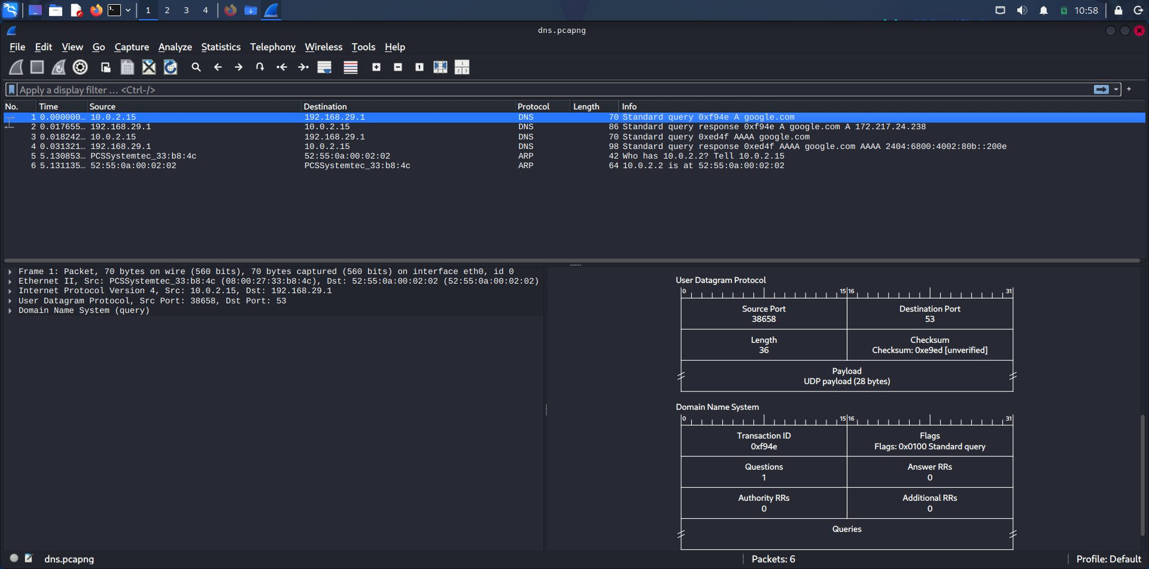
▶ Packet 1 selected — right panel shows UDP header and DNS fields broken down

STEP 3 TCP 3-Way Handshake

Why TCP First?
Before any TLS encryption begins, TCP must establish a reliable connection. This is the 3-way handshake — think of it as knocking on a door and confirming both sides are ready.

The 3 Steps
- SYN — your machine sends: I want to connect (Seq=0)
- SYN-ACK — server replies: OK, I'm ready (Seq=0, Ack=1)
- ACK — your machine confirms: Got it, let's go (Ack=1)

Wireshark Filter
tcp.stream eq 0

This filter isolates only the first TCP conversation — useful when there are hundreds of packets. Stream 0 is always the first connection established.

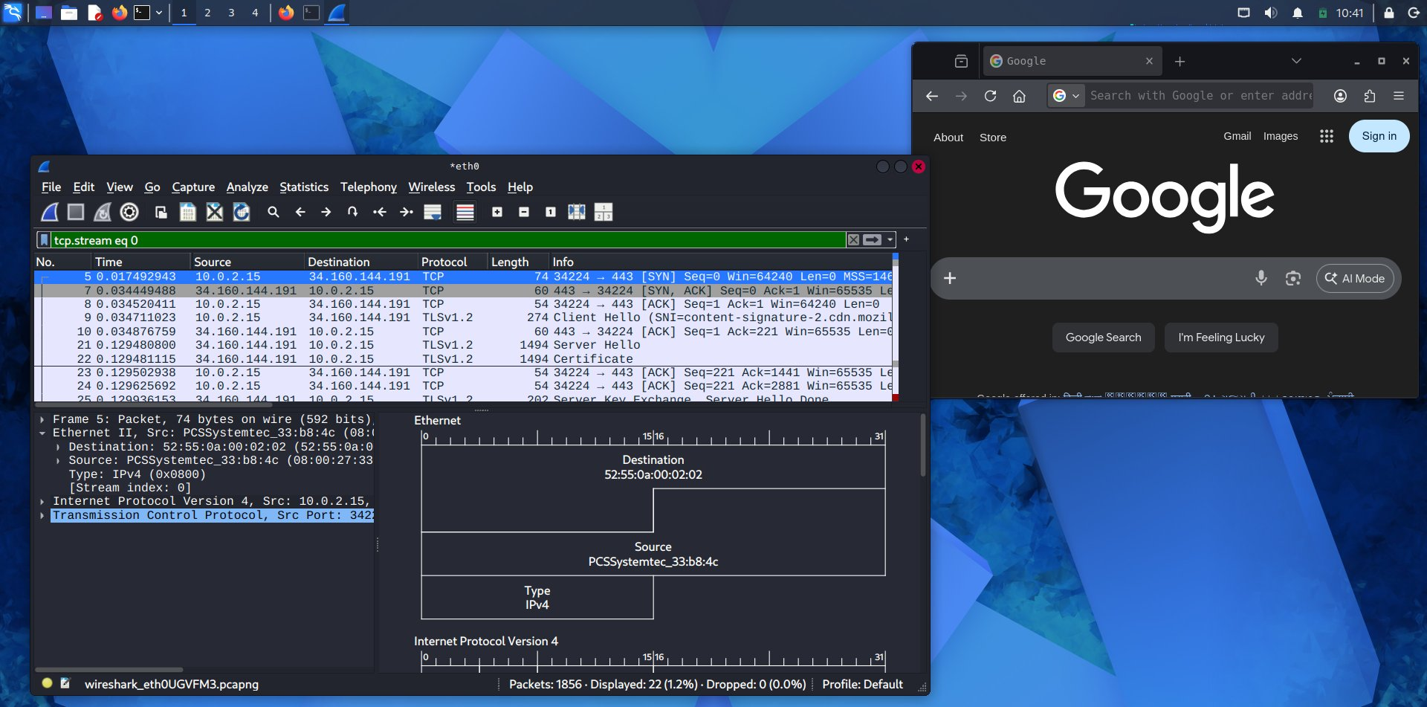
▶ tcp.stream eq 0 — SYN → SYN-ACK → ACK handshake clearly visible, followed by TLS

STEP 4 TLS 1.3 Handshake — Encryption Negotiation

What Is TLS?
TLS (Transport Layer Security) is what turns HTTP into HTTPS. After TCP connects, TLS negotiates the encryption before any real data is sent. TLS 1.3 is the latest and fastest version.

The TLS Handshake Sequence
- Client Hello — browser says: here are the cipher suites I support, and my SNI (Server Name Indication) = google.com
- Server Hello — server picks a cipher, sends its certificate
- Change Cipher Spec — both sides switch to encrypted mode
- Application Data — all further traffic is fully encrypted

What SNI Reveals
Even in encrypted HTTPS traffic, the SNI field in Client Hello is visible in plaintext — it tells you exactly which domain was requested. Security analysts use this to monitor traffic without breaking encryption.

Wireshark Filter
tls.stream eq 0

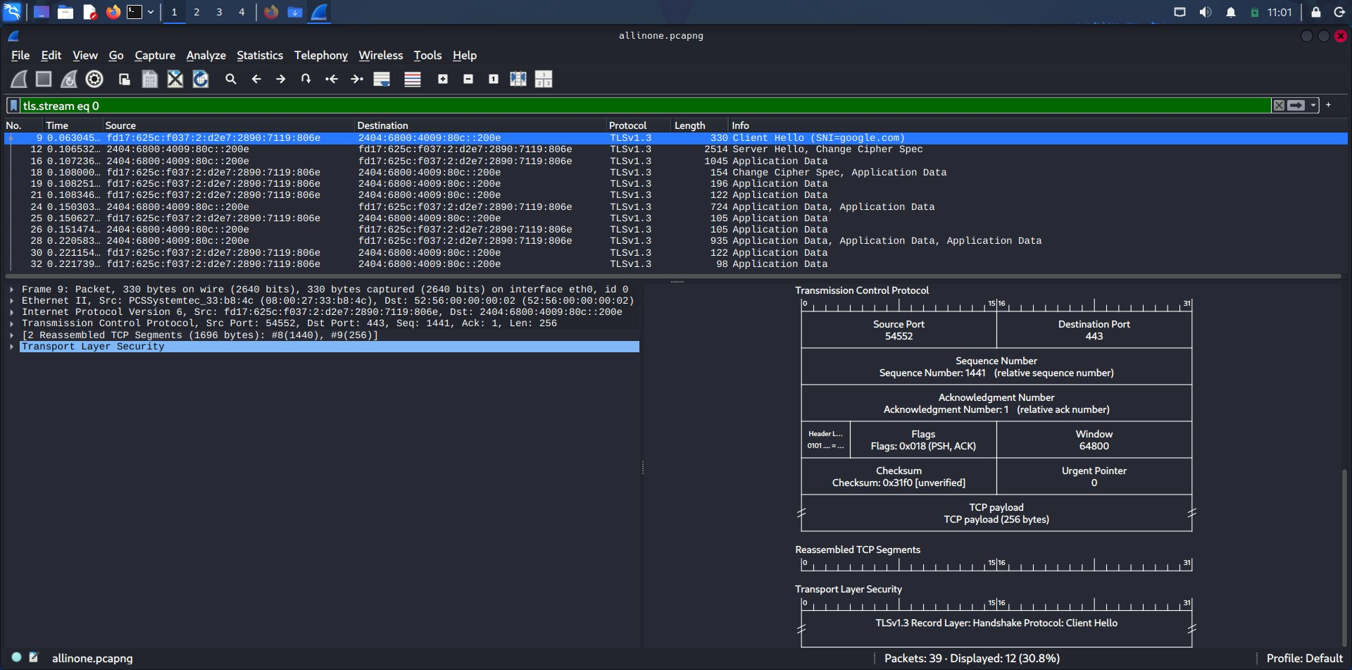
▶ tls.stream eq 0 — Client Hello with SNI=google.com, Server Hello, Application Data

STEP 5 Full Picture — Everything in One Capture

allinone.pcapng
This single capture file contains the complete story — DNS queries, TCP handshake, and TLS negotiation — all in chronological order. This is how real analysts work: capture everything, then filter down.

- Packets 1–4 — DNS (A and AAAA queries + responses)
- Packets 5–8 — TCP handshake (SYN, SYN-ACK, ACK, ACK)
- Packets 9+ — TLS 1.3 Client Hello, Server Hello, Application Data
- IPv6 traffic visible — real-world dual-stack network

Key Takeaway
Every time you visit an HTTPS website, all of these steps happen in milliseconds. Wireshark lets you freeze time and inspect each one in detail.

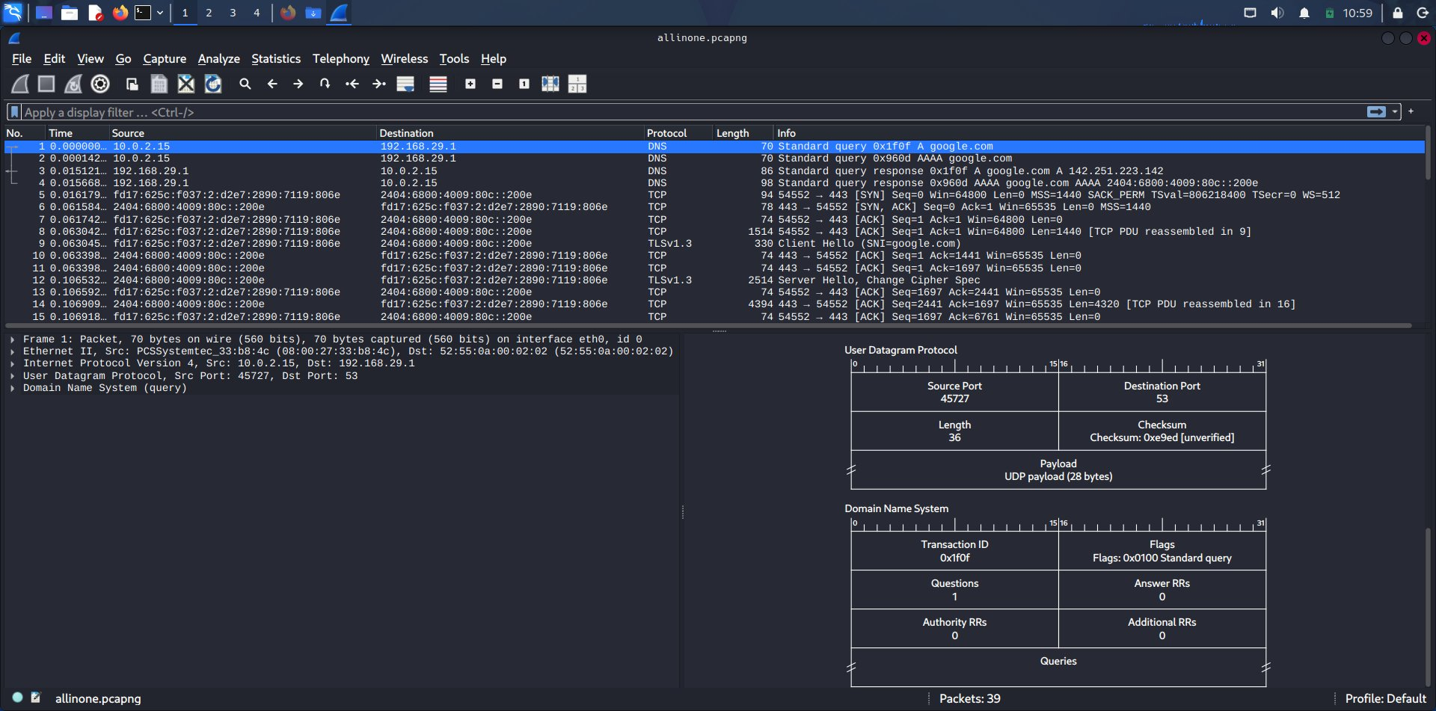
▶ allinone.pcapng — DNS → TCP → TLS all in one file, 39 packets total

Quick Reference
Step | What Happens | Protocol | Wireshark Filter
1 — DNS | Domain resolved to IP address | UDP / DNS | dns
2 — TCP | Reliable connection established | TCP | tcp.stream eq 0
3 — TLS | Encryption negotiated | TLSv1.3 | tls.stream eq 0
4 — Data | Encrypted HTTPS traffic flows | TLS App Data | tls

Made with Wireshark on Kali Linux

