YUVAINTERN
Data Science with Python Analyst Internship
Week 2 Internship Report
Data Identification, Sourcing Strategy and Initial Analysis Planning
Project: Customer Churn Prediction and Retention Analysis in the Beauty & Wellness Industry
Submitted by | HONEY VERMA
Degree | B.Tech in Artificial Intelligence
Organization | YuvaIntern
Role | Data Science with Python Analyst Internship
Internship Mode | Remote
Internship Period | September 25, 2026 – November 06, 2026 (6 weeks)
Report Covers | Week 2 of 6
Submitted to | Internship Mentor, YuvaIntern

Table of Contents

Note: if the Table of Contents appears empty, right-click it in Microsoft Word and select "Update Field", then "Update entire table".

1. Internship Details
This report documents the work completed in Week 2 of the Data Science with Python Analyst Internship at YuvaIntern. The relevant internship particulars are summarised below.
Table 1. Internship particulars
Item | Detail
Student name | HONEY VERMA
Degree | B.Tech in Artificial Intelligence
Organization | YuvaIntern
Internship role | Data Science with Python Analyst Internship
Mode | Remote
Location mentioned in offer | Coimbatore
Start date | September 25, 2026
End date | November 06, 2026
Duration | 6 weeks
Internship focus | Data Science with Python; data analysis; exploratory data analysis; statistical analysis; customer analytics; data cleaning and preprocessing; business problem solving
Nature of work | Structured tasks and projects aligned with the internship curriculum, completed under mentor guidance

2. Executive Summary
Week 1 defined the business problem of customer churn and retention in the Beauty & Wellness industry. Week 2 translated that problem into a data-driven plan: identifying data requirements, selecting a public dataset, assessing its quality, engineering customer-level features and performing an initial statistical analysis.
The selected dataset, Beauty E-Commerce Analytics (file beauty_clean.csv), contains 51,290 transaction-line records across 19 columns, covering January 1, 2020 to December 31, 2023, with 17,415 unique customers and 25,728 unique orders. The data contained no missing values and no duplicate rows. The dataset does not contain a direct churn label. An analytical proxy, Inactive/Lapsed Customer, was therefore defined using customer recency relative to a reference date of December 31, 2023. This proxy represents observed inactivity and is not a confirmed or permanent churn outcome.
Key observations from the initial analysis:
- Purchase-gap analysis showed long intervals between repeat purchases (median 302.5 days), so a 365-day threshold was selected as a practical middle ground. Under this definition, 7,647 customers (43.91%) were Active and 9,768 (56.09%) were Inactive/Lapsed.
- 11,979 customers placed only one order and 5,436 were repeat customers. This indicates a potential retention opportunity, although one-time customers are not automatically churned customers.
- Active customers showed higher purchase frequency, cumulative sales, quantity and total profit than inactive customers, while Average Order Value was almost identical (250.47 versus 251.10). Observed inactivity therefore appears more closely related to purchase frequency than to individual order value.
- Mann–Whitney U tests showed statistically significant differences (p < 0.05) for all six tested customer metrics. Chi-square tests indicated a significant association between activity status and both product category and market, but not customer segment (p = 0.3463).
- Activity levels differed notably across markets: the active proportion was highest in USCA (61.63%) and lowest in Africa (40.33%).
These results are associational and descriptive. They do not establish causation, and no machine learning model was built in Week 2. Predictive modelling is proposed as future work once a temporally valid churn label can be defined.

3. Introduction
Customer retention is a central concern for subscription, appointment-based and repeat-purchase businesses. Retaining existing customers is widely regarded as economically important, and classic work on service quality has linked reductions in customer defection to improved profitability (Reichheld & Sasser, 1990). In the Beauty & Wellness industry, where products and services are frequently repurchased, understanding which customers become inactive is a natural application of data science.
Effective analysis depends on appropriate data. Before building any predictive model, an analyst must identify the data needed, locate suitable sources, assess data quality and understand the structure and behaviour of the data through exploratory analysis (Tukey, 1977). Week 2 of this internship focuses on these foundational steps. The work in this report was carried out in Python and is presented in a structured manner, from data identification through to business implications and future work.

4. Week 1 Business Problem
The Week 1 business problem was defined as:
Customer Churn Prediction and Retention Analysis in the Beauty & Wellness Industry
Core business question: Which customer behaviors and characteristics are associated with customer inactivity/churn, and how can data science help identify potential retention opportunities in the Beauty & Wellness industry?
The selected dataset does not include a direct churn column. Consequently, the Week 2 analysis uses an analytical proxy termed Inactive/Lapsed Customer, defined from observed purchase history. Throughout this report, the terms "observed inactivity", "inactive/lapsed customers" and "inactivity proxy" are used deliberately to avoid presenting this proxy as confirmed churn.

5. Week 2 Objectives
The Week 2 task is Data Identification, Sourcing Strategy and Initial Analysis Planning. The objectives were to:
- Identify the data sources relevant to the Week 1 business problem.
- Select and justify a suitable dataset.
- Define a data sourcing strategy, including future data needs.
- Assess data quality.
- Conduct initial exploratory data analysis and statistical analysis.
- Clean and preprocess the data and engineer customer-level features.
- Analyse customer inactivity using an explicit and justified proxy.
- Connect the findings to the Week 1 business problem.
- Document limitations, ethical considerations, future data requirements and practical business implications.

6. Data Requirements
To study customer inactivity, the data should allow customer behaviour to be observed over time. The minimum requirements identified for this task are summarised in Table 2.
Table 2. Data requirements for the inactivity analysis
Requirement | Purpose
Customer identifier | Link multiple transactions to the same customer and build customer-level features
Transaction or order date | Calculate recency, purchase gaps and the duration of observed activity
Order identifier | Distinguish unique orders from individual product lines to measure purchase frequency
Sales or monetary value | Measure customer value and spending behaviour
Quantity, discount and profit | Examine purchasing intensity, discount behaviour and profitability
Product category | Explore whether purchasing patterns differ by product type
Customer segment and geography | Compare activity across customer groups and markets
Sufficient history | Observe repeat-purchase behaviour across several years

Ideal data for a full churn study would additionally include loyalty, feedback, marketing and service-interaction information. These requirements are discussed in Section 9.

7. Data Source Identification and Selection

7.1 Candidate Data Source Types
Several categories of data could support the business problem. Table 3 compares them with respect to the requirements above.
Table 3. Evaluation of candidate data source types
Source type | Potential value | Main limitation
Public transaction/e-commerce datasets | Customer-level purchase history; readily accessible for academic work | May lack churn labels, demographics and marketing context
CRM / loyalty programme data | Membership, rewards and engagement history | Typically proprietary and not publicly available
Salon/spa appointment data | Visit frequency and service-level behaviour | Usually private; difficult to obtain at scale
Customer reviews and feedback | Satisfaction and sentiment signals | Often unlinked to customer purchase history
Marketing campaign data | Exposure and response to promotions | Proprietary; requires linkage to customers
Public business/location datasets | Market and location context | Aggregate level; no individual customer behaviour
Public APIs | Programmatic access to supplementary data | Subject to terms of use, licensing and data protection

7.2 Selection and Justification
Of these options, a public transaction-level beauty e-commerce dataset was the most practical choice, because customer-level proprietary data is rarely accessible during an internship. The selected dataset, Beauty E-Commerce Analytics (Nguyen, n.d.), was chosen for the following reasons:
- It is publicly available and directly relevant to the beauty and personal-care domain.
- It contains a customer identifier, order identifier and order date, which allow recency, frequency and monetary features to be derived.
- It spans four years (2020–2023), allowing repeat-purchase intervals to be examined.
- It includes product category, customer segment, market, discount and profit fields.
- It had no missing values and no duplicate rows in the file reviewed.
Its principal shortcoming is the absence of a churn label, which is addressed through the inactivity proxy described in Section 13. The provenance and licensing of the repository data should be confirmed before any use beyond academic analysis.

8. Selected Dataset Description
The analysis uses the file beauty_clean.csv from the public GitHub repository "Beauty-Ecommerce-Analytics" (https://github.com/xanhnguyen186/Beauty-Ecommerce-Analytics). It contains transaction-level beauty e-commerce data for 2020–2023. Each row represents a product line within an order.
Table 4. Dataset overview
Characteristic | Value
Shape | 51,290 rows × 19 columns
Date range | January 1, 2020 – December 31, 2023
Unique customers | 17,415
Unique orders | 25,728
Missing values | 0 in every column
Duplicate rows | 0

Table 5. Column descriptions
Column | Type | Description
Row ID | Integer | Row-level identifier
Order ID | Text | Identifier of the order
Order Date | Date | Date of the order (converted to datetime)
Customer ID | Text | Identifier of the customer
Segment | Text | Customer segment (Consumer, Corporate, Self-Employed)
City, State, Country | Text | Geographic location fields
Country latitude, Country longitude | Decimal | Coordinates associated with the country
Region | Text | Regional grouping
Market | Text | Broader market grouping (five markets)
Subcategory, Category, Product | Text | Product hierarchy (five categories)
Quantity | Integer | Units in the transaction line
Sales | Integer | Sales value of the transaction line
Discount | Decimal | Discount rate applied
Profit | Decimal | Profit of the transaction line (may be negative)

9. Data Collection and Sourcing Strategy
Week 2 relied on a single public dataset. A longer-term strategy for a production-grade churn analysis would combine multiple complementary sources, subject to legal, ethical and technical constraints.
Table 6. Proposed multi-source data strategy
Source | Intended contribution
Transaction / e-commerce data | Order history, recency, frequency and monetary value (current dataset)
CRM / customer loyalty data | Membership status, tenure and reward activity
Salon/spa appointment data | Visit history, cancellations and service preferences
Customer feedback and review data | Satisfaction, complaints and sentiment
Marketing campaign data | Campaign exposure, engagement and response
Public business/location datasets | Contextual information on markets and locations
Public APIs (where legally and technically appropriate) | Supplementary contextual data, subject to terms of use and privacy requirements

A future analytical dataset should ideally include the following fields:
Table 7. Desired fields for future data collection
Customer and transaction fields | Engagement and service fields
Customer ID | Loyalty membership
First purchase date | Appointment/visit history
Last purchase date | Customer feedback
Order frequency | Marketing engagement
Monetary value | Customer service interactions
Product category | Returns
Discount usage

No external API data were collected or analysed in Week 2, and no statistics from such sources are reported.

10. Data Quality Assessment

10.1 Strengths
- A large number of transaction records (51,290 rows).
- 17,415 unique customers.
- Four years of transaction history (2020–2023).
- No missing values in any column.
- No duplicate rows.
- Customer, product, geographic, sales, discount and profit fields are all present.

10.2 Limitations
- No direct churn label.
- No customer demographic variables such as age or gender.
- No explicit customer satisfaction or feedback data.
- No marketing campaign history.
- No customer-service interaction data.
- No post-period return information.
- Observed inactivity cannot confirm permanent churn.
An additional provenance observation was made: the year embedded in each Order ID string differs consistently from the year of the corresponding Order Date. This suggests that the dates in the prepared file may have been transformed from an original source. This does not affect the internal consistency of the Order Date field used here, but it reinforces the need to confirm the dataset's origin before drawing real-world business conclusions.

11. Data Cleaning and Preprocessing
The preprocessing steps applied are listed in Table 8. The dataset required no imputation or de-duplication because 0 missing values and 0 duplicate rows were found.
Table 8. Data cleaning and preprocessing steps
Step | Action
1 | Loaded the CSV file using pandas
2 | Converted Order Date to datetime format
3 | Checked the dataset shape
4 | Checked missing values (none found)
5 | Checked duplicate rows (none found)
6 | Reviewed data types
7 | Created the customer-level aggregation
8 | Created a unique order-level purchase history before calculating purchase gaps
9 | Calculated Recency, Frequency, Monetary and related customer metrics
10 | Created Activity_Status using the 365-day threshold
11 | Created customer-level category, segment and market profiles for categorical analysis

12. Customer-Level Feature Engineering
Because the research question concerns customers rather than individual transactions, the transaction-line data were aggregated to one row per customer (17,415 rows). The reference date for all time-based features was December 31, 2023, the last date in the dataset. The approach follows the widely used Recency–Frequency–Monetary (RFM) framework for customer analytics (Fader et al., 2005).
Table 9. Customer-level features
Feature | Definition
Recency | Number of days since the customer's most recent purchase (relative to December 31, 2023)
Frequency | Number of unique orders placed by the customer
Monetary | Total sales generated by the customer
Total Quantity | Total units purchased by the customer
Total Profit | Total profit associated with the customer's transactions
Avg Discount | Average discount applied across the customer's transaction lines
Average Order Value | Monetary divided by Frequency

Customer-level category, segment and market profiles were also created for the chi-square analyses. Because some customers purchase across multiple categories or markets, this representation simplifies their behaviour (see Section 24).

13. Inactivity Definition and Threshold Selection

13.1 Purchase-Gap Analysis
To choose an inactivity threshold that reflects how customers in this dataset actually behave, purchase gaps were calculated between consecutive purchases of the same customer. The gaps were computed at the unique-order level to avoid duplicate dates arising from multiple product lines in one order. A total of 8,324 repeat-purchase gaps were observed.
Table 10. Purchase-gap statistics (days)
Statistic | Value
Count of observed gaps | 8,324
Mean | 378.565
Standard deviation | 307.576
Minimum | 0
25th percentile | 127
Median | 302.5
75th percentile | 562
90th percentile | 831
95th percentile | 1003.85
Maximum | 1451

Customers in this dataset may have relatively long purchase intervals: the median gap exceeds 300 days and one quarter of gaps exceed 562 days. A very short threshold such as 30 or 90 days would therefore classify many customers as inactive simply because they purchase infrequently, and would be too aggressive for this dataset. The minimum gap of 0 days indicates that some distinct orders share the same order date.

13.2 Threshold Comparison
Three thresholds were evaluated and are compared in Table 11.
Table 11. Comparison of candidate inactivity thresholds
Threshold (days) | Active | Inactive | Inactive (%)
180 | 4,867 | 12,548 | 72.05%
365 | 7,647 | 9,768 | 56.09%
540 | 10,401 | 7,014 | 40.28%

13.3 Selected Threshold
A 365-day threshold was selected. The 180-day threshold falls between the 25th percentile and the median of the purchase gaps and classifies roughly 72% of customers as inactive, while the 540-day threshold lies just below the 75th percentile (562 days). The 365-day value lies between the median (302.5 days) and the 75th percentile and was adopted as a practical middle-ground threshold given the observed purchase-gap distribution.
- Recency ≤ 365 days → Active
- Recency > 365 days → Inactive/Lapsed
Important: This classification is an analytical proxy for observed inactivity. It is not a confirmed churn label. Customers classified as inactive may return after December 31, 2023, and the 365-day threshold is specific to this dataset and analysis.

14. Exploratory Data Analysis

14.1 Categorical Distributions
Table 12 shows the distribution of transaction-line records across segment, category and market. Percentages are shares of the 51,290 rows.
Table 12. Distribution of records by segment, category and market
Variable | Group | Rows | Share of rows
Segment | Consumer | 26,518 | 51.70%
 | Corporate | 15,429 | 30.08%
 | Self-Employed | 9,343 | 18.22%
Category | Body care | 21,062 | 41.06%
 | Home and Accessories | 9,516 | 18.55%
 | Make up | 9,017 | 17.58%
 | Hair care | 8,203 | 15.99%
 | Face care | 3,492 | 6.81%
Market | Asia Pacific | 14,302 | 27.88%
 | Europe | 11,729 | 22.87%
 | USCA | 10,378 | 20.23%
 | LATAM | 10,294 | 20.07%
 | Africa | 4,587 | 8.94%

14.2 Numeric Variables
Table 13. Descriptive statistics of transaction-level numeric variables
Variable | Mean | Median | Minimum | Maximum
Quantity | 5.4158 | 4 | 1 | 20
Sales | 127.0749 | 56 | 2 | 3,940
Discount | 0.1429 | 0 | 0 | 0.85
Profit | 20.7723 | 7.2 | -1,746 | 1,820

For Sales and Profit, the means exceed the medians, indicating right-skewed distributions with some large values. The median discount is 0, which indicates that at least half of the transaction lines carried no discount. Profit ranges from -1,746 to 1,820; the presence of negative profit values indicates that some transactions include loss-making observations, so profit must be interpreted carefully.

14.3 Customer Purchase Frequency
Table 14. Customer purchase frequency
Measure | Value
One-time customers | 11,979
Repeat customers | 5,436
Mean order count per customer | 1.477979
Median order count per customer | 1
Maximum order count per customer | 9

Most customers (11,979 of 17,415) placed only one order. This represents a potential retention opportunity, since converting one-time buyers into repeat customers may be valuable. However, one-time customers must not automatically be called churned customers: some may have purchased recently, and others may simply buy infrequently.

15. Active vs Inactive Customer Analysis

15.1 Activity Distribution
Table 15. Distribution of customers by activity status (365-day threshold)
Activity status | Customers | Percentage
Active | 7,647 | 43.91%
Inactive/Lapsed | 9,768 | 56.09%
Total | 17,415 | 100.00%

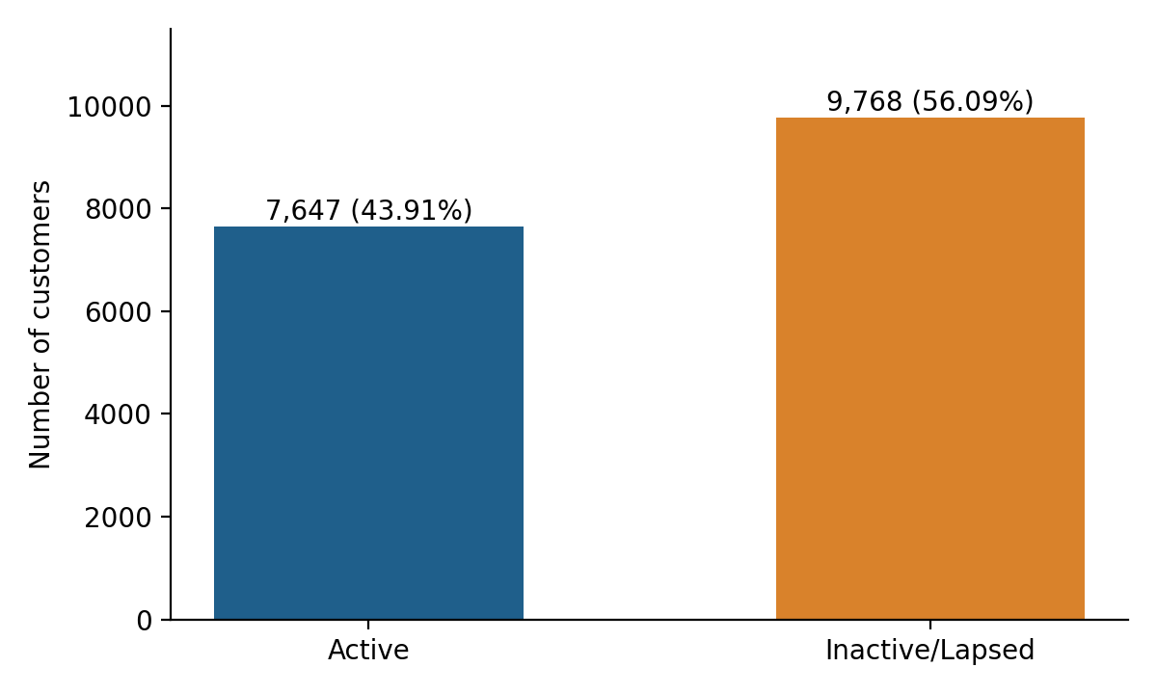
Figure 1. Distribution of Active and Inactive Customers

15.2 Comparison of Means and Medians
Table 16. Mean values by activity status
Metric | Active | Inactive/Lapsed | Observation
Recency | 143.916176 | 791.401413 | Higher for inactive (by definition)
Frequency | 1.748137 | 1.266482 | Higher for active
Monetary | 442.415065 | 320.897420 | Higher for active
Total Quantity | 18.889761 | 13.649468 | Higher for active
Total Profit | 66.196450 | 57.249119 | Higher for active
Avg Discount | 0.142890 | 0.145952 | Very similar
Average Order Value | 250.473069 | 251.096131 | Almost identical

Table 17. Median values by activity status
Metric | Active | Inactive/Lapsed
Recency | 126 | 759
Frequency | 1 | 1
Monetary | 212 | 144
Total Quantity | 11 | 8
Total Profit | 24.164 | 19.850
Avg Discount | 0.05 | 0.00
Average Order Value | 131.5 | 123

15.3 Interpretation
- Active customers purchase more frequently (mean 1.75 versus 1.27 orders). The median frequency is 1 in both groups because most customers in each group placed a single order; the difference arises from the greater share of repeat customers among active customers.
- Active customers generate higher cumulative monetary value (mean 442.42 versus 320.90).
- Active customers purchase greater quantities (mean 18.89 versus 13.65 units).
- Active customers generate higher total profit (mean 66.20 versus 57.25).
- Average Order Value is almost identical between the groups (250.47 versus 251.10).
Taken together, observed inactivity appears more closely related to purchase frequency than to major differences in individual order value. Higher cumulative sales, quantity and profit among active customers are consistent with their greater number of orders. These are descriptive associations only; the analysis does not show that low frequency causes inactivity, or the reverse.

15.4 Visual Summary
Figures 2 to 7 summarise the activity comparison visually. Figures 4 and 5 are discussed further in Sections 19 and 17 respectively.
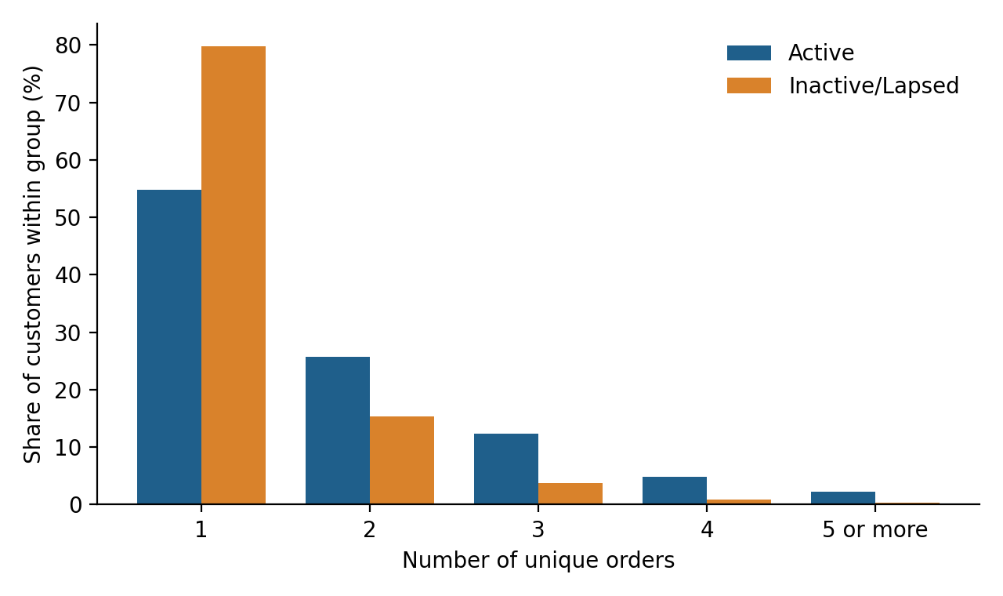
Figure 2. Purchase Frequency by Customer Activity Status
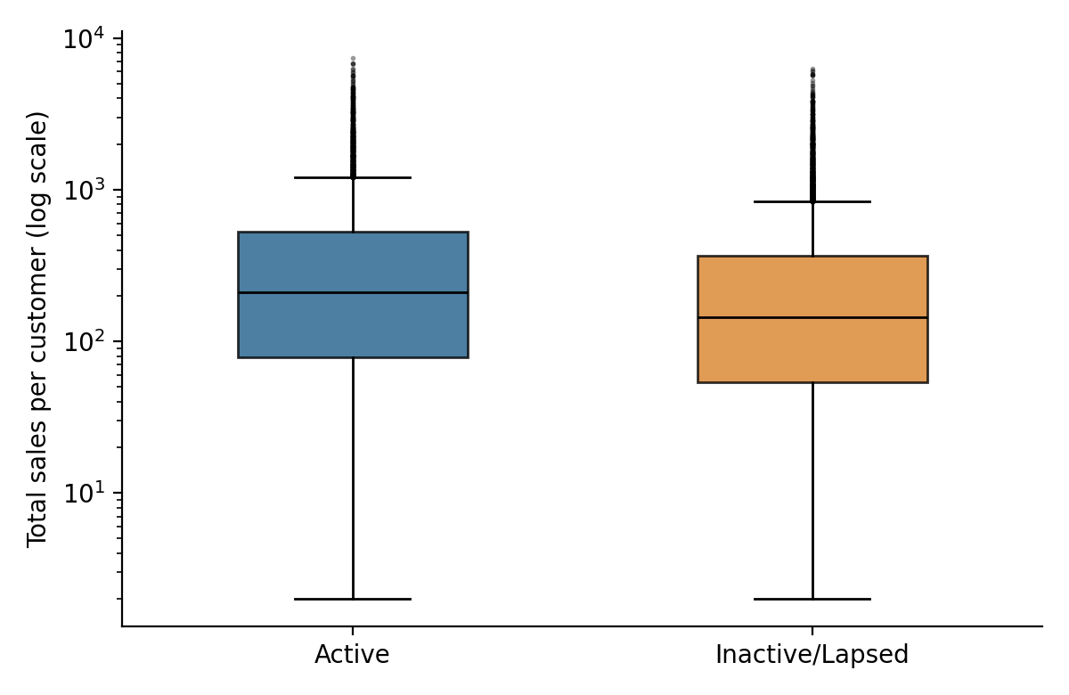
Figure 3. Customer Monetary Value by Activity Status
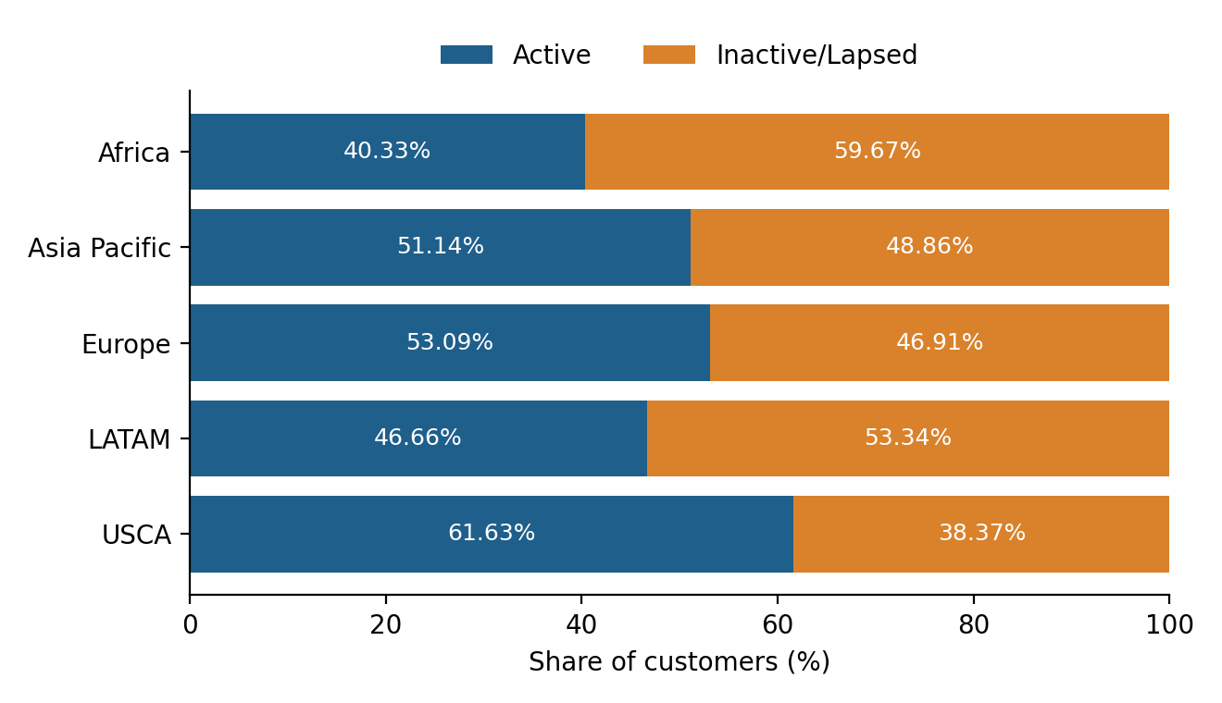
Figure 4. Activity Distribution Across Markets
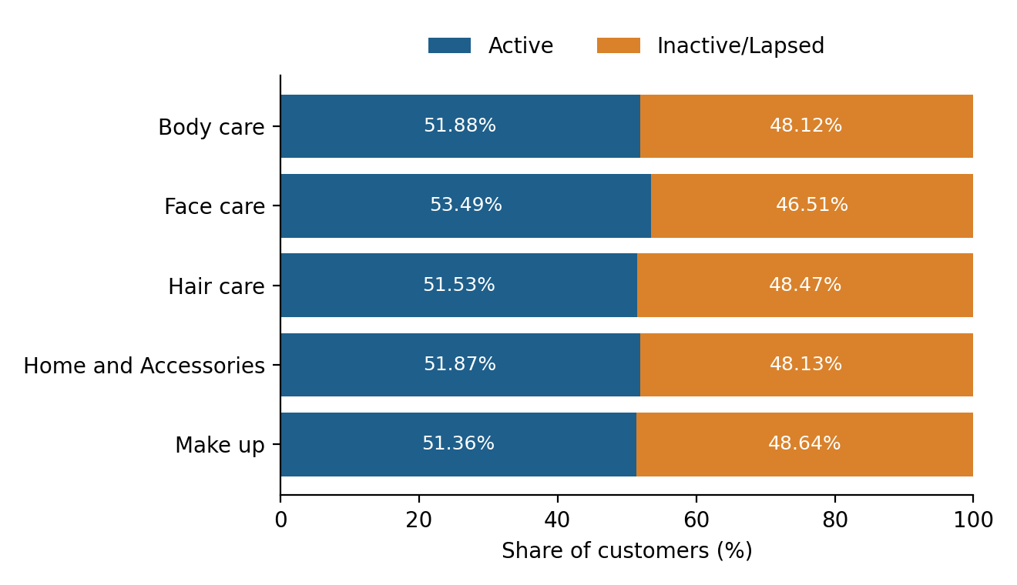
Figure 5. Activity Distribution Across Product Categories
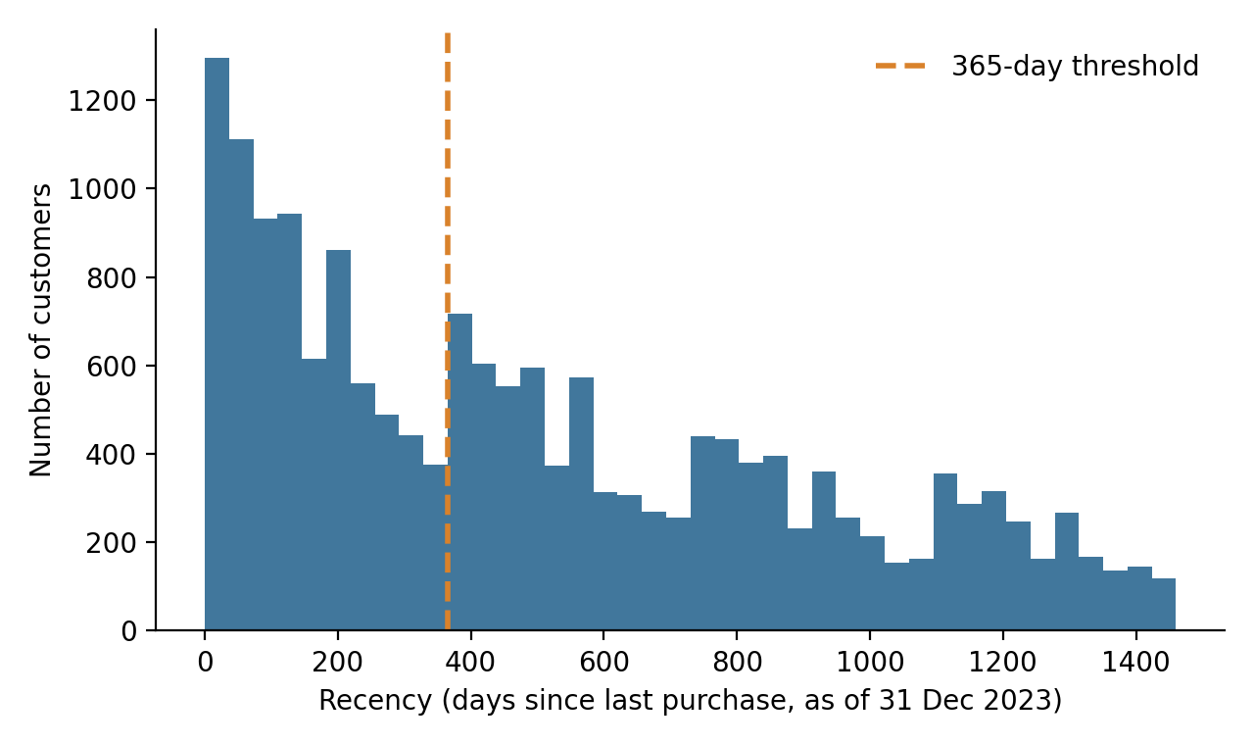
Figure 6. Customer Recency Distribution and 365-Day Inactivity Threshold
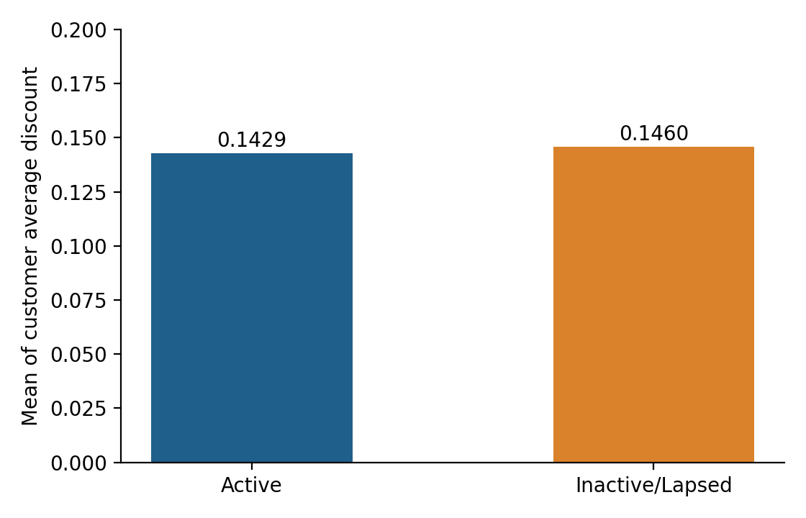
Figure 7. Average Discount by Activity Status
Figure 7 shows near-identical mean discount levels between the groups. Medians differ (0.05 for active versus 0.00 for inactive customers), so discount behaviour shows a mixed pattern that cannot be summarised as a simple direction of effect.

16. Statistical Hypothesis Testing

16.1 Mann–Whitney U Test
The Mann–Whitney U test (Mann & Whitney, 1947) was used to compare Active and Inactive customers because the customer-level variables are not assumed to follow normal distributions and contain skewed values and outliers. As a rank-based test, it assesses whether values in one group tend to be larger than in the other, without assuming normality. The significance level was α = 0.05.
Table 18. Mann–Whitney U test results (Active vs Inactive/Lapsed)
Metric | U statistic | P value | Significant at α = 0.05
Frequency | 47,359,431.0 | 9.477308e-304 | Yes
Monetary | 42,647,513.5 | 2.732924e-58 | Yes
Total Quantity | 43,139,228.0 | 2.166327e-69 | Yes
Total Profit | 38,544,614.5 | 2.785385e-04 | Yes
Avg Discount | 39,173,871.0 | 3.835876e-09 | Yes
Average Order Value | 38,684,567.0 | 4.916661e-05 | Yes

All six variables show statistically significant distributional differences between the Active and Inactive groups, since every p-value is below 0.05.

16.2 Statistical versus Practical Significance
Statistical significance does not automatically imply practical or business significance (Wasserstein & Lazar, 2016). With 17,415 customers, even small differences can produce very small p-values. The Average Order Value illustrates this: the test is significant (p = 4.916661e-05), yet the group means are 250.47 (Active) and 251.10 (Inactive), a difference that is extremely small in practical terms. Similarly, the mean Avg Discount values (0.1429 and 0.1460) differ only slightly. By contrast, differences in Frequency and Monetary value are accompanied by clearer descriptive gaps. Effect-size measures were not computed in Week 2 and are recommended for future analysis.

16.3 Chi-Square Tests of Independence
Chi-square tests of independence (Pearson, 1900) were used to examine whether activity status is associated with product category, customer segment and market. The results are reported in Sections 17 to 19 and summarised in Table 19.
Table 19. Summary of chi-square tests
Variable | Chi-square | df | P value | Conclusion at α = 0.05
Category | 33.792182 | 4 | 8.220138e-07 | Significant association
Segment | 2.120809 | 2 | 0.3463158 | No significant association
Market | 94.504351 | 4 | 1.452639e-19 | Significant association

17. Category Analysis
Table 20. Activity status by product category (% of customers)
Category | Active (%) | Inactive (%)
Body care | 51.884911 | 48.115089
Face care | 53.493700 | 46.506300
Hair care | 51.529928 | 48.470072
Home and Accessories | 51.870534 | 48.129466
Make up | 51.358545 | 48.641455

Figure 5 (Section 15) displays these percentages. The chi-square test (χ² = 33.792182, df = 4, p = 8.220138e-07) indicates a statistically significant association between product category and activity status. However, the descriptive differences are relatively modest: the active share ranges from about 51.4% (Make up) to 53.5% (Face care), a spread of roughly two percentage points. Category should therefore be monitored as one contextual variable, but these results do not support treating category as a dominant driver of inactivity.

18. Segment Analysis
Table 21. Activity status by customer segment (% of customers)
Segment | Active (%) | Inactive (%)
Consumer | 51.440531 | 48.559469
Corporate | 51.623566 | 48.376434
Self-Employed | 53.344750 | 46.655250

The chi-square test (χ² = 2.120809, df = 2, p = 0.3463158) shows no statistically significant association between customer segment and activity status at α = 0.05. The observed percentage differences between segments are small and are consistent with random variation. Customer segment alone is therefore not a reliable basis for retention targeting in this dataset.

19. Market Analysis
Table 22. Activity status by market (% of customers)
Market | Active (%) | Inactive (%)
Africa | 40.331371 | 59.668629
Asia Pacific | 51.139701 | 48.860299
Europe | 53.090630 | 46.909370
LATAM | 46.658248 | 53.341752
USCA | 61.630372 | 38.369628

Figure 4 (Section 15) displays these percentages. The chi-square test (χ² = 94.504351, df = 4, p = 1.452639e-19) indicates that activity levels differed significantly across markets. USCA had the highest active proportion (61.63%), whereas Africa had the lowest (40.33%). LATAM (46.66% active) also had more inactive than active customers, as did Africa. The strength of this association is notably greater than for category or segment.
These findings show differences in observed activity between markets. They do not show that geography causes inactivity; differences could reflect factors not captured in the data, such as logistics, pricing, competition, marketing intensity or the timing of customer acquisition.

20. Correlation Analysis
A correlation matrix was generated for Recency, Frequency, Monetary, Total Quantity, Total Profit, Avg Discount and Average Order Value (Figure 8). The coefficients displayed are Pearson correlations computed directly from the customer-level dataset.
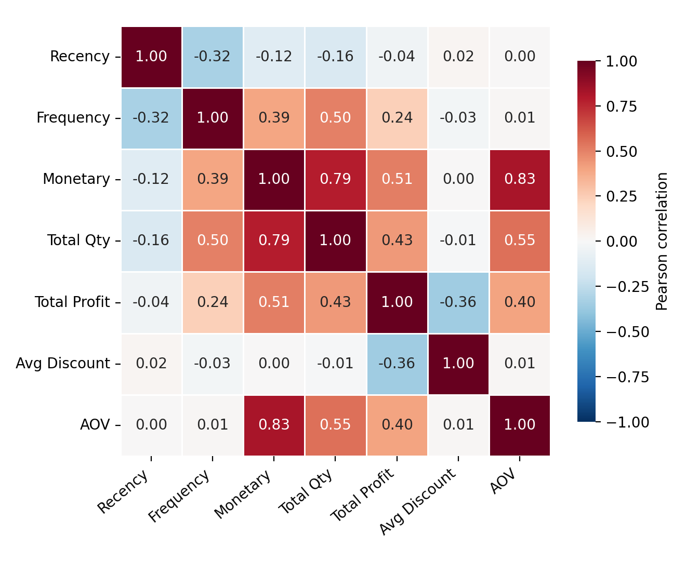
Figure 8. Correlation Matrix of Customer-Level Metrics
Three qualitative patterns are visible in the matrix. First, Recency is negatively associated with Frequency, consistent with the earlier finding that customers who order more often tend to have purchased more recently. Second, the value-related variables (Monetary, Total Quantity and Average Order Value) are positively associated with one another, as expected because they are mechanically related. Third, Avg Discount shows weak association with most variables. Specific coefficients are read from Figure 8 and are not restated here.
Correlation indicates association, not causation. Pearson correlation also assumes linear relationships and is sensitive to skewed values and outliers, both of which are present here; a rank-based measure such as Spearman correlation could be examined in future work. Because the inactivity proxy is defined from Recency, the relationship between Recency and activity status is partly definitional.

21. Hypothesis Evaluation
Each hypothesis was evaluated strictly against the analysis results. "Supported by the observed data" refers to a statistically significant association or difference at α = 0.05 and does not constitute causal proof.
Table 23. Evaluation of hypotheses
Hypothesis | Test / Method | Result | Interpretation
H1: Lower purchase frequency is associated with higher observed inactivity. | Mann–Whitney U test; group means | p = 9.477308e-304; mean frequency 1.748137 (Active) vs 1.266482 (Inactive) | Supported by the observed data. Inactive customers had lower purchase frequency; this is an association, not a demonstrated cause.
H2: Higher recency is associated with observed inactivity. | Descriptive comparison of Recency | Mean recency 143.916176 (Active) vs 791.401413 (Inactive); medians 126 vs 759 | Consistent with the data, but largely by construction because inactivity is defined from recency. It is not an independent test.
H3: Customer monetary value differs between active and inactive customers. | Mann–Whitney U test | p = 2.732924e-58; mean 442.415065 vs 320.897420 | Supported by the observed data. Active customers show higher cumulative sales.
H4: Discount behavior differs between active and inactive customers. | Mann–Whitney U test | p = 3.835876e-09; mean 0.142890 vs 0.145952; median 0.05 vs 0.00 | Statistically supported, but the mean difference is very small and the pattern is mixed; practical significance is limited.
H5: Customer activity differs across product categories. | Chi-square test of independence | χ² = 33.792182, df = 4, p = 8.220138e-07 | Supported by the observed data, though percentage differences are modest.
H6: Customer activity differs across customer segments. | Chi-square test of independence | χ² = 2.120809, df = 2, p = 0.3463158 | Not supported. No significant association at α = 0.05.
H7: Customer activity differs across markets. | Chi-square test of independence | χ² = 94.504351, df = 4, p = 1.452639e-19 | Supported by the observed data. Activity levels differed significantly across markets.

22. Key Findings
- The dataset is large and complete (51,290 rows; 0 missing values; 0 duplicates) but has no churn label, so inactivity is modelled as a proxy.
- Repeat-purchase intervals are long (median 302.5 days), which justified a 365-day inactivity threshold rather than a short window such as 30 or 90 days.
- Under this threshold, 56.09% of customers (9,768) are Inactive/Lapsed and 43.91% (7,647) are Active.
- 11,979 customers purchased only once, a potential retention opportunity that should not be equated with confirmed churn.
- Active customers have higher purchase frequency, total sales, quantity and profit, whereas Average Order Value is almost identical across groups.
- All six tested customer metrics differ significantly between groups, but practical significance varies; it is clearest for frequency and cumulative value and weakest for Average Order Value and discount.
- Market is associated with activity status much more strongly than category, while segment shows no significant association.

23. Business Implications
The following implications are drawn from the observed associations. They are suggestions for further validation and not proven causal strategies.
- Prioritise customers with long recency and low frequency. These customers show the pattern most closely associated with observed inactivity and are natural candidates for retention attention.
- Use RFM features in future predictive modelling. The customer-level Recency, Frequency and Monetary features are a sound starting point for later model development.
- Consider market-specific retention strategies. Activity differs significantly across markets, with USCA the most active and Africa and LATAM having more inactive than active customers.
- Monitor category-level behaviour without over-relying on it. Category is statistically associated with activity, but the differences are modest.
- Avoid relying solely on customer segment. No significant association with activity status was found.
- Develop targeted re-engagement campaigns. Campaigns directed at lapsed and one-time customers should be tested through controlled experiments to measure their actual effect.
- Collect richer CRM and behavioural data. Loyalty, feedback, marketing and service data would improve future churn prediction.

24. Limitations
- Inactivity is an analytical proxy, not confirmed churn.
- The dataset ends on December 31, 2023, so recent customers have had limited time to repurchase and customers may return after the observation period.
- The 365-day threshold is analytical and dataset-specific. Alternative thresholds produce substantially different inactive proportions (72.05% at 180 days and 40.28% at 540 days).
- Historical transaction data may not represent the complete Beauty & Wellness industry, which also includes services such as salon and spa visits.
- Correlation and statistical association do not establish causation.
- Customer-level category, segment and market representation may oversimplify customers who purchased across multiple categories or markets.
- No experimental data is available to show that retention interventions cause improved retention.
- With a large sample, small differences can be statistically significant without being practically important; effect sizes were not computed.
- The provenance of the prepared dataset, including the apparent transformation of order dates noted in Section 10, should be confirmed with the repository author.

25. Ethical Considerations
- Responsible handling of customer data: customer-level data should be used only for its legitimate analytical purpose and in line with applicable data protection law, such as the EU General Data Protection Regulation (European Parliament & Council of the European Union, 2016) and India's Digital Personal Data Protection Act, 2023 (Government of India, 2023).
- Privacy and anonymisation: customer identifiers should be pseudonymised or anonymised, and only the minimum data necessary should be retained.
- Avoiding discriminatory targeting: retention or marketing actions should not unfairly disadvantage customers on the basis of market, segment or other sensitive characteristics.
- Avoiding misleading churn labels: inactive customers should not be described as permanently lost without evidence.
- Transparent use of proxy variables: the inactivity proxy and its threshold should be documented clearly so that stakeholders understand its limits.
- Appropriate access controls: customer-level datasets should be accessible only to authorised personnel.
- Responsible use of predictive models: future models should be validated, interpreted carefully and used to support, rather than replace, human judgement.

26. Future Work
Scope note: No machine learning model was built or evaluated in Week 2. The items below are planned future work.
- Create a true temporal churn label using an observation window and a future outcome window.
- Build baseline classification models.
- Try Logistic Regression and Random Forest, and XGBoost or LightGBM where appropriate.
- Evaluate models using Precision, Recall, F1-score and ROC-AUC.
- Handle class imbalance if required.
- Perform feature-importance and interpretability analysis.
- Develop customer segmentation using RFM.
- Design retention recommendations based on customer segments.
- Validate the model on a future time period.

27. Conclusion
Week 2 moved the project from a defined business problem to a documented, data-supported analytical foundation. A suitable public dataset was identified and justified, its quality was assessed, and customer-level RFM-based features were engineered. Because the dataset contains no churn label, an inactivity proxy based on a 365-day recency threshold was defined, informed by the observed purchase-gap distribution.
The initial analysis indicates that observed inactivity is more closely associated with lower purchase frequency than with differences in individual order value, and that activity levels differ significantly across markets and, to a modest extent, across product categories, but not across customer segments. These findings are associational and limited by the use of a proxy, a fixed observation period and a single dataset. They nevertheless provide a clear basis for the subsequent weeks, in which a temporally valid churn definition, predictive models and segment-level retention recommendations can be developed and validated.

28. References
European Parliament & Council of the European Union. (2016). Regulation (EU) 2016/679 of the European Parliament and of the Council of 27 April 2016 on the protection of natural persons with regard to the processing of personal data and on the free movement of such data (General Data Protection Regulation). Official Journal of the European Union, L 119, 1–88.
Fader, P. S., Hardie, B. G. S., & Lee, K. L. (2005). "Counting your customers" the easy way: An alternative to the Pareto/NBD model. Marketing Science, 24(2), 275–284. https://doi.org/10.1287/mksc.1040.0098
Government of India. (2023). The Digital Personal Data Protection Act, 2023 (Act No. 22 of 2023).
Hunter, J. D. (2007). Matplotlib: A 2D graphics environment. Computing in Science & Engineering, 9(3), 90–95. https://doi.org/10.1109/MCSE.2007.55
Mann, H. B., & Whitney, D. R. (1947). On a test of whether one of two random variables is stochastically larger than the other. The Annals of Mathematical Statistics, 18(1), 50–60. https://doi.org/10.1214/aoms/1177730491
McKinney, W. (2010). Data structures for statistical computing in Python. In S. van der Walt & J. Millman (Eds.), Proceedings of the 9th Python in Science Conference (pp. 56–61). https://doi.org/10.25080/Majora-92bf1922-00a
Nguyen, X. (n.d.). Beauty-Ecommerce-Analytics [Data set]. GitHub. https://github.com/xanhnguyen186/Beauty-Ecommerce-Analytics
Pearson, K. (1900). On the criterion that a given system of deviations from the probable in the case of a correlated system of variables is such that it can be reasonably supposed to have arisen from random sampling. The London, Edinburgh, and Dublin Philosophical Magazine and Journal of Science, 50(302), 157–175. https://doi.org/10.1080/14786440009463897
Reichheld, F. F., & Sasser, W. E., Jr. (1990). Zero defections: Quality comes to services. Harvard Business Review, 68(5), 105–111.
Tukey, J. W. (1977). Exploratory data analysis. Addison-Wesley.
Virtanen, P., Gommers, R., Oliphant, T. E., Haberland, M., Reddy, T., Cournapeau, D., et al. (2020). SciPy 1.0: Fundamental algorithms for scientific computing in Python. Nature Methods, 17(3), 261–272. https://doi.org/10.1038/s41592-019-0686-2
Waskom, M. L. (2021). seaborn: Statistical data visualization. Journal of Open Source Software, 6(60), 3021. https://doi.org/10.21105/joss.03021
Wasserstein, R. L., & Lazar, N. A. (2016). The ASA statement on p-values: Context, process, and purpose. The American Statistician, 70(2), 129–133. https://doi.org/10.1080/00031305.2016.1154108

29. Appendix: Important Tables and Methodology

29.1 Summary of All Statistical Tests
Table 24. Statistical tests performed in Week 2
Test | Variable(s) | Statistic | P value | Result
Mann–Whitney U | Frequency | U = 47,359,431.0 | 9.477308e-304 | Significant
Mann–Whitney U | Monetary | U = 42,647,513.5 | 2.732924e-58 | Significant
Mann–Whitney U | Total Quantity | U = 43,139,228.0 | 2.166327e-69 | Significant
Mann–Whitney U | Total Profit | U = 38,544,614.5 | 2.785385e-04 | Significant
Mann–Whitney U | Avg Discount | U = 39,173,871.0 | 3.835876e-09 | Significant
Mann–Whitney U | Average Order Value | U = 38,684,567.0 | 4.916661e-05 | Significant
Chi-square | Category | χ² = 33.792182 (df = 4) | 8.220138e-07 | Significant
Chi-square | Segment | χ² = 2.120809 (df = 2) | 0.3463158 | Not significant
Chi-square | Market | χ² = 94.504351 (df = 4) | 1.452639e-19 | Significant

29.2 Methodology Workflow
- Load beauty_clean.csv and convert Order Date to datetime.
- Check shape, missing values, duplicates and data types.
- Aggregate transaction lines to one row per customer, using December 31, 2023 as the reference date.
- Compute Recency, Frequency (unique orders), Monetary, Total Quantity, Total Profit, Avg Discount and Average Order Value.
- Build unique order-level purchase histories and calculate gaps between consecutive orders per customer.
- Evaluate 180-, 365- and 540-day thresholds and select 365 days.
- Create Activity_Status (Active if Recency ≤ 365 days; otherwise Inactive/Lapsed).
- Compare groups with descriptive statistics and Mann–Whitney U tests (α = 0.05).
- Test category, segment and market against activity status with chi-square tests of independence (α = 0.05).
- Produce visualisations and the correlation matrix, and evaluate hypotheses.

29.3 Tools and Reproducibility
The analysis was performed in Python using the pandas library for data handling (McKinney, 2010) and SciPy for statistical testing (Virtanen et al., 2020). Figures were produced with Matplotlib (Hunter, 2007) and Seaborn (Waskom, 2021). Figures 1, 2, 3, 6, 7 and 8 were generated from the customer-level data, and Figures 4 and 5 were generated from the activity percentages reported in Tables 22 and 20 respectively.
Note: all values reported are derived from the dataset as supplied; no external data were used.

