WEEK 6 REPORT
Model Evaluation, Reporting & Business Impact Communication
Customer Churn Prediction and Retention Analysis
Beauty & Wellness Industry
Dataset period: 1 January 2020 – 31 December 2023
Models: Logistic Regression and Decision Tree

Executive Summary
This report evaluates two machine-learning models designed to identify customers who made no purchase during a defined 90-day future observation window. The cleaned dataset contains 51,290 transactions, 17,415 unique customers and 25,728 orders. The final modeling dataset contains 14,716 customers: 13,690 (93.03%) labelled churned and 1,026 (6.97%) labelled retained.
On the held-out test set, the Decision Tree achieved a churn F1-score of 0.8191 and accuracy of 70.38%, compared with 0.7808 and 65.25% for Logistic Regression. However, ROC-AUC remained modest (0.6183 and 0.5863 respectively), and both models performed poorly at identifying retained customers. Five-fold cross-validation F1-scores were almost identical: 0.7842 for Decision Tree and 0.7832 for Logistic Regression. The Decision Tree is a candidate for further validation, not a production-ready system.
The business opportunity is to prioritize retention outreach, test personalized engagement and protect margins. Before wider deployment, the company should validate on later time periods, tune thresholds using business costs and run a controlled pilot. Model metrics alone do not prove that a campaign will increase retention or profit.

1. Objective and Scope
The purpose of Week 6 is to explain model evaluation in accessible language, justify the selected metrics, define a validation framework, summarize model performance and translate the findings into actionable business recommendations for beauty and wellness stakeholders.
- Target: no purchase during a 90-day future observation window.
- Historical cutoff: 30 June 2023; future observation window ends 28 September 2023.
- Models: scaled, class-weighted Logistic Regression and a constrained, class-weighted Decision Tree.
- Use case: help prioritize customer-retention outreach, not automate customer treatment without review.
The label “churn” is operational: it means no observed purchase during the specified window. It does not prove that a customer has permanently left the brand.

2. Dataset and Modeling Summary
Item | Result
Transaction records | 51,290
Unique customers in cleaned dataset | 17,415
Unique orders | 25,728
Data period | 2020-01-01 to 2023-12-31
Historical records through cutoff | 40,584
Future-window records | 4,634
Modeling customers | 14,716
Churned label | 13,690 (93.03%)
Retained label | 1,026 (6.97%)
Train/test split | 80:20, stratified, random_state=42

Historical customer features included transaction count, purchase frequency, monetary value, total profit, quantity, average discount, average sales, category diversity, recency and average order value. Customer ID was excluded. Features were computed from historical data up to the cutoff to reduce future-information leakage.

3. Evaluation Framework and Metric Rationale
Metric | Meaning | Business interpretation and use
Accuracy | Share of all predictions correct. | Easy summary but can mislead when one class dominates; never use alone.
Precision (churn) | Of predicted churn customers, share labelled churned. | Higher precision can reduce wasted outreach to customers who would purchase anyway.
Recall (churn) | Share of churn-labelled customers correctly identified. | Higher recall covers more at-risk customers but may increase outreach volume.
F1-score (churn) | Balance of churn precision and recall. | Primary comparison metric for balancing coverage and targeting efficiency.
ROC-AUC | Ability to rank positive and negative examples across thresholds. | Modest values suggest limited separation between churned and retained customers.
PR-AUC / Average Precision | Precision-recall trade-off across thresholds. | Useful for imbalanced classification, but the baseline is influenced by 93.03% churn prevalence.
Confusion matrix | Counts correct and incorrect predictions by class. | Makes the volume and type of errors visible to business teams.
Cross-validation | Performance across multiple training folds. | Helps assess stability and whether results depend on one split.

Because churn is the majority class, a model may appear successful by frequently predicting churn. F1-score, class-specific metrics, confusion matrices and ROC-AUC are therefore important. The final threshold should also reflect outreach costs, customer value and offer effectiveness.

4. Test-Set Results
Metric | Logistic Regression | Decision Tree
Accuracy | 0.6525 (65.25%) | 0.7038 (70.38%)
Precision — churn | 0.9450 | 0.9486
Recall — churn | 0.6652 | 0.7207
F1-score — churn | 0.7808 | 0.8191
ROC-AUC | 0.5863 | 0.6183
PR-AUC / Average Precision | 0.9460 | 0.9496

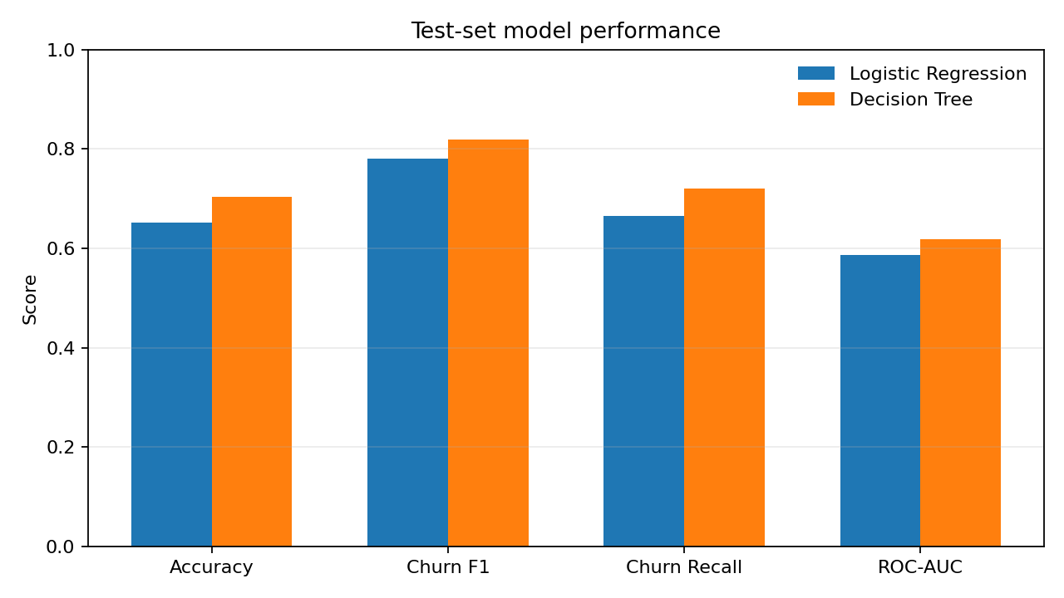
The Decision Tree has a 0.0383 higher test churn F1-score and a 0.0544 higher recall than Logistic Regression. Its ROC-AUC is still modest. The high PR-AUC should be interpreted in light of the very high churn prevalence; it does not mean the model is good at finding retained customers.

5. Confusion Matrix and Error Analysis
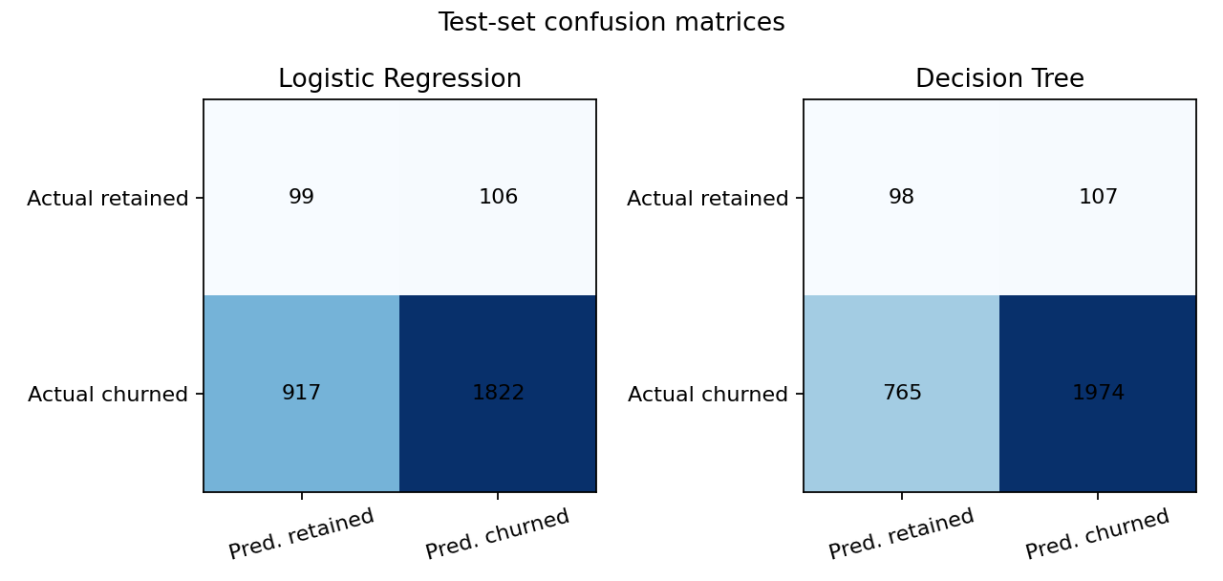
Actual class | LR: predicted retained | LR: predicted churned | Tree: predicted retained | Tree: predicted churned
Retained | 99 | 106 | 98 | 107
Churned | 917 | 1,822 | 765 | 1,974

Rows are actual classes and columns are predicted classes. The Decision Tree correctly identifies 1,974 churn-labelled customers and misses 765, compared with 1,822 identified and 917 missed by Logistic Regression. However, it predicts churn for 107 of 205 actual retained test customers; only 98 retained customers are correctly identified. Retained-class F1 is approximately 0.18 for the Decision Tree and 0.16 for Logistic Regression. This is a major limitation for campaigns that need to identify likely returners or avoid unnecessary incentives.

6. Cross-Validation and Validation Plan
Model | Train F1 mean | CV F1 mean | CV F1 std. | Train ROC-AUC | CV ROC-AUC mean | CV PR-AUC mean
Logistic Regression | 0.7836 | 0.7832 | 0.0140 | 0.5878 | 0.5722 | 0.9438
Decision Tree | 0.7909 | 0.7842 | 0.0516 | 0.6748 | 0.5753 | 0.9408

Cross-validation F1 differs by only 0.0010 between the models. The Decision Tree has higher fold-to-fold F1 variability, and its training ROC-AUC is higher than its cross-validation ROC-AUC. The test-set advantage should therefore be treated as preliminary.

Recommended validation stages
- Data and label audit: verify the 90-day definition, date boundaries, customer IDs and that no future-window information appears in features.
- Hold-out test: reserve the test set for one final evaluation after model selection; avoid repeatedly tuning against it.
- Cross-validation: compare average F1, ROC-AUC, PR-AUC, per-class metrics and fold-to-fold variation.
- Temporal validation: train on an earlier period and evaluate on a later untouched period; repeat across cutoffs if sufficient data exists.
- Threshold selection: select a probability threshold using validation data, outreach costs and expected customer value rather than assuming 0.50 is optimal.
- Pilot campaign: compare a model-targeted group with a suitable control group to measure incremental repeat purchases and margin.
- Monitoring: track class prevalence, precision, recall, campaign conversion, margin, complaints and feature drift monthly.

7. Feature Importance
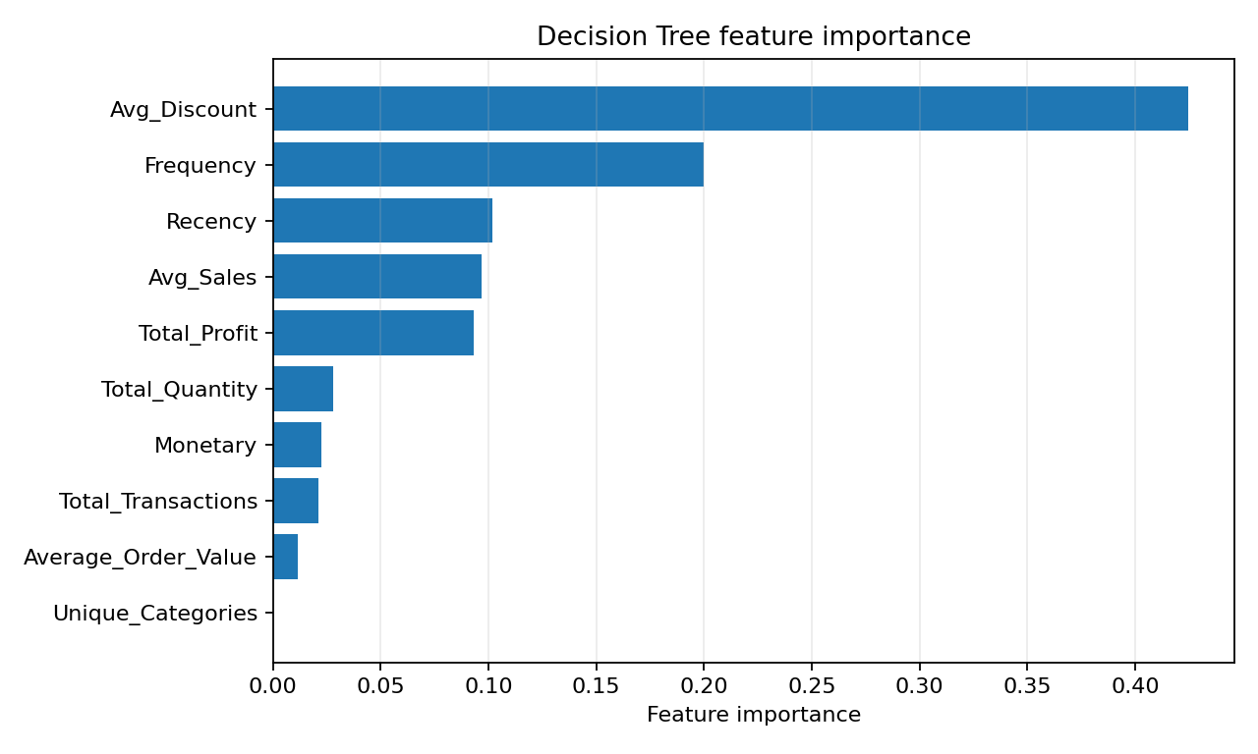
Feature | Decision Tree importance
Avg_Discount | 0.4249
Frequency | 0.2000
Recency | 0.1016
Avg_Sales | 0.0969
Total_Profit | 0.0933
Total_Quantity | 0.0280
Monetary | 0.0226
Total_Transactions | 0.0213
Average_Order_Value | 0.0115
Unique_Categories | 0.0000

Average discount is the most influential feature in this Decision Tree, followed by frequency and recency. Feature importance is model-specific and does not establish causation. The business should investigate whether discount levels reflect promotions, customer segments, market differences or lower-margin purchases before changing pricing strategy.

8. Customer-Level Findings
Measure | Retained (n=1,026) | Churn-labelled (n=13,690)
Average recency | 446.85 | 487.38
Average frequency | 1.588 | 1.367
Average monetary value | 416.85 | 348.42
Average total profit | 81.96 | 59.15
Average discount | 0.131 | 0.146
Average order value | 268.42 | 253.16

Churn-labelled customers show lower average purchase frequency, monetary value, profit and order value, along with a higher average discount and higher recency. These are descriptive associations, not proof that any single feature causes churn.

9. Business Impact and Recommendations

9.1 Prioritize outreach, not automatic discounting
Use model scores as one signal alongside customer value, purchase history, product category and contact preferences. Avoid sending the same discount to every flagged customer.

9.2 Test personalized re-engagement
Test replenishment reminders, product recommendations based on previous categories, wellness or beauty routine tips, and new-product content. Compare results against a control group to estimate incremental impact.

9.3 Protect margin
Because average discount is the top tree feature and churn-labelled customers have a higher average discount in the descriptive comparison, investigate discount dependence and profitability. Test bundles, loyalty points, samples or personalized content before increasing discount depth.

9.4 Create different customer journeys
Design separate journeys for high-value infrequent buyers, customers with lengthening purchase intervals, and first-time buyers who have not yet made a second purchase. Validate these segments with business teams and campaign tests.

9.5 Measure outcomes
- Incremental repeat-purchase rate compared with a control group.
- Incremental revenue and gross margin after discounts and campaign costs.
- Offer redemption, contact rate, unsubscribe rate and customer complaints.
- Precision, recall and conversion at the selected campaign threshold.

9.6 Apply governance
Document threshold changes, restrict personal data use to approved purposes, avoid unfair pricing or denial of service based on a score, and allow human review of recommendations.

10. Business Impact Measurement Framework
Business question | Metric | Decision
Does the campaign create additional purchases? | Incremental repeat-purchase rate vs. control | Scale, revise or stop the campaign.
Does the campaign make money? | Incremental gross margin minus campaign cost | Set spending and offer budgets.
Are discounts necessary? | Margin per customer and redemption by offer | Choose the least costly effective incentive.
Is targeting useful? | Precision, recall and conversion at threshold | Adjust threshold and audience size.
Are customers reacting negatively? | Unsubscribes, complaints and contact frequency | Set contact limits and suppression rules.
Is performance deteriorating? | Monthly model metrics and feature distributions | Investigate drift and retraining needs.

Do not estimate revenue uplift from model metrics alone. Financial impact must be measured in a campaign pilot using actual costs, margins and a control group.

11. Limitations and Risks
- Severe class imbalance: churn is 93.03% of the modeling dataset; accuracy and PR-AUC need context.
- Retained-customer identification is weak, with retained-class F1 around 0.18 for the Decision Tree.
- ROC-AUC values of 0.5863 and 0.6183 indicate limited class separation.
- The 90-day operational label does not prove permanent churn.
- A single cutoff and test split may not represent future seasons, promotions or market changes.
- Feature importance is not causal evidence; average discount importance does not prove discounts cause churn.
- No campaign experiment has yet shown that model-driven action increases retention or profit.

12. Conclusion
The Decision Tree is the leading candidate because it achieved the highest held-out churn F1-score (0.8191), recall (0.7207) and accuracy (70.38%). Yet its five-fold cross-validation F1-score (0.7842) is almost the same as Logistic Regression's (0.7832), and ROC-AUC remains modest at 0.6183. The evidence supports further testing, not immediate production deployment.
Beauty and wellness businesses can use predictive analytics to prioritize customer engagement, test personalized retention strategies and protect margins. Before scaling, conduct temporal validation, tune thresholds to business costs, improve retained-customer detection and run a controlled pilot. Success should be judged by incremental retention and profit, not model metrics alone.

Appendix: Selected References
- Fawcett, T. (2006). An introduction to ROC analysis. Pattern Recognition Letters, 27(8), 861–874. https://doi.org/10.1016/j.patrec.2005.10.010
- Saito, T., & Rehmsmeier, M. (2015). The precision-recall plot is more informative than the ROC plot when evaluating binary classifiers on imbalanced datasets. PLOS ONE, 10(3), e0118432. https://doi.org/10.1371/journal.pone.0118432
- scikit-learn developers. (n.d.). Model evaluation: Quantifying the quality of predictions. https://scikit-learn.org/stable/modules/model_evaluation.html
- scikit-learn developers. (n.d.). Cross-validation: Evaluating estimator performance. https://scikit-learn.org/stable/modules/cross_validation.html

