YUVAINTERN
Data Science with Python Analyst Internship
WEEK 4 INTERNSHIP REPORT
Exploratory Data Analysis and Feature Engineering
Beauty and Wellness E-commerce Transactions (2020–2023)
Submitted by
HONEY VERMA
B.Tech in Artificial Intelligence
Internship Programme: YuvaIntern
Week 4 · October 2026

Table of Contents
1. Introduction and Objectives 3
2. Dataset Description 3
2.1 Source and Scope 3
2.2 Data Quality Checks 4
2.3 Summary Statistics 4
2.4 Outlier Review 4
3. Python Libraries and Workflow 4
4. Distribution Analysis 5
5. Monthly and Yearly Trend Analysis 6
5.1 Yearly Results 6
5.2 Monthly Sales Trend 7
6. Category Performance 8
7. Market Performance 9
8. Active versus Inactive Customer Analysis 10
8.1 Customer-level Dataset and Activity Proxy 10
8.2 Results 11
9. Correlation Analysis 12
10. Feature Engineering 13
10.1 Customer-level Features 13
10.2 Transaction-level Features 16
11. Final Validation 16
12. Summary of Key Findings 17
13. Recommendations 17
14. Limitations 17
15. Conclusion 18
References 18

1. Introduction and Objectives
This report documents the work completed in Week 4 of the YuvaIntern Data Science with Python Analyst Internship. The task for this week was Exploratory Data Analysis (EDA) and Feature Engineering on a Beauty and Wellness e-commerce transaction dataset covering the period 1 January 2020 to 31 December 2023. The work builds on the data preparation completed in earlier weeks and produces two enriched datasets that can be used in later analysis.
The objectives for the week were to:
- inspect the structure, quality and statistical distribution of the numerical transaction features;
- analyse yearly sales and profit trends and compare performance across product categories and geographic markets;
- build a customer-level dataset and compare active and inactive customers using a recency-based proxy;
- measure linear association between the main numerical variables; and
- engineer customer-level and transaction-level features that support segmentation, seasonal analysis and profitability analysis.
Scope note. This week involved descriptive analysis and feature engineering only. No predictive model was trained or evaluated, and no inferential hypothesis test results are reported. All figures and tables in this report are based on the results obtained during the analysis; where a visual would have required raw data that is not reproduced in this document, a clearly labelled placeholder or the code needed to generate it is provided instead.

2. Dataset Description

2.1 Source and Scope
The dataset consists of e-commerce transactions from a beauty and wellness retailer and was obtained from a public GitHub repository (xanhnguyen186, n.d.). Each row is a transaction line, and a single order can contain several rows. The key properties of the dataset used in this week's analysis are summarised in Table 1.
Table 1. Overview of the original transaction dataset
Property | Value
Time span | 1 January 2020 to 31 December 2023
Rows × columns | 51,290 × 19
Unique customers | 17,415
Unique orders | 25,728
Missing values | None
Duplicate rows | None
Order Date | Converted to datetime; no invalid dates after conversion

2.2 Data Quality Checks
Before any analysis, the dataset was checked for missing values, duplicate rows and invalid dates. None were found. The Order Date column was converted to a datetime type, and the conversion produced no invalid dates, which made it safe to derive time-based features later in the week.

2.3 Summary Statistics
Table 2 reports the central tendency, range and skewness of the four main numerical features. Skewness is discussed further in Section 4.
Table 2. Summary statistics for the numerical transaction features
Feature | Mean | Median | Minimum | Maximum | Skewness
Quantity | 5.42 | 4 | 1 | 20 | 1.47
Sales | 127.07 | 56 | 2 | 3,940 | 6.40
Discount | 0.14 | 0 | 0 | 0.85 | 1.39
Profit | 20.77 | 7.2 | -1,746 | 1,820 | 3.95
Sales and Profit are in the currency units recorded in the dataset. Discount is a fraction between 0 and 1.

2.4 Outlier Review
Potential outliers were flagged using the interquartile range (IQR) criterion. The number of flagged values for each feature is shown in Table 3.
Table 3. Potential IQR outliers identified per feature
Feature | Flagged values | Share of 51,290 rows
Quantity | 4,604 | 9.0%
Sales | 5,126 | 10.0%
Discount | 4,172 | 8.1%
Profit | 7,740 | 15.1%
Shares are calculated from the supplied counts and the 51,290-row total.
After review in the business context, these values were retained and not removed. Large Sales and Quantity values are plausible for bulk or high-value purchases, and a negative Profit can be a genuine outcome when a transaction is loss-making, for example because of a heavy discount or a high cost relative to the selling price. Removing such rows would have discarded legitimate business events and understated the variability of the data.

3. Python Libraries and Workflow
The analysis was carried out in Python. The roles of the main libraries are described below.
- Pandas (McKinney, 2010) was used for loading the data, date conversion, aggregation by year, category, market and customer, feature creation, and final validation.
- NumPy was used for numerical operations such as conditional logic and handling of infinite or undefined values.
- Matplotlib (Hunter, 2007) and Seaborn (Waskom, 2021) were used for histograms, boxplots and the correlation heatmap, and for the charts in this report.
- SciPy was imported for statistical analysis support. This report does not claim that any specific inferential test was conducted.
- Scikit-learn's StandardScaler was used in the previous (Week 3) preprocessing stage. It is mentioned only as prior-work context and was not part of a new experiment this week.
The workflow followed these ordered steps: (1) load the data and convert Order Date; (2) validate quality; (3) flag potential outliers and inspect distributions; (4) aggregate by year, category and market; (5) build the customer-level table; (6) compare active and inactive customers; (7) compute correlations; (8) add engineered features; and (9) validate and save the final datasets under new file names.
Code 1. Loading the data and running quality checks
import pandas as pd
import numpy as np
import matplotlib.pyplot as plt
import seaborn as sns

df = pd.read_csv("beauty_clean.csv") # Week 3 cleaned data (not overwritten)
df["Order Date"] = pd.to_datetime(df["Order Date"], errors="coerce")

print(df.shape) # (51290, 19)
print(df.isna().sum().sum()) # missing values
print(df.duplicated().sum()) # duplicate rows
print(df["Order Date"].isna().sum()) # invalid dates after conversion
print(df["Customer ID"].nunique(), df["Order ID"].nunique())

num_cols = ["Quantity", "Sales", "Discount", "Profit"]
print(df[num_cols].agg(["mean", "median", "min", "max", "skew"]).T)

Snippets are condensed representations of the workflow. Column names follow the dataset used in this report.

4. Distribution Analysis
Inspecting distributions before modelling is an essential EDA step, because the shape of a variable determines which summary statistics are meaningful and which transformations or robust methods may be needed. All four numerical features showed positive (right) skewness (Table 2). Figure 1 compares the means and medians and shows the skewness values.
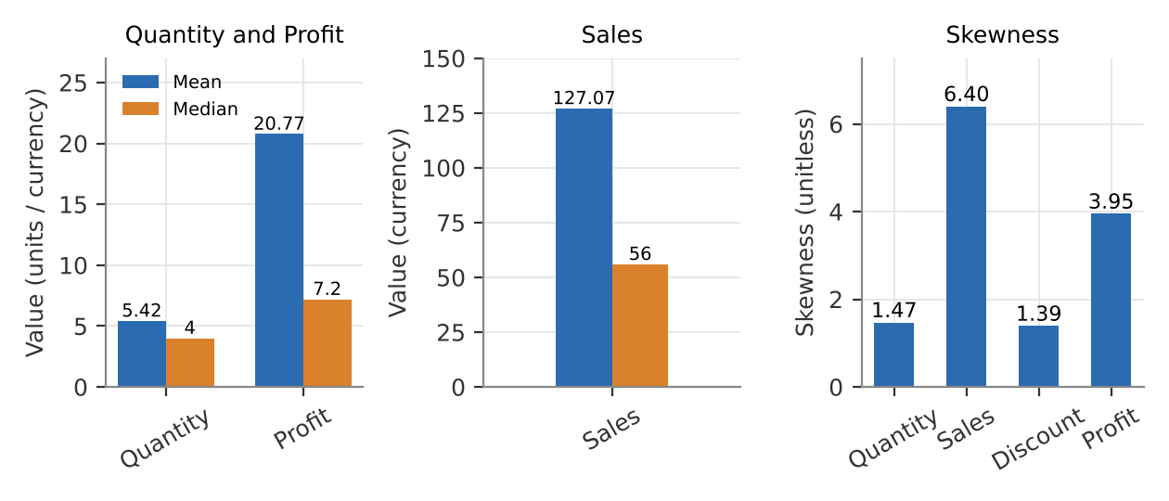
Figure 1. Mean versus median (left, centre) and skewness (right) of the numerical features. Source: summary statistics from the analysis.
- Sales was the most skewed feature (skewness 6.40). Its mean (127.07) is more than double its median (56), which indicates that a relatively small number of high-value transactions pull the average upwards.
- Profit (skewness 3.95) had a mean of 20.77 against a median of 7.2. It also has a wide range, from -1,746 to 1,820, so both large losses and large gains contribute to the tails.
- Quantity (skewness 1.47) and Discount (skewness 1.39) were moderately right-skewed. The Discount median of 0 shows that at least half of the transaction lines carried no discount, while the mean of 0.14 reflects the discounted subset.
Because of this right-skewness, the mean alone is a misleading description of a typical transaction, and the median is the more representative measure of the centre. Heavily skewed variables can also affect techniques that assume symmetry or are sensitive to extreme values. For this reason, distributions should always be examined, and the choice of statistics, scaling or transformation should be made deliberately before any modelling is attempted.
PLACEHOLDER: Histograms and boxplots of Quantity, Sales, Discount and Profit
These plots require the transaction-level data, which is not reproduced in this report. They were generated in the analysis workflow, and Code 2 regenerates them from the dataset. Figure 1 is built only from the summary statistics.
Code 2. Histograms and boxplots for the numerical features
fig, axes = plt.subplots(2, 4, figsize=(16, 7))
for i, col in enumerate(num_cols):
sns.histplot(df[col], bins=40, ax=axes[0, i])
axes[0, i].set_title(f"{col} distribution")
sns.boxplot(x=df[col], ax=axes[1, i])
axes[1, i].set_title(f"{col} boxplot")
plt.tight_layout()
plt.savefig("fig_distributions.png", dpi=200)

# IQR-based potential outlier counts (rows retained, not removed)
for col in num_cols:
q1, q3 = df[col].quantile([0.25, 0.75])
iqr = q3 - q1
mask = (df[col] < q1 - 1.5 * iqr) | (df[col] > q3 + 1.5 * iqr)
print(col, int(mask.sum()))

5. Monthly and Yearly Trend Analysis

5.1 Yearly Results
Table 4 presents yearly total sales, total profit and unique orders. The right-hand columns are derived directly from the supplied totals: year-on-year change and the profit margin (total profit divided by total sales).
Table 4. Yearly sales, profit and orders (amounts in dataset currency units)
Year | Total Sales | Total Profit | Unique Orders | Sales YoY | Profit YoY | Profit margin
2020 | 1,148,361 | 207,116.12 | 4,515 | – | – | 18.0%
2021 | 1,405,876 | 259,696.96 | 5,473 | 22.4% | 25.4% | 18.5%
2022 | 1,770,790 | 318,671.89 | 6,883 | 26.0% | 22.7% | 18.0%
2023 | 2,192,647 | 279,928.68 | 8,857 | 23.8% | -12.2% | 12.8%
YoY = year-on-year percentage change; margin = Profit / Sales × 100. Derived from the totals in the table.
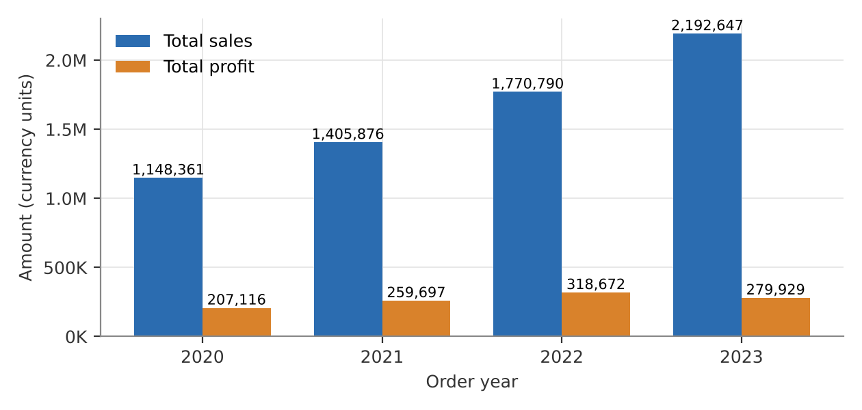
Figure 3. Total sales and total profit by order year. Amounts in dataset currency units.
The main findings are:
- Sales increased every year, and total sales grew by approximately 91% between 2020 and 2023.
- The number of unique orders also increased every year, from 4,515 in 2020 to 8,857 in 2023.
- Profit rose from 2020 through 2022 but declined in 2023.
- From 2022 to 2023, sales increased by approximately 23.8%, while profit declined by approximately 12.2%.
The divergence between rising sales and falling profit in 2023 is an important observation, and the derived margin falls from about 18.0% in 2022 to about 12.8% in 2023. However, this analysis does not establish why. Possible areas for further investigation include discount levels, product costs and changes in product mix, but none of these was shown to be the cause in this week's work.

5.2 Monthly Sales Trend
A monthly sales trend (Figure 2) is useful for identifying seasonality. The monthly aggregates were not carried into this report, so no monthly values are shown or estimated here. Code 3 generates both the yearly table and the monthly trend chart from the dataset.
PLACEHOLDER (Figure 2): Monthly sales trend, 2020–2023
Monthly totals were not supplied for this report and have deliberately not been estimated. Run Code 3 on the dataset to generate the chart, then replace this box.
Figure 2. Monthly sales trend (placeholder; to be generated with Code 3).
Code 3. Yearly aggregation and monthly sales trend
df["Order_Year"] = df["Order Date"].dt.year
yearly = df.groupby("Order_Year").agg(
Total_Sales=("Sales", "sum"),
Total_Profit=("Profit", "sum"),
Unique_Orders=("Order ID", "nunique"),
)
yearly["Sales_YoY_%"] = yearly["Total_Sales"].pct_change() * 100
yearly["Profit_YoY_%"] = yearly["Total_Profit"].pct_change() * 100

monthly = (df.set_index("Order Date")["Sales"]
.resample("M").sum()) # monthly total sales
ax = monthly.plot(figsize=(10, 4), marker="o")
ax.set_xlabel("Month"); ax.set_ylabel("Total sales (currency units)")
plt.tight_layout(); plt.savefig("fig_monthly_sales.png", dpi=200)

6. Category Performance
Table 5 compares the five product categories on sales, profit, quantity, unique orders and profit margin.
Table 5. Performance by product category
Category | Sales | Profit | Quantity | Orders | Margin
Body care | 2,682,942 | 590,907.78 | 113,437 | 14,855 | 22.02%
Home and Accessories | 1,245,643 | -57,187.64 | 52,847 | 7,986 | -4.59%
Make up | 1,121,222 | 368,998.18 | 48,284 | 7,613 | 32.91%
Hair care | 1,022,151 | 3,677.23 | 43,994 | 7,067 | 0.36%
Face care | 445,716 | 159,018.10 | 19,216 | 3,199 | 35.68%
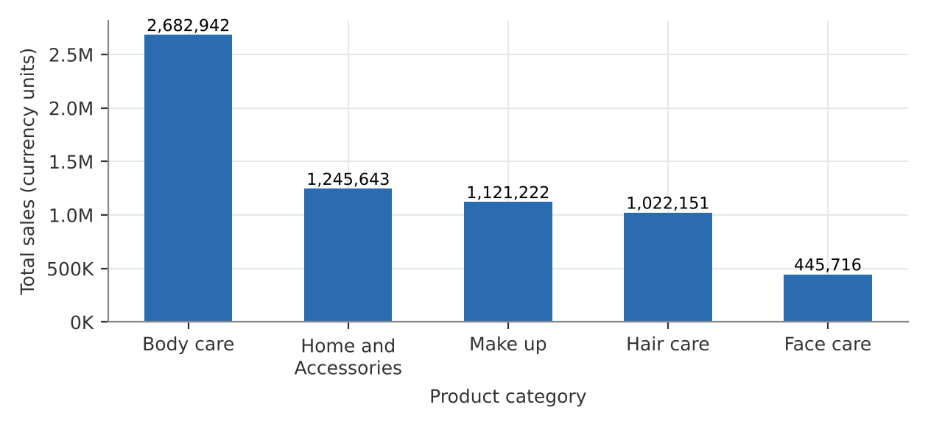
Figure 4. Total sales by product category (dataset currency units).
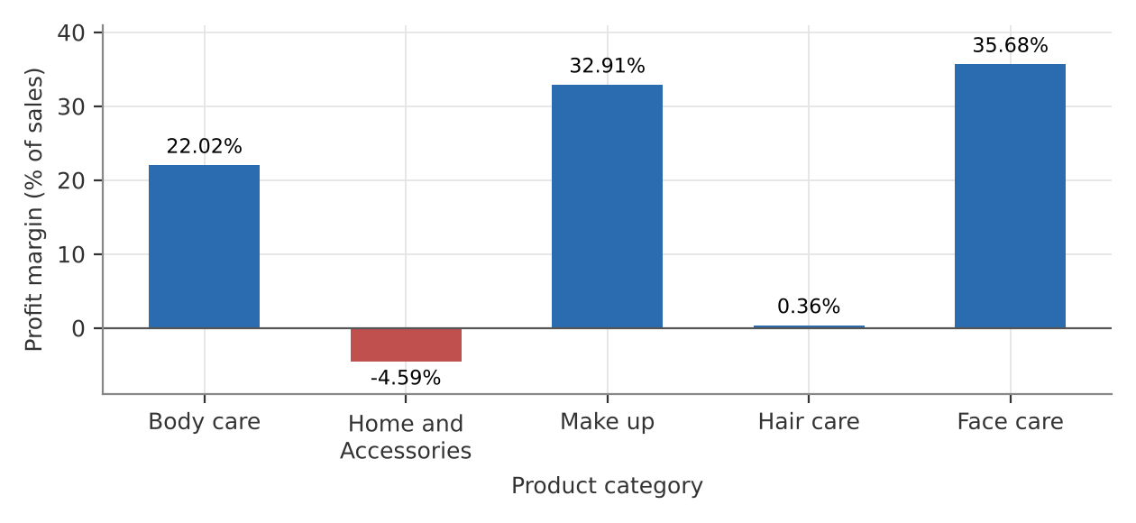
Figure 5. Profit margin by product category (profit as a percentage of sales). The negative margin is shown in red.
- Body care had the highest total sales (2,682,942), about 41.2% of all sales, and also the highest total profit (590,907.78).
- Face care had the highest profit margin (35.68%) even though its total sales were the lowest of the five categories.
- Home and Accessories had the second-highest sales but a negative total profit (-57,187.64) and a negative margin (-4.59%).
- Hair care had a positive but very low margin (0.36%), with a total profit of only 3,677.23 on sales of 1,022,151.
Together, Home and Accessories and Hair care account for about 34.8% of total sales (2,267,794) but have a combined profit of -53,510.41. These figures are descriptive. The reasons for the low or negative margins, such as pricing, costs, discounting or returns, were not examined this week and should not be inferred from these results.

7. Market Performance
Table 6. Performance by market
Market | Sales | Profit | Quantity | Orders | Margin
Asia Pacific | 1,831,648 | 228,742.59 | 77,628 | 7,080 | 12.49%
Europe | 1,487,444 | 331,644.70 | 64,656 | 6,013 | 22.30%
USCA | 1,372,045 | 222,770.12 | 57,709 | 5,203 | 16.24%
LATAM | 1,339,726 | 216,042.79 | 56,349 | 5,144 | 16.13%
Africa | 486,811 | 66,213.45 | 21,436 | 2,288 | 13.60%
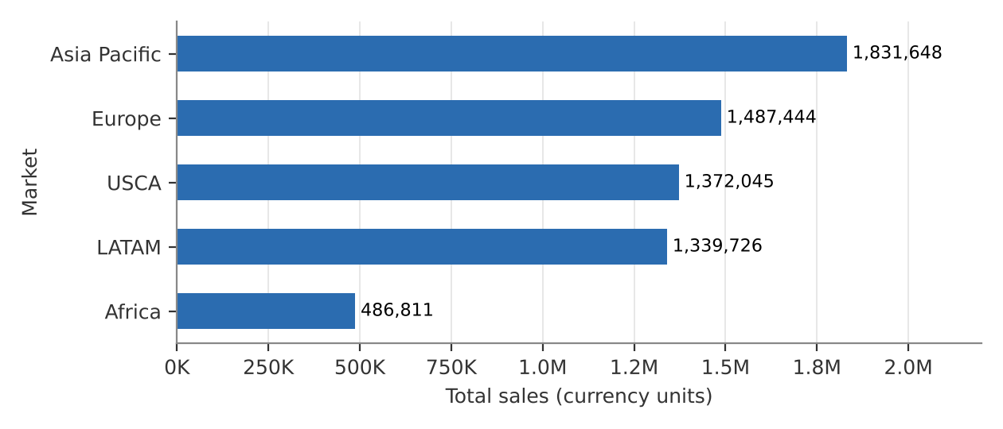
Figure 6. Total sales by market (dataset currency units).
- Asia Pacific was the highest-sales market (1,831,648) but had the lowest profit margin of the five markets (12.49%).
- Europe had the highest profit (331,644.70) and the highest margin (22.30%), despite ranking second on sales.
- USCA and LATAM were close to each other on sales, profit and margin.
- Africa was the lowest-sales market (486,811), with the fewest orders (2,288) and the lowest profit (66,213.45).
As with categories, these are descriptive differences. This analysis does not explain why margins differ between markets.

8. Active versus Inactive Customer Analysis

8.1 Customer-level Dataset and Activity Proxy
To analyse customer behaviour, the transactions were grouped by Customer ID into a customer-level dataset of 17,415 customers. For each customer, the following measures were calculated: Recency (days since the customer's most recent recorded order, relative to the maximum Order Date in the dataset), Frequency (number of unique orders), Monetary (total Sales), Total Quantity, Total Profit, Average Discount and Average Order Value.
Activity was defined using an analytical proxy: customers with Recency ≤ 365 days were labelled Active, and those with Recency > 365 days were labelled Inactive. This is an inactivity proxy based on recorded purchase dates. It is not verified customer churn, because the data cannot show whether an inactive customer has permanently left or may still return.
Code 4. Customer-level table and activity proxy
snapshot = df["Order Date"].max()

cust = df.groupby("Customer ID").agg(
Last_Order=("Order Date", "max"),
Frequency=("Order ID", "nunique"),
Monetary=("Sales", "sum"),
Total_Quantity=("Quantity", "sum"),
Total_Profit=("Profit", "sum"),
Avg_Discount=("Discount", "mean"),
).reset_index()

cust["Recency"] = (snapshot - cust["Last_Order"]).dt.days
cust["Avg_Order_Value"] = cust["Monetary"] / cust["Frequency"]
cust["Activity_Status"] = np.where(cust["Recency"] <= 365, "Active", "Inactive")

print(cust["Activity_Status"].value_counts()) # Active 7,647 / Inactive 9,768
print(cust.groupby("Activity_Status")[
["Recency", "Frequency", "Monetary", "Total_Quantity",
"Total_Profit", "Avg_Discount", "Avg_Order_Value"]].mean().round(2))

8.2 Results
There were 7,647 Active customers (43.9%) and 9,768 Inactive customers (56.1%). Table 7 compares the group averages.
Table 7. Average customer metrics by activity status
Metric | Active (n = 7,647) | Inactive (n = 9,768)
Recency (days) | 143.92 | 791.40
Frequency (unique orders) | 1.75 | 1.27
Monetary (total sales) | 442.42 | 320.90
Total Quantity | 18.89 | 13.65
Total Profit | 66.20 | 57.25
Average Discount | 0.14 | 0.15
Average Order Value | 250.47 | 251.10
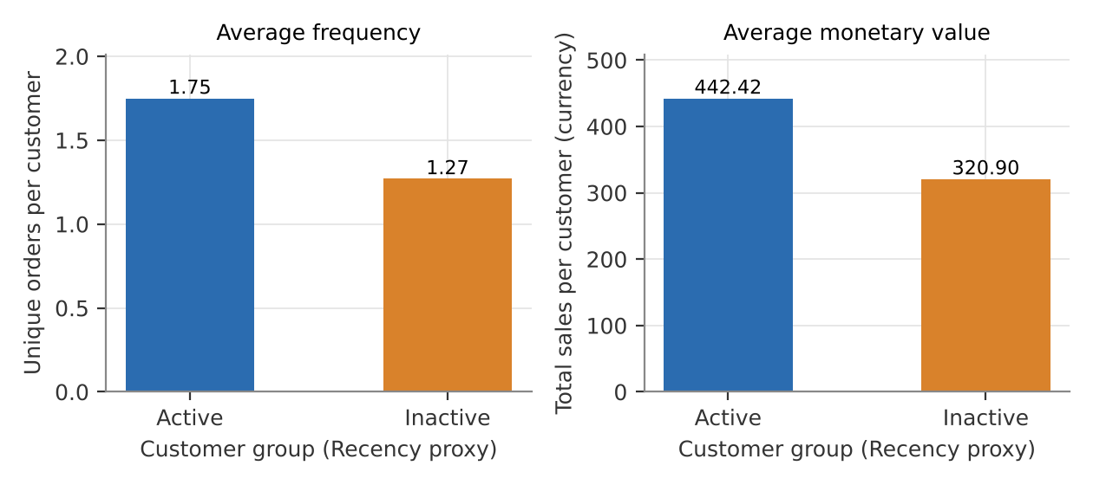
Figure 7. Average purchase frequency (left) and average total sales per customer (right) for Active and Inactive customers.
Active customers showed a higher average purchase frequency (1.75 versus 1.27 orders) and higher average total spending (442.42 versus 320.90). Their average quantity and total profit per customer were also higher. In contrast, the average order value was almost identical between the groups (250.47 versus 251.10), and average discount levels were similar (0.14 versus 0.15). This pattern suggests that the difference in total spending is associated mainly with how often customers purchased rather than with how much they spent per order. This is an observation from group averages and has not been tested statistically.
Inactive customers should not be described as churned. The label reflects only a long gap since the last recorded order within the dataset window.

9. Correlation Analysis
The Pearson correlation matrix of the four numerical features is shown in Table 8 and visualised in Figure 8.
Table 8. Pearson correlation matrix
 | Quantity | Sales | Discount | Profit
Quantity | 1.000 | 0.491 | 0.000 | 0.215
Sales | 0.491 | 1.000 | 0.008 | 0.417
Discount | 0.000 | 0.008 | 1.000 | -0.317
Profit | 0.215 | 0.417 | -0.317 | 1.000
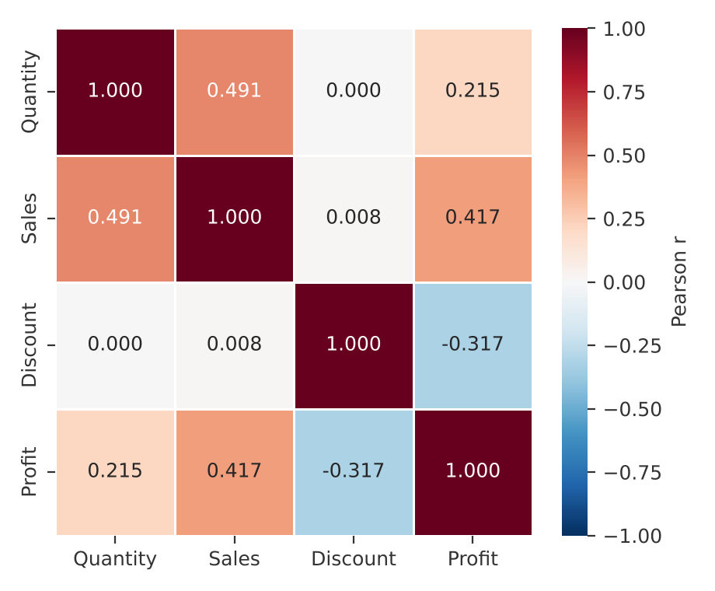
Figure 8. Correlation heatmap (Pearson r) for Quantity, Sales, Discount and Profit.
- Quantity and Sales: moderate positive association (r = 0.491).
- Sales and Profit: moderate positive association (r = 0.417).
- Discount and Profit: moderate negative association (r = -0.317).
- Quantity and Profit: weak positive association (r = 0.215).
- Discount and Sales: almost no linear association (r = 0.008).
These coefficients describe linear association only. Correlation does not prove causation, and the Pearson coefficient can be influenced by the extreme values and strong skewness identified in Section 4. Profit is likely to depend on other factors, such as product category and cost, that are not captured in this four-variable matrix. The negative Discount–Profit association supports the recommendation to monitor discounts alongside profitability, but it does not show that discounts caused lower profit.

10. Feature Engineering
Feature engineering added new columns to both the customer-level and transaction-level datasets. The purpose was to make behavioural and time-based information directly available for later segmentation and analysis.

10.1 Customer-level Features
Recency_Group divides customers by time since their last order. The three groups with Recency ≤ 365 days together contain the 7,647 Active customers, and the fourth group contains the 9,768 Inactive customers. The group names are analytical labels and have not been validated against actual customer outcomes.
Table 9. Recency_Group distribution
Recency_Group | Customers | Share
Recent (0–90 days) | 2,814 | 16.2%
Cooling (91–180 days) | 2,053 | 11.8%
At Risk (181–365 days) | 2,780 | 16.0%
Inactive (>365 days) | 9,768 | 56.1%
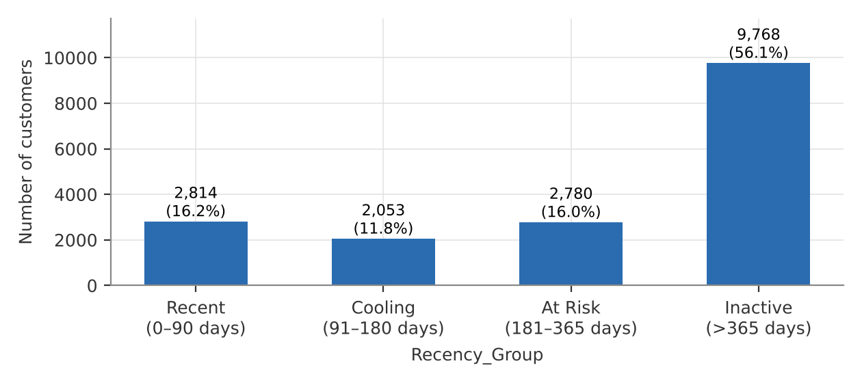
Figure 9. Number of customers in each Recency_Group.
Frequency_Group classifies customers by number of unique orders. A large majority of customers (68.8%) placed only one order.
Table 10. Frequency_Group distribution
Frequency_Group | Customers | Share
One-time (1 order) | 11,979 | 68.8%
Two orders | 3,467 | 19.9%
Frequent (3+ orders) | 1,969 | 11.3%
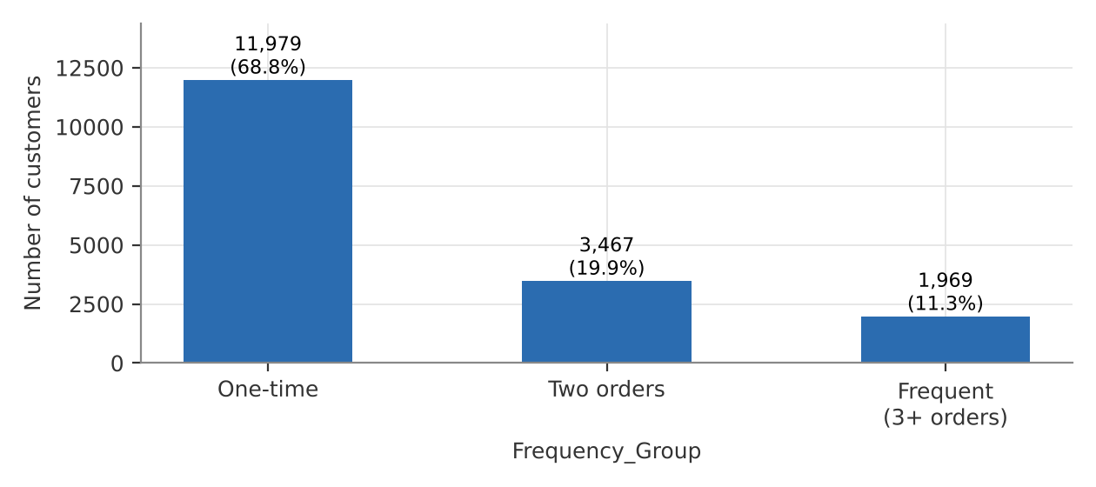
Figure 10. Number of customers in each Frequency_Group.
Spending_Group was created using pandas.qcut on customer Monetary values. These groups are relative spending quartiles and not fixed monetary thresholds; each group contains roughly a quarter of customers by construction, and the boundaries depend on the distribution of this particular dataset.
Table 11. Spending_Group distribution (relative quartiles)
Spending_Group | Customers | Share
Low | 4,386 | 25.2%
Medium | 4,340 | 24.9%
High | 4,336 | 24.9%
Very High | 4,353 | 25.0%
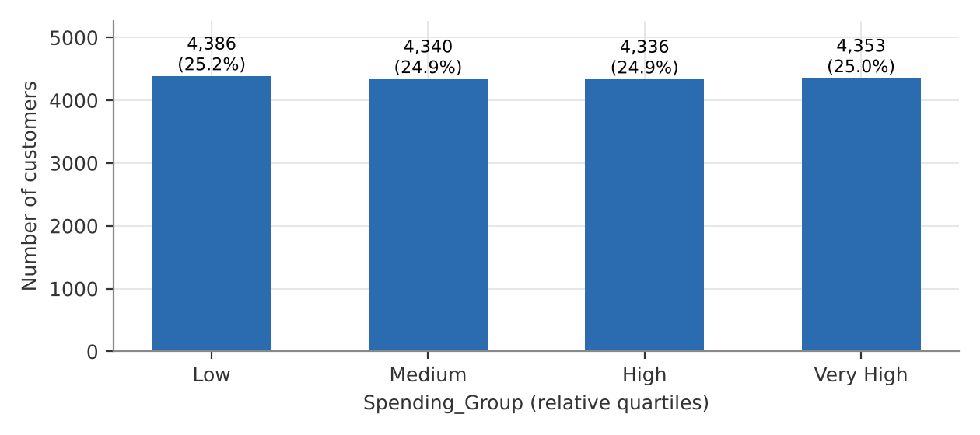
Figure 11. Number of customers in each Spending_Group (relative quartiles of Monetary value).
Code 5. Customer-level engineered features
cust["Recency_Group"] = pd.cut(
cust["Recency"], bins=[-1, 90, 180, 365, np.inf],
labels=["Recent (0-90)", "Cooling (91-180)", "At Risk (181-365)", "Inactive (>365)"])

cust["Frequency_Group"] = np.select(
[cust["Frequency"] == 1, cust["Frequency"] == 2],
["One-time", "Two orders"], default="Frequent (3+ orders)")

cust["Spending_Group"] = pd.qcut(
cust["Monetary"], q=4, labels=["Low", "Medium", "High", "Very High"])

for col in ["Recency_Group", "Frequency_Group", "Spending_Group"]:
print(cust[col].value_counts().sort_index(), "\n")

10.2 Transaction-level Features
Table 12. Transaction-level features added
Feature | Definition | Possible use
Order_Month | Month extracted from Order Date | Seasonal analysis
Order_Quarter | Quarter extracted from Order Date | Seasonal and quarterly reporting
Order_Year | Year extracted from Order Date | Yearly trend analysis
Profit_Margin_Pct | Profit / Sales × 100 | Profitability comparison
Sales_Per_Unit | Sales / Quantity | Price-level and product-mix analysis

Sales has a minimum of 2 and Quantity a minimum of 1 in this dataset, so neither calculated feature involves division by zero. Together, the time-based features may support seasonal analysis, the customer-level groups may support segmentation, and the margin and unit-price features may support profitability analysis. No model was trained, so this report makes no claim that these features improve model accuracy; their value for prediction would need to be tested separately.
Code 6. Transaction-level engineered features
df["Order_Month"] = df["Order Date"].dt.month
df["Order_Quarter"] = df["Order Date"].dt.quarter
df["Order_Year"] = df["Order Date"].dt.year
df["Profit_Margin_Pct"] = df["Profit"] / df["Sales"] * 100
df["Sales_Per_Unit"] = df["Sales"] / df["Quantity"]

11. Final Validation
Both final datasets were validated for missing values and duplicate rows and then saved as new files. The original Week 3 datasets were not overwritten.
Table 13. Final validation of the engineered datasets
Dataset | Shape (rows × columns) | Missing | Duplicates | Saved file
Customer dataset | 17,415 × 12 | 0 | 0 | week4_customer_features.csv
Transaction dataset | 51,290 × 27 | 0 | 0 | week4_transaction_features.csv
Code 7. Validation and saving
for name, d in [("customer", cust), ("transaction", df)]:
print(name, d.shape, d.isna().sum().sum(), d.duplicated().sum())

cust.to_csv("week4_customer_features.csv", index=False)
df.to_csv("week4_transaction_features.csv", index=False)

12. Summary of Key Findings
Table 14. Summary of key descriptive findings
Area | Finding
Data quality | No missing values, duplicates or invalid dates; potential outliers retained after review.
Distributions | All four numerical features are right-skewed; Sales is the most skewed (6.40).
Trends | Sales grew about 91% from 2020 to 2023; profit fell about 12.2% in 2023 while sales rose about 23.8%.
Categories | Body care leads sales; Face care has the highest margin (35.68%); Home and Accessories has negative profit; Hair care margin is 0.36%.
Markets | Asia Pacific has the highest sales; Europe has the highest profit and margin; Africa has the lowest sales.
Customers | Active customers purchase more often and spend more in total; average order value is nearly equal.
Correlation | Discount and Profit are moderately negatively correlated (-0.317); Sales and Profit moderately positively (0.417).
Engineered features | Recency, Frequency and Spending groups plus five transaction-level features were added.

13. Recommendations
The following recommendations follow from the descriptive results. They propose areas for further investigation and are not conclusions about causes.
- Investigate profitability in Home and Accessories and Hair care. Examine pricing, costs and discounting for these two categories, which account for a large share of sales but little or negative profit.
- Review the decline in profit in 2023 despite higher sales. Analyse discounts, costs and product mix by year to understand the change in margin.
- Explore repeat-purchase strategies for one-time buyers. One-time customers form the largest Frequency_Group, so even small improvements in repeat purchasing could be valuable.
- Investigate reactivation opportunities for inactive customers. Use the Recency_Group labels to study customers in the Cooling and At Risk stages before they pass the 365-day threshold.
- Monitor discounts alongside profitability. Given the moderate negative Discount–Profit correlation, track both together rather than discount volume alone.
- Use the engineered features in future analysis and in carefully designed predictive modelling, with appropriate validation, and with attention to the skewed distributions noted in Section 4.

14. Limitations
- The dataset is observational, so correlations and group differences do not establish causation.
- Activity status is only a recency-based proxy and does not confirm customer churn.
- No churn prediction model was built, and no model validation was performed.
- The findings depend on the available historical dataset (2020–2023) and may not generalise to other periods or businesses.
- The drivers of profitability, including the 2023 decline and the weak margins in some categories and markets, require further investigation.
- Monthly trend values and the raw-data histograms and boxplots are not reproduced in this report; placeholders and code are provided instead.

15. Conclusion
This week's work completed an exploratory analysis and feature engineering stage on 51,290 transaction rows from 17,415 customers. The data were confirmed to be complete and free of duplicates, the numerical features were found to be strongly right-skewed, and potential outliers were retained after business-context review. The analysis showed steady growth in sales and orders from 2020 to 2023, a fall in profit in 2023 despite higher sales, large differences in profit margin between categories and markets, and higher purchase frequency among recently active customers.
Customer-level and transaction-level features were engineered and validated, and two new datasets were saved without overwriting earlier work. These datasets provide a documented foundation for further segmentation, profitability and seasonal analysis, and for carefully designed predictive modelling in later work. The results here are descriptive; the causes behind them remain to be investigated.

References
Hunter, J. D. (2007). Matplotlib: A 2D graphics environment. Computing in Science & Engineering, 9(3), 90–95. https://doi.org/10.1109/MCSE.2007.55
McKinney, W. (2010). Data structures for statistical computing in Python. In Proceedings of the 9th Python in Science Conference (pp. 56–61). https://doi.org/10.25080/Majora-92bf1922-00a
Waskom, M. L. (2021). seaborn: Statistical data visualization. Journal of Open Source Software, 6(60), Article 3021. https://doi.org/10.21105/joss.03021
xanhnguyen186. (n.d.). Beauty-Ecommerce-Analytics [Data set and source code]. GitHub. https://github.com/xanhnguyen186/Beauty-Ecommerce-Analytics

