WEEK 4 ANALYTICAL REPORT
Exploratory Data Analysis, Statistical Testing & Feature Engineering
Data Science with Python Analyst Internship
Global Beauty & Wellness E-commerce Transactions
Analysis period: 1 January 2020 – 31 December 2023
Prepared by: Honey Verma
Submission version: Revised analytical report

Executive Summary
This report presents an exploratory and business-focused analysis of a global beauty and wellness e-commerce transaction dataset. The transaction table contains 51,290 line-level records, 17,415 unique customers and 25,728 unique orders covering 2020–2023. The work combines data validation, descriptive statistics, distribution and boxplot review, time-based performance analysis, category and market profitability comparisons, customer activity analysis, non-parametric statistical testing, correlation analysis and engineered features.
The most important business signal is a divergence between growth and profitability in 2023: sales rose 23.82% year over year, while profit declined 12.16%. Home and Accessories had a negative overall margin of −4.59%, and Hair care was close to break-even at 0.36%. Face care and Make up showed the highest observed category margins, at 35.68% and 32.91%, respectively. Europe had the highest observed market margin (22.30%), whereas Asia Pacific had the highest sales among the listed markets but a lower margin (12.49%).
At customer level, 9,768 of 17,415 customers (56.09%) were labelled inactive under the project's recency rule (last purchase more than 365 days ago), and 11,979 (68.79%) were one-time buyers. These are descriptive retention indicators, not a validated churn model. Mann–Whitney U tests found statistically significant differences between active and inactive groups for six customer metrics (all p < .001). Statistical significance should be interpreted alongside effect size, practical impact and the large sample size.
The report recommends investigating category-level costs and pricing, reviewing discount policies, examining the 2023 profit decline, testing targeted win-back and repeat-purchase campaigns, and monitoring margin—not sales alone. The dataset contains no direct evidence establishing the cause of the profit decline; further product-, discount-band-, cost- and return-level analyses are needed before causal conclusions are drawn.

1. Objectives
- Validate the integrity, coverage and structure of the transaction and customer-level datasets.
- Describe the distributions and variability of Quantity, Sales, Discount and Profit.
- Compare annual performance, product-category performance and market-level profitability.
- Compare customer activity groups using descriptive summaries and Mann–Whitney U tests.
- Engineer interpretable customer and transaction features for subsequent analytics.
- Translate observed patterns into cautious, testable business recommendations.

2. Dataset Description and Scope
The analysis uses the public Beauty E-commerce Analytics repository, which describes a global beauty/skincare e-commerce dataset with transaction-line-level records and fields for orders, customers, geography, product hierarchy, quantity, sales, discount and profit. The local transaction dataset used in this analysis contains the following fields.
Dataset | Rows × columns | Key content
Transaction-level | 51,290 × 19 before engineering; 51,290 × 27 after engineering | Order/customer identifiers, dates, segment, geography, product/category, quantity, sales, discount and profit.
Customer-level | 17,415 × 9 before engineering; 17,415 × 12 after engineering | Recency, frequency, monetary value, quantity, profit, discount, average order value and activity status.

The transaction table spans 2020-01-01 to 2023-12-31. It is important to distinguish a transaction-line row from an order: a single order can contain multiple product lines. Accordingly, transaction counts and unique order counts are not interchangeable.

3. Data Quality and Preparation
Validation check | Transaction dataset | Customer dataset
Shape before feature engineering | 51,290 × 19 | 17,415 × 9
Missing values | 0 | 0
Duplicate rows | 0 | 0
Unique customers | 17,415 | 17,415 customer IDs
Unique orders | 25,728 | Not applicable as a customer-level grain
Date validation | Order Date parsed to datetime; no invalid dates reported | Recency feature available

No imputation was required for the observed missing-value check. The Order Date field was converted to datetime to enable monthly and yearly grouping. Negative profit observations were retained because they can represent genuine loss-making transactions; deleting them would bias profitability analysis. The maximum observed discount was 0.85, and maximum quantity was 20, so unusually large values were flagged for review rather than automatically removed. A zero missing-value count does not by itself prove that all values are semantically correct.

4. Methodology
- Data profiling: row/column counts, unique customer/order counts, missingness, duplicate rows, date coverage and data types.
- Descriptive statistics: count, mean, standard deviation, minimum, quartiles, median and maximum; additional skewness, kurtosis, variance and mode checks.
- Outlier screening: the 1.5 × IQR rule was used to flag potential outliers. Flags are diagnostic and do not automatically imply errors.
- Time analysis: annual and monthly aggregations of sales, profit and unique orders; year-over-year percentage change was calculated for annual comparisons.
- Profitability: category and market sales, profit, average discount, transaction/order/customer counts and profit margin. Margin was calculated as total profit divided by total sales, multiplied by 100.
- Customer comparison: Mann–Whitney U tests compared active and inactive customer distributions for six metrics because the metrics were skewed and median summaries were informative.
- Feature engineering: recency/frequency/spending groups, order month/quarter/year, profit margin percentage and sales per unit.
- Correlation: Pearson correlation coefficients were inspected for numeric transaction features. Correlation is associative and does not establish causality.

5. Exploratory Data Analysis

5.1 Numerical distributions
Metric | Mean | Median | Std. dev. | Skewness | Kurtosis | IQR
Quantity | 5.416 | 4.000 | 4.908 | 1.469 | 1.196 | 5
Sales | 127.075 | 56.000 | 236.075 | 6.402 | 60.608 | 107
Discount | 0.143 | 0.000 | 0.212 | 1.388 | 0.717 | 0.2
Profit | 20.772 | 7.200 | 83.583 | 3.955 | 99.842 | 25

Sales is strongly right-skewed: the mean (127.075) is well above the median (56), and skewness is 6.402. This suggests that a relatively small number of high-value lines influence the average. Profit is also strongly right-skewed and heavy-tailed, with a minimum of −1,746 and maximum of 1,820; the median profit is only 7.2. The discount median is zero, indicating that at least half of line-level observations have no discount. Quantity has a mean of 5.416 and median of 4, with a maximum of 20.
The IQR rule flagged 4,604 Quantity rows (8.98%), 5,126 Sales rows (9.99%), 4,172 Discount rows (8.13%) and 7,740 Profit rows (15.09%). These counts should be interpreted as potential outliers, not confirmed data errors. The appropriate next step is to inspect records by product, order, discount and cost context before deciding whether to correct, cap or retain them.
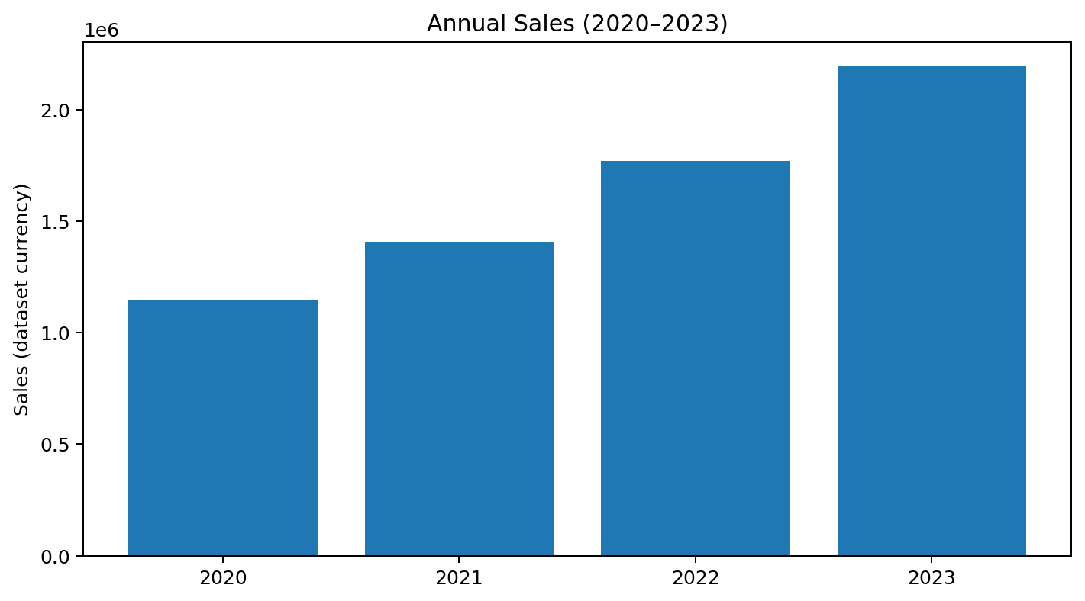
Figure 1. Annual sales using the verified annual totals.
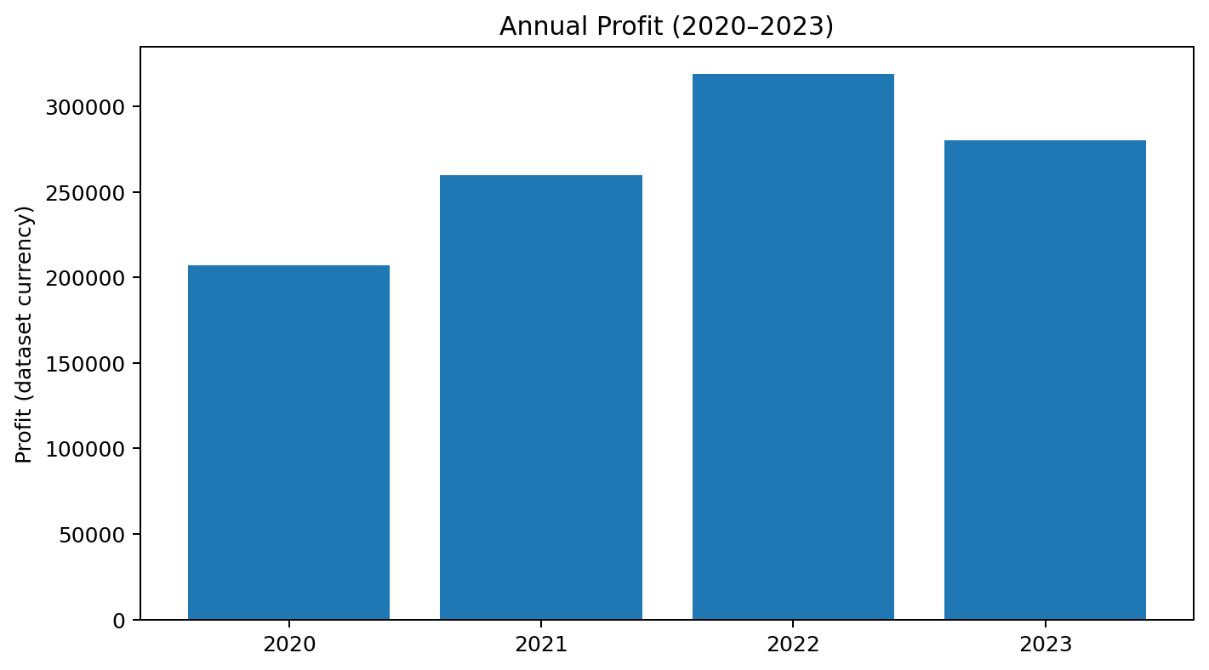
Figure 2. Annual profit using the verified annual totals.
The notebook's original distribution files are also part of the analysis: week4_numerical_distributions.png and week4_numerical_boxplots.png. Their intended interpretation is to show the skewness and extreme values described above. They are listed in the deliverables section for inclusion alongside the report if required by the evaluator.

5.2 Annual performance
Year | Total sales | Total profit | Unique orders | Sales growth | Profit growth | Order growth
2020 | 1,148,361 | 207,116.12 | 4,515 | — | — | —
2021 | 1,405,876 | 259,696.96 | 5,473 | 22.42% | 25.39% | 21.22%
2022 | 1,770,790 | 318,671.89 | 6,883 | 25.96% | 22.71% | 25.76%
2023 | 2,192,647 | 279,928.68 | 8,857 | 23.82% | −12.16% | 28.68%

Sales increased each year, from 1.148 million in 2020 to 2.193 million in 2023—approximately 91% growth over the full period. Unique orders also rose each year, reaching 8,857 in 2023. However, profit peaked in 2022 at 318,671.89 and fell to 279,928.68 in 2023. This is the clearest management signal in the analysis: growth in sales and order volume did not translate into higher total profit in 2023.
Possible explanations include changes in product mix, deeper discounts, costs, fulfilment, returns or the mix of markets/customers, but the current summary does not establish which factor caused the decline. The next analysis should decompose the profit change by category, product, discount band and market, then compare like-for-like periods. Monthly trend charts (week4_monthly_trends.png) should be checked for seasonality and unusual months; monthly peaks alone do not establish a recurring seasonal effect.

5.3 Category performance and profitability
Category | Sales | Profit | Avg. discount | Transactions | Profit margin
Body care | 2,682,942 | 590,907.78 | 0.15 | 21,062 | 22.02%
Home and Accessories | 1,245,643 | −57,187.64 | 0.14 | 9,516 | −4.59%
Make up | 1,121,222 | 368,998.18 | 0.13 | 9,017 | 32.91%
Hair care | 1,022,151 | 3,677.23 | 0.14 | 8,203 | 0.36%
Face care | 445,716 | 159,018.10 | 0.11 | 3,492 | 35.68%

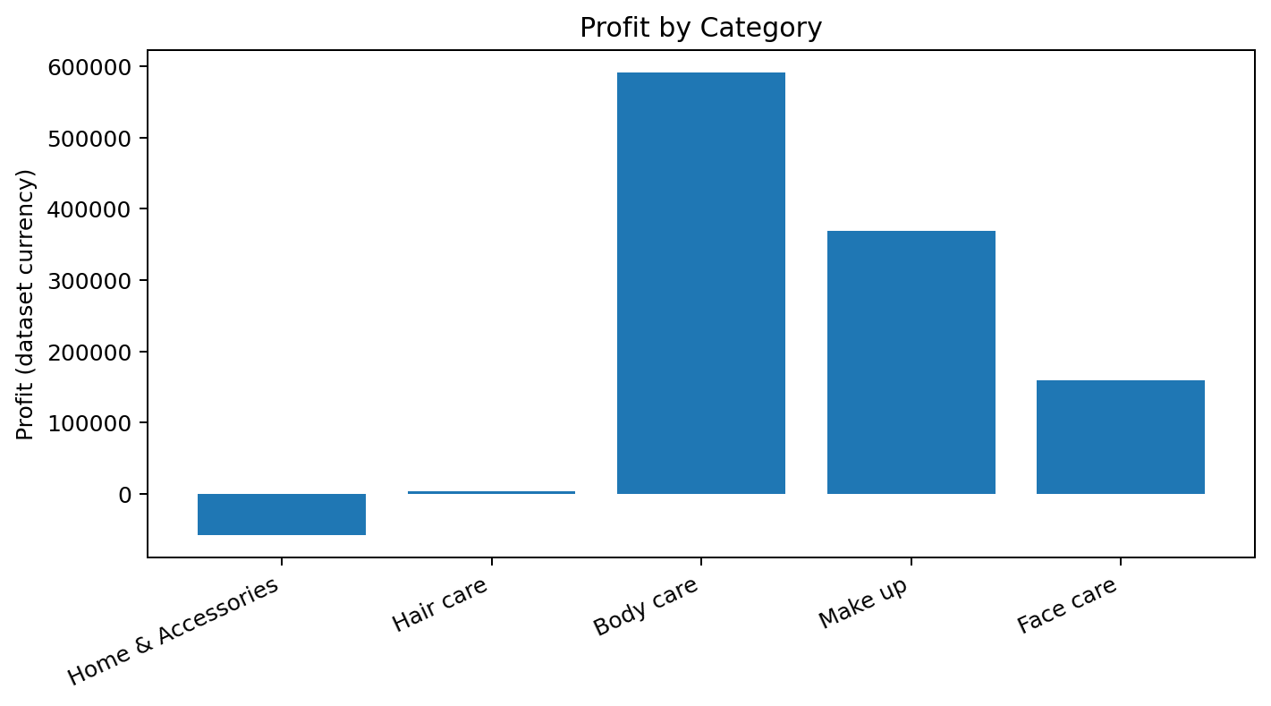
Figure 3. Profit by category.
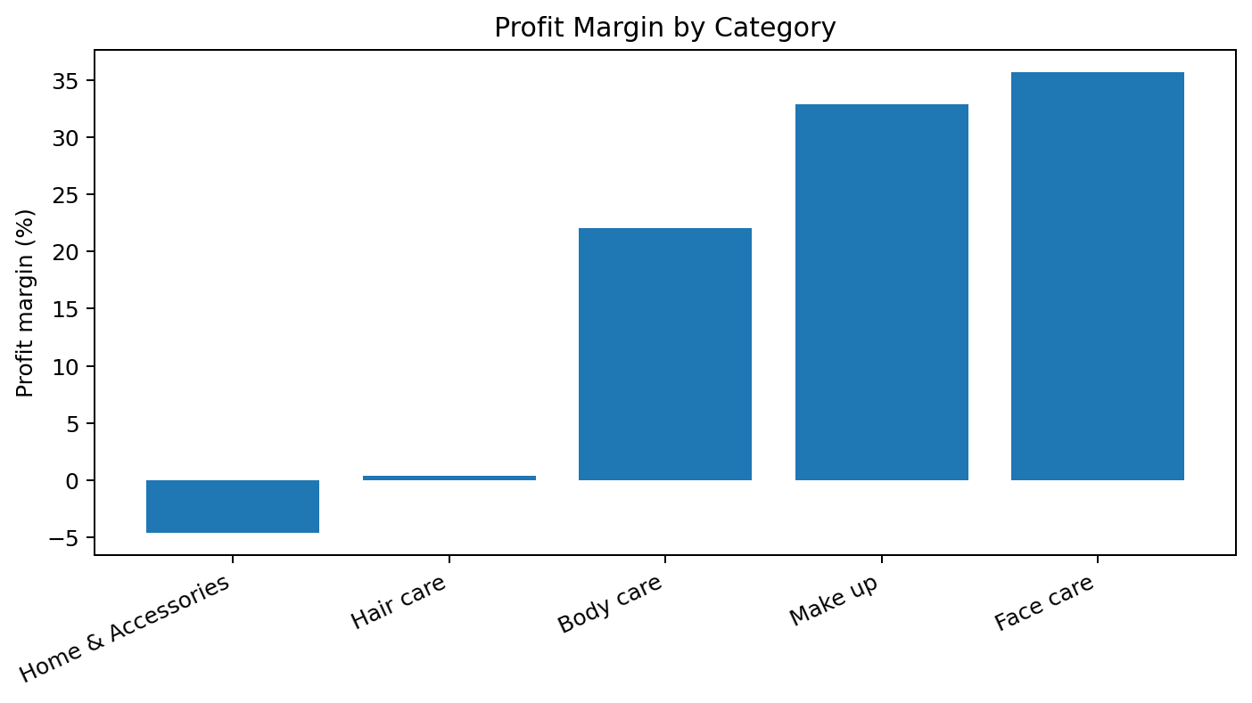
Figure 4. Profit margin by category.
Body care contributes the largest sales and profit totals in this dataset. Face care has the highest margin (35.68%) among the listed categories, followed by Make up (32.91%). These margins are promising but should be validated at product/SKU level, including volume and cost assumptions. Home and Accessories is loss-making in aggregate, with −57,187.64 profit and a −4.59% margin. Hair care generates positive profit but has a 0.36% margin, leaving little room for cost increases or promotional errors.
Recommended diagnostic: for Home and Accessories and Hair care, break down profit by product, discount band, market and order size. Compare the proportion of loss-making lines and the contribution of high-loss items. Do not assume discounting is the sole cause from average-discount summaries alone.

5.4 Market performance
Market | Sales | Profit | Avg. discount | Transactions | Unique orders | Unique customers | Margin
Asia Pacific | 1,831,648 | 228,742.59 | 0.18 | 14,302 | 7,080 | 4,941 | 12.49%
Africa | 486,811 | 66,213.45 | 0.16 | 4,587 | 2,288 | 2,055 | 13.60%
LATAM | 1,339,726 | 216,042.79 | 0.14 | 10,294 | 5,144 | 3,702 | 16.13%
USCA | 1,372,045 | 222,770.12 | 0.15 | 10,378 | 5,203 | 2,682 | 16.24%
Europe | 1,487,444 | 331,644.70 | 0.09 | 11,729 | 6,013 | 4,035 | 22.30%

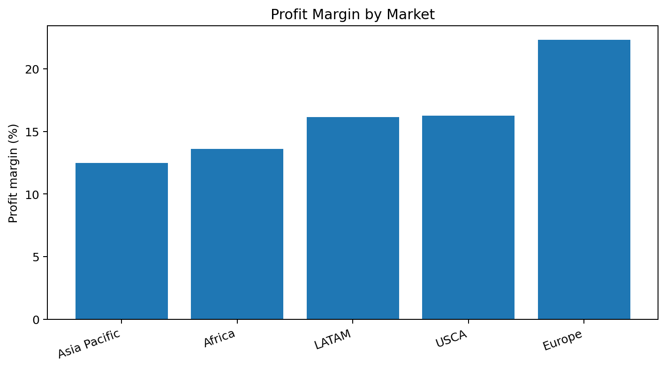
Figure 5. Profit margin by market.
Asia Pacific has the highest sales among these markets (1,831,648) and the largest transaction count, but its margin is 12.49%, the lowest of the five listed markets. Europe has the highest observed margin (22.30%) and the largest profit total (331,644.70), despite sales below Asia Pacific. Europe also has the lowest average discount (0.09) in the summary. These are associations, not proof that discount differences explain margin differences. Market-level cost structures, product mix and order economics should be checked before changing regional strategy.

5.5 Customer activity and retention indicators
Indicator | Count | Share
All customers | 17,415 | 100.00%
Inactive (recency > 365 days) | 9,768 | 56.09%
Active (recency ≤ 365 days) | 7,647 | 43.91%
One-time buyers | 11,979 | 68.79%
Frequent buyers (3+ orders) | 1,969 | 11.31%

Metric | Active mean | Inactive mean
Recency (days) | 143.92 | 791.40
Frequency | 1.75 | 1.27
Monetary | 442.42 | 320.90
Total quantity | 18.89 | 13.65
Total profit | 66.20 | 57.25
Average discount | 0.14 | 0.15
Average order value | 250.47 | 251.10

The activity label is defined by recency: customers with a last-purchase recency of 365 days or less are Active; those above 365 days are Inactive. It is a practical inactivity proxy, not a validated prediction of churn or customer intent. The 56.09% inactive share and 68.79% one-time-buyer share suggest opportunities to test reactivation and second-purchase interventions. Active customers show higher mean frequency, monetary value, quantity and profit in the supplied summary. Average order value is similar between groups, so retention work may be more focused on purchase frequency than on increasing basket value alone.

5.6 Statistical testing: Active versus inactive customers
Six Mann–Whitney U tests were performed to compare active and inactive customer groups. The test is a non-parametric method for comparing independent samples and is suitable for skewed data when the analysis is focused on differences in rank distributions. The null hypothesis for each metric was that the two groups have the same distribution/location; the alternative was that they differ. A two-sided significance threshold of α = .05 was used.
Metric | Active median | Inactive median | U statistic | Reported p-value
Frequency | 1.00 | 1.00 | 47,359,431.0 | < .001
Monetary | 212.00 | 144.00 | 42,647,513.5 | < .001
Total quantity | 11.00 | 8.00 | 43,139,228.0 | < .001
Total profit | 24.164 | 19.85 | 38,544,338.0 | 0.000279
Average discount | 0.05 | 0.00 | 39,170,399.0 | < .001
Average order value | 131.50 | 123.00 | 38,684,567.0 | 0.000049

All six p-values are below .05, so the null hypothesis is rejected for each metric at the selected threshold. Values displayed as 0.000000 in the notebook are rounded small numbers, not literal zero probabilities; they are reported here as p < .001 where appropriate. Median differences are evident for Monetary, Total quantity, Total profit, Average discount and Average order value. Frequency medians are both 1.00 despite a significant test, which can happen when distributions contain many tied/low values and differ elsewhere in their ranks.
Caution: statistical significance is not the same as business importance, particularly with thousands of customers. Effect sizes and confidence intervals should be added in a later revision, and a multiple-testing correction was not applied to this set of six tests. The activity definition itself is based on recency, so the group comparison is descriptive and should not be interpreted as independent proof that inactivity causes lower spending.

6. Feature Engineering

6.1 Customer-level features
Feature | Definition / use
Recency | Days since the customer's latest observed purchase; lower values indicate more recent activity.
Frequency | Number of distinct orders associated with the customer.
Monetary | Aggregated customer sales value in the source feature pipeline.
Total_Quantity | Total quantity across the customer's observed transaction lines.
Total_Profit | Aggregated profit across the customer's observed transaction lines.
Avg_Discount | Average discount across observed transaction lines.
Average_Order_Value | Customer-level average order value derived in the pipeline.
Activity_Status | Active if Recency ≤ 365 days; otherwise Inactive.
Recency_Group | Recent (0–90 days), Cooling (91–180), At Risk (181–365), Inactive (>365).
Frequency_Group | One-time (≤1 order), Two orders, Frequent (3+ orders).
Spending_Group | Rank-based quartile groups labelled Low, Medium, High and Very High.

The resulting customer feature table contains 17,415 rows and 12 columns, with one unique row per customer, no duplicate rows and no missing values. Recency groups contained 2,814 Recent, 2,053 Cooling, 2,780 At Risk and 9,768 Inactive customers. Frequency groups contained 11,979 One-time, 3,467 Two orders and 1,969 Frequent customers. Spending quartiles were balanced at approximately 4,353–4,354 customers each because ranking was used before quartile assignment.

6.2 Transaction-level features
Feature | Definition | Potential analytical use
Order_Month | Month extracted from Order Date | Monthly seasonality and campaign comparison.
Order_Quarter | Quarter extracted from Order Date | Quarterly planning and performance monitoring.
Order_Year | Year extracted from Order Date | Year-over-year comparisons.
Profit_Margin_Pct | (Profit / Sales) × 100 | Line-level margin diagnostics; review negative and extreme values.
Sales_Per_Unit | Sales / Quantity | Approximate sales per unit for product/price comparisons.

The engineered transaction table contains 51,290 rows and 27 columns. Validation reported zero missing values, zero duplicate rows and no invalid profit-margin or sales-per-unit values. Since Sales is positive in the supplied descriptive statistics and Quantity ranges from 1 to 20, the divisions were valid for the observed data. Derived features should still be checked for extreme values and should not be used as predictors if they leak information from a target variable in a future predictive model.

7. Correlation Analysis
Feature pair | Correlation (r) | Interpretation
Sales – Sales_Per_Unit | 0.639 | Strongest positive correlation in the reported matrix.
Quantity – Sales | 0.491 | Higher quantities tend to be associated with higher sales.
Sales – Profit | 0.417 | Higher sales tend to be associated with higher profit, but the relationship is not perfect.
Profit – Profit_Margin_Pct | 0.416 | Positive association, partly mathematical because margin includes profit.
Profit – Discount | −0.317 | Moderate negative association in the observed line-level data.
Discount – Profit_Margin_Pct | −0.766 | Strong negative association; inspect calculation and business context before inferring impact.

Correlation coefficients summarize linear association and do not establish causal relationships. Profit margin is calculated using Profit, so correlations between profit and margin are partly induced by the formula. The strong negative discount–margin correlation is a useful investigation lead, but it can also reflect product mix, pricing and how the source data calculates profit. A more defensible follow-up would compare margin by discount band while controlling or stratifying for category, product, market and time.
The notebook generated week4_correlation_heatmap.png to visualize the complete correlation matrix. The heatmap should be included in the submission package with its caption and the caveats above.

8. Business Insights and Hypothetical Scenarios

Scenario A: Home and Accessories profitability review
Observed evidence: the category generated sales of 1,245,643 but a total loss of 57,187.64 and margin of −4.59%. Hypothetical response: the business team selects the ten products with the largest total losses, reviews landed costs, discounting, returns and fulfilment charges, then tests revised pricing or reduced promotions on a small eligible subset. Success metrics: contribution profit, margin, conversion rate and units sold. The test should include a comparison group so that changes are not attributed to the intervention without evidence.

Scenario B: 2023 sales growth with declining profit
Observed evidence: sales increased 23.82% and unique orders increased 28.68%, but total profit fell 12.16%. Hypothetical response: finance and analytics build a year-over-year profit bridge by category, market, product and discount band. They separate changes in volume, selling price, product mix and unit economics. Success metrics: profit per order, weighted margin, loss-making line share and total profit. No single cause should be declared until the bridge explains the decline.

Scenario C: One-time-buyer conversion
Observed evidence: 68.79% of customers are one-time buyers. Hypothetical response: test a post-purchase reminder or relevant replenishment offer among eligible first-time buyers, using a randomized holdout group. Measure second-purchase conversion, incremental gross profit, time to second purchase and unsubscribe/complaint rate. A discount should not be the default incentive because profitability already needs investigation.

Scenario D: Inactive-customer win-back
Observed evidence: 56.09% of customers have a recency above 365 days. Hypothetical response: segment inactive customers by historic monetary value and product category, then test a tailored win-back message. Exclude customers with insufficient contact permissions according to the business's own policy; this dataset does not contain evidence about consent or lawful basis. Evaluate incremental reactivation and profit against a holdout.

Scenario E: Market-level margin monitoring
Observed evidence: Europe has a 22.30% margin while Asia Pacific has the highest sales but a 12.49% margin. Hypothetical response: compare product mix, shipping/cost structures, discount bands and customer cohorts across markets before reallocating budget. Track margin and incremental profit alongside sales and order growth.

9. Recommendations
- Investigate the 2023 profit decline first. Create a profit bridge by category, product, market and discount band; validate cost, return and fulfilment fields if available.
- Prioritize Home and Accessories for product-level profitability diagnosis because its aggregate margin is negative.
- Review Hair care products close to break-even; avoid blanket actions until product-level evidence identifies the loss drivers.
- Design controlled experiments for second-purchase and win-back initiatives; evaluate incremental profit, not only response rate or revenue.
- Monitor weighted profit margin, profit per order, loss-making product share, repeat-purchase rate and inactive-customer share in a recurring dashboard.
- Use Europe’s higher observed margin as a hypothesis for further analysis, not an automatic budget-allocation decision; account for scale, costs and product/customer mix.
- Add effect sizes, confidence intervals and a multiple-testing correction to future statistical reporting.
- Preserve valid extreme observations unless a documented data-quality investigation confirms errors; provide sensitivity analysis with and without extreme values when appropriate.

10. Limitations
- The report is based on observational transaction data; it cannot prove that discounts or any other factor caused profit changes.
- The activity status is a rule-based recency proxy and is not a validated churn label or predictive model.
- The dataset summary does not include all possible cost, return, marketing exposure or customer-contact variables needed to explain profitability and retention.
- Large sample sizes can produce small p-values for modest differences; effect sizes and confidence intervals were not included in the supplied output.
- Six statistical tests were performed without a multiple-comparison adjustment.
- The Pearson correlation matrix describes linear relationships and may be influenced by skewed values and formula-derived variables.
- Outliers were flagged using the IQR rule but were not independently verified as errors. Their business validity should be checked.
- Currency is described as USD in the public repository. All monetary values in this report follow the dataset's reported units; the currency convention should be confirmed before external business use.

11. Conclusion
The Week 4 analysis progressed from dataset validation to exploratory analysis, statistical comparison, feature engineering and business recommendations. The data is complete under the reported missingness and duplicate checks, and the engineered files passed the stated structural validations. The key findings are that sales and order volume increased across the period, 2023 profit declined despite sales growth, Home and Accessories is loss-making in aggregate, Europe has the highest observed market margin, and a large share of customers is one-time or inactive under the project's definitions.
The strongest next step is not to make unsupported causal claims but to perform targeted follow-up analyses: product-level loss diagnosis, discount-band comparisons stratified by category and market, and controlled retention experiments. This approach connects statistical evidence to measurable business decisions while acknowledging the limits of observational data.

12. Deliverables and Figure Inventory
File / figure | Purpose
week4_numerical_distributions.png | Histogram/KDE view of Quantity, Sales, Discount and Profit.
week4_numerical_boxplots.png | Boxplots to review spread and potential extreme observations.
week4_monthly_trends.png | Monthly sales, profit and order trends.
week4_yearly_comparison.png | Annual performance comparison.
week4_category_performance.png | Category-level performance comparison.
week4_market_performance.png | Market-level performance comparison.
week4_customer_activity_analysis.png | Active versus inactive customer summaries.
week4_correlation_heatmap.png | Correlation matrix for numerical and engineered variables.
week4_market_profitability_risk.png | Market profitability risk view.
week4_customer_features.csv | Validated customer-level engineered features; 17,415 × 12.
week4_transaction_features.csv | Validated transaction-level engineered features; 51,290 × 27.
week4_category_risk_analysis.csv | Category profitability summary.
week4_market_risk_analysis.csv | Market profitability summary.
week4_business_insights.csv | Concise findings, implications and recommended actions.

The five annual/category/market charts embedded in this Word report were recreated only from the verified summary values shown in the analysis outputs. The original nine notebook figures and exported CSVs should be submitted alongside this report if the internship portal accepts supporting files.

References
Heckert, N. A., & Filliben, J. J. (2003). NIST/SEMATECH e-Handbook of Statistical Methods: Chapter 1—Exploratory data analysis. National Institute of Standards and Technology. https://www.nist.gov/publications/nistsematech-e-handbook-statistical-methods-chapter-1-exploratory-data-analysis
National Institute of Standards and Technology. (n.d.). Do two arbitrary processes have the same central tendency? In NIST/SEMATECH e-Handbook of Statistical Methods. https://itl.nist.gov/div898/handbook/prc/section3/prc35.htm
xanhnguyen186. (n.d.). Beauty-Ecommerce-Analytics [Data and project repository]. GitHub. https://github.com/xanhnguyen186/Beauty-Ecommerce-Analytics

Appendix A. Statistical reporting notes
A p-value below .05 indicates that the observed data would be unusual under the specified null model, given the test assumptions; it does not quantify the probability that the null hypothesis is true. The values shown as 0.000000 in the notebook are rounded outputs. In narrative reporting they are represented as p < .001 rather than p = 0. The Mann–Whitney U test is rank-based and is not strictly a test of medians unless additional distribution-shape assumptions are reasonable.

Appendix B. Reproducibility checklist
- Confirm the transaction and customer CSV filenames match those used in the notebook.
- Keep the nine original PNG figures with the report when submitting supporting evidence.
- Retain negative-profit records unless a verified correction is documented.
- Record Python/library versions and notebook execution date if the internship requires reproducibility metadata.
- Verify the currency and exact business definitions before using findings in a real business decision.

