WEEK 5 INTERNSHIP REPORT
Predictive Modeling and Algorithm Selection
Customer Retention in the Beauty & Wellness Industry

Internship: Data Science with Python Analyst
Organization: YuvaIntern
Project: Customer Churn Prediction and Retention Analysis
Reporting period: Week 5

Executive Summary
This report documents the predictive-modelling phase of a customer-retention project in the beauty and wellness e-commerce domain. Historical transaction records were transformed into customer-level behavioural features, a 90-day no-purchase outcome was defined, and Logistic Regression and Decision Tree classifiers were trained and compared. The source dataset contains 51,290 transaction rows, 17,415 customers, and 25,728 distinct orders from 1 January 2020 to 31 December 2023. Features were computed using transactions through 30 June 2023; purchases from 1 July through 28 September 2023 were used only to assign the outcome label.
The modelling sample contains 14,716 customers: 13,690 (93.03%) had no purchase during the future window and 1,026 (6.97%) made at least one purchase. Decision Tree achieved a test F1-score of 0.8191 for the majority churn class and five-fold mean F1 of 0.7842. However, retained-class F1 was only 0.18 and test ROC-AUC was 0.6183. These findings make the models useful as exploratory baselines, not production-ready churn systems.

1. Business Problem and Week 1 Alignment
The business problem is to identify customers who may not return to purchase in the near term so that a beauty and wellness retailer can prioritise retention activity. This aligns with the Week 1 project theme, “Customer Churn Prediction and Retention Analysis in the Beauty & Wellness Industry.” Predictions should support human and business decisions rather than automatically determine customer treatment.
In this project, churn is an operational label: a customer is labelled churned if no order is observed during the 90-day window after the cutoff. It does not prove permanent customer loss; a customer may purchase after the observation window. The definition should be confirmed with business stakeholders.

2. Dataset and Data Quality
Item | Observed result
Source transaction rows | 51,290
Columns | 19
Unique customers | 17,415
Unique orders | 25,728
Date range | 2020-01-01 to 2023-12-31
Missing values | 0
Duplicate rows | 0
Historical transactions through cutoff | 40,584
Future-window transactions | 4,634
Modelling customers | 14,716

The Order Date column was converted to datetime before filtering. Initial inspection found no missing values or duplicate rows. The target was created from the future observation window, while predictors were aggregated from historical transactions only, reducing the risk of target leakage.

3. Target Construction and Feature Engineering
Cutoff date: 30 June 2023. Future observation window: 1 July–28 September 2023, inclusive. Churn = 1 indicates zero unique orders during that window; Churn = 0 indicates one or more orders. The final label distribution was 93.03% churned and 6.97% retained.
Feature | Definition
Total_Transactions | Number of transaction rows before cutoff
Frequency | Number of unique orders before cutoff
Monetary | Sum of historical Sales
Total_Profit | Sum of historical Profit
Total_Quantity | Sum of historical Quantity
Avg_Discount | Mean discount across historical transaction rows
Avg_Sales | Mean sales value per transaction row
Unique_Categories | Number of distinct categories purchased
Recency | Days since last purchase as of 30 June 2023
Average_Order_Value | Monetary divided by Frequency

Customer ID was excluded because it is an identifier rather than a behavioural feature. Unique_Markets was removed because it equalled one for every customer and therefore carried no variation.

4. Model Selection Rationale

4.1 Logistic Regression
Logistic Regression was used as an interpretable binary-classification baseline. It models the probability of a binary outcome using a logistic function applied to a linear combination of predictors. StandardScaler was included in a scikit-learn Pipeline, and class_weight='balanced' was used to account for class imbalance. Strengths include simplicity and interpretability; limitations include difficulty capturing complex nonlinear relationships without feature engineering.

4.2 Decision Tree
Decision Tree was selected because it can model nonlinear splits and interactions and can yield understandable decision rules. The model used max_depth=5, min_samples_leaf=30, class_weight='balanced', and random_state=42. Depth and leaf constraints reduce tree complexity, although trees can still be unstable across samples.

5. Validation Strategy and Metrics
The data was split into 80% training (11,772 customers) and 20% testing (2,944 customers) using random_state=42 and stratify=y. Five-fold StratifiedKFold cross-validation was run on the training set. The held-out test set was not used to fit the models. This random holdout does not replace a temporal validation design that tests performance on later periods.
Metric | Interpretation
Accuracy | Overall proportion of correct predictions; potentially misleading with severe imbalance.
Precision | Among predicted positives, the share that are truly positive.
Recall | Among actual positives, the share identified by the model.
F1-score | Harmonic mean of precision and recall for a specified class.
ROC-AUC | Ranking/discrimination across thresholds; 0.5 is approximately random ranking.
Average precision | Summarises precision-recall performance; strongly influenced by class prevalence.

The F1 values below refer to the Churned class (label 1). Since churned customers form 93.03% of the sample, a high churn-class F1 does not mean that the model identifies retained customers well. For retention operations, minority-class metrics, lift, campaign capacity, and the costs of false positives and false negatives matter.

6. Held-Out Test Results
Model | Accuracy | Precision (Churn) | Recall (Churn) | F1 (Churn) | ROC-AUC | Average Precision
Logistic Regression | 0.6525 | 0.9450 | 0.6652 | 0.7808 | 0.5863 | 0.9460
Decision Tree | 0.7038 | 0.9486 | 0.7207 | 0.8191 | 0.6183 | 0.9496

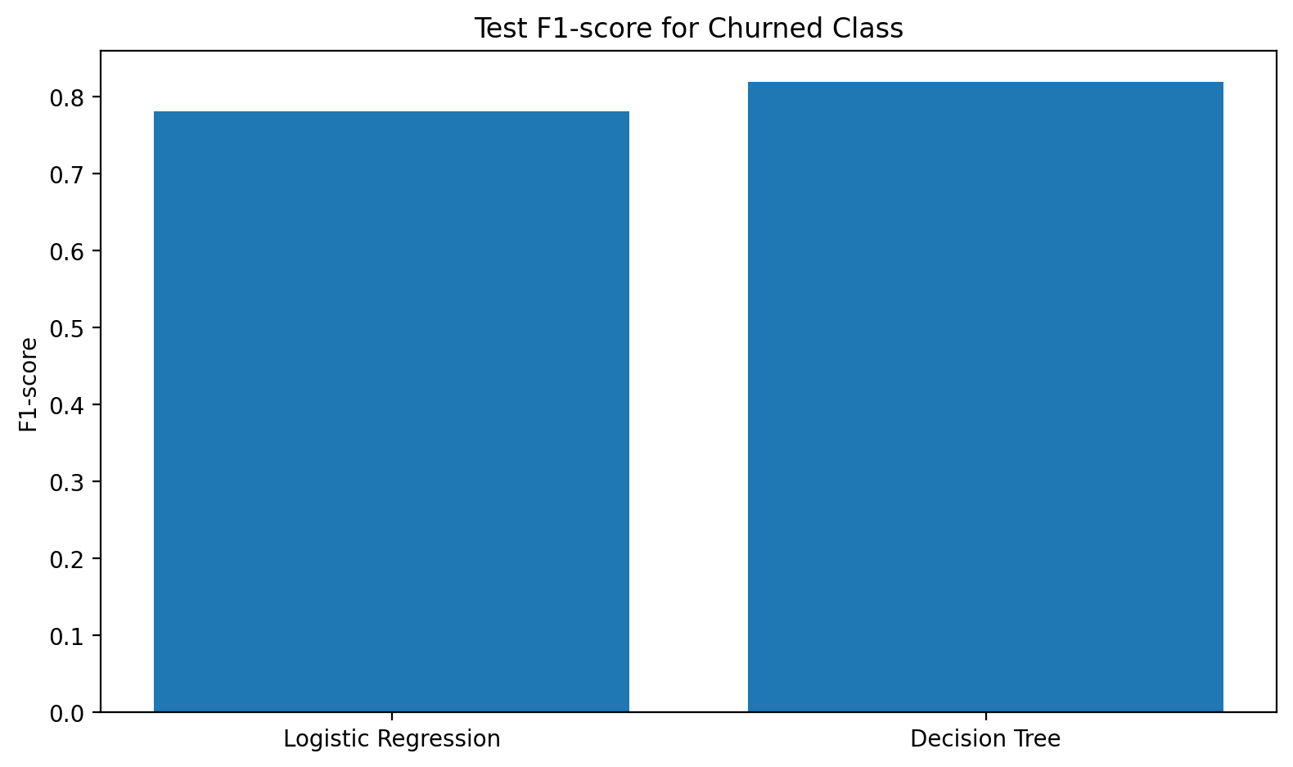
Figure 1. Held-out test F1-score for the churned class.
Decision Tree performed better on the reported test metrics, including churn-class F1 (0.8191 versus 0.7808). Nevertheless, ROC-AUC of 0.6183 is weak, indicating limited ranking/discrimination. Average precision is high but must be interpreted in light of the 93.03% positive-class prevalence; it should not be treated as evidence that retained customers are effectively identified.

6.1 Confusion Matrices and Retained-Class Results
Model | Actual retained predicted retained | Actual retained predicted churned | Actual churned predicted retained | Actual churned predicted churned
Logistic Regression | 99 | 106 | 917 | 1,822
Decision Tree | 98 | 107 | 765 | 1,974

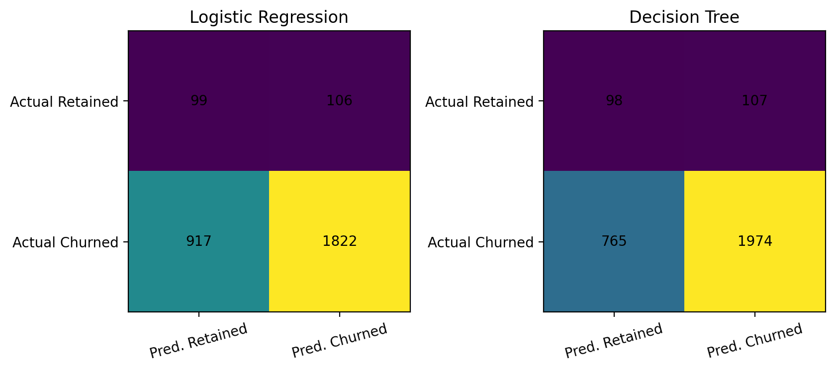
Figure 2. Confusion matrices for the held-out test set; rows are actual classes and columns are predicted classes.
Model | Retained precision | Retained recall | Retained F1 | Churned precision | Churned recall | Churned F1
Logistic Regression | 0.10 | 0.48 | 0.16 | 0.95 | 0.67 | 0.78
Decision Tree | 0.11 | 0.48 | 0.18 | 0.95 | 0.72 | 0.82

Decision Tree identified 98 of 205 retained customers but also predicted 765 churned customers as retained. That may create an expensive outreach list. The model threshold should be chosen based on campaign capacity and the relative cost of missed opportunities versus unnecessary outreach.

7. Five-Fold Cross-Validation and Overfitting
Model | Train F1 mean | CV F1 mean | CV F1 SD | Train ROC-AUC | CV ROC-AUC mean | CV average precision
Logistic Regression | 0.7836 | 0.7832 | 0.0140 | 0.5878 | 0.5722 | 0.9438
Decision Tree | 0.7909 | 0.7842 | 0.0516 | 0.6748 | 0.5753 | 0.9408

Cross-validation F1 means are nearly identical: 0.7842 for Decision Tree and 0.7832 for Logistic Regression. Decision Tree has higher fold-to-fold F1 variation (standard deviation 0.0516 versus 0.0140), suggesting less stability. The small train–CV F1 gaps do not show strong overfitting on F1 alone, but Decision Tree's train ROC-AUC (0.6748) is notably above its CV ROC-AUC (0.5753). Both models' CV ROC-AUC remains weak.

8. Feature Importance
Rank | Feature | Importance
1 | Avg_Discount | 0.4249
2 | Frequency | 0.2000
3 | Recency | 0.1016
4 | Avg_Sales | 0.0969
5 | Total_Profit | 0.0933
6 | Total_Quantity | 0.0280
7 | Monetary | 0.0226
8 | Total_Transactions | 0.0213
9 | Average_Order_Value | 0.0115
10 | Unique_Categories | 0.0000

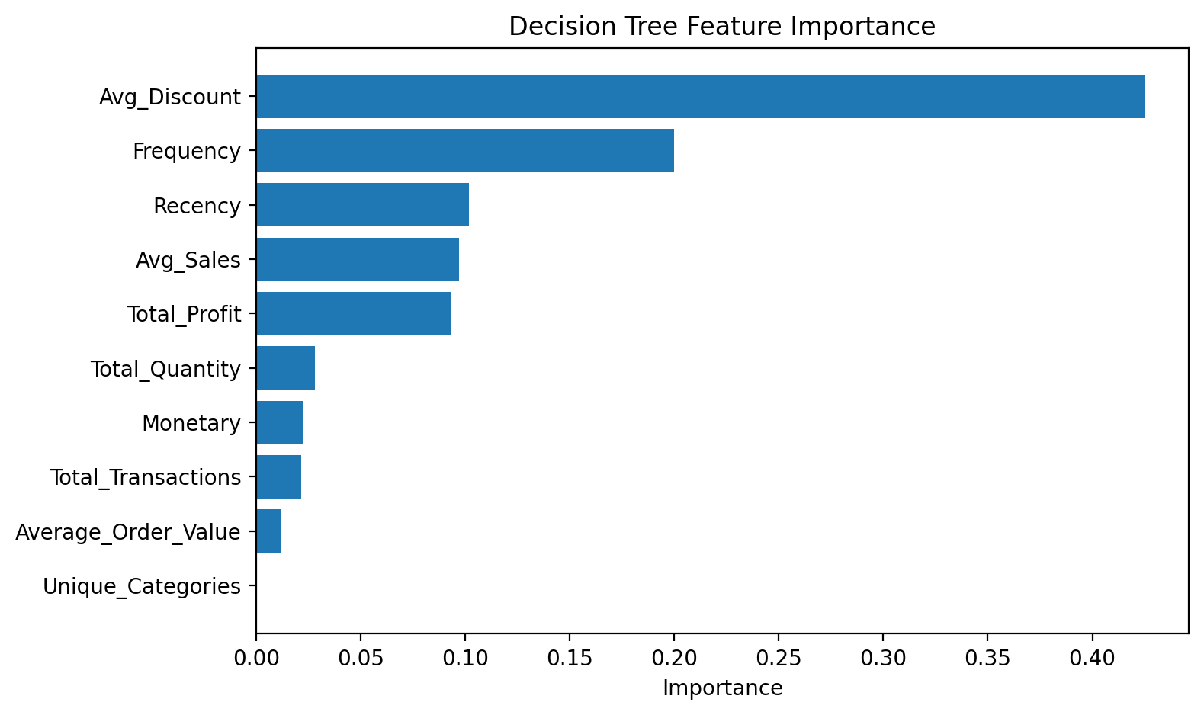
Figure 3. Impurity-based importance from the fitted Decision Tree.
Avg_Discount has the highest importance (0.4249), followed by Frequency (0.2000), Recency (0.1016), Avg_Sales (0.0969), and Total_Profit (0.0933). Unique_Categories has importance 0.0000 in this fitted tree. These scores are model-specific associations, not causal effects or evidence that changing discounts will change churn. Correlated predictors can affect importance; permutation importance or SHAP and stability checks are recommended.

9. Retained versus Churned Customer Comparison
Group | Customers | Mean recency (days) | Mean frequency | Mean monetary | Mean profit | Mean discount | Mean order value
Retained | 1,026 | 446.848 | 1.588 | 416.848 | 81.955 | 0.131 | 268.422
Churned | 13,690 | 487.378 | 1.367 | 348.416 | 59.150 | 0.146 | 253.163

Relative to retained customers, the churned group had 9.07% higher average recency, 13.92% lower frequency, 16.42% lower monetary value, 27.83% lower profit, 11.43% higher average discount, and 5.68% lower average order value. These are descriptive group differences, not controlled causal effects.

10. Business Recommendations
- Treat the models as exploratory baselines rather than automated customer-decision systems.
- Evaluate retention lists using retained-class precision/recall, lift at top-k, expected incremental profit, outreach cost, and campaign capacity—not accuracy alone.
- Explore purchase-frequency and recency-based segments for carefully tested follow-up or replenishment reminders.
- Investigate discount policy, but do not conclude that discounts cause churn: discounts may be targeted to customers already at risk.
- Use multiple time-based snapshots, training on earlier periods and testing on later periods, to evaluate future generalisation.
- Compare with simple baselines such as majority-class prediction and a rule-based recency policy.
- Before use, calibrate probabilities, select thresholds using business costs, check subgroup performance, and verify feature availability at scoring time.

11. Limitations and Robustness
- Severe imbalance: 93.03% churned and 6.97% retained.
- The label means no purchase during a 90-day window, not confirmed permanent churn.
- A single cutoff snapshot and random split do not establish temporal generalisation.
- Test ROC-AUC values (0.5863 and 0.6183) show weak discrimination.
- Retained-class F1 is low (0.16 for Logistic Regression and 0.18 for Decision Tree).
- Impurity-based feature importance is non-causal and may be unstable with correlated predictors.
- No campaign experiment was available, so incremental revenue, ROI, and causal retention impact were not measured.

12. Future Work
Build several cutoff snapshots and use later periods as temporal validation. Compare class-weighted Logistic Regression, shallow Decision Tree, Random Forest, and gradient boosting under the same temporal design. Report retained-class precision, recall, F1, precision-recall curves, calibration, lift at campaign top-k, and expected profit. Test feature importance with permutation methods or SHAP. If campaign exposure and follow-up purchases become available, use a controlled A/B test to measure whether retention interventions improve outcomes.

13. Conclusion
The Week 5 workflow created a future-window target, engineered ten historical behavioural features, trained two classifiers, compared test metrics and confusion matrices, conducted five-fold cross-validation, and interpreted feature importance and customer-group differences. Decision Tree slightly outperformed Logistic Regression on the majority churn class, but both models have weak ROC-AUC and low retained-customer F1. The appropriate conclusion is an evidence-based baseline and validation plan, not a production-ready churn predictor.

References
Breiman, L., Friedman, J. H., Olshen, R. A., & Stone, C. J. (1984). Classification and regression trees. Wadsworth.
Fawcett, T. (2006). An introduction to ROC analysis. Pattern Recognition Letters, 27(8), 861–874. https://doi.org/10.1016/j.patrec.2005.10.010
Kuhn, M., & Johnson, K. (2013). Applied predictive modeling. Springer. https://doi.org/10.1007/978-1-4614-6849-3
scikit-learn developers. (n.d.). LogisticRegression. scikit-learn documentation. https://scikit-learn.org/stable/modules/generated/sklearn.linear_model.LogisticRegression.html
scikit-learn developers. (n.d.). DecisionTreeClassifier. scikit-learn documentation. https://scikit-learn.org/stable/modules/generated/sklearn.tree.DecisionTreeClassifier.html
scikit-learn developers. (n.d.). Model evaluation: Quantifying the quality of predictions. scikit-learn documentation. https://scikit-learn.org/stable/modules/model_evaluation.html
scikit-learn developers. (n.d.). Cross-validation: Evaluating estimator performance. scikit-learn documentation. https://scikit-learn.org/stable/modules/cross_validation.html
Nguyen, X. (n.d.). Beauty ecommerce analytics [Data set]. GitHub. https://github.com/xanhnguyen186/Beauty-Ecommerce-Analytics

Appendix A. Reproducibility
Notebook environment versions: pandas 2.2.3, NumPy 2.1.3, scikit-learn 1.6.1. Split: test_size=0.20, random_state=42, stratify=y. Logistic Regression: StandardScaler in Pipeline, class_weight='balanced', max_iter=2000, random_state=42. Decision Tree: max_depth=5, min_samples_leaf=30, class_weight='balanced', random_state=42. Cross-validation: StratifiedKFold, five splits, shuffle=True, random_state=42.
Confusion matrices use observed counts, with rows = actual (Retained, Churned) and columns = predicted (Retained, Churned): Logistic Regression [[99, 106], [917, 1822]]; Decision Tree [[98, 107], [765, 1974]]. Report figures were regenerated from the notebook metrics supplied in the conversation.

