Supplementary Information

S9. RGB-Specific Structural Adaptation and Inverse Design Results
To validate the tunability and design generalizability of our PS-QD hybrid emissive architecture, we extended the structural-performance database to cover red, green, and blue devices. Using normalized target performance vectors (e.g., EQE = 0.85, Luminance = 0.65, etc.), our conditional inverse design module based on nearest-neighbor search identified distinct optimal structure combinations for each emission color.
As shown in Supplementary Fig. S9, red devices tend to favor smaller QD superlattice domains with higher PS coverage, while blue devices exhibit stronger preference for sparse spacing and medium-size microspheres. This difference reflects the interplay between spectral photon confinement, excitonic recombination dynamics, and charge injection balance.
A summary heatmap (Supplementary Fig. S10) reveals averaged structural profiles across RGB subgroups, further validating the adaptability of our platform to color-specific device demands.
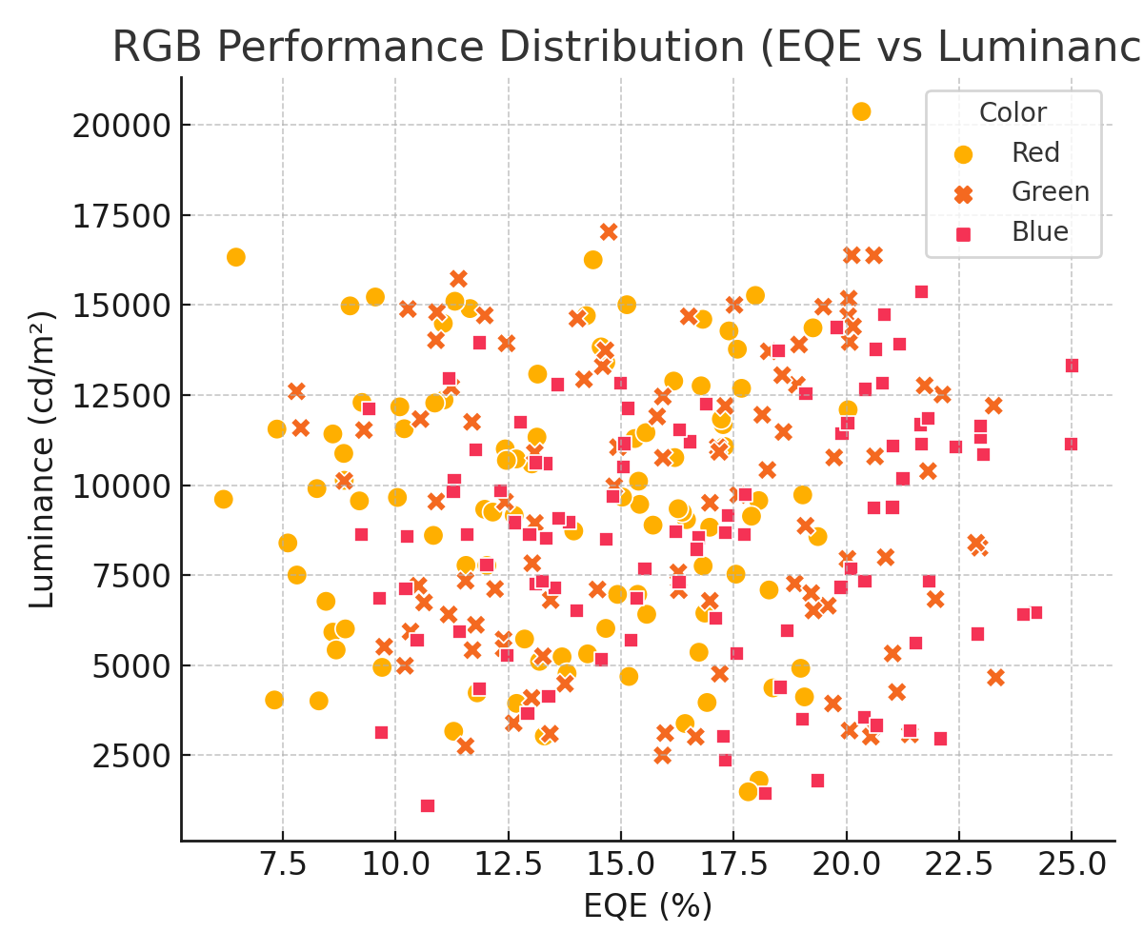
Supplementary Figure S9 | EQE vs Luminance scatter plot for RGB QLEDs showing color-dependent performance clustering.
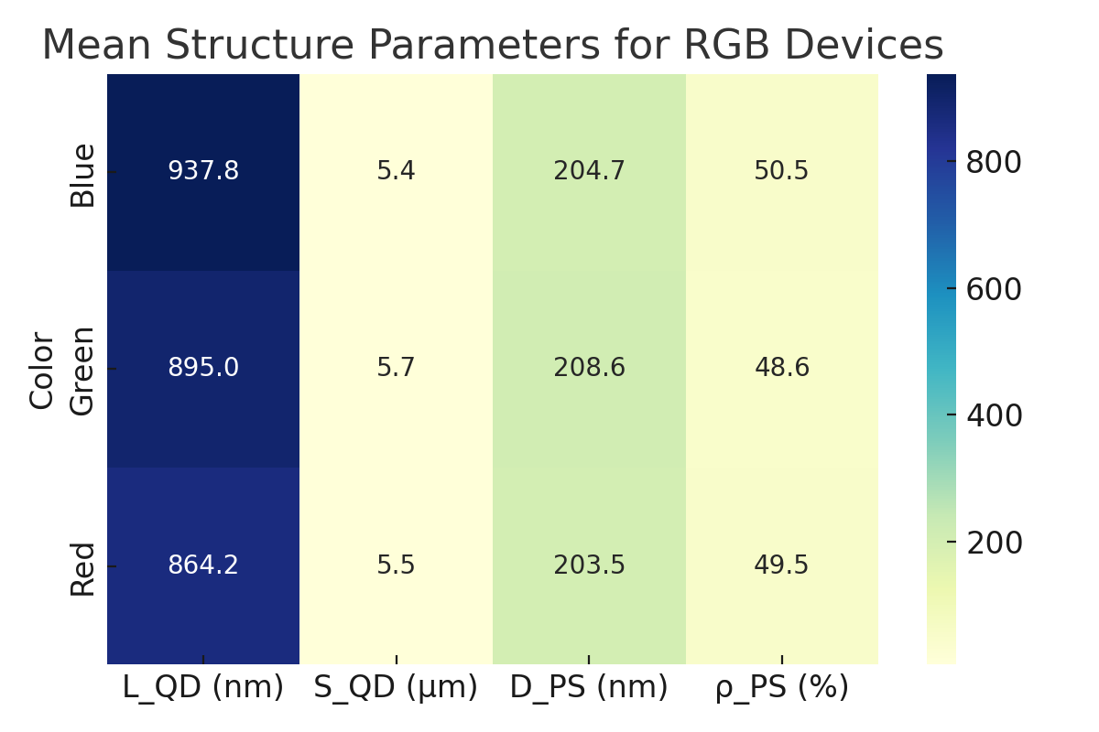
Supplementary Figure S10 | Heatmap of average structural parameters for RGB QLED groups, highlighting design divergence.

