**Task 1**

1. Simulating geometric Brownian motion

Theoretical expectation value of S(3):

E[S(t)] = $S\left(0\right)e^{ μt}$

E[S(3)] = 39e 0.1( 3) = 52.6444935

Theoretical variance of S(3):

Var[S(t)] = ${ S\left(0\right)}^{2}e^{2μt}\left(e^{σ^{2}t}-1\right)$

Var[S(t)] = ${ 39}^{2}e^{2(0.1)(3)}\left(e^{{0.26}^{2}(3)}-1\right)$ = 623.0964723

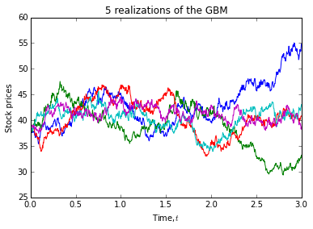

**To calculate E[S(3)] and the Var[S(3)]:**

Since the range is from 0 to 3, the last column in the dataframe will be S(3). By using the build-in function numpy.mean and numpy.var, I can find the expectation value of S(3) and variance of S(3) respectively.

Following results are generated from python:

Expectation value of S(3) = 49.0306493026

Variance of S(3) = 161.189630973

**To calculate P[S(3)> 39]:**

In the column of S(3), I find the number of value which is greater than 39, then the number is divided by the length of the column (which is 1000), to get the probability.

Results: P[S(3)>39]= 0.776

**To calculate E[S(3) | S(3) > 39]:**

There is a given condition which is S(3) > 39, so I sum up the price which is greater than 39, then divided by the number of the value which is greater than 39.

Results: E[S(3)|S(3)>39]= 53.3404119231

2. Simulating mean reversal process

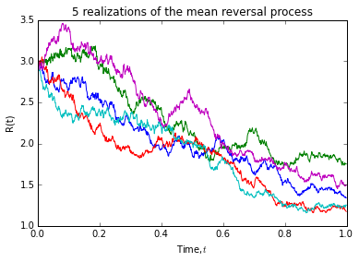

**To calculate expectation value of R(1):**

Since the range is from 0 to 1, the last column in the dataframe will be R(1). By using the build-in function numpy.mean, I can find the expectation value of R(1).

Results: Expectation value of R(1) = 1.12815726248

**To calculate P[R(1)> 2]:**

In the column of R(3), I find the number of value which is greater than 2, then the number is divided by the length of the column (which is 1000), to get the probability.

Results: P[R(1)>2]= 0.019

**Task 2**

1. FTSE Bursa Malaysia KLCI Index

How many components stocks are there?

Ans: 30

Create a table list the following information for all the component stocks: Stock Name, Stock Code, Stock Sector, Weightage in FTSEKLCI, PE Ratio, Net Market Capital.

Ans:

|  |  |  |  |  |  |  |
| --- | --- | --- | --- | --- | --- | --- |
| No. | Stock Name | Stock Code | Stock Sector | Weightage(%) | PE Ratio | Net M. Capital (RM in billion) |
| 1 | AMMB Holdings | 1015 | Banks | 2.38 | 8.9 | 17.42 |
| 2 | CIMB Group Holdings | 1023 | Banks | 5.76 | 17.4 | 47.29 |
| 3 | Hong Leong Bank | 5819 | Banks | 1.67 | 11.2 | 24.6 |
| 4 | Hong Leong Financial | 1082 | Banks | 0.64 | 10.0 | 16.25 |
| 5 | Maybank | 1155 | Banks | 9.32 | 12.4 | 88.041 |
| 6 | Public Bank | 1295 | Banks | 11.60 | 15.2 | 73.368 |
| 7 | RHB Capital | 1066 | Banks | 1.06 | 9.4 | 19.13 |
| 8 | Tenaga Nasional | 5347 | Alternative Electricity | 9.28 | 9.2 | 69.304 |
| 9 | Axiata Group Bhd | 6888 | Mobile Telecommunications | 5.62 | 24.3 | 55.349 |
| 10 | Digi.com | 6947 | Mobile Telecommunications | 4.16 | 20.7 | 41.830 |
| 11 | Maxis Bhd | 6012 | Mobile Telecommunications | 3.45 | 30.2 | 49.409 |
| 12 | Genting | 3182 | Hotels | 3.68 | 19.8 | 30.748 |
| 13 | Genting Malaysia BHD | 4715 | Hotels | 2.50 | 20.4 | 24.097 |
| 14 | Sime Darby Bhd | 4197 | Diversified Industrials | 5.51 | 22.7 | 52.671 |
| 15 | PETRONAS Chemicals Group Bhd | 5183 | Commodity Chemicals | 3.55 | 22.2 | 50.640 |
| 16 | Petronas Gas | 6033 | Exploration & Production | 3.40 | 22.8 | 42.50 |
| 17 | IHH Healthcare | 5225 | Health Care Providers | 3.28 | 63.5 | 48.8 |
| 18 | IOI | 1961 | Farming & Fishing | 2.99 | 0.0 | 26.731 |
| 19 | Kuala Lumpur Kepong | 2445 | Farming & Fishing | 2.28 | 29.2 | 23.983 |
| 20 | Telekom Malaysia | 4863 | Fixed Line Telecommunications | 2.96 | 32.7 | 24.915 |
| 21 | MISC | 3816 | Marine Transportation | 2.45 | 16.1 | 35.26 |
| 22 | SapuraKencana Petroleum | 5218 | Oil Equipment & Services | 1.98 | 12.0 | 14.321 |
| 23 | PPB Group | 4065 | Food Products | 1.80 | 17.7 | 18.233 |
| 24 | British American Tobacco (Malaysia) | 4162 | Tobacco | 1.7 | 20.6 | 18.445 |
| 25 | YTL Corp | 4677 | Multiutilities | 1.63 | 14.8 | 16.67 |
| 26 | UMW Holdings | 4588 | Automobiles | 1.37 | 20.6 | 12.0 |
| 27 | Astro Malaysia Holdings | 6399 | Broadcasting & Entertainment | 1.22 | 28.6 | 12.73 |
| 28 | Petronas Dagangan Bhd | 5681 | Integrated Oil & Gas | 1.21 | 37.0 | 20.445 |
| 29 | Westports Holdings | 5246 | Transportation Services | 0.93 | 26.6 | 13.9 |
| 30 | KLCC Prop&Reits-Stapled Sec | 5235SS | Real Estate Holding & Development | 0.63 | 26.6 | 12.73 |
|  |  |  |  | 100 |  |  |

2. Downloading data

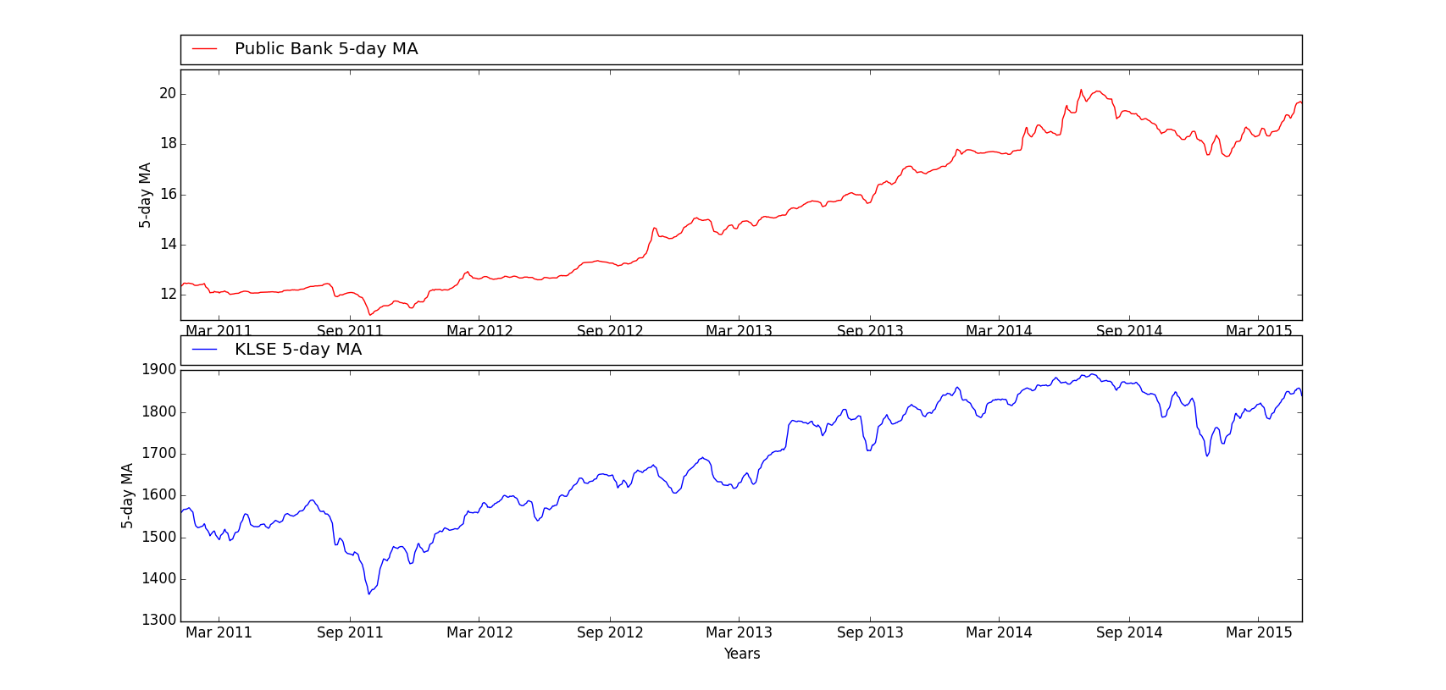

Figure 1: 5-day moving average of KLSE and Public Bank.

**Calculate the 5-day moving average**

By using the built-in function ‘pandas.rolling_mean’, I can calculate the 5-day moving average by setting the window equals to 5.

**Compute the correlation of Public Bank with FTSEKLCI**

Based on figure 1, we clearly see that the correlation between the two stocks is positive. To confirm the relationship, a built-in function ‘numpy.corrcoef’ can be used to calculate correlation coefficient. I merge the two dataframes with key = ‘Date’ to make the size equal and to avoid any calculation mistake.

Results: Correlation coefficient = 0.95411689 [#quite a strong positive relationship]