實驗名稱 | LCD 顯示器
組別 | 15 | 組員 | 05050652沈書鴻

- 實驗目的
使用 Arduino LCD 程式庫, 於 16x2 LCD 顯示器上顯示特 定文字?
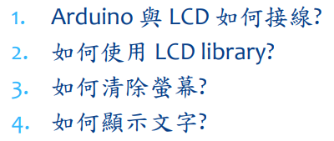

- 實驗步驟
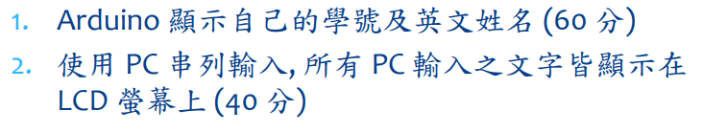
- 程式碼
實驗一
#include <LiquidCrystal.h> // include the library code
LiquidCrystal lcd(12, 11, 5, 4, 3, 2); // initialize interface pins
void setup()
{
lcd.begin(16, 2); // set up the LCD's number of columns and rows:
lcd.print("05050652 Marin"); // Print a message to the LCD.
}
void loop()
{
// set the cursor to column 0, line 1
// (note: line 1 is the second row, since counting begins with 0):
lcd.setCursor(0, 1);
lcd.print(millis()/1000); // print the number of seconds since reset:
}
實驗二
#include "LiquidCrystal.h"// include the library code
LiquidCrystal lcd(12, 11, 5, 4, 3, 2); // initialize interface pins
void setup() {
Serial.begin(9600);
lcd.begin(16, 2);
}
void loop() {
// (note: line 1 is the second row, since counting begins with 0):
String s = "";
if(Serial.available())
{
char c = Serial.read();
if(c!='\n'){
s += c;
delay(5);
}
Serial.print(s);
lcd.print(s);
}
}

- 實驗結果及分析
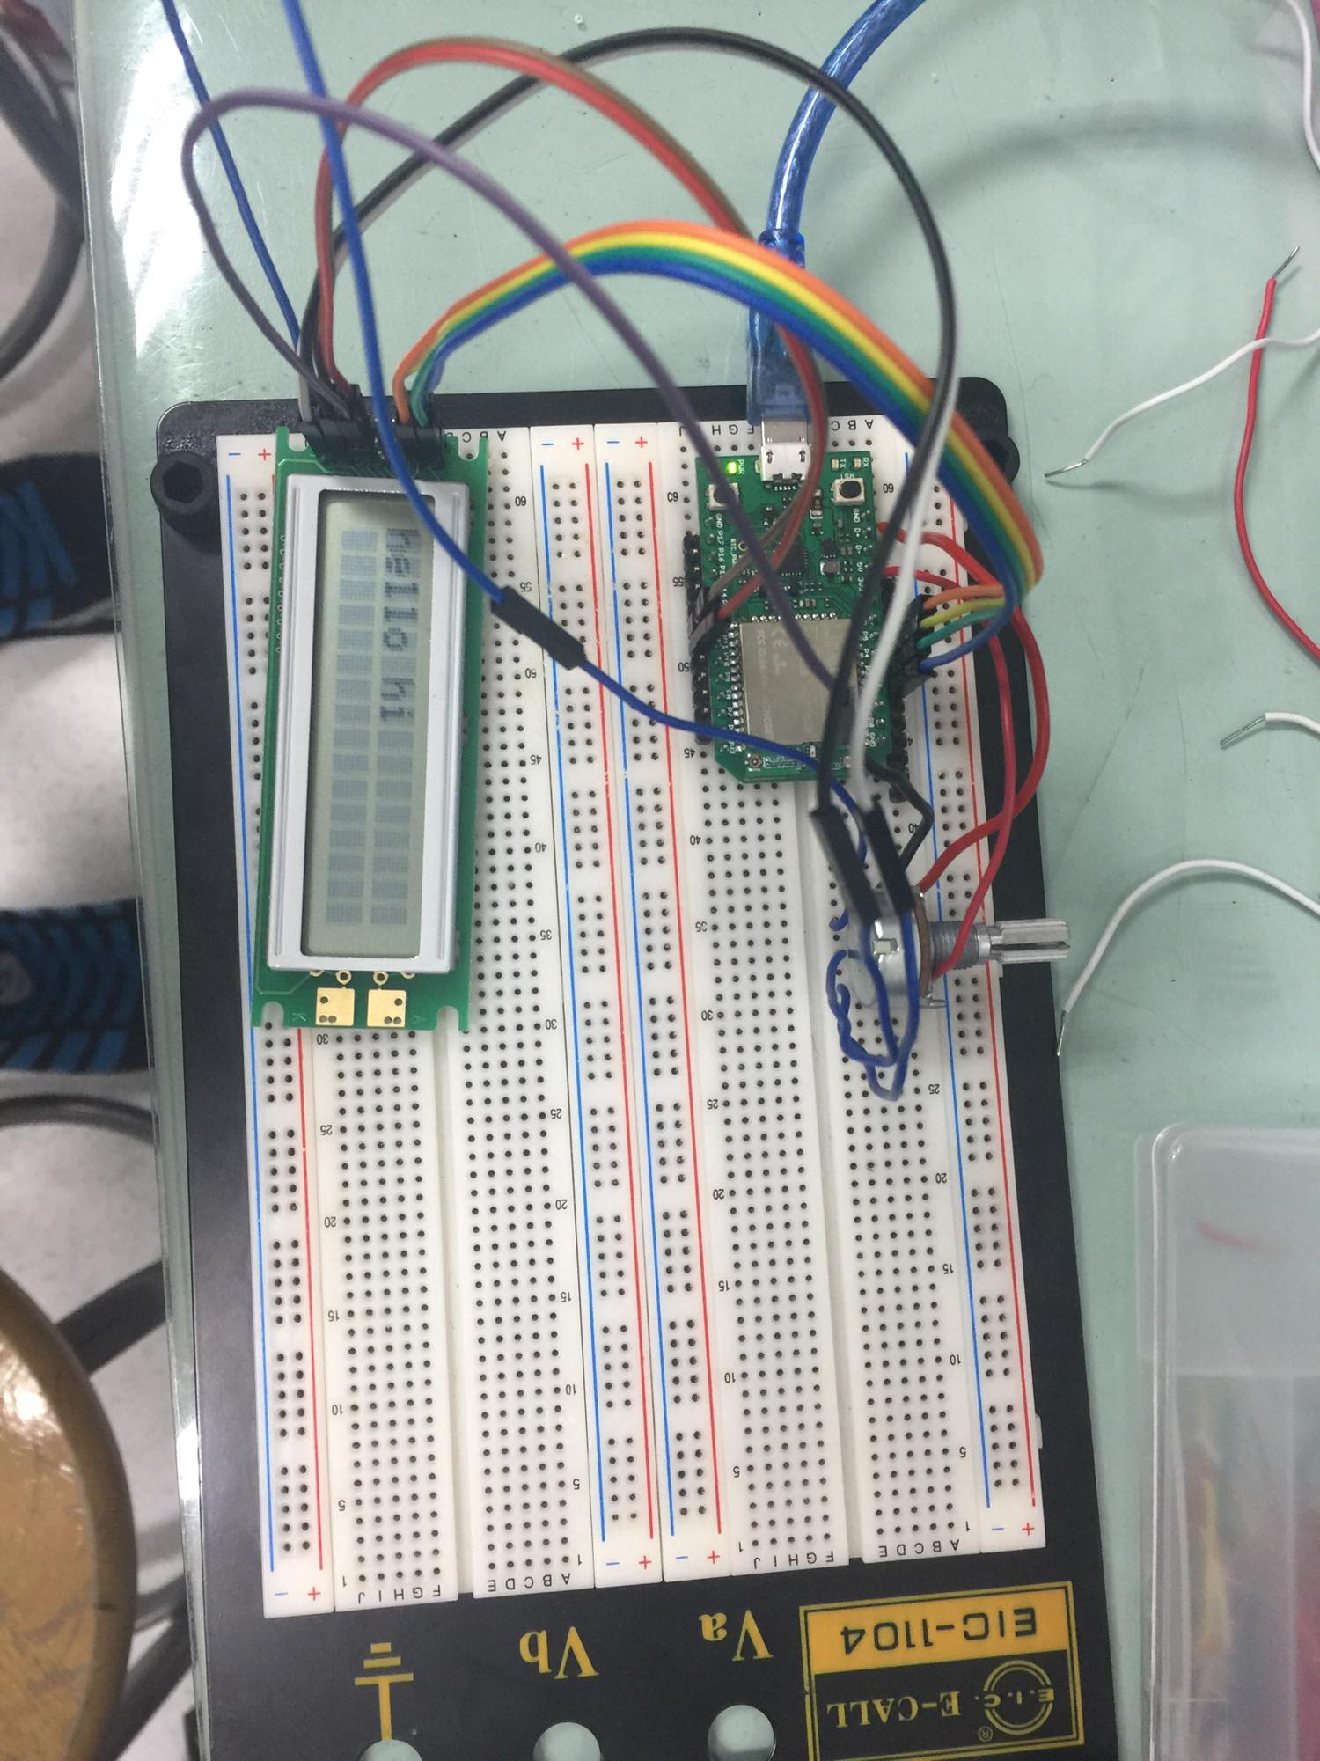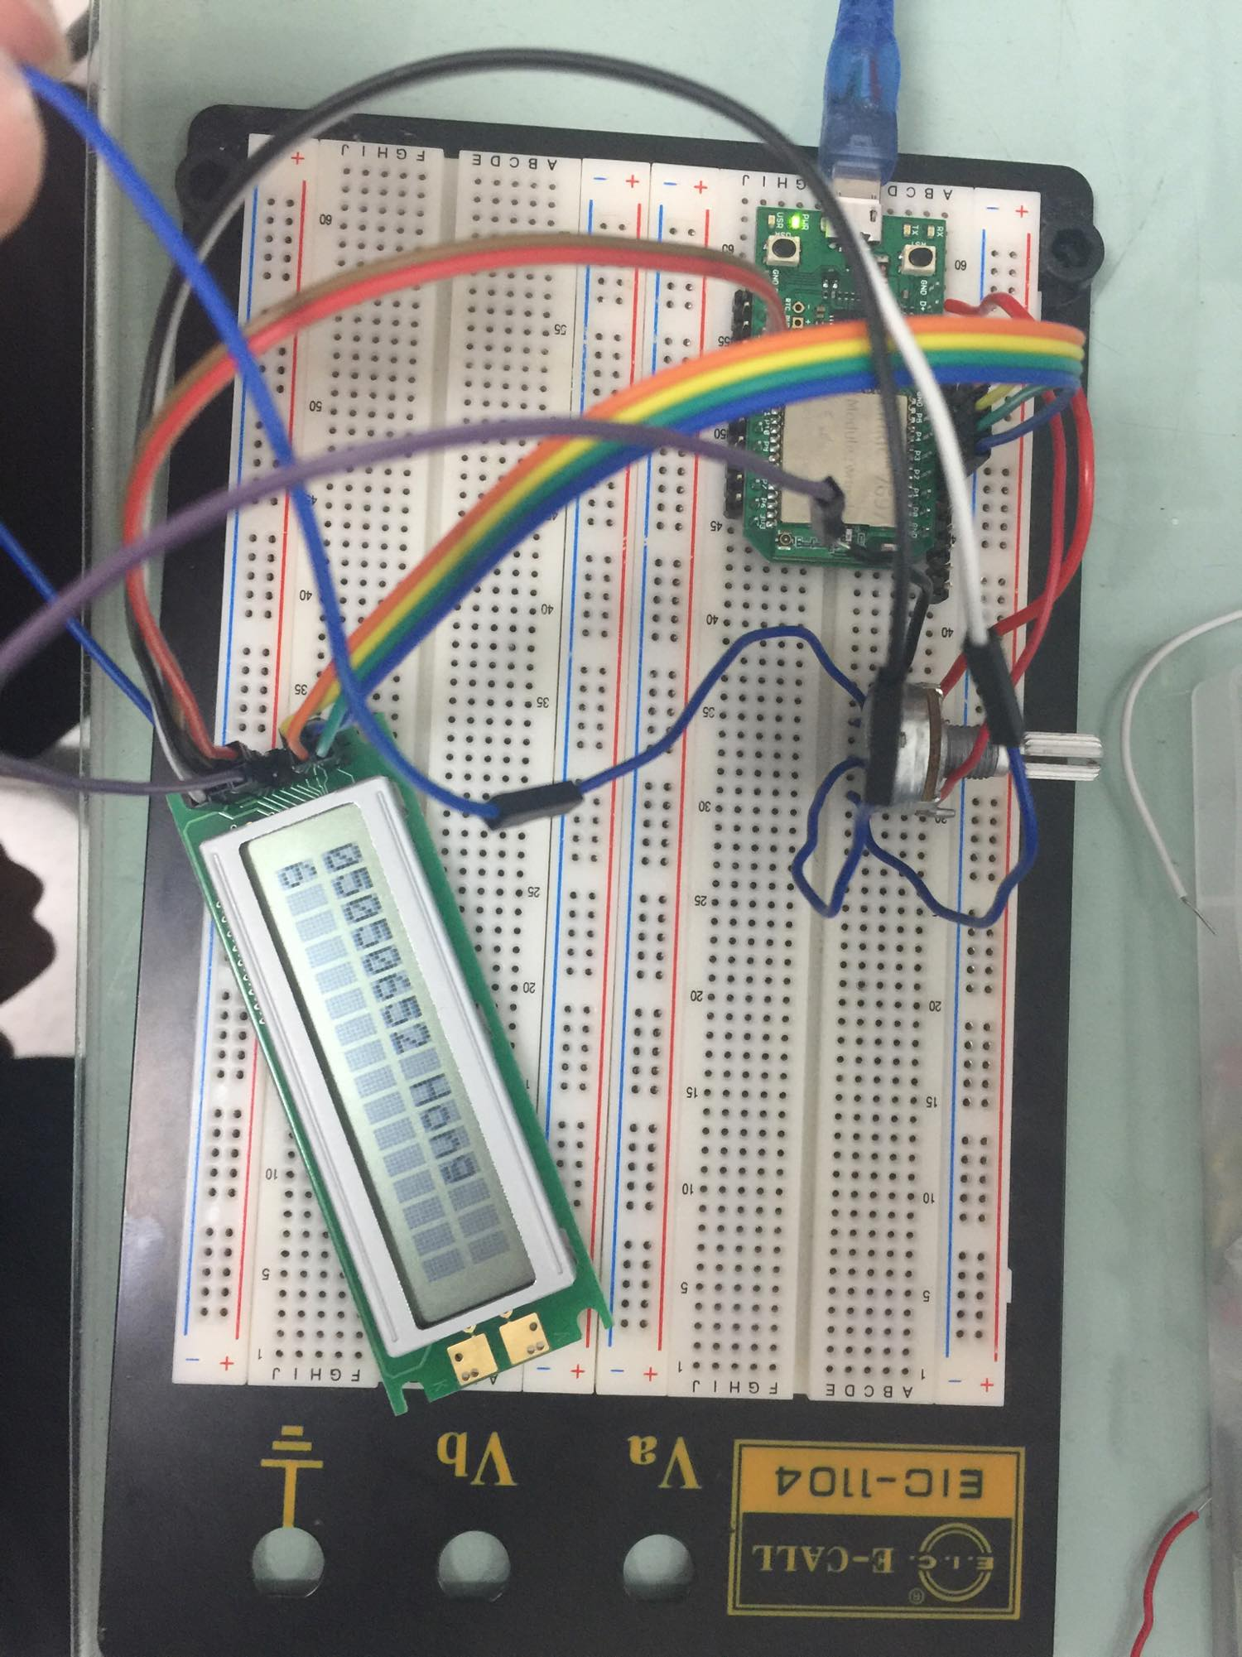

- 心得討論
這是實驗接線真的接到瘋掉，有些線還壞掉或接觸不良，試了很久

