電通二乙微處理器實驗 實驗結報

實驗名稱 | 中斷控制與超音波測距
組別 | 15 | 組員 | 05050652沈書鴻

- 實驗目的
Arduino 於 當按下 Pin 2 外部中斷 0 時, 讀入超音波測距 之值並顯示於 PC上
- 實驗步驟
1. 如何讀取超音波測距之值
2. 如何將超音波測距之值顯示於 LCD?
3. Arduino 如何規劃外部中斷 INT0?
4. 接一 SW, 當 SW 按下時暫停所有中斷, 實驗結果又如 何
- 程式碼
實驗一
#include <LiquidCrystal.h>
LiquidCrystal lcd(12, 11, 5, 4, 3, 2);
const int trig = 7;
const int echo = 6;
int inter_time = 1000;
int time = 0;
void setup() {
Serial.begin(9600);
lcd.begin(16, 2);
pinMode (trig, OUTPUT);
pinMode (echo, INPUT);
}
void loop() {
float duration, distance;
digitalWrite(trig, HIGH);
delayMicroseconds(1000);
digitalWrite(trig, LOW);
duration = pulseIn (echo, HIGH);
distance = (duration/50);
lcd.setCursor (0,0);
lcd.print("Data No.");
lcd.print (time);
time = time +1;
lcd.setCursor(0, 1);
lcd.print ("Distance:");
lcd.print(distance);
lcd.print ("cm");
delay(900);
lcd.clear();
delay(100);
}
實驗二

// HCSR04Ultrasonic/examples/UltrasonicDemo/UltrasonicDemo.pde
#include <Ultrasonic.h>
#include <LiquidCrystal.h> // include the library code
LiquidCrystal lcd(12, 11, 5, 4, 3, 8); // initialize interface pins
#define TRIGGER_PIN 14
#define ECHO_PIN 13
const byte intPin=2;
volatile boolean state=LOW;
Ultrasonic ultrasonic(TRIGGER_PIN, ECHO_PIN);

void setup() {
Serial.begin(9600);
lcd.begin(16, 2);
attachInterrupt(intPin, int0, LOW);
}

void loop(){
delay(1000);
}
void int0() {
float cmMsec, inMsec;
long microsec = ultrasonic.Timing();
cmMsec = ultrasonic.Ranging(CM);
inMsec = ultrasonic.Ranging(INC);
//Serial.print(", IN: "); Serial.println(inMsec);
lcd.setCursor(0, 0);
lcd.print("MS:"); lcd.print(microsec);
lcd.setCursor(0, 1);
lcd.print(" CM:"); lcd.print(cmMsec);
//lcd.print(" IN:"); lcd.print(inMsec);
}

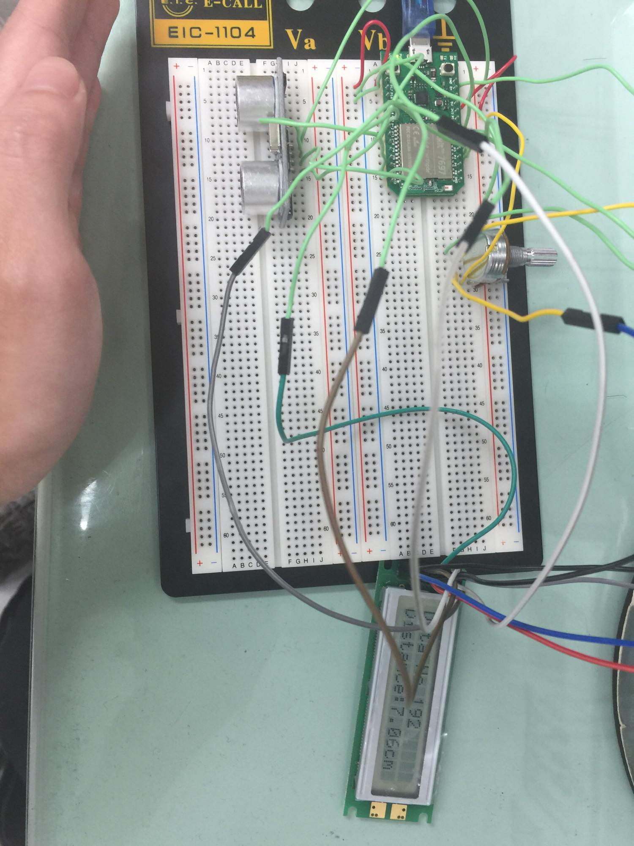
- 實驗結果及分析
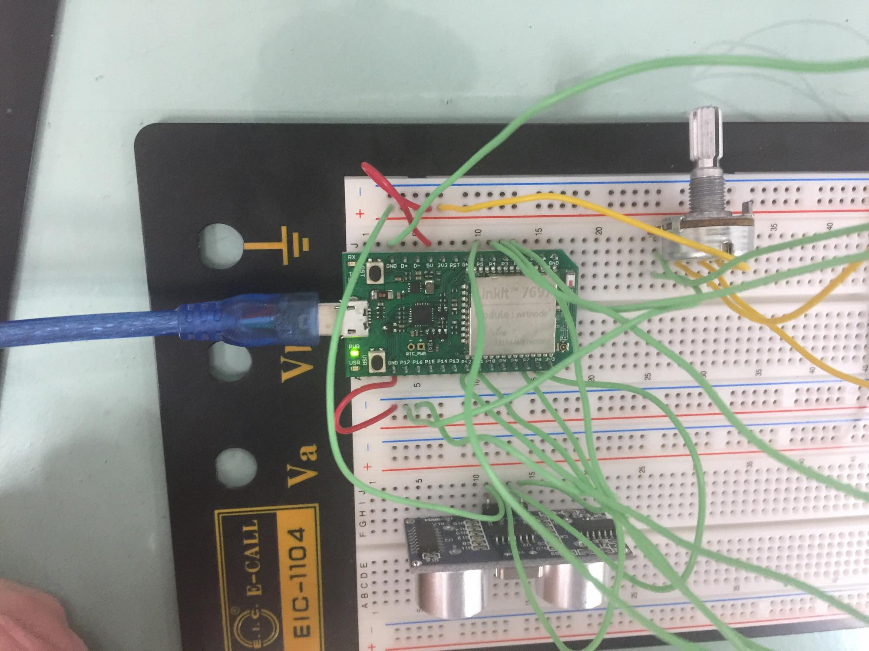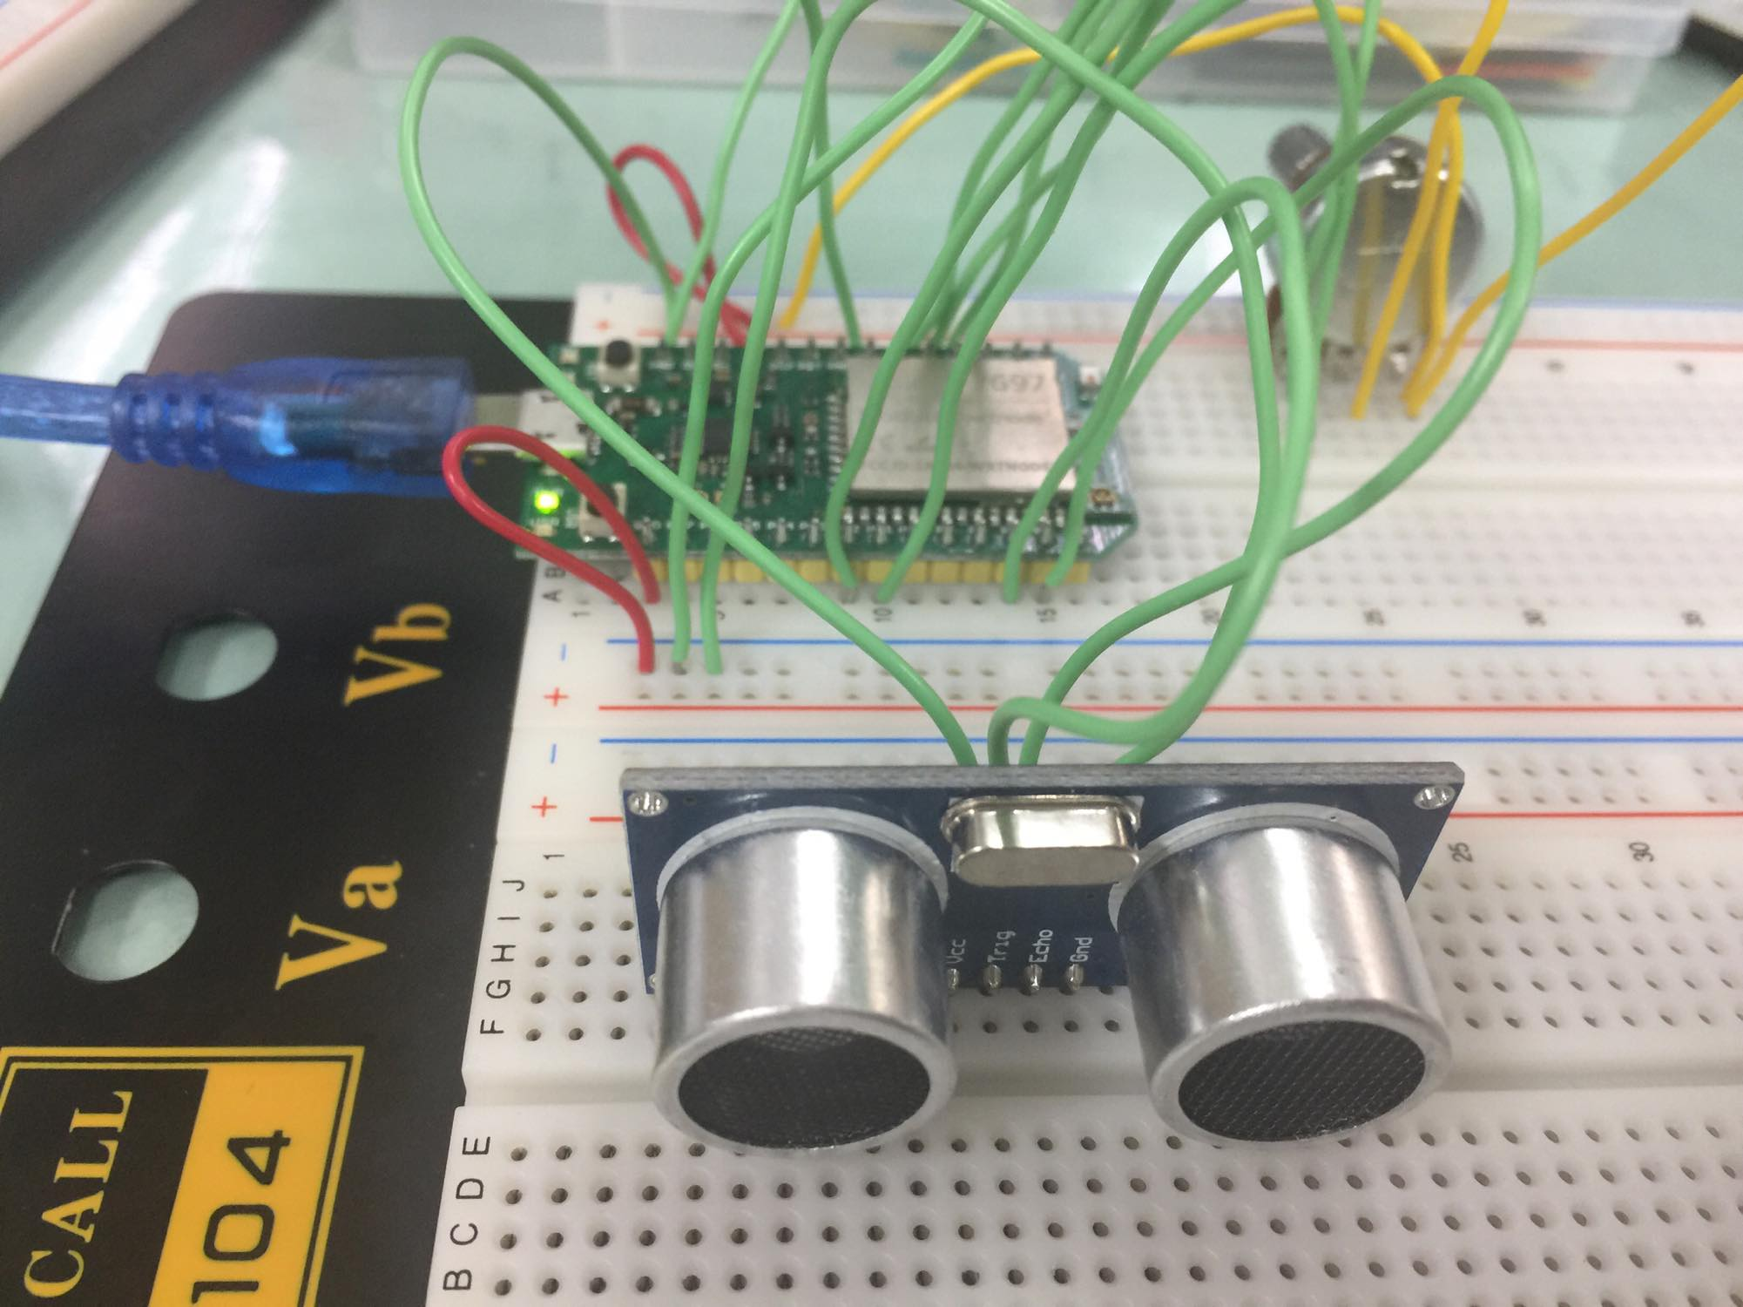

- 心得討論
這次實驗就是結合之前的LCD只要接得好就OK了

