電通二乙微處理器實驗 實驗結報

實驗名稱 | Lab 11 – MCS Cloud
組別 | 15 | 組員 | 沈書鴻

- 實驗目的
- MediaTek Cloud Sandbox (MCS) 雲端平台，執行程式
- 例：Google App Engine、Amazon Web Services、Microsoft Azure
- 提供網頁介面，讓你「點按滑鼠」就能建立雲端程式
- 提供API程式存取介面
- 提供網頁介面，觀看與控制各種資料

- 實驗步驟
到MCS註冊帳號
建立網頁應用程式（web application）
透過MCS REST API進行溝通
LinkIt 家族開發板、手機、瀏覽器

- 程式碼
程式一
#include <LWiFi.h>
#include "MCS.h"

char _lwifi_ssid[] = "Hong0302";
char _lwifi_pass[] = "05050652";
MCSDevice mcs("DfwKA0KT", "GGUm0y2HRnU7o58s");

MCSControllerOnOff led("05050652");
MCSDisplayOnOff remote("LED");

void setup()
{
Serial.begin(9600);

Serial.println("Connect to Wifi");
while (WiFi.begin(_lwifi_ssid, _lwifi_pass) != WL_CONNECTED) {
Serial.println("Wifi Reconnecting..");
delay(1000);
}

Serial.println("Connect to MCS...");
while (!mcs.connected()) {
Serial.println("MCS Reconnecting..");
mcs.connect();
}
Serial.println("MCS Connected!");
mcs.addChannel(led);

pinMode(7, OUTPUT);
mcs.addChannel(led);
mcs.addChannel(remote);

while(!mcs.connected())
{
Serial.println("MCS.connect()...");
mcs.connect();
}
}
void loop()
{
while(!led.valid())
{
Serial.println("read LED value from MCS...");
led.value(); //取得MCS數值
}
Serial.print("done, LED value = ");
Serial.println(led.value()); //顯示出來
digitalWrite(7,led.value() ? HIGH : LOW);

while (!mcs.connected()) {
mcs.connect();
if (mcs.connected()) {
Serial.println("MCS Reconnect");
}
}

mcs.process(1000);

if (led.value() == 1) {
digitalWrite(7, HIGH);

}
else {
digitalWrite(7, LOW);

}

if(!remote.set(led.value()))
{
Serial.print("Failed to update remote");
Serial.println(remote.value());
}
}

程式二
#include <LWiFi.h>
#include "MCS.h"

char _lwifi_ssid[] = "Hong0302";
char _lwifi_pass[] = "05050652";
MCSDevice mcs("DfwKA0KT", "GGUm0y2HRnU7o58s");

MCSDisplayInteger Temp("050506521");

void setup()
{
Serial.begin(9600);

Serial.println("Connect to Wifi");
while (WiFi.begin(_lwifi_ssid, _lwifi_pass) != WL_CONNECTED) {
Serial.println("Wifi Reconnecting..");
delay(1000);
}

Serial.println("Connect to MCS...");
while (!mcs.connected()) {
Serial.println("MCS Reconnecting..");
mcs.connect();
}
Serial.println("MCS Connected!");

mcs.addChannel(Temp);

}

void loop()
{
while (!mcs.connected()) {
mcs.connect();
if (mcs.connected()) {
Serial.println("MCS Reconnect");
}
}
mcs.process(1000);

int sensor = analogRead(A0);//pin14

Temp.set(sensor);
Serial.println("Add sensor value.");
delay(200);
}
- 實驗結果及分析
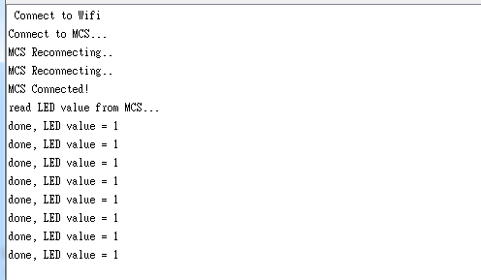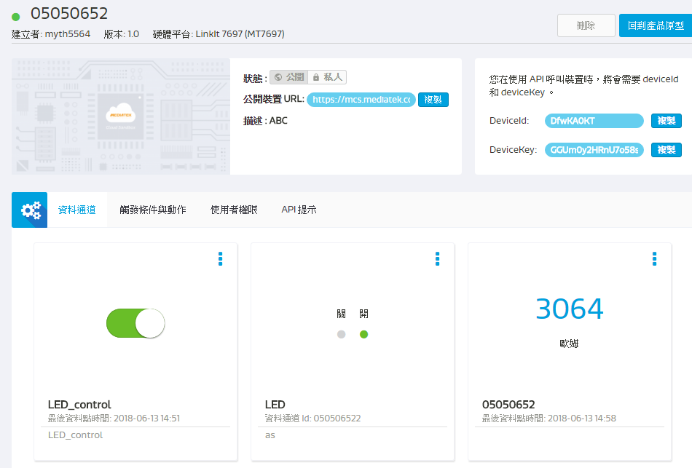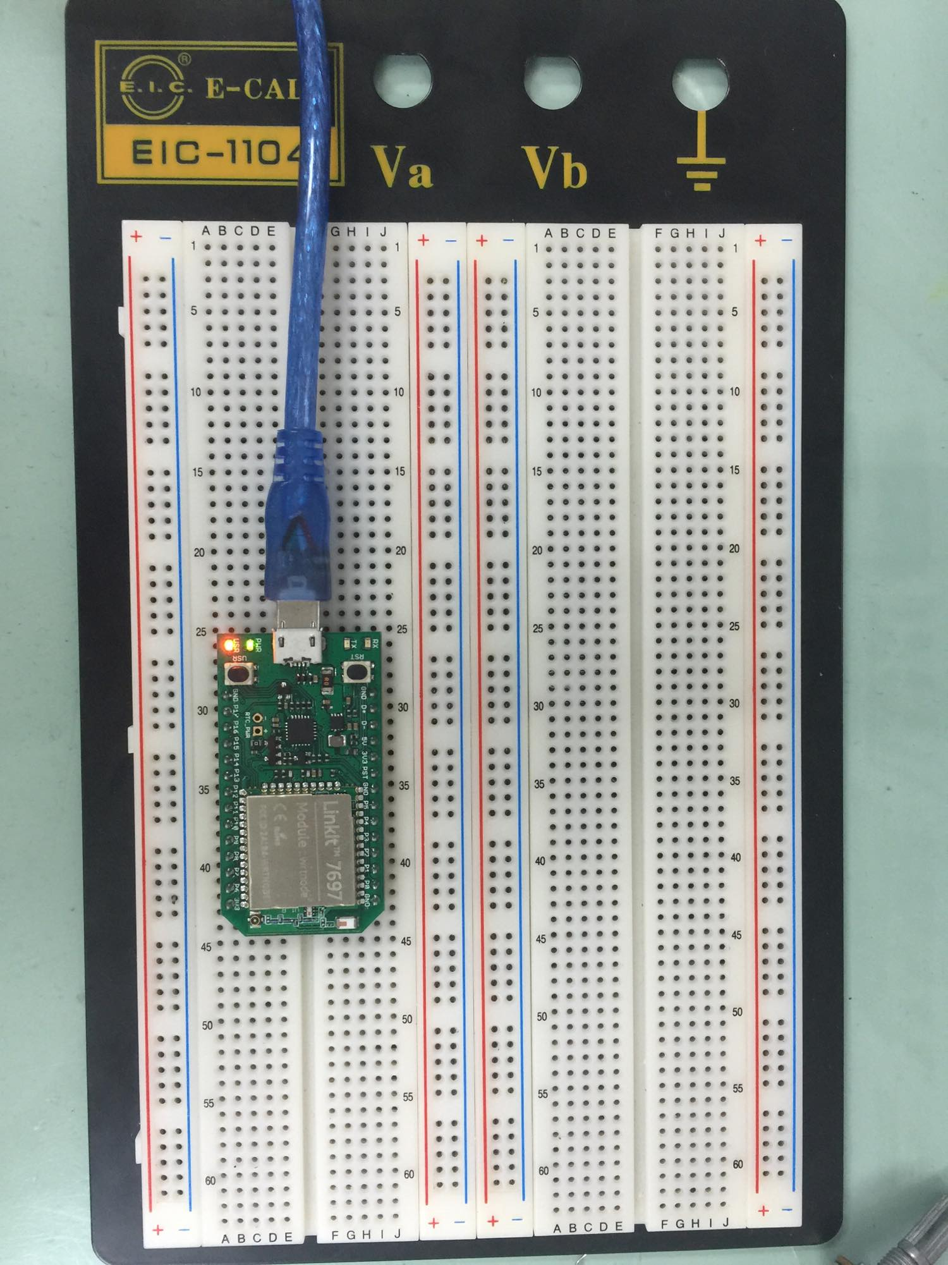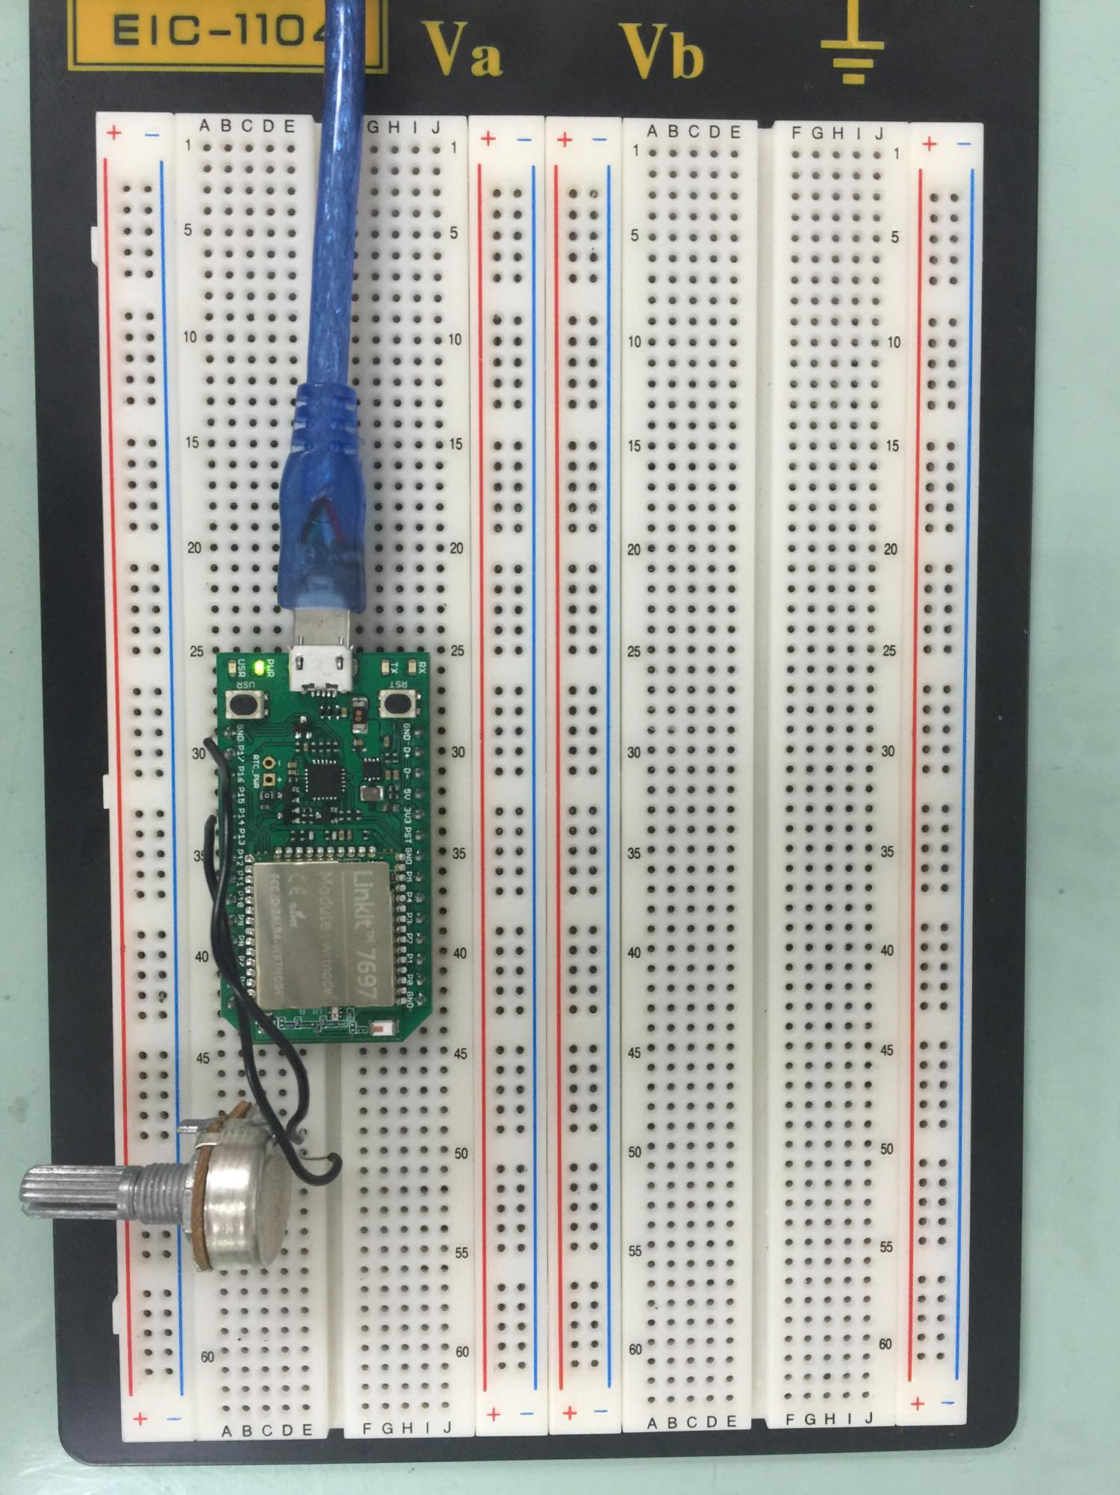
- 心得討論
這次實驗前面需要時間摸索一下，後來才了解MCS要怎麼用。

