Service

1. 請參考投影片內容，建立以下的Android應用程式

並請將1.**建立過程**; 2.程式**執行結果**截圖; 2.程式**原始檔 copy&paste**置入作業中

1. 請參考範例
   1. 使用兩種方式建立Broadcast機制
      1. 第一種為xml裡註冊,receiver收到後顯示”收到來自MCU ITE的訊息了 ”
      2. 第二種為程式內動態註冊,receiver收到後顯示”收到來自MCU ITE的訊息了 ”

(Mainifest)

*<?***xml version="1.0" encoding="utf-8"***?>*<**manifest xmlns:android="http://schemas.android.com/apk/res/android"  
 package="com.broadcastintentandbroadcastreceiver"**>  
  
 <**application  
 android:allowBackup="true"  
 android:icon="@mipmap/ic_launcher"  
 android:label="@string/app_name"  
 android:supportsRtl="true"  
 android:theme="@style/AppTheme"**>  
 <**activity android:name=".MainActivity"**>  
 <**intent-filter**>  
 <**action android:name="android.intent.action.MAIN"** />  
  
 <**category android:name="android.intent.category.LAUNCHER"** />  
 </**intent-filter**>  
 </**activity**>  
 <**receiver android:name=".MyBroadcastReceiver1"  
 android:label="@string/app_name"**>  
 <**intent-filter**>  
 <**action android:name="com.android.MY_BROADCAST1"** />  
 </**intent-filter**>  
 </**receiver**>  
 </**application**>  
  
</**manifest**>

(act)

*<?***xml version="1.0" encoding="utf-8"***?>*<**LinearLayout xmlns:android="http://schemas.android.com/apk/res/android"  
 xmlns:tools="http://schemas.android.com/tools"  
 android:layout_width="match_parent"  
 android:layout_height="match_parent"  
 android:paddingBottom="@dimen/activity_vertical_margin"  
 android:paddingLeft="@dimen/activity_horizontal_margin"  
 android:paddingRight="@dimen/activity_horizontal_margin"  
 android:paddingTop="@dimen/activity_vertical_margin"  
 tools:context="com.broadcastintentandbroadcastreceiver.MainActivity"  
 android:orientation="vertical"**>  
  
 <**Button  
 android:id="@+id/btnRegReceiver"  
 android:layout_width="match_parent"  
 android:layout_height="wrap_content"  
 android:text="註冊Broadcast Receiver2"  
 android:layout_marginTop="20dp"** />  
  
 <**Button  
 android:id="@+id/btnUnregReceiver"  
 android:layout_width="match_parent"  
 android:layout_height="wrap_content"  
 android:text="註銷Broadcast Receiver2"** />  
  
 <**Button  
 android:id="@+id/btnSendBroadcast1"  
 android:layout_width="match_parent"  
 android:layout_height="wrap_content"  
 android:text="傳送MY_BROADCAST1"** />  
  
 <**Button  
 android:id="@+id/btnSendBroadcast2"  
 android:layout_width="match_parent"  
 android:layout_height="wrap_content"  
 android:text="傳送MY_BROADCAST2"** />  
  
</**LinearLayout**>

(B1)

**package** com.broadcastintentandbroadcastreceiver;  
  
**import** android.content.BroadcastReceiver;  
**import** android.content.Context;  
**import** android.content.Intent;  
**import** android.widget.Toast;  
  
**public class** MyBroadcastReceiver1 **extends** BroadcastReceiver {  
 @Override  
 **public void** onReceive(Context context, Intent intent) {  
 String sender = intent.getStringExtra(**"sender_name"**);  
 Toast.*makeText*(context, **"收到來自MCU ITE的訊息了"**,  
 Toast.***LENGTH_LONG***).show();  
 }  
}

*(B2)

**package** com.broadcastintentandbroadcastreceiver;  
  
**import** android.content.BroadcastReceiver;  
**import** android.content.Context;  
**import** android.content.Intent;  
**import** android.widget.Toast;  
  
**public class** MyBroadcastReceiver2 **extends** BroadcastReceiver {  
 @Override  
 **public void** onReceive(Context context, Intent intent) {  
 String sender = intent.getStringExtra(**"sender_name"**);  
 Toast.*makeText*(context, **"收到來自MCU ITE的訊息了"**,  
 Toast.***LENGTH_LONG***).show();  
 }  
}

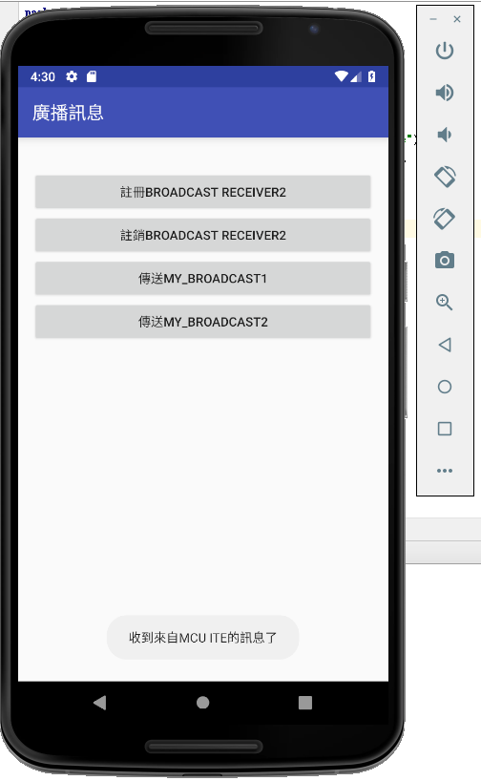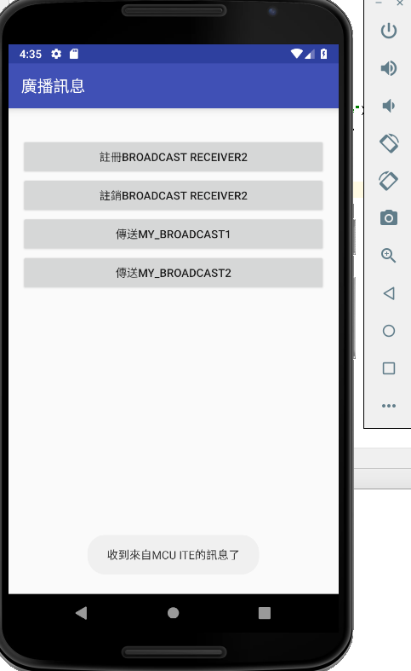

1. 請參考範例
   1. 建立兩種形式的Service
      * startService -> 顯示AlertDialog, 使用者點選確定後消失
      * bindService -> 由主程式呼叫Service裡的method, 該method為顯示Toast訊息

(Main)

**package** com.service;  
  
**import** android.content.ComponentName;  
**import** android.content.Intent;  
**import** android.content.ServiceConnection;  
**import** android.os.IBinder;  
**import** android.support.v7.app.AppCompatActivity;  
**import** android.os.Bundle;  
**import** android.util.Log;  
**import** android.view.View;  
**import** android.widget.Button;  
**import** android.app.DatePickerDialog;  
**import** android.app.TimePickerDialog;  
**import** android.content.Context;  
**import** android.content.DialogInterface;  
**import** android.os.Handler;  
**import** android.support.v7.app.AlertDialog;  
**import** android.support.v7.app.AppCompatActivity;  
**import** android.os.Bundle;  
**import** android.view.View;  
**import** android.widget.Button;  
**import** android.widget.DatePicker;  
**import** android.widget.TextView;  
**import** android.widget.TimePicker;  
**import** android.widget.Toast;  
  
  
**import** java.util.Calendar;  
  
  
**public class** MainActivity **extends** AppCompatActivity {  
  
 **private final** String **LOG_TAG** = **"ServiceDemo"**;  
  
 **private** Button **mBtnStartMyService**,  
 **mBtnStopMyService**,  
 **mBtnBindMyService**,  
 **mBtnUnbindMyService**,  
 **mBtnCallMyServiceMethod**;  
 **private** TextView **mTxtResult**;  
  
  
 **private** MyService **mMyServ** = **null**;  
  
 **private** ServiceConnection **mServConn** = **new** ServiceConnection() {  
 @Override  
 **public void** onServiceConnected(ComponentName componentName, IBinder iBinder) {  
 Log.*d*(**LOG_TAG**, **"onServiceConnected() "** + componentName.getClassName());  
 **mMyServ** = ((MyService.LocalBinder)iBinder).getService();  
 }  
  
 @Override  
 **public void** onServiceDisconnected(ComponentName componentName) {  
 Log.*d*(**LOG_TAG**, **"onServiceDisconnected()"** + componentName.getClassName());  
 }  
 };  
  
 @Override  
 **protected void** onCreate(Bundle savedInstanceState) {  
 **super**.onCreate(savedInstanceState);  
 setContentView(R.layout.***activity_main***);  
 **mTxtResult** = (TextView)findViewById(R.id.***txtResult***);  
 **mBtnStartMyService** = (Button) findViewById(R.id.***btnStartMyService***);  
 **mBtnStopMyService** = (Button) findViewById(R.id.***btnStopMyService***);  
 **mBtnBindMyService** = (Button) findViewById(R.id.***btnBindMyService***);  
 **mBtnUnbindMyService** = (Button) findViewById(R.id.***btnUnbindMyService***);  
 **mBtnCallMyServiceMethod** = (Button) findViewById(R.id.***btnCallMyServiceMethod***);  
  
 **mBtnStartMyService**.setOnClickListener(**btnStartMyServiceOnClick**);  
 **mBtnStopMyService**.setOnClickListener(**btnStopMyServiceOnClick**);  
 **mBtnBindMyService**.setOnClickListener(**btnBindMyServiceOnClick**);  
 **mBtnUnbindMyService**.setOnClickListener(**btnUnbindMyServiceOnClick**);  
 **mBtnCallMyServiceMethod**.setOnClickListener(**btnCallMyServiceMethodOnClick**);  
 }  
  
 **private** View.OnClickListener **btnStartMyServiceOnClick** = **new** View.OnClickListener() {  
 **public void** onClick(View v) {  
 **mMyServ** = **null**;  
 Intent it = **new** Intent(MainActivity.**this**, MyService.**class**);  
 startService(it);  
 **mTxtResult**.setText(**""**);  
 AlertDialog.Builder altDlgBldr = **new** AlertDialog.Builder(MainActivity.**this**);  
 altDlgBldr.setTitle(**"AlerDialig"** );  
 altDlgBldr.setMessage(**"是否設定正確?"**);  
 altDlgBldr.setIcon(android.R.drawable.***ic_dialog_info***);  
 altDlgBldr.setCancelable(**false**);  
 altDlgBldr.setPositiveButton(**"是"**,  
 **new** DialogInterface.OnClickListener() {  
 @Override  
 **public void** onClick(DialogInterface dialog, **int** which) {  
 **mTxtResult**.setText(  
 **"是"**);  
 }  
 });  
 altDlgBldr.setNegativeButton(**"否"**,  
 **new** DialogInterface.OnClickListener() {  
 @Override  
 **public void** onClick(DialogInterface dialog, **int** which) {  
 **mTxtResult**.setText(  
 **"否"**);  
 }  
 });  
  
 altDlgBldr.show();  
 }  
  
  
 };  
  
 **private** View.OnClickListener **btnStopMyServiceOnClick** = **new** View.OnClickListener() {  
 **public void** onClick(View v) {  
 **mMyServ** = **null**;  
 Intent it = **new** Intent(MainActivity.**this**, MyService.**class**);  
 stopService(it);  
 }  
 };  
  
 **private** View.OnClickListener **btnBindMyServiceOnClick** = **new** View.OnClickListener() {  
 **public void** onClick(View v) {  
 **mMyServ** = **null**;  
 Intent it = **new** Intent(MainActivity.**this**, MyService.**class**);  
 bindService(it, **mServConn**, ***BIND_AUTO_CREATE***);  
 }  
 };  
  
 **private** View.OnClickListener **btnUnbindMyServiceOnClick** = **new** View.OnClickListener() {  
 **public void** onClick(View v) {  
 **mMyServ** = **null**;  
 unbindService(**mServConn**);  
 }  
 };  
  
 **private** View.OnClickListener **btnCallMyServiceMethodOnClick** = **new** View.OnClickListener() {  
 **public void** onClick(View v) {  
 **if** (**mMyServ** != **null**)  
 **mMyServ**.myMethod();  
 }  
 };  
}

(act)

*<?***xml version="1.0" encoding="utf-8"***?>*<**LinearLayout xmlns:android="http://schemas.android.com/apk/res/android"  
 xmlns:tools="http://schemas.android.com/tools"  
 android:layout_width="match_parent"  
 android:layout_height="match_parent"  
 android:paddingBottom="@dimen/activity_vertical_margin"  
 android:paddingLeft="@dimen/activity_horizontal_margin"  
 android:paddingRight="@dimen/activity_horizontal_margin"  
 android:paddingTop="@dimen/activity_vertical_margin"  
 tools:context="com.service.MainActivity"  
 android:orientation="vertical"**>  
  
 <**Button  
 android:id="@+id/btnStartMyService"  
 android:layout_width="match_parent"  
 android:layout_height="wrap_content"  
 android:text="啟動 MyService"** />  
  
 <**Button  
 android:id="@+id/btnStopMyService"  
 android:layout_width="match_parent"  
 android:layout_height="wrap_content"  
 android:text="停止 MyService"** />  
  
 <**Button  
 android:id="@+id/btnBindMyService"  
 android:layout_width="match_parent"  
 android:layout_height="wrap_content"  
 android:text="連結 MyService"** />  
  
 <**Button  
 android:id="@+id/btnUnbindMyService"  
 android:layout_width="match_parent"  
 android:layout_height="wrap_content"  
 android:text="斷開 MyService"** />  
  
 <**Button  
 android:id="@+id/btnCallMyServiceMethod"  
 android:layout_width="match_parent"  
 android:layout_height="wrap_content"  
 android:text="呼叫 MyService中的 myMethod()"** />  
  
 <**TextView android:id="@+id/txtResult"  
 android:layout_width="wrap_content"  
 android:layout_height="wrap_content"  
 android:layout_marginTop="15dp"**/>  
  
  
</**LinearLayout**>

(Mainfest)

*<?***xml version="1.0" encoding="utf-8"***?>*<**manifest xmlns:android="http://schemas.android.com/apk/res/android"  
 package="com.service"**>  
  
 <**application  
 android:allowBackup="true"  
 android:icon="@mipmap/ic_launcher"  
 android:label="@string/app_name"  
 android:supportsRtl="true"  
 android:theme="@style/AppTheme"**>  
 <**activity android:name=".MainActivity"**>  
 <**intent-filter**>  
 <**action android:name="android.intent.action.MAIN"** />  
  
 <**category android:name="android.intent.category.LAUNCHER"** />  
 </**intent-filter**>  
 </**activity**>  
  
 <**service  
 android:name=".MyService"  
 android:enabled="true"  
 android:exported="true"**></**service**>  
 </**application**>  
  
</**manifest**>

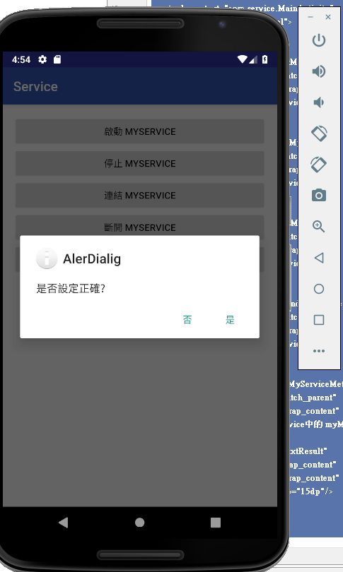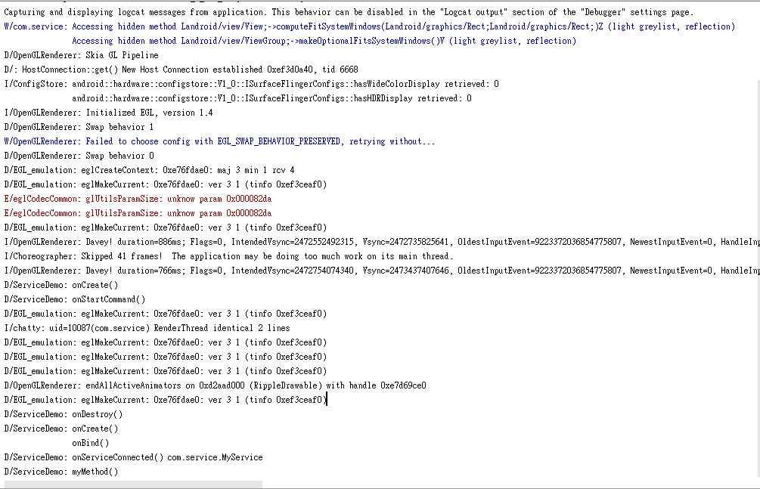

1. 請參考範例
   1. 建立基本的App Widget
      1. App Widget的圖示為 MCU的圖示或是自己找到的圖示
      2. 並於log中可看到APP Widget的相關訊息

(appwidget)

**package** com.advancedappwidget;  
  
**import** android.app.AlarmManager;  
**import** android.app.PendingIntent;  
**import** android.appwidget.AppWidgetManager;  
**import** android.content.Intent;  
**import** android.support.v7.app.AppCompatActivity;  
**import** android.os.Bundle;  
**import** android.widget.RemoteViews;  
  
**import** java.util.Calendar;  
  
**public class** AppWidgetConfigActivity **extends** AppCompatActivity {  
  
 **int mAppWidgetId**;  
  
 @Override  
 **protected void** onCreate(Bundle savedInstanceState) {  
 **super**.onCreate(savedInstanceState);  
 setContentView(R.layout.***activity_app_widget_config***);  
  
 Intent itIn = getIntent();  
 Bundle extras = itIn.getExtras();  
 **if** (extras != **null**) {  
 **mAppWidgetId** = extras.getInt(  
 AppWidgetManager.***EXTRA_APPWIDGET_ID***,  
 AppWidgetManager.***INVALID_APPWIDGET_ID***);  
 }  
  
 **if** (**mAppWidgetId** == AppWidgetManager.***INVALID_APPWIDGET_ID***) {  
 finish();  
 }  
  
 Intent itOut = **new** Intent(**"com.android.MY_OWN_WIDGET_UPDATE"**);  
 PendingIntent penIt = PendingIntent.*getBroadcast*(**this**, 0, itOut, 0);  
 AlarmManager alarmMan = (AlarmManager)getSystemService(***ALARM_SERVICE***);  
 Calendar calendar = Calendar.*getInstance*();  
 calendar.setTimeInMillis(System.*currentTimeMillis*());  
 calendar.add(Calendar.***SECOND***, 5);  
 alarmMan.setRepeating(AlarmManager.***RTC_WAKEUP***,  
 calendar.getTimeInMillis(), 20*1000, penIt);  
  
 MyAppWidget.*SaveAlarmManager*(alarmMan, penIt);  
  
 *// 以下是新加入的程式碼。* RemoteViews viewAppWidget = **new** RemoteViews(getPackageName(),  
 R.layout.***app_widget***);  
 viewAppWidget.setImageViewResource(R.id.***imgViewAppWidget***,  
 R.drawable.***app_widget_icon***);  
 AppWidgetManager appWidgetMan = AppWidgetManager.*getInstance*(**this**);  
 appWidgetMan.updateAppWidget(**mAppWidgetId**, viewAppWidget);  
  
 Intent itAppWidgetConfigResult = **new** Intent();  
 itAppWidgetConfigResult.putExtra(AppWidgetManager.***EXTRA_APPWIDGET_ID***,  
 **mAppWidgetId**);  
 setResult(***RESULT_OK***, itAppWidgetConfigResult);  
  
 finish();  
 }  
}

(Mainifest)

*<?***xml version="1.0" encoding="utf-8"***?>*<**manifest xmlns:android="http://schemas.android.com/apk/res/android"  
 package="com.advancedappwidget"**>  
  
 <**application  
 android:allowBackup="true"  
 android:icon="@mipmap/ic_launcher"  
 android:label="@string/app_name"  
 android:supportsRtl="true"  
 android:theme="@style/AppTheme"**>  
 <**receiver  
 android:name=".MyAppWidget"  
 android:label="App Widget"**>  
 <**intent-filter**>  
 <**action android:name="android.appwidget.action.APPWIDGET_UPDATE"** />  
 <**action android:name="com.android.MY_OWN_WIDGET_UPDATE"** />  
 </**intent-filter**>  
  
 <**meta-data  
 android:name="android.appwidget.provider"  
 android:resource="@xml/app_widget_config"** />  
 </**receiver**>  
  
 <**activity android:name=".AppWidgetConfigActivity"**>  
 <**intent-filter**>  
 <**action android:name="android.appwidget.action.APPWIDGET_CONFIGURE"** />  
 </**intent-filter**>  
 </**activity**>  
 </**application**>  
  
</**manifest**>

