Intent

1. 請參考投影片內容，建立以下的Android應用程式

並請將1.**建立過程**; 2.程式**執行結果**截圖; 2.程式**原始檔 copy&paste**置入作業中

1. 請參考範例
   1. 利用Intent Filter建立數個Button
   2. Button 1, 送出網址,開啟的方式為 Intent.ACTION_VIEW
   3. Button 2, 指定圖片, 開啟的方式為 Intent.ACTION_VIEW
   4. Button 3, 指定圖片, 開啟的方式為 Intent.ACTION_EDIT
   5. 並請於AndroidManifest.xml中設定相關的Intent Filter

MainActivity:

**package** com.intentfilter;  
  
**import** android.content.Intent;  
**import** android.net.Uri;  
**import** android.os.Environment;  
**import** android.support.v7.app.AppCompatActivity;  
**import** android.os.Bundle;  
**import** android.view.View;  
**import** android.widget.Button;  
  
**import** java.io.File;  
  
**public class** MainActivity **extends** AppCompatActivity {  
  
 **private** Button **mBtnBrowseWWW**,  
 **mBtnEditImg**,  
 **mBtnViewImg**;  
  
  
 @Override  
 **protected void** onCreate(Bundle savedInstanceState) {  
 **super**.onCreate(savedInstanceState);  
 setContentView(R.layout.***activity_main***);  
  
 **mBtnBrowseWWW** = (Button)findViewById(R.id.***btnBrowseWWW***);  
 **mBtnEditImg** = (Button)findViewById(R.id.***btnEditImg***);  
 **mBtnViewImg** = (Button)findViewById(R.id.***btnViewImg***);  
  
 **mBtnBrowseWWW**.setOnClickListener(**btnBrowseWWWOnClick**);  
 **mBtnEditImg**.setOnClickListener(**btnEditImgOnClick**);  
 **mBtnViewImg**.setOnClickListener(**btnViewImgOnClick**);  
 }  
  
 **private** View.OnClickListener **btnBrowseWWWOnClick** = **new** View.OnClickListener() {  
 **public void** onClick(View v) {  
 Uri uri = Uri.*parse*(**"https://moodle.mcu.edu.tw/"**);  
 Intent it = **new** Intent(Intent.***ACTION_VIEW***, uri);  
 startActivity(it);  
 }  
 };  
  
 **private** View.OnClickListener **btnEditImgOnClick** = **new** View.OnClickListener() {  
 **public void** onClick(View v) {  
 Intent it = **new** Intent(Intent.***ACTION_EDIT***);  
 File file = **new** File(**"/sdcard/gg2.jpg"**);  
 it.setDataAndType(Uri.*fromFile*(file), **"image/*"**);  
 startActivity(it);  
 }  
 };  
  
 **private** View.OnClickListener **btnViewImgOnClick** = **new** View.OnClickListener() {  
 **public void** onClick(View v) {  
 Intent it = **new** Intent(Intent.***ACTION_VIEW***);  
 File file = **new** File(**"/sdcard/gg.png"**);  
 it.setDataAndType(Uri.*fromFile*(file), **"image/*"**);  
 startActivity(it);  
 }  
 };  
}

MyImageActivity:

**package** com.intentfilter;  
  
**import** android.content.Intent;  
**import** android.support.v7.app.AppCompatActivity;  
**import** android.os.Bundle;  
**import** android.widget.TextView;  
  
**public class** MyImageActivity **extends** AppCompatActivity {  
  
 **private** TextView **mTxtResult**;  
  
 @Override  
 **protected void** onCreate(Bundle savedInstanceState) {  
 **super**.onCreate(savedInstanceState);  
 setContentView(R.layout.***activity_my_image***);  
  
 **mTxtResult** = (TextView)findViewById(R.id.***txtResult***);  
 showResult();  
 }  
  
 **private void** showResult() {  
 Intent it = getIntent();  
 String sAct = it.getAction();  
 String sScheme = it.getScheme();  
 **if** (sScheme.equals(**"http"**)) {  
 String s = **"接收到的Intent物件要求\"開啟網頁\""** + it.getData().toString();  
 **mTxtResult**.setText(s);  
 } **else if** (sScheme.equals(**"tel"**)) {  
 String s = **"接收到的Intent物件要求\"撥打電話\""** + it.getData().toString();  
 **mTxtResult**.setText(s);  
 } **else if** (sScheme.equals(**"file"**)) {  
 **if** (sAct.equals(**"android.intent.action.VIEW"**)) {  
 String s = **"接收到的Intent物件要求\"檢視\""** + it.getData().toString();  
 **mTxtResult**.setText(s);  
 } **else if** (sAct.equals(**"android.intent.action.EDIT"**)) {  
 String s = **"接收到的Intent物件要求\"編輯\""** + it.getData().toString();  
 **mTxtResult**.setText(s);  
 }  
 }  
 }  
}

Activity_main:

*<?***xml version="1.0" encoding="utf-8"***?>*<**LinearLayout xmlns:android="http://schemas.android.com/apk/res/android"  
 xmlns:tools="http://schemas.android.com/tools"  
 android:layout_width="match_parent"  
 android:layout_height="match_parent"  
 android:paddingBottom="@dimen/activity_vertical_margin"  
 android:paddingLeft="@dimen/activity_horizontal_margin"  
 android:paddingRight="@dimen/activity_horizontal_margin"  
 android:paddingTop="@dimen/activity_vertical_margin"  
 android:orientation="vertical"**>  
  
 <**Button  
 android:id="@+id/btnBrowseWWW"  
 android:layout_width="match_parent"  
 android:layout_height="wrap_content"  
 android:text="銘傳網頁"  
 android:layout_marginTop="20dp"  
 android:paddingLeft="50dp"  
 android:paddingRight="50dp"** />  
  
 <**Button  
 android:id="@+id/btnEditImg"  
 android:layout_width="match_parent"  
 android:layout_height="wrap_content"  
 android:text="野豬圖片"  
 android:paddingLeft="50dp"  
 android:paddingRight="50dp"** />  
  
 <**Button  
 android:id="@+id/btnViewImg"  
 android:layout_width="match_parent"  
 android:layout_height="wrap_content"  
 android:text="吃雞圖片"  
 android:paddingLeft="50dp"  
 android:paddingRight="50dp"** />  
  
</**LinearLayout**>

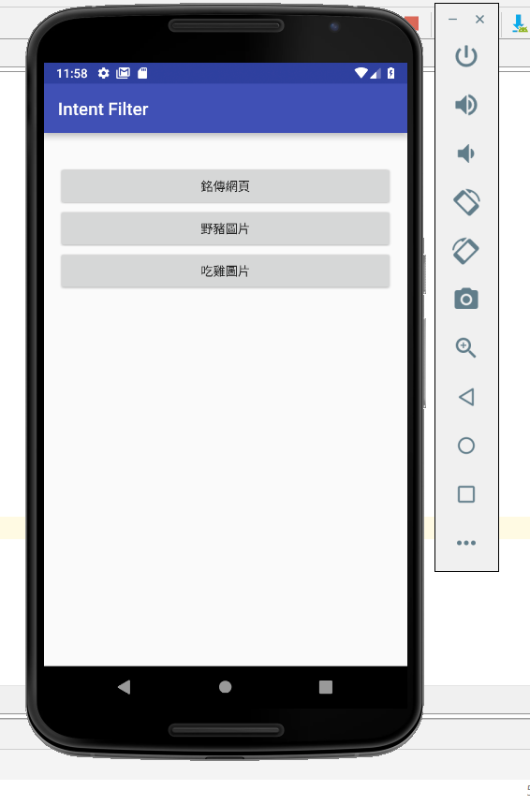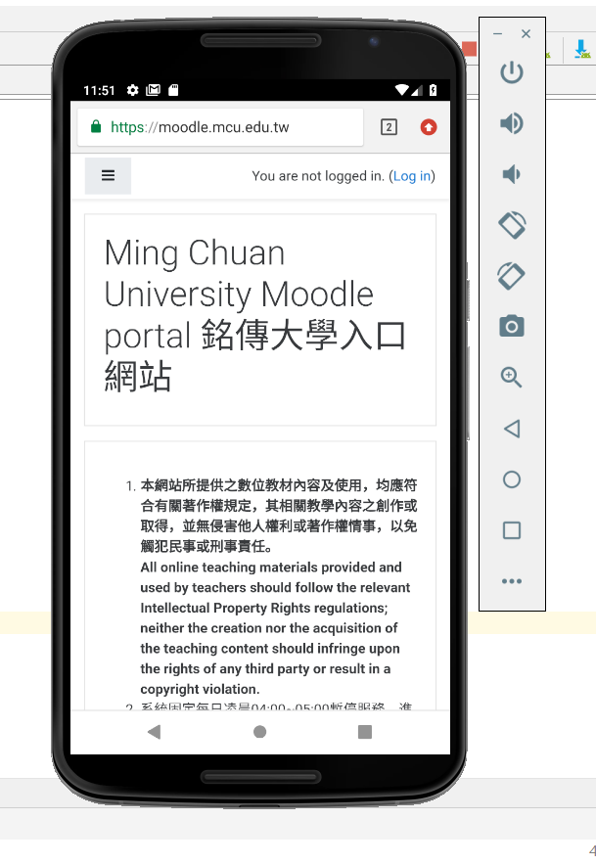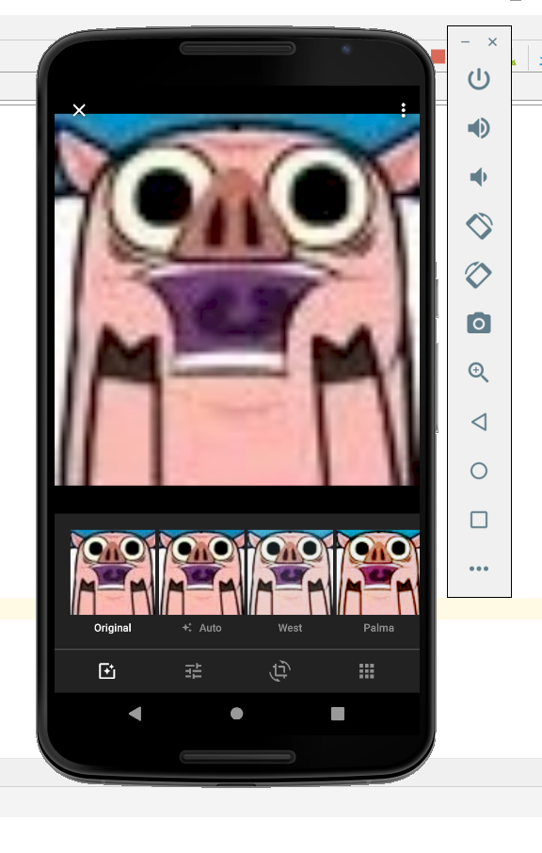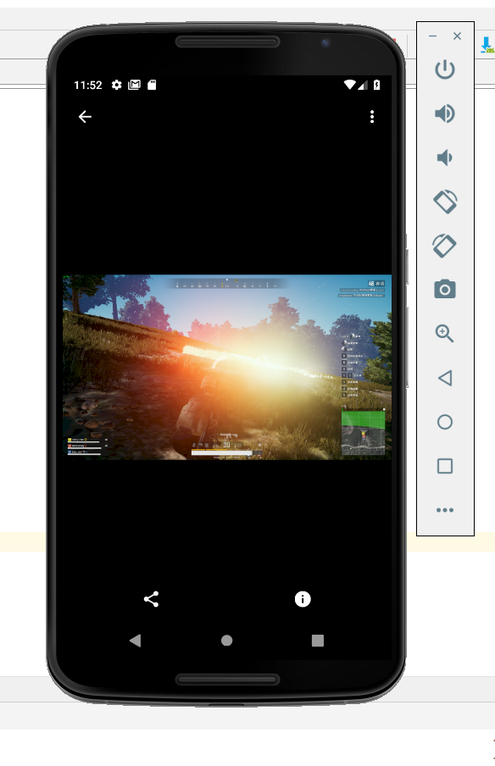

1. 請參考範例
   1. 使用Intent技術,改寫之前的作業 **數字比大小**
   2. 主畫面中只有一個Button, 按一下Button 即跳出數字比大小的程式
   3. 數字比大小結束後,會回傳比賽結果給主畫面顯示
2. MainActivity:
3. **package** com.activityreturndata;  
     
   **import** android.content.Intent;  
   **import** android.support.v7.app.AppCompatActivity;  
   **import** android.os.Bundle;  
   **import** android.view.View;  
   **import** android.widget.Button;  
   **import** android.widget.TextView;  
     
   **public class** MainActivity **extends** AppCompatActivity {  
     
    **final static private int *LAUNCH_GAME*** = 0;  
    **private** TextView **mTxtResult**;  
    **private** Button **mBtnLaunchGame**;  
     
    @Override  
    **protected void** onCreate(Bundle savedInstanceState) {  
    **super**.onCreate(savedInstanceState);  
    setContentView(R.layout.***activity_main***);  
     
    Button btn = (Button) findViewById(R.id.***btnLaunchGame***);  
    btn.setOnClickListener(**btnLaunchGameOnClick**);  
     
    **mTxtResult** = (TextView)findViewById(R.id.***txtResult***);  
    }  
     
    @Override  
    **protected void** onActivityResult(**int** requestCode, **int** resultCode, Intent data) {  
    **if** (requestCode != ***LAUNCH_GAME***)  
    **return**;  
     
    **switch** (resultCode) {  
    **case *RESULT_OK***:  
    Bundle bundle = data.getExtras();  
     
    **int** iCountSet = bundle.getInt(**"KEY_COUNT_SET"**);  
    **int** iCountPlayerWin = bundle.getInt(**"KEY_COUNT_PLAYER_WIN"**);  
    **int** iCountComWin = bundle.getInt(**"KEY_COUNT_COM_WIN"**);  
    **int** iCountDraw = bundle.getInt(**"KEY_COUNT_DRAW"**);  
     
    String s = **"遊戲結果：你總共玩了"** + iCountSet +  
    **"局, 贏了"** + iCountPlayerWin +  
    **"局, 輸了"** + iCountComWin +  
    **"局, 平手"** + iCountDraw + **"局"**;  
    **mTxtResult**.setText(s);  
     
    **break**;  
    **case *RESULT_CANCELED***:  
    **mTxtResult**.setText(**"你選擇取消遊戲。"**);  
    }  
    }  
     
    **private** View.OnClickListener **btnLaunchGameOnClick** = **new** View.OnClickListener() {  
    @Override  
    **public void** onClick(View view) {  
    Intent it = **new** Intent();  
    it.setClass(MainActivity.**this**, GameActivity.**class**);  
    startActivityForResult(it, ***LAUNCH_GAME***);  
    }  
    };  
   }
4. GameActivity:
5. **package** com.activityreturndata;  
     
   **import** android.content.Intent;  
   **import** android.os.Bundle;  
   **import** android.support.v7.app.AppCompatActivity;  
   **import** android.view.View;  
   **import** android.widget.Button;  
   **import** android.widget.ImageButton;  
   **import** android.widget.ImageView;  
   **import** android.widget.TextView;  
     
   **public class** GameActivity **extends** AppCompatActivity {  
     
    **private** TextView **mTxtResult**;  
    **private** ImageView **mImgViewComPlay**;  
    *//private ImageButton mImgBtnScissors, mImgBtnStone, mImgBtnPaper;* **private** ImageButton **mImgBtnOne**, **mImgBtnTwo**, **mImgBtnThree**, **mImgBtnFour**, **mImgBtnFive**, **mImgBtnSix**;  
    **private** Button **mBtnOK**, **mBtnCancel**;  
     
    *// 新增統計遊戲局數和輸贏的變數* **private int miCountSet** = 0,  
    **miCountPlayerWin** = 0,  
    **miCountComWin** = 0,  
    **miCountDraw** = 0;  
     
    @Override  
    **protected void** onCreate(Bundle savedInstanceState) {  
    **super**.onCreate(savedInstanceState);  
    setContentView(R.layout.***activity_game***);  
     
    **mImgViewComPlay** = (ImageView)findViewById(R.id.***imgViewComPlay***);  
    **mTxtResult** = (TextView)findViewById(R.id.***txtResult***);  
    *//mImgBtnScissors = (ImageButton)findViewById(R.id.imgBtnScissors);  
    //mImgBtnStone = (ImageButton)findViewById(R.id.imgBtnStone);  
    //mImgBtnPaper = (ImageButton)findViewById(R.id.imgBtnPaper);* **mImgBtnOne** = (ImageButton)findViewById(R.id.***imgBtnOne***);  
    **mImgBtnTwo** = (ImageButton)findViewById(R.id.***imgBtnTwo***);  
    **mImgBtnThree** = (ImageButton)findViewById(R.id.***imgBtnThree***);  
    **mImgBtnFour** = (ImageButton)findViewById(R.id.***imgBtnFour***);  
    **mImgBtnFive** = (ImageButton)findViewById(R.id.***imgBtnFive***);  
    **mImgBtnSix** = (ImageButton)findViewById(R.id.***imgBtnSix***);  
     
    *//mImgBtnScissors.setOnClickListener(imgBtnScissorsOnClick);  
    //mImgBtnStone.setOnClickListener(imgBtnStoneOnClick);  
    //mImgBtnPaper.setOnClickListener(imgBtnPaperOnClick);* **mImgBtnOne**.setOnClickListener(**imgBtnOneOnClick**);  
    **mImgBtnTwo**.setOnClickListener(**imgBtnTwoOnClick**);  
    **mImgBtnThree**.setOnClickListener(**imgBtnThreeOnClick**);  
    **mImgBtnFour**.setOnClickListener(**imgBtnFourOnClick**);  
    **mImgBtnFive**.setOnClickListener(**imgBtnFiveOnClick**);  
    **mImgBtnSix**.setOnClickListener(**imgBtnSixOnClick**);  
     
    **mBtnOK** = (Button)findViewById(R.id.***btnOK***);  
    **mBtnCancel** = (Button)findViewById(R.id.***btnCancel***);  
    **mBtnOK**.setOnClickListener(**btnOKOnClick**);  
    **mBtnCancel**.setOnClickListener(**btnCancelOnClick**);  
    }  
     
    **private** View.OnClickListener **imgBtnOneOnClick** = **new** View.OnClickListener() {  
    **public void** onClick(View v) {  
    *// 決定電腦出拳.* **int** iComPlay = (**int**)(Math.*random*()*6 + 1);  
     
    **miCountSet**++;  
     
    *// 1 – 剪刀, 2 – 石頭, 3 – 布.* **if** (iComPlay == 1) {  
    **mImgViewComPlay**.setImageResource(R.drawable.***one***);  
    **mTxtResult**.setText(getString(R.string.***result***) +  
    getString(R.string.***player_flat***));  
    **miCountDraw**++;  
    }  
    **else if** (iComPlay == 2) {  
    **mImgViewComPlay**.setImageResource(R.drawable.***two***);  
    **mTxtResult**.setText(getString(R.string.***result***) +  
    getString(R.string.***player_lose***));  
    **miCountComWin**++;  
    }  
    **else if** (iComPlay == 3){  
    **mImgViewComPlay**.setImageResource(R.drawable.***three***);  
    **mTxtResult**.setText(getString(R.string.***result***) +  
    getString(R.string.***player_lose***));  
    **miCountComWin**++;  
    }  
    **else if** (iComPlay == 4){  
    **mImgViewComPlay**.setImageResource(R.drawable.***four***);  
    **mTxtResult**.setText(getString(R.string.***result***) +  
    getString(R.string.***player_lose***));  
    **miCountComWin**++;  
    }  
    **else if** (iComPlay == 5){  
    **mImgViewComPlay**.setImageResource(R.drawable.***five***);  
    **mTxtResult**.setText(getString(R.string.***result***) +  
    getString(R.string.***player_lose***));  
    **miCountComWin**++;  
    }  
    **else if** (iComPlay == 6){  
    **mImgViewComPlay**.setImageResource(R.drawable.***six***);  
    **mTxtResult**.setText(getString(R.string.***result***) +  
    getString(R.string.***player_lose***));  
    **miCountComWin**++;  
    }  
    }  
    };  
     
    **private** View.OnClickListener **imgBtnTwoOnClick** = **new** View.OnClickListener() {  
    **public void** onClick(View v) {  
    *// 決定電腦出拳.* **int** iComPlay = (**int**)(Math.*random*()*6 + 1);  
     
    **miCountSet**++;  
     
    *// 1 – 剪刀, 2 – 石頭, 3 – 布.* **if** (iComPlay == 1) {  
    **mImgViewComPlay**.setImageResource(R.drawable.***one***);  
    **mTxtResult**.setText(getString(R.string.***result***) +  
    getString(R.string.***player_win***));  
    **miCountPlayerWin**++;  
     
    }  
    **else if** (iComPlay == 2) {  
    **mImgViewComPlay**.setImageResource(R.drawable.***two***);  
    **mTxtResult**.setText(getString(R.string.***result***) +  
    getString(R.string.***player_flat***));  
    **miCountDraw**++;  
    }  
    **else if** (iComPlay == 3){  
    **mImgViewComPlay**.setImageResource(R.drawable.***three***);  
    **mTxtResult**.setText(getString(R.string.***result***) +  
    getString(R.string.***player_lose***));  
    **miCountComWin**++;  
    }  
    **else if** (iComPlay == 4){  
    **mImgViewComPlay**.setImageResource(R.drawable.***four***);  
    **mTxtResult**.setText(getString(R.string.***result***) +  
    getString(R.string.***player_lose***));  
    **miCountComWin**++;  
    }  
    **else if** (iComPlay == 5){  
    **mImgViewComPlay**.setImageResource(R.drawable.***five***);  
    **mTxtResult**.setText(getString(R.string.***result***) +  
    getString(R.string.***player_lose***));  
    **miCountComWin**++;  
    }  
    **else if** (iComPlay == 6){  
    **mImgViewComPlay**.setImageResource(R.drawable.***six***);  
    **mTxtResult**.setText(getString(R.string.***result***) +  
    getString(R.string.***player_lose***));  
    **miCountComWin**++;  
    }  
    }  
    };  
     
    **private** View.OnClickListener **imgBtnThreeOnClick** = **new** View.OnClickListener() {  
    **public void** onClick(View v) {  
    *// 決定電腦出拳.* **int** iComPlay = (**int**)(Math.*random*()*6 + 1);  
     
    **miCountSet**++;  
     
    *// 1 – 剪刀, 2 – 石頭, 3 – 布.* **if** (iComPlay == 1) {  
    **mImgViewComPlay**.setImageResource(R.drawable.***one***);  
    **mTxtResult**.setText(getString(R.string.***result***) +  
    getString(R.string.***player_win***));  
    **miCountPlayerWin**++;  
     
    }  
    **else if** (iComPlay == 2) {  
    **mImgViewComPlay**.setImageResource(R.drawable.***two***);  
    **mTxtResult**.setText(getString(R.string.***result***) +  
    getString(R.string.***player_win***));  
    **miCountPlayerWin**++;  
     
    }  
    **else if** (iComPlay == 3){  
    **mImgViewComPlay**.setImageResource(R.drawable.***three***);  
    **mTxtResult**.setText(getString(R.string.***result***) +  
    getString(R.string.***player_flat***));  
    **miCountDraw**++;  
    }  
    **else if** (iComPlay == 4){  
    **mImgViewComPlay**.setImageResource(R.drawable.***four***);  
    **mTxtResult**.setText(getString(R.string.***result***) +  
    getString(R.string.***player_lose***));  
    **miCountComWin**++;  
    }  
    **else if** (iComPlay == 5){  
    **mImgViewComPlay**.setImageResource(R.drawable.***five***);  
    **mTxtResult**.setText(getString(R.string.***result***) +  
    getString(R.string.***player_lose***));  
    **miCountComWin**++;  
    }  
    **else if** (iComPlay == 6) {  
    **mImgViewComPlay**.setImageResource(R.drawable.***six***);  
    **mTxtResult**.setText(getString(R.string.***result***) +  
    getString(R.string.***player_lose***));  
    **miCountComWin**++;  
    }  
    }  
    };  
     
    **private** View.OnClickListener **imgBtnFourOnClick** = **new** View.OnClickListener() {  
    **public void** onClick(View v) {  
    *// 決定電腦出拳.* **int** iComPlay = (**int**)(Math.*random*()*6 + 1);  
     
    **miCountSet**++;  
     
    *// 1 – 剪刀, 2 – 石頭, 3 – 布.* **if** (iComPlay == 1) {  
    **mImgViewComPlay**.setImageResource(R.drawable.***one***);  
    **mTxtResult**.setText(getString(R.string.***result***) +  
    getString(R.string.***player_win***));  
    **miCountPlayerWin**++;  
    }  
    **else if** (iComPlay == 2) {  
    **mImgViewComPlay**.setImageResource(R.drawable.***two***);  
    **mTxtResult**.setText(getString(R.string.***result***) +  
    getString(R.string.***player_win***));  
    **miCountPlayerWin**++;  
    }  
    **else if** (iComPlay == 3){  
    **mImgViewComPlay**.setImageResource(R.drawable.***three***);  
    **mTxtResult**.setText(getString(R.string.***result***) +  
    getString(R.string.***player_win***));  
    **miCountPlayerWin**++;  
    }  
    **else if** (iComPlay == 4){  
    **mImgViewComPlay**.setImageResource(R.drawable.***four***);  
    **mTxtResult**.setText(getString(R.string.***result***) +  
    getString(R.string.***player_flat***));  
    **miCountDraw**++;  
    }  
    **else if** (iComPlay == 5){  
    **mImgViewComPlay**.setImageResource(R.drawable.***five***);  
    **mTxtResult**.setText(getString(R.string.***result***) +  
    getString(R.string.***player_lose***));  
    **miCountComWin**++;  
    }  
    **else if** (iComPlay == 6) {  
    **mImgViewComPlay**.setImageResource(R.drawable.***six***);  
    **mTxtResult**.setText(getString(R.string.***result***) +  
    getString(R.string.***player_lose***));  
    **miCountComWin**++;  
    }  
    }  
    };  
     
    **private** View.OnClickListener **imgBtnFiveOnClick** = **new** View.OnClickListener() {  
    **public void** onClick(View v) {  
    *// 決定電腦出拳.* **int** iComPlay = (**int**)(Math.*random*()*6 + 1);  
     
    **miCountSet**++;  
     
    *// 1 – 剪刀, 2 – 石頭, 3 – 布.* **if** (iComPlay == 1) {  
    **mImgViewComPlay**.setImageResource(R.drawable.***one***);  
    **mTxtResult**.setText(getString(R.string.***result***) +  
    getString(R.string.***player_win***));  
    **miCountPlayerWin**++;  
    }  
    **else if** (iComPlay == 2) {  
    **mImgViewComPlay**.setImageResource(R.drawable.***two***);  
    **mTxtResult**.setText(getString(R.string.***result***) +  
    getString(R.string.***player_win***));  
    **miCountPlayerWin**++;  
    }  
    **else if** (iComPlay == 3){  
    **mImgViewComPlay**.setImageResource(R.drawable.***three***);  
    **mTxtResult**.setText(getString(R.string.***result***) +  
    getString(R.string.***player_win***));  
    **miCountPlayerWin**++;  
    }  
    **else if** (iComPlay == 4){  
    **mImgViewComPlay**.setImageResource(R.drawable.***four***);  
    **mTxtResult**.setText(getString(R.string.***result***) +  
    getString(R.string.***player_win***));  
    **miCountPlayerWin**++;  
    }  
    **else if** (iComPlay == 5){  
    **mImgViewComPlay**.setImageResource(R.drawable.***five***);  
    **mTxtResult**.setText(getString(R.string.***result***) +  
    getString(R.string.***player_flat***));  
    **miCountDraw**++;  
    }  
    **else if** (iComPlay == 6) {  
    **mImgViewComPlay**.setImageResource(R.drawable.***six***);  
    **mTxtResult**.setText(getString(R.string.***result***) +  
    getString(R.string.***player_lose***));  
    **miCountComWin**++;  
    }  
    }  
    };  
     
    **private** View.OnClickListener **imgBtnSixOnClick** = **new** View.OnClickListener() {  
    **public void** onClick(View v) {  
    *// 決定電腦出拳.* **int** iComPlay = (**int**)(Math.*random*()*6 + 1);  
     
    **miCountSet**++;  
     
    *// 1 – 剪刀, 2 – 石頭, 3 – 布.* **if** (iComPlay == 1) {  
    **mImgViewComPlay**.setImageResource(R.drawable.***one***);  
    **mTxtResult**.setText(getString(R.string.***result***) +  
    getString(R.string.***player_win***));  
    **miCountPlayerWin**++;  
    }  
    **else if** (iComPlay == 2) {  
    **mImgViewComPlay**.setImageResource(R.drawable.***two***);  
    **mTxtResult**.setText(getString(R.string.***result***) +  
    getString(R.string.***player_win***));  
    **miCountPlayerWin**++;  
    }  
    **else if** (iComPlay == 3){  
    **mImgViewComPlay**.setImageResource(R.drawable.***three***);  
    **mTxtResult**.setText(getString(R.string.***result***) +  
    getString(R.string.***player_win***));  
    **miCountPlayerWin**++;  
    }  
    **else if** (iComPlay == 4){  
    **mImgViewComPlay**.setImageResource(R.drawable.***four***);  
    **mTxtResult**.setText(getString(R.string.***result***) +  
    getString(R.string.***player_win***));  
    **miCountPlayerWin**++;  
    }  
    **else if** (iComPlay == 5){  
    **mImgViewComPlay**.setImageResource(R.drawable.***five***);  
    **mTxtResult**.setText(getString(R.string.***result***) +  
    getString(R.string.***player_win***));  
    **miCountPlayerWin**++;  
    }  
    **else if** (iComPlay == 6) {  
    **mImgViewComPlay**.setImageResource(R.drawable.***six***);  
    **mTxtResult**.setText(getString(R.string.***result***) +  
    getString(R.string.***player_flat***));  
    **miCountDraw**++;  
    }  
    }  
    };  
     
    **private** View.OnClickListener **btnOKOnClick** = **new** View.OnClickListener() {  
    **public void** onClick(View v) {  
    Intent it = **new** Intent();  
     
    Bundle bundle = **new** Bundle();  
    bundle.putInt(**"KEY_COUNT_SET"**, **miCountSet**);  
    bundle.putInt(**"KEY_COUNT_PLAYER_WIN"**, **miCountPlayerWin**);  
    bundle.putInt(**"KEY_COUNT_COM_WIN"**, **miCountComWin**);  
    bundle.putInt(**"KEY_COUNT_DRAW"**, **miCountDraw**);  
    it.putExtras(bundle);  
     
    setResult(***RESULT_OK***, it);  
    finish();  
    }  
    };  
     
    **private** View.OnClickListener **btnCancelOnClick** = **new** View.OnClickListener() {  
    **public void** onClick(View v) {  
    setResult(***RESULT_CANCELED***);  
    finish();  
    }  
    };  
   }
6. activity_main:
7. *<?***xml version="1.0" encoding="utf-8"***?>*<**LinearLayout xmlns:android="http://schemas.android.com/apk/res/android"  
    xmlns:tools="http://schemas.android.com/tools"  
    android:layout_width="match_parent"  
    android:layout_height="match_parent"  
    android:paddingBottom="@dimen/activity_vertical_margin"  
    android:paddingLeft="@dimen/activity_horizontal_margin"  
    android:paddingRight="@dimen/activity_horizontal_margin"  
    android:paddingTop="@dimen/activity_vertical_margin"  
    android:orientation="vertical"**>  
     
    <**Button  
    android:id="@+id/btnLaunchGame"  
    android:layout_width="match_parent"  
    android:layout_height="wrap_content"  
    android:text="執行「電腦比數字大小遊戲」程式"** />  
     
    <**TextView  
    android:id="@+id/txtResult"  
    android:layout_width="wrap_content"  
    android:layout_height="wrap_content"** />  
     
   </**LinearLayout**>
8. Activity_Game:
9. *<?***xml version="1.0" encoding="utf-8"***?>*<**RelativeLayout xmlns:android="http://schemas.android.com/apk/res/android"  
    android:layout_width="match_parent"  
    android:layout_height="match_parent"  
    android:paddingBottom="@dimen/activity_vertical_margin"  
    android:paddingLeft="@dimen/activity_horizontal_margin"  
    android:paddingRight="@dimen/activity_horizontal_margin"  
    android:paddingTop="@dimen/activity_vertical_margin"**>  
     
    <**TextView  
    android:id="@+id/txtTitle"  
    android:layout_width="wrap_content"  
    android:layout_height="wrap_content"  
    android:layout_centerHorizontal="true"  
    android:layout_marginTop="20dp"  
    android:layout_marginBottom="20dp"  
    android:paddingLeft="20dp"  
    android:paddingRight="20dp"  
    android:text="@string/prompt_title"  
    android:textColor="#FF00FF"  
    android:textSize="40sp"  
    android:textStyle="bold"** />  
     
    <**TextView  
    android:id="@+id/txtCom"  
    android:layout_width="wrap_content"  
    android:layout_height="wrap_content"  
    android:layout_below="@id/txtTitle"  
    android:layout_marginTop="244dp"  
    android:text="@string/prompt_com_play"  
    android:textSize="20sp"** />  
     
    <**TextView  
    android:id="@+id/txtMyPlay"  
    android:layout_width="wrap_content"  
    android:layout_height="wrap_content"  
    android:layout_below="@id/txtTitle"  
    android:layout_alignRight="@id/txtTitle"  
    android:layout_marginTop="20dp"  
    android:layout_marginRight="198dp"  
    android:layout_marginBottom="20dp"  
    android:text="@string/prompt_my_play"  
    android:textSize="20sp"** />  
     
    <**ImageButton  
    android:id="@+id/imgBtnOne"  
    android:layout_width="74dp"  
    android:layout_height="65dp"  
    android:layout_below="@id/txtMyPlay"  
    android:layout_alignLeft="@id/txtMyPlay"  
    android:layout_marginLeft="-1dp"  
    android:layout_marginTop="14dp"  
    android:paddingLeft="15dp"  
    android:paddingRight="15dp"  
    android:src="@drawable/one"** />  
     
    <**ImageView  
    android:id="@+id/imgViewComPlay"  
    android:layout_width="wrap_content"  
    android:layout_height="wrap_content"  
    android:layout_below="@id/imgBtnOne"  
    android:layout_alignLeft="@id/txtCom"  
    android:layout_marginLeft="1dp"  
    android:layout_marginTop="134dp"** />  
     
    <**ImageButton  
    android:id="@+id/imgBtnTwo"  
    android:layout_width="78dp"  
    android:layout_height="74dp"  
    android:layout_alignLeft="@+id/imgBtnOne"  
    android:layout_alignBottom="@+id/imgBtnOne"  
    android:layout_marginStart="90dp"  
    android:layout_marginLeft="90dp"  
    android:layout_marginBottom="-8dp"  
    android:paddingLeft="15dp"  
    android:paddingRight="15dp"  
    android:src="@drawable/two"** />  
     
    <**ImageButton  
    android:id="@+id/imgBtnThree"  
    android:layout_width="77dp"  
    android:layout_height="71dp"  
    android:layout_alignBottom="@+id/imgBtnOne"  
    android:layout_alignParentEnd="true"  
    android:layout_alignParentRight="true"  
    android:layout_marginEnd="97dp"  
    android:layout_marginRight="97dp"  
    android:layout_marginBottom="0dp"  
    android:paddingLeft="15dp"  
    android:paddingRight="15dp"  
    android:src="@drawable/three"** />  
     
    <**ImageButton  
    android:id="@+id/imgBtnFour"  
    android:layout_width="77dp"  
    android:layout_height="72dp"  
    android:layout_below="@id/txtMyPlay"  
    android:layout_alignLeft="@id/txtMyPlay"  
    android:layout_marginLeft="266dp"  
    android:layout_marginTop="14dp"  
    android:paddingLeft="15dp"  
    android:paddingRight="15dp"  
    android:src="@drawable/four"** />  
     
    <**ImageButton  
    android:id="@+id/imgBtnFive"  
    android:layout_width="79dp"  
    android:layout_height="71dp"  
    android:layout_below="@id/txtMyPlay"  
    android:layout_alignLeft="@id/txtMyPlay"  
    android:layout_marginLeft="1dp"  
    android:layout_marginTop="96dp"  
    android:paddingLeft="15dp"  
    android:paddingRight="15dp"  
    android:src="@drawable/five"** />  
     
    <**ImageButton  
    android:id="@+id/imgBtnSix"  
    android:layout_width="75dp"  
    android:layout_height="72dp"  
    android:layout_below="@id/txtMyPlay"  
    android:layout_alignLeft="@id/txtMyPlay"  
    android:layout_marginLeft="88dp"  
    android:layout_marginTop="97dp"  
    android:paddingLeft="15dp"  
    android:paddingRight="15dp"  
    android:src="@drawable/six"** />  
     
    <**TextView  
    android:id="@+id/txtResult"  
    android:layout_width="wrap_content"  
    android:layout_height="wrap_content"  
    android:layout_below="@id/imgBtnThree"  
    android:layout_alignLeft="@id/txtCom"  
    android:layout_marginLeft="0dp"  
    android:layout_marginTop="215dp"  
    android:text="@string/result"  
    android:textColor="#0000FF"  
    android:textSize="20sp"** />  
     
    <**Button  
    android:id="@+id/btnOK"  
    android:layout_width="wrap_content"  
    android:layout_height="wrap_content"  
    android:text="完成遊戲"  
    android:layout_below="@id/txtResult"  
    android:textSize="20sp"  
    android:layout_marginTop="10dp"  
    android:layout_alignLeft="@+id/txtResult"** />  
     
    <**Button  
    android:id="@+id/btnCancel"  
    android:layout_width="wrap_content"  
    android:layout_height="wrap_content"  
    android:text="取消"  
    android:layout_toRightOf="@+id/btnOK"  
    android:layout_alignTop="@id/btnOK"  
    android:textSize="20sp"  
    android:layout_marginLeft="50dp"** />  
     
   </**RelativeLayout**>
10. String:
11. <**resources**>  
     <**string name="app_name"**>數字比大小</**string**>  
     <**string name="action_settings"**>Settings</**string**>  
     <**string name="prompt_com_play"**>電腦數字：</**string**>  
     <**string name="prompt_my_play"**>玩家數字：</**string**>  
     <**string name="play_scissors"**>1</**string**>  
     <**string name="play_stone"**>2</**string**>  
     <**string name="play_paper"**>3</**string**>  
     <**string name="player_win"**>恭喜，你贏了！</**string**>  
     <**string name="player_lose"**>很可惜，你輸了！</**string**>  
     <**string name="player_flat"**>平手！</**string**>  
     <**string name="prompt_title"**>數字比大小</**string**>  
     <**string name="result"**>判定輸贏：</**string**>  
    </**resources**>

