Service

1. 請參考投影片內容，建立以下的Android應用程式

並請將1.**建立過程**; 2.程式**執行結果**截圖; 2.程式**原始檔 copy&paste**置入作業中

1. 請參考範例
   1. 使用兩種方式建立Broadcast機制
      1. 第一種為xml裡註冊,receiver收到後顯示”收到來自MCU ITE的訊息了 ”
      2. 第二種為程式內動態註冊,receiver收到後顯示”收到來自MCU ITE的訊息了 ”

*<?***xml version="1.0" encoding="utf-8"***?>*<**LinearLayout xmlns:android="http://schemas.android.com/apk/res/android"  
 xmlns:tools="http://schemas.android.com/tools"  
 android:layout_width="match_parent"  
 android:layout_height="match_parent"  
 android:paddingBottom="@dimen/activity_vertical_margin"  
 android:paddingLeft="@dimen/activity_horizontal_margin"  
 android:paddingRight="@dimen/activity_horizontal_margin"  
 android:paddingTop="@dimen/activity_vertical_margin"  
 tools:context="com.broadcastintentandbroadcastreceiver.MainActivity"  
 android:orientation="vertical"**>  
  
 <**Button  
 android:id="@+id/btnRegReceiver"  
 android:layout_width="match_parent"  
 android:layout_height="wrap_content"  
 android:text="註冊Broadcast Receiver2"  
 android:layout_marginTop="20dp"** />  
  
 <**Button  
 android:id="@+id/btnUnregReceiver"  
 android:layout_width="match_parent"  
 android:layout_height="wrap_content"  
 android:text="註銷Broadcast Receiver2"** />  
  
 <**Button  
 android:id="@+id/btnSendBroadcast1"  
 android:layout_width="match_parent"  
 android:layout_height="wrap_content"  
 android:text="傳送MY_BROADCAST1"** />  
  
 <**Button  
 android:id="@+id/btnSendBroadcast2"  
 android:layout_width="match_parent"  
 android:layout_height="wrap_content"  
 android:text="傳送MY_BROADCAST2"** />  
  
</**LinearLayout**>

**package** com.broadcastintentandbroadcastreceiver;  
  
**import** android.content.Intent;  
**import** android.content.IntentFilter;  
**import** android.support.v7.app.AppCompatActivity;  
**import** android.os.Bundle;  
**import** android.view.View;  
**import** android.widget.Button;  
  
**public class** MainActivity **extends** AppCompatActivity {  
  
 **private** Button **mBtnRegReceiver**,  
 **mBtnUnregReceiver**,  
 **mBtnSendBroadcast1**,  
 **mBtnSendBroadcast2**;  
  
 **private** MyBroadcastReceiver2 **mMyReceiver2**;  
  
 @Override  
 **protected void** onCreate(Bundle savedInstanceState) {  
 **super**.onCreate(savedInstanceState);  
 setContentView(R.layout.***activity_main***);  
  
 **mBtnRegReceiver** = (Button)findViewById(R.id.***btnRegReceiver***);  
 **mBtnUnregReceiver** = (Button)findViewById(R.id.***btnUnregReceiver***);  
 **mBtnSendBroadcast1** = (Button)findViewById(R.id.***btnSendBroadcast1***);  
 **mBtnSendBroadcast2** = (Button)findViewById(R.id.***btnSendBroadcast2***);  
  
 **mBtnRegReceiver**.setOnClickListener(**btnRegReceiverOnClick**);  
 **mBtnUnregReceiver**.setOnClickListener(**btnUnregReceiverOnClick**);  
 **mBtnSendBroadcast1**.setOnClickListener(**btnSendBroadcast1OnClick**);  
 **mBtnSendBroadcast2**.setOnClickListener(**btnSendBroadcast2OnClick**);  
 }  
  
 **private** View.OnClickListener **btnRegReceiverOnClick** = **new** View.OnClickListener() {  
 **public void** onClick(View v) {  
 IntentFilter itFilter = **new** IntentFilter(**"com.android.MY_BROADCAST2"**);  
 **mMyReceiver2** = **new** MyBroadcastReceiver2();  
 registerReceiver(**mMyReceiver2**, itFilter);  
 }  
 };  
  
 **private** View.OnClickListener **btnUnregReceiverOnClick** = **new** View.OnClickListener() {  
 **public void** onClick(View v) {  
 unregisterReceiver(**mMyReceiver2**);  
 }  
 };  
  
 **private** View.OnClickListener **btnSendBroadcast1OnClick** = **new** View.OnClickListener() {  
 **public void** onClick(View v) {  
 Intent it = **new** Intent(**"com.android.MY_BROADCAST1"**);  
 it.putExtra(**"sender_name"**, **"主程式"**);  
 sendBroadcast(it);  
 }  
 };  
  
 **private** View.OnClickListener **btnSendBroadcast2OnClick** = **new** View.OnClickListener() {  
 **public void** onClick(View v) {  
 Intent it = **new** Intent(**"com.android.MY_BROADCAST2"**);  
 it.putExtra(**"sender_name"**, **"主程式"**);  
 sendBroadcast(it);  
 }  
 };  
}

註冊Broadcast2  
**public class** MyBroadcastReceiver1 **extends** BroadcastReceiver {  
 @Override  
 **public void** onReceive(Context context, Intent intent) {  
 String sender = intent.getStringExtra(**"sender_name"**);  
 Toast.*makeText*(context, **"收到來自MCU ITE 05050652的訊息了"**,  
 Toast.***LENGTH_LONG***).show();

註銷Broadcast2  
**public class** MyBroadcastReceiver2 **extends** BroadcastReceiver {  
 @Override  
 **public void** onReceive(Context context, Intent intent) {  
 String sender = intent.getStringExtra(**"sender_name"**);  
 Toast.*makeText*(context, **"05050652 已註冊成功"**,  
 Toast.***LENGTH_LONG***).show();  
 }  
}

}  
}

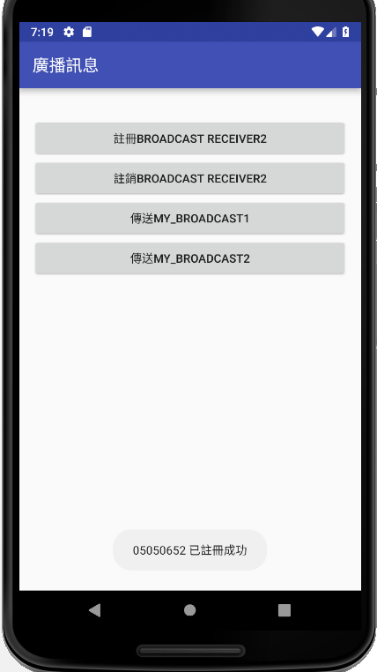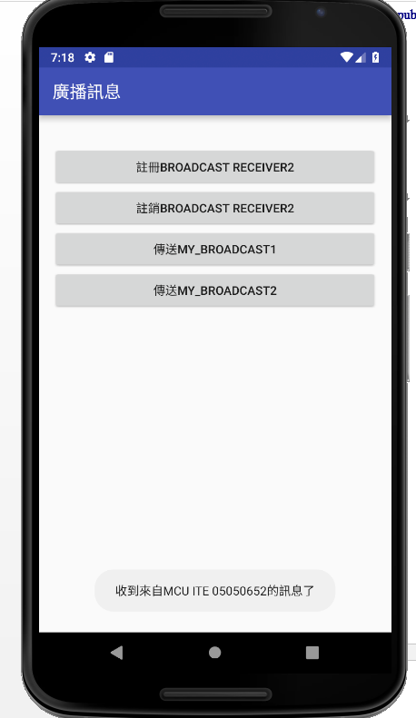

1. 請參考範例
   1. 建立兩種形式的Service
      * startService -> 顯示AlertDialog, 使用者點選確定後消失
      * bindService -> 由主程式呼叫Service裡的method, 該method為顯示Toast訊息
2. 請參考範例
   1. 建立基本的App Widget
      1. App Widget的圖示為 MCU的圖示或是自己找到的圖示
      2. 並於log中可看到APP Widget的相關訊息