Intent

1. 請參考投影片內容，建立以下的Android應用程式

並請將1.**建立過程**; 2.程式**執行結果**截圖; 2.程式**原始檔 copy&paste**置入作業中

1. 請參考範例
   1. 利用Intent Filter建立數個Button
   2. Button 1, 送出網址,開啟的方式為 Intent.ACTION_VIEW
   3. Button 2, 指定圖片, 開啟的方式為 Intent.ACTION_VIEW
   4. Button 3, 指定圖片, 開啟的方式為 Intent.ACTION_EDIT
   5. 並請於AndroidManifest.xml中設定相關的Intent Filter

**package** com.intentfilter;  
  
**import** android.content.Intent;  
**import** android.support.v7.app.AppCompatActivity;  
**import** android.os.Bundle;  
**import** android.widget.TextView;  
  
**public class** MyImageActivity **extends** AppCompatActivity {  
  
 **private** TextView **mTxtResult**;  
  
 @Override  
 **protected void** onCreate(Bundle savedInstanceState) {  
 **super**.onCreate(savedInstanceState);  
 setContentView(R.layout.***activity_my_image***);  
  
 **mTxtResult** = (TextView)findViewById(R.id.***txtResult***);  
 showResult();  
 }  
  
 **private void** showResult() {  
 Intent it = getIntent();  
 String sAct = it.getAction();  
 String sScheme = it.getScheme();  
 **if** (sScheme.equals(**"http"**)) {  
 String s = **"接收到的Intent物件要求\"開啟網頁\""** + it.getData().toString();  
 **mTxtResult**.setText(s);  
 } **else if** (sScheme.equals(**"tel"**)) {  
 String s = **"接收到的Intent物件要求\"撥打電話\""** + it.getData().toString();  
 **mTxtResult**.setText(s);  
 } **else if** (sScheme.equals(**"file"**)) {  
 **if** (sAct.equals(**"android.intent.action.VIEW"**)) {  
 String s = **"接收到的Intent物件要求\"檢視\""** + it.getData().toString();  
 **mTxtResult**.setText(s);  
 } **else if** (sAct.equals(**"android.intent.action.EDIT"**)) {  
 String s = **"接收到的Intent物件要求\"編輯\""** + it.getData().toString();  
 **mTxtResult**.setText(s);  
 }  
 }  
 }  
}

**package** com.intentfilter;  
  
**import** android.content.Intent;  
**import** android.net.Uri;  
**import** android.os.Environment;  
**import** android.support.v7.app.AppCompatActivity;  
**import** android.os.Bundle;  
**import** android.view.View;  
**import** android.widget.Button;  
  
**import** java.io.File;  
  
**public class** MainActivity **extends** AppCompatActivity {  
  
 **private** Button **mBtnBrowseWWW**,  
 **mBtnEditImg**,  
 **mBtnViewImg**;  
  
  
 @Override  
 **protected void** onCreate(Bundle savedInstanceState) {  
 **super**.onCreate(savedInstanceState);  
 setContentView(R.layout.***activity_main***);  
  
 **mBtnBrowseWWW** = (Button)findViewById(R.id.***btnBrowseWWW***);  
 **mBtnEditImg** = (Button)findViewById(R.id.***btnEditImg***);  
 **mBtnViewImg** = (Button)findViewById(R.id.***btnViewImg***);  
  
 **mBtnBrowseWWW**.setOnClickListener(**btnBrowseWWWOnClick**);  
 **mBtnEditImg**.setOnClickListener(**btnEditImgOnClick**);  
 **mBtnViewImg**.setOnClickListener(**btnViewImgOnClick**);  
 }  
  
 **private** View.OnClickListener **btnBrowseWWWOnClick** = **new** View.OnClickListener() {  
 **public void** onClick(View v) {  
 Uri uri = Uri.*parse*(**"https://www.youtube.com/watch?v=WlosjSe5B8c"**);  
 Intent it = **new** Intent(Intent.***ACTION_VIEW***, uri);  
 startActivity(it);  
 }  
 };  
  
 **private** View.OnClickListener **btnEditImgOnClick** = **new** View.OnClickListener() {  
 **public void** onClick(View v) {  
 Intent it = **new** Intent(Intent.***ACTION_EDIT***);  
 File file = **new** File(**"/sdcard/image.PNG"**);  
 it.setDataAndType(Uri.*fromFile*(file), **"image/*"**);  
 startActivity(it);  
 }  
 };  
  
 **private** View.OnClickListener **btnViewImgOnClick** = **new** View.OnClickListener() {  
 **public void** onClick(View v) {  
 Intent it = **new** Intent(Intent.***ACTION_VIEW***);  
 File file = **new** File(**"/sdcard/image1.jpg"**);  
 it.setDataAndType(Uri.*fromFile*(file), **"image/*"**);  
 startActivity(it);  
 }  
 };  
}

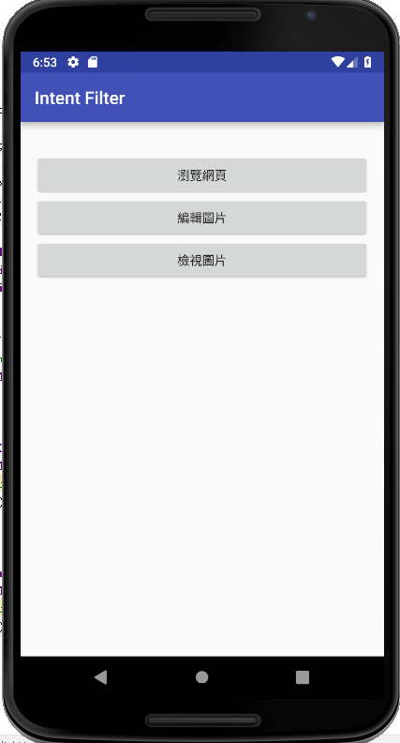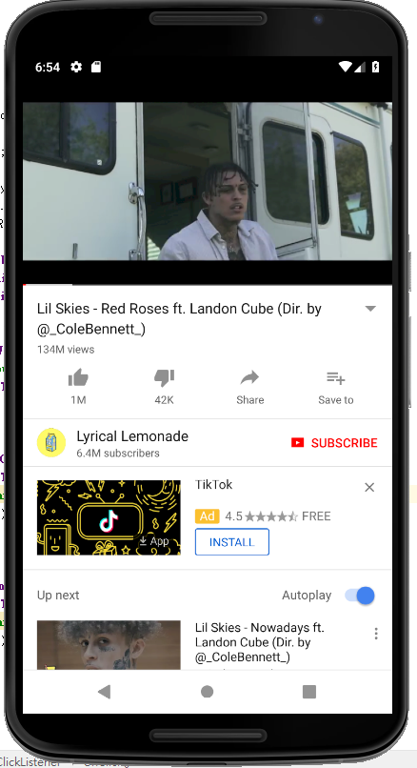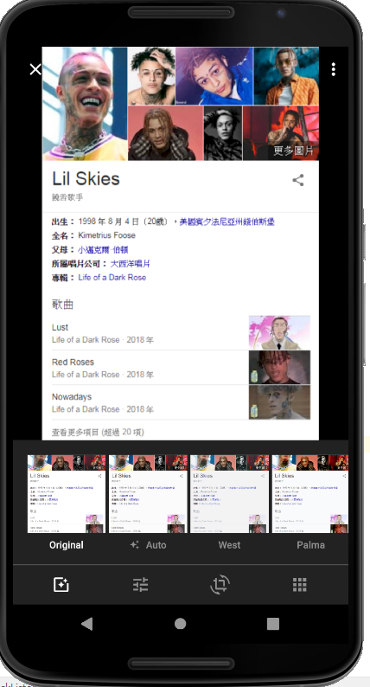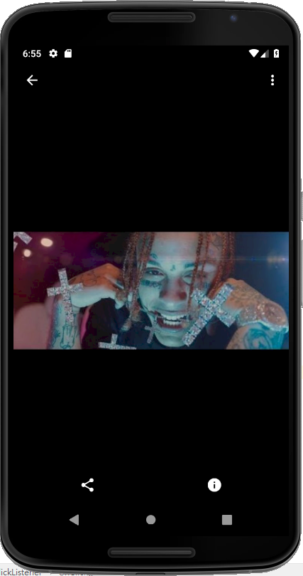

1. 請參考範例
   1. 使用Intent技術,改寫之前的作業 **數字比大小**
   2. 主畫面中只有一個Button, 按一下Button 即跳出數字比大小的程式
   3. 數字比大小結束後,會回傳比賽結果給主畫面顯示

Game activity

**package** com.activityreturndata;  
  
**import** android.content.Intent;  
**import** android.os.Bundle;  
**import** android.support.v7.app.AppCompatActivity;  
**import** android.view.View;  
**import** android.widget.Button;  
**import** android.widget.ImageButton;  
**import** android.widget.ImageView;  
**import** android.widget.TextView;  
  
**public class** GameActivity **extends** AppCompatActivity {  
  
 **private** TextView **mTxtResult**;  
 **private** ImageView **mImgViewComPlay**;  
 **private** ImageButton **mImgBtnOne**, **mImgBtnTwo**, **mImgBtnThree**, **mImgBtnFour**, **mImgBtnFive**, **mImgBtnSix**;  
 **private** Button **mBtnOK**, **mBtnCancel**;  
  
 *// 新增統計遊戲局數和輸贏的變數* **private int miCountSet** = 0,  
 **miCountPlayerWin** = 0,  
 **miCountComWin** = 0,  
 **miCountDraw** = 0;  
  
 @Override  
 **protected void** onCreate(Bundle savedInstanceState) {  
 **super**.onCreate(savedInstanceState);  
 setContentView(R.layout.***activity_game***);  
  
 **mImgViewComPlay** = (ImageView) findViewById(R.id.***imgViewComPlay***);  
 **mTxtResult** = (TextView)findViewById(R.id.***txtResult***);  
 **mImgBtnOne** = (ImageButton)findViewById(R.id.***imgBtnone***);  
 **mImgBtnTwo** = (ImageButton)findViewById(R.id.***imgBtntwo***);  
 **mImgBtnThree** = (ImageButton)findViewById(R.id.***imgBtnthree***);  
 **mImgBtnFour** = (ImageButton)findViewById(R.id.***imgBtnfour***);  
 **mImgBtnFive** = (ImageButton)findViewById(R.id.***imgBtnfive***);  
 **mImgBtnSix** = (ImageButton)findViewById(R.id.***imgBtnsix***);  
  
 **mImgBtnOne**.setOnClickListener(**imgBtnOneOnClick**);  
 **mImgBtnTwo**.setOnClickListener(**imgBtnTwoOnClick**);  
 **mImgBtnThree**.setOnClickListener(**imgBtnThreeOnClick**);  
 **mImgBtnFour**.setOnClickListener(**imgBtnFourOnClick**);  
 **mImgBtnFive**.setOnClickListener(**imgBtnFiveOnClick**);  
 **mImgBtnSix**.setOnClickListener(**imgBtnSixOnClick**);  
  
  
 **mBtnOK** = (Button)findViewById(R.id.***btnOK***);  
 **mBtnCancel** = (Button)findViewById(R.id.***btnCancel***);  
 **mBtnOK**.setOnClickListener(**btnOKOnClick**);  
 **mBtnCancel**.setOnClickListener(**btnCancelOnClick**);  
 }  
  
  
 **private** View.OnClickListener **imgBtnOneOnClick** = **new** View.OnClickListener() {  
 **public void** onClick(View v) {  
 *// 決定電腦出拳.* **int** iComPlay = (**int**)(Math.*random*()*6 + 1);  
  
 **miCountSet**++;  
  
 *// 1 – 剪刀, 2 – 石頭, 3 – 布.* **if** (iComPlay == 1) {  
 **mImgViewComPlay**.setImageResource(R.drawable.***one***);  
 **mTxtResult**.setText(getString(R.string.***result***) +  
 getString(R.string.***player_flat***));  
 **miCountDraw**++;  
 }  
 **else if** (iComPlay == 2) {  
 **mImgViewComPlay**.setImageResource(R.drawable.***two***);  
 **mTxtResult**.setText(getString(R.string.***result***) +  
 getString(R.string.***player_lose***));  
 **miCountComWin**++;  
 }  
 **else if** (iComPlay == 3){  
 **mImgViewComPlay**.setImageResource(R.drawable.***three***);  
 **mTxtResult**.setText(getString(R.string.***result***) +  
 getString(R.string.***player_lose***));  
 **miCountComWin**++;  
 }  
 **else if** (iComPlay == 4){  
 **mImgViewComPlay**.setImageResource(R.drawable.***four***);  
 **mTxtResult**.setText(getString(R.string.***result***) +  
 getString(R.string.***player_lose***));  
 **miCountComWin**++;  
 }  
 **else if** (iComPlay == 5){  
 **mImgViewComPlay**.setImageResource(R.drawable.***five***);  
 **mTxtResult**.setText(getString(R.string.***result***) +  
 getString(R.string.***player_lose***));  
 **miCountComWin**++;  
 }  
 **else if** (iComPlay == 6){  
 **mImgViewComPlay**.setImageResource(R.drawable.***six***);  
 **mTxtResult**.setText(getString(R.string.***result***) +  
 getString(R.string.***player_lose***));  
 **miCountComWin**++;  
 }  
 }  
 };  
  
 **private** View.OnClickListener **imgBtnTwoOnClick** = **new** View.OnClickListener() {  
 **public void** onClick(View v) {  
 *// 決定電腦出拳.* **int** iComPlay = (**int**)(Math.*random*()*6 + 1);  
  
 **miCountSet**++;  
  
 *// 1 – 剪刀, 2 – 石頭, 3 – 布.* **if** (iComPlay == 1) {  
 **mImgViewComPlay**.setImageResource(R.drawable.***one***);  
 **mTxtResult**.setText(getString(R.string.***result***) +  
 getString(R.string.***player_win***));  
 **miCountPlayerWin**++;  
  
 }  
 **else if** (iComPlay == 2) {  
 **mImgViewComPlay**.setImageResource(R.drawable.***two***);  
 **mTxtResult**.setText(getString(R.string.***result***) +  
 getString(R.string.***player_flat***));  
 **miCountDraw**++;  
 }  
 **else if** (iComPlay == 3){  
 **mImgViewComPlay**.setImageResource(R.drawable.***three***);  
 **mTxtResult**.setText(getString(R.string.***result***) +  
 getString(R.string.***player_lose***));  
 **miCountComWin**++;  
 }  
 **else if** (iComPlay == 4){  
 **mImgViewComPlay**.setImageResource(R.drawable.***four***);  
 **mTxtResult**.setText(getString(R.string.***result***) +  
 getString(R.string.***player_lose***));  
 **miCountComWin**++;  
 }  
 **else if** (iComPlay == 5){  
 **mImgViewComPlay**.setImageResource(R.drawable.***five***);  
 **mTxtResult**.setText(getString(R.string.***result***) +  
 getString(R.string.***player_lose***));  
 **miCountComWin**++;  
 }  
 **else if** (iComPlay == 6){  
 **mImgViewComPlay**.setImageResource(R.drawable.***six***);  
 **mTxtResult**.setText(getString(R.string.***result***) +  
 getString(R.string.***player_lose***));  
 **miCountComWin**++;  
 }  
 }  
 };  
  
 **private** View.OnClickListener **imgBtnThreeOnClick** = **new** View.OnClickListener() {  
 **public void** onClick(View v) {  
 *// 決定電腦出拳.* **int** iComPlay = (**int**)(Math.*random*()*6 + 1);  
  
 **miCountSet**++;  
  
 *// 1 – 剪刀, 2 – 石頭, 3 – 布.* **if** (iComPlay == 1) {  
 **mImgViewComPlay**.setImageResource(R.drawable.***one***);  
 **mTxtResult**.setText(getString(R.string.***result***) +  
 getString(R.string.***player_win***));  
 **miCountPlayerWin**++;  
  
 }  
 **else if** (iComPlay == 2) {  
 **mImgViewComPlay**.setImageResource(R.drawable.***two***);  
 **mTxtResult**.setText(getString(R.string.***result***) +  
 getString(R.string.***player_win***));  
 **miCountPlayerWin**++;  
  
 }  
 **else if** (iComPlay == 3){  
 **mImgViewComPlay**.setImageResource(R.drawable.***three***);  
 **mTxtResult**.setText(getString(R.string.***result***) +  
 getString(R.string.***player_flat***));  
 **miCountDraw**++;  
 }  
 **else if** (iComPlay == 4){  
 **mImgViewComPlay**.setImageResource(R.drawable.***four***);  
 **mTxtResult**.setText(getString(R.string.***result***) +  
 getString(R.string.***player_lose***));  
 **miCountComWin**++;  
 }  
 **else if** (iComPlay == 5){  
 **mImgViewComPlay**.setImageResource(R.drawable.***five***);  
 **mTxtResult**.setText(getString(R.string.***result***) +  
 getString(R.string.***player_lose***));  
 **miCountComWin**++;  
 }  
 **else if** (iComPlay == 6) {  
 **mImgViewComPlay**.setImageResource(R.drawable.***six***);  
 **mTxtResult**.setText(getString(R.string.***result***) +  
 getString(R.string.***player_lose***));  
 **miCountComWin**++;  
 }  
 }  
 };  
  
 **private** View.OnClickListener **imgBtnFourOnClick** = **new** View.OnClickListener() {  
 **public void** onClick(View v) {  
 *// 決定電腦出拳.* **int** iComPlay = (**int**)(Math.*random*()*6 + 1);  
  
 **miCountSet**++;  
  
 *// 1 – 剪刀, 2 – 石頭, 3 – 布.* **if** (iComPlay == 1) {  
 **mImgViewComPlay**.setImageResource(R.drawable.***one***);  
 **mTxtResult**.setText(getString(R.string.***result***) +  
 getString(R.string.***player_win***));  
 **miCountPlayerWin**++;  
 }  
 **else if** (iComPlay == 2) {  
 **mImgViewComPlay**.setImageResource(R.drawable.***two***);  
 **mTxtResult**.setText(getString(R.string.***result***) +  
 getString(R.string.***player_win***));  
 **miCountPlayerWin**++;  
 }  
 **else if** (iComPlay == 3){  
 **mImgViewComPlay**.setImageResource(R.drawable.***three***);  
 **mTxtResult**.setText(getString(R.string.***result***) +  
 getString(R.string.***player_win***));  
 **miCountPlayerWin**++;  
 }  
 **else if** (iComPlay == 4){  
 **mImgViewComPlay**.setImageResource(R.drawable.***four***);  
 **mTxtResult**.setText(getString(R.string.***result***) +  
 getString(R.string.***player_flat***));  
 **miCountDraw**++;  
 }  
 **else if** (iComPlay == 5){  
 **mImgViewComPlay**.setImageResource(R.drawable.***five***);  
 **mTxtResult**.setText(getString(R.string.***result***) +  
 getString(R.string.***player_lose***));  
 **miCountComWin**++;  
 }  
 **else if** (iComPlay == 6) {  
 **mImgViewComPlay**.setImageResource(R.drawable.***six***);  
 **mTxtResult**.setText(getString(R.string.***result***) +  
 getString(R.string.***player_lose***));  
 **miCountComWin**++;  
 }  
 }  
 };  
  
 **private** View.OnClickListener **imgBtnFiveOnClick** = **new** View.OnClickListener() {  
 **public void** onClick(View v) {  
 *// 決定電腦出拳.* **int** iComPlay = (**int**)(Math.*random*()*6 + 1);  
  
 **miCountSet**++;  
  
 *// 1 – 剪刀, 2 – 石頭, 3 – 布.* **if** (iComPlay == 1) {  
 **mImgViewComPlay**.setImageResource(R.drawable.***one***);  
 **mTxtResult**.setText(getString(R.string.***result***) +  
 getString(R.string.***player_win***));  
 **miCountPlayerWin**++;  
 }  
 **else if** (iComPlay == 2) {  
 **mImgViewComPlay**.setImageResource(R.drawable.***two***);  
 **mTxtResult**.setText(getString(R.string.***result***) +  
 getString(R.string.***player_win***));  
 **miCountPlayerWin**++;  
 }  
 **else if** (iComPlay == 3){  
 **mImgViewComPlay**.setImageResource(R.drawable.***three***);  
 **mTxtResult**.setText(getString(R.string.***result***) +  
 getString(R.string.***player_win***));  
 **miCountPlayerWin**++;  
 }  
 **else if** (iComPlay == 4){  
 **mImgViewComPlay**.setImageResource(R.drawable.***four***);  
 **mTxtResult**.setText(getString(R.string.***result***) +  
 getString(R.string.***player_win***));  
 **miCountPlayerWin**++;  
 }  
 **else if** (iComPlay == 5){  
 **mImgViewComPlay**.setImageResource(R.drawable.***five***);  
 **mTxtResult**.setText(getString(R.string.***result***) +  
 getString(R.string.***player_flat***));  
 **miCountDraw**++;  
 }  
 **else if** (iComPlay == 6) {  
 **mImgViewComPlay**.setImageResource(R.drawable.***six***);  
 **mTxtResult**.setText(getString(R.string.***result***) +  
 getString(R.string.***player_lose***));  
 **miCountComWin**++;  
 }  
 }  
 };  
  
 **private** View.OnClickListener **imgBtnSixOnClick** = **new** View.OnClickListener() {  
 **public void** onClick(View v) {  
 *// 決定電腦出拳.* **int** iComPlay = (**int**)(Math.*random*()*6 + 1);  
  
 **miCountSet**++;  
  
 *// 1 – 剪刀, 2 – 石頭, 3 – 布.* **if** (iComPlay == 1) {  
 **mImgViewComPlay**.setImageResource(R.drawable.***one***);  
 **mTxtResult**.setText(getString(R.string.***result***) +  
 getString(R.string.***player_win***));  
 **miCountPlayerWin**++;  
 }  
 **else if** (iComPlay == 2) {  
 **mImgViewComPlay**.setImageResource(R.drawable.***two***);  
 **mTxtResult**.setText(getString(R.string.***result***) +  
 getString(R.string.***player_win***));  
 **miCountPlayerWin**++;  
 }  
 **else if** (iComPlay == 3){  
 **mImgViewComPlay**.setImageResource(R.drawable.***three***);  
 **mTxtResult**.setText(getString(R.string.***result***) +  
 getString(R.string.***player_win***));  
 **miCountPlayerWin**++;  
 }  
 **else if** (iComPlay == 4){  
 **mImgViewComPlay**.setImageResource(R.drawable.***four***);  
 **mTxtResult**.setText(getString(R.string.***result***) +  
 getString(R.string.***player_win***));  
 **miCountPlayerWin**++;  
 }  
 **else if** (iComPlay == 5){  
 **mImgViewComPlay**.setImageResource(R.drawable.***five***);  
 **mTxtResult**.setText(getString(R.string.***result***) +  
 getString(R.string.***player_win***));  
 **miCountPlayerWin**++;  
 }  
 **else if** (iComPlay == 6) {  
 **mImgViewComPlay**.setImageResource(R.drawable.***six***);  
 **mTxtResult**.setText(getString(R.string.***result***) +  
 getString(R.string.***player_flat***));  
 **miCountDraw**++;  
 }  
 }  
 };  
  
  
  
  
  
 **private** View.OnClickListener **btnOKOnClick** = **new** View.OnClickListener() {  
 **public void** onClick(View v) {  
 Intent it = **new** Intent();  
  
 Bundle bundle = **new** Bundle();  
 bundle.putInt(**"KEY_COUNT_SET"**, **miCountSet**);  
 bundle.putInt(**"KEY_COUNT_PLAYER_WIN"**, **miCountPlayerWin**);  
 bundle.putInt(**"KEY_COUNT_COM_WIN"**, **miCountComWin**);  
 bundle.putInt(**"KEY_COUNT_DRAW"**, **miCountDraw**);  
 it.putExtras(bundle);  
  
 setResult(***RESULT_OK***, it);  
 finish();  
 }  
 };  
  
 **private** View.OnClickListener **btnCancelOnClick** = **new** View.OnClickListener() {  
 **public void** onClick(View v) {  
 setResult(***RESULT_CANCELED***);  
 finish();  
 }  
 };  
}

Main activity

**package** com.activityreturndata;  
  
**import** android.content.Intent;  
**import** android.support.v7.app.AppCompatActivity;  
**import** android.os.Bundle;  
**import** android.view.View;  
**import** android.widget.Button;  
**import** android.widget.TextView;  
  
**public class** MainActivity **extends** AppCompatActivity {  
  
 **final static private int *LAUNCH_GAME*** = 0;  
 **private** TextView **mTxtResult**;  
 **private** Button **mBtnLaunchGame**;  
  
 @Override  
 **protected void** onCreate(Bundle savedInstanceState) {  
 **super**.onCreate(savedInstanceState);  
 setContentView(R.layout.***activity_main***);  
  
 Button btn = (Button) findViewById(R.id.***btnLaunchGame***);  
 btn.setOnClickListener(**btnLaunchGameOnClick**);  
  
 **mTxtResult** = (TextView)findViewById(R.id.***txtResult***);  
 }  
  
 @Override  
 **protected void** onActivityResult(**int** requestCode, **int** resultCode, Intent data) {  
 **if** (requestCode != ***LAUNCH_GAME***)  
 **return**;  
  
 **switch** (resultCode) {  
 **case *RESULT_OK***:  
 Bundle bundle = data.getExtras();  
  
 **int** iCountSet = bundle.getInt(**"KEY_COUNT_SET"**);  
 **int** iCountPlayerWin = bundle.getInt(**"KEY_COUNT_PLAYER_WIN"**);  
 **int** iCountComWin = bundle.getInt(**"KEY_COUNT_COM_WIN"**);  
 **int** iCountDraw = bundle.getInt(**"KEY_COUNT_DRAW"**);  
  
 String s = **"遊戲結果：你總共玩了"** + iCountSet +  
 **"局, 贏了"** + iCountPlayerWin +  
 **"局, 輸了"** + iCountComWin +  
 **"局, 平手"** + iCountDraw + **"局"**;  
 **mTxtResult**.setText(s);  
  
 **break**;  
 **case *RESULT_CANCELED***:  
 **mTxtResult**.setText(**"你選擇取消遊戲。"**);  
 }  
 }  
  
 **private** View.OnClickListener **btnLaunchGameOnClick** = **new** View.OnClickListener() {  
 @Override  
 **public void** onClick(View view) {  
 Intent it = **new** Intent();  
 it.setClass(MainActivity.**this**, GameActivity.**class**);  
 startActivityForResult(it, ***LAUNCH_GAME***);  
 }  
 };  
}

Game layout

*<?***xml version="1.0" encoding="utf-8"***?>*<**RelativeLayout xmlns:android="http://schemas.android.com/apk/res/android"  
 android:layout_width="match_parent"  
 android:layout_height="match_parent"  
 android:paddingBottom="@dimen/activity_vertical_margin"  
 android:paddingLeft="@dimen/activity_horizontal_margin"  
 android:paddingRight="@dimen/activity_horizontal_margin"  
 android:paddingTop="@dimen/activity_vertical_margin"**>  
  
 <**TextView android:id="@+id/txtTitle"  
 android:layout_width="wrap_content"  
 android:layout_height="wrap_content"  
 android:text="@string/prompt_title"  
 android:textSize="40sp"  
 android:textColor="#FF00FF"  
 android:textStyle="bold"  
 android:layout_centerHorizontal="true"  
 android:paddingLeft="20dp"  
 android:paddingRight="20dp"  
 android:layout_marginTop="20dp"  
 android:layout_marginBottom="20dp"** />  
  
  
 <**TextView android:id="@+id/txtCom"  
 android:layout_width="wrap_content"  
 android:layout_height="wrap_content"  
 android:text="@string/prompt_com_play"  
 android:layout_below="@id/txtTitle"  
 android:layout_alignLeft="@id/txtTitle"  
 android:textSize="20sp"  
 android:layout_marginBottom="20dp"** />  
  
  
 <**TextView android:id="@+id/txtMyPlay"  
 android:layout_width="wrap_content"  
 android:layout_height="wrap_content"  
 android:text="@string/prompt_my_play"  
 android:layout_below="@id/txtTitle"  
 android:layout_alignRight="@id/txtTitle"  
 android:textSize="20sp"  
 android:layout_marginBottom="20dp"** />  
  
  
 <**ImageButton  
 android:id="@+id/imgBtnone"  
 android:layout_width="63dp"  
 android:layout_height="56dp"  
 android:layout_alignLeft="@id/txtMyPlay"  
 android:layout_alignBottom="@id/txtCom"  
 android:layout_marginLeft="1dp"  
 android:layout_marginTop="62dp"  
 android:layout_marginBottom="-63dp"  
 android:paddingLeft="15dp"  
 android:paddingRight="15dp"  
 android:src="@drawable/one"** />  
  
  
 <**ImageView android:id="@+id/imgViewComPlay"  
 android:layout_width="wrap_content"  
 android:layout_height="wrap_content"  
 android:layout_marginLeft="1dp"  
 android:layout_marginTop="62dp"  
 android:layout_marginBottom="-63dp"  
 android:layout_below="@id/imgBtnone"  
 android:layout_alignLeft="@id/txtCom"** />  
  
  
 <**ImageButton  
 android:id="@+id/imgBtntwo"  
 android:layout_width="63dp"  
 android:layout_height="56dp"  
 android:layout_below="@id/imgBtnone"  
 android:layout_alignLeft="@id/imgBtnone"  
 android:layout_marginLeft="1dp"  
 android:layout_marginTop="100dp"  
 android:paddingLeft="15dp"  
 android:paddingRight="15dp"  
 android:src="@drawable/two"** />  
  
  
 <**ImageButton  
 android:id="@+id/imgBtnthree"  
 android:layout_width="63dp"  
 android:layout_height="56dp"  
 android:layout_below="@id/imgBtntwo"  
 android:layout_alignLeft="@id/imgBtntwo"  
 android:layout_marginLeft="0dp"  
 android:layout_marginTop="32dp"  
 android:paddingLeft="15dp"  
 android:paddingRight="15dp"  
 android:src="@drawable/three"** />  
  
  
 <**ImageButton  
 android:id="@+id/imgBtnfour"  
 android:layout_width="63dp"  
 android:layout_height="56dp"  
 android:layout_alignLeft="@id/imgBtnthree"  
 android:layout_alignTop="@+id/imgBtnone"  
 android:layout_marginLeft="84dp"  
 android:layout_toRightOf="@id/imgBtnone"  
 android:paddingLeft="15dp"  
 android:paddingRight="15dp"  
 android:src="@drawable/four"** />  
  
  
 <**ImageButton  
 android:id="@+id/imgBtnfive"  
 android:layout_width="63dp"  
 android:layout_height="56dp"  
 android:layout_alignLeft="@id/imgBtntwo"  
 android:layout_alignTop="@+id/imgBtnfour"  
 android:layout_marginLeft="84dp"  
 android:layout_marginTop="94dp"  
 android:layout_toRightOf="@id/imgBtntwo"  
 android:paddingLeft="15dp"  
 android:paddingRight="15dp"  
 android:src="@drawable/five"** />  
  
  
 <**ImageButton  
 android:id="@+id/imgBtnsix"  
 android:layout_width="63dp"  
 android:layout_height="56dp"  
 android:layout_alignLeft="@id/imgBtnthree"  
 android:layout_alignTop="@+id/imgBtnthree"  
 android:layout_marginLeft="86dp"  
 android:layout_marginTop="-1dp"  
 android:layout_toRightOf="@id/imgBtnthree"  
 android:paddingLeft="15dp"  
 android:paddingRight="15dp"  
 android:src="@drawable/six"** />  
  
  
 <**TextView android:id="@+id/txtResult"  
 android:layout_width="wrap_content"  
 android:layout_height="wrap_content"  
 android:text="@string/result"  
 android:layout_below="@id/imgBtnthree"  
 android:layout_alignLeft="@id/txtCom"  
 android:textSize="20sp"  
 android:textColor="#0000FF"  
 android:layout_marginTop="20dp"** />  
  
 <**Button  
 android:id="@+id/btnOK"  
 android:layout_width="wrap_content"  
 android:layout_height="wrap_content"  
 android:text="完成遊戲"  
 android:layout_below="@id/txtResult"  
 android:textSize="20sp"  
 android:layout_marginTop="10dp"  
 android:layout_alignLeft="@+id/txtResult"** />  
  
 <**Button  
 android:id="@+id/btnCancel"  
 android:layout_width="wrap_content"  
 android:layout_height="wrap_content"  
 android:text="取消"  
 android:layout_toRightOf="@+id/btnOK"  
 android:layout_alignTop="@id/btnOK"  
 android:textSize="20sp"  
 android:layout_marginLeft="50dp"** />  
  
</**RelativeLayout**>

Main layout

*<?***xml version="1.0" encoding="utf-8"***?>*<**LinearLayout xmlns:android="http://schemas.android.com/apk/res/android"  
 xmlns:tools="http://schemas.android.com/tools"  
 android:layout_width="match_parent"  
 android:layout_height="match_parent"  
 android:paddingBottom="@dimen/activity_vertical_margin"  
 android:paddingLeft="@dimen/activity_horizontal_margin"  
 android:paddingRight="@dimen/activity_horizontal_margin"  
 android:paddingTop="@dimen/activity_vertical_margin"  
 android:orientation="vertical"**>  
  
 <**Button  
 android:id="@+id/btnLaunchGame"  
 android:layout_width="match_parent"  
 android:layout_height="wrap_content"  
 android:text="執行「電腦比大小遊戲」程式"** />  
  
 <**TextView  
 android:id="@+id/txtResult"  
 android:layout_width="wrap_content"  
 android:layout_height="wrap_content"** />  
  
</**LinearLayout**>

Strings

<**resources**>  
 <**string name="app_name"**>數字比大小遊戲</**string**>  
 <**string name="action_settings"**>Settings</**string**>  
 <**string name="prompt_com_play"**>電腦數字：</**string**>  
 <**string name="prompt_my_play"**>玩家數字：</**string**>  
  
 <**string name="player_win"**>恭喜，你贏了！</**string**>  
 <**string name="player_lose"**>很可惜，你輸了！</**string**>  
 <**string name="player_draw"**>雙方平手！</**string**>  
 <**string name="player_flat"**>雙方平手！</**string**>  
 <**string name="prompt_title"**>數字比大小</**string**>  
 <**string name="result"**>判定輸贏：</**string**>  
</**resources**>

