Activity進階功能

1. 請參考投影片內容，建立以下的Android應用程式

並請將1.**建立過程**; 2.程式**執行結果**截圖; 2.程式**原始檔 copy&paste**置入作業中

1. 請參考範例
   1. 建立Menu,請在程式中直接建立
      * Menu的選項有 1.銘傳網頁, 點選後開啟銘傳的網頁
      * 2.關於這個程式, 點選後會跳出AlertDialog顯示相關資訊
      * 3.結束

MainActivity:

**package** com.menu;  
  
**import** android.app.AlertDialog;  
**import** android.content.DialogInterface;  
**import** android.content.Intent;  
**import** android.net.Uri;  
**import** android.os.Bundle;  
**import** android.support.design.widget.FloatingActionButton;  
**import** android.support.design.widget.Snackbar;  
**import** android.support.v7.app.AppCompatActivity;  
**import** android.support.v7.widget.Toolbar;  
**import** android.view.SubMenu;  
**import** android.view.View;  
**import** android.view.Menu;  
**import** android.view.MenuItem;  
**import** android.widget.Button;  
**import** android.widget.TextView;  
  
**public class** MainActivity **extends** AppCompatActivity {  
  
 **private static final int *MENU_MUSIC*** = Menu.***FIRST***,  
 ***MENU_PLAY_MUSIC*** = Menu.***FIRST*** + 1,  
 ***MENU_STOP_PLAYING_MUSIC*** = Menu.***FIRST*** + 2,  
 ***MENU_ABOUT*** = Menu.***FIRST*** + 3,  
 ***MENU_EXIT*** = Menu.***FIRST*** + 4;  
  
 **private** TextView **gg**;  
  
  
 @Override  
 **protected void** onCreate(Bundle savedInstanceState) {  
 **super**.onCreate(savedInstanceState);  
 setContentView(R.layout.***activity_main***);  
  
 **gg** = (TextView) findViewById(R.id.***txtResulT***);  
 }  
  
 @Override  
 **public boolean** onCreateOptionsMenu(Menu menu) {  
 menu.add(0, ***MENU_MUSIC***, 0, **"銘傳網頁"**)  
 .setIcon(android.R.drawable.***ic_media_ff***);  
 menu.add(0, ***MENU_ABOUT***, 1, **"關於這個程式..."**)  
 .setIcon(android.R.drawable.***ic_dialog_info***);  
 menu.add(0, ***MENU_EXIT***, 2, **"結束"**)  
 .setIcon(android.R.drawable.***ic_menu_close_clear_cancel***);  
  
 **return true**;  
 }  
  
 @Override  
 **public boolean** onOptionsItemSelected(MenuItem item) {  
 **switch** (item.getItemId()) {  
 **case *MENU_MUSIC***:  
 Uri uri = Uri.*parse*(**"https://moodle.mcu.edu.tw/"**);  
 Intent its = **new** Intent(Intent.***ACTION_VIEW***, uri);  
 startActivity(its);  
 **return true**;  
 **case *MENU_ABOUT***:  
 */*new AlertDialog.Builder(MainActivity.this)  
 .setTitle("關於這個程式")  
 .setMessage("選單範例程式")  
 .setCancelable(false)  
 .setIcon(android.R.drawable.star_big_on)  
 .setPositiveButton("確定",  
 new DialogInterface.OnClickListener() {  
 @Override  
 public void onClick(DialogInterface dialog, int which) {  
 }  
 })  
 .show();*/* **gg**.setText(**""**);  
 AlertDialog.Builder altDlgBldr = **new** AlertDialog.Builder(MainActivity.**this**);  
 altDlgBldr.setTitle(**"AlertDialog"**);  
 altDlgBldr.setMessage(**"確認AlertDialog是否正確"**);  
 altDlgBldr.setIcon(android.R.drawable.***ic_dialog_info***);  
 altDlgBldr.setCancelable(**false**);  
 altDlgBldr.setPositiveButton(**"是"**,  
 **new** DialogInterface.OnClickListener() {  
 @Override  
 **public void** onClick(DialogInterface dialog, **int** which) {  
 **gg**.setText(  
 **"點選了是!"**);  
  
 }  
 });  
  
 altDlgBldr.setNegativeButton(**"否"**,  
 **new** DialogInterface.OnClickListener() {  
 @Override  
 **public void** onClick(DialogInterface dialog, **int** which) {  
 **gg**.setText(  
 **"點選了否!"**);  
 }  
 });  
  
 altDlgBldr.show();  
 **return true**;  
 **case *MENU_EXIT***:  
 finish();  
 **return true**;  
 }  
  
 **return super**.onOptionsItemSelected(item);  
 }  
}

MediaPlayService:

**package** com.menu;  
  
**import** android.app.Service;  
**import** android.content.Intent;  
**import** android.media.MediaPlayer;  
**import** android.net.Uri;  
**import** android.os.Bundle;  
**import** android.os.Environment;  
**import** android.os.IBinder;  
**import** android.support.annotation.Nullable;  
**import** android.widget.TextView;  
  
**import** java.io.File;  
  
**public class** MediaPlayService **extends** Service{  
  
 **private** MediaPlayer **player**;  
  
 @Nullable  
 @Override  
 **public** IBinder onBind(Intent intent) {  
 **return null**;  
 }  
  
 @Override  
 **public void** onDestroy() {  
 **super**.onDestroy();  
 **player**.stop();  
 }  
  
 @Override  
 **public int** onStartCommand(Intent intent, **int** flags, **int** startId) {  
 Uri uriFile = Uri.*fromFile*(**new** File(  
 Environment.*getExternalStorageDirectory*().getPath() + **"/song.mp3"**));  
 **player** = MediaPlayer.*create*(**this**, uriFile);  
 **player**.start();  
  
  
  
 **return super**.onStartCommand(intent, flags, startId);  
  
  
 }  
  
 }

activity_main:

<**RelativeLayout xmlns:android="http://schemas.android.com/apk/res/android"  
 xmlns:tools="http://schemas.android.com/tools"  
 android:layout_width="match_parent"  
 android:layout_height="match_parent"  
 android:paddingBottom="@dimen/activity_vertical_margin"  
 android:paddingLeft="@dimen/activity_horizontal_margin"  
 android:paddingRight="@dimen/activity_horizontal_margin"  
 android:paddingTop="@dimen/activity_vertical_margin"  
 tools:context=".MainActivity"** >  
  
 <**TextView  
 android:layout_width="wrap_content"  
 android:layout_height="wrap_content"  
 android:text="@string/hello_world"** />  
  
 <**TextView android:id="@+id/txtResulT"  
 android:layout_width="wrap_content"  
 android:layout_height="wrap_content"  
 android:layout_marginTop="15dp"**/>  
  
</**RelativeLayout**>

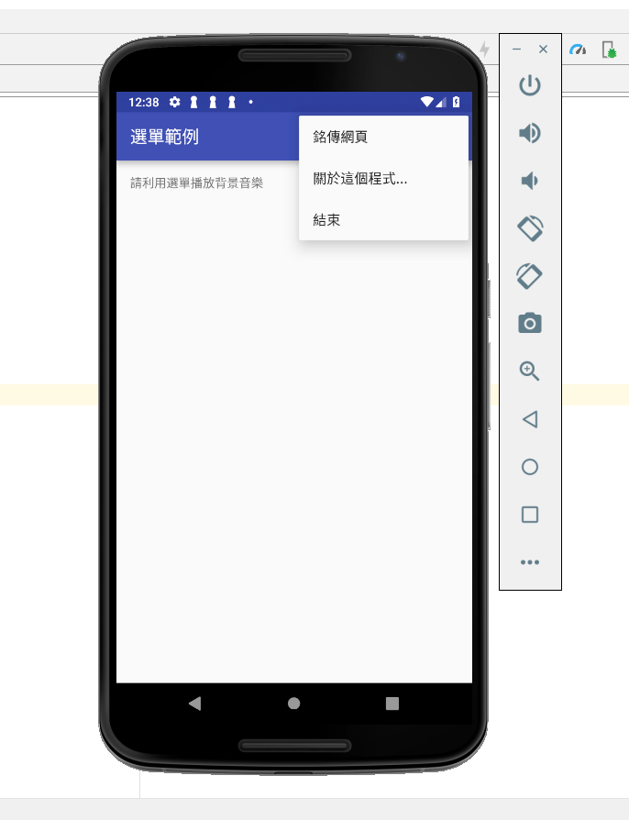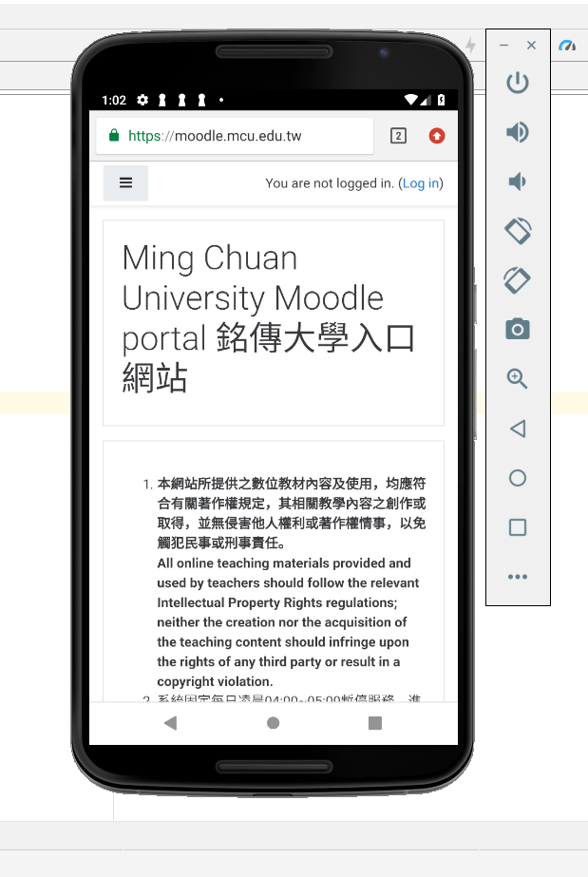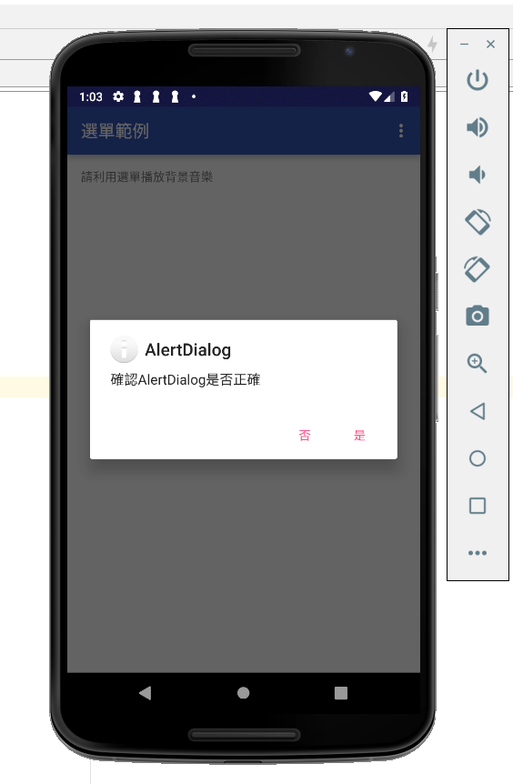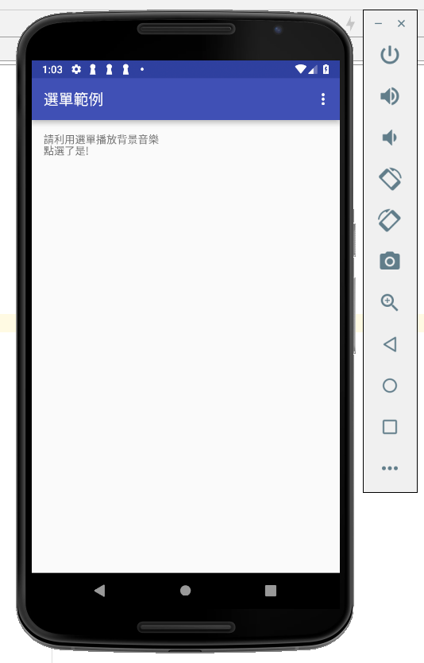

* 1. 建立Context Menu,請使用xml檔案的方式建立
     + Menu的選項有 1.銘傳網頁, 點選後開啟銘傳的網頁
     + 2.關於這個程式, 點選後會跳出AlertDialog顯示相關資訊
     + 3.結束

MainActivity:

**package** com.contextmenu;  
  
**import** android.app.AlertDialog;  
**import** android.content.DialogInterface;  
**import** android.content.Intent;  
**import** android.net.Uri;  
**import** android.support.v7.app.AppCompatActivity;  
**import** android.os.Bundle;  
**import** android.view.ContextMenu;  
**import** android.view.Menu;  
**import** android.view.MenuItem;  
**import** android.view.SubMenu;  
**import** android.view.View;  
**import** android.widget.RelativeLayout;  
**import** android.widget.TextView;  
  
**public class** MainActivity **extends** AppCompatActivity {  
  
 **private static final int *MENU_MUSIC*** = Menu.***FIRST***,  
 ***MENU_PLAY_MUSIC*** = Menu.***FIRST*** + 1,  
 ***MENU_STOP_PLAYING_MUSIC*** = Menu.***FIRST*** + 2,  
 ***MENU_ABOUT*** = Menu.***FIRST*** + 3,  
 ***MENU_EXIT*** = Menu.***FIRST*** + 4;  
  
 **private** RelativeLayout **mRelativeLayout**;  
 **private** TextView **mTxtView**;  
  
 **private** TextView **gg**;  
  
 @Override  
 **protected void** onCreate(Bundle savedInstanceState) {  
 **super**.onCreate(savedInstanceState);  
 setContentView(R.layout.***activity_main***);  
  
 **mRelativeLayout** = (RelativeLayout) findViewById(R.id.***relativeLayout***);  
 registerForContextMenu(**mRelativeLayout**);  
 **mTxtView** = (TextView) findViewById(R.id.***txtView***);  
 registerForContextMenu(**mTxtView**);  
  
 **gg** = (TextView) findViewById(R.id.***txtResulT***);  
 }  
  
 @Override  
 **public boolean** onCreateOptionsMenu(Menu menu) {  
 menu.add(0, ***MENU_MUSIC***, 0, **"銘傳網頁"**)  
 .setIcon(android.R.drawable.***ic_media_ff***);  
 menu.add(0, ***MENU_ABOUT***, 1, **"關於這個程式..."**)  
 .setIcon(android.R.drawable.***ic_dialog_info***);  
 menu.add(0, ***MENU_EXIT***, 2, **"結束"**)  
 .setIcon(android.R.drawable.***ic_menu_close_clear_cancel***);  
  
 **return true**;  
 }  
  
 @Override  
 **public boolean** onOptionsItemSelected(MenuItem item) {  
 **switch** (item.getItemId()) {  
 **case *MENU_MUSIC***:  
 Uri uri = Uri.*parse*(**"https://moodle.mcu.edu.tw/"**);  
 Intent its = **new** Intent(Intent.***ACTION_VIEW***, uri);  
 startActivity(its);  
 **return true**;  
 **case *MENU_ABOUT***:  
 */*new AlertDialog.Builder(MainActivity.this)  
 .setTitle("關於這個程式")  
 .setMessage("選單範例程式")  
 .setCancelable(false)  
 .setIcon(android.R.drawable.star_big_on)  
 .setPositiveButton("確定",  
 new DialogInterface.OnClickListener() {  
 @Override  
 public void onClick(DialogInterface dialog, int which) {  
 //* ***TODO Auto-generated method stub*** *}  
 })  
 .show();*/* **gg**.setText(**""**);  
 AlertDialog.Builder altDlgBldr = **new** AlertDialog.Builder(MainActivity.**this**);  
 altDlgBldr.setTitle(**"AlertDialog"**);  
 altDlgBldr.setMessage(**"確認AlertDialog是否正確"**);  
 altDlgBldr.setIcon(android.R.drawable.***ic_dialog_info***);  
 altDlgBldr.setCancelable(**false**);  
 altDlgBldr.setPositiveButton(**"是"**,  
 **new** DialogInterface.OnClickListener() {  
 @Override  
 **public void** onClick(DialogInterface dialog, **int** which) {  
 **gg**.setText(  
 **"點選了是!"**);  
  
 }  
 });  
  
 altDlgBldr.setNegativeButton(**"否"**,  
 **new** DialogInterface.OnClickListener() {  
 @Override  
 **public void** onClick(DialogInterface dialog, **int** which) {  
 **gg**.setText(  
 **"點選了否!"**);  
 }  
 });  
  
 altDlgBldr.show();  
  
 **return true**;  
 **case *MENU_EXIT***:  
 finish();  
 **return true**;  
 }  
  
 **return super**.onOptionsItemSelected(item);  
 }  
  
 @Override  
 **public void** onCreateContextMenu(ContextMenu menu, View v, ContextMenu.ContextMenuInfo menuInfo) {  
 **super**.onCreateContextMenu(menu, v, menuInfo);  
  
 **if** (v == **mRelativeLayout**) {  
 **if** (menu.size() == 0) {  
 menu.add(0, ***MENU_MUSIC***, 0, **"銘傳網頁"**);  
 menu.add(0, ***MENU_ABOUT***, 1, **"關於這個程式..."**);  
 menu.add(0, ***MENU_EXIT***, 2, **"結束"**);  
 }  
 }  
 **else if** (v == **mTxtView**) {  
 menu.add(0, ***MENU_ABOUT***, 1, **"關於這個程式..."**);  
 }  
 }  
  
 @Override  
 **public boolean** onContextItemSelected(MenuItem item) {  
 onOptionsItemSelected(item);  
 **return super**.onContextItemSelected(item);  
 }  
}

MediaPlayService:

**package** com.contextmenu;  
  
**import** android.app.Service;  
**import** android.content.Intent;  
**import** android.media.MediaPlayer;  
**import** android.net.Uri;  
**import** android.os.Environment;  
**import** android.os.IBinder;  
**import** android.support.annotation.Nullable;  
  
**import** java.io.File;  
  
**public class** MediaPlayService **extends** Service{  
  
 **private** MediaPlayer **player**;  
  
 @Nullable  
 @Override  
 **public** IBinder onBind(Intent intent) {  
 **return null**;  
 }  
  
 @Override  
 **public void** onDestroy() {  
 **super**.onDestroy();  
 **player**.stop();  
 }  
  
 @Override  
 **public int** onStartCommand(Intent intent, **int** flags, **int** startId) {  
 Uri uriFile = Uri.*fromFile*(**new** File(  
 Environment.*getExternalStorageDirectory*().getPath() + **"/song.mp3"**));  
 **player** = MediaPlayer.*create*(**this**, uriFile);  
 **player**.start();  
  
 **return super**.onStartCommand(intent, flags, startId);  
 }  
}

activity_main:

*<?***xml version="1.0" encoding="utf-8"***?>*<**RelativeLayout xmlns:android="http://schemas.android.com/apk/res/android"  
 xmlns:tools="http://schemas.android.com/tools"  
 android:layout_width="match_parent"  
 android:layout_height="match_parent"  
 android:paddingBottom="@dimen/activity_vertical_margin"  
 android:paddingLeft="@dimen/activity_horizontal_margin"  
 android:paddingRight="@dimen/activity_horizontal_margin"  
 android:paddingTop="@dimen/activity_vertical_margin"  
 tools:context="com.contextmenu.MainActivity"  
 android:id="@+id/relativeLayout"** >  
  
 <**TextView  
 android:id="@+id/txtView"  
 android:layout_width="wrap_content"  
 android:layout_height="wrap_content"  
 android:text="@string/hello_world"** />  
  
 <**TextView android:id="@+id/txtResulT"  
 android:layout_width="wrap_content"  
 android:layout_height="wrap_content"  
 android:layout_marginTop="15dp"**/>  
</**RelativeLayout**>

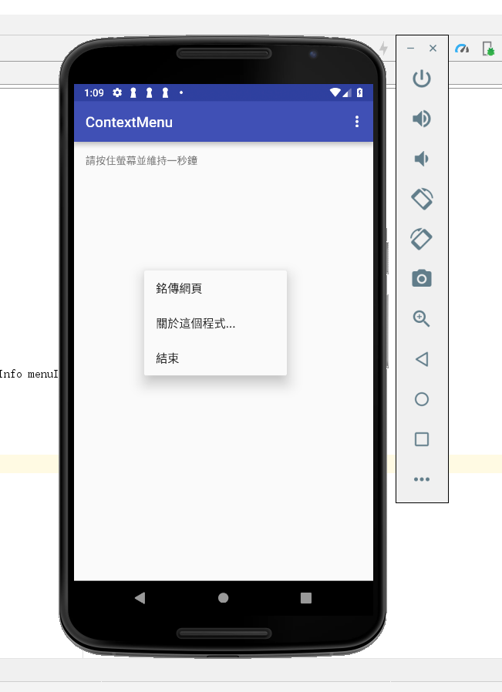



1. 請參考範例
   * + 改寫數字比大小遊戲,每一局的遊戲結果請以Notification顯示在狀態列

MainActivty:

**package** com.activityreturndata;  
  
**import** android.content.Intent;  
**import** android.support.v7.app.AppCompatActivity;  
**import** android.os.Bundle;  
**import** android.view.View;  
**import** android.widget.Button;  
**import** android.widget.TextView;  
  
**public class** MainActivity **extends** AppCompatActivity {  
  
 **final static private int *LAUNCH_GAME*** = 0;  
 **private** TextView **mTxtResult**;  
 **private** Button **mBtnLaunchGame**;  
  
 @Override  
 **protected void** onCreate(Bundle savedInstanceState) {  
 **super**.onCreate(savedInstanceState);  
 setContentView(R.layout.***activity_main***);  
  
 Button btn = (Button) findViewById(R.id.***btnLaunchGame***);  
 btn.setOnClickListener(**btnLaunchGameOnClick**);  
  
 **mTxtResult** = (TextView)findViewById(R.id.***txtResult***);  
 }  
  
 @Override  
 **protected void** onActivityResult(**int** requestCode, **int** resultCode, Intent data) {  
 **if** (requestCode != ***LAUNCH_GAME***)  
 **return**;  
  
 **switch** (resultCode) {  
 **case *RESULT_OK***:  
 Bundle bundle = data.getExtras();  
  
 **int** iCountSet = bundle.getInt(**"KEY_COUNT_SET"**);  
 **int** iCountPlayerWin = bundle.getInt(**"KEY_COUNT_PLAYER_WIN"**);  
 **int** iCountComWin = bundle.getInt(**"KEY_COUNT_COM_WIN"**);  
 **int** iCountDraw = bundle.getInt(**"KEY_COUNT_DRAW"**);  
  
 String s = **"遊戲結果：你總共玩了"** + iCountSet +  
 **"局, 贏了"** + iCountPlayerWin +  
 **"局, 輸了"** + iCountComWin +  
 **"局, 平手"** + iCountDraw + **"局"**;  
 **mTxtResult**.setText(s);  
  
 **break**;  
 **case *RESULT_CANCELED***:  
 **mTxtResult**.setText(**"你選擇取消遊戲。"**);  
 }  
 }  
  
 **private** View.OnClickListener **btnLaunchGameOnClick** = **new** View.OnClickListener() {  
 @Override  
 **public void** onClick(View view) {  
 Intent it = **new** Intent();  
 it.setClass(MainActivity.**this**, GameActivity.**class**);  
 startActivityForResult(it, ***LAUNCH_GAME***);  
 }  
 };  
}

GameActivity:

**package** com.activityreturndata;  
  
**import** android.app.PendingIntent;  
**import** android.content.Intent;  
**import** android.os.Bundle;  
**import** android.support.v7.app.AppCompatActivity;  
**import** android.view.View;  
**import** android.widget.Button;  
**import** android.widget.ImageButton;  
**import** android.widget.ImageView;  
**import** android.widget.TextView;  
**import** android.app.Notification;  
**import** android.app.NotificationManager;  
  
**public class** GameActivity **extends** AppCompatActivity {  
  
 **private static final int *NOTI_ID*** = 100;  
  
 **private** TextView **mTxtResult**;  
 **private** ImageView **mImgViewComPlay**;  
 *//private ImageButton mImgBtnScissors, mImgBtnStone, mImgBtnPaper;* **private** ImageButton **mImgBtnOne**, **mImgBtnTwo**, **mImgBtnThree**, **mImgBtnFour**, **mImgBtnFive**, **mImgBtnSix**;  
 **private** Button **mBtnOK**, **mBtnCancel**;  
  
 *// 新增統計遊戲局數和輸贏的變數* **private int miCountSet** = 0,  
 **miCountPlayerWin** = 0,  
 **miCountComWin** = 0,  
 **miCountDraw** = 0;  
  
 @Override  
 **protected void** onCreate(Bundle savedInstanceState) {  
 **super**.onCreate(savedInstanceState);  
 setContentView(R.layout.***activity_game***);  
  
 **mImgViewComPlay** = (ImageView)findViewById(R.id.***imgViewComPlay***);  
 **mTxtResult** = (TextView)findViewById(R.id.***txtResult***);  
 *//mImgBtnScissors = (ImageButton)findViewById(R.id.imgBtnScissors);  
 //mImgBtnStone = (ImageButton)findViewById(R.id.imgBtnStone);  
 //mImgBtnPaper = (ImageButton)findViewById(R.id.imgBtnPaper);* **mImgBtnOne** = (ImageButton)findViewById(R.id.***imgBtnOne***);  
 **mImgBtnTwo** = (ImageButton)findViewById(R.id.***imgBtnTwo***);  
 **mImgBtnThree** = (ImageButton)findViewById(R.id.***imgBtnThree***);  
 **mImgBtnFour** = (ImageButton)findViewById(R.id.***imgBtnFour***);  
 **mImgBtnFive** = (ImageButton)findViewById(R.id.***imgBtnFive***);  
 **mImgBtnSix** = (ImageButton)findViewById(R.id.***imgBtnSix***);  
  
 *//mImgBtnScissors.setOnClickListener(imgBtnScissorsOnClick);  
 //mImgBtnStone.setOnClickListener(imgBtnStoneOnClick);  
 //mImgBtnPaper.setOnClickListener(imgBtnPaperOnClick);* **mImgBtnOne**.setOnClickListener(**imgBtnOneOnClick**);  
 **mImgBtnTwo**.setOnClickListener(**imgBtnTwoOnClick**);  
 **mImgBtnThree**.setOnClickListener(**imgBtnThreeOnClick**);  
 **mImgBtnFour**.setOnClickListener(**imgBtnFourOnClick**);  
 **mImgBtnFive**.setOnClickListener(**imgBtnFiveOnClick**);  
 **mImgBtnSix**.setOnClickListener(**imgBtnSixOnClick**);  
  
 **mBtnOK** = (Button)findViewById(R.id.***btnOK***);  
 **mBtnCancel** = (Button)findViewById(R.id.***btnCancel***);  
 **mBtnOK**.setOnClickListener(**btnOKOnClick**);  
 **mBtnCancel**.setOnClickListener(**btnCancelOnClick**);  
 }  
  
 @Override  
 **protected void** onDestroy() {  
 ((NotificationManager) getSystemService(***NOTIFICATION_SERVICE***))  
 .cancel(***NOTI_ID***);  
  
 **super**.onDestroy();  
 }  
  
 **private** View.OnClickListener **imgBtnOneOnClick** = **new** View.OnClickListener() {  
 **public void** onClick(View v) {  
 *// 決定電腦出拳.* **int** iComPlay = (**int**)(Math.*random*()*6 + 1);  
  
 **miCountSet**++;  
  
 *// 1 – 剪刀, 2 – 石頭, 3 – 布.* **if** (iComPlay == 1) {  
 **mImgViewComPlay**.setImageResource(R.drawable.***one***);  
 **mTxtResult**.setText(getString(R.string.***result***) +  
 getString(R.string.***player_flat***));  
 **miCountDraw**++;  
 showNotification(**"平手"** + Integer.*toString*(**miCountDraw**) + **"局"**);  
 }  
 **else if** (iComPlay == 2) {  
 **mImgViewComPlay**.setImageResource(R.drawable.***two***);  
 **mTxtResult**.setText(getString(R.string.***result***) +  
 getString(R.string.***player_lose***));  
 **miCountComWin**++;  
 showNotification(**"電腦贏"** + Integer.*toString*(**miCountComWin**) + **"局"**);  
 }  
 **else if** (iComPlay == 3){  
 **mImgViewComPlay**.setImageResource(R.drawable.***three***);  
 **mTxtResult**.setText(getString(R.string.***result***) +  
 getString(R.string.***player_lose***));  
 **miCountComWin**++;  
 showNotification(**"電腦贏"** + Integer.*toString*(**miCountComWin**) + **"局"**);  
 }  
 **else if** (iComPlay == 4){  
 **mImgViewComPlay**.setImageResource(R.drawable.***four***);  
 **mTxtResult**.setText(getString(R.string.***result***) +  
 getString(R.string.***player_lose***));  
 **miCountComWin**++;  
 showNotification(**"電腦贏"** + Integer.*toString*(**miCountComWin**) + **"局"**);  
 }  
 **else if** (iComPlay == 5){  
 **mImgViewComPlay**.setImageResource(R.drawable.***five***);  
 **mTxtResult**.setText(getString(R.string.***result***) +  
 getString(R.string.***player_lose***));  
 **miCountComWin**++;  
 showNotification(**"電腦贏"** + Integer.*toString*(**miCountComWin**) + **"局"**);  
 }  
 **else if** (iComPlay == 6){  
 **mImgViewComPlay**.setImageResource(R.drawable.***six***);  
 **mTxtResult**.setText(getString(R.string.***result***) +  
 getString(R.string.***player_lose***));  
 **miCountComWin**++;  
 showNotification(**"電腦贏"** + Integer.*toString*(**miCountComWin**) + **"局"**);  
 }  
 }  
 };  
  
 **private** View.OnClickListener **imgBtnTwoOnClick** = **new** View.OnClickListener() {  
 **public void** onClick(View v) {  
 *// 決定電腦出拳.* **int** iComPlay = (**int**)(Math.*random*()*6 + 1);  
  
 **miCountSet**++;  
  
 *// 1 – 剪刀, 2 – 石頭, 3 – 布.* **if** (iComPlay == 1) {  
 **mImgViewComPlay**.setImageResource(R.drawable.***one***);  
 **mTxtResult**.setText(getString(R.string.***result***) +  
 getString(R.string.***player_win***));  
 **miCountPlayerWin**++;  
 showNotification(**"玩家贏"** + Integer.*toString*(**miCountPlayerWin**) + **"局"**);  
  
 }  
 **else if** (iComPlay == 2) {  
 **mImgViewComPlay**.setImageResource(R.drawable.***two***);  
 **mTxtResult**.setText(getString(R.string.***result***) +  
 getString(R.string.***player_flat***));  
 **miCountDraw**++;  
 showNotification(**"平手"** + Integer.*toString*(**miCountDraw**) + **"局"**);  
 }  
 **else if** (iComPlay == 3){  
 **mImgViewComPlay**.setImageResource(R.drawable.***three***);  
 **mTxtResult**.setText(getString(R.string.***result***) +  
 getString(R.string.***player_lose***));  
 **miCountComWin**++;  
 showNotification(**"電腦贏"** + Integer.*toString*(**miCountComWin**) + **"局"**);  
 }  
 **else if** (iComPlay == 4){  
 **mImgViewComPlay**.setImageResource(R.drawable.***four***);  
 **mTxtResult**.setText(getString(R.string.***result***) +  
 getString(R.string.***player_lose***));  
 **miCountComWin**++;  
 showNotification(**"電腦贏"** + Integer.*toString*(**miCountComWin**) + **"局"**);  
 }  
 **else if** (iComPlay == 5){  
 **mImgViewComPlay**.setImageResource(R.drawable.***five***);  
 **mTxtResult**.setText(getString(R.string.***result***) +  
 getString(R.string.***player_lose***));  
 **miCountComWin**++;  
 showNotification(**"電腦贏"** + Integer.*toString*(**miCountComWin**) + **"局"**);  
 }  
 **else if** (iComPlay == 6){  
 **mImgViewComPlay**.setImageResource(R.drawable.***six***);  
 **mTxtResult**.setText(getString(R.string.***result***) +  
 getString(R.string.***player_lose***));  
 **miCountComWin**++;  
 showNotification(**"電腦贏"** + Integer.*toString*(**miCountComWin**) + **"局"**);  
 }  
 }  
 };  
  
 **private** View.OnClickListener **imgBtnThreeOnClick** = **new** View.OnClickListener() {  
 **public void** onClick(View v) {  
 *// 決定電腦出拳.* **int** iComPlay = (**int**)(Math.*random*()*6 + 1);  
  
 **miCountSet**++;  
  
 *// 1 – 剪刀, 2 – 石頭, 3 – 布.* **if** (iComPlay == 1) {  
 **mImgViewComPlay**.setImageResource(R.drawable.***one***);  
 **mTxtResult**.setText(getString(R.string.***result***) +  
 getString(R.string.***player_win***));  
 **miCountPlayerWin**++;  
 showNotification(**"玩家贏"** + Integer.*toString*(**miCountPlayerWin**) + **"局"**);  
  
 }  
 **else if** (iComPlay == 2) {  
 **mImgViewComPlay**.setImageResource(R.drawable.***two***);  
 **mTxtResult**.setText(getString(R.string.***result***) +  
 getString(R.string.***player_win***));  
 **miCountPlayerWin**++;  
 showNotification(**"玩家贏"** + Integer.*toString*(**miCountPlayerWin**) + **"局"**);  
  
 }  
 **else if** (iComPlay == 3){  
 **mImgViewComPlay**.setImageResource(R.drawable.***three***);  
 **mTxtResult**.setText(getString(R.string.***result***) +  
 getString(R.string.***player_flat***));  
 **miCountDraw**++;  
 showNotification(**"平手"** + Integer.*toString*(**miCountDraw**) + **"局"**);  
 }  
 **else if** (iComPlay == 4){  
 **mImgViewComPlay**.setImageResource(R.drawable.***four***);  
 **mTxtResult**.setText(getString(R.string.***result***) +  
 getString(R.string.***player_lose***));  
 **miCountComWin**++;  
 showNotification(**"電腦贏"** + Integer.*toString*(**miCountComWin**) + **"局"**);  
 }  
 **else if** (iComPlay == 5){  
 **mImgViewComPlay**.setImageResource(R.drawable.***five***);  
 **mTxtResult**.setText(getString(R.string.***result***) +  
 getString(R.string.***player_lose***));  
 **miCountComWin**++;  
 showNotification(**"電腦贏"** + Integer.*toString*(**miCountComWin**) + **"局"**);  
 }  
 **else if** (iComPlay == 6) {  
 **mImgViewComPlay**.setImageResource(R.drawable.***six***);  
 **mTxtResult**.setText(getString(R.string.***result***) +  
 getString(R.string.***player_lose***));  
 **miCountComWin**++;  
 showNotification(**"電腦贏"** + Integer.*toString*(**miCountComWin**) + **"局"**);  
 }  
 }  
 };  
  
 **private** View.OnClickListener **imgBtnFourOnClick** = **new** View.OnClickListener() {  
 **public void** onClick(View v) {  
 *// 決定電腦出拳.* **int** iComPlay = (**int**)(Math.*random*()*6 + 1);  
  
 **miCountSet**++;  
  
 *// 1 – 剪刀, 2 – 石頭, 3 – 布.* **if** (iComPlay == 1) {  
 **mImgViewComPlay**.setImageResource(R.drawable.***one***);  
 **mTxtResult**.setText(getString(R.string.***result***) +  
 getString(R.string.***player_win***));  
 **miCountPlayerWin**++;  
 showNotification(**"玩家贏"** + Integer.*toString*(**miCountPlayerWin**) + **"局"**);  
 }  
 **else if** (iComPlay == 2) {  
 **mImgViewComPlay**.setImageResource(R.drawable.***two***);  
 **mTxtResult**.setText(getString(R.string.***result***) +  
 getString(R.string.***player_win***));  
 **miCountPlayerWin**++;  
 showNotification(**"玩家贏"** + Integer.*toString*(**miCountPlayerWin**) + **"局"**);  
 }  
 **else if** (iComPlay == 3){  
 **mImgViewComPlay**.setImageResource(R.drawable.***three***);  
 **mTxtResult**.setText(getString(R.string.***result***) +  
 getString(R.string.***player_win***));  
 **miCountPlayerWin**++;  
 showNotification(**"玩家贏"** + Integer.*toString*(**miCountPlayerWin**) + **"局"**);  
 }  
 **else if** (iComPlay == 4){  
 **mImgViewComPlay**.setImageResource(R.drawable.***four***);  
 **mTxtResult**.setText(getString(R.string.***result***) +  
 getString(R.string.***player_flat***));  
 **miCountDraw**++;  
 showNotification(**"平手"** + Integer.*toString*(**miCountDraw**) + **"局"**);  
 }  
 **else if** (iComPlay == 5){  
 **mImgViewComPlay**.setImageResource(R.drawable.***five***);  
 **mTxtResult**.setText(getString(R.string.***result***) +  
 getString(R.string.***player_lose***));  
 **miCountComWin**++;  
 showNotification(**"電腦贏"** + Integer.*toString*(**miCountComWin**) + **"局"**);  
 }  
 **else if** (iComPlay == 6) {  
 **mImgViewComPlay**.setImageResource(R.drawable.***six***);  
 **mTxtResult**.setText(getString(R.string.***result***) +  
 getString(R.string.***player_lose***));  
 **miCountComWin**++;  
 showNotification(**"電腦贏"** + Integer.*toString*(**miCountComWin**) + **"局"**);  
 }  
 }  
 };  
  
 **private** View.OnClickListener **imgBtnFiveOnClick** = **new** View.OnClickListener() {  
 **public void** onClick(View v) {  
 *// 決定電腦出拳.* **int** iComPlay = (**int**)(Math.*random*()*6 + 1);  
  
 **miCountSet**++;  
  
 *// 1 – 剪刀, 2 – 石頭, 3 – 布.* **if** (iComPlay == 1) {  
 **mImgViewComPlay**.setImageResource(R.drawable.***one***);  
 **mTxtResult**.setText(getString(R.string.***result***) +  
 getString(R.string.***player_win***));  
 **miCountPlayerWin**++;  
 showNotification(**"玩家贏"** + Integer.*toString*(**miCountPlayerWin**) + **"局"**);  
 }  
 **else if** (iComPlay == 2) {  
 **mImgViewComPlay**.setImageResource(R.drawable.***two***);  
 **mTxtResult**.setText(getString(R.string.***result***) +  
 getString(R.string.***player_win***));  
 **miCountPlayerWin**++;  
 showNotification(**"玩家贏"** + Integer.*toString*(**miCountPlayerWin**) + **"局"**);  
 }  
 **else if** (iComPlay == 3){  
 **mImgViewComPlay**.setImageResource(R.drawable.***three***);  
 **mTxtResult**.setText(getString(R.string.***result***) +  
 getString(R.string.***player_win***));  
 **miCountPlayerWin**++;  
 showNotification(**"玩家贏"** + Integer.*toString*(**miCountPlayerWin**) + **"局"**);  
 }  
 **else if** (iComPlay == 4){  
 **mImgViewComPlay**.setImageResource(R.drawable.***four***);  
 **mTxtResult**.setText(getString(R.string.***result***) +  
 getString(R.string.***player_win***));  
 **miCountPlayerWin**++;  
 showNotification(**"玩家贏"** + Integer.*toString*(**miCountPlayerWin**) + **"局"**);  
 }  
 **else if** (iComPlay == 5){  
 **mImgViewComPlay**.setImageResource(R.drawable.***five***);  
 **mTxtResult**.setText(getString(R.string.***result***) +  
 getString(R.string.***player_flat***));  
 **miCountDraw**++;  
 showNotification(**"平手"** + Integer.*toString*(**miCountDraw**) + **"局"**);  
 }  
 **else if** (iComPlay == 6) {  
 **mImgViewComPlay**.setImageResource(R.drawable.***six***);  
 **mTxtResult**.setText(getString(R.string.***result***) +  
 getString(R.string.***player_lose***));  
 **miCountComWin**++;  
 }  
 }  
 };  
  
 **private** View.OnClickListener **imgBtnSixOnClick** = **new** View.OnClickListener() {  
 **public void** onClick(View v) {  
 *// 決定電腦出拳.* **int** iComPlay = (**int**)(Math.*random*()*6 + 1);  
  
 **miCountSet**++;  
  
 *// 1 – 剪刀, 2 – 石頭, 3 – 布.* **if** (iComPlay == 1) {  
 **mImgViewComPlay**.setImageResource(R.drawable.***one***);  
 **mTxtResult**.setText(getString(R.string.***result***) +  
 getString(R.string.***player_win***));  
 **miCountPlayerWin**++;  
 showNotification(**"玩家贏"** + Integer.*toString*(**miCountPlayerWin**) + **"局"**);  
 }  
 **else if** (iComPlay == 2) {  
 **mImgViewComPlay**.setImageResource(R.drawable.***two***);  
 **mTxtResult**.setText(getString(R.string.***result***) +  
 getString(R.string.***player_win***));  
 **miCountPlayerWin**++;  
 showNotification(**"玩家贏"** + Integer.*toString*(**miCountPlayerWin**) + **"局"**);  
 }  
 **else if** (iComPlay == 3){  
 **mImgViewComPlay**.setImageResource(R.drawable.***three***);  
 **mTxtResult**.setText(getString(R.string.***result***) +  
 getString(R.string.***player_win***));  
 **miCountPlayerWin**++;  
 showNotification(**"玩家贏"** + Integer.*toString*(**miCountPlayerWin**) + **"局"**);  
 }  
 **else if** (iComPlay == 4){  
 **mImgViewComPlay**.setImageResource(R.drawable.***four***);  
 **mTxtResult**.setText(getString(R.string.***result***) +  
 getString(R.string.***player_win***));  
 **miCountPlayerWin**++;  
 showNotification(**"玩家贏"** + Integer.*toString*(**miCountPlayerWin**) + **"局"**);  
 }  
 **else if** (iComPlay == 5){  
 **mImgViewComPlay**.setImageResource(R.drawable.***five***);  
 **mTxtResult**.setText(getString(R.string.***result***) +  
 getString(R.string.***player_win***));  
 **miCountPlayerWin**++;  
 showNotification(**"玩家贏"** + Integer.*toString*(**miCountPlayerWin**) + **"局"**);  
 }  
 **else if** (iComPlay == 6) {  
 **mImgViewComPlay**.setImageResource(R.drawable.***six***);  
 **mTxtResult**.setText(getString(R.string.***result***) +  
 getString(R.string.***player_flat***));  
 **miCountDraw**++;  
 showNotification(**"平手"** + Integer.*toString*(**miCountDraw**) + **"局"**);  
 }  
 }  
 };  
  
 **private** View.OnClickListener **btnOKOnClick** = **new** View.OnClickListener() {  
 **public void** onClick(View v) {  
 Intent it = **new** Intent();  
  
 Bundle bundle = **new** Bundle();  
 bundle.putInt(**"KEY_COUNT_SET"**, **miCountSet**);  
 bundle.putInt(**"KEY_COUNT_PLAYER_WIN"**, **miCountPlayerWin**);  
 bundle.putInt(**"KEY_COUNT_COM_WIN"**, **miCountComWin**);  
 bundle.putInt(**"KEY_COUNT_DRAW"**, **miCountDraw**);  
 it.putExtras(bundle);  
  
 setResult(***RESULT_OK***, it);  
 finish();  
 }  
 };  
  
 **private** View.OnClickListener **btnCancelOnClick** = **new** View.OnClickListener() {  
 **public void** onClick(View v) {  
 setResult(***RESULT_CANCELED***);  
 finish();  
 }  
 };  
  
 **private void** showNotification(String sMsg) {  
 Intent it = **new** Intent(getApplicationContext(), GameActivity.**class**);  
 it.setFlags(Intent.***FLAG_ACTIVITY_NEW_TASK***);  
 Bundle bundle = **new** Bundle();  
 bundle.putInt(**"KEY_COUNT_SET"**, **miCountSet**);  
 bundle.putInt(**"KEY_COUNT_PLAYER_WIN"**, **miCountPlayerWin**);  
 bundle.putInt(**"KEY_COUNT_COM_WIN"**, **miCountComWin**);  
 bundle.putInt(**"KEY_COUNT_DRAW"**, **miCountDraw**);  
 it.putExtras(bundle);  
  
 PendingIntent penIt = PendingIntent.*getActivity*(getApplicationContext(),  
 0, it, PendingIntent. ***FLAG_CANCEL_CURRENT***);  
  
 Notification noti = **new** Notification.Builder(**this**)  
 .setSmallIcon(android.R.drawable.***btn_star_big_on***)  
 .setTicker(sMsg)  
 .setContentTitle(getString(R.string.***app_name***))  
 .setContentText(sMsg)  
 .setContentIntent(penIt)  
 .build();  
  
 NotificationManager notiMgr =  
 (NotificationManager) getSystemService(***NOTIFICATION_SERVICE***);  
 notiMgr.notify(***NOTI_ID***, noti);  
 }  
}

