WebView

1. 請參考投影片內容，建立以下的Android應用程式

並請將1.**建立過程**; 2.程式**執行結果**截圖; 2.程式**原始檔 copy&paste**置入作業中

1. 請參考**投影片(沒有給範例)**
   1. 請嘗試建立出如圖示的簡易型網頁瀏覽器
   2. 鍵入網址後可以將網頁內容載入
   3. 使用到的元件有 TextView, EditText, Button, WebView

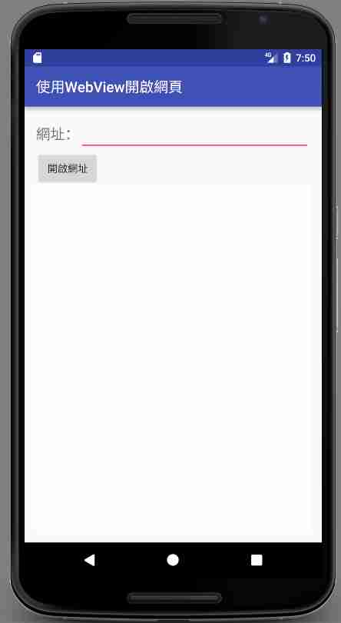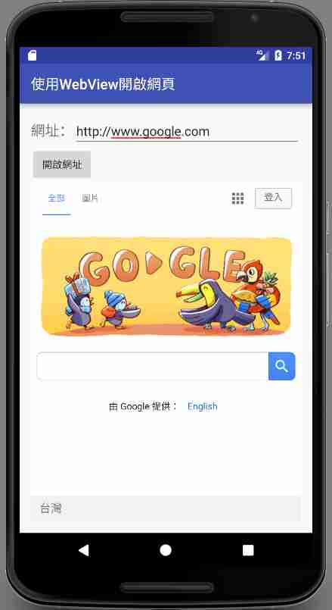

MainActivity:

**package** com.webbrowser;  
  
**import** android.support.v7.app.AppCompatActivity;  
**import** android.os.Bundle;  
**import** android.view.View;  
**import** android.view.Window;  
**import** android.webkit.WebChromeClient;  
**import** android.webkit.WebSettings;  
**import** android.webkit.WebView;  
**import** android.webkit.WebViewClient;  
**import** android.widget.Button;  
**import** android.widget.EditText;  
**import** android.widget.Toast;  
  
**public class** MainActivity **extends** AppCompatActivity  
 **implements** View.OnClickListener {  
  
 **private** Button **mBtnOpenUrl**,  
 **mBtnGoBack**,  
 **mBtnGoForward**,  
 **mBtnStop**,  
 **mBtnReload**;  
 **private** EditText **mEdtUrl**;  
 WebView **mWebView**;  
  
 @Override  
 **protected void** onCreate(Bundle savedInstanceState) {  
 **super**.onCreate(savedInstanceState);  
 setContentView(R.layout.***activity_main***);  
  
 **mBtnOpenUrl** = (Button)findViewById(R.id.***btnOpenUrl***);  
 **mEdtUrl** = (EditText)findViewById(R.id.***edtUrl***);  
 **mWebView** = (WebView)findViewById(R.id.***webView***);  
  
 *// 使用自訂的 MyWebViewClient 可以篩選在程式中  
 // 瀏覽的網頁，或是啟動外部的瀏覽器。* **mWebView**.setWebViewClient(**new** MyWebViewClient());  
  
 */*mWebView.setWebChromeClient(new WebChromeClient() {  
 public void onProgressChanged(WebView view, int progress) {  
 if (progress >= 100)  
 Toast.makeText(MainActivity.this, "網頁下載完成",  
 Toast.LENGTH_SHORT)  
 .show();  
 }  
 });*/* WebSettings webSettings = **mWebView**.getSettings();  
 webSettings.setJavaScriptEnabled(**true**);  
 *//webSettings.setSupportZoom(true);  
 //webSettings.setBuiltInZoomControls(true);* **mBtnOpenUrl**.setOnClickListener(**this**);  
  
 }  
  
 @Override  
 **public void** onClick(View view) {  
  
 **mWebView**.loadUrl(**mEdtUrl**.getText().toString());  
  
 }  
}

activity_main:

*<?***xml version="1.0" encoding="utf-8"***?>*<**LinearLayout xmlns:android="http://schemas.android.com/apk/res/android"  
 xmlns:tools="http://schemas.android.com/tools"  
 android:layout_width="match_parent"  
 android:layout_height="match_parent"  
 android:paddingBottom="@dimen/activity_vertical_margin"  
 android:paddingLeft="@dimen/activity_horizontal_margin"  
 android:paddingRight="@dimen/activity_horizontal_margin"  
 android:paddingTop="@dimen/activity_vertical_margin"  
 tools:context="com.webbrowser.MainActivity"  
 android:orientation="vertical"**>  
  
  
 <**LinearLayout  
 android:layout_width="match_parent"  
 android:layout_height="wrap_content"  
 android:orientation="horizontal"**>  
  
 <**TextView  
 android:layout_width="wrap_content"  
 android:layout_height="wrap_content"  
 android:text="網址："  
 android:textSize="20sp"** />  
  
 <**EditText  
 android:id="@+id/edtUrl"  
 android:layout_width="wrap_content"  
 android:layout_height="wrap_content"  
 android:ems="10"  
 android:singleLine="true"** />  
  
 <**Button  
 android:id="@+id/btnOpenUrl"  
 android:layout_width="wrap_content"  
 android:layout_height="wrap_content"  
 android:text="開啟網址"** />  
  
  
 </**LinearLayout**>  
  
  
 <**WebView  
 android:id="@+id/webView"  
 android:layout_width="372dp"  
 android:layout_height="436dp"  
  
 android:layout_weight="0"**/>  
  
</**LinearLayout**>

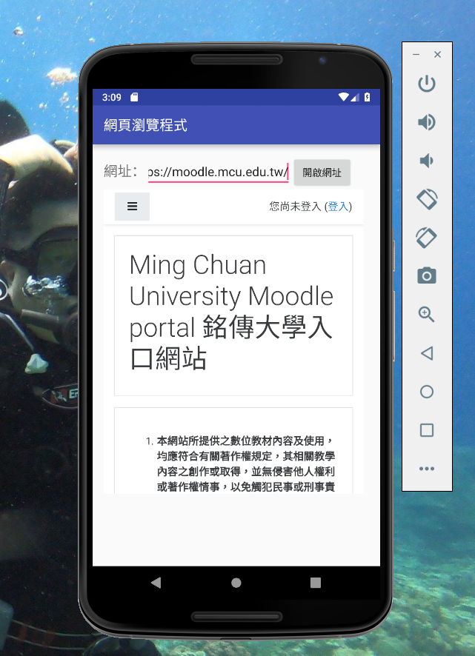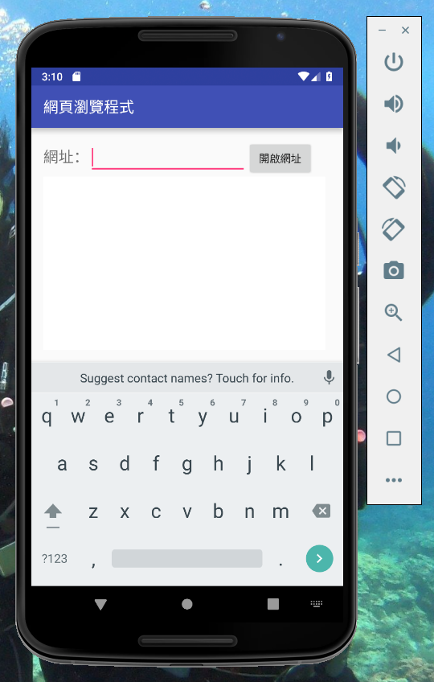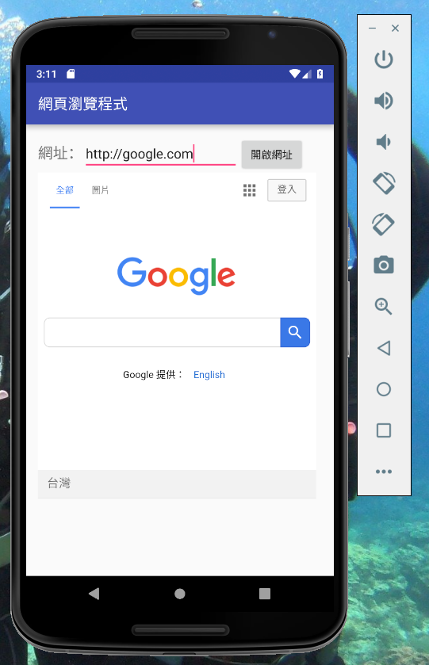

1. 請參考**範例專案**
   1. 於APP內透過WebView載入內建網頁,網頁中有一個Button為 ” 呼叫 Android 程式顯示 Dialog” ,按下後,可由內建網頁呼叫APP的一個方法, 該方法為顯示AlertDialog,如下圖



* 1. APP內的按鈕 “用程式碼建立網頁” , 可由APP內自動建立出網頁並顯示於WebView內,網頁內容為一行字與一張圖,如下所示



MainActivity:

**package** com.javascriptandapp;  
  
**import** android.app.AlertDialog;  
**import** android.support.v7.app.AppCompatActivity;  
**import** android.os.Bundle;  
**import** android.view.View;  
**import** android.webkit.WebSettings;  
**import** android.webkit.WebView;  
**import** android.widget.Button;  
**import** android.content.DialogInterface;  
  
**import** java.net.URLDecoder;  
  
**public class** MainActivity **extends** AppCompatActivity  
 **implements** View.OnClickListener {  
  
 **private** Button **mBtnLoadHtml**,  
 **mBtnShowImage**,  
 **mBtnBuildHtml**;  
 **private** WebView **mWebView**;  
  
 @Override  
 **protected void** onCreate(Bundle savedInstanceState) {  
 **super**.onCreate(savedInstanceState);  
 setContentView(R.layout.***activity_main***);  
  
 **mBtnLoadHtml** = (Button)findViewById(R.id.***btnLoadHtml***);  
 **mBtnShowImage** = (Button)findViewById(R.id.***btnShowImage***);  
 **mBtnBuildHtml** = (Button)findViewById(R.id.***btnBuildHtml***);  
 **mWebView** = (WebView)findViewById(R.id.***webView***);  
  
 WebSettings webSettings = **mWebView**.getSettings();  
 webSettings.setJavaScriptEnabled(**true**);  
  
 **mWebView**.addJavascriptInterface(**new** JavaScriptCallFunc(**this**), **"Android"**);  
  
 **mBtnLoadHtml**.setOnClickListener(**this**);  
 **mBtnShowImage**.setOnClickListener(**this**);  
 **mBtnBuildHtml**.setOnClickListener(**this**);  
 }  
  
 *//file:///android_asset/my_web_page.html  
 //javascript:myAlertDialog()* @Override  
 **public void** onClick(View view) {  
 **switch** (view.getId()) {  
 **case** R.id.***btnLoadHtml***:  
 **mWebView**.loadUrl(**"file:///android_asset/my_web_page.html"**);  
  
 **break**;  
 **case** R.id.***btnShowImage***:  
 **mWebView**.loadUrl(**"javascript:showImage()"**);  
 **break**;  
 **case** R.id.***btnBuildHtml***:  
 String sHtml = **null**;  
 **try** {  
 sHtml = URLDecoder.*decode*(**"<html>"** +  
 **"<META http-equiv=\"Content-Type\" content=\"text/html; charset=UTF-8\">"** +  
 **"<body>這是由程式碼建立的網頁。</body>"** + **"<img src=file:///android_asset/android.jpg>"**+  
 **"</html>"**, **"utf-8"**);  
  
 } **catch** (Exception e) {  
 e.printStackTrace();  
 }  
  
 *// 在有些版本的Android平台，loadData()無法正常顯示中文，  
 // 如果遇到這種情況，可以換成使用loadDataWithBaseURL()。  
// mWebView.loadData(sHtml, "text/html", "utf-8");* **mWebView**.loadDataWithBaseURL(**null**, sHtml, **"text/html"**, **"utf-8"**, **null**);  
  
 **break**;  
 }  
 }  
}

JavaScriptCallFunc:

**package** com.javascriptandapp;  
  
**import** android.app.AlertDialog;  
**import** android.content.Context;  
**import** android.content.DialogInterface;  
**import** android.content.Intent;  
**import** android.view.View;  
**import** android.webkit.JavascriptInterface;  
**import** android.webkit.WebSettings;  
**import** android.webkit.WebView;  
**import** android.widget.Toast;  
  
**public class** JavaScriptCallFunc {  
  
 Context **mContext**;  
  
 JavaScriptCallFunc(Context c) {  
 **mContext** = c;  
 }  
  
  
 @JavascriptInterface  
 **public void** show_myAlertDialog() {  
 *//gg.setText("");* AlertDialog.Builder altDlgBldr = **new** AlertDialog.Builder(**mContext**);  
 altDlgBldr.setTitle(**"AlertDialog"**);  
 altDlgBldr.setMessage(**"確認AlertDialog是否正確"**);  
 altDlgBldr.setIcon(android.R.drawable.***ic_dialog_info***);  
 altDlgBldr.setCancelable(**false**);  
 altDlgBldr.setPositiveButton(**"是"**,  
 **new** DialogInterface.OnClickListener() {  
 @Override  
 **public void** onClick(DialogInterface dialog, **int** which) {  
 *//gg.setText(  
 //"點選了是!");* }  
 });  
  
 altDlgBldr.setNegativeButton(**"否"**,  
 **new** DialogInterface.OnClickListener() {  
 @Override  
 **public void** onClick(DialogInterface dialog, **int** which) {  
 *//gg.setText(  
 //"點選了否!");* }  
 });  
  
 altDlgBldr.show();  
  
 }  
  
}

my_web_page.html:

<**html**>  
  
<**head**>  
 <**META http-equiv="Content-Type" content="text/html; charset=UTF-8"**>  
 <**title**>My web page</**title**>  
</**head**>  
  
<**body**>  
<**input type="button" value="呼叫 Android 程式顯示AlertDialog "  
 onClick="myAlertDialog()"** />  
<**br**>  
<**img id="img_demo"**/>  
  
<**script type="text/javascript"**>  
function myAlertDialog() {  
 Android.show_myAlertDialog();  
}  
  
function showImage() {  
 document.getElementById("img_demo").src="file:///android_asset/android.jpg";  
}  
</**script**>  
</**body**>  
  
</**html**>

activity_main:

*<?***xml version="1.0" encoding="utf-8"***?>*<**LinearLayout xmlns:android="http://schemas.android.com/apk/res/android"  
 xmlns:tools="http://schemas.android.com/tools"  
 android:layout_width="match_parent"  
 android:layout_height="match_parent"  
 android:paddingBottom="@dimen/activity_vertical_margin"  
 android:paddingLeft="@dimen/activity_horizontal_margin"  
 android:paddingRight="@dimen/activity_horizontal_margin"  
 android:paddingTop="@dimen/activity_vertical_margin"  
 tools:context="com.javascriptandapp.MainActivity"  
 android:orientation="vertical"**>  
  
 <**LinearLayout  
 android:orientation="horizontal"  
 android:layout_width="match_parent"  
 android:layout_height="wrap_content"  
 android:gravity="center"**>  
  
 <**Button  
 android:id="@+id/btnLoadHtml"  
 android:layout_width="wrap_content"  
 android:layout_height="wrap_content"  
 android:text="載入網頁"** />  
  
 <**Button  
 android:id="@+id/btnShowImage"  
 android:layout_width="wrap_content"  
 android:layout_height="wrap_content"  
 android:text="在網頁中顯示圖片"** />  
  
 <**Button  
 android:id="@+id/btnBuildHtml"  
 android:layout_width="wrap_content"  
 android:layout_height="wrap_content"  
 android:text="用程式碼\n建立網頁"** />  
  
 </**LinearLayout**>  
  
 <**WebView  
 android:id="@+id/webView"  
 android:layout_width="match_parent"  
 android:layout_height="match_parent"** />  
  
</**LinearLayout**>

