儲存資料

1. 請參考投影片內容，建立以下的Android應用程式

並請將1.**建立過程**; 2.程式**執行結果**截圖; 2.程式**原始檔 copy&paste**置入作業中

1. 請參考範例
   1. 改寫數字比大小遊戲,並使用SharedPreferences儲存資料,其功能有
      * 儲存局數,輸,贏,平手
      * 載入局數,輸,贏,平手
      * 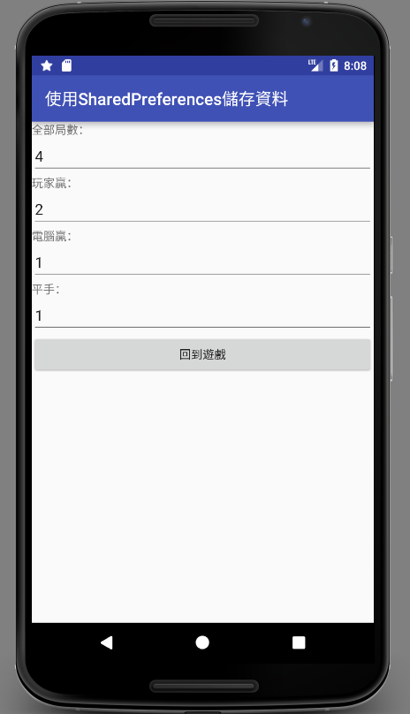清除局數,輸,贏,平手

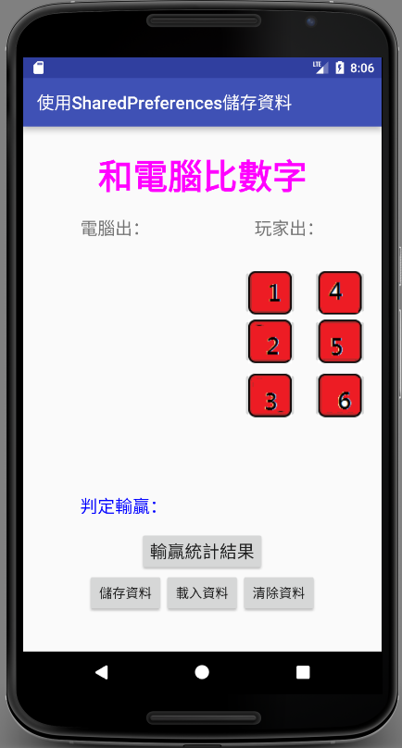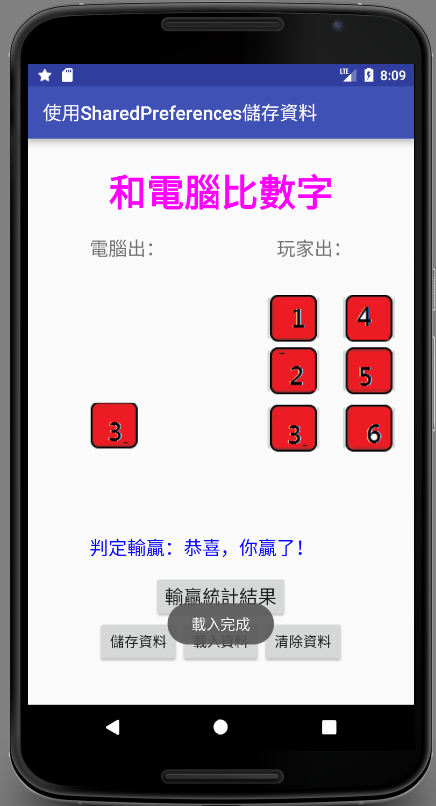

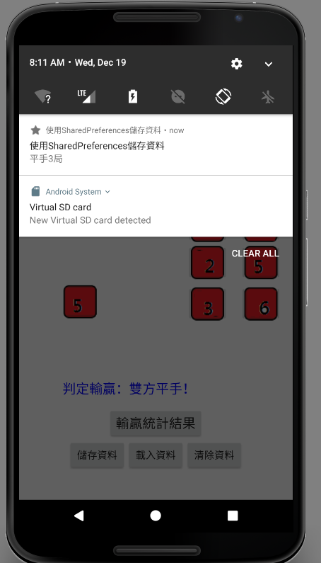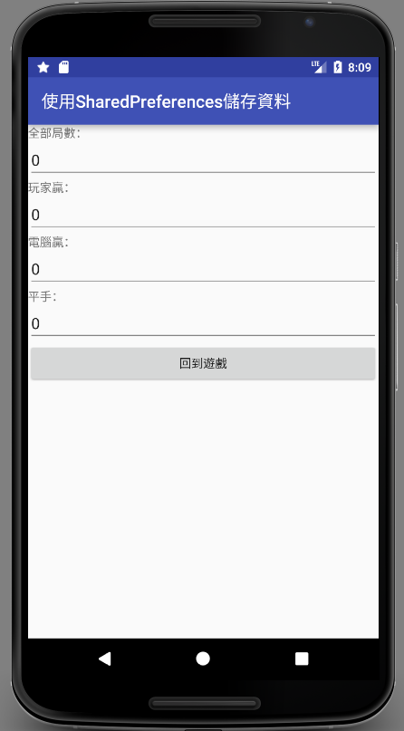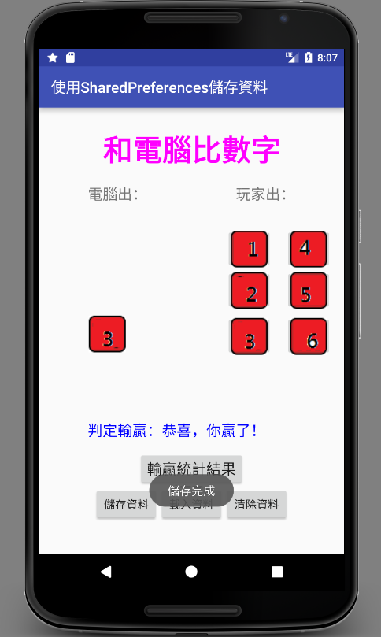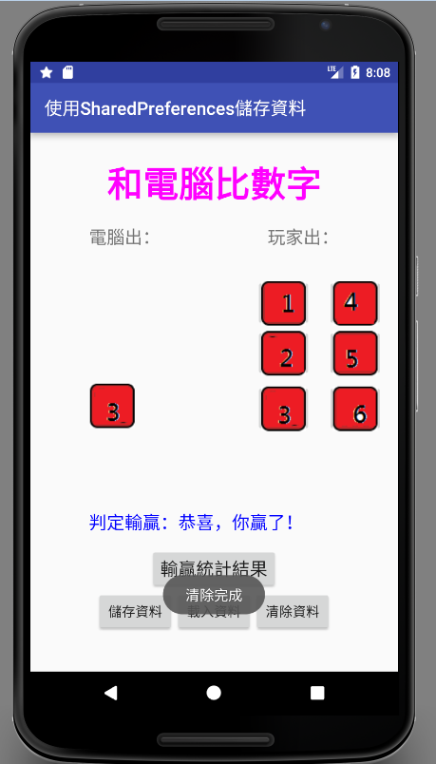

**package** com.savedatausingsharedpreferences;  
  
**import** android.app.Notification;  
**import** android.app.NotificationManager;  
**import** android.app.PendingIntent;  
**import** android.content.Intent;  
**import** android.content.SharedPreferences;  
**import** android.support.v7.app.AppCompatActivity;  
**import** android.os.Bundle;  
**import** android.support.v7.app.NotificationCompat;  
**import** android.view.View;  
**import** android.widget.Button;  
**import** android.widget.ImageButton;  
**import** android.widget.ImageView;  
**import** android.widget.TextView;  
**import** android.widget.Toast;  
  
**public class** MainActivity **extends** AppCompatActivity {  
  
 **private static final int *NOTI_ID*** = 100;  
  
 **private** Button **mBtnSaveResult**,  
 **mBtnLoadResult**,  
 **mBtnClearResult**;  
  
 **private** TextView **mTxtResult**;  
 **private** ImageView **mImgViewComPlay**;  
 **private** ImageButton **mImgBtnOne**, **mImgBtnTwo**, **mImgBtnThree**, **mImgBtnFour**, **mImgBtnFive**, **mImgBtnSix**;  
 **private** Button **mBtnOK**;  
 *// 新增統計遊戲局數和輸贏的變數* **private int miCountSet** = 0,  
 **miCountPlayerWin** = 0,  
 **miCountComWin** = 0,  
 **miCountDraw** = 0;  
  
 **private** Button **mBtnShowResult**;  
  
 @Override  
 **protected void** onCreate(Bundle savedInstanceState) {  
 **super**.onCreate(savedInstanceState);  
 setContentView(R.layout.***activity_main***);  
  
 **mImgViewComPlay** = (ImageView)findViewById(R.id.***imgViewComPlay***);  
 **mTxtResult** = (TextView)findViewById(R.id.***txtResult***);  
 **mImgBtnOne** = (ImageButton)findViewById(R.id.***imgBtnone***);  
 **mImgBtnTwo** = (ImageButton)findViewById(R.id.***imgBtntwo***);  
 **mImgBtnThree** = (ImageButton)findViewById(R.id.***imgBtnthree***);  
 **mImgBtnFour** = (ImageButton)findViewById(R.id.***imgBtnfour***);  
 **mImgBtnFive** = (ImageButton)findViewById(R.id.***imgBtnfive***);  
 **mImgBtnSix** = (ImageButton)findViewById(R.id.***imgBtnsix***);  
  
 **mImgBtnOne**.setOnClickListener(**imgBtnOneOnClick**);  
 **mImgBtnTwo**.setOnClickListener(**imgBtnTwoOnClick**);  
 **mImgBtnThree**.setOnClickListener(**imgBtnThreeOnClick**);  
 **mImgBtnFour**.setOnClickListener(**imgBtnFourOnClick**);  
 **mImgBtnFive**.setOnClickListener(**imgBtnFiveOnClick**);  
 **mImgBtnSix**.setOnClickListener(**imgBtnSixOnClick**);  
  
  
 **mBtnOK** = (Button)findViewById(R.id.***btnOK***);  
 **mBtnOK**.setOnClickListener(**btnOKOnClick**);  
  
  
 **mBtnSaveResult** = (Button)findViewById(R.id.***btnSaveResult***);  
 **mBtnLoadResult** = (Button)findViewById(R.id.***btnLoadResult***);  
 **mBtnClearResult** = (Button)findViewById(R.id.***btnClearResult***);  
  
 **mBtnSaveResult**.setOnClickListener(**btnSaveResultOnClick**);  
 **mBtnLoadResult**.setOnClickListener(**btnLoadResultOnClick**);  
 **mBtnClearResult**.setOnClickListener(**btnClearResultOnClick**);  
 }  
  
 @Override  
 **protected void** onDestroy() {  
 ((NotificationManager) getSystemService(***NOTIFICATION_SERVICE***))  
 .cancel(***NOTI_ID***);  
  
 **super**.onDestroy();  
 }  
  
 **private** View.OnClickListener **imgBtnOneOnClick** = **new** View.OnClickListener() {  
 **public void** onClick(View v) {  
 *// Decide computer play.* **int** iComPlay = (**int**)(Math.*random*()*6 + 1);  
  
 **miCountSet**++;  
  
 *// 1 – 剪刀, 2 – 石頭, 3 – 布.* **if** (iComPlay == 1) {  
 **mImgViewComPlay**.setImageResource(R.drawable.***one***);  
 **mTxtResult**.setText(getString(R.string.***result***) +  
 getString(R.string.***player_flat***));  
 **miCountDraw**++;  
 showNotification(**"平手"** + Integer.*toString*(**miCountDraw**) + **"局"**);  
 }  
 **else if** (iComPlay == 2) {  
 **mImgViewComPlay**.setImageResource(R.drawable.***two***);  
 **mTxtResult**.setText(getString(R.string.***result***) +  
 getString(R.string.***player_lose***));  
 **miCountComWin**++;  
 showNotification(**"電腦贏"** + Integer.*toString*(**miCountDraw**) + **"局"**);  
 }  
 **else if** (iComPlay == 3){  
 **mImgViewComPlay**.setImageResource(R.drawable.***three***);  
 **mTxtResult**.setText(getString(R.string.***result***) +  
 getString(R.string.***player_lose***));  
 **miCountComWin**++;  
 showNotification(**"電腦贏"** + Integer.*toString*(**miCountDraw**) + **"局"**);  
 }  
 **else if** (iComPlay == 4){  
 **mImgViewComPlay**.setImageResource(R.drawable.***four***);  
 **mTxtResult**.setText(getString(R.string.***result***) +  
 getString(R.string.***player_lose***));  
 **miCountComWin**++;  
 showNotification(**"電腦贏"** + Integer.*toString*(**miCountDraw**) + **"局"**);  
 }  
 **else if** (iComPlay == 5){  
 **mImgViewComPlay**.setImageResource(R.drawable.***five***);  
 **mTxtResult**.setText(getString(R.string.***result***) +  
 getString(R.string.***player_lose***));  
 **miCountComWin**++;  
 showNotification(**"電腦贏"** + Integer.*toString*(**miCountDraw**) + **"局"**);  
 }  
 **else if** (iComPlay == 6){  
 **mImgViewComPlay**.setImageResource(R.drawable.***six***);  
 **mTxtResult**.setText(getString(R.string.***result***) +  
 getString(R.string.***player_lose***));  
 **miCountComWin**++;  
 showNotification(**"電腦贏"** + Integer.*toString*(**miCountDraw**) + **"局"**);  
 }  
 }  
 };  
  
 **private** View.OnClickListener **imgBtnTwoOnClick** = **new** View.OnClickListener() {  
 **public void** onClick(View v) {  
 *// 決定電腦出拳.* **int** iComPlay = (**int**)(Math.*random*()*6 + 1);  
  
 **miCountSet**++;  
  
 *// 1 – 剪刀, 2 – 石頭, 3 – 布.* **if** (iComPlay == 1) {  
 **mImgViewComPlay**.setImageResource(R.drawable.***one***);  
 **mTxtResult**.setText(getString(R.string.***result***) +  
 getString(R.string.***player_win***));  
 **miCountPlayerWin**++;  
 showNotification(**"玩家贏"** + Integer.*toString*(**miCountDraw**) + **"局"**);  
  
 }  
 **else if** (iComPlay == 2) {  
 **mImgViewComPlay**.setImageResource(R.drawable.***two***);  
 **mTxtResult**.setText(getString(R.string.***result***) +  
 getString(R.string.***player_flat***));  
 **miCountDraw**++;  
 showNotification(**"平手"** + Integer.*toString*(**miCountDraw**) + **"局"**);  
 }  
 **else if** (iComPlay == 3){  
 **mImgViewComPlay**.setImageResource(R.drawable.***three***);  
 **mTxtResult**.setText(getString(R.string.***result***) +  
 getString(R.string.***player_lose***));  
 **miCountComWin**++;  
 showNotification(**"電腦贏"** + Integer.*toString*(**miCountDraw**) + **"局"**);  
 }  
 **else if** (iComPlay == 4){  
 **mImgViewComPlay**.setImageResource(R.drawable.***four***);  
 **mTxtResult**.setText(getString(R.string.***result***) +  
 getString(R.string.***player_lose***));  
 **miCountComWin**++;  
 showNotification(**"電腦贏"** + Integer.*toString*(**miCountDraw**) + **"局"**);  
 }  
 **else if** (iComPlay == 5){  
 **mImgViewComPlay**.setImageResource(R.drawable.***five***);  
 **mTxtResult**.setText(getString(R.string.***result***) +  
 getString(R.string.***player_lose***));  
 **miCountComWin**++;  
 showNotification(**"電腦贏"** + Integer.*toString*(**miCountDraw**) + **"局"**);  
 }  
 **else if** (iComPlay == 6){  
 **mImgViewComPlay**.setImageResource(R.drawable.***six***);  
 **mTxtResult**.setText(getString(R.string.***result***) +  
 getString(R.string.***player_lose***));  
 **miCountComWin**++;  
 showNotification(**"電腦贏"** + Integer.*toString*(**miCountDraw**) + **"局"**);  
 }  
 }  
 };  
  
 **private** View.OnClickListener **imgBtnThreeOnClick** = **new** View.OnClickListener() {  
 **public void** onClick(View v) {  
 *// 決定電腦出拳.* **int** iComPlay = (**int**)(Math.*random*()*6 + 1);  
  
 **miCountSet**++;  
  
 *// 1 – 剪刀, 2 – 石頭, 3 – 布.* **if** (iComPlay == 1) {  
 **mImgViewComPlay**.setImageResource(R.drawable.***one***);  
 **mTxtResult**.setText(getString(R.string.***result***) +  
 getString(R.string.***player_win***));  
 **miCountPlayerWin**++;  
 showNotification(**"玩家贏"** + Integer.*toString*(**miCountDraw**) + **"局"**);  
  
 }  
 **else if** (iComPlay == 2) {  
 **mImgViewComPlay**.setImageResource(R.drawable.***two***);  
 **mTxtResult**.setText(getString(R.string.***result***) +  
 getString(R.string.***player_win***));  
 **miCountPlayerWin**++;  
 showNotification(**"玩家贏"** + Integer.*toString*(**miCountDraw**) + **"局"**);  
  
 }  
 **else if** (iComPlay == 3){  
 **mImgViewComPlay**.setImageResource(R.drawable.***three***);  
 **mTxtResult**.setText(getString(R.string.***result***) +  
 getString(R.string.***player_flat***));  
 **miCountDraw**++;  
 showNotification(**"平手"** + Integer.*toString*(**miCountDraw**) + **"局"**);  
 }  
 **else if** (iComPlay == 4){  
 **mImgViewComPlay**.setImageResource(R.drawable.***four***);  
 **mTxtResult**.setText(getString(R.string.***result***) +  
 getString(R.string.***player_lose***));  
 **miCountComWin**++;  
 showNotification(**"電腦贏"** + Integer.*toString*(**miCountDraw**) + **"局"**);  
 }  
 **else if** (iComPlay == 5){  
 **mImgViewComPlay**.setImageResource(R.drawable.***five***);  
 **mTxtResult**.setText(getString(R.string.***result***) +  
 getString(R.string.***player_lose***));  
 **miCountComWin**++;  
 showNotification(**"電腦贏"** + Integer.*toString*(**miCountDraw**) + **"局"**);  
 }  
 **else if** (iComPlay == 6) {  
 **mImgViewComPlay**.setImageResource(R.drawable.***six***);  
 **mTxtResult**.setText(getString(R.string.***result***) +  
 getString(R.string.***player_lose***));  
 **miCountComWin**++;  
 showNotification(**"電腦贏"** + Integer.*toString*(**miCountDraw**) + **"局"**);  
 }  
 }  
 };  
  
 **private** View.OnClickListener **imgBtnFourOnClick** = **new** View.OnClickListener() {  
 **public void** onClick(View v) {  
 *// 決定電腦出拳.* **int** iComPlay = (**int**)(Math.*random*()*6 + 1);  
  
 **miCountSet**++;  
  
 *// 1 – 剪刀, 2 – 石頭, 3 – 布.* **if** (iComPlay == 1) {  
 **mImgViewComPlay**.setImageResource(R.drawable.***one***);  
 **mTxtResult**.setText(getString(R.string.***result***) +  
 getString(R.string.***player_win***));  
 **miCountPlayerWin**++;  
 showNotification(**"玩家贏"** + Integer.*toString*(**miCountDraw**) + **"局"**);  
 }  
 **else if** (iComPlay == 2) {  
 **mImgViewComPlay**.setImageResource(R.drawable.***two***);  
 **mTxtResult**.setText(getString(R.string.***result***) +  
 getString(R.string.***player_win***));  
 **miCountPlayerWin**++;  
 showNotification(**"玩家贏"** + Integer.*toString*(**miCountDraw**) + **"局"**);  
 }  
 **else if** (iComPlay == 3){  
 **mImgViewComPlay**.setImageResource(R.drawable.***three***);  
 **mTxtResult**.setText(getString(R.string.***result***) +  
 getString(R.string.***player_win***));  
 **miCountPlayerWin**++;  
 showNotification(**"玩家贏"** + Integer.*toString*(**miCountDraw**) + **"局"**);  
 }  
 **else if** (iComPlay == 4){  
 **mImgViewComPlay**.setImageResource(R.drawable.***four***);  
 **mTxtResult**.setText(getString(R.string.***result***) +  
 getString(R.string.***player_flat***));  
 **miCountDraw**++;  
 showNotification(**"平手"** + Integer.*toString*(**miCountDraw**) + **"局"**);  
 }  
 **else if** (iComPlay == 5){  
 **mImgViewComPlay**.setImageResource(R.drawable.***five***);  
 **mTxtResult**.setText(getString(R.string.***result***) +  
 getString(R.string.***player_lose***));  
 **miCountComWin**++;  
 showNotification(**"電腦贏"** + Integer.*toString*(**miCountDraw**) + **"局"**);  
 }  
 **else if** (iComPlay == 6) {  
 **mImgViewComPlay**.setImageResource(R.drawable.***six***);  
 **mTxtResult**.setText(getString(R.string.***result***) +  
 getString(R.string.***player_lose***));  
 **miCountComWin**++;  
 showNotification(**"電腦贏"** + Integer.*toString*(**miCountDraw**) + **"局"**);  
 }  
 }  
 };  
  
 **private** View.OnClickListener **imgBtnFiveOnClick** = **new** View.OnClickListener() {  
 **public void** onClick(View v) {  
 *// 決定電腦出拳.* **int** iComPlay = (**int**)(Math.*random*()*6 + 1);  
  
 **miCountSet**++;  
  
 *// 1 – 剪刀, 2 – 石頭, 3 – 布.* **if** (iComPlay == 1) {  
 **mImgViewComPlay**.setImageResource(R.drawable.***one***);  
 **mTxtResult**.setText(getString(R.string.***result***) +  
 getString(R.string.***player_win***));  
 **miCountPlayerWin**++;  
 showNotification(**"玩家贏"** + Integer.*toString*(**miCountDraw**) + **"局"**);  
 }  
 **else if** (iComPlay == 2) {  
 **mImgViewComPlay**.setImageResource(R.drawable.***two***);  
 **mTxtResult**.setText(getString(R.string.***result***) +  
 getString(R.string.***player_win***));  
 **miCountPlayerWin**++;  
 showNotification(**"玩家贏"** + Integer.*toString*(**miCountDraw**) + **"局"**);  
 }  
 **else if** (iComPlay == 3){  
 **mImgViewComPlay**.setImageResource(R.drawable.***three***);  
 **mTxtResult**.setText(getString(R.string.***result***) +  
 getString(R.string.***player_win***));  
 **miCountPlayerWin**++;  
 showNotification(**"玩家贏"** + Integer.*toString*(**miCountDraw**) + **"局"**);  
 }  
 **else if** (iComPlay == 4){  
 **mImgViewComPlay**.setImageResource(R.drawable.***four***);  
 **mTxtResult**.setText(getString(R.string.***result***) +  
 getString(R.string.***player_win***));  
 **miCountPlayerWin**++;  
 showNotification(**"玩家贏"** + Integer.*toString*(**miCountDraw**) + **"局"**);  
 }  
 **else if** (iComPlay == 5){  
 **mImgViewComPlay**.setImageResource(R.drawable.***five***);  
 **mTxtResult**.setText(getString(R.string.***result***) +  
 getString(R.string.***player_flat***));  
 **miCountDraw**++;  
 showNotification(**"平手"** + Integer.*toString*(**miCountDraw**) + **"局"**);  
 }  
 **else if** (iComPlay == 6) {  
 **mImgViewComPlay**.setImageResource(R.drawable.***six***);  
 **mTxtResult**.setText(getString(R.string.***result***) +  
 getString(R.string.***player_lose***));  
 **miCountComWin**++;  
 showNotification(**"電腦贏"** + Integer.*toString*(**miCountDraw**) + **"局"**);  
 }  
 }  
 };  
  
 **private** View.OnClickListener **imgBtnSixOnClick** = **new** View.OnClickListener() {  
 **public void** onClick(View v) {  
 *// 決定電腦出拳.* **int** iComPlay = (**int**)(Math.*random*()*6 + 1);  
  
 **miCountSet**++;  
  
 *// 1 – 剪刀, 2 – 石頭, 3 – 布.* **if** (iComPlay == 1) {  
 **mImgViewComPlay**.setImageResource(R.drawable.***one***);  
 **mTxtResult**.setText(getString(R.string.***result***) +  
 getString(R.string.***player_win***));  
 **miCountPlayerWin**++;  
 showNotification(**"玩家贏"** + Integer.*toString*(**miCountDraw**) + **"局"**);  
 }  
 **else if** (iComPlay == 2) {  
 **mImgViewComPlay**.setImageResource(R.drawable.***two***);  
 **mTxtResult**.setText(getString(R.string.***result***) +  
 getString(R.string.***player_win***));  
 **miCountPlayerWin**++;  
 showNotification(**"玩家贏"** + Integer.*toString*(**miCountDraw**) + **"局"**);  
 }  
 **else if** (iComPlay == 3){  
 **mImgViewComPlay**.setImageResource(R.drawable.***three***);  
 **mTxtResult**.setText(getString(R.string.***result***) +  
 getString(R.string.***player_win***));  
 **miCountPlayerWin**++;  
 showNotification(**"玩家贏"** + Integer.*toString*(**miCountDraw**) + **"局"**);  
 }  
 **else if** (iComPlay == 4){  
 **mImgViewComPlay**.setImageResource(R.drawable.***four***);  
 **mTxtResult**.setText(getString(R.string.***result***) +  
 getString(R.string.***player_win***));  
 **miCountPlayerWin**++;  
 showNotification(**"玩家贏"** + Integer.*toString*(**miCountDraw**) + **"局"**);  
 }  
 **else if** (iComPlay == 5){  
 **mImgViewComPlay**.setImageResource(R.drawable.***five***);  
 **mTxtResult**.setText(getString(R.string.***result***) +  
 getString(R.string.***player_win***));  
 **miCountPlayerWin**++;  
 showNotification(**"玩家贏"** + Integer.*toString*(**miCountDraw**) + **"局"**);  
 }  
 **else if** (iComPlay == 6) {  
 **mImgViewComPlay**.setImageResource(R.drawable.***six***);  
 **mTxtResult**.setText(getString(R.string.***result***) +  
 getString(R.string.***player_flat***));  
 **miCountDraw**++;  
 showNotification(**"平手"** + Integer.*toString*(**miCountDraw**) + **"局"**);  
 }  
 }  
 };  
  
  
 **private** View.OnClickListener **btnOKOnClick**= **new** View.OnClickListener() {  
 **public void** onClick(View v) {  
 Intent it = **new** Intent();  
 it.setClass(MainActivity.**this**, GameResultActivity.**class**);  
  
 Bundle bundle = **new** Bundle();  
 bundle.putInt(**"KEY_COUNT_SET"**, **miCountSet**);  
 bundle.putInt(**"KEY_COUNT_PLAYER_WIN"**, **miCountPlayerWin**);  
 bundle.putInt(**"KEY_COUNT_COM_WIN"**, **miCountComWin**);  
 bundle.putInt(**"KEY_COUNT_DRAW"**, **miCountDraw**);  
 it.putExtras(bundle);  
  
 startActivity(it);  
 }  
 };  
  
 **private void** showNotification(String sMsg) {  
 Intent it = **new** Intent(getApplicationContext(), GameResultActivity.**class**);  
 it.setFlags(Intent.***FLAG_ACTIVITY_NEW_TASK***);  
 Bundle bundle = **new** Bundle();  
 bundle.putInt(**"KEY_COUNT_SET"**, **miCountSet**);  
 bundle.putInt(**"KEY_COUNT_PLAYER_WIN"**, **miCountPlayerWin**);  
 bundle.putInt(**"KEY_COUNT_COM_WIN"**, **miCountComWin**);  
 bundle.putInt(**"KEY_COUNT_DRAW"**, **miCountDraw**);  
 it.putExtras(bundle);  
  
 PendingIntent penIt = PendingIntent.*getActivity*(getApplicationContext(),  
 0, it, PendingIntent. ***FLAG_CANCEL_CURRENT***);  
  
 Notification noti = **new** Notification.Builder(**this**)  
 .setSmallIcon(android.R.drawable.***btn_star_big_on***)  
 .setTicker(sMsg)  
 .setContentTitle(getString(R.string.***app_name***))  
 .setContentText(sMsg)  
 .setContentIntent(penIt)  
 .build();  
  
 NotificationManager notiMgr =  
 (NotificationManager) getSystemService(***NOTIFICATION_SERVICE***);  
 notiMgr.notify(***NOTI_ID***, noti);  
 }  
  
 **private** View.OnClickListener **btnSaveResultOnClick** = **new** View.OnClickListener() {  
 **public void** onClick(View v) {  
 SharedPreferences gameResultData =  
 getSharedPreferences(**"GAME_RESULT"**, 0);  
  
 gameResultData.edit()  
 .putInt(**"COUNT_SET"**, **miCountSet**)  
 .putInt(**"COUNT_PLAYER_WIN"**, **miCountPlayerWin**)  
 .putInt(**"COUNT_COM_WIN"**, **miCountComWin**)  
 .putInt(**"COUNT_DRAW"**, **miCountDraw**)  
 .commit();  
  
 Toast.*makeText*(MainActivity.**this**, **"儲存完成"**, Toast.***LENGTH_LONG***)  
 .show();  
 }  
 };  
  
 **private** View.OnClickListener **btnLoadResultOnClick** = **new** View.OnClickListener() {  
 **public void** onClick(View v) {  
 SharedPreferences gameResultData =  
 getSharedPreferences(**"GAME_RESULT"**, 0);  
  
 **miCountSet** = gameResultData.getInt(**"COUNT_SET"**, 0);  
 **miCountPlayerWin** = gameResultData.getInt(**"COUNT_PLAYER_WIN"**, 0);  
 **miCountComWin** = gameResultData.getInt(**"COUNT_COM_WIN"**, 0);  
 **miCountDraw** = gameResultData.getInt(**"COUNT_DRAW"**, 0);  
  
 Toast.*makeText*(MainActivity.**this**, **"載入完成"**, Toast.***LENGTH_LONG***)  
 .show();  
 }  
 };  
  
 **private** View.OnClickListener **btnClearResultOnClick** = **new** View.OnClickListener() {  
 **public void** onClick(View v) {  
 SharedPreferences gameResultData =  
 getSharedPreferences(**"GAME_RESULT"**, 0);  
  
 gameResultData.edit()  
 .clear()  
 .commit();  
  
 Toast.*makeText*(MainActivity.**this**, **"清除完成"**, Toast.***LENGTH_LONG***)  
 .show();  
 }  
 };  
}

*<?***xml version="1.0" encoding="utf-8"***?>*<**RelativeLayout xmlns:android="http://schemas.android.com/apk/res/android"  
 android:layout_width="match_parent"  
 android:layout_height="match_parent"  
 android:paddingBottom="@dimen/activity_vertical_margin"  
 android:paddingLeft="@dimen/activity_horizontal_margin"  
 android:paddingRight="@dimen/activity_horizontal_margin"  
 android:paddingTop="@dimen/activity_vertical_margin"**>  
  
  
 <**TextView android:id="@+id/txtTitle"  
 android:layout_width="wrap_content"  
 android:layout_height="wrap_content"  
 android:text="@string/prompt_title"  
 android:textSize="40sp"  
 android:textColor="#FF00FF"  
 android:textStyle="bold"  
 android:layout_centerHorizontal="true"  
 android:paddingLeft="20dp"  
 android:paddingRight="20dp"  
 android:layout_marginTop="20dp"  
 android:layout_marginBottom="20dp"** />  
  
  
 <**TextView android:id="@+id/txtCom"  
 android:layout_width="wrap_content"  
 android:layout_height="wrap_content"  
 android:text="@string/prompt_com_play"  
 android:layout_below="@id/txtTitle"  
 android:layout_alignLeft="@id/txtTitle"  
 android:textSize="20sp"  
 android:layout_marginBottom="20dp"** />  
  
  
 <**TextView android:id="@+id/txtMyPlay"  
 android:layout_width="wrap_content"  
 android:layout_height="wrap_content"  
 android:text="@string/prompt_my_play"  
 android:layout_below="@id/txtTitle"  
 android:layout_alignRight="@id/txtTitle"  
 android:textSize="20sp"  
 android:layout_marginBottom="20dp"** />  
  
  
 <**ImageButton  
 android:id="@+id/imgBtnone"  
 android:layout_width="63dp"  
 android:layout_height="56dp"  
 android:layout_marginTop="13dp"  
 android:paddingLeft="15dp"  
 android:paddingRight="15dp"  
 android:src="@drawable/one"  
 android:layout_below="@+id/txtMyPlay"  
 android:layout_toLeftOf="@+id/imgBtnfour"  
 android:layout_toStartOf="@+id/imgBtnfour"  
 android:layout_marginRight="17dp"  
 android:layout_marginEnd="17dp"** />  
  
  
 <**ImageView android:id="@+id/imgViewComPlay"  
 android:layout_width="wrap_content"  
 android:layout_height="wrap_content"  
 android:layout_marginLeft="1dp"  
 android:layout_marginTop="62dp"  
 android:layout_marginBottom="-63dp"  
 android:layout_below="@id/imgBtnone"  
 android:layout_alignLeft="@id/txtCom"** />  
  
  
 <**ImageButton  
 android:id="@+id/imgBtntwo"  
 android:layout_width="63dp"  
 android:layout_height="56dp"  
 android:layout_alignStart="@+id/imgBtnone"  
 android:layout_below="@+id/imgBtnone"  
 android:paddingLeft="15dp"  
 android:paddingRight="15dp"  
 android:src="@drawable/two"** />  
  
  
 <**ImageButton  
 android:id="@+id/imgBtnthree"  
 android:layout_width="63dp"  
 android:layout_height="56dp"  
 android:layout_alignStart="@+id/imgBtnone"  
 android:layout_alignTop="@+id/imgViewComPlay"  
 android:paddingLeft="15dp"  
 android:paddingRight="15dp"  
 android:src="@drawable/three"** />  
  
  
 <**ImageButton  
 android:id="@+id/imgBtnfour"  
 android:layout_width="63dp"  
 android:layout_height="56dp"  
 android:layout_alignParentEnd="true"  
 android:layout_alignTop="@+id/imgBtnone"  
 android:paddingLeft="15dp"  
 android:paddingRight="15dp"  
 android:src="@drawable/four"** />  
  
  
 <**ImageButton  
 android:id="@+id/imgBtnfive"  
 android:layout_width="63dp"  
 android:layout_height="56dp"  
 android:layout_alignStart="@+id/imgBtnfour"  
 android:layout_below="@+id/imgBtnone"  
 android:paddingLeft="15dp"  
 android:paddingRight="15dp"  
 android:src="@drawable/five"** />  
  
  
 <**ImageButton  
 android:id="@+id/imgBtnsix"  
 android:layout_width="63dp"  
 android:layout_height="56dp"  
 android:layout_alignParentEnd="true"  
 android:layout_alignTop="@+id/imgViewComPlay"  
 android:paddingLeft="15dp"  
 android:paddingRight="15dp"  
 android:src="@drawable/six"** />  
  
  
 <**TextView  
 android:id="@+id/txtResult"  
 android:layout_width="wrap_content"  
 android:layout_height="wrap_content"  
 android:layout_alignParentBottom="true"  
 android:layout_alignStart="@+id/txtTitle"  
 android:layout_marginBottom="144dp"  
 android:text="@string/result"  
 android:textColor="#0000FF"  
 android:textSize="20sp"** />  
  
 <**Button  
 android:id="@+id/btnOK"  
 android:layout_width="wrap_content"  
 android:layout_height="wrap_content"  
 android:text="輸贏統計結果"  
 android:textSize="20sp"  
 android:layout_above="@+id/btnLoadResult"  
 android:layout_centerHorizontal="true"** />  
  
 <**Button  
 android:id="@+id/btnLoadResult"  
 android:layout_width="wrap_content"  
 android:layout_height="wrap_content"  
 android:layout_alignParentBottom="true"  
 android:layout_centerHorizontal="true"  
 android:layout_marginBottom="33dp"  
 android:text="載入資料"  
 android:textSize="15sp"** />  
  
 <**Button  
 android:id="@+id/btnSaveResult"  
 android:layout_width="wrap_content"  
 android:layout_height="wrap_content"  
 android:text="儲存資料"  
 android:layout_toLeftOf="@id/btnLoadResult"  
 android:layout_alignTop="@id/btnLoadResult"  
 android:textSize="15sp"  
 android:layout_centerHorizontal="true"** />  
  
 <**Button  
 android:id="@+id/btnClearResult"  
 android:layout_width="wrap_content"  
 android:layout_height="wrap_content"  
 android:text="清除資料"  
 android:layout_toRightOf="@id/btnLoadResult"  
 android:layout_alignTop="@id/btnLoadResult"  
 android:textSize="15sp"  
 android:layout_centerHorizontal="true"** />  
  
</**RelativeLayout**>

<**resources**>  
 <**string name="app_name"**>使用SharedPreferences儲存資料</**string**>  
 <**string name="action_settings"**>Settings</**string**>  
  
 <**string name="prompt_com_play"**>電腦出：</**string**>  
 <**string name="prompt_my_play"**>玩家出：</**string**>  
  
 <**string name="player_win"**>恭喜，你贏了！</**string**>  
 <**string name="player_flat"**>雙方平手！</**string**>  
 <**string name="player_lose"**>很可惜，你輸了！</**string**>  
 <**string name="player_draw"**>雙方平手！</**string**>  
 <**string name="prompt_title"**>和電腦比數字</**string**>  
 <**string name="result"**>判定輸贏：</**string**>  
</**resources**>

1. 請參考範例
   1. 使用SQLite建立修課資料,其欄位如下,可以加入,查詢與列表
      * 姓名
      * 學號
      * 課程1,學分
      * 課程2,學分
      * 課程3,學分
      * 課程4,學分
      * 課程5,學分
2. **package** com.sqlitedatabase;  
     
   **import** android.content.ContentValues;  
   **import** android.database.Cursor;  
   **import** android.database.sqlite.SQLiteDatabase;  
   **import** android.support.v7.app.AppCompatActivity;  
   **import** android.os.Bundle;  
   **import** android.view.View;  
   **import** android.widget.Button;  
   **import** android.widget.EditText;  
   **import** android.widget.Toast;  
     
   **public class** MainActivity **extends** AppCompatActivity {  
     
    **private static final** String ***DB_FILE*** = **"choiceclass.db"**,  
    ***DB_TABLE*** = **"choiceclass"**;  
    **private** SQLiteDatabase **mclassDb**;  
     
    **private** EditText **mEdtName**,  
    **mEdtnumber**,  
    **myclass1**,  
    **myclass2**,  
    **myclass3**,  
    **myclass4**,  
    **myclass5**,  
    **mEdtList**;  
     
    **private** Button **mBtnAdd**,  
    **mBtnQuery**,  
    **mBtnList**;  
     
    @Override  
    **protected void** onCreate(Bundle savedInstanceState) {  
    **super**.onCreate(savedInstanceState);  
    setContentView(R.layout.***activity_main***);  
     
    FriendDbOpenHelper friendDbOpenHelper =  
    **new** FriendDbOpenHelper(getApplicationContext(), ***DB_FILE***, **null**, 1);  
    **mclassDb** = friendDbOpenHelper.getWritableDatabase();  
     
    *// 檢查資料表是否已經存在，如果不存在，就建立一個。* Cursor cursor = **mclassDb**.rawQuery(  
    **"select DISTINCT tbl_name from sqlite_master where tbl_name = '"** +  
    ***DB_TABLE*** + **"'"**, **null**);  
     
    **if**(cursor != **null**) {  
    **if**(cursor.getCount() == 0) *// 沒有資料表，要建立一個資料表。* **mclassDb**.execSQL(**"CREATE TABLE "** + ***DB_TABLE*** + **" ("** +  
    **"_id INTEGER PRIMARY KEY,"** +  
    **"name TEXT NOT NULL,"** +  
    **"number TEXT,"** +  
    **"class1 TEXT  
    "class2 TEXT  
    "class3 TEXT  
    "class4 TEXT  
    "class5 TEXT);"**);  
     
    cursor.close();  
    }  
     
    **mEdtName** = (EditText)findViewById(R.id.***edtName***);  
    **mEdtnumber** = (EditText)findViewById(R.id.edtnumber);  
    **myclass1** = (EditText)findViewById(R.id.class1);  
    **myclass2** = (EditText)findViewById(R.id.class2);  
    **myclass3** = (EditText)findViewById(R.id.class3);  
    **myclass4** = (EditText)findViewById(R.id.class4);  
    **myclass5** = (EditText)findViewById(R.id.class5);  
    **mEdtList** = (EditText)findViewById(R.id.***edtList***);  
     
    **mBtnAdd** = (Button)findViewById(R.id.***btnAdd***);  
    **mBtnQuery** = (Button)findViewById(R.id.***btnQuery***);  
    **mBtnList** = (Button)findViewById(R.id.***btnList***);  
     
    **mBtnAdd**.setOnClickListener(**btnAddOnClick**);  
    **mBtnQuery**.setOnClickListener(**btnQueryOnClick**);  
    **mBtnList**.setOnClickListener(**btnListOnClick**);  
    }  
     
    @Override  
    **protected void** onDestroy() {  
    **super**.onDestroy();  
    **mclassDb**.close();  
    }  
     
    **private** View.OnClickListener **btnAddOnClick** = **new** View.OnClickListener() {  
    @Override  
    **public void** onClick(View v) {  
     
    ContentValues newRow = **new** ContentValues();  
    newRow.put(**"name"**, **mEdtName**.getText().toString());  
    newRow.put(**"number"**, **mEdtnumber**.getText().toString());  
    newRow.put(**"class1"**, **myclass1**.getText().toString());  
    newRow.put(**"class2"**, **myclass2**.getText().toString());  
    newRow.put(**"class3"**, **myclass3**.getText().toString());  
    newRow.put(**"class4"**, **myclass4**.getText().toString());  
    newRow.put(**"class5"**, **myclass5**.getText().toString());  
    **mclassDb**.insert(***DB_TABLE***, **null**, newRow);  
    }  
    };  
     
    **private** View.OnClickListener **btnQueryOnClick** = **new** View.OnClickListener() {  
    @Override  
    **public void** onClick(View v) {  
    Cursor c = **null**;  
     
    **if** (!**mEdtName**.getText().toString().equals(**""**)) {  
    c = **mclassDb**.query(**true**, ***DB_TABLE***, **new** String[]{**"name"**, **"number"**,  
    **"class1"**,**"class2"**,**"class3"**,**"class4"**,**"class5"**}, **"name="** + **"\""** + **mEdtName**.getText().toString()  
    + **"\""**, **null**, **null**, **null**, **null**, **null**);  
    } **else if** (!**mEdtnumber**.getText().toString().equals(**""**)) {  
    c = **mclassDb**.query(**true**, ***DB_TABLE***, **new** String[]{**"name"**, **"number"**,  
    **"class1"**,**"class2"**,**"class3"**,**"class4"**,**"class5"**}, **"number="** + **"\""** + **mEdtnumber**.getText().toString()  
    + **"\""**, **null**, **null**, **null**, **null**, **null**);  
    }  
    **if** (c == **null**)  
    **return**;  
     
    **if** (c.getCount() == 0) {  
    **mEdtList**.setText(**""**);  
    Toast.*makeText*(MainActivity.**this**, **"沒有這筆資料"**, Toast.***LENGTH_LONG***)  
    .show();  
    } **else** {  
    c.moveToFirst();  
    **mEdtList**.setText(c.getString(0) + c.getString(1) + c.getString(2));  
     
    **while** (c.moveToNext())  
    **mEdtList**.append(**"\n"** + c.getString(0) + c.getString(1) +  
    c.getString(2));  
    }  
    }  
    };  
     
    **private** View.OnClickListener **btnListOnClick** = **new** View.OnClickListener() {  
    @Override  
    **public void** onClick(View v) {  
    Cursor c = mFriendDb.query(**true**, ***DB_TABLE***, **new** String[]{**"name"**, **"sex"**,  
    **"address"**}, **null**, **null**, **null**, **null**, **null**, **null**);  
     
    **if** (c == **null**)  
    **return**;  
     
    **if** (c.getCount() == 0) {  
    **mEdtList**.setText(**""**);  
    Toast.*makeText*(MainActivity.**this**, **"沒有資料"**, Toast.***LENGTH_LONG***)  
    .show();  
    }  
    **else** {  
    c.moveToFirst();  
    **mEdtList**.setText(c.getString(0) + c.getString(1) + c.getString(2));  
     
    **while** (c.moveToNext())  
    **mEdtList**.append(**"\n"** + c.getString(0) + c.getString(1) +  
    c.getString(2));  
    }  
    }  
    };  
   }