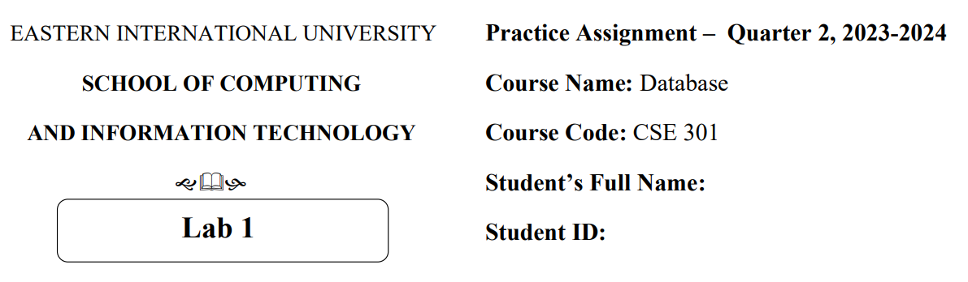

Từ Thị Hồng Điệp

2131200119

**Question 2 :**

**Problem 1**

1. **Finding Entities, key Attributes and related Attributes**

* **Finding entities**
* Treatment
* Doctor
* Patient
* Hospital
* **Key attributes**
* Treatment : Treatment_Date, Treatment_Duration, Results
* Doctor : Doctor_ID
* Patient : Patient_ID
* **Related attributes**
* Doctor : Doctor_Name, Employment_Date, Specialty
* Patient : Patient_Name

1. **Finding relationships**

* Doctor- Patient : admit

- One to one: A patient is admitted to the hospital by only one doctor

* Doctor- Patient: treat

- Many to many : A doctor may treat no one patient or treat multiple patients.Once admitted to the hospital, a patient will be treated by at least one doctor

* Hospital - Treatment : save

- One to many : One hospital save many treatments.

1. **Finding weak Entities and weak Relationships (if any)**

Week entities : Treatment

Week realtionship : Hospital - Treatment ( save : one to many )

**4. Draw an ER model**

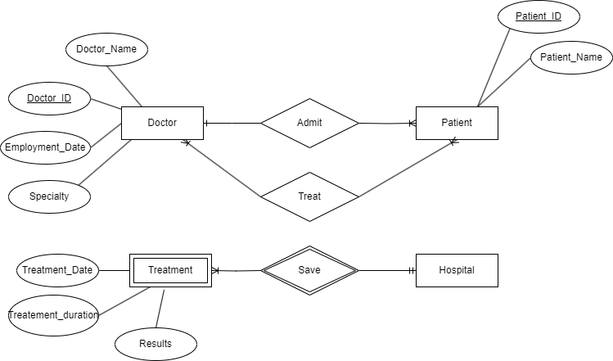

**Problem 2:**

1. **Finding Entities, key Attributes and related Attributes**

* **Finding entities**
* Faculty
* Class
* Student
* Subject
* Library Card
* **Key attributes**
* Faculty : Faculty Code
* Class : Class Code
* Student: Student ID
* Subject : Subject code
* Library Card : Card number
* **Related attributes**
* Faculty : Faculty Name
* Class : Class name, Wholesale number
* Student : Full name, Date of birth, Gender, Address, Graduation Point
* Subject : Subject name, Number of credits, Exam scores
* Library Card : Issue date, Expiration date.

1. **Finding relationships**

* **Faculty - Class : has**

**- One to many :** Each department has many classes

* **Student - Class : placed in**

**- One to many :** A student upon admission is placed in a class

* **Student - Subject : study**

**- Many to many :** Students study a variety of subjects

* **Student - Library Card : has**

- **One to one :** Each student has a library card

1. **Finding weak Entities and weak Relationships (if any)**

Week entities : Class, Library Card

Week relationship :

* **Faculty - Class : has**

**- One to many :** Each department has many classes

* **Student - Class : placed in**

**- One to many :** A student upon admission is placed in a class

* **Student - Library Card : has**

- **One to one :** Each student has a library card

**4. Draw an ER model**

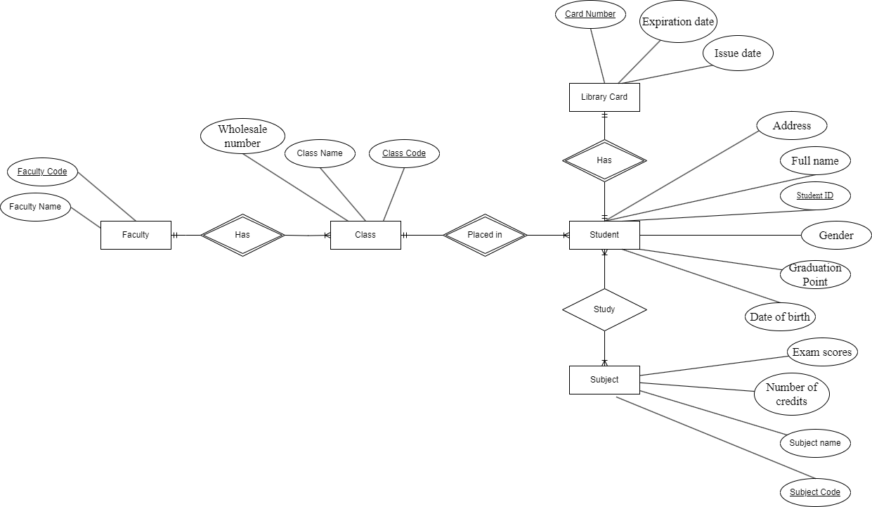

**Problem 3:**

1. **Finding Entities, key Attributes and related Attributes**

* **Finding entities**
* Room
* Floor
* Guest
* Service
* Invoice
* **Finding attributes**
* Room : Room code
* Floor : Floor code
* Guest : Identity card number
* Service : Service code
* Invoice : Invoice code
* **Related attributes**
* Room : Room name
* Floor : Floor name
* Guest : Full name, Corresponding phone number
* Service : Service name, Corresponding amount
* Invoice : Identity card code, Customer full name, Arrival date, Departure date, Room code, Total Room Amount, Total Service Amount, Total Amount to Pay

1. **Finding relationships**

* **Room - Floor**: Locate

- Many-to-One : Each room is located on exactly one floor

* **Service- Room**: Attach

- One-to-Many : There is also service information attached for each room

* **Guest - Invoice**: Have

- One-to-Many : Each guest can have multiple invoices

* **Room - Invoice**: Associate with

- One-to-One : Each invoice is associated with exactly one room.

1. **Finding weak Entities and weak Relationships (if any)**

Week entities : Service, Invoice

Week relationship :

* **Service- Room**: Attach

- One-to-Many : There is also service information attached for each room

* **Guest - Invoice**: Have

- One-to-Many : Each guest can have multiple invoices

* **Room - Invoice**: Associate with

- One-to-One : Each invoice is associated with exactly one room.

**4. Draw an ER model**

