Từ Thị Hồng Điệp

2131200119

**Question 2. Using draw.io to solve the problems below:**

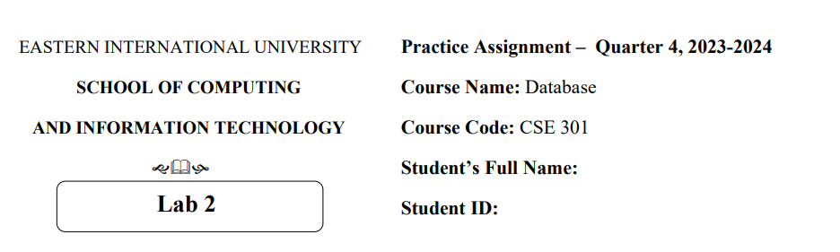**PROBLEM 1**

1. **Finding Entities, key Attributes and related Attributes**

* **Finding entities**
* CUSTOMERS
* STAFF
* PRODUCTS
* INVOICE
* DETAILOFINVOICE
* **Key attributes**
* CUSTOMERS : CUSTOMERID
* STAFF : STAFFID
* PRODUCTS : PRODUCTID
* INVOICE : INVOICEID
* DETAILOFINVOICE : INVOICEID, PRODUCTID
* **Related attributes**
* CUSTOMERS : FULLNAME, ADDRESS, PHONE, BIRTHDAY, SALE, REGISTRATIONDATE
* STAFF : FULLNAME, DAYOFENTRY, PHONE
* PRODUCTS : PRODUCTNAME, UNIT, NATION, PRICE
* INVOICE : PURCHASEDATE, CUSTOMERID, STAFFID, VALUE
* DETAILOFINVOICE : QUANTITY

1. **Finding relationships**

* **CUSTOMERS - INVOICE : Has**

- One to many: Many invoices can belong to one customer, one customer has many invoices

* **STAFF - INVOICE : Has**

**-** One to many : Staff can assist/ has many invoices.

* **DETAILOFINVOICE - INVOICE : Has**

**-** One to one : One detail of invoice has one invoice and one invoice has one detail invoice

* **DETAILOFINVOICE - PRODUCTS : Has**

**-** One to many : One detail of invoice can have multiple products.

1. **Finding weak Entities and weak Relationships (if any)**

Week entities : DETAILOFINVOICE

Week realtionship :

* **DETAILOFINVOICE - INVOICE :**

**-** One to one : One detail of invoice describes one invoice and one invoice has one detail invoice

* **DETAILOFINVOICE - PRODUCTS :**

**-** One to many : One detail of invoice can have multiple products.

**4. Draw an ER model**

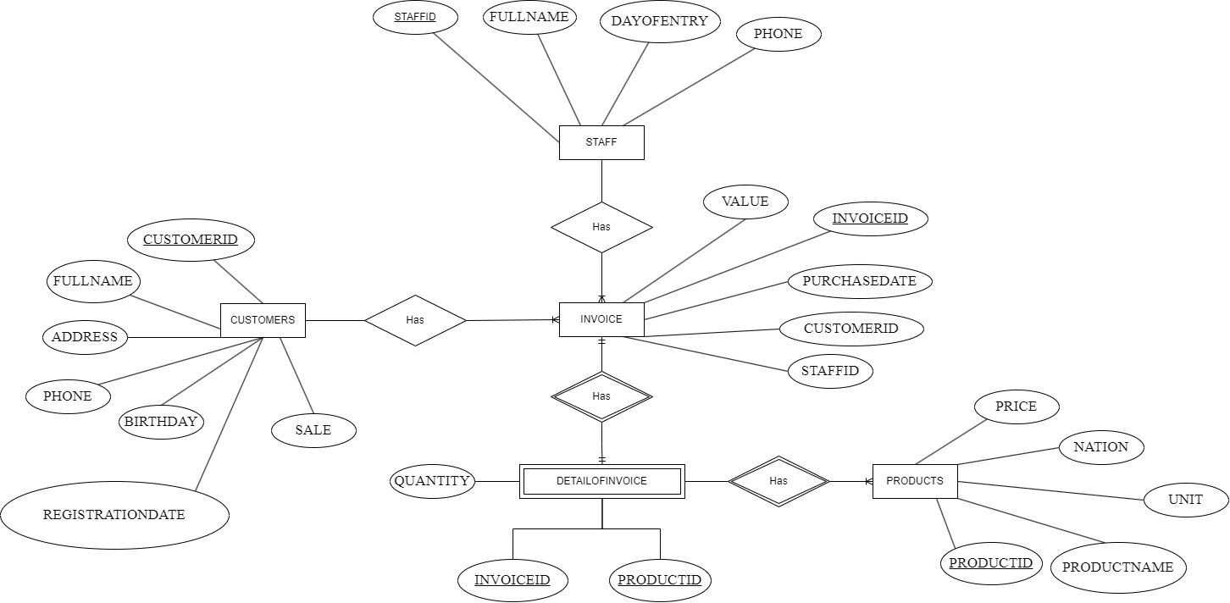

**PROBLEM 2**

1. **Finding Entities, key Attributes and related Attributes**

* **Finding entities**
* Employee
* Department
* Project
* Location
* Relative
* **Key attributes**
* Employee : EmployeeID
* Department : DepartmentID, LocationID
* Project : ProjectID
* Location : LocationID
* Relative : RelativeID
* **Related attributes**
* Employee : Fullname, DateOfBirth, Address, Gender, ManagerID, DepartmentID, WorkingType, Salary
* Department :RoomName, ManagerID
* Project : ProjectName, LocationID
* Relative : EmployeeID, Name, DateOfBirth, Relationship

1. **Finding relationships**

* ****Employee - Department**: Belong to**

- Many to one : Each employee belongs to a single department. While a department can oversee many employees

* **Department - Project : Manage**

- One to many : One department can manage many projects

* **Employee - Project : Participate in**

- Many to many : One employee can participate in many projects, One project can be participated in by many employees.

* **Employee - Employee : Be manager**

- Self-Referencing : Employee can be manager

* **Employee - Relative : Has**

- One to many : One employee can have multiple relatives

* **Department - Location: Be located**

- One to many : One department can be located in many location

1. **Finding weak Entities and weak Relationships (if any)**

Weak entities : Relative

Weak replationships :

* **Employee - Relative : Has**

- One to many : One employee can have multiple relatives

**4. Draw an ER model**

