|  |  |
| --- | --- |
| **EASTERN INTERNATIONAL UNIVERSITY**  *School of Computing and Information of Technology*  IMG_256  **Lab 1** | **Practice Assignment - Q1, 2025-2026**  **Course Name**: Mobile Application Development  **Course Code**: CSW 430  **Student’s Full Name**: Tu Thi Hong Diep  **Student Id**: 2131200119 |

**Question 3: Create Expo CLI apps**

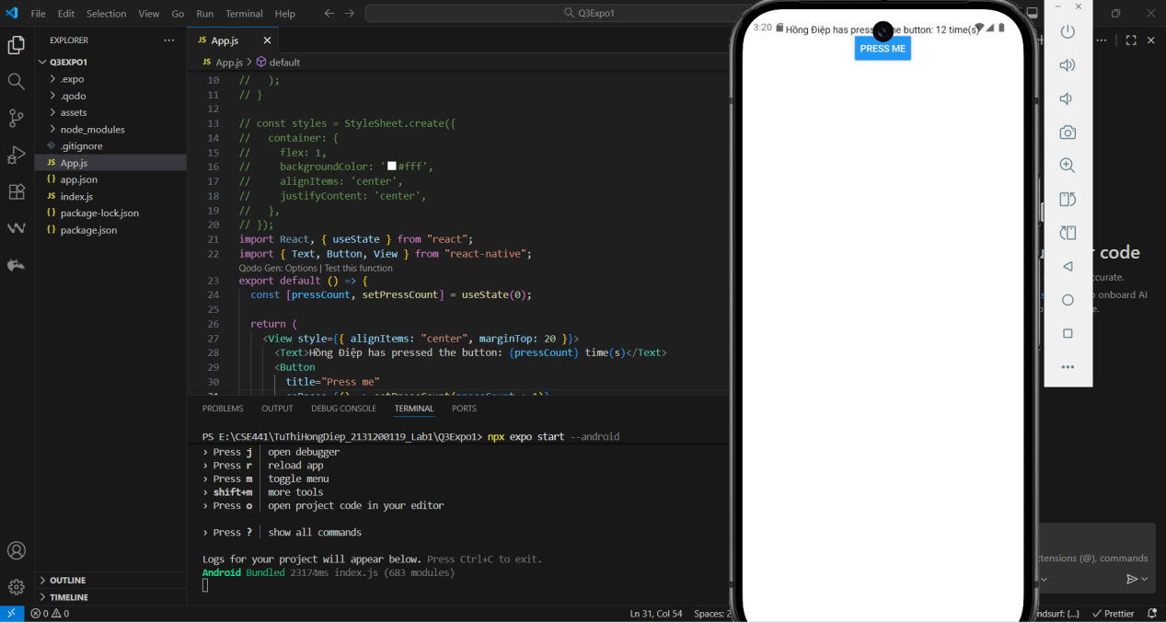

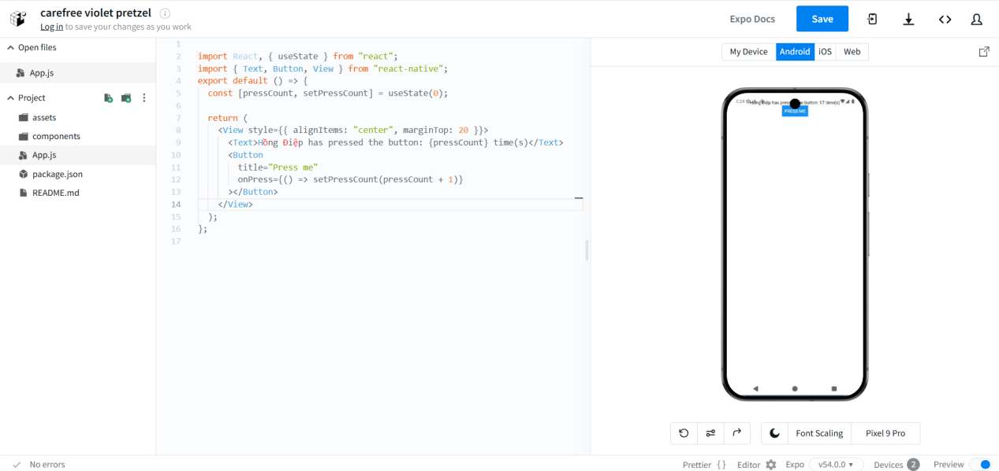

**Question 4: Create React native CLI apps**

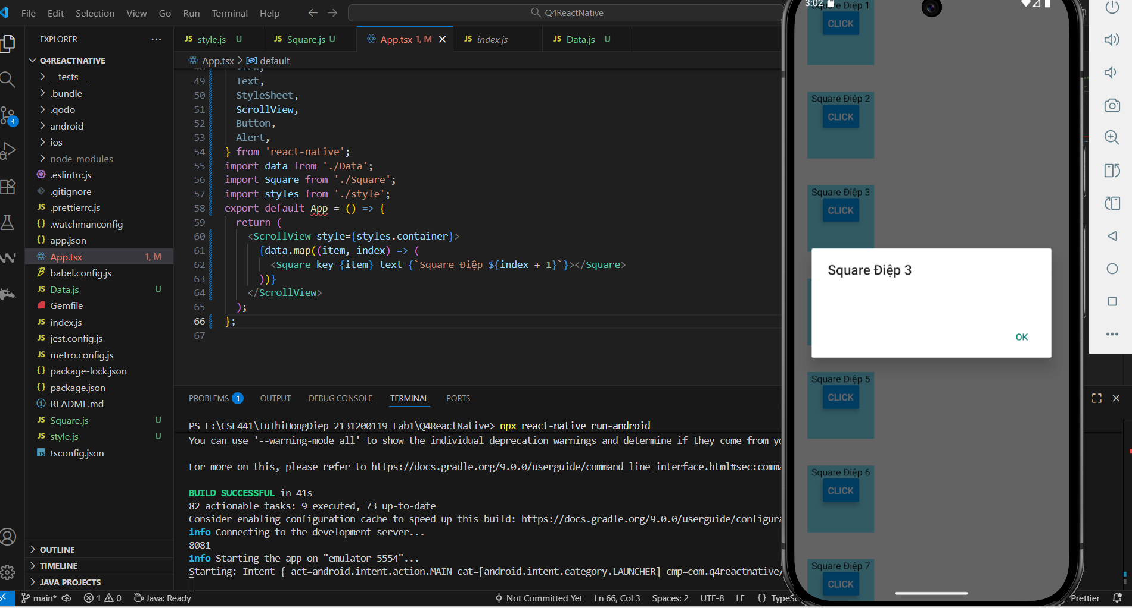

**Question 5: Publishing**

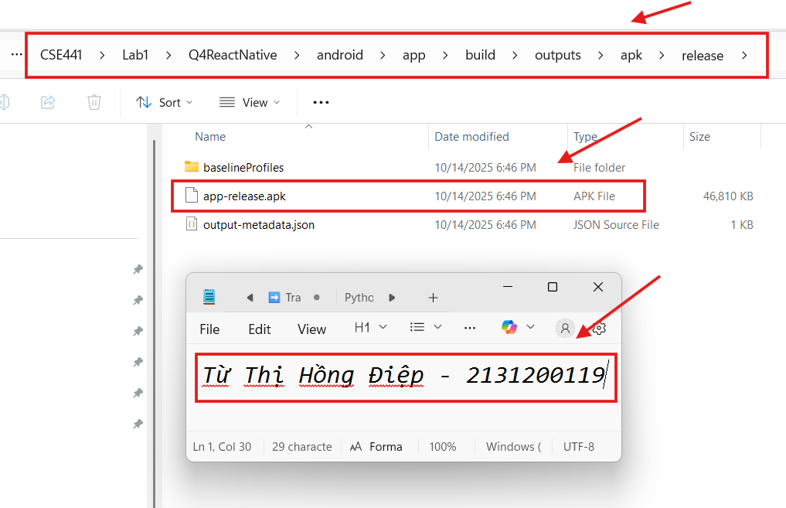

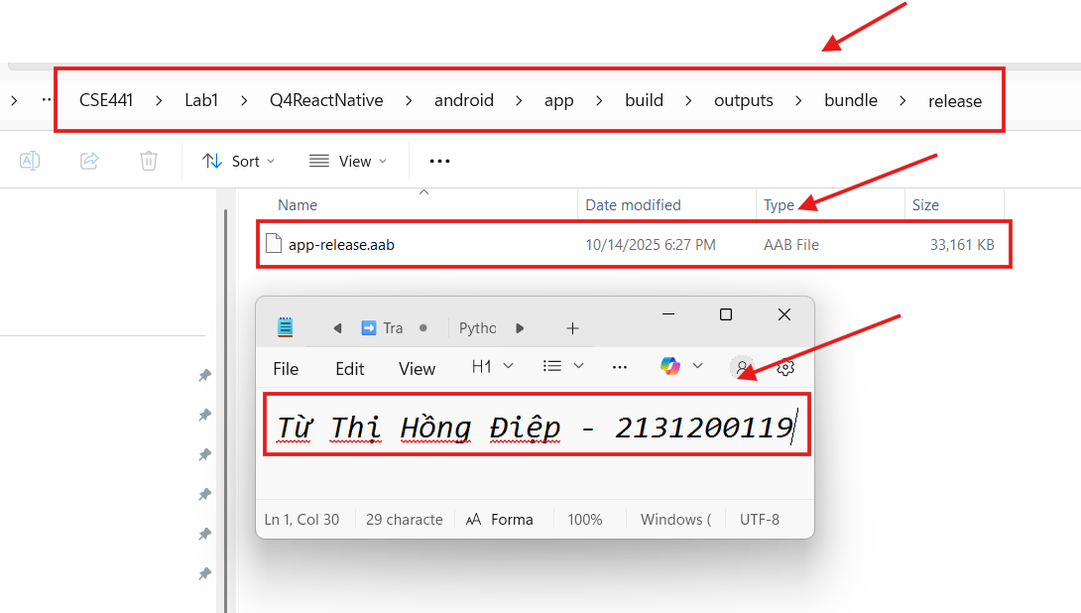

**Question 6: Build apps with props and state.**

1. Build an employee information entry screen with: full name, age, occupation

specialized in training and an update button (display success message) (Component, Props).

|  |  |
| --- | --- |
|  |  |

2. Write a program to sum the first digit and the last digit of a number. (Component,

State)

|  |  |
| --- | --- |
|  |  |

3. Write a program to find the minimum between three numbers. (Component &

state)

|  |  |
| --- | --- |
|  |  |

4. Write a program that displays the Hailstone sequence: With some positive number

(n > 0): (Component & State)

a. If n is an even number, divide by 2.

b. If n is an odd number, multiply it by 3 and add 1.

c. Repeat two steps above until n equals 1.

|  |  |
| --- | --- |
|  |  |