|  |
| --- |
| Kookmin University |
| Design Project |
| Multi party Messenger |

|  |  |
| --- | --- |
| **Name** | 20093267 Kim Sung Geun |
| 20093284 Na Hong Cheol |
| 20093268 Kim Se Hoon |

**Ⅰ. Application Architecture**

|  |
| --- |
|  |
| Login – User sends information of user to Server. And then Server gets that information and saves in storage.  Invite – If Client in Message Section wants to invite Client not in Message Section(CNIM), Client sends Message type of ‘invite’ to server. Server sends IP information of Host Client to CNIM. CNIM accepts that IP information and then connect to Host Client.  Leave – Host Client sends Message type of ‘leave’ to Server. Server chooses one Host Client of the Clients in Message Section and then sends IP information of New Host Client to others. Others connect to New Host Client. |

**Ⅱ. Implementation**

**-** Initiate Phase

Every Clients initiate for chatting. ‘Initiate’ means Client connects to Server and sends message of Client information including port number ,IP number and ID . Server knows who is online and waiting for chatting.

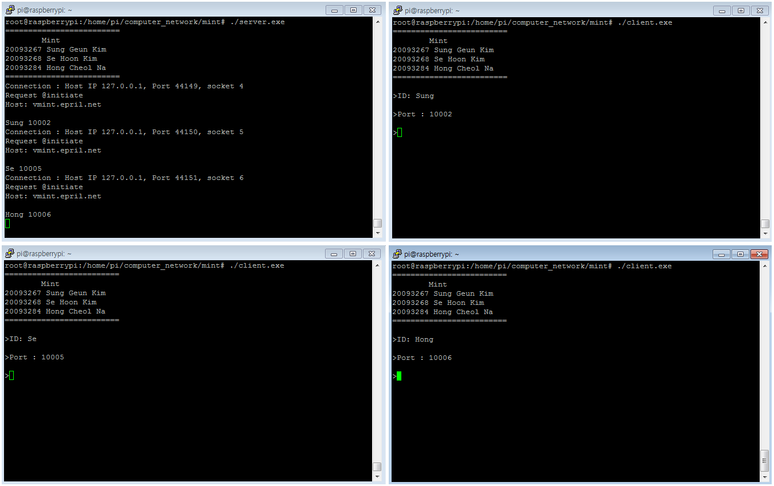

- Get List Phase

Clients can get list of Clients from Server. If Client inputs ‘@list’ command, Server receive message of ‘@list’ from Client who wants to get list of clients. And then Server Sends information of Clients. That information includes condition Chatting or not.

[List of not chatting Clients]

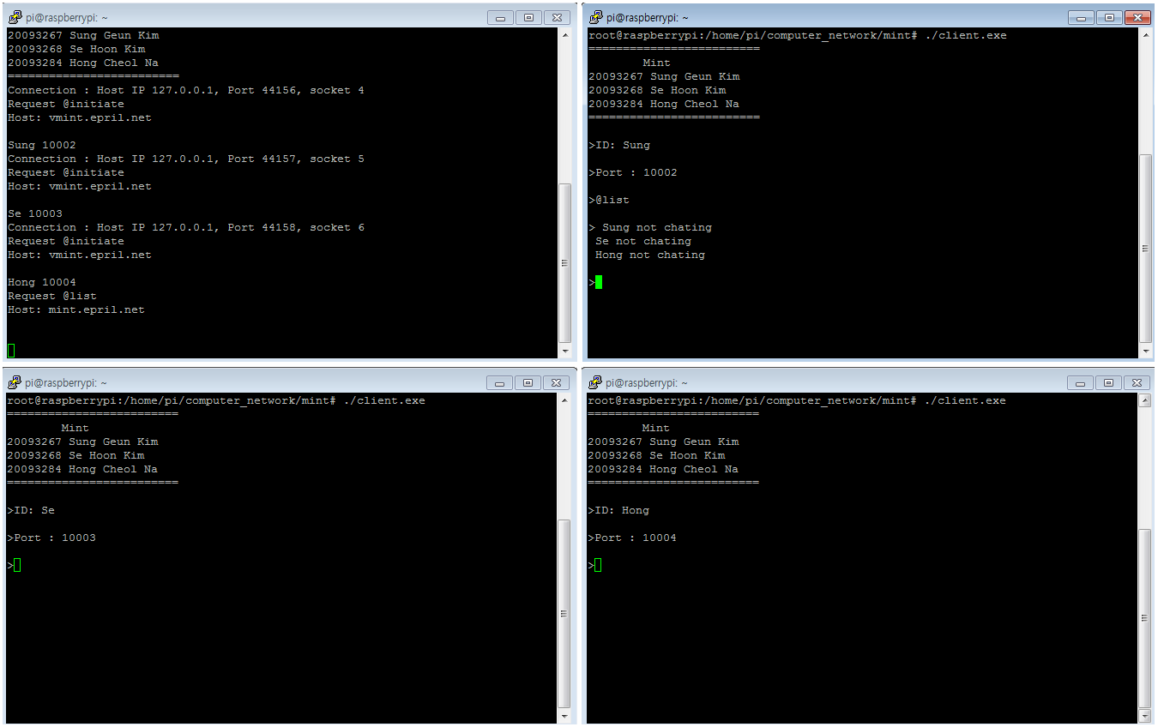

[List of Chatting Clients]

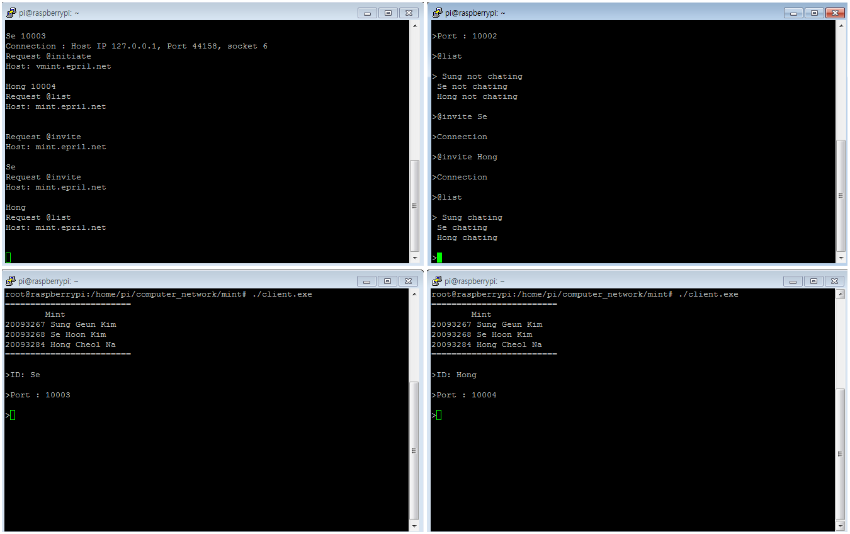

- Invite Phase

Client can chat with other Client. That message is ‘@invite’. Client inputs that message with ID of invited Clint. Server receives ID of invited Client and finds Client IP and Port number. And then Server sends message that Client connect to Host to invited Client. Client connect to Host. No matter who invite Client. But invited Client must be not chatting. Caution!! Maximum number of chatting Clients is 10.

[ Client (Sung) invites Client (Se and Hong) ]

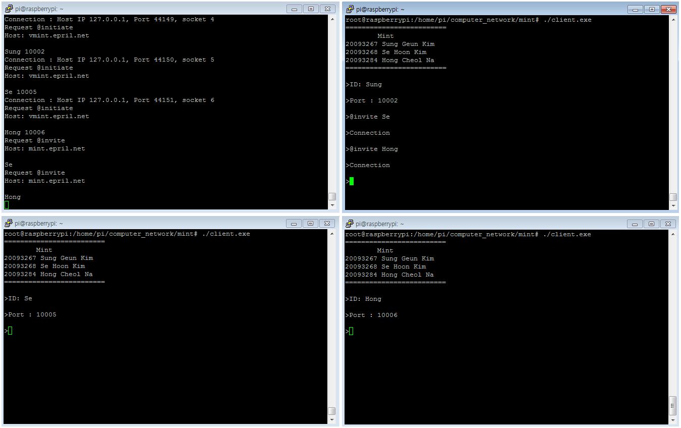

- Message Phase

Invited Clients can chat with Clients in same host group.

[ 1-1. Client(Se) inputs message to other Clients]

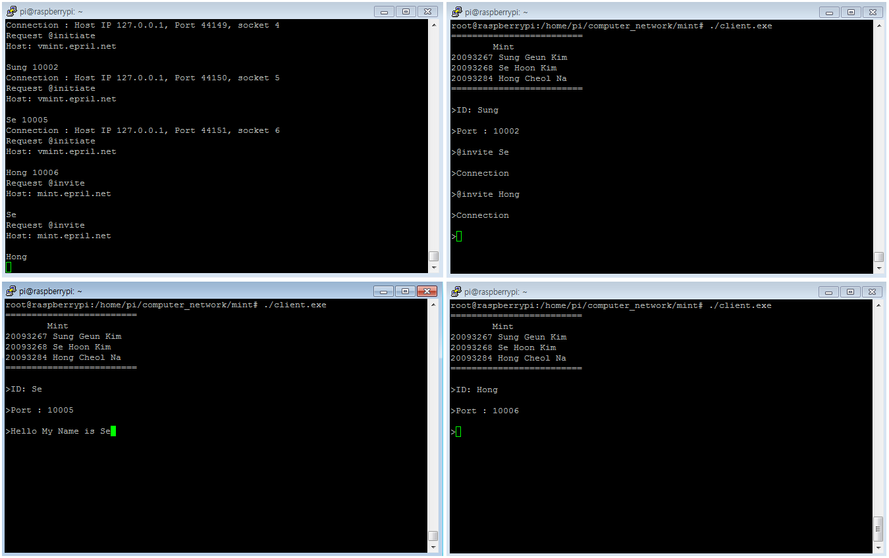

[ 1-2. Other Clients can receive message from Client(Se) ]

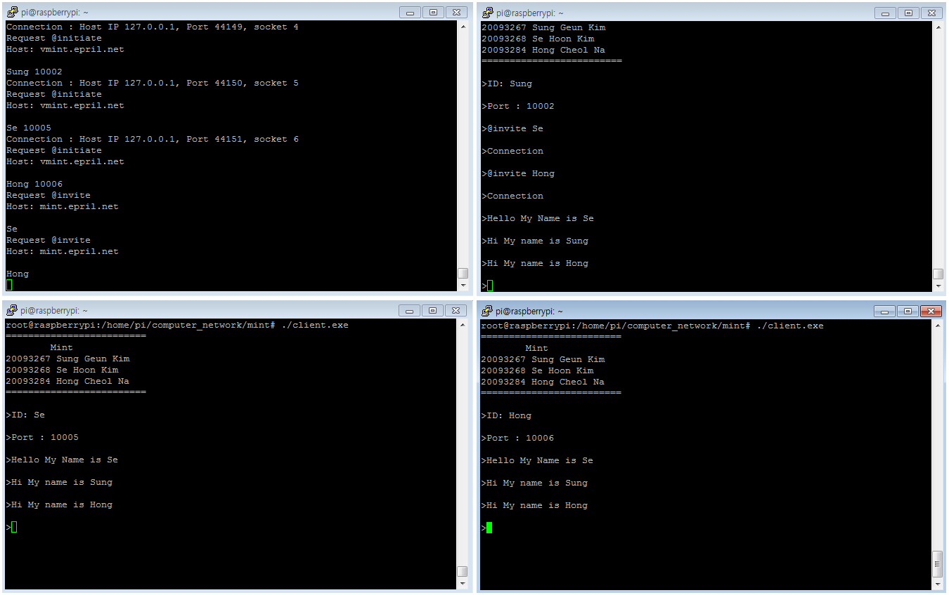

[ 2-1. Client(Hong) inputs message to other Clients]

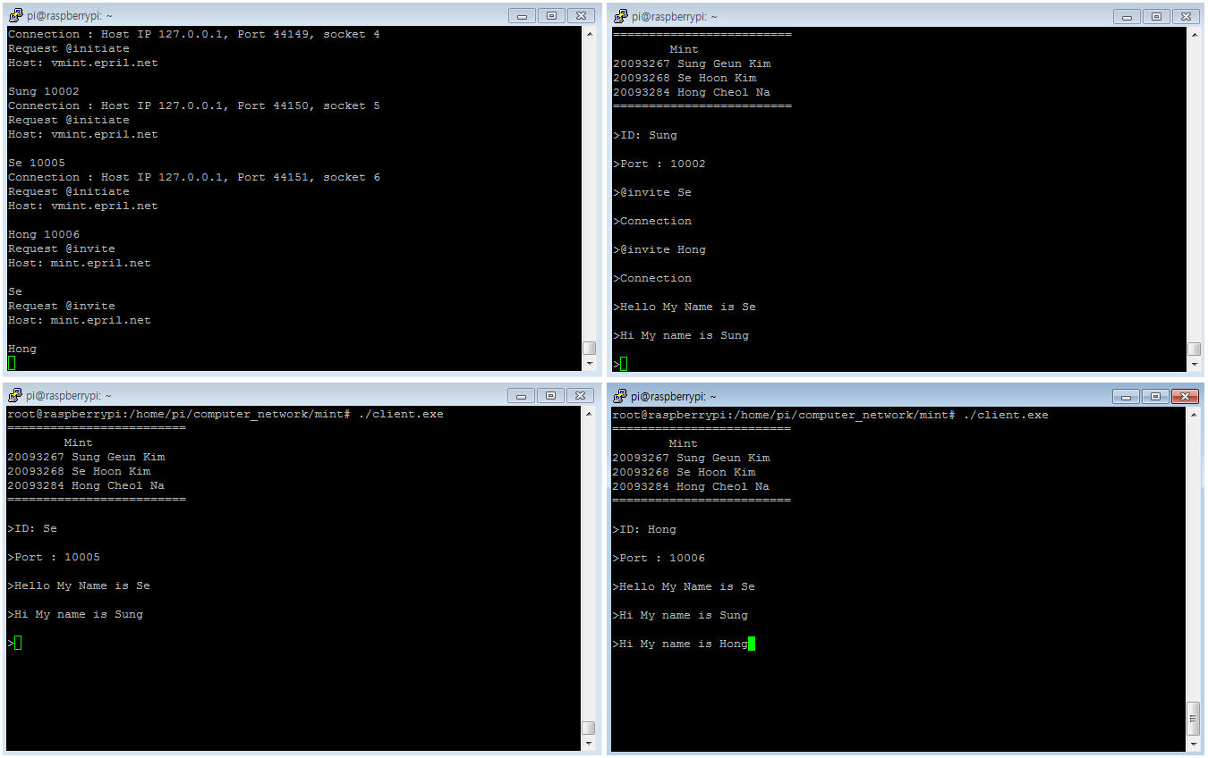

[ 2-2. Other Clients can receive message from Client(Hong) ]

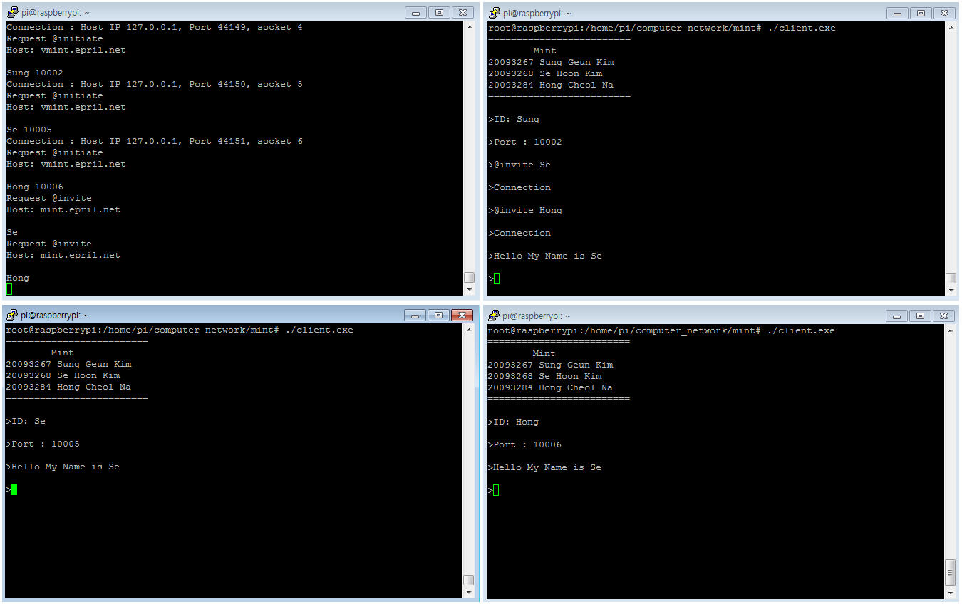

- Leave Phase

All Clients can leave host group easily except Host Client. Normal Client inputs ‘@leave’ message, and then shutdown program with leaving host group. Server receive that leave message and then delete Client array of structure. When Host Client wants to leave, Server choose one Client in host group to make Host Client. After choose one, Server sends message that Client connect to Host to all Clients in host group. Those Clients connect to new host.

[ 1. Client(Hong) leaves host group ]

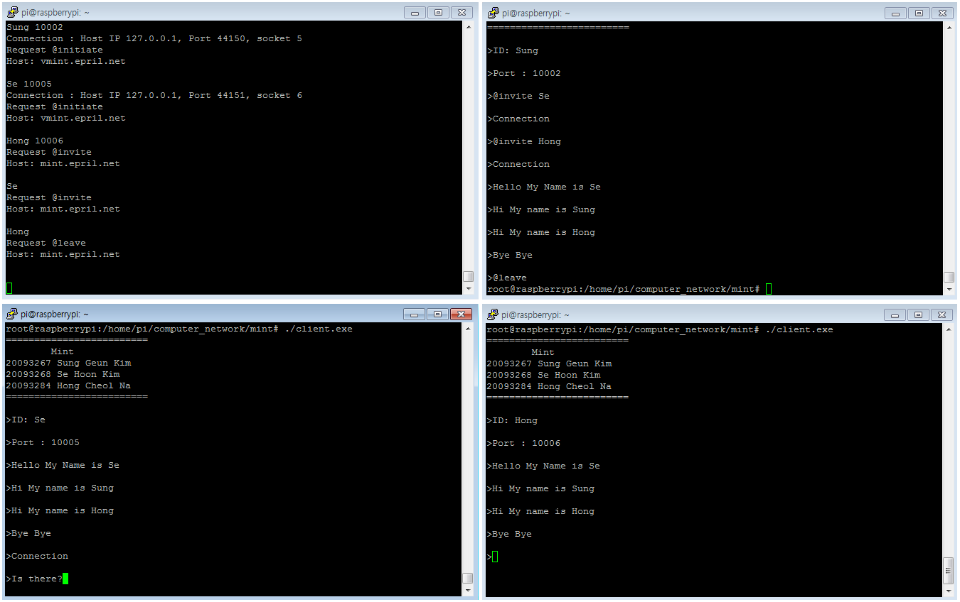

[ 2-1. Checking connection without Client(Sung) ]

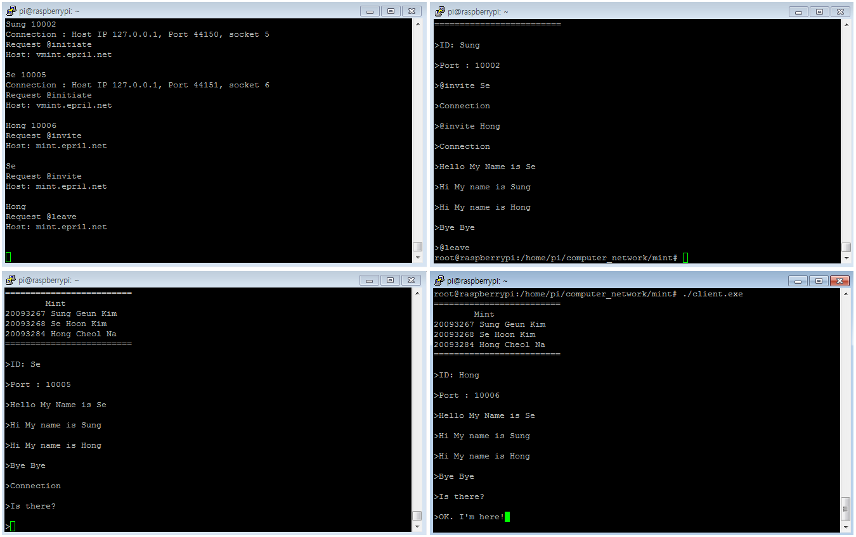

[ 2-2. Checking connection without Client(Hong) ]

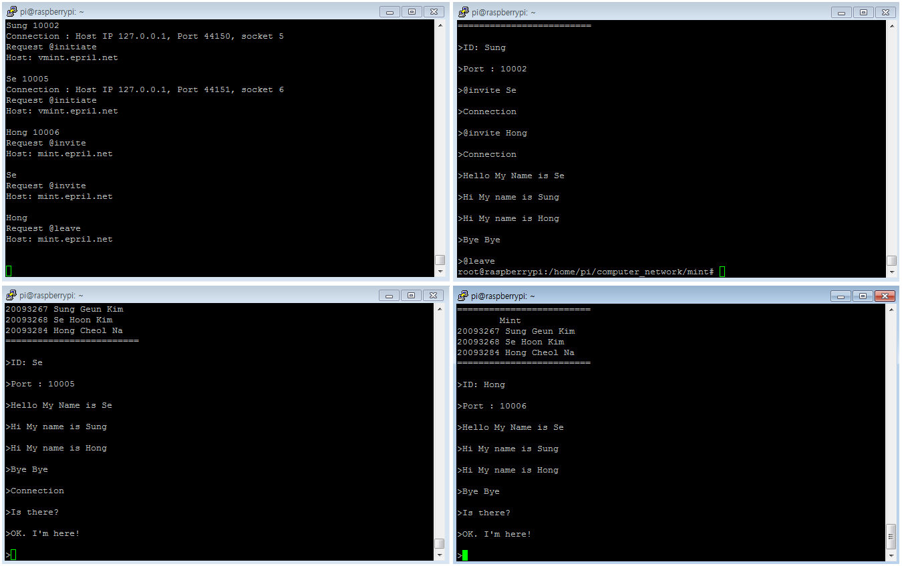

Ⅲ. User Manual

* Starting Program
  + $ ./client
  + >ID: [ ID ]
  + >Port : [ Port Number ]
* Invite Client command
  + @invite [ ID ]
* Get List Command
  + @list
* Shut down chatting program
  + @leave