# 线程安全

## 一丶同步方法Synchronized

//线程安全 锁定正确

public synchronized void test2() {

if (num <= 0) {

flag = false; //跳出循环

return;

}

try {

Thread.sleep(500); //模拟 延时

} catch (InterruptedException e) {

e.printStackTrace();

}

System.out.println(Thread.currentThread().getName() + "抢到了" + num--);

}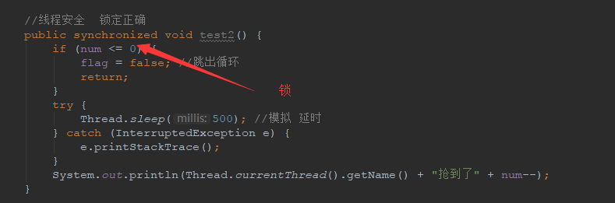

## 二丶同步块{ }

synchronized (this) {

}

This 🡪要锁的对象 eg: Person.Class

//线程安全 锁定正确

public void test3() {

//a b c

synchronized (this) {

if (num <= 0) {

flag = false; //跳出循环

return;

}

try {

Thread.sleep(500); //模拟 延时

} catch (InterruptedException e) {

e.printStackTrace();

}

System.out.println(Thread.currentThread().getName() + "抢到了" + num--);

}

}

