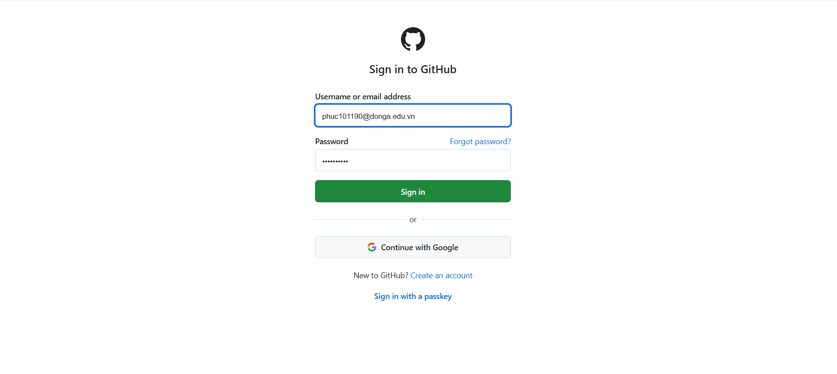

Step 1: Create a local git repository

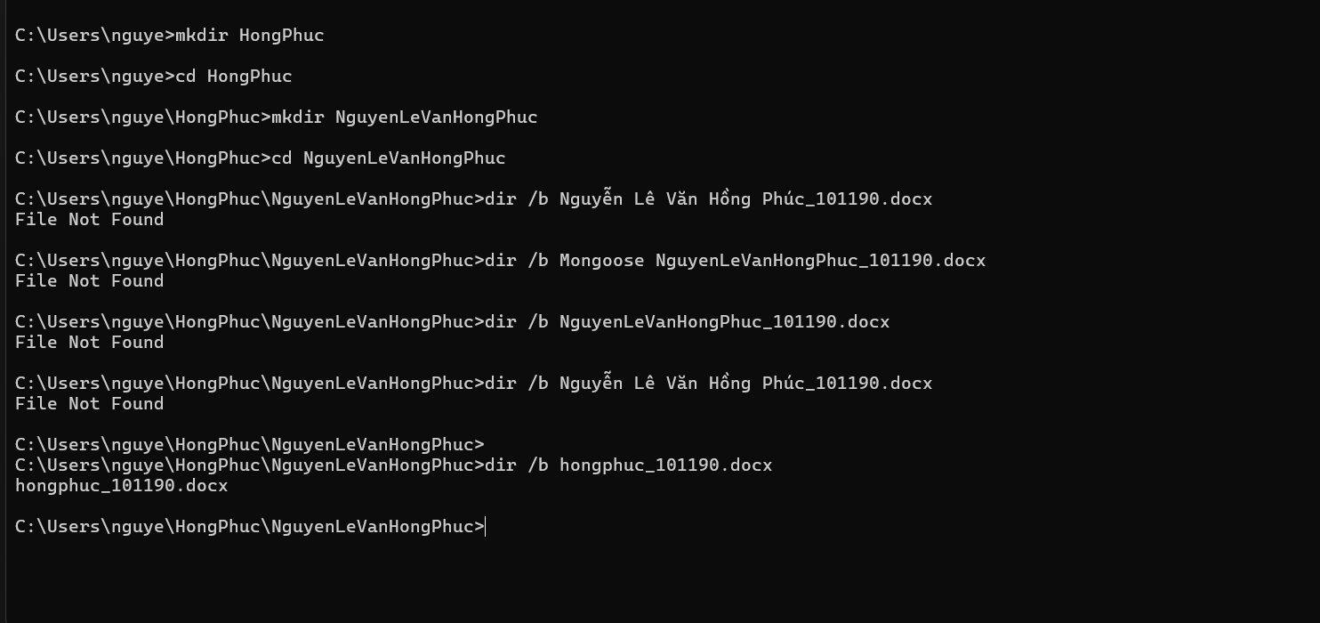

Step 2: Add a new file to the repo

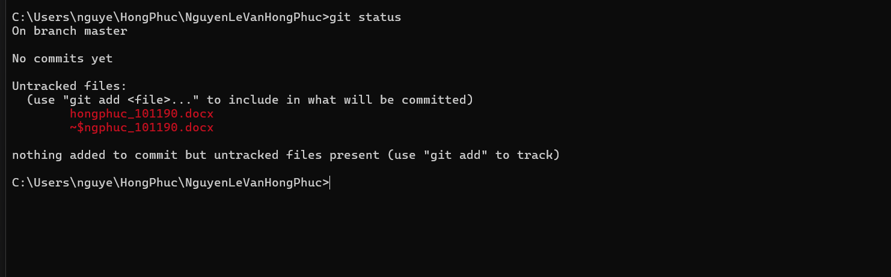

Step 3: Add a file to the staging environment

Step 4: Create a commit

Step 5: Create a new branch



Step 6: Create a new repository on GitHub

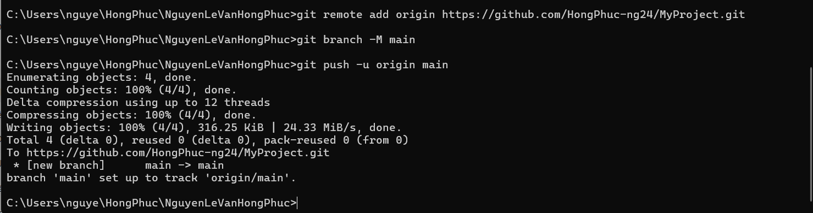

Step 7: Push a branch to GitHub

