Họ và tên: Nguyễn Thị Thùy  MSSV: 24527154 | LAB 4: PHP, MySQL
Phần 1:

- PHP Introduction:
24521754_NguyenThiThuy
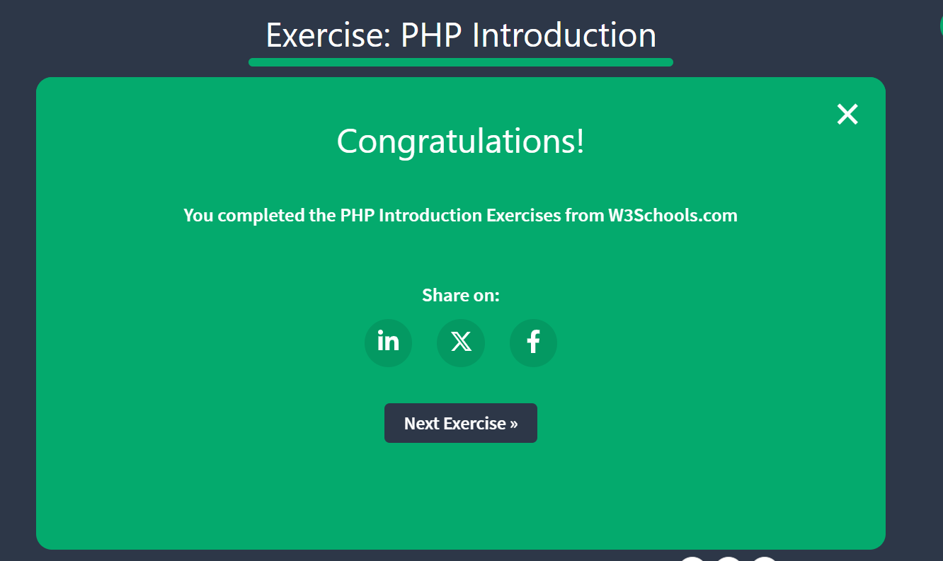

- PHP syntax:
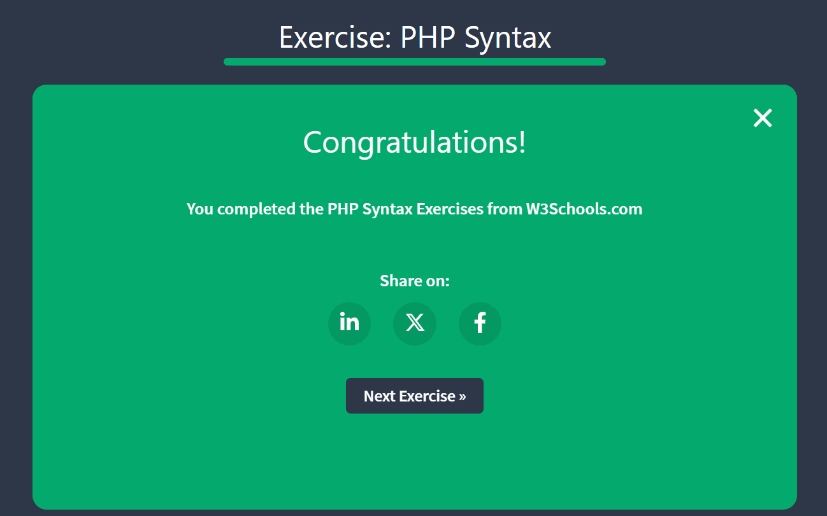
24521754_NguyenThiThuy
24521754_NguyenThiThuy
24521754_NguyenThiThuy
24521754_NguyenThiThuy
24521754_NguyenThiThuy

- PHP Comments
24521754_NguyenThiThuy
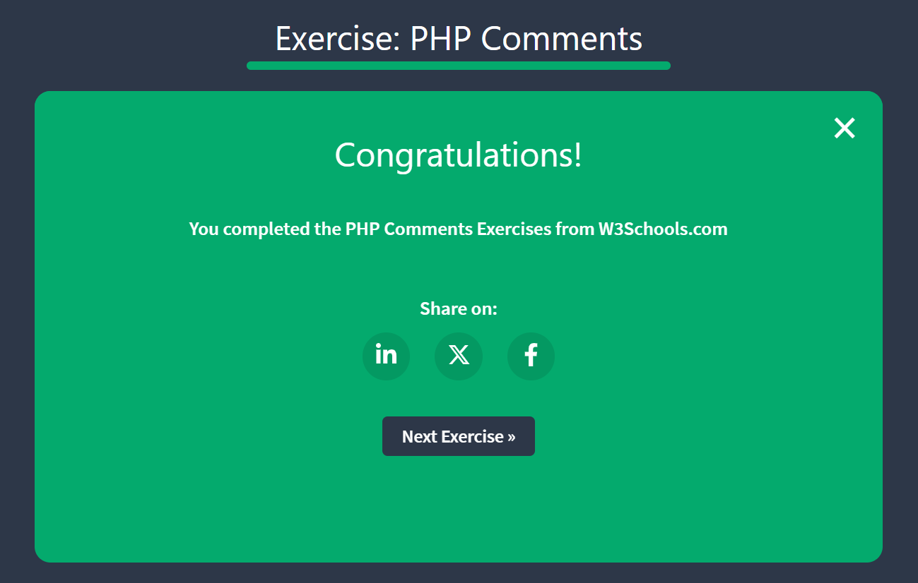

- PHP Variables
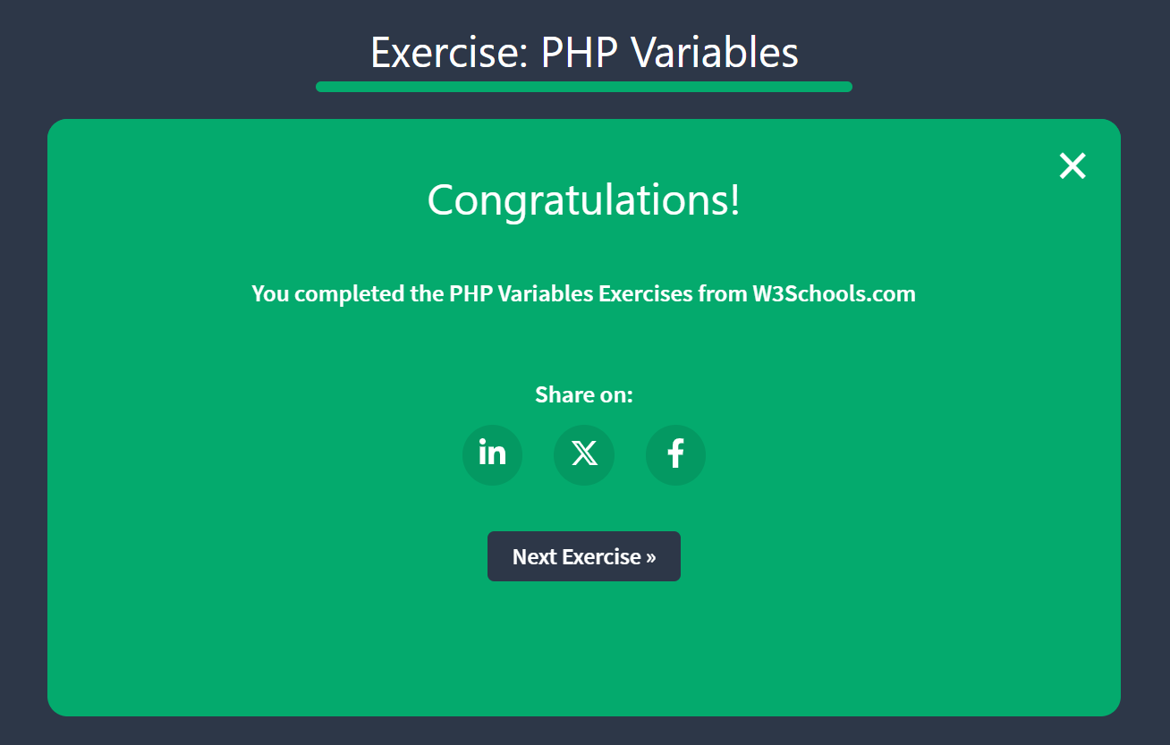
24521754_NguyenThiThuy
24521754_NguyenThiThuy
- PHP Variable Scope
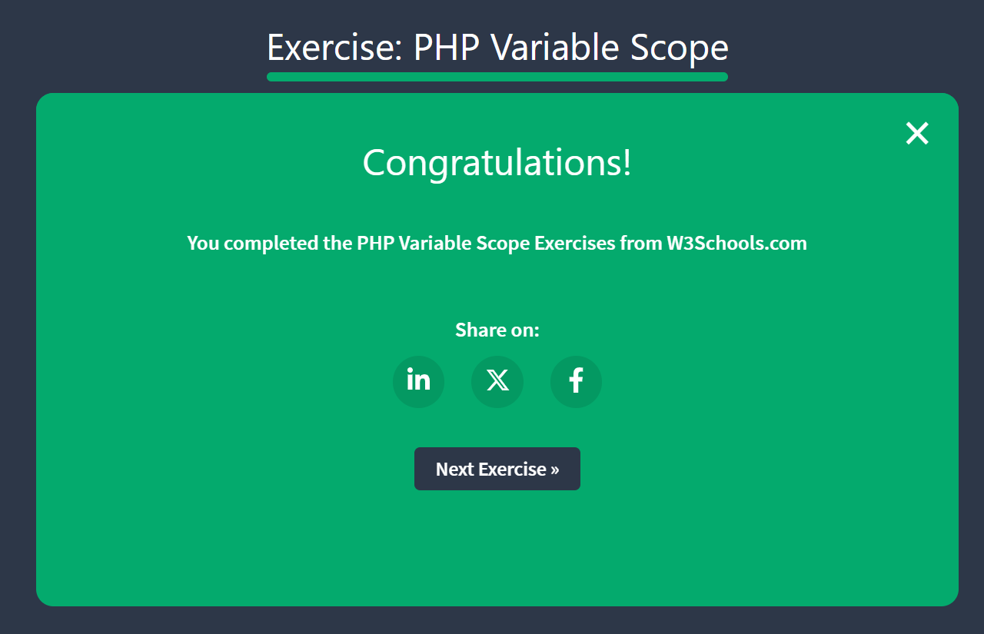
24521754_NguyenThiThuy

- PHP Echo and Print
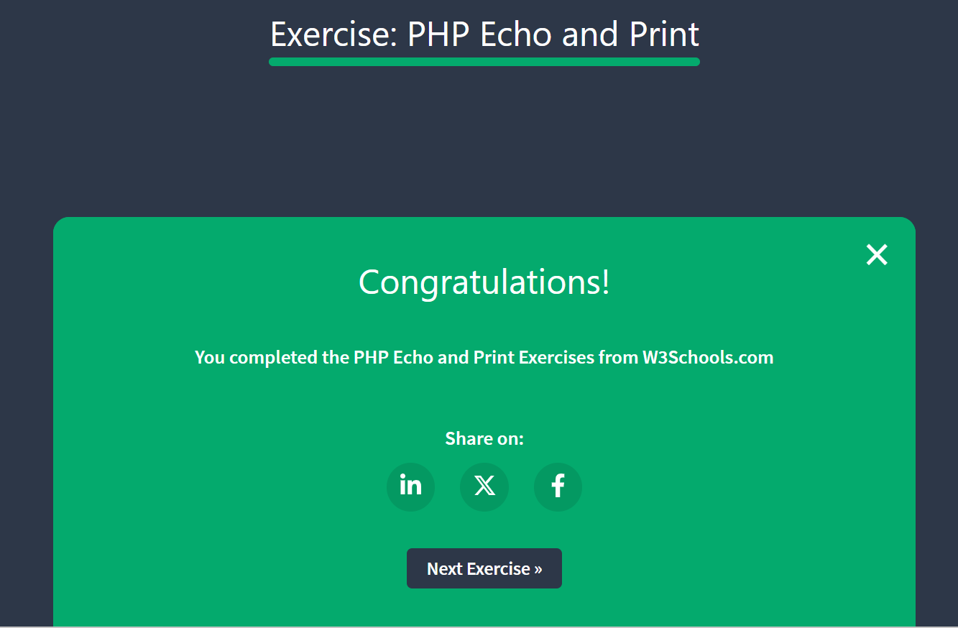
24521754_NguyenThiThuy
24521754_NguyenThiThuy
- PHP Data Types
24521754_NguyenThiThuy
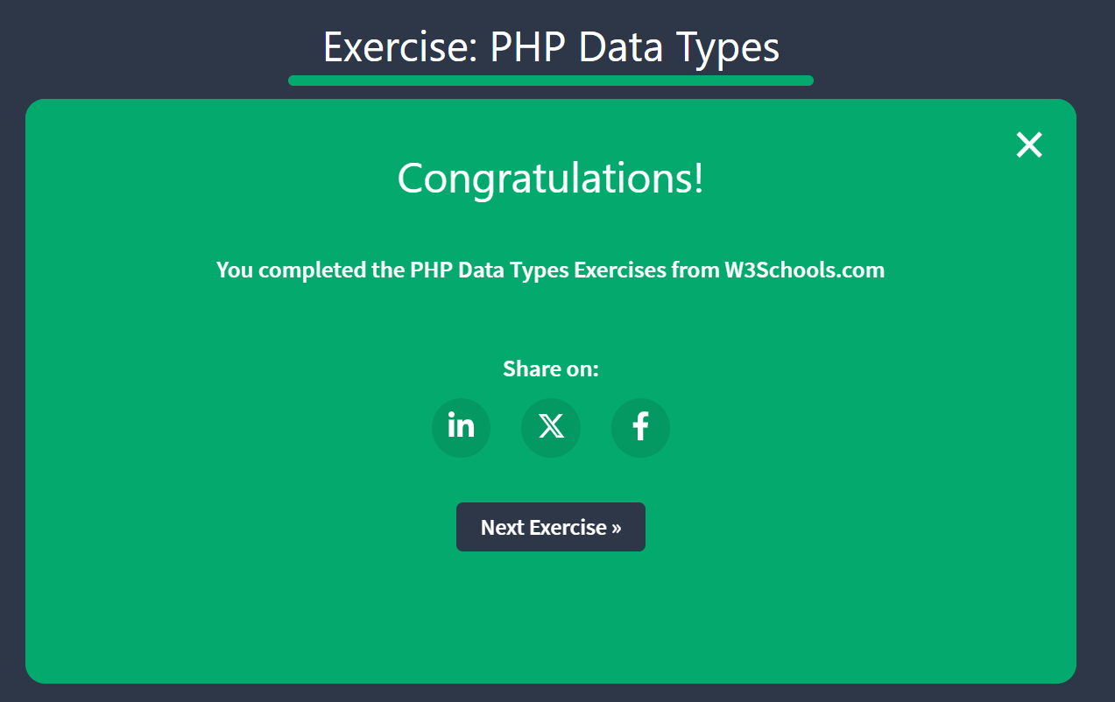

- PHP Strings
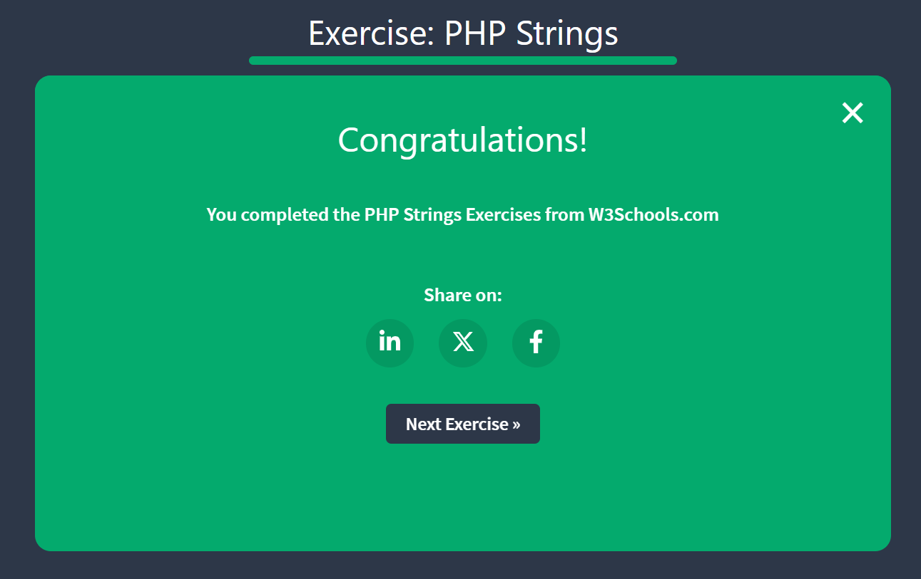
24521754_NguyenThiThuy

- PHP Modify strings
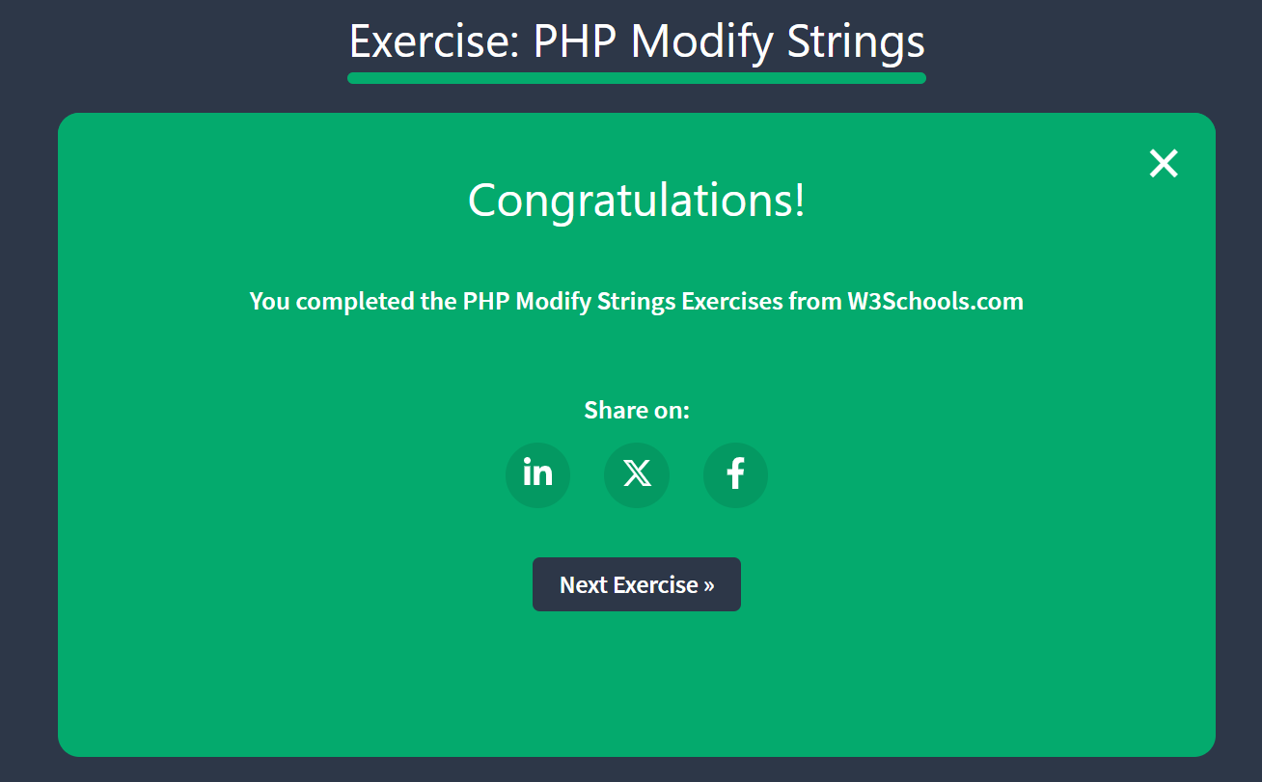
24521754_NguyenThiThuy

- PHP Concatenate Strings
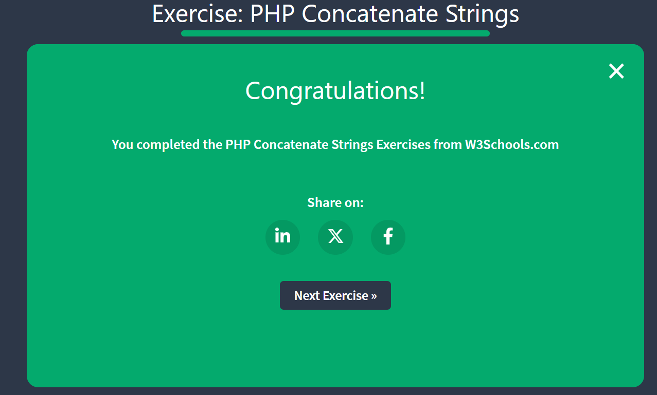
24521754_NguyenThiThuy
- PHP Slice Strings
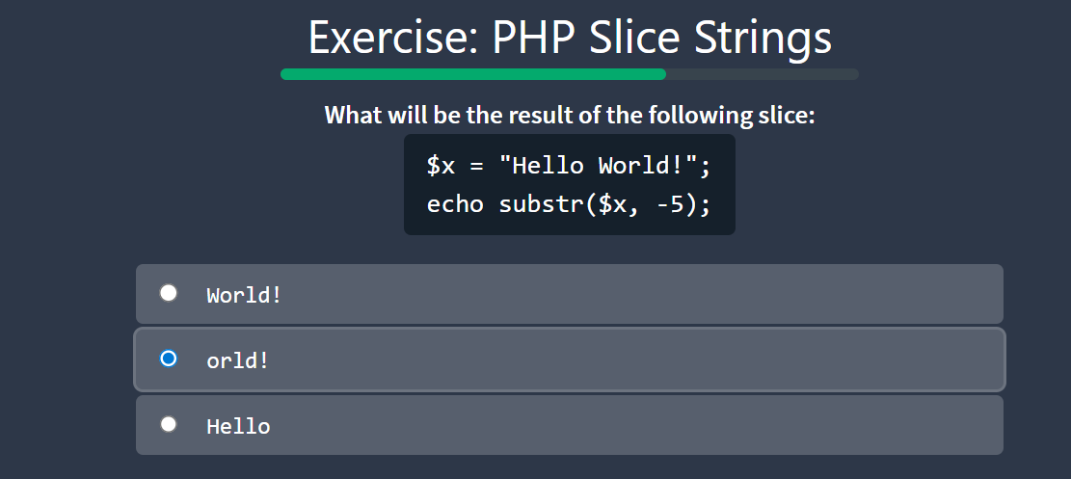
24521754_NguyenThiThuy

- PHP Numbers
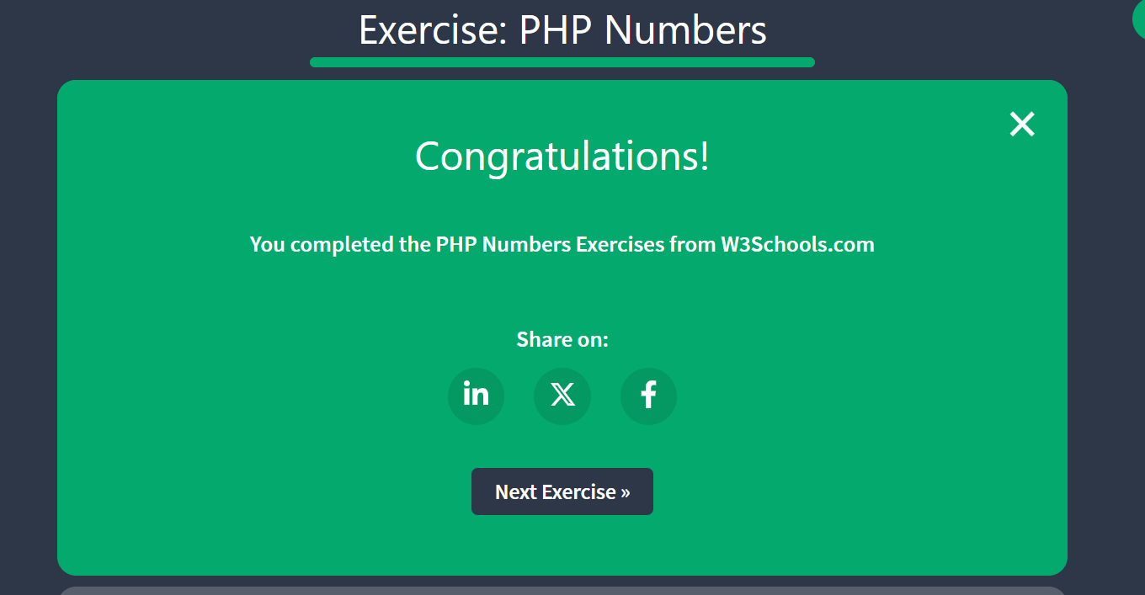
24521754_NguyenThiThuy

- PHP Casting

24521754_NguyenThiThuy

- PHP Math
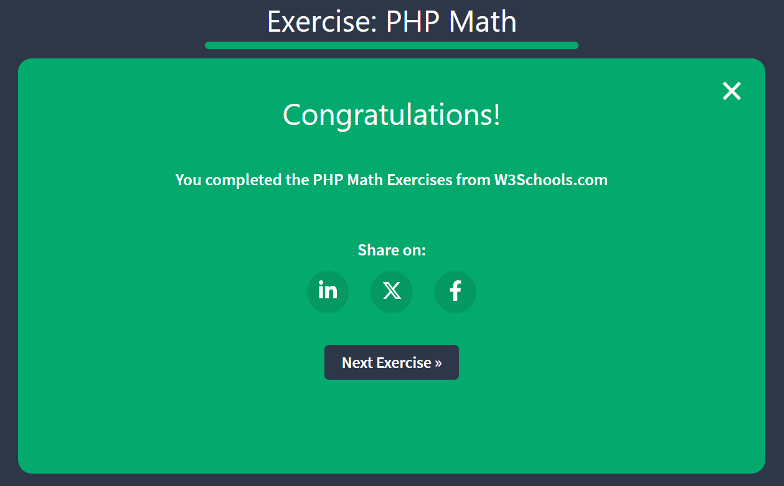
24521754_NguyenThiThuy

- PHP Constants
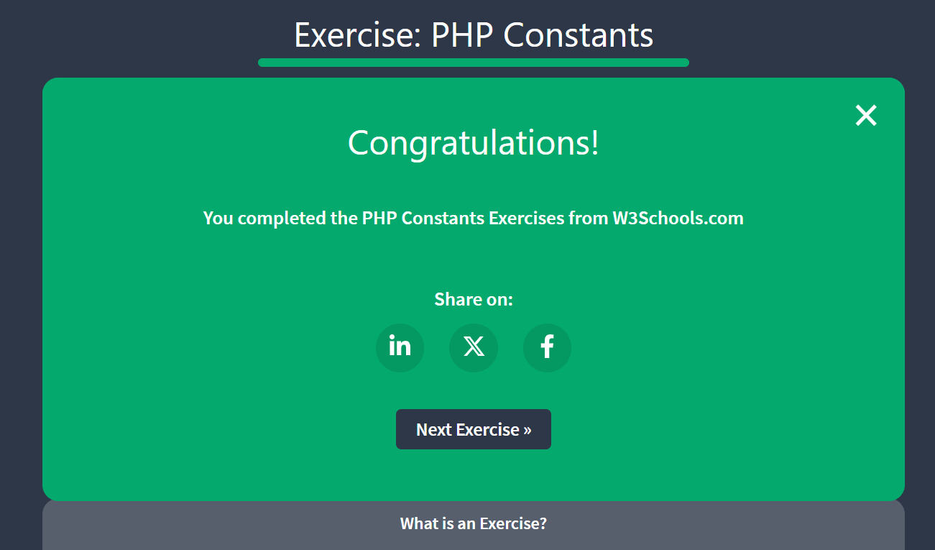
24521754_NguyenThiThuy

- PHP Operators
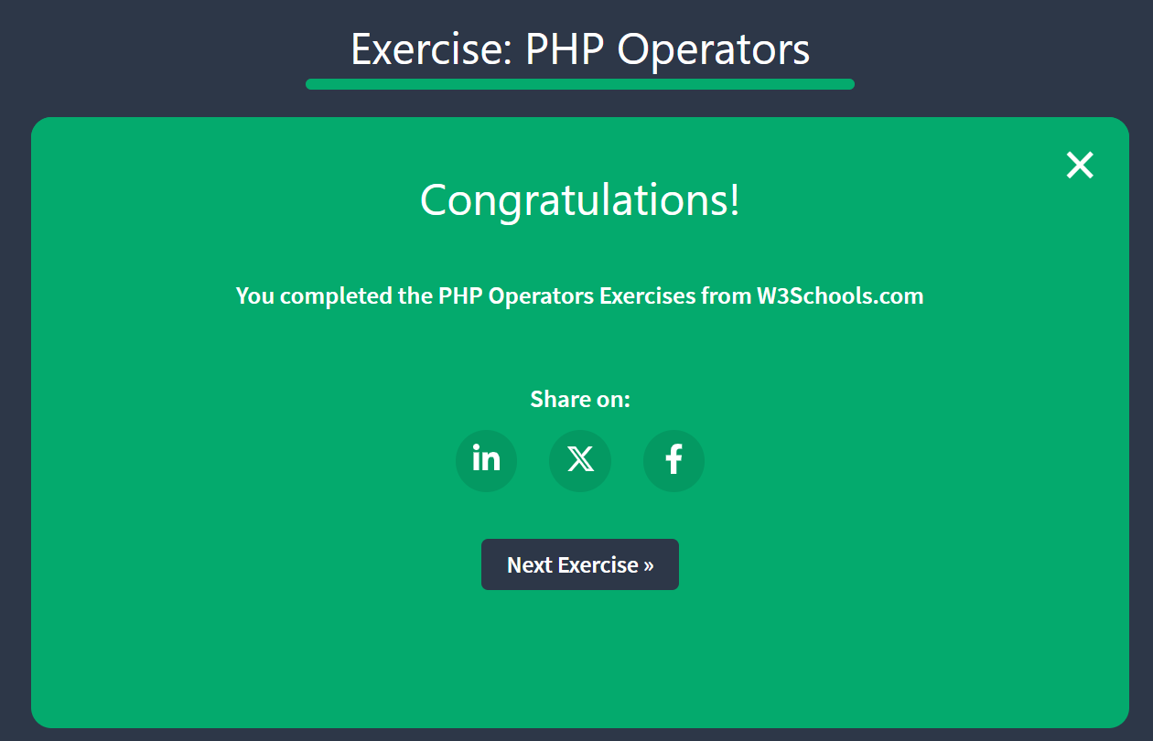
24521754_NguyenThiThuy

- PHP If Statement
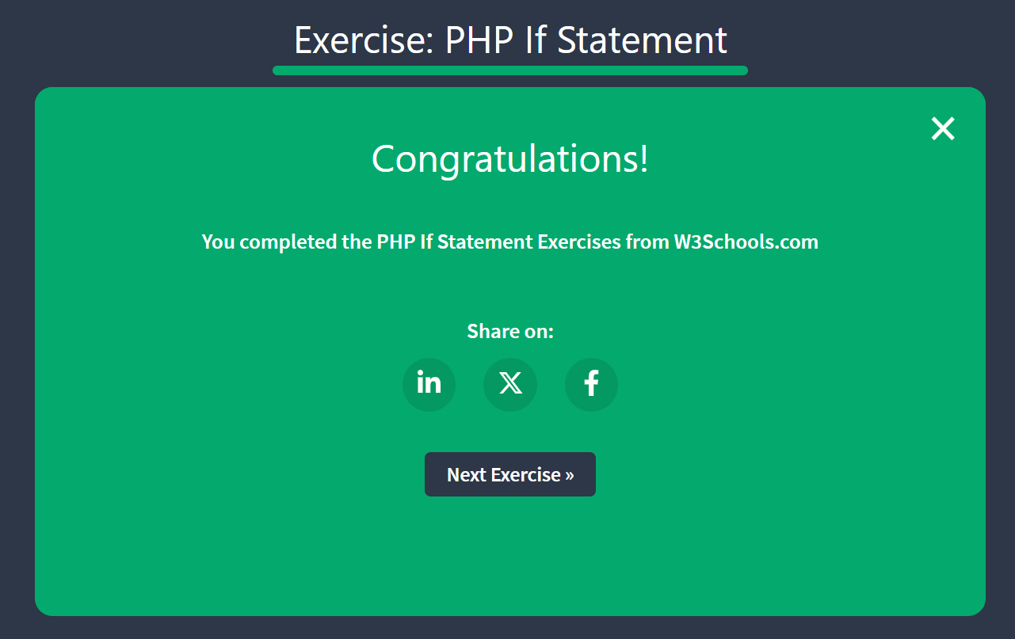
24521754_NguyenThiThuy

- PHP If Operators
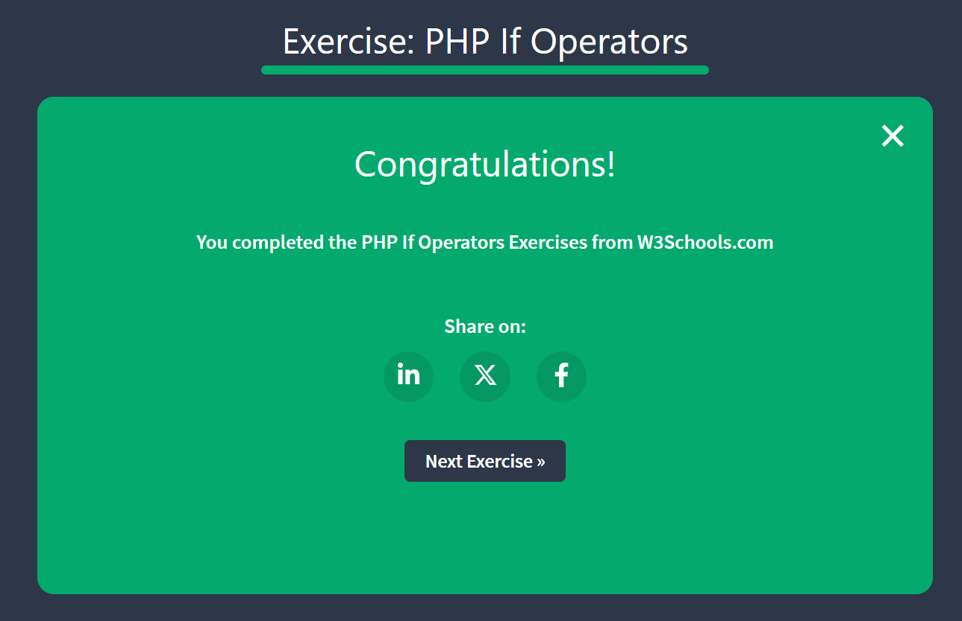
24521754_NguyenThiThuy

- PHP If … else
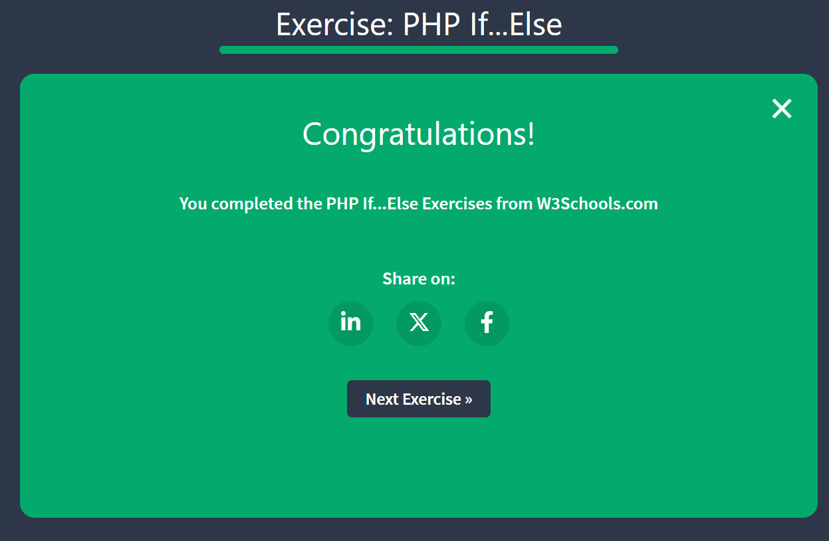
24521754_NguyenThiThuy

- PHP Switch
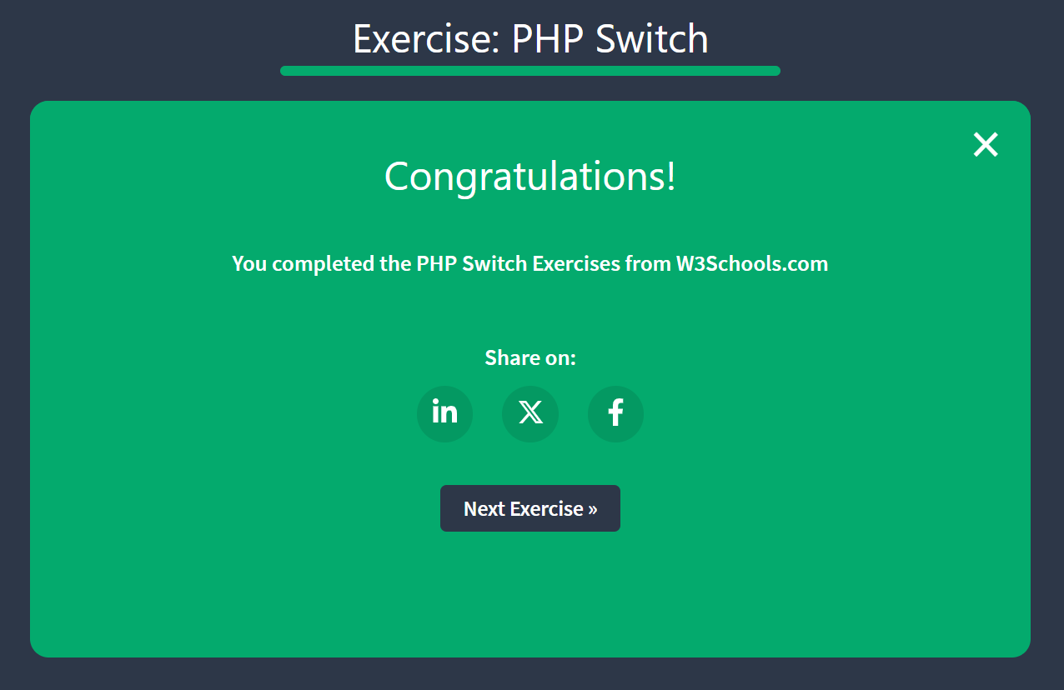
24521754_NguyenThiThuy
- PHP Loops
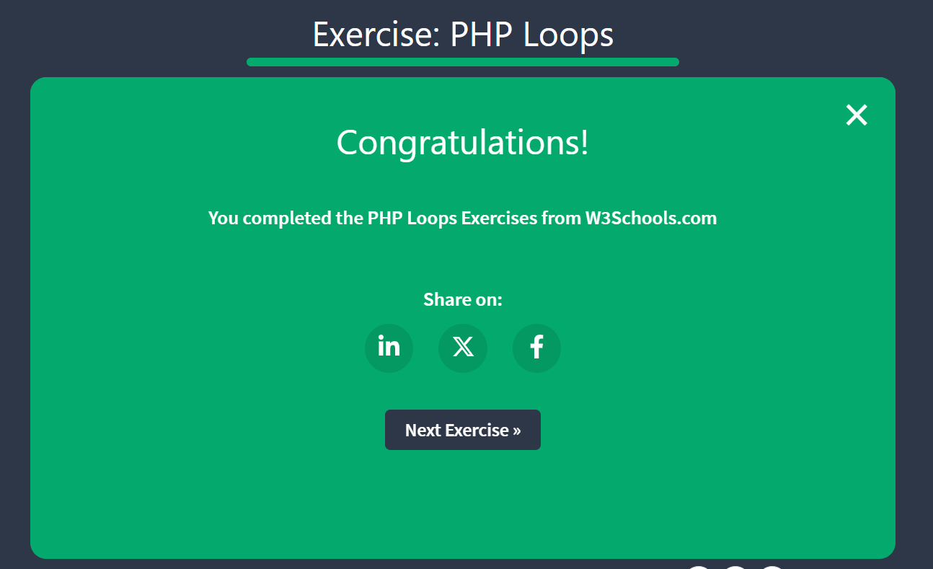
24521754_NguyenThiThuy

- PHP While Loops
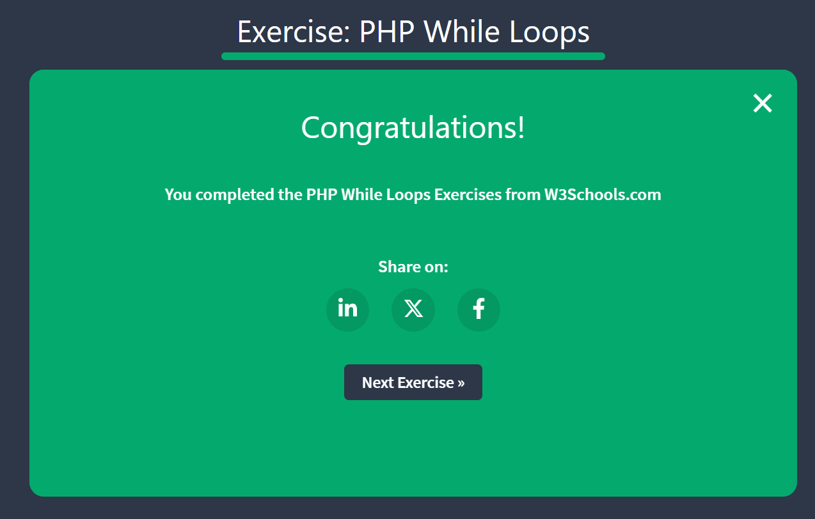
24521754_NguyenThiThuy

- PHP Do While Loops

24521754_NguyenThiThuy

- PHP For Loops
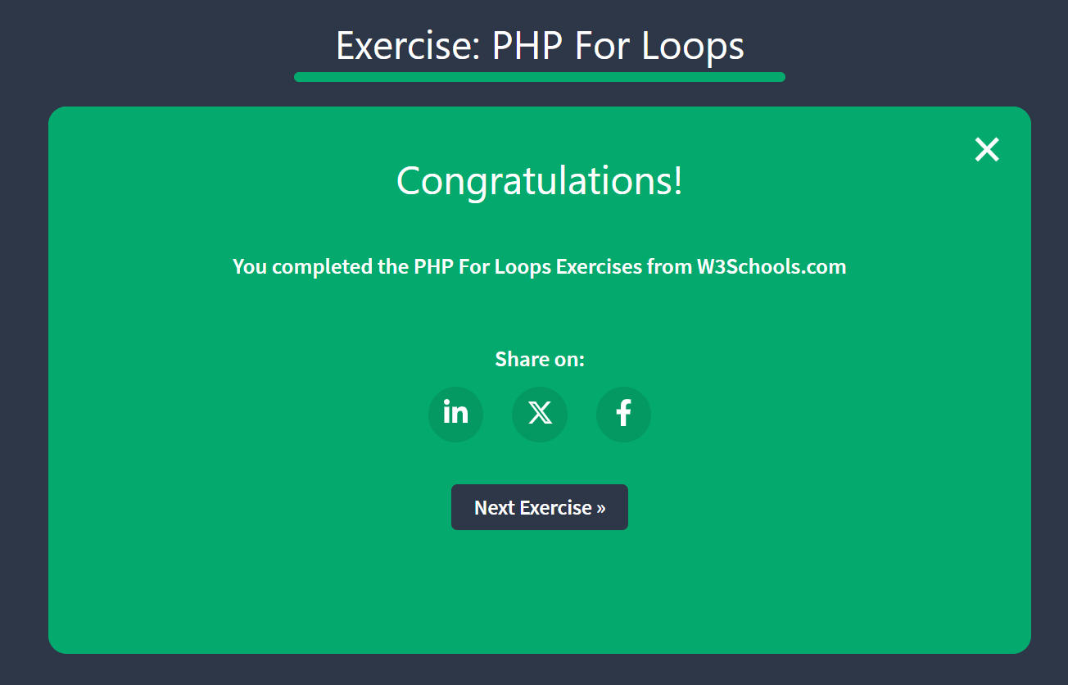
24521754_NguyenThiThuy

- PHP Foreach Loops
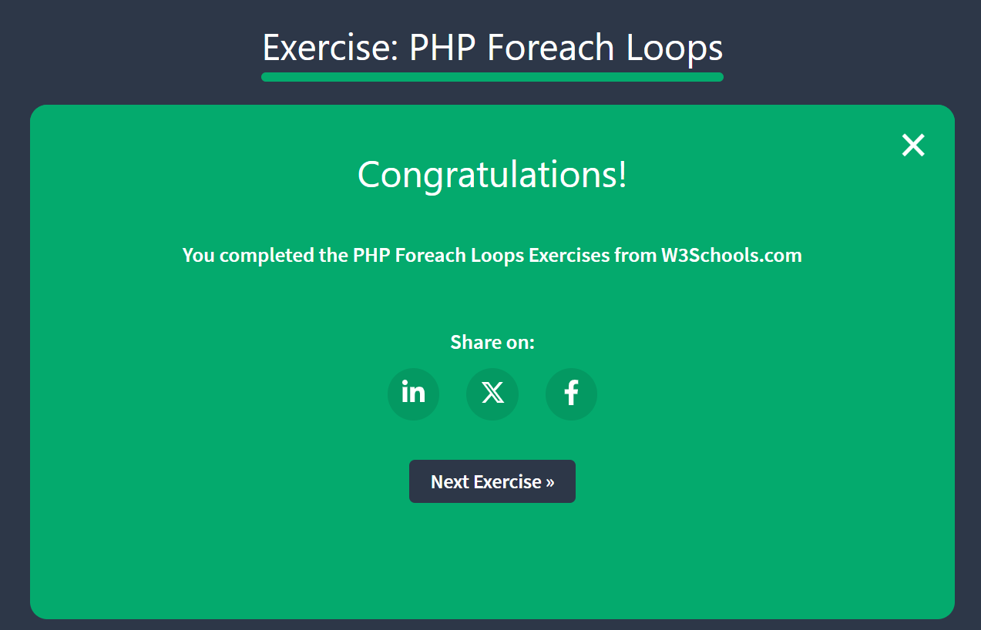
24521754_NguyenThiThuy
- PHP Functions
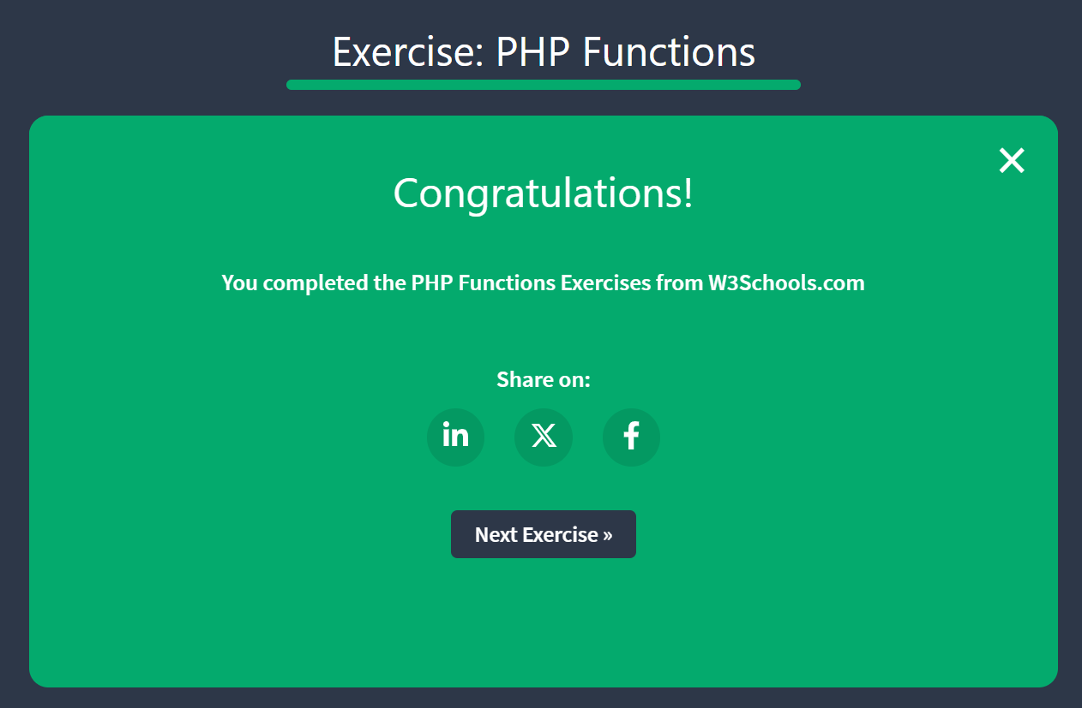
24521754_NguyenThiThuy

- PHP Arrays
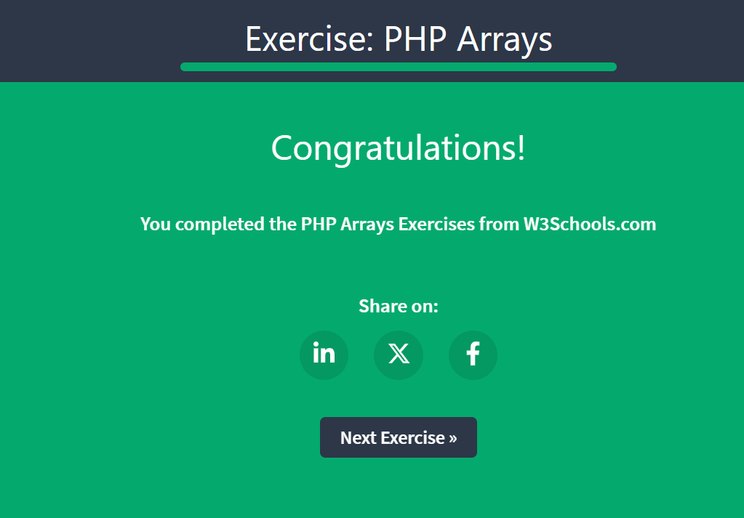
24521754_NguyenThiThuy

- PHP Indexed Arrays
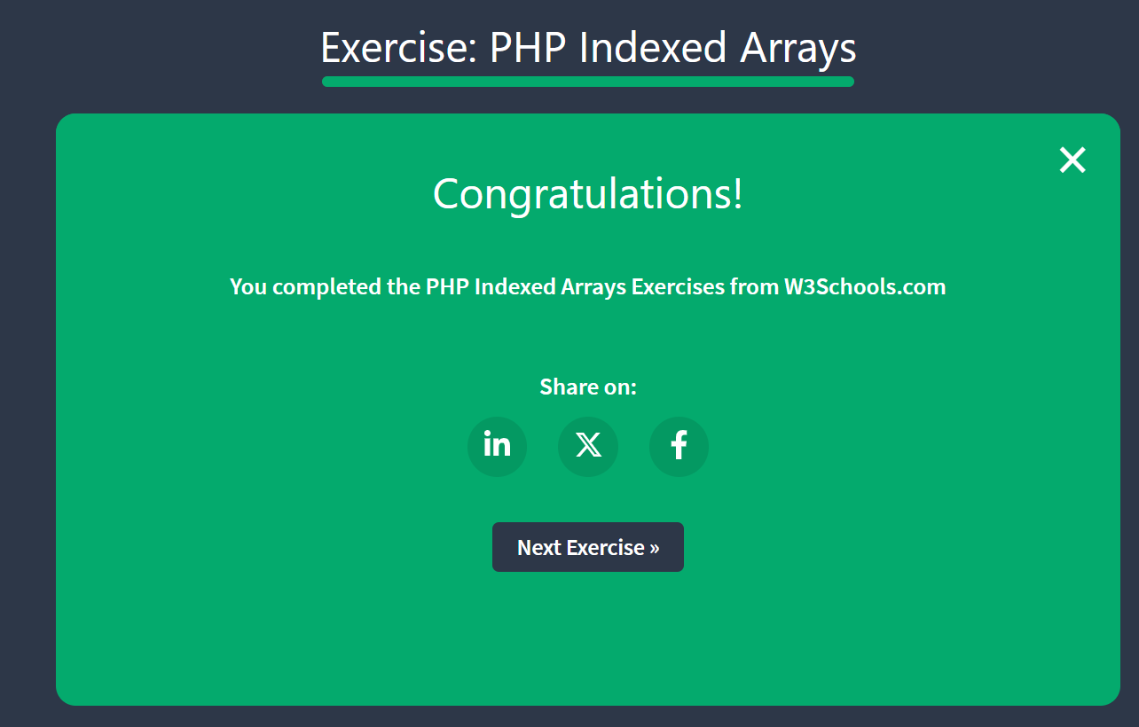
24521754_NguyenThiThuy

- PHP Associative Arrays
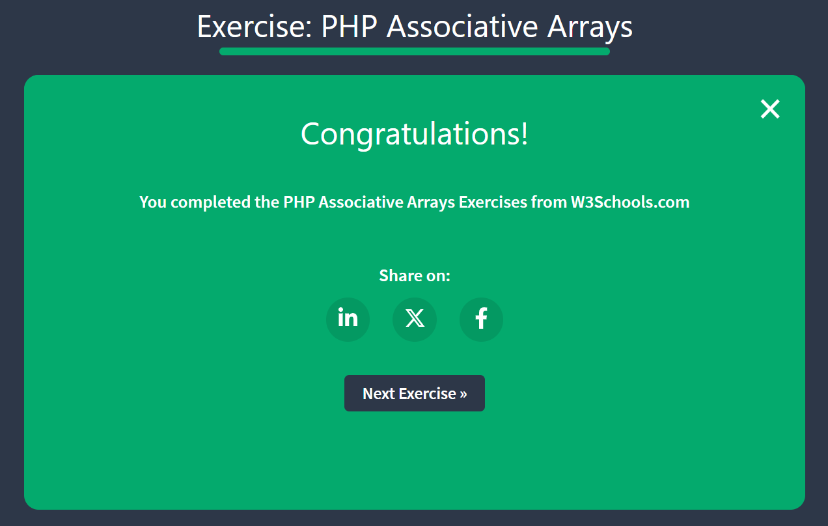
24521754_NguyenThiThuy

- PHP Create Arrays
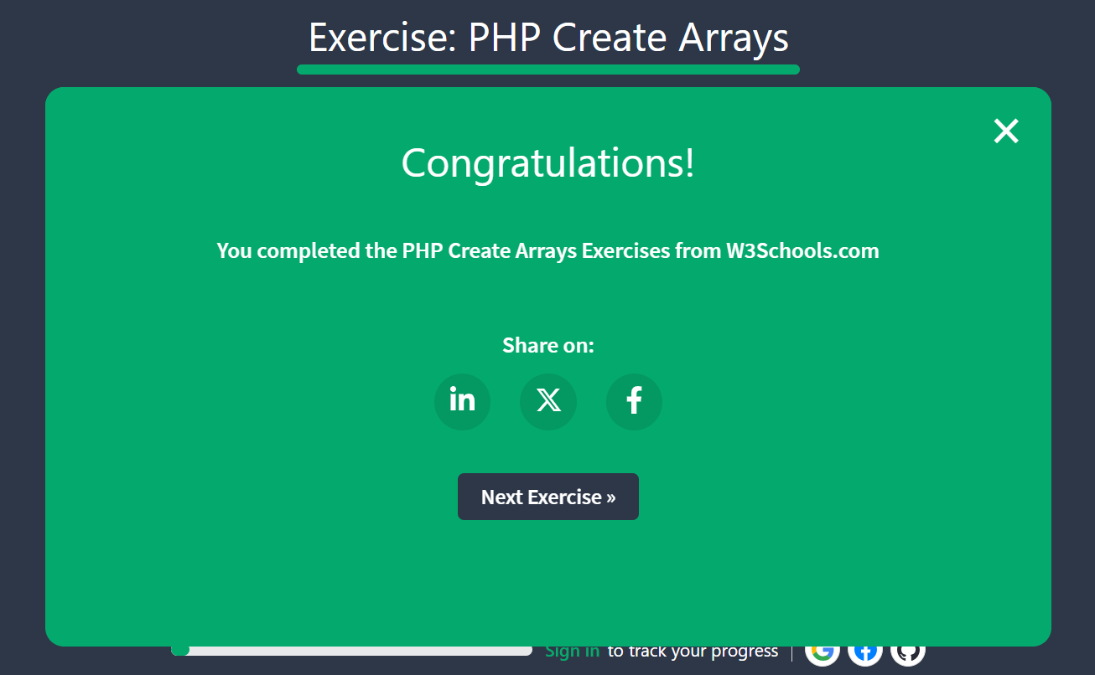
24521754_NguyenThiThuy

- PHP Access Arrays

24521754_NguyenThiThuy

- PHP Update Arrays

24521754_NguyenThiThuy

- PHP Add Array Items
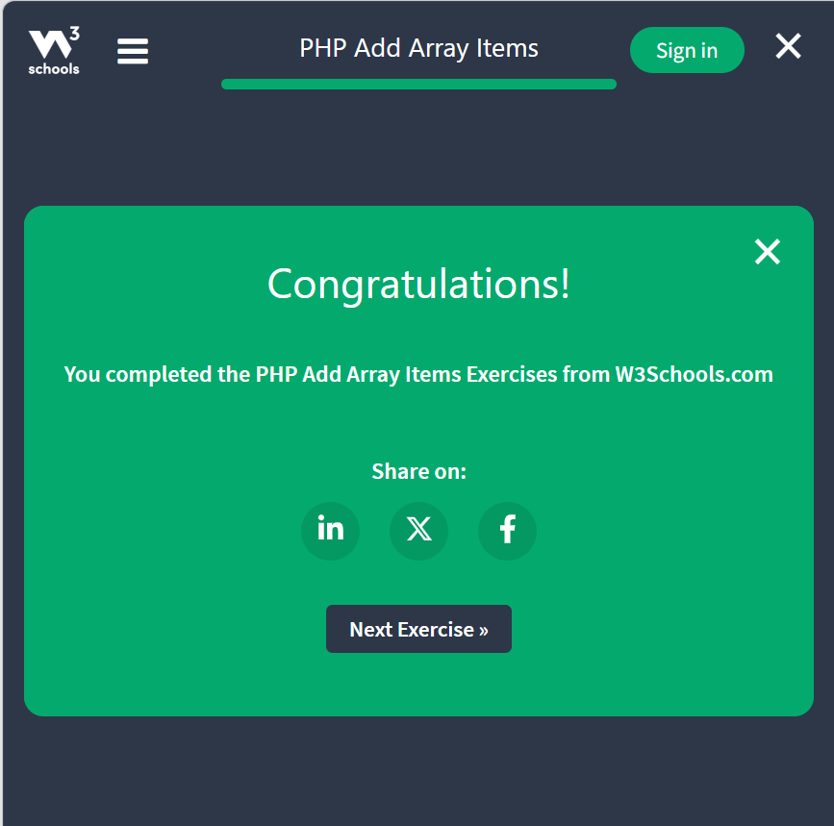
24521754_NguyenThiThuy

- PHP Remove Array Items
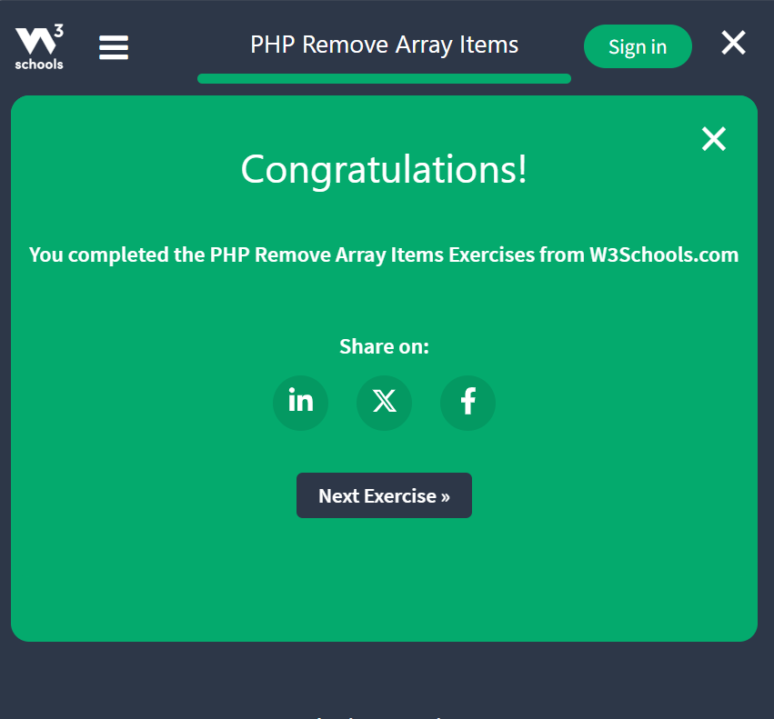
24521754_NguyenThiThuy

- PHP Sorting Arrays
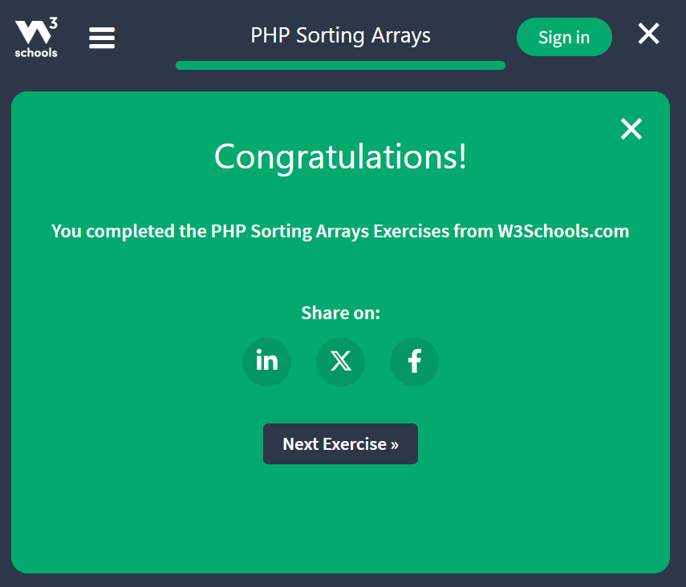
24521754_NguyenThiThuy

- PHP $Global

24521754_NguyenThiThuy

- PHP Requests

24521754_NguyenThiThuy
24521754_NguyenThiThuy

- PHP Reqular Expressions
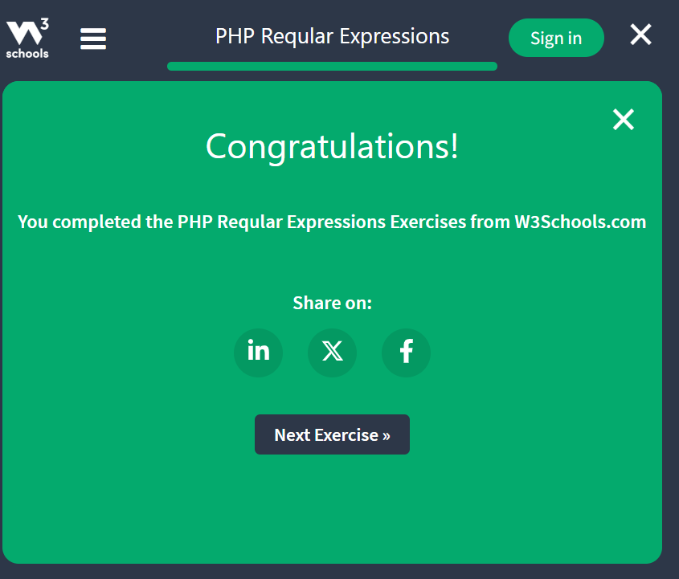
24521754_NguyenThiThuy

- PHP Forms
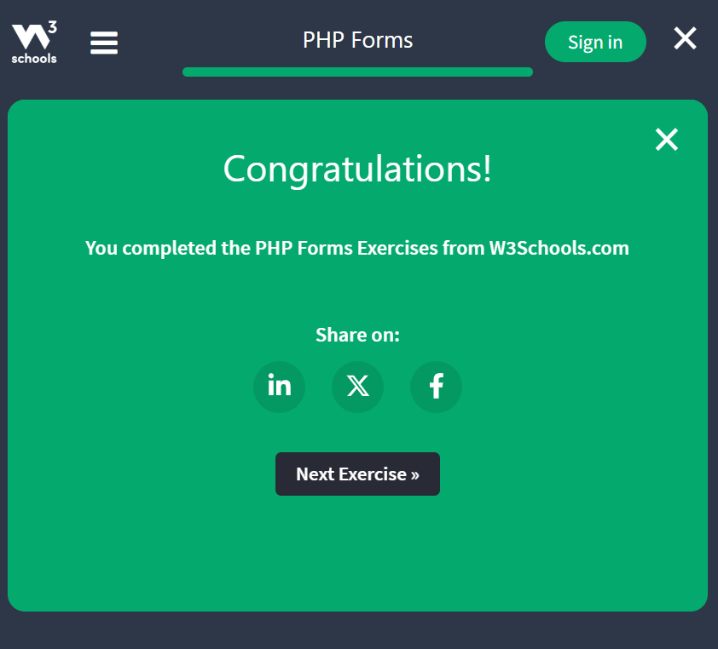
24521754_NguyenThiThuy

- PHP Dates

24521754_NguyenThiThuy

- PHP Includes
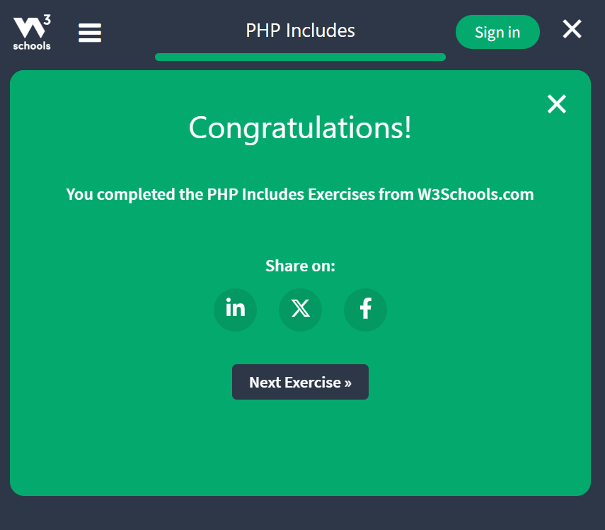
24521754_NguyenThiThuy

- PHP File Handling
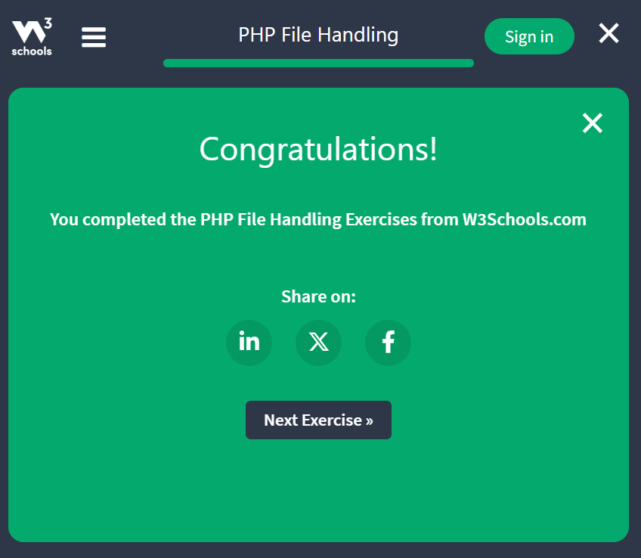
24521754_NguyenThiThuy

- PHP Cookie

24521754_NguyenThiThuy

- PHP Session Variables
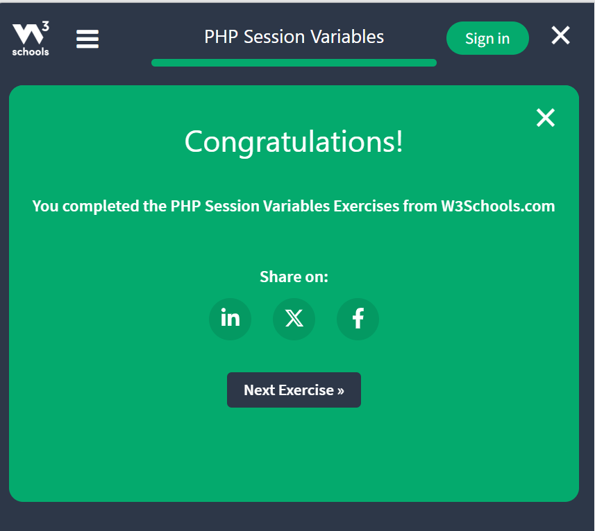
24521754_NguyenThiThuy
24521754_NguyenThiThuy

- PHP Json

24521754_NguyenThiThuy
24521754_NguyenThiThuy
24521754_NguyenThiThuy

2. Bài tập:
LAB01 - Làm quen PHP + Form (2Đ)

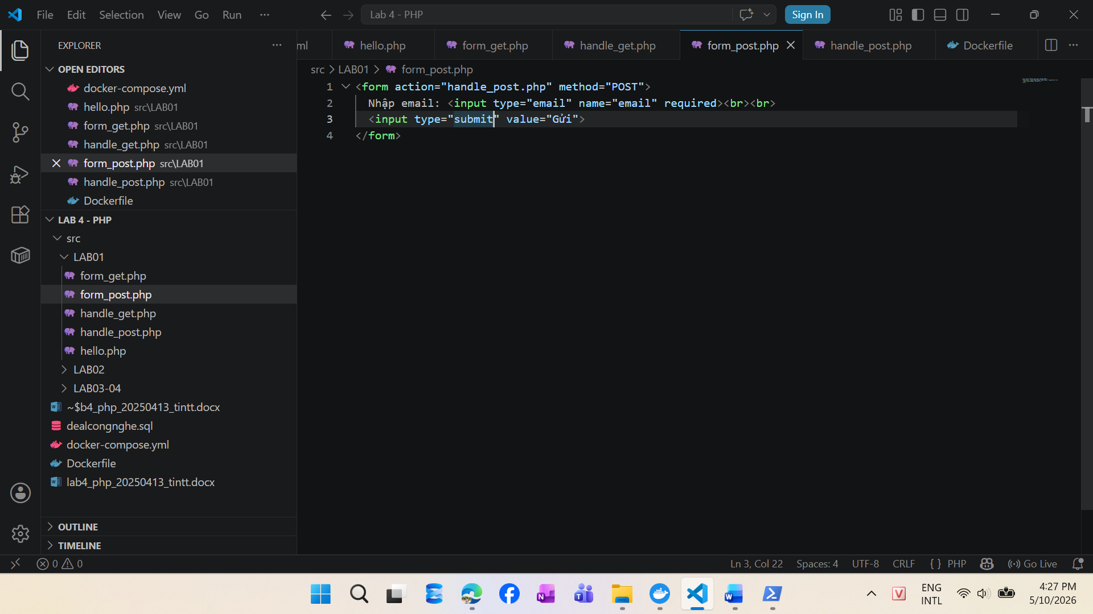
24521754_NguyenThiThuy
24521754_NguyenThiThuy
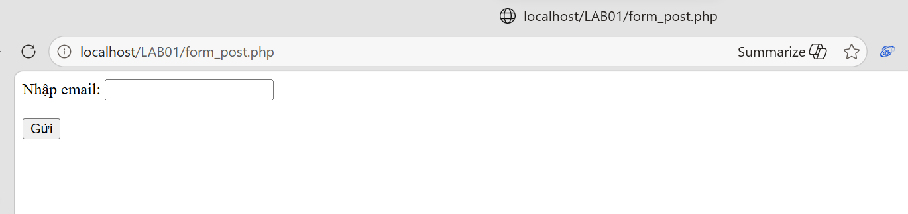
24521754_NguyenThiThuy

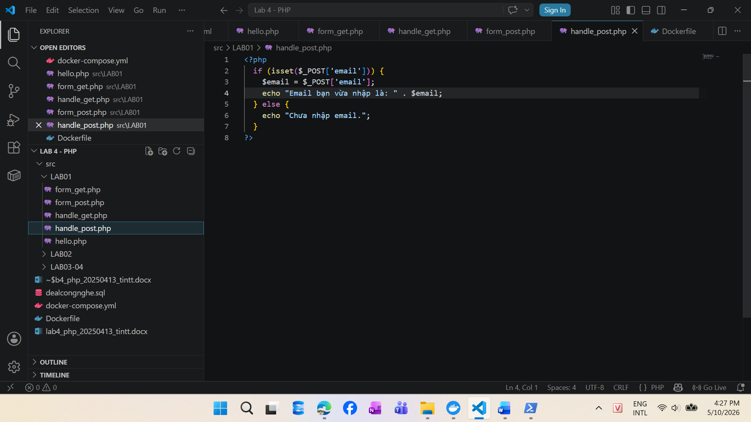
24521754_NguyenThiThuy
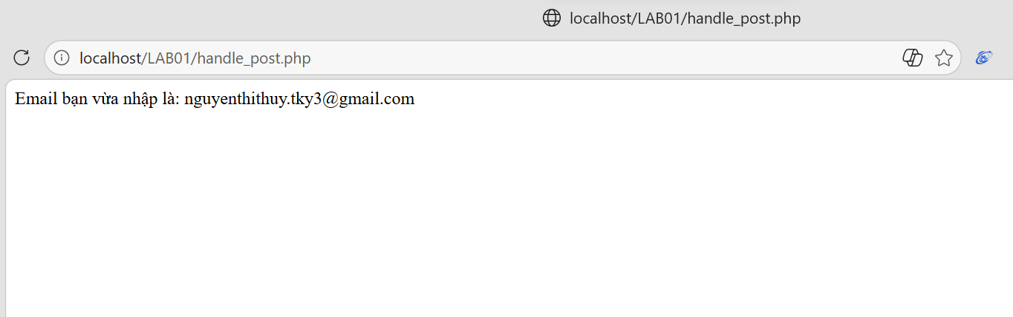
24521754_NguyenThiThuy

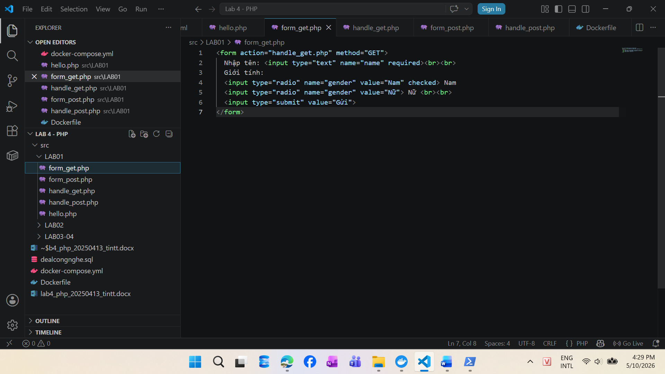
24521754_NguyenThiThuy
24521754_NguyenThiThuy
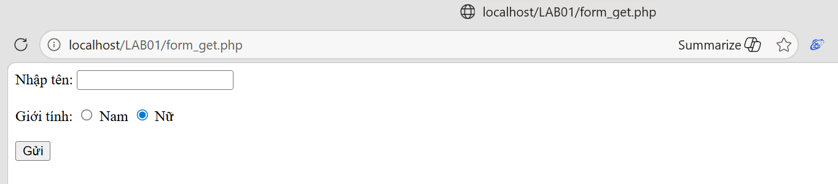
24521754_NguyenThiThuy

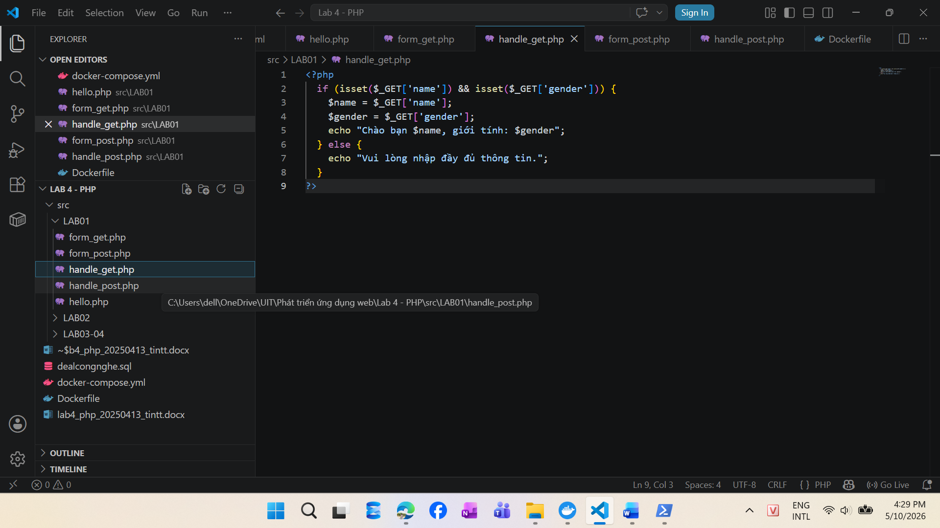
24521754_NguyenThiThuy
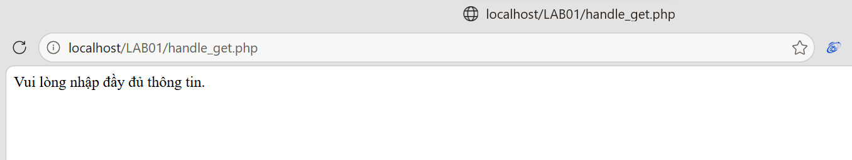
24521754_NguyenThiThuy
24521754_NguyenThiThuy
24521754_NguyenThiThuy
24521754_NguyenThiThuy

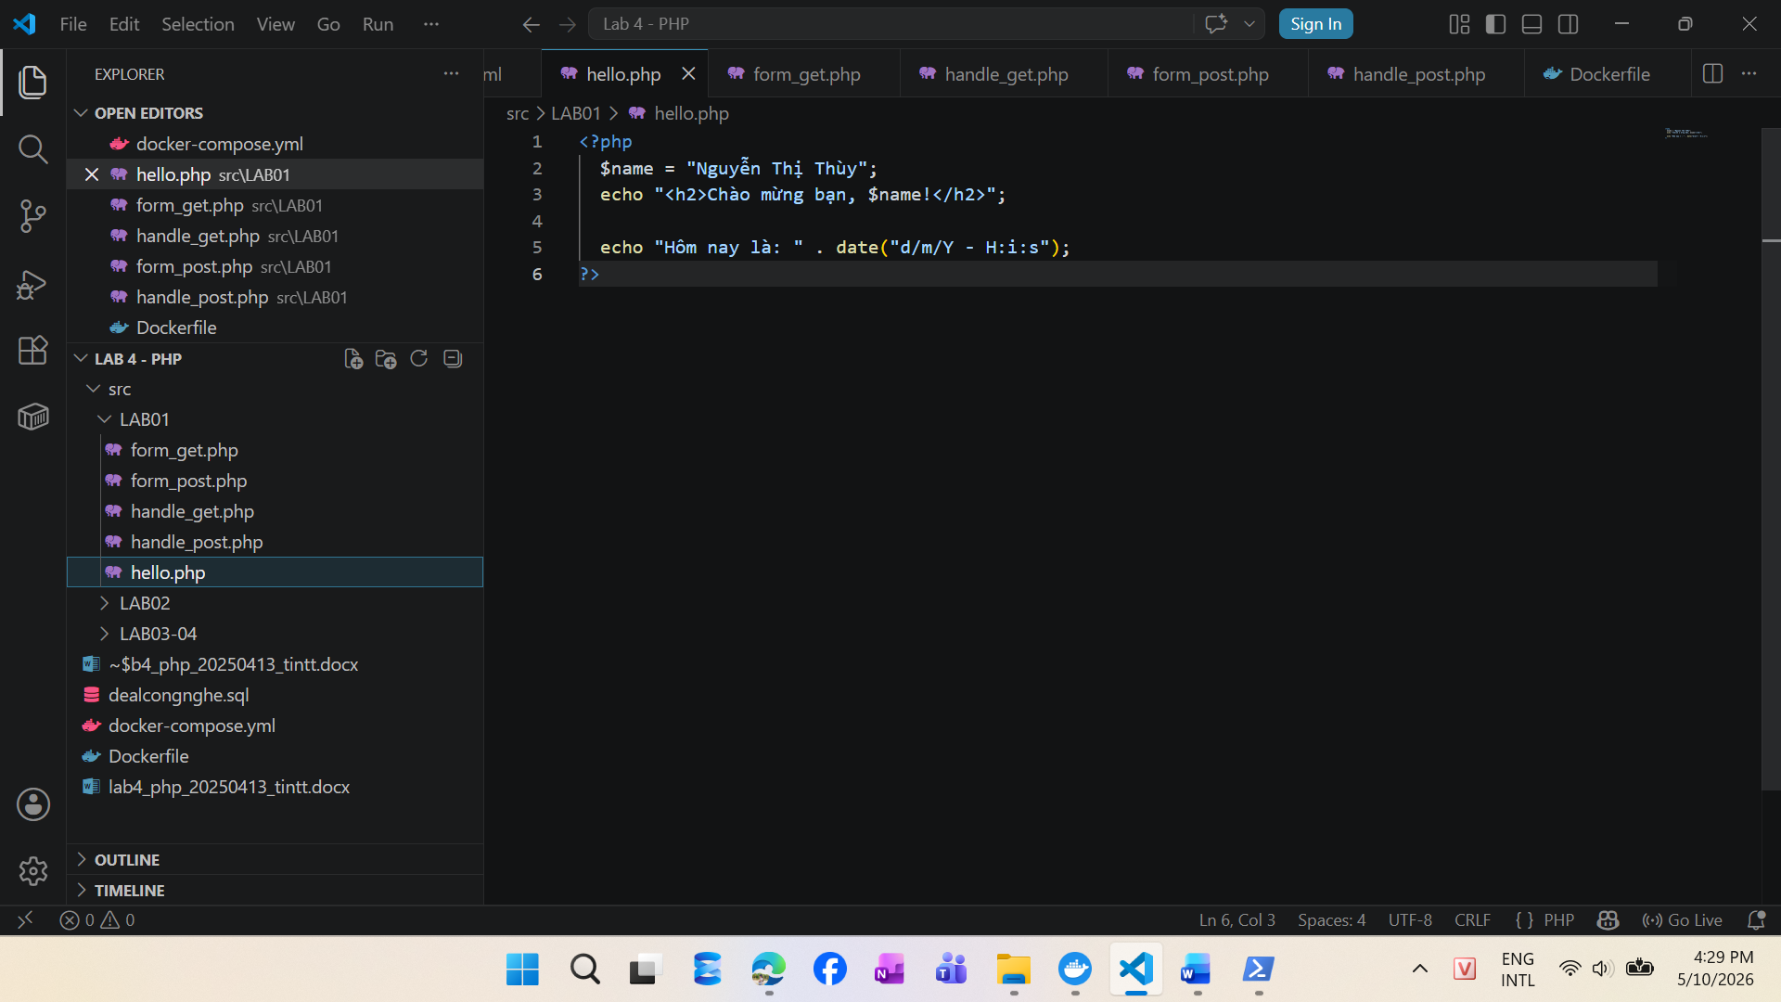
24521754_NguyenThiThuy
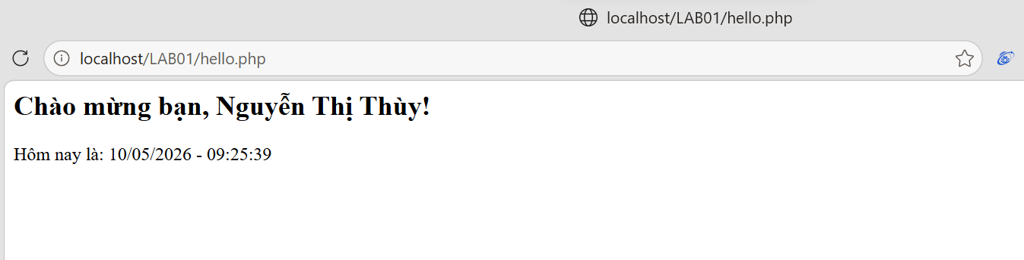
24521754_NguyenThiThuy

LAB02 – Mảng và điều kiện (2Đ)
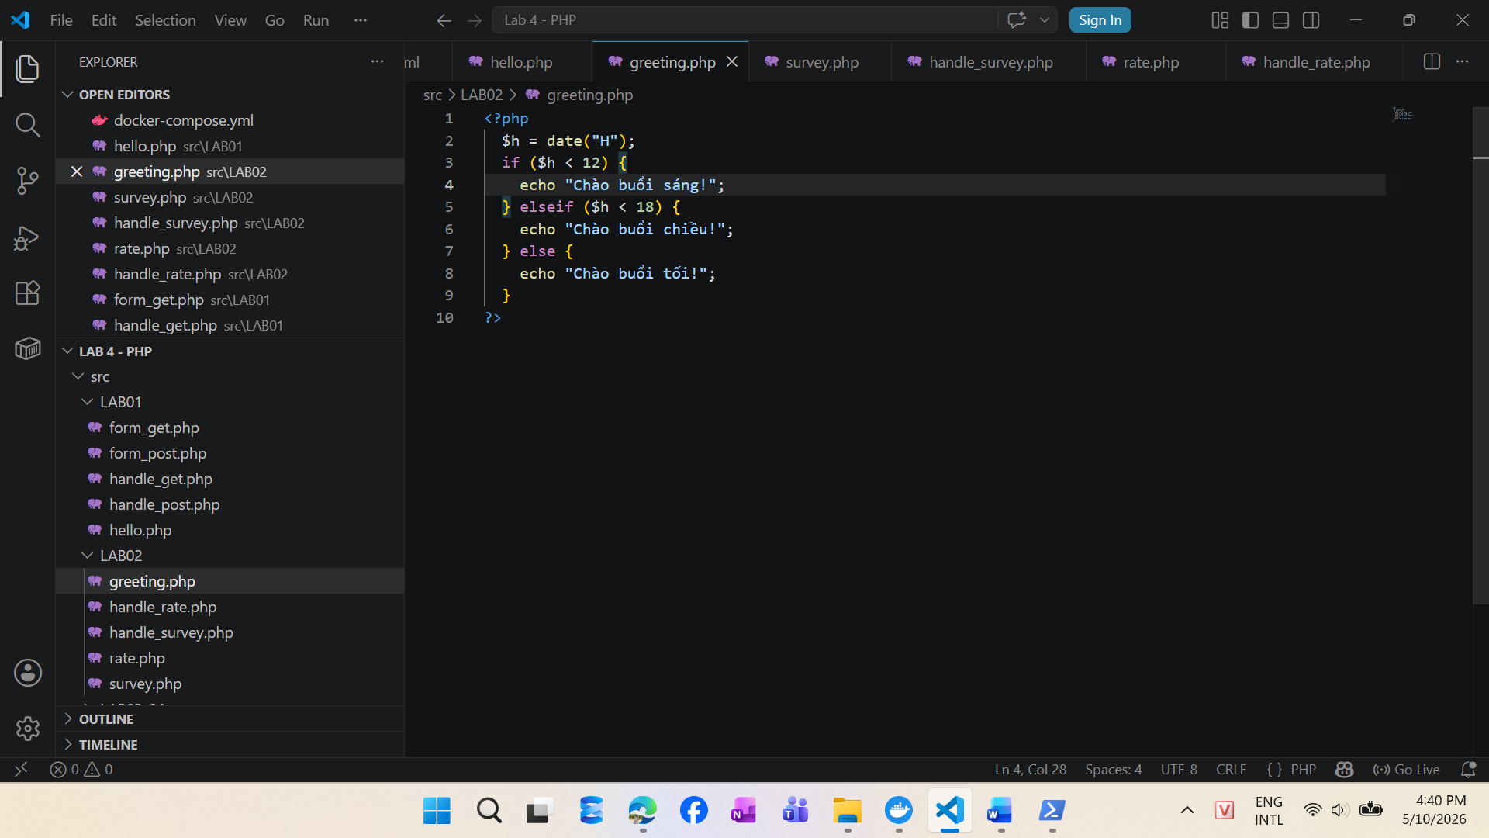
24521754_NguyenThiThuy
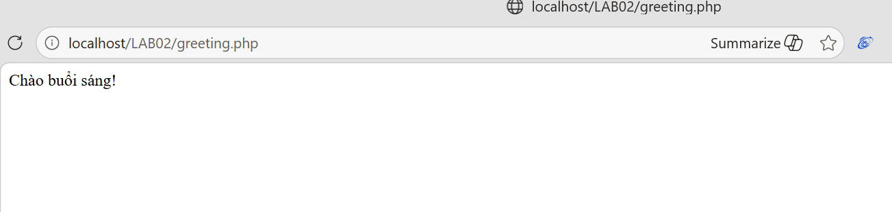
24521754_NguyenThiThuy

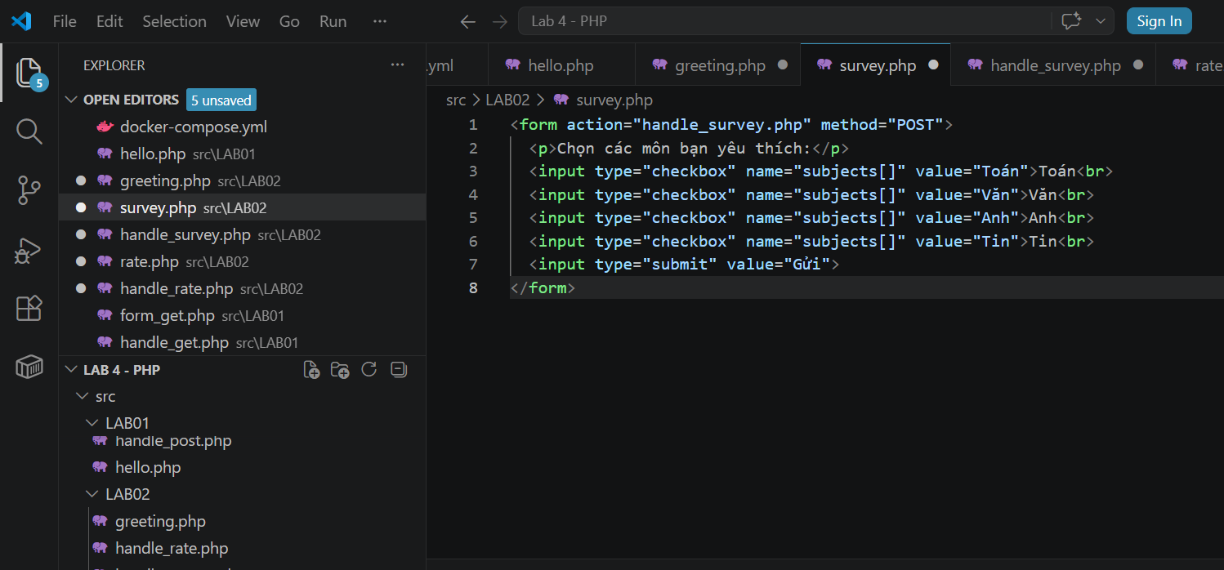
24521754_NguyenThiThuy
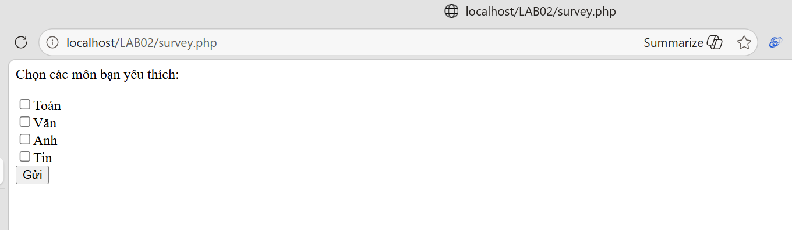
24521754_NguyenThiThuy

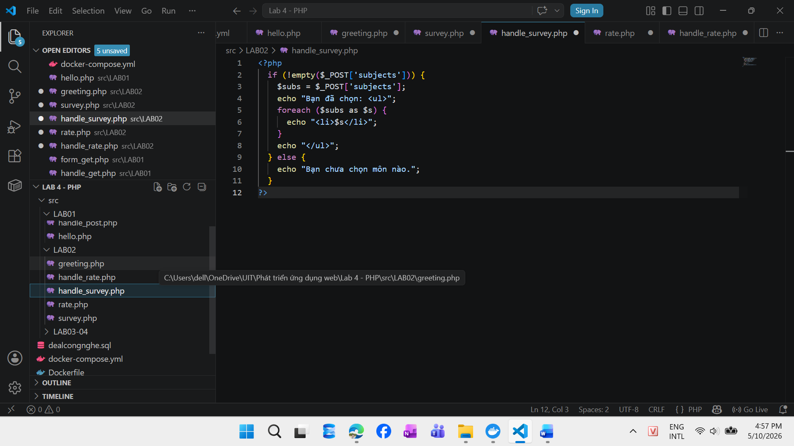
24521754_NguyenThiThuy
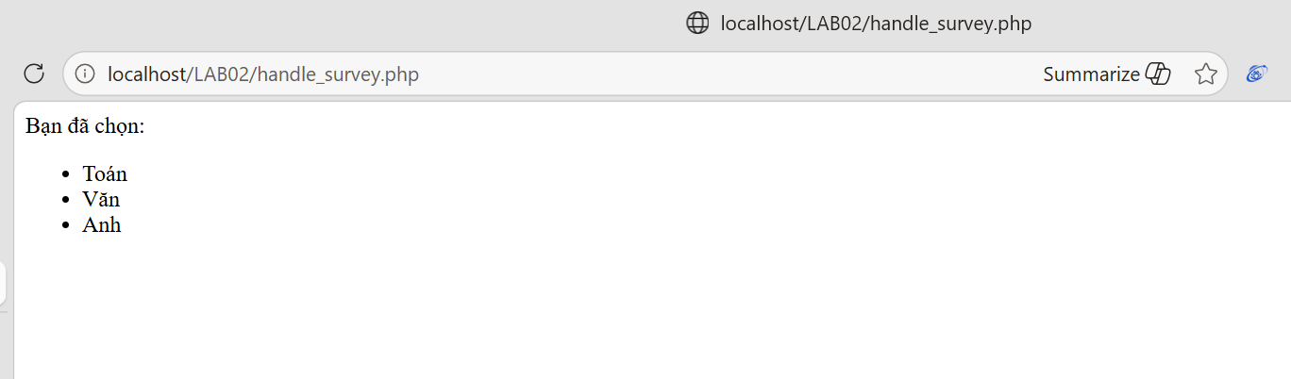
24521754_NguyenThiThuy

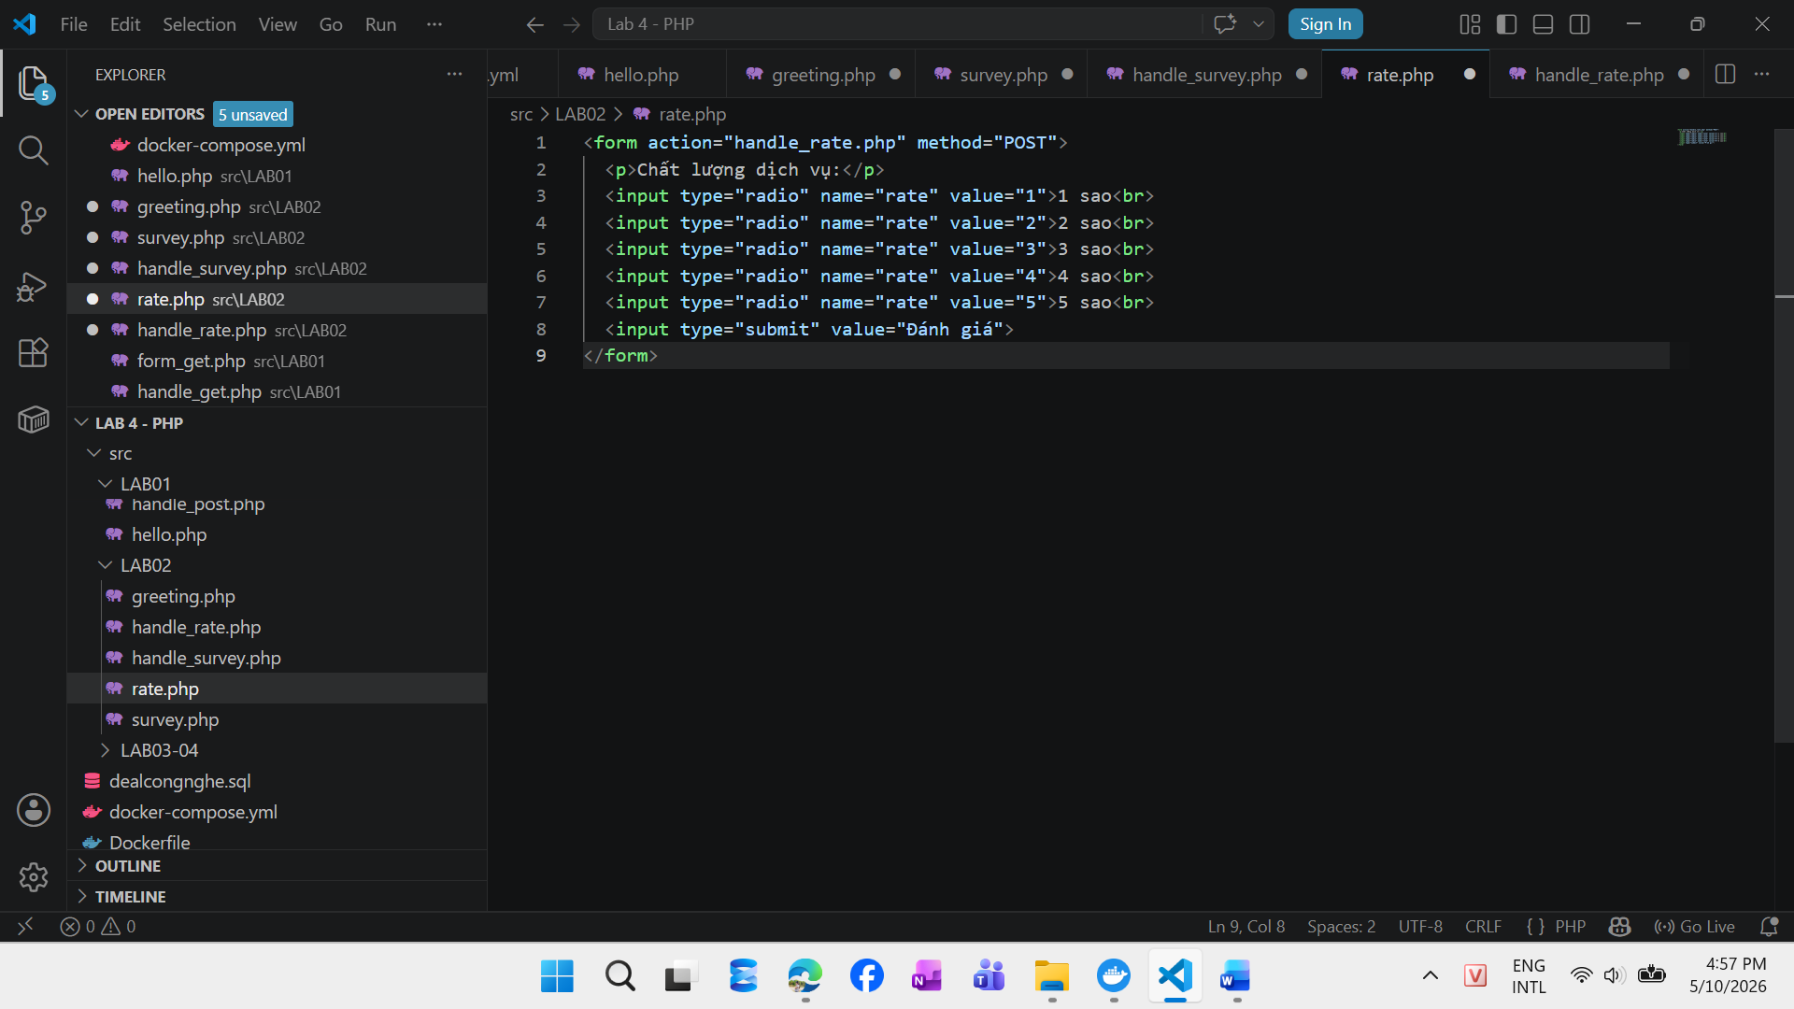
24521754_NguyenThiThuy
24521754_NguyenThiThuy
24521754_NguyenThiThuy
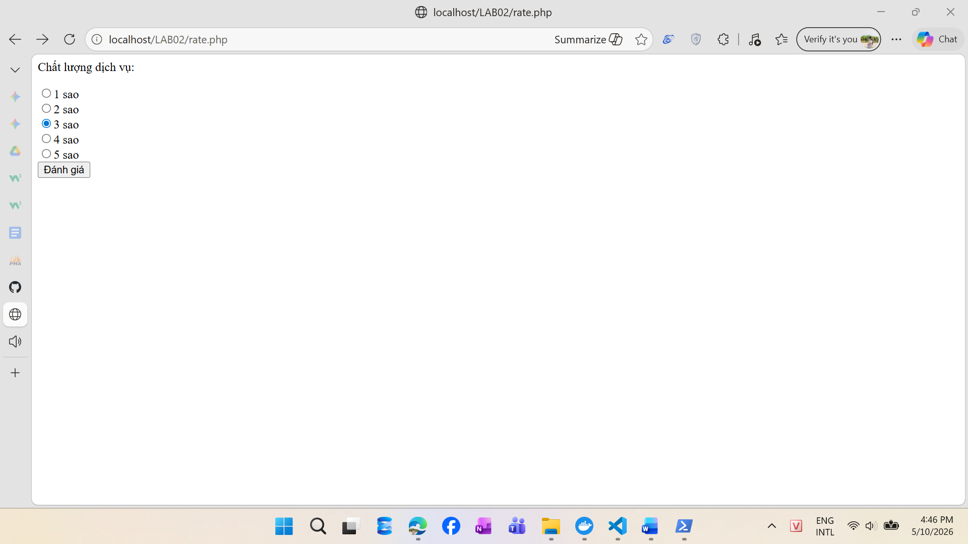

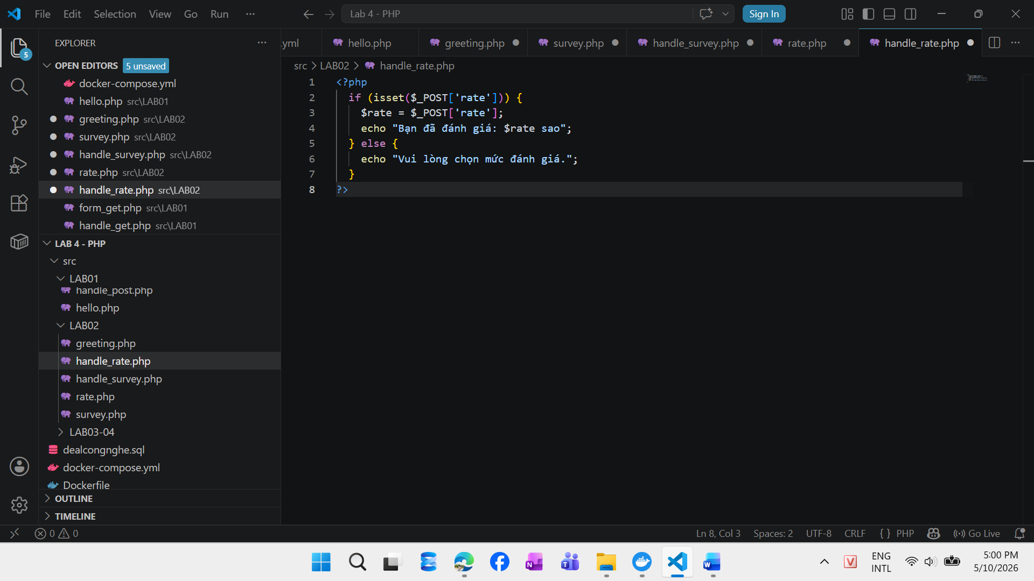
24521754_NguyenThiThuy

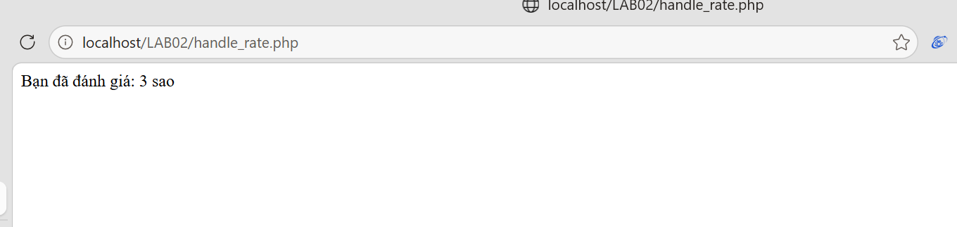
LAB03 + 4 – Kết nối cơ sở dữ liệu & Hiển thị dữ liệu (2Đ)
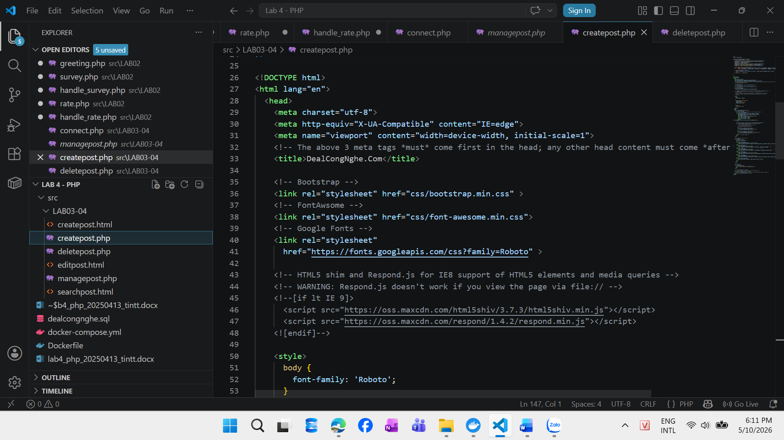
24521754_NguyenThiThuy
24521754_NguyenThiThuy
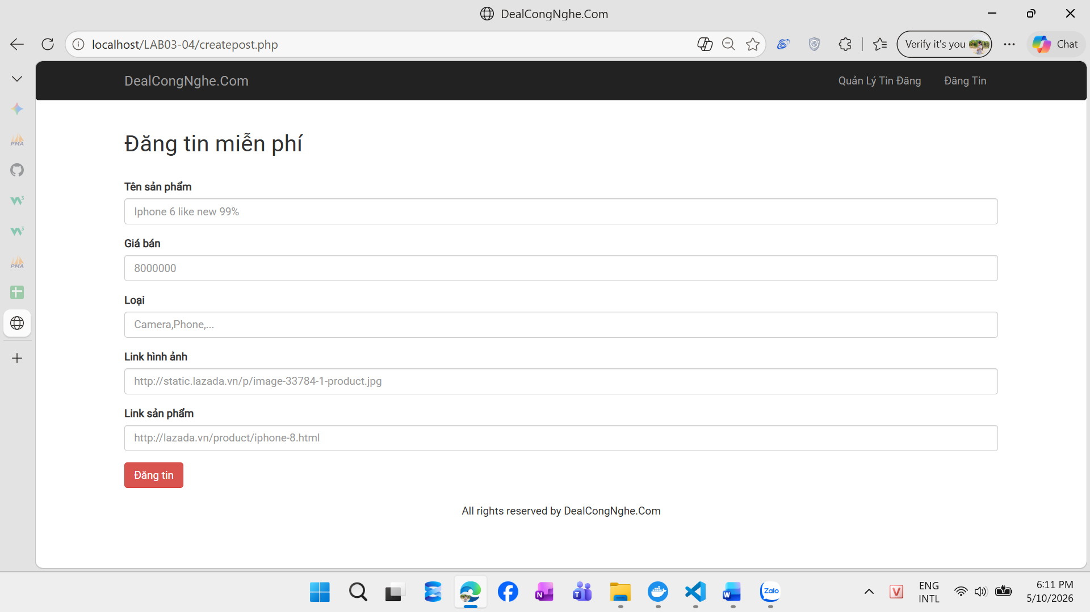
24521754_NguyenThiThuy

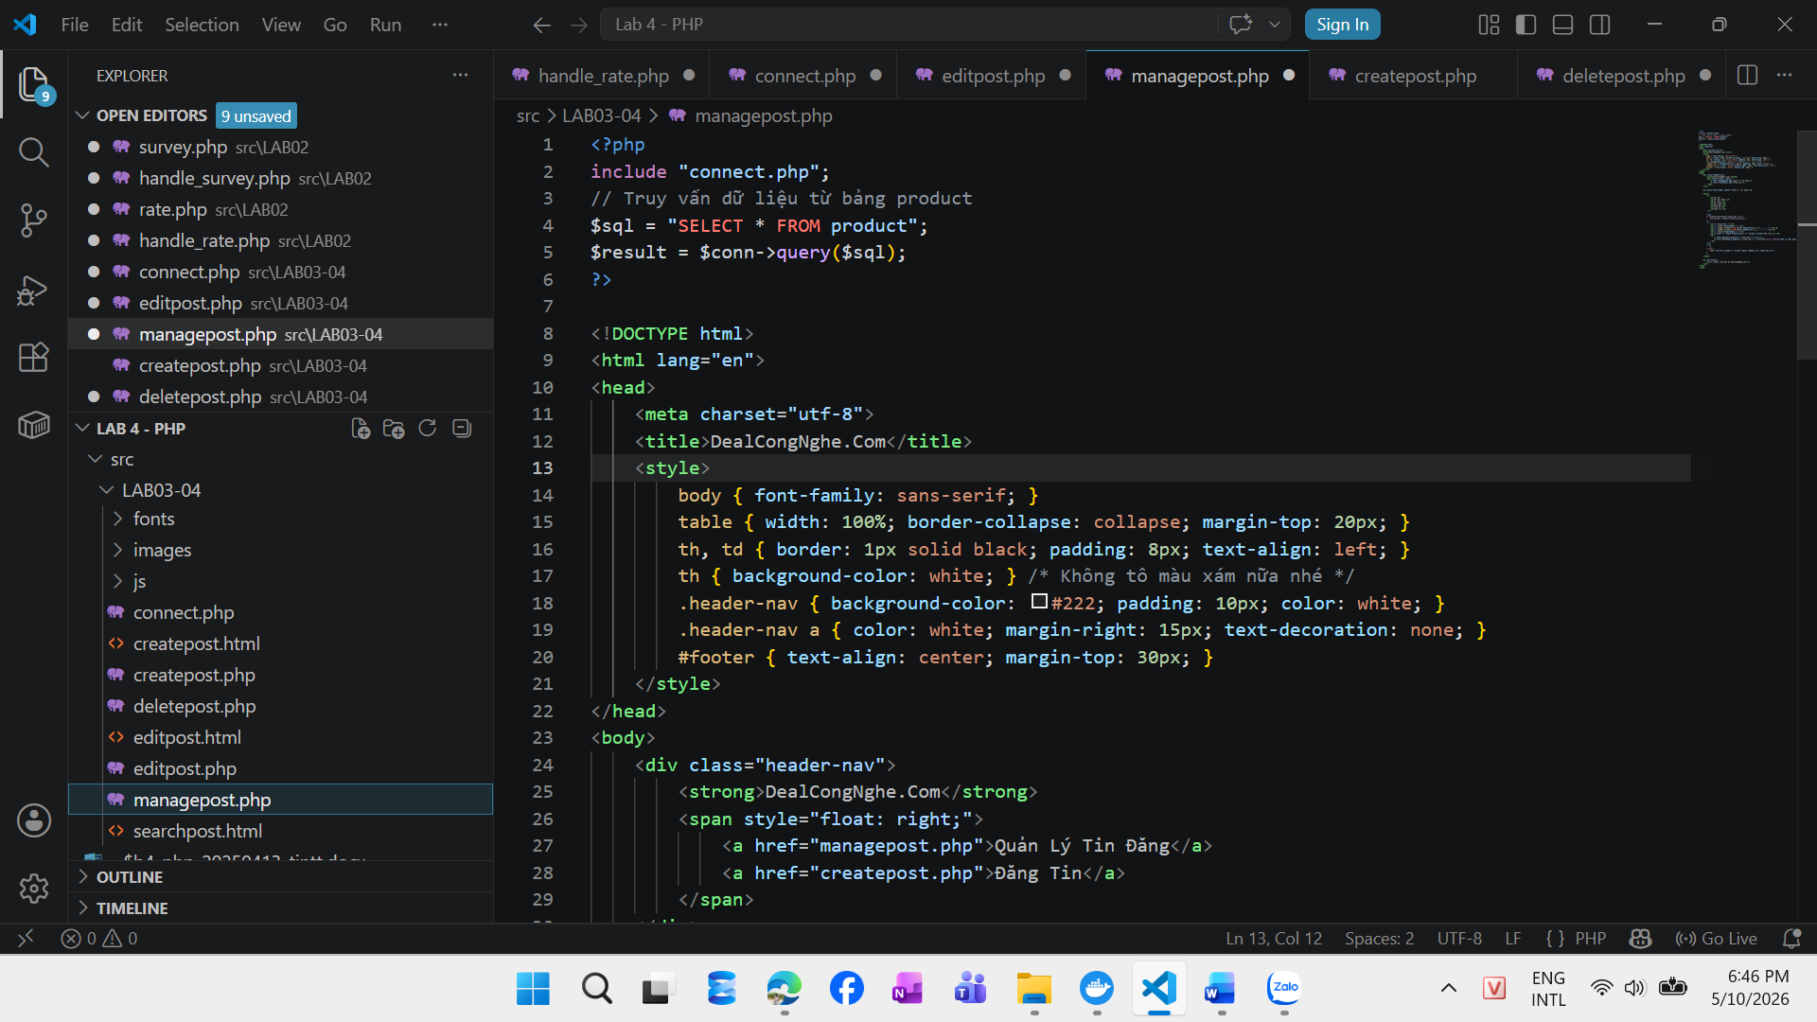
24521754_NguyenThiThuy
24521754_NguyenThiThuy
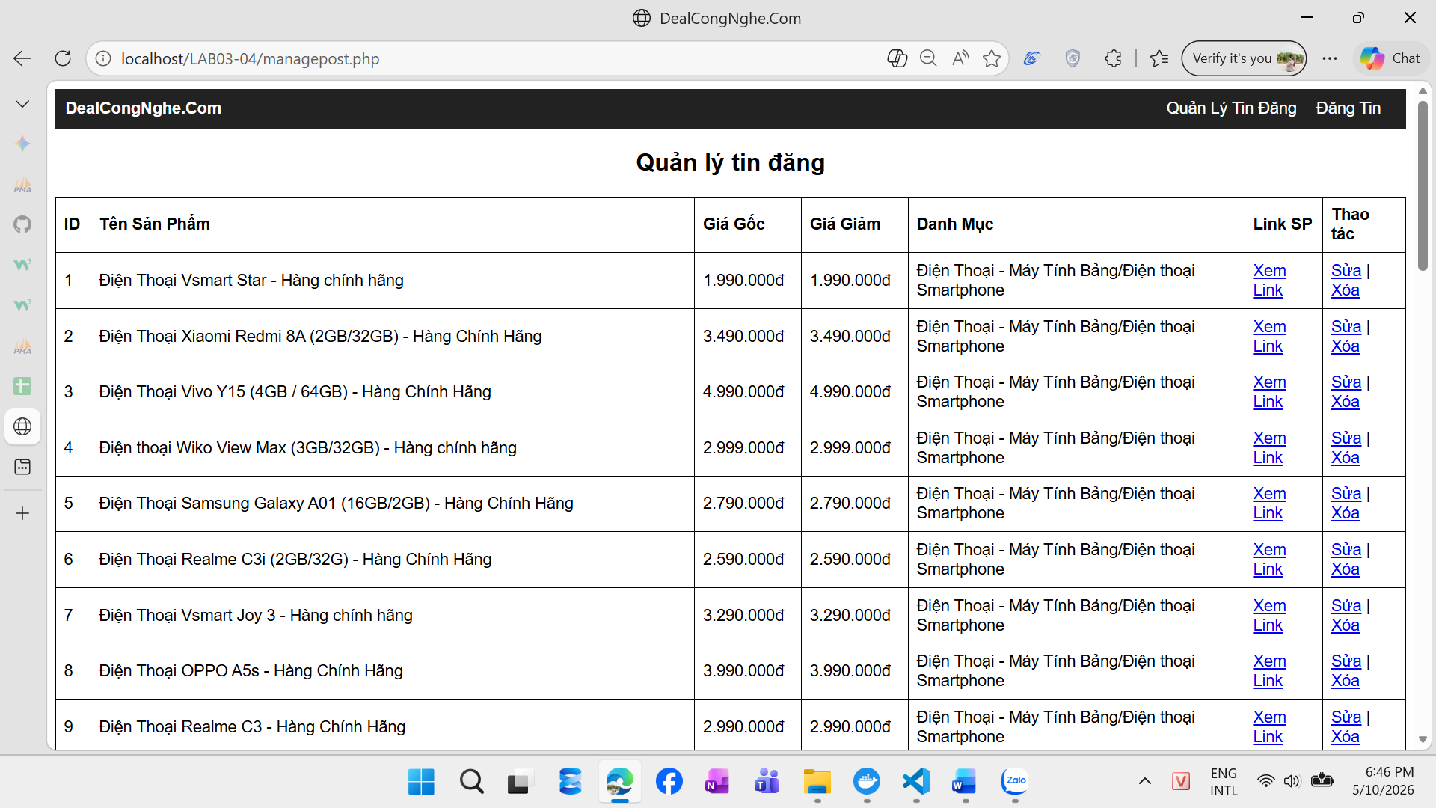
24521754_NguyenThiThuy
24521754_NguyenThiThuy

