<https://docs.google.com/document/d/1rW765Ta24LeK1i1pnD_P_nG1wcl4bAg-U3WHHDokKTw/edit?usp=sharing>

Data set: Boston Globe 2018

Word Cloud for Doc2Vec: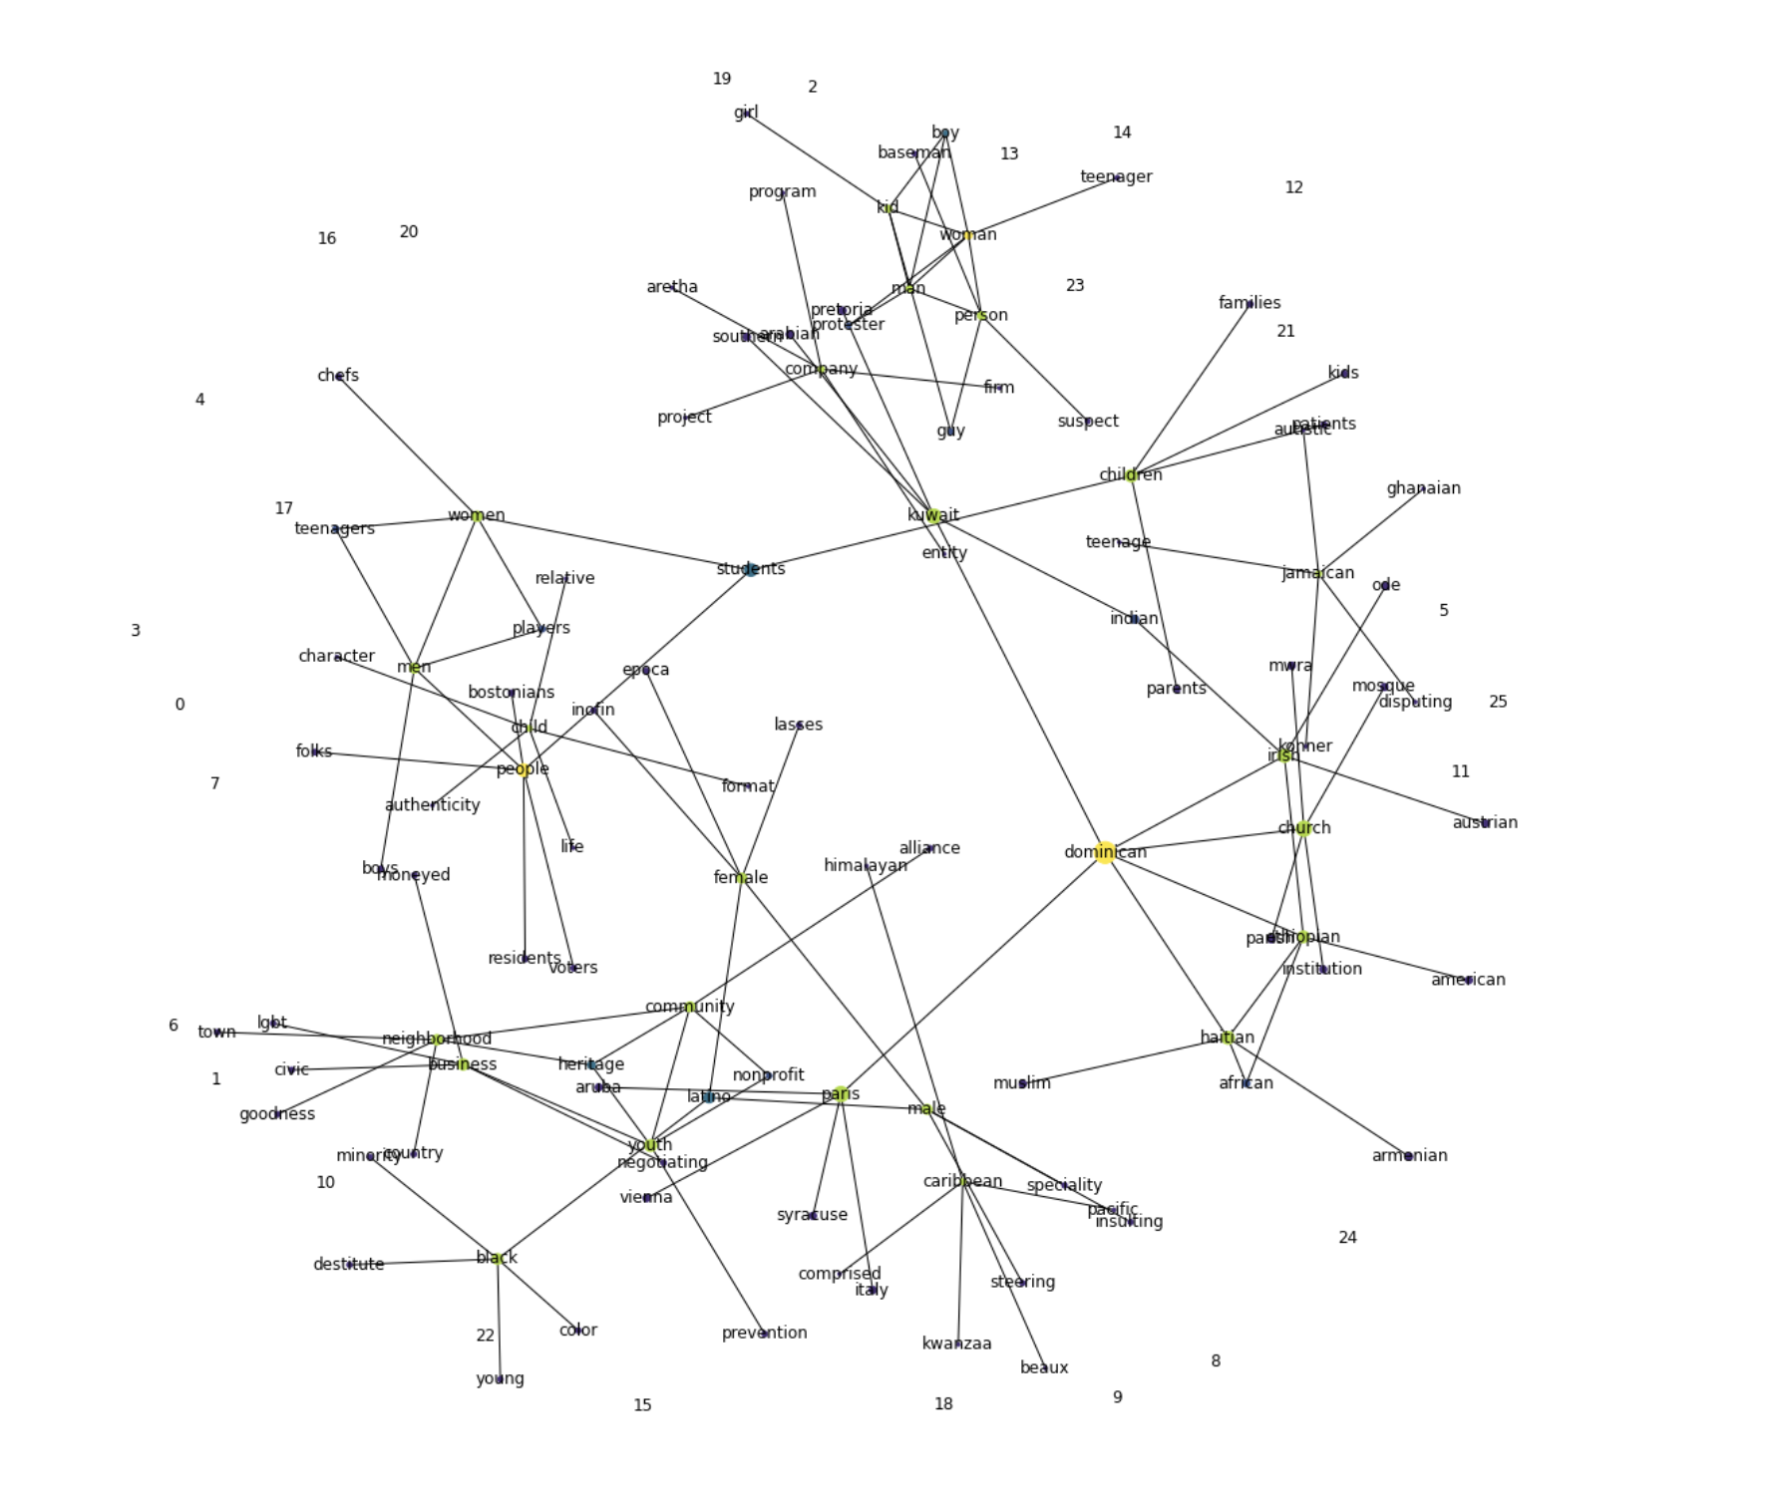

Word Cloud for Word2Vec: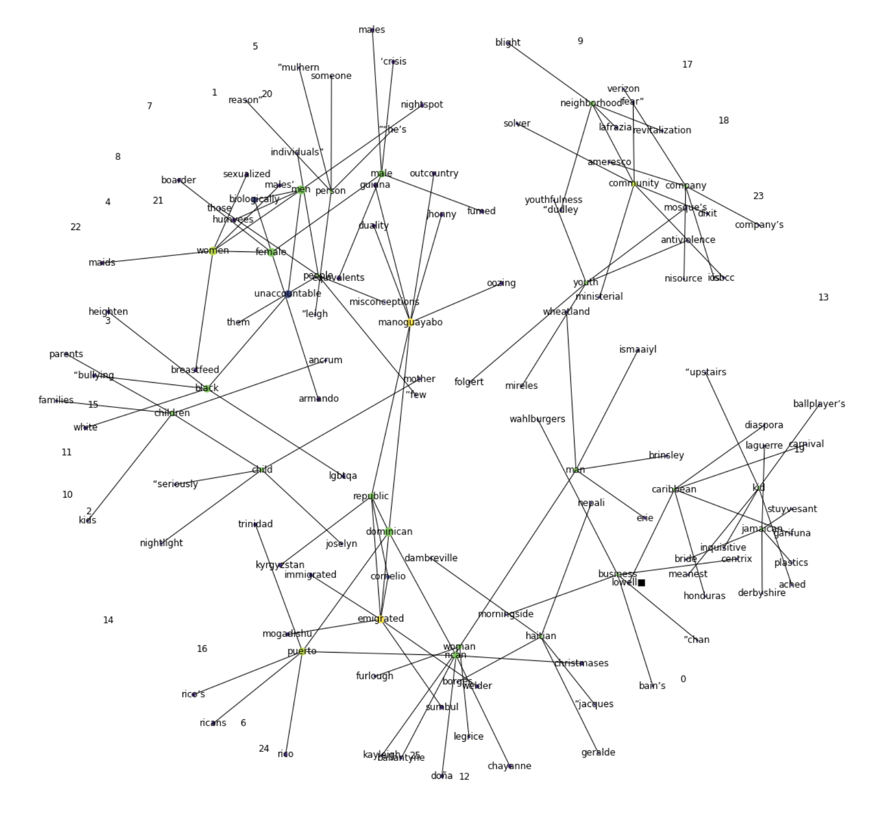

Gensim Phrases package to automatically detect common phrases (bigrams) from a list of sentences.

*#look up a list of the most similar words from keyword,"black"*

Code:

w2v_model.wv.most_similar(positive=['black'])

Output:

[('white', 0.812944769859314),

('african_american', 0.7083898782730103),

('latino', 0.5846176743507385),

('color', 0.5713448524475098),

('young', 0.5659607648849487),

('asian', 0.5410647392272949),

('women', 0.5286791324615479),

('asian_american', 0.5229591727256775),

('hispanic', 0.5162984132766724),

('male', 0.5044015049934387)]

*#measure the similarity between any 2 words*

Code:

w2v_model.wv.similarity('black', 'green')

Output

0.1462823

*#Analogy difference*

*#Which word is to "lation" as "black" is to "african_american"?*

Code:

w2v_model.wv.most_similar(positive=["latino", "black"], negative=["african_american"], topn=3)

Output:

[('white', 0.5755782723426819),

('hispanic', 0.5324521660804749),

('minority', 0.5324294567108154)]

*#t-SNE visualizations:=====================================*

