Answers by WangZhifang
19.1-1.
If x is not a root node, then Degree[x]=Degree[sibling[x]]+1
If x is a root node, then Degree[x]<Degree[sibling[x]]

19.1-2
Degree[x]<degree[p[x]]

19.2-2
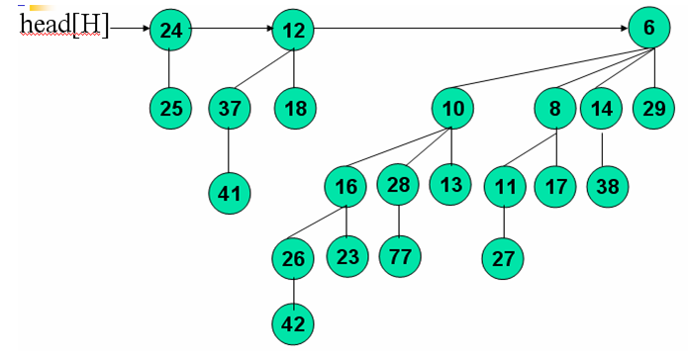

19.2-6

