LAB04B

Nguyễn Văn Hồng

File c/c++:

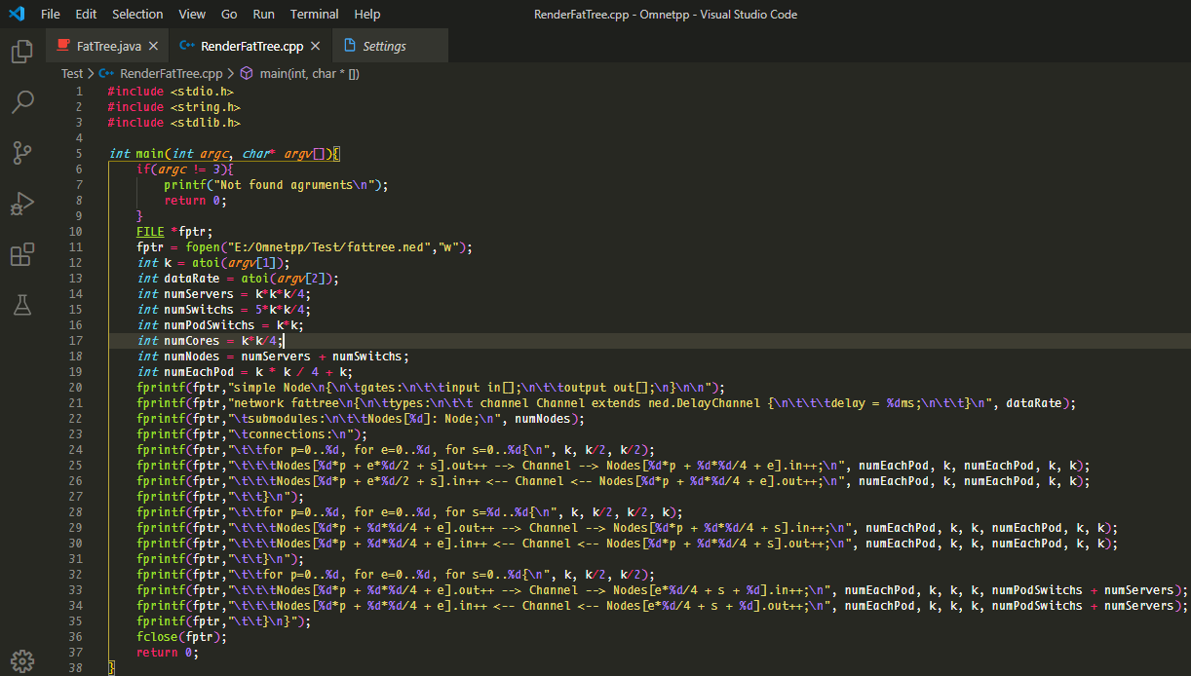

File ned: k =8, dataRate =100

