

**Course MS Installation Notes:**

Version: CourseMS2.1

**Requirements:**

Development of this application was done on the XAMPP platform with the following server requirements:

* Apache 2.2.17
* MySQL 5.5.8
* PHP 5.3.5
* phpMyAdmin 3.3.9 (optional but suggested)

**Database Installation:**

First, create a new MySQL database for your installation. From the project files look in the SQL folder. The file that you need to import into the new database that you have created is the coursems2_0.sql file.

Navigate to the import tab in phpMyAdmin and select coursems2_0.sql.

Press the Go button and that should load all the CourseMS tables into your database.

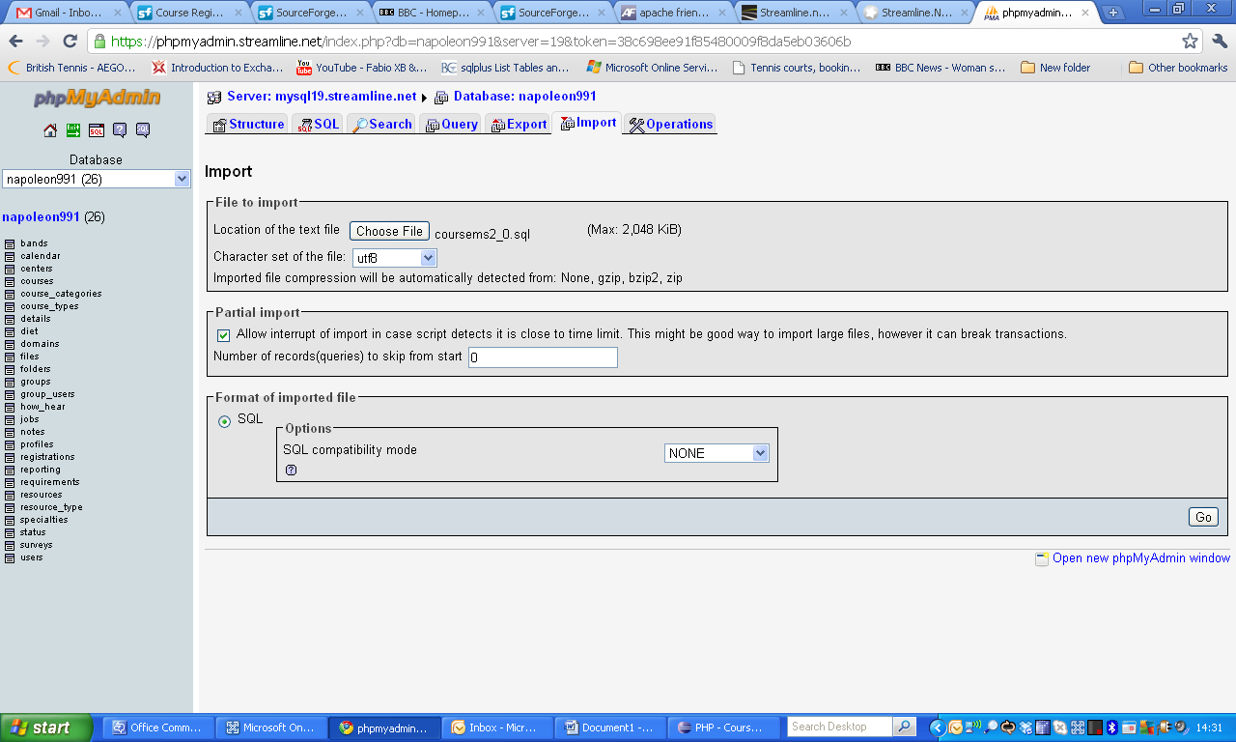

That concludes the installation of the CourseMS database.

**Uploading all files to your server**

You will need to upload all project files to the destination folder on your server. Do this by FTP or whatever method your hosting provider provides.

**Configuring the config.php files**

For this application, there are 2 config.php files to configure.

**Front End config.php file:**

The first config file is in the root directory and contains the configuration for the front end of the website. Initially you only need to change the following:

1. Database details
2. CourseMS paths

You will be able to configure the rest of the file using the application back end.

Database Details:

Edit the parts highlighted in red below to point to the database that you created

//Database configuration

define('DB_NAME', 'database_name');

define('DB_USER', 'database_user_name');

define('DB_PASS', 'database_password');

define('DB_HOST', 'localhost');

define('USE_PCONNECT', 'false');

CourseMS path details:

//CourseMS Paths

define('HTTP_SERVER', 'http://coursems.org');

define('HTTP_PATH', '/home/fhlinux194/coursems/user/htdocs/');

define('EXPORT_PATH', '/home/fhlinux194/coursems/user/htdocs/exports/');

define('REL_EXPORT_PATH', 'exports/');

Once again, you will need to edit the parts highlighted in red. HTTP_SERVER needs to be set to the URL that you will use to access your application.

HPPT_PATH needs to point to the full path on your server where your files are located. This can be tricky to ‘guess’ so follow the following instructions on getting this path:

You should be able to run the following file if your installation up to this point has been successful:

<http://coursems.org/phpinfo.php>

Obviously, change coursems.org to where your installation has been done.

You will be presented with all the installation parameters of your system. If you scroll down, you will find the correct path that you need to use under the PHP Variables section (highlighted below):

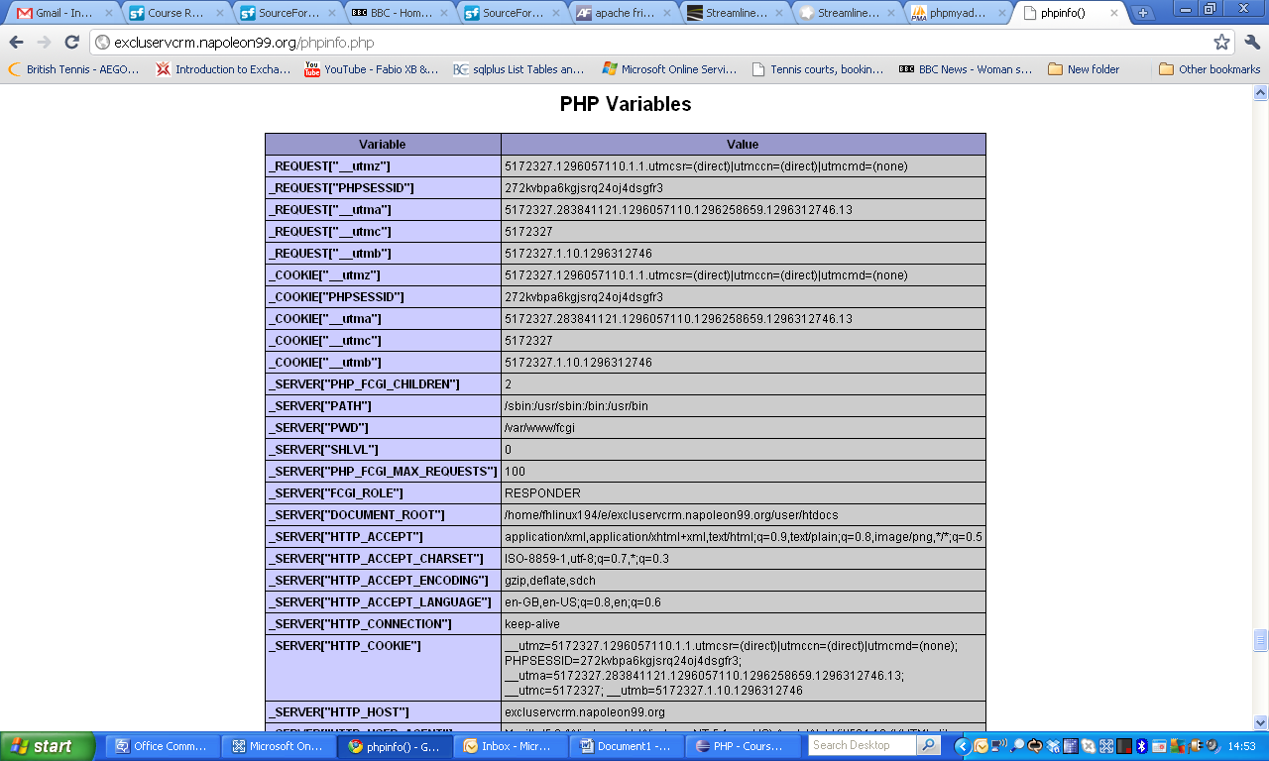

Copy the path, and paste into the config.php file for the HTTP_PATH variable. Make sure you add a “/” to the end of the path. The EXPORT_PATH is the same path, but with “/exports/” appended to the end.

**Changing the Admin config.php file:**

The second config file that you will need to update, is the config.php file located in the *admin* directory situated in the root directory.

The admin config file, is in most ways identical to the previous config file that you edited. Copy the Database and CourseMS path details and paste it over the Database and CourseMS path details present in the admin config.php file.

Now the only other adjustment you need to make is change the CourseMS paths slightly.

define('HTTP_SERVER', 'http://coursems.org/admin/');

define('HTTP_PATH', '/home/fhlinux194/coursems/user/htdocs/admin/');

define('EXPORT_PATH', '/home/fhlinux194/coursems/user/htdocs/exports/');

define('REL_EXPORT_PATH', 'exports/');

The only changes you have to make is add the 2 admin parts (highlighted in red) to the config file. Save and Close both config.php files.

**Logging in for the first time:**

The first time that you log in, you will log into the admin section to start setting up your system.

Go to: <https://YourCourseMsURL.com/admin>

You will be presented with the following screen:

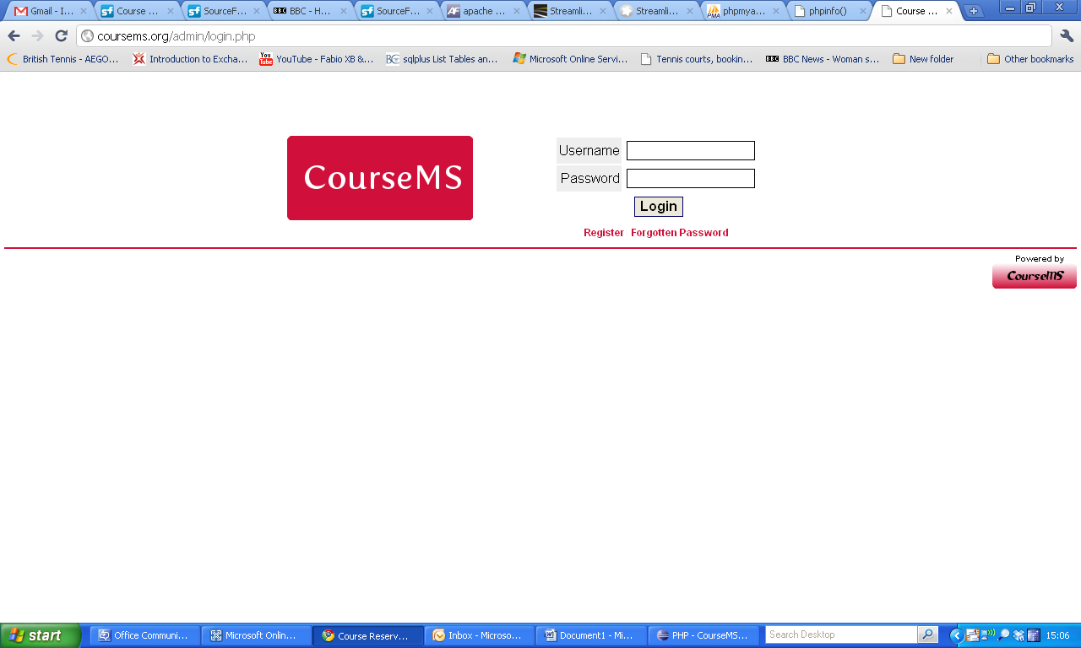

The default login details are:

Username: Admin

Password: 4dm1n

It is very strongly suggested that you change this password as soon as you have entered the installation.

**Setting up your environment**

This is not a detailed user guide, as most of the functionality is self explanatory and easy to figure out, once you have started using the application. There are a couple of things you need to do before the application will start making sense to you.

The first page you need to visit, is the **Site** link. Here you need to set up the following:

1. Centre – This is meant to be the location of your courses.
2. Resource Type – This is meant to categorise resources, eg. Training Rooms / Computer Rooms / Lab assistants etc
3. Resources – This is defining more in detail the resource, eg. First Floor Training Room / IT room 3.1
4. User status – Initially I recommend that you keep this as is, but you can edit the different stages of registration users will be for a course. You can also select which colour the status will display as.
5. There are 3 level of requirements that can be set up for courses. These names can be changed in the site parameters site. At the time of writing this documentation it would only change what is displayed in the front end and not what is displayed in the admin section (to change that, you will need to edit the config.php file in the admin folder manually): By default they are:
   1. Job Title
   2. Specialties
   3. Bands
6. The 3 levels of requirements can be used to restrict users who can register on courses when you create courses. You can reduce the levels of restrictions displayed in the front end within the Site Parameters page.
7. Special Requirements (dietery requirements etc) and How Hear Options (How someone heard about you) can be edited to change the options displayed to a user on the front end.
8. Site parameters – Here you will need to add the Google Map Keyfile. This you can generate from <http://code.google.com/apis/maps/signup.html>. You can also change the following:
   1. TABLE_WIDTH – this will adjust the width of the main table on the front end of the application
   2. SEC_TABLE_WIDTH – this will adjust the width of the secondary table. Best is to play around with the percentages (or px) to see how it changes.
   3. JOB_REQUIREMENTS – This is a feature that toggles whether users with a job title can only see courses restricted to that job title or whether they can see all courses.
   4. Requirement Levels – This is the names of the requirements that will be displayed on the front end. You can also choose not to display levels of requirement by putting the LEVEL_REQUIRED variables to false.

So, that should get you going and the rest I am sure you will pick up quickly as you start creating, scheduling and registering for courses.

Please note all bugs you find on Sourceforge.Net in the Bugs forum and they will be included in subsequent releases.