**Parallelogram Equations**  
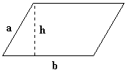

|  |  |
| --- | --- |
| [parallelogram area](http://www.ajdesigner.com/phpgeometricformulas/parallelogram_area_a.php) | [parallelogram perimeter](http://www.ajdesigner.com/phpgeometricformulas/parallelogram_perimeter_p.php) |

**Rectangle Equations**  
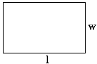

|  |  |
| --- | --- |
| [rectangle area](http://www.ajdesigner.com/phpgeometricformulas/rectangle_area_a.php) | [rectangle perimeter](http://www.ajdesigner.com/phpgeometricformulas/rectangle_perimeter_p.php) |

**Square Equations**  
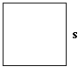

|  |  |  |  |
| --- | --- | --- | --- |
| [square area](http://www.ajdesigner.com/phpgeometricformulas/square_area_a.php) | [square length of side](http://www.ajdesigner.com/phpgeometricformulas/square_area_s.php) | [square perimeter](http://www.ajdesigner.com/phpgeometricformulas/square_perimeter_p.php) | [square length of side](http://www.ajdesigner.com/phpgeometricformulas/square_perimeter_s.php) |

**Trapezoid Equations**  
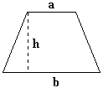

|  |
| --- |
| [trapezoid area](http://www.ajdesigner.com/phpgeometricformulas/trapezoid_area_a.php) |

**Circular Cylinder Equations**  
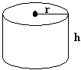

|  |  |
| --- | --- |
| [circular cylinder volume](http://www.ajdesigner.com/phpgeometricformulas/circular_cylinder_volume_v.php) | [circular cylinder lateral surface area](http://www.ajdesigner.com/phpgeometricformulas/circular_cylinder_area_lsa.php) |

**Circular Cone Equations**  
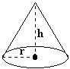

|  |  |
| --- | --- |
| [circular cone volume](http://www.ajdesigner.com/phpgeometricformulas/circular_cone_volume_v.php) | [circular cone lateral surface area](http://www.ajdesigner.com/phpgeometricformulas/circular_cone_area_lsa.php) |

**Pyramid Equations**  
  
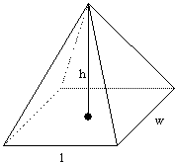

|  |
| --- |
| [pyramid volume](http://www.ajdesigner.com/phpgeometricformulas/pyramid_volume_v.php) |

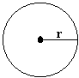

|  |  |  |  |
| --- | --- | --- | --- |
| [circle area](http://www.ajdesigner.com/phpgeometricformulas/circle_area_a.php) | [circle radius](http://www.ajdesigner.com/phpgeometricformulas/circle_area_r.php) | [circle circumference](http://www.ajdesigner.com/phpgeometricformulas/circle_circumference_c.php) | [circle radius](http://www.ajdesigner.com/phpgeometricformulas/circle_circumference_r.php) |

**Rectangular Solid Equations**  
  
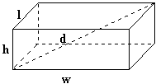

|  |  |  |
| --- | --- | --- |
| [rectangular solid volume](http://www.ajdesigner.com/phpgeometricformulas/rectangular_solid_volume_v.php) | [rectangular solid area](http://www.ajdesigner.com/phpgeometricformulas/rectangular_solid_area_a.php) | [rectangular solid diagonal](http://www.ajdesigner.com/phpgeometricformulas/rectangular_solid_diagonal_d.php) |

**Sphere Equations**  
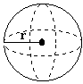

|  |  |
| --- | --- |
| [sphere volume](http://www.ajdesigner.com/phpgeometricformulas/sphere_volume_v.php) | [sphere surface area](http://www.ajdesigner.com/phpgeometricformulas/sphere_area_a.php) |