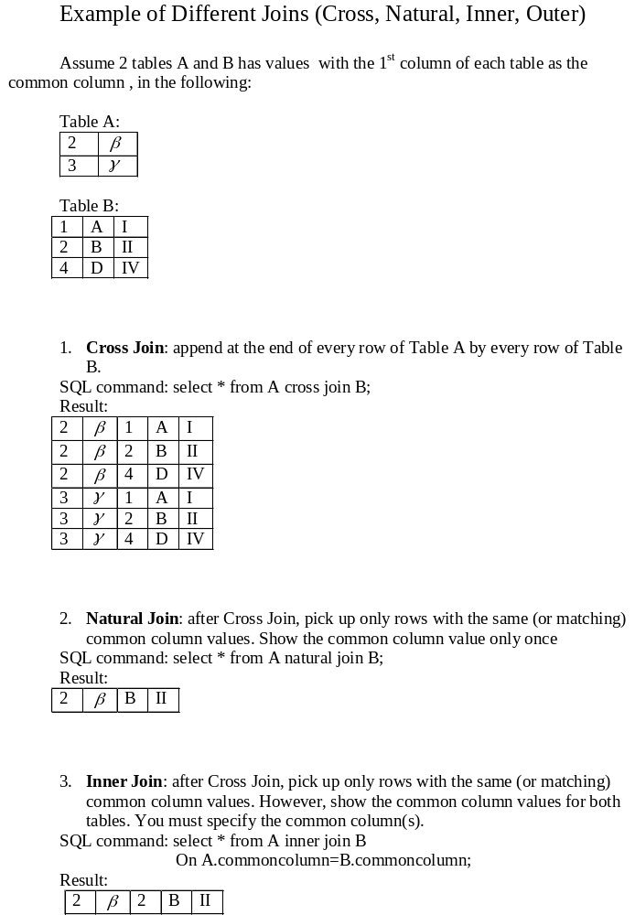 Outer Join:

(1) Left Outer Join: after Inner Join, add rows of the left Table (A) which is non-matching common column values from row of Cross Join with all fields of Table B blanked. You must specify the common column(s).
SQL command: select * from A left outer join B
On A.commoncolumn=B.commoncolumn;
Result:

2 | 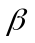 | 2 | B | II
3

(2) Right Outer Join: after Inner Join, add rows of the right Table (B) which is non-matching common column values from row of Cross Join with all fields of Table A blanked. You must specify the common column(s).
SQL command: select * from A right outer join B
On A.commoncolumn=B.commoncolumn;
Result:

2 |  | 2 | B | II
 |  | 1 | A | I
 |  | 4 | D | IV

(3) Full Outer Join: after Inner Join, add rows of the left Table (A) and the right Table (B) which are non-matching common column values from row of Cross Join with all fields of the other Table blanked. You must specify the common column(s).
SQL command: select * from A full join B
On A.commoncolumn=B.commoncolumn;
Result:

2 |  | 2 | B | II
3
 |  | 1 | A | I
 |  | 4 | D | IV

