Chapter 3 Selections
3.1 List six comparison operators.
3.2 Show the printout of the following statements:
System.out.println('a' < 'b');
System.out.println('a' <= 'A');
System.out.println('a' > 'b');
System.out.println('a' >= 'A');
System.out.println('a' == 'a');
System.out.println('a' != 'b');
3.3 Can the following conversions involving casting be allowed? If so, find the converted result.
boolean b = true;
i = (int)b;
int i = 1;
boolean b = (boolean)i;
1. <, <=, ==, !=, >, >=
2.
true
false
false
true
true
true
3. No. Boolean values cannot be cast to other types.
3.4 Write an if statement that assigns 1 to x if y is greater than 0.
3.5 Write an if statement that increases pay by 3% if score is greater than 90.
4.
if (y > 0)
x = 1;

5.
if (score > 90)
pay *= 1.03;
3.6 Write an if statement that increases pay by 3% if score is greater than 90, otherwise increases pay by 1%.
3.7 What is the printout of the code in (a) and (b) if number is 30? What if number is 35?
6.
if (score > 90)
pay *= 1.03;
else
pay *= 1.01;

7.
If number is 30,
(a) displays
30 is even
30 is odd
(b) displays
30 is even

If number is 35,
(a) displays
35 is odd
(b) displays
35 is odd
3.8 Suppose x = 3 and y = 2; show the output, if any, of the following code. What is the output if x = 3 and y = 4? What is the output if x = 2 and y = 2? Draw a flowchart of the code.
if (x > 2) {
if (y > 2) {
z = x + y;
System.out.println("z is " + z);
}
}
else
System.out.println("x is " + x);
3.9 Suppose x = 2 and y = 3. Show the output, if any, of the following code. What is the output if x = 3 and y = 2? What is the output if x = 3 and y = 3? (Hint: Indent the statement correctly first.)
if (x > 2)
if (y > 2) {
int z = x + y;
System.out.println("z is " + z);
}
else
System.out.println("x is " + x);
3.10 What is wrong in the following code?
if (score >= 60.0)
grade = 'D';
else if (score >= 70.0)
grade = 'C';
else if (score >= 80.0)
grade = 'B';
else if (score >= 90.0)
grade = 'A';
else
grade = 'F';
8. Note: else matches the first if clause. No output if x = 3 and y = 2. Output is “z is 7” if if x = 3 and y = 4. Output is “x is 2” if if x = 2 and y = 2.

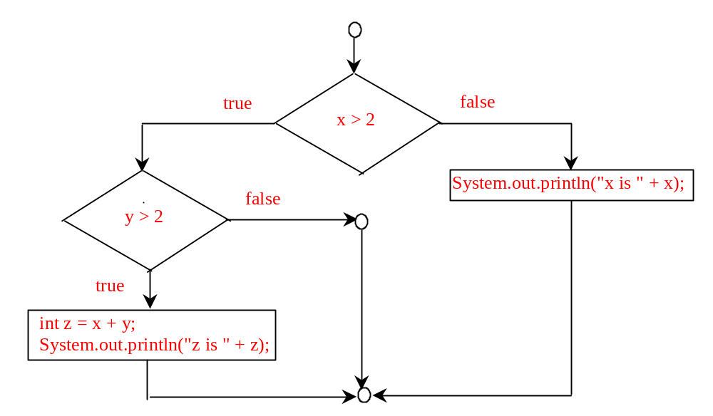
9. No output if x = 2 and y = 3. Output is “x is 3” if x = 3 and y = 2. Output is “z is 6” if x = 3 and y = 3.
10.
Consider score is 90, what will be the grade?
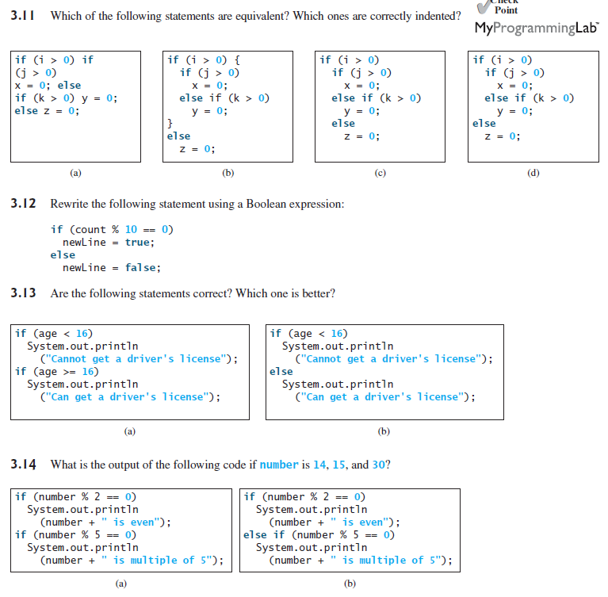
11. a, c, and d are the same. (B) and (C) are correctly indented.

12. newLine = (count % 10 == 0);

- Both are correct. (b) is better.

- for (a) if number is 14, the output is
14 is even
if number is 15, the output is
15 is multiple of 5
if number is 30, the output is
30 is even
30 is multiple of 5

for (b) if number is 14, the output is
14 is even
if number is 15, the output is
15 is multiple of 5
if number is 30, the output is
30 is even
3.15 Which of the following is a possible output from invoking Math.random()?
323.4, 0.5, 34, 1.0, 0.0, 0.234
3.16 a. How do you generate a random integer i such that
b. How do you generate a random integer i such that
c. How do you generate a random integer i such that
15. 0.5, 0.0, 0.234
16. (int)(Math.random() * 20)
10 + (int)(Math.random() * 10)
10 + (int)(Math.random() * 41)
3.17 Are the following two statements equivalent?
A}if (income <= 10000)
tax = income * 0.1;
else if (income <= 20000)
tax = 1000 +
(income - 10000) * 0.15;
B) if (income <= 10000)
tax = income * 0.1;
else if (income > 10000 &&
income <= 20000)
tax = 1000 +
(income - 10000) * 0.15;
17. Yes
3.18 Assuming that x is 1, show the result of the following Boolean expressions.
(true) && (3 > 4)
!(x > 0) && (x > 0)
(x > 0) || (x < 0)
(x != 0) || (x == 0)
(x >= 0) || (x < 0)
(x != 1) == !(x == 1)
3.19 Write a Boolean expression that evaluates to true if a number stored in variable num is between 1 and 100.
3.20 Write a Boolean expression that evaluates to true if a number stored in variable num is between 1 and 100 or the number is negative.
3.21 Assume that x and y are int type. Which of the following are legal Java expressions?
x > y > 0
x = y && y
x /= y
x or y
x and y
(x != 0) || (x = 0)
3.22 Suppose that x is 1. What is x after the evaluation of the following expression?
a. (x >= 1) && (x++ > 1)
b. (x > 1) && (x++ > 1)
3.23 What is the value of the expression ch >= 'A' && ch <= 'Z' if ch is 'A', 'p',
'E', or '5'?
3.24 Suppose, when you run the program, you enter input 2 3 6 from the console. What is the output?
public class Test {
public static void main(String[] args) {
java.util.Scanner input = new java.util.Scanner(System.in);
double x = input.nextDouble();
double y = input.nextDouble();
double z = input.nextDouble();
System.out.println("(x < y && y < z) is " + (x < y && y < z));
System.out.println("(x < y || y < z) is " + (x < y || y < z));
System.out.println("!(x < y) is " + !(x < y));
System.out.println("(x + y < z) is " + (x + y < z));
System.out.println("(x + y < z) is " + (x + y < z));
}
}
3.25 Write a Boolean expression that evaluates true if age is greater than 13 and less than 18.
3.26 Write a Boolean expression that evaluates true if weight is greater than 50 pounds or height is greater than 60 inches.
3.27 Write a Boolean expression that evaluates true if weight is greater than 50 pounds and height is greater than 60 inches.
3.28 Write a Boolean expression that evaluates true if either weight is greater than 50 pounds or height is greater than 60 inches, but not both.
18. (true) && (3 > 4)
false

!(x > 0) && (x > 0)
false

(x > 0) || (x < 0)
true

(x != 0) || (x == 0)
true

(x >= 0) || (x < 0)
true

(x != 1) == !(x == 1)
true

19. (x > 1) && (x < 100)

20. ((x > 1) && (x < 100)) || (x < 0)

21. x > y > 0
incorrect

x = y && y
incorrect

x /= y
correct

x or y
incorrect

x and y
incorrect

22.
a. x is 2.
b. x is 1.

23.
If ch is 'A', the expression is true;
If ch is 'p', the expression is false;
If ch is 'E', the expression is true;
If ch is '5', the expression is false;

24.

(x < y && y < z) is true
(x < y || y < z) is true
!(x < y) is false
(x + y < z) is true
(x + y < z) is true

25. age > 13 && age < 18

26.

weight > 50 || height > 60.

27.

weight > 50 && height > 60.

28.

weight > 50 ^ height > 60.
3.29 What data types are required for a switch variable? If the keyword break is not used after a case is processed, what is the next statement to be executed? Can you convert a switch statement to an equivalent if statement, or vice versa? What are the advantages of using a switch statement?
3.30 What is y after the following switch statement is executed? Rewrite the code using the if-else statement.
x = 3; y = 3;
switch (x + 3) {
case 6: y = 1;
default: y += 1;
}
3.31 What is x after the following if-else statement is executed? Use a switch statement to rewrite it and draw the flowchart for the new switch statement.
int x = 1, a = 3;
if (a == 1)
x += 5;
else if (a == 2)
x += 10;
else if (a == 3)
x += 16;
else if (a == 4)
x += 34;
3.32 Write a switch statement that assigns a String variable dayName with Sunday, Monday, Tuesday, Wednesday, Thursday, Friday, Saturday, if day is 0, 1, 2, 3, 4, 5, 6, accordingly.
29. Switch variables must be of char, byte, short, or int data types. If a break statement is not used, the next case statement is performed. You can always convert a switch statement to an equivalent if statement, but not an if statement to a switch statement. The use of the switch statement can improve readability of the program in some cases. The compiled code for the switch statement is also more efficient than its corresponding if statement.

30. y is 2.

- x is 17

switch (a) {
case 1: x += 5; break;
case 2: x += 10; break;
case 3: x += 16; break;
case 4: x += 34;
}

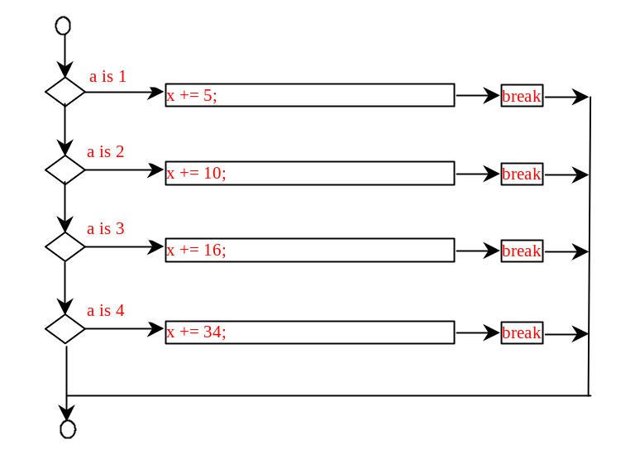
32. switch (day) {
case 0: dayName = "Sunday"; break;
case 1: dayName = "Monday"; break;
case 2: dayName = "Tuesday"; break;
case 3: dayName = "Wednesday"; break;
case 4: dayName = "Thurday"; break;
case 5: dayName = "Friday"; break;
case 6: dayName = "Saturday"; break;
}
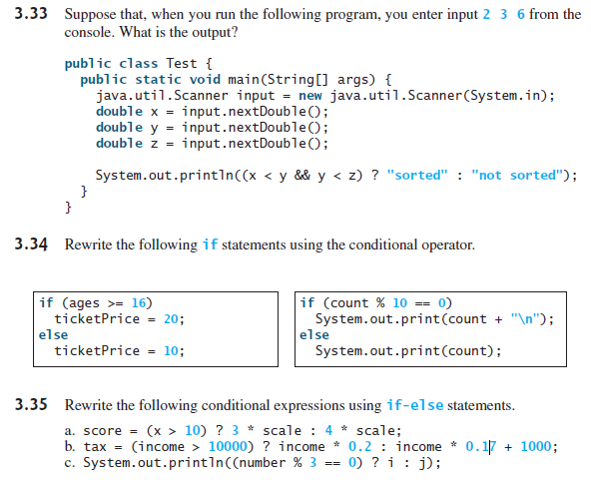
33. Sorted

34.
(A) ticketPrice = (ages >= 16) ? 20 : 10;
(B) System.out.print((count % 10 == 0) ? count + "\n" : count + " ");

35.
(A)

if (x > 10)
score = 3 * scale;
else
score = 4 * scale;

(B)

if (income > 10000)
tax = income * 0.2;
else
tax = income * 0.17 + 1000;

(C)

if (number % 3 == 0)
System.out.println(i);
else
System.out.println(j);
3.36 What are the format specifiers for outputting a Boolean value, a character, a decimal integer, a floating-point number, and a string?
3.37 What is wrong in the following statements?
a. System.out.printf("%5d %d", 1, 2, 3);
b. System.out.printf("%5d %f", 1);
c. System.out.printf("%5d %f", 1, 2);
3.38 Show the output of the following statements.
a. System.out.printf("amount is %f %e\n", 32.32, 32.32);
b. System.out.printf("amount is %5.4f %5.4e\n", 32.32, 32.32);
c. System.out.printf("%6b\n", (1 > 2));
d. System.out.printf("%6s\n", "Java");
e. System.out.printf("%-6b%s\n", (1 > 2), "Java");
f. System.out.printf("%6b%-8s\n", (1 > 2), "Java");
36.

The specifiers for outputting a boolean value, a character, a decimal integer, a floating-point number, and a string are %b, %c, %d, %f, and %s.

37.
  - the last item 3 does not have any specifier.
  - There is not enough items
  - The data for %f must a floating-point value

38.
- amount is 32.320000 3.233000e+01
- amount is 32.3200 3.2330e+01
- *false // * denote a space
- **Java // * denote a space
- false*****Java
- *falseJava
3.39 List the precedence order of the Boolean operators. Evaluate the following expressions:
true || true && false
true && true || false
3.40 True or false? All the binary operators except = are left associative.
3.41 Evaluate the following expressions:
2 * 2 - 3 > 2 && 4 – 2 > 5
2 * 2 - 3 > 2 || 4 – 2 > 5
3.42 Is (x > 0 && x < 10) the same as ((x > 0) && (x < 10))? Is (x > 0 || x < 10) the same as ((x > 0) || (x < 10))? Is (x > 0 || x < 10 && y < 0) the same as (x > 0 || (x < 10 && y < 0))?
39. The precedence order for boolean operators is ^, &&, and ||

true || true && false is true

true && true || false is true

- True
- both are false
- Yes. Yes. Yes.
3.43 How do you display a confirmation dialog? What value is returned when invoking
JOptionPane.showConfirmDialog?
- To display a confirmation dialog box, invoke JOptionPane.showConfirmDialog(null, “Prompting message”). The method returns an int value: 0 if the Yes button is clicked, 1 if the No button is clicked, and 2 if the Cancel button is clicked,

