Grade:
Instructor’s comments:

Section 7-2, page 251

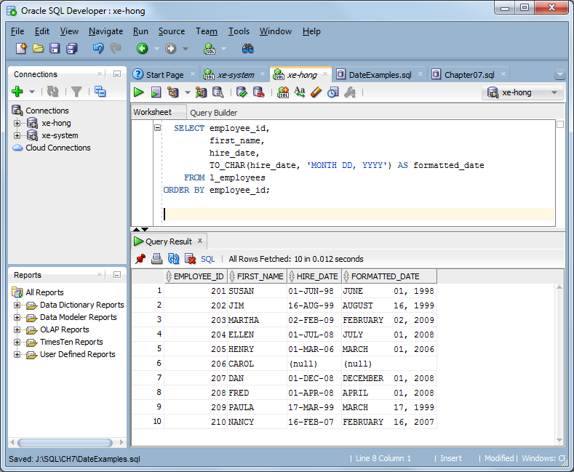
SELECT employee_id,
first_name,
hire_date,
TO_CHAR(hire_date, 'MONTH DD, YYYY') AS formatted_date
FROM l_employees
ORDER BY employee_id;

Section 7-12, page 269

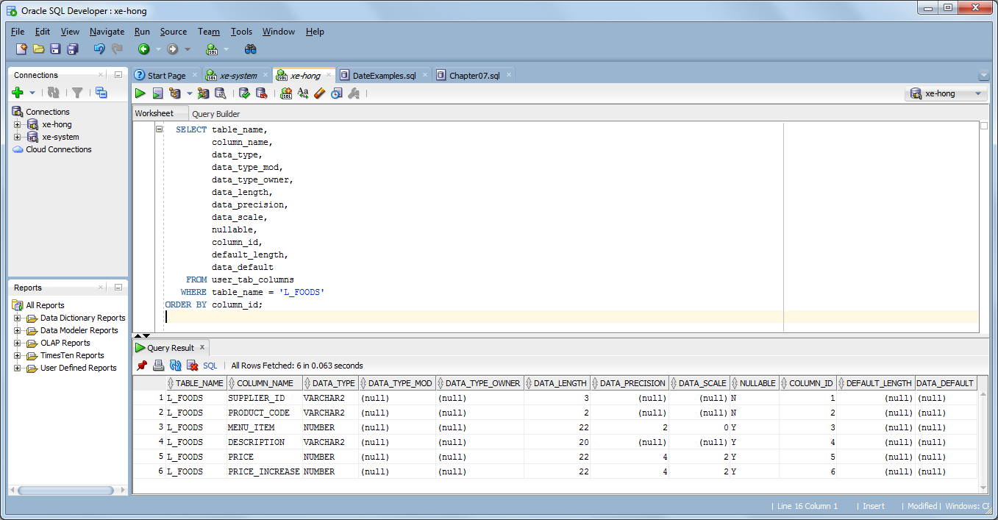
SELECT table_name,
column_name,
data_type,
data_type_mod,
data_type_owner,
data_length,
data_precision,
data_scale,
nullable,
column_id,
default_length,
data_default
FROM user_tab_columns
WHERE table_name = 'L_FOODS'
ORDER BY column_id;

Step #1 - ALTER TABLE to add DATE column
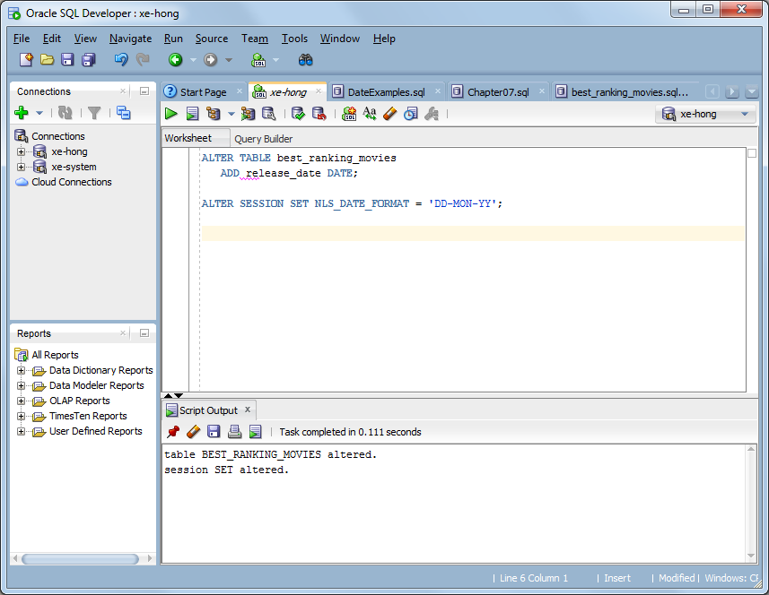
ALTER TABLE best_ranking_movies
ADD release_date DATE;

ALTER SESSION SET NLS_DATE_FORMAT = 'DD-MON-YY';

Step #2 – UPDATE existing rows
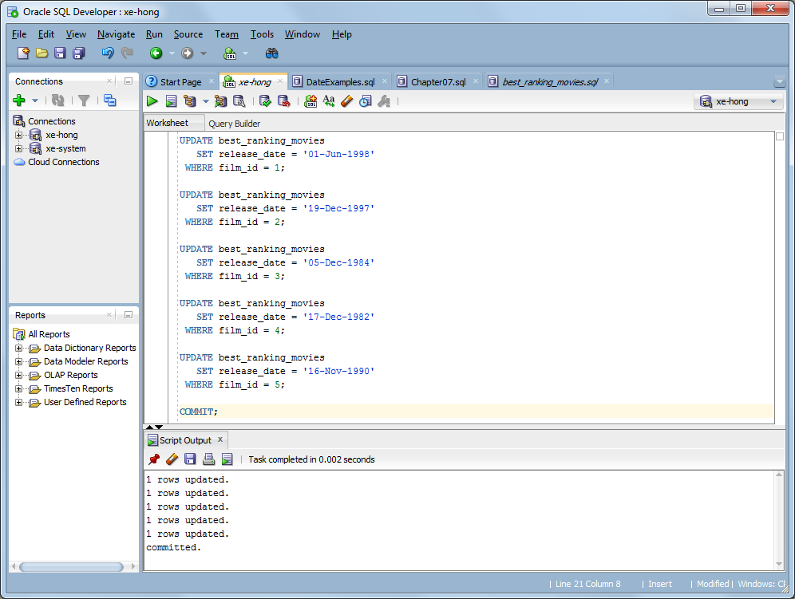
UPDATE best_ranking_movies
SET release_date = '01-Jun-1998'
WHERE film_id = 1;

UPDATE best_ranking_movies
SET release_date = '19-Dec-1997'
WHERE film_id = 2;

UPDATE best_ranking_movies
SET release_date = '05-Dec-1984'
WHERE film_id = 3;

UPDATE best_ranking_movies
SET release_date = '17-Dec-1982'
WHERE film_id = 4;

UPDATE best_ranking_movies
SET release_date = '16-Nov-1990'
WHERE film_id = 5;

COMMIT;

Step #3 – INSERT statements
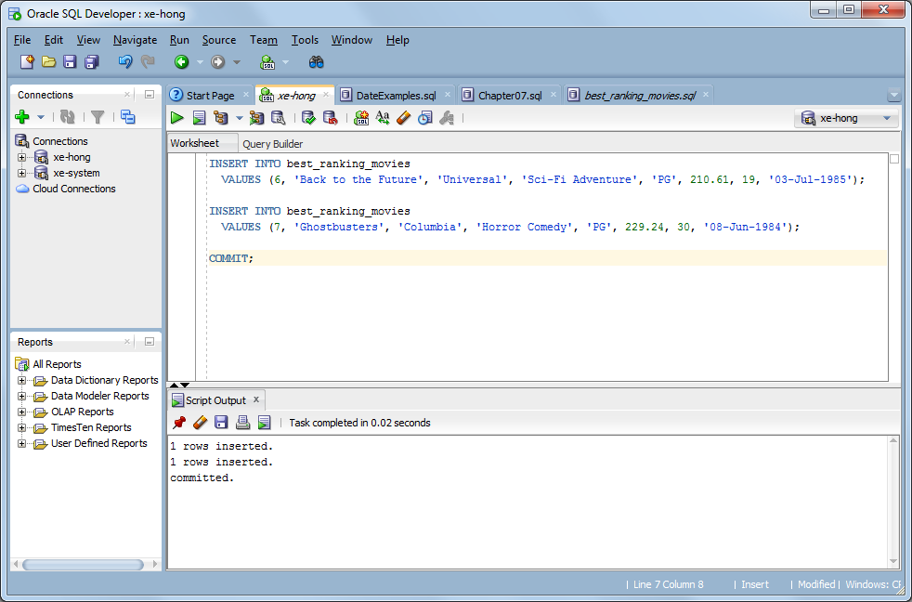
INSERT INTO best_ranking_movies
VALUES (6, 'Back to the Future', 'Universal', 'Sci-Fi Adventure', 'PG', 210.61, 19, '03-Jul-1985');

INSERT INTO best_ranking_movies
VALUES (7, 'Ghostbusters', 'Columbia', 'Horror Comedy', 'PG', 229.24, 30, '08-Jun-1984');

COMMIT;

Step #4 – SELECT statements
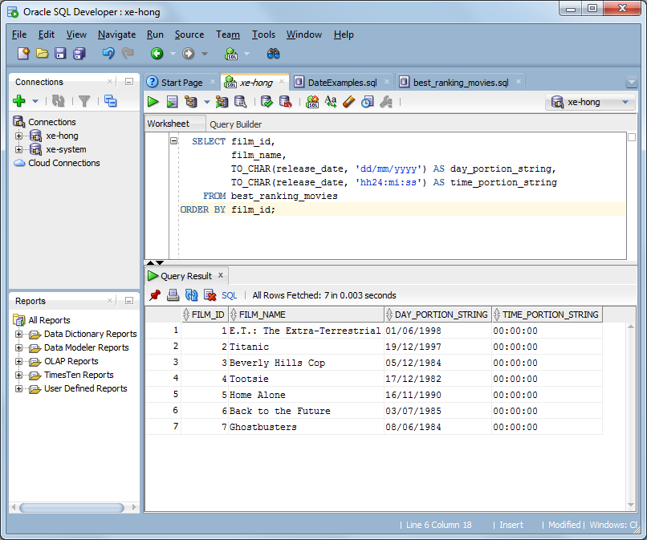
SELECT film_id,
film_name,
TO_CHAR(release_date, 'dd/mm/yyyy') AS day_portion_string,
TO_CHAR(release_date, 'hh24:mi:ss') AS time_portion_string
FROM best_ranking_movies
ORDER BY film_id;

