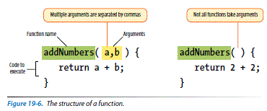

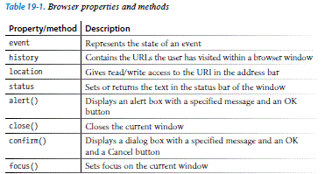

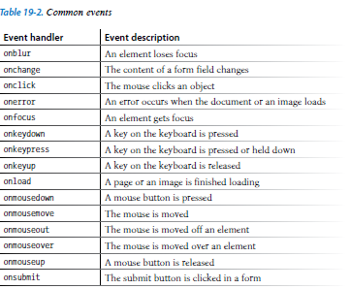

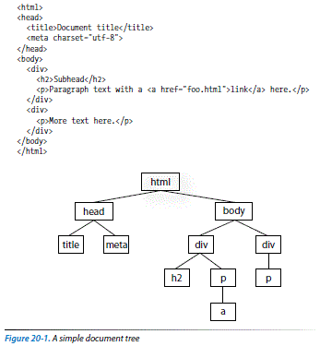

Accessing DOM nodes

By element name

**getElementsByTagName()**

By id attribute value

**getElementById()**

By class attribute value

**getElementsByClassName()**

By selector

**querySelectorAll()**

Accessing an attribute value

**getAttribute()**

Manipulating nodes

**setAttribute()**

**innerHTML**

var introDiv = document.getElementsByClassName("intro");

introDiv.innerHTML = "<p>This is our intro text</p>";

**style**

document.getElementById("intro").style.color = "#fff";

document.getElementById("intro").style.backgroundColor = "#f58220";

//orange