1. I change the sales_date from 2000-01-03 to 2015-01-03 in the source file.



Then, in the fact table, it shows a dummy row. The date_key changed to 19000101.

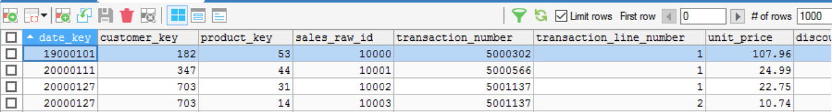

1. I add a row in the source file.

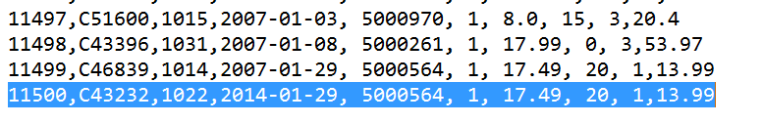

Then, in the fact table, we will see the changes, the date-key is 19000101 and the customer-key is 0.

