**Name**: Hong Zhang

**Email Address**: [hzhan121@hawk.iit.edu](mailto:hzhan121@hawk.iit.edu)

**Class**: ITMD 562 -02

**Assignment 1**

**Project Description**: Creates tow simple PHP web pages, index.php and form.php that contain dynaic data and process GET and POST data. The web page of index.php process GET dynaic data. The parameter to see the dynamic data is name. The web page of form.php is a form and show the result after the user submit.

**Development Environment:**

* Computer OS: Windows 8.1
* Loacl Server: XAMPP v3.2.1
* Editor: Sublime Text 3

**Installation Instruction:** User should run index.php first. If you open this web page in the local server, you will see “Welcome Guest” in the page and offer a link to another web page of form.php. If you use a parameter which is the name, you will see this parameter of the name to replace the guest. After you go to the form.php, you can fill in it and submit. If you submit successfully, the form will be gone and the result will show up. If you upload a file, the result will offer a link to download the file. By the way, the name of the upload fold is upload.

**Insights and Results:**

Open index.php: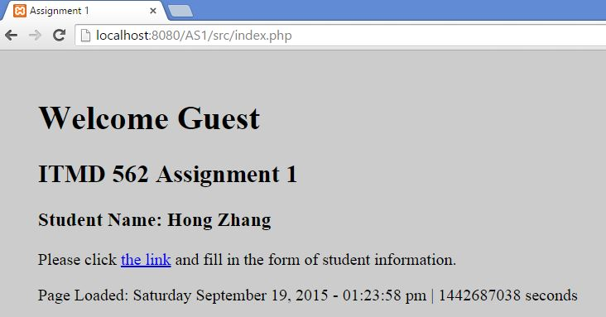

If you use the parameter of name, such as name = Sam: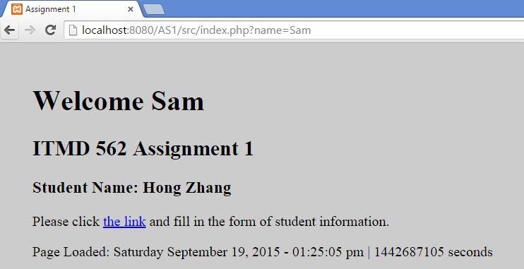

Click the link and go to form.php: 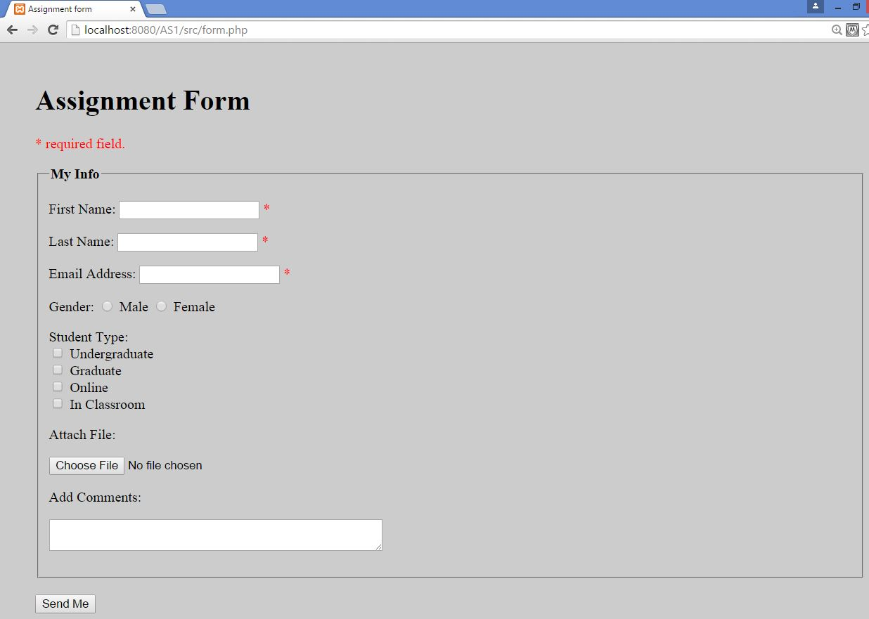

First name, Last name and Email Address are required fields. If these fields are blank or you do not fill in letters, you can not submit this form but other fields which you have filled will be kept. 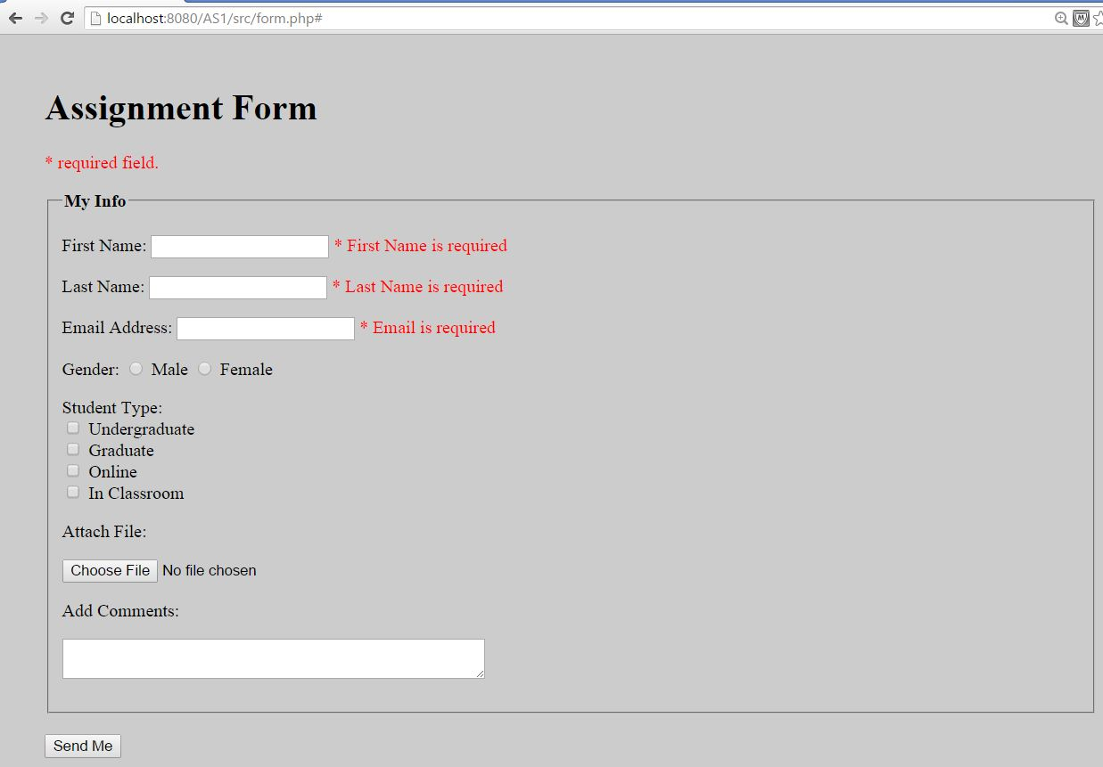 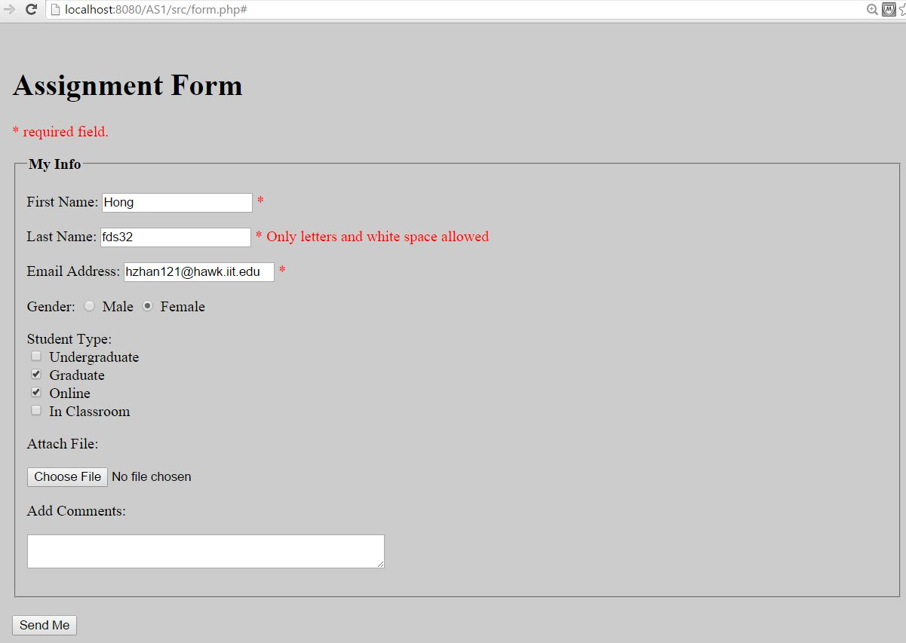

If you fill in any extra whitespace characters at the beginning or end, you will not see them in the result. If you type some Javascript codes in this form, it will not work. 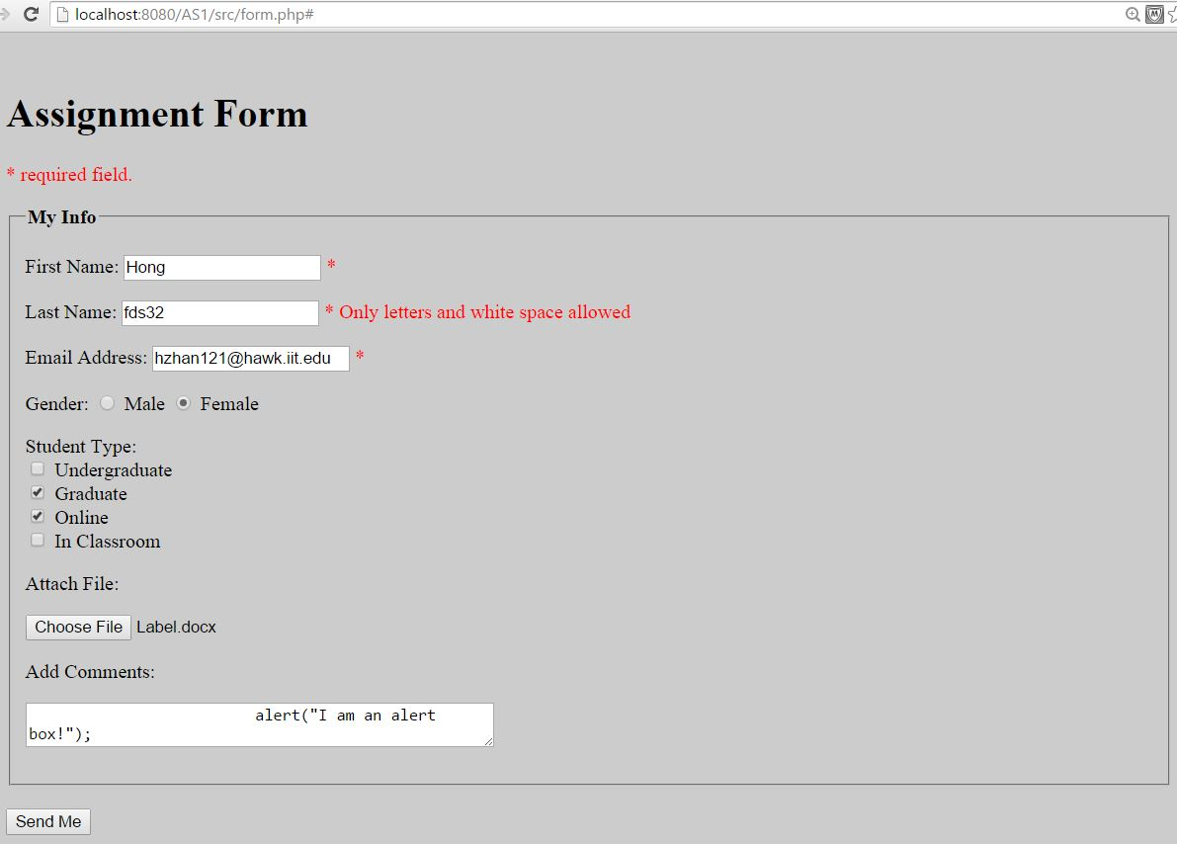

After you submit the form successfully, you will see the result and the form will be gone. 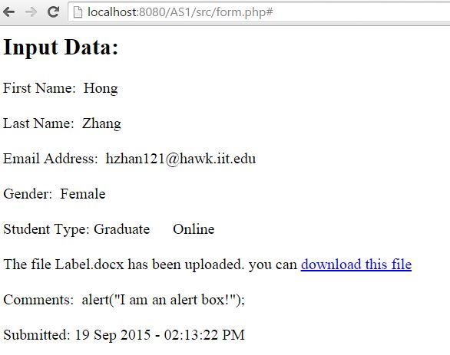

If you upload a file, this file will be stored in the fold of upload. Then, the result will offer a link to download the file which you have uploaded.

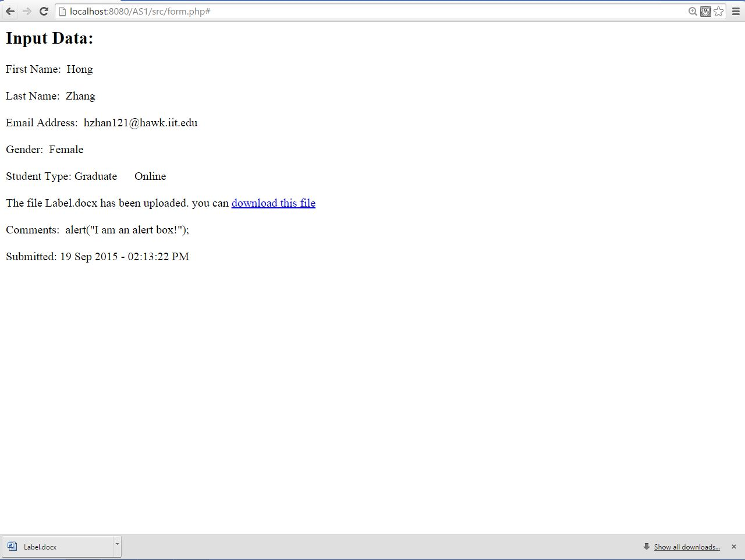

References: the example which post in the [www.w3.org](http://www.w3.org) is very useful to check the form validation.