**Name**: Hong Zhang

**Email Address**: [hzhan121@hawk.iit.edu](mailto:hzhan121@hawk.iit.edu)

**Class**: ITMD 562 -02

**Final Project**

**Project Description**: Build a Note CRUD application using the symphony PHP framework. In this project, I create two sections, the public section to show the notes and the backend section to edit these notes. It is notable that users need to use username and password to log in the backend section. Additional, there were multiple users to use this applications and each user only edits his notes. You can use command to create new users.

The note data is stored in SQlite. There are two entities, one is for notes whose name is Post.php and the other is for users whose name is User.php. There are three controllers, one is for security part to log in, the second one is for public section to show the notes and the last one is for backend section to edit notes. There are two repositories, one is for save notes whose name is PostRepository.php and the other one is for users whose name is UserRepository.php.

Here are the most steps which I did in this project.

1. Create SQLite: data/ note.sqlite
2. Create entity: (folder name) Src/AppBundle/Entity

Notes: Post.php

Users: User.php

1. Create form type: (folder name) Src/AppBundle/Form.

Public Section: CommentType.php

Edit Section: PostType.php

Time type: Type/ DateTimePickerType.php

1. Create Repository: (folder name) Src/AppBundle/ Repository

Notes: PostRepository.php

Users: UserRepository.php

1. Create controller: (folder name) Src/AppBundle/Controller.

Login: SecurityController.php;

Public Section: NoteController.php;

Edit Section: /Admin/ NoteController.php

1. Create Template: (folder name) app/Resources/views.

Basic Template: base.html.twig

HomePage Template: /defalt/ homepage.html.twig

Flash Message Template: /defalt/ _flash_messages.html.twig

Time Template: /form/ fields.html.twig

Login Template: /security/ login.html.twig

Public Section Template: note/_comment_form.html.twig

note/_delete_post_confirmation.html.twig

note/comment_form_error.html.twig

note/index.html.twig

note/post_show.html.twig

Edit Section Template: basic template – layout.html.twig

note/ _form.html.twig

note/ edit.html.twig

note/ index.html.twig

note/ new.html.twig

note/ show.html.twig

1. Configration Part: (folder name) app/config.

Need to configure routing, security and parameters.

Update SQLite’s Path (database_path: '%kernel.root_dir%/data/note.sqlite')

Update app/config/ parameters.yml

Update app/config/config.yml (the main configuration file of your application. It stores all the common options for every execution environment ('prod', 'dev', 'test').)

1. Create new user (use cmd to create: $ php app/console app:add-user). This part if coming from the symphony demo part and I have not change them. This part can use cmd to create new user, delete user or list user. The files are stored in the folder of Src/AppBundle/Command.

Add user: AddUserCommand.php

Delete user: DeleteUserCommand.php

List user: ListUsersCommand.php

1. Update autoload classes and namespaces: vendor/composer/ autoload_classmap.php, autoload_namespaces.php and ClassLoader.php.
2. Update CSS: web folder.

**Development Environment:**

* Computer OS: Windows 8.1
* Local build-in PHP server
* Symphony 2.7.6 PHP framework
* Editor: Sublime Text 3

**Installation Instruction:**

Use cmd to change the directory to the project fold and run the server: php app/console server:run. After the server running, go to the web brower using the port 8000.

I create two users, as follows.

username: Admin

password: HongZhang

email:hzhan121@hawk.iit.edu

username: Angel

password:itmd562

email:angel@hawk.iit.edu

**Insights and Results:**

Open the web browser using the address: <http://localhost:8000> and go to the default home page.

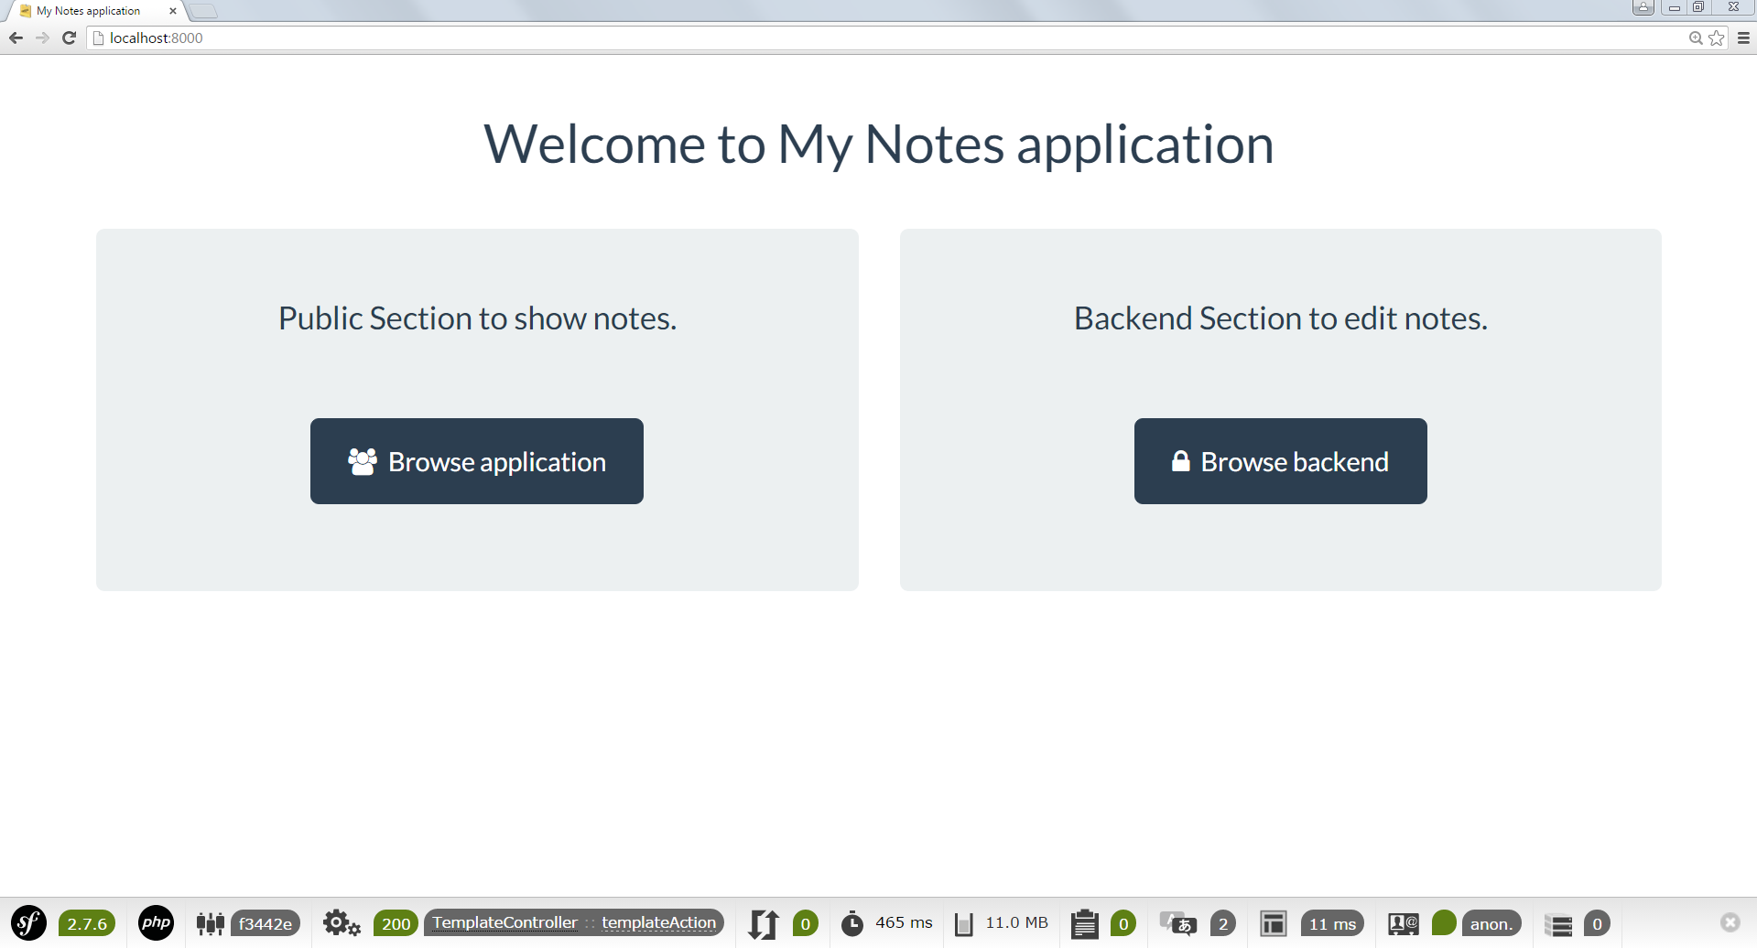

**Public Section:**

Click the public section, *Browser application* and you will see the notes list which includes the note title and the note summary. I will call this page, [www.localhost:8000/en/note](http://www.localhost:8000/en/note) the index page of public section.

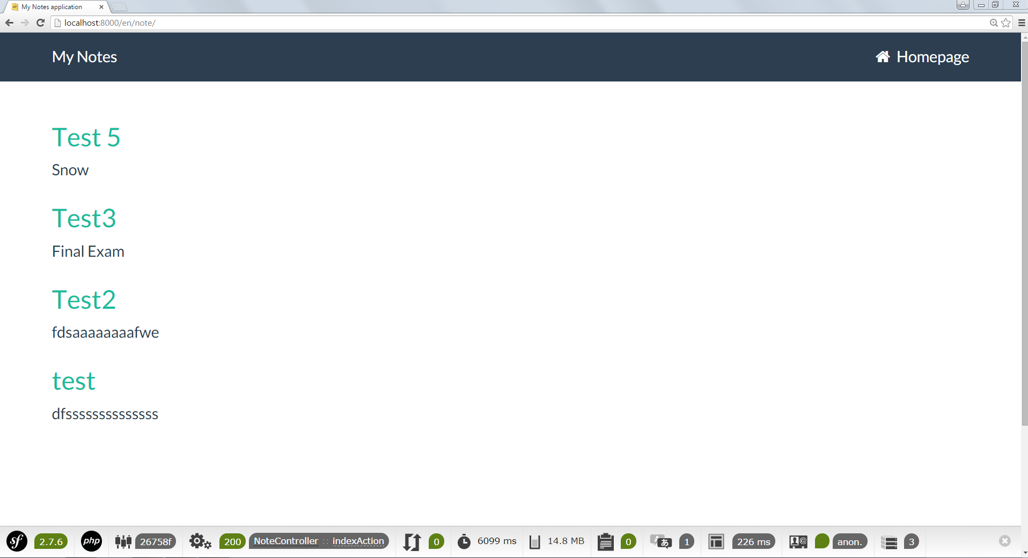

In this index page of public section, when you click the note title, you will see the note title and note content.

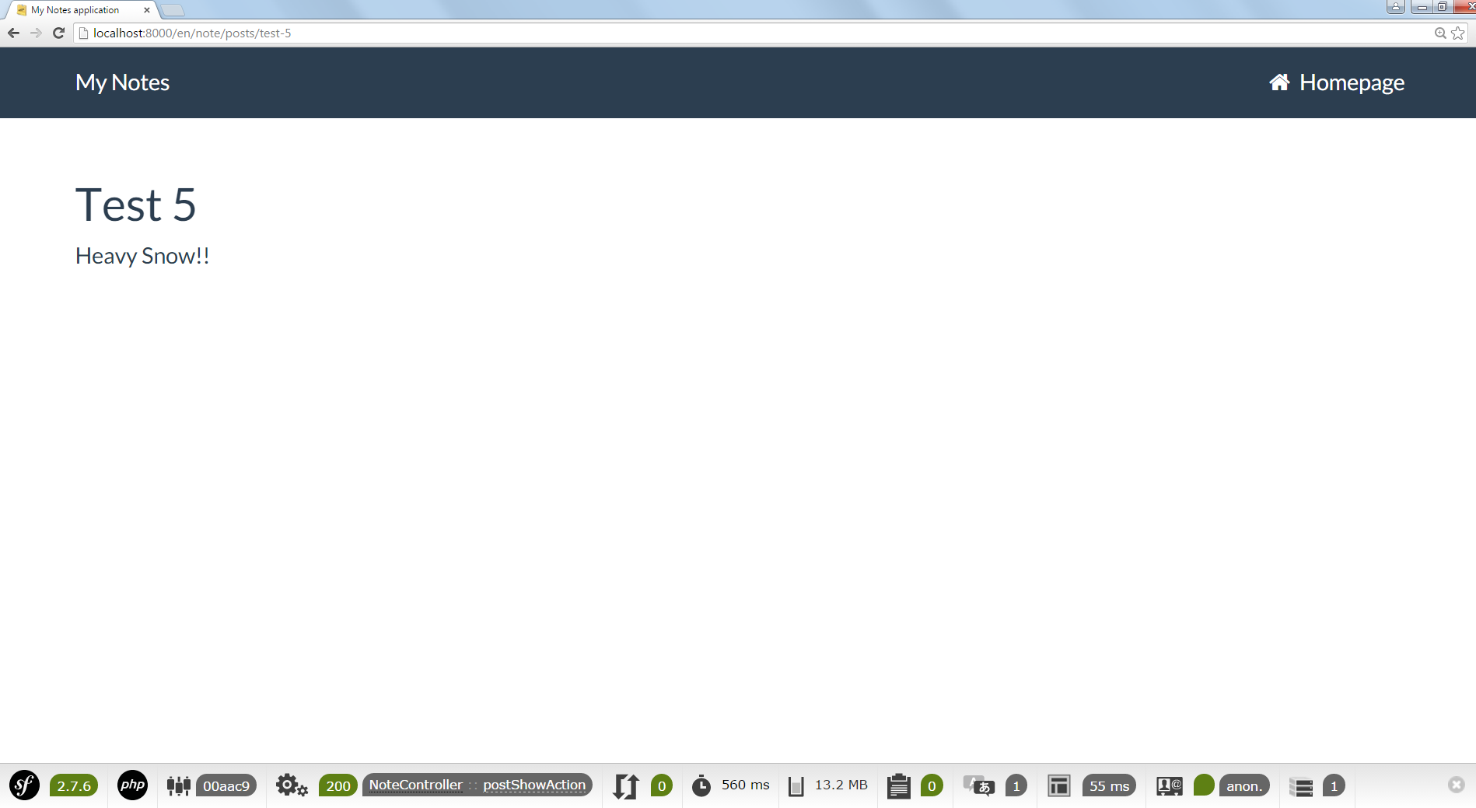

When you click *Homepage*, you will go back to [www.localhost:8000/en/note](http://www.localhost:8000/en/note), the index page of public section.

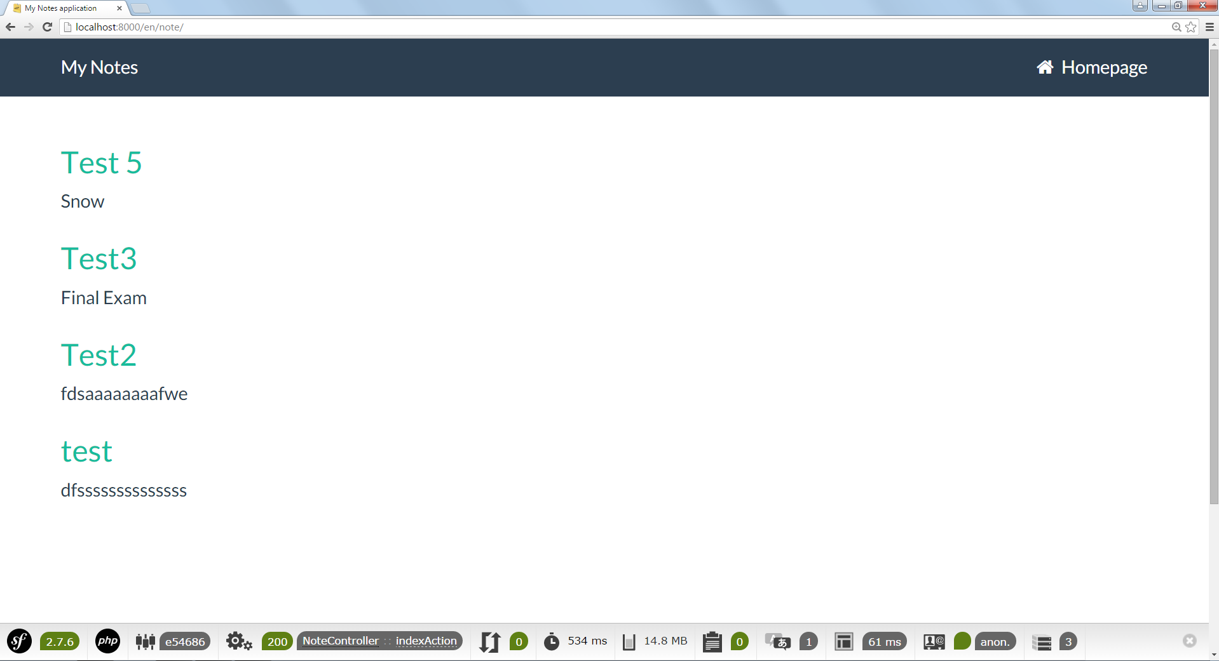

If you click the *My Notes*, you will go to the default home page, [www.localhost:8000](http://www.localhost:8000).



**Backend Section:**

In the default home page, [www.localhost:8000](http://www.localhost:8000), when you click the backend section, *Browser backend*, you will go to the log in page, [www.localhost:8000/en/login](http://www.localhost:8000/en/login).

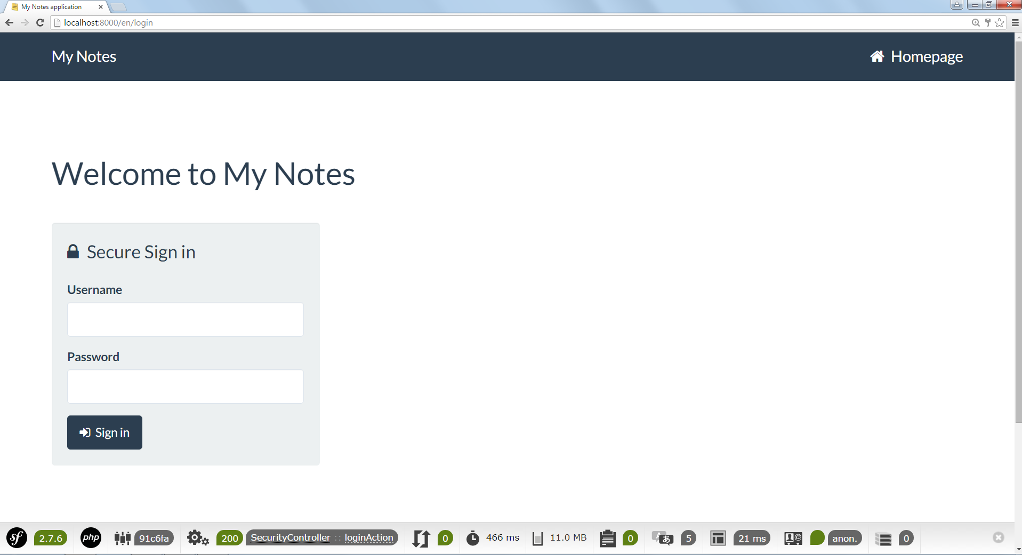

If you type wrong username or password, you will get the error message and is still in the log in page.

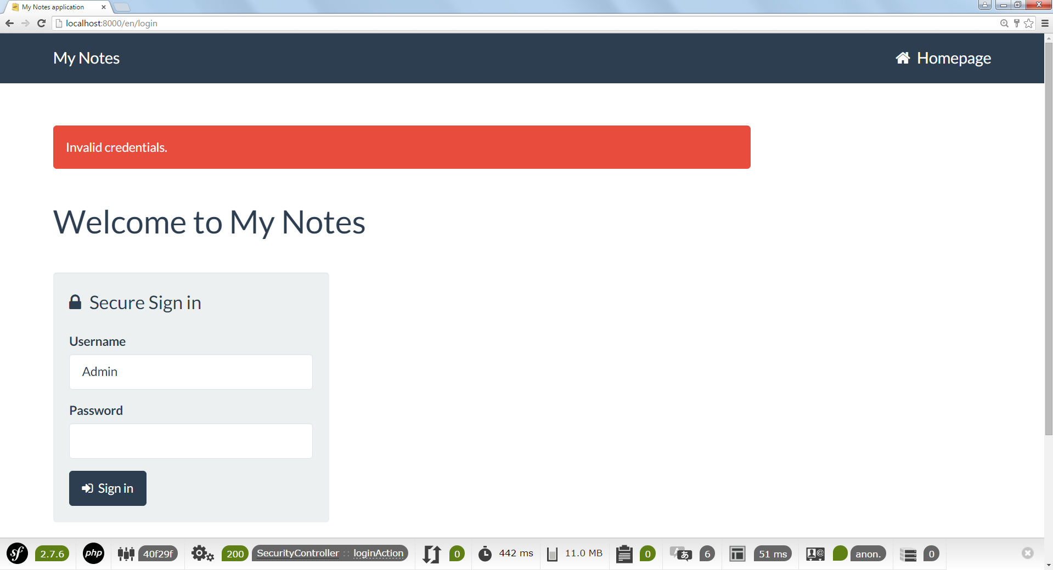

This time, I choose the account, the username is Admin. After I log in, it comes back to the default home page, [www.localhost:8000](http://www.localhost:8000). However, this time, you can go the backend section.



When you click the backend section now, you get a different view for notes list. Now, you can create a note, show the whole note and edit it. I call this page the index page of backend section, [www.localhost:8000/en/admin/post](http://www.localhost:8000/en/admin/post).

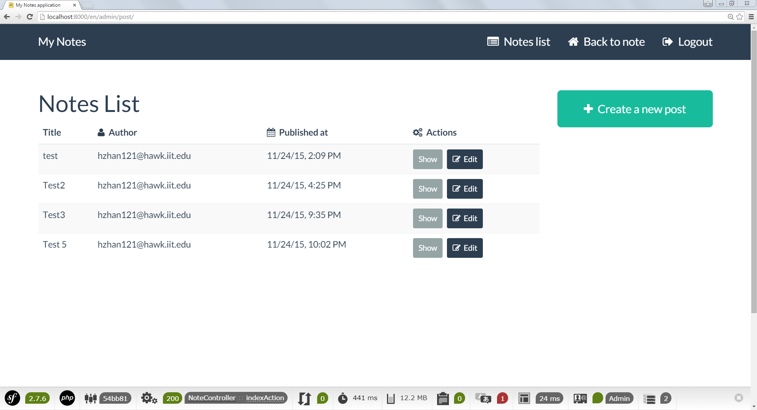

In the index page of backend section, [www.localhost:8000/en/admin/post](http://www.localhost:8000/en/admin/post), there are four web links on navigation bar. As I mentioned above, clicking *My Notes* will come back to the default home page, [www.localhost:8000](http://www.localhost:8000). Clicking *Notes list* will show the index page of backend section, [www.localhost:8000/en/admin/post](http://www.localhost:8000/en/admin/post). Clicking *Back to note* will show the index page of public section, [www.localhost:8000/en/note](http://www.localhost:8000/en/note). Clicking Logout will log out this account and come back to the default home page, [www.localhost:8000](http://www.localhost:8000).

Now, come back to the index page of backend section, [www.localhost:8000/en/admin/post](http://www.localhost:8000/en/admin/post). This time, I will create a new note. Then, I click the button of *Create a new post*. It leads to the creation page, [www.localhost:8000/en/admin/post/new](http://www.localhost:8000/en/admin/post/new).

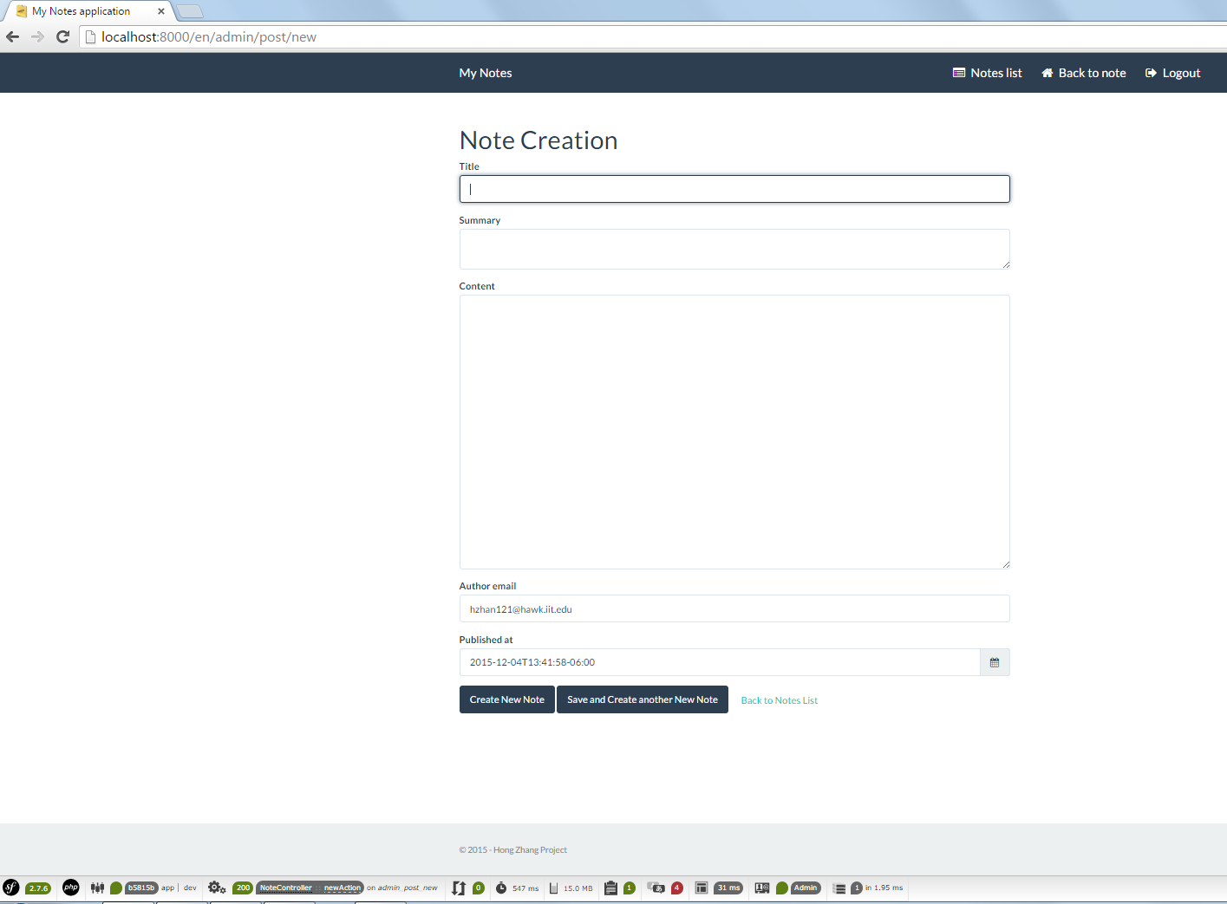

In this page, there are two different submit buttons and one web link. The *Create New Note* let you save the note. The *Save and Create another New Note* let you save this note then you can create another new note. The *Back to Notes list* let you give up the creation, give up the saving process and go back to the index page of backend section, [www.localhost:8000/en/admin/post](http://www.localhost:8000/en/admin/post).

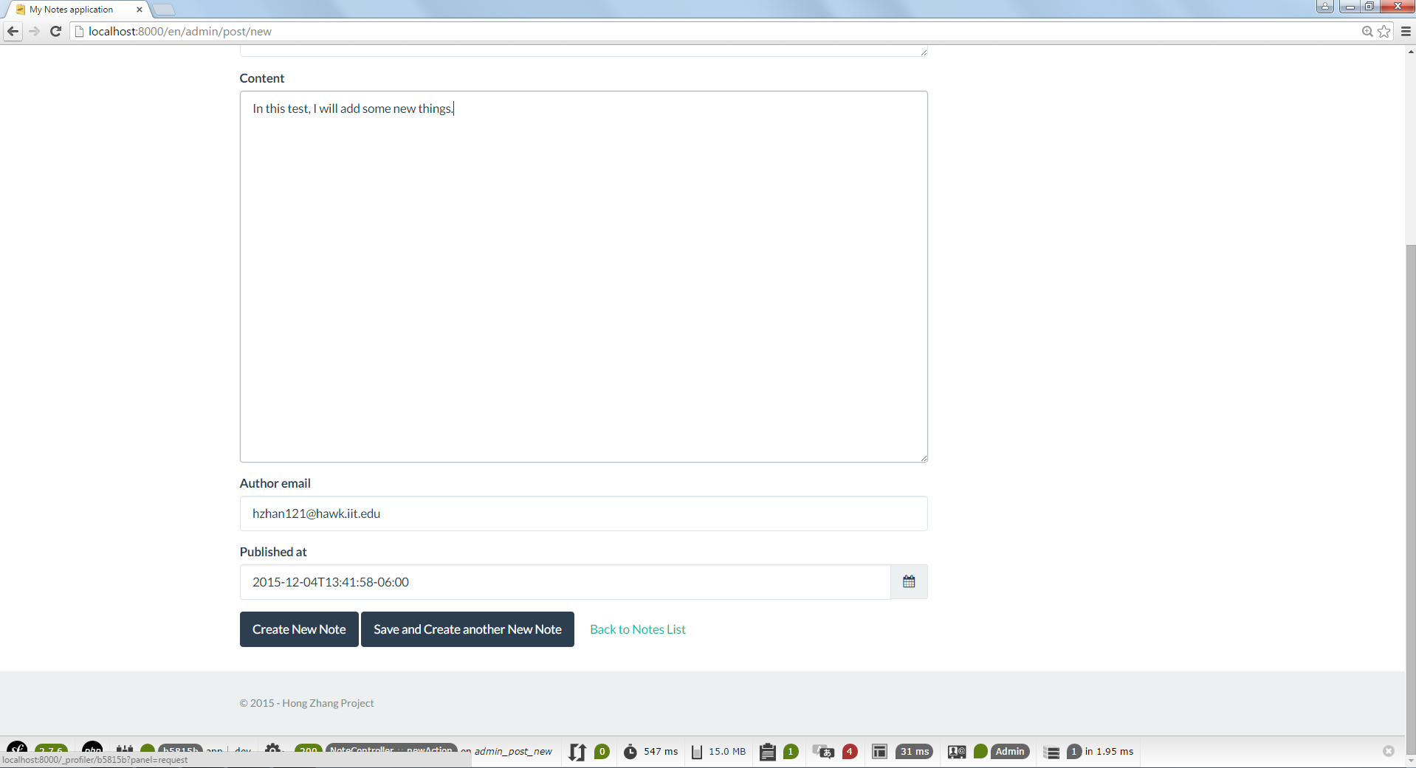

This time, I click the Create New Note and save this note. Now, it comes back to the index page of backend section, [www.localhost:8000/en/admin/post](http://www.localhost:8000/en/admin/post) and you will see the new note in the notes list.

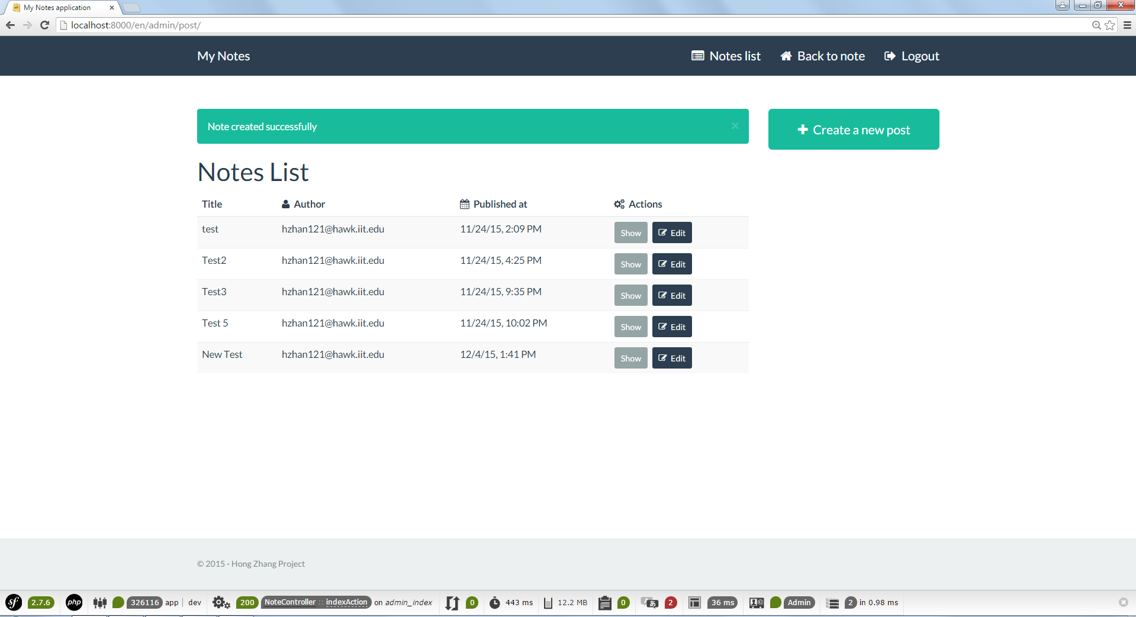

Then, I can use *Show* button and *Edit* button to edit the notes.

First, I choose the *Show* button. After I click the *Show* button, you will see this note’s every detail which includes title, summary, content, author and published time.

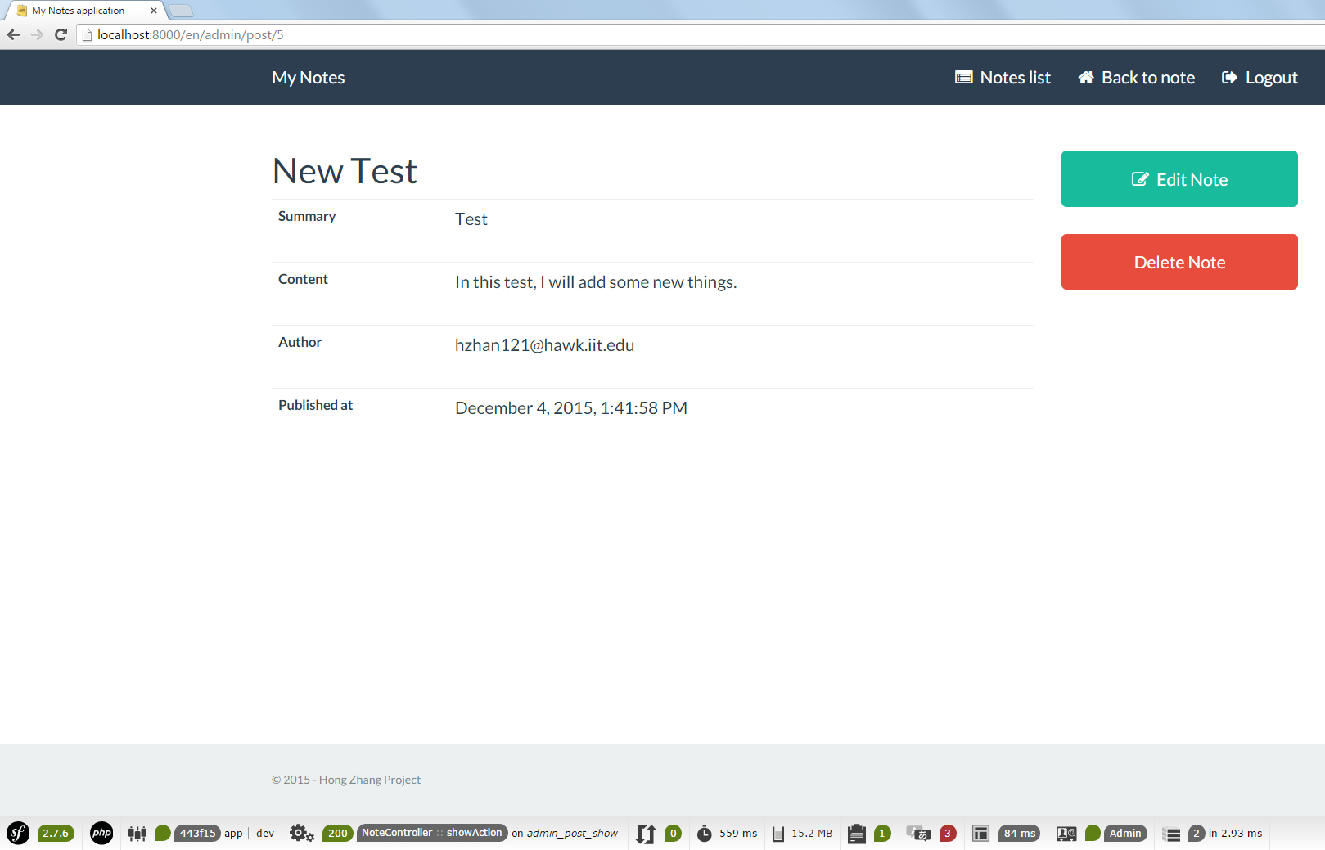

Click *Edit Note*, you can edit this note. Click *Delete Note*, you can delete this note. Now, I click *Edit Note*.

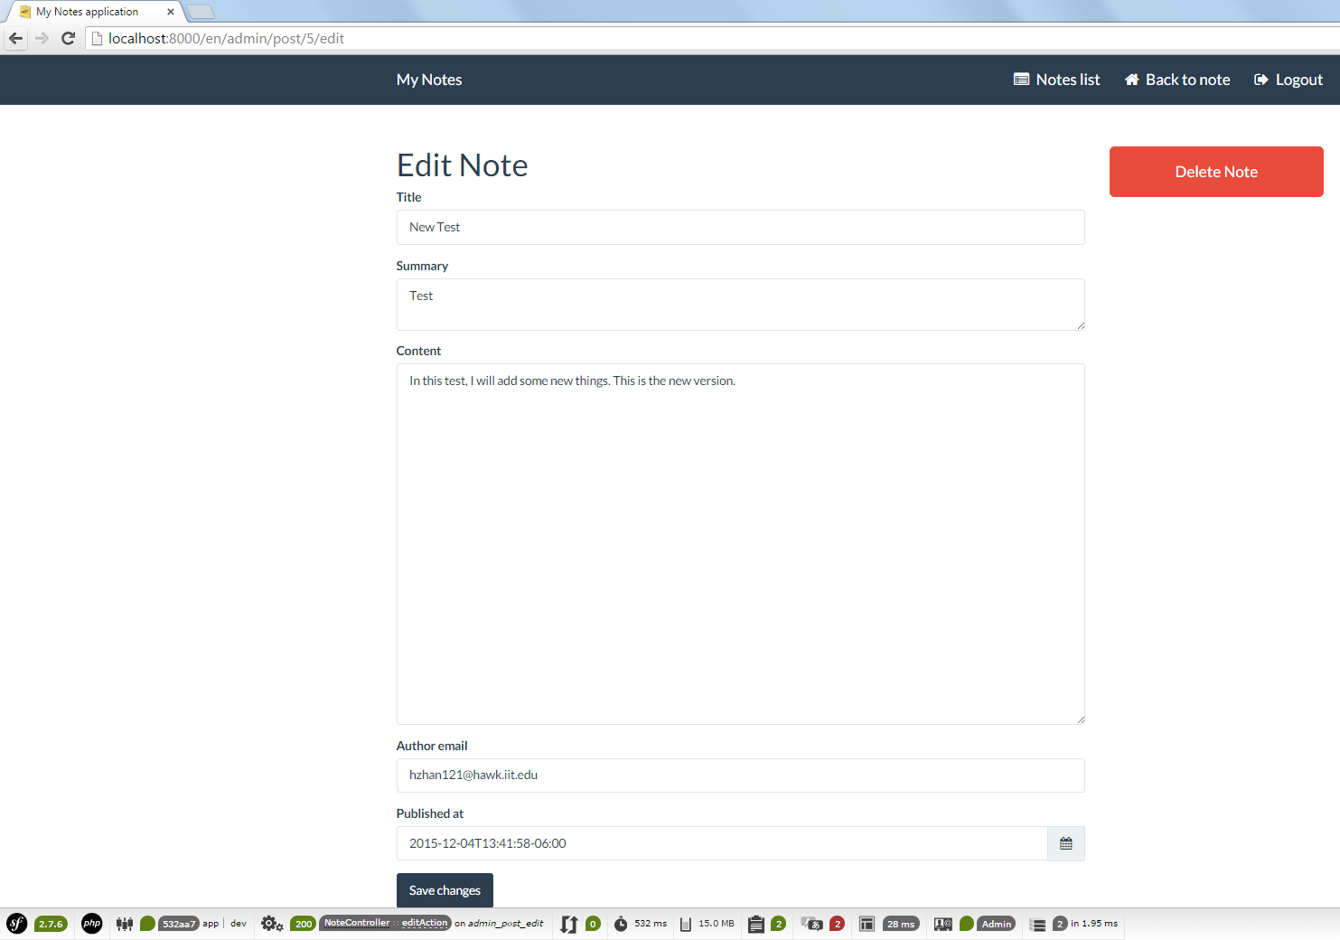

After clicking the *Save changes* button, the flash message will tell you the note update successfully. In this page, you can also choose the delete options.

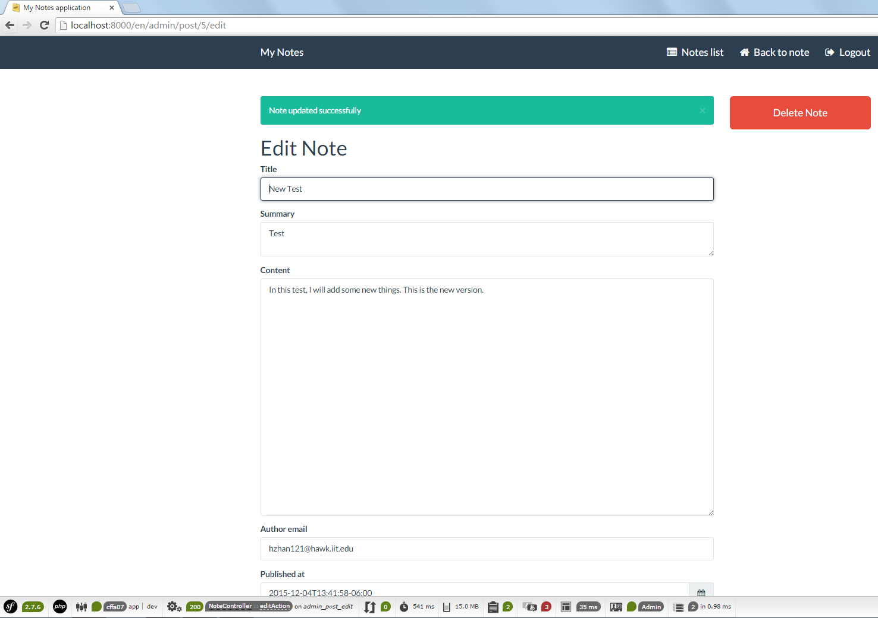

Click Delete Note, you can delete this note. However, after you click this button, there will appear a flash message which asks you if you want to delete this note or not. If not, it will go back to the page which you stay. If clicking *Delete post*, the note will be delete.

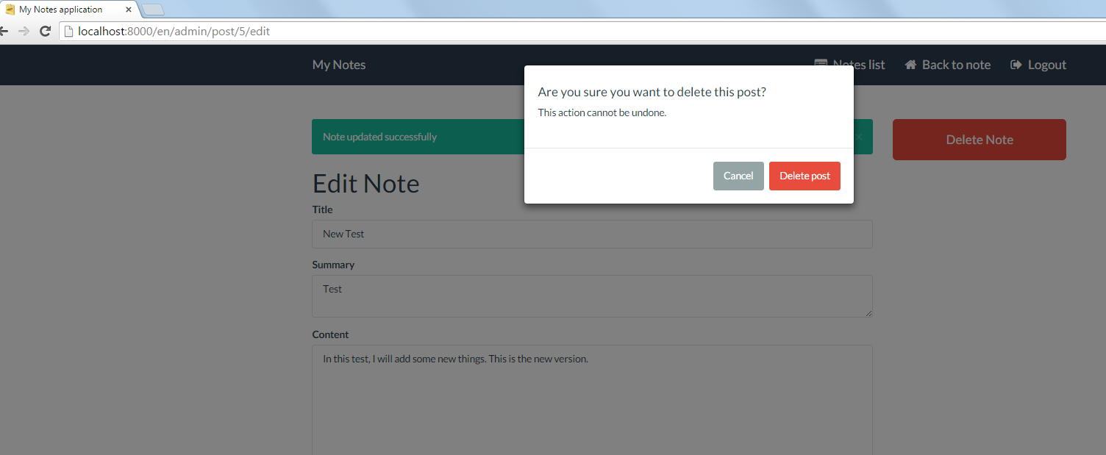

After I choose the option of delete the note, it will go back to the index page of backend section, [www.localhost:8000/en/admin/post](http://www.localhost:8000/en/admin/post) and you will see the note has been deleted.

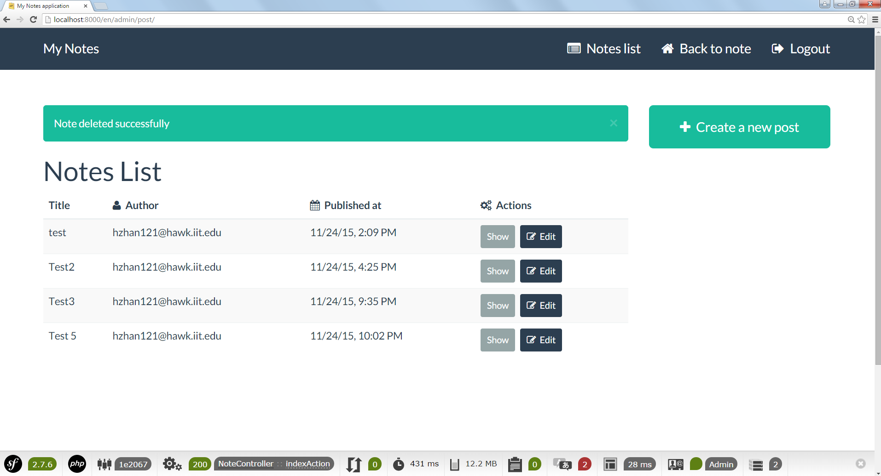

Then, I log out the account of Admin.

Next thing is I will test another account, the username is Angel. After I log in this account, I will see notes list which includes all uses’ notes. The use can show all notes details but every use can only edit his own.

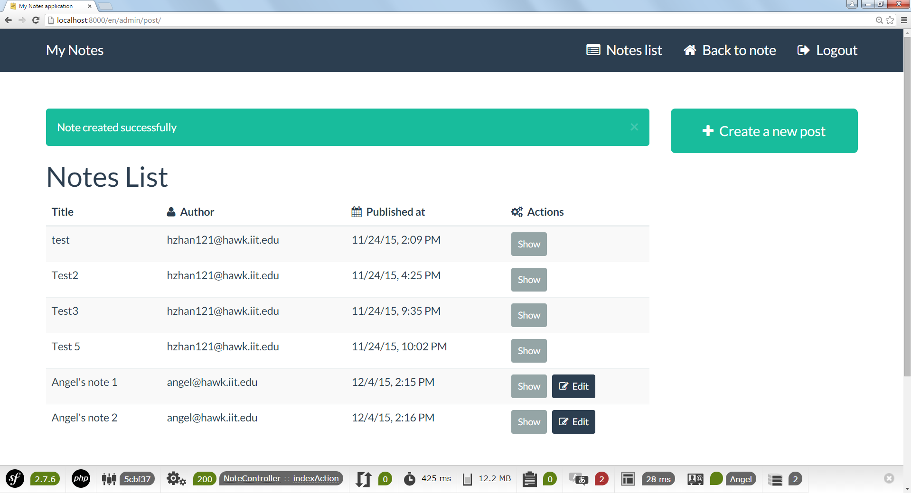

The last thing which I want to show is creating new user when you use cmd.

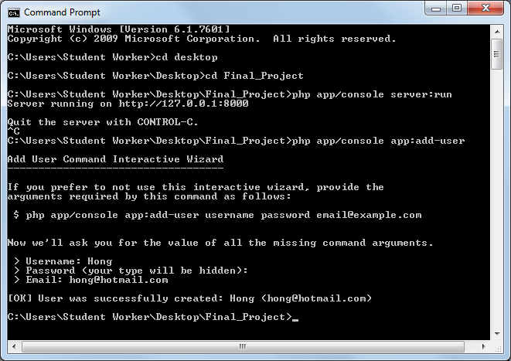

When you go to the SQLite, you will see this user in the user table.

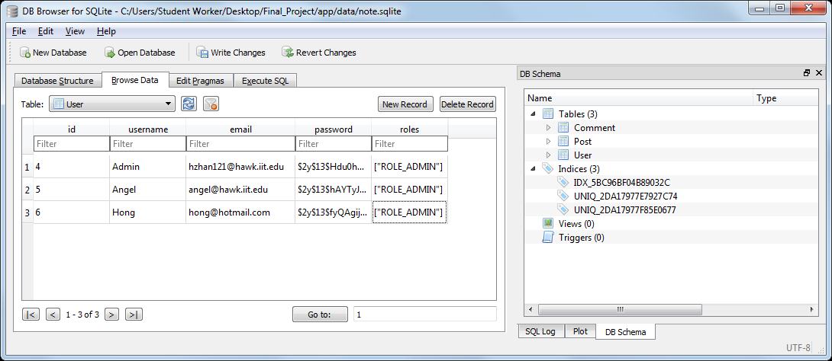

**References**: I get Symfony2 demo form the Symfony website and dig it so much. This demo is very helpful and help me to figure out the standard process to build up a Symfony sever. However, I have not enough time to finish it, such as the css part. It needs more time to learn twig part.