Login.php

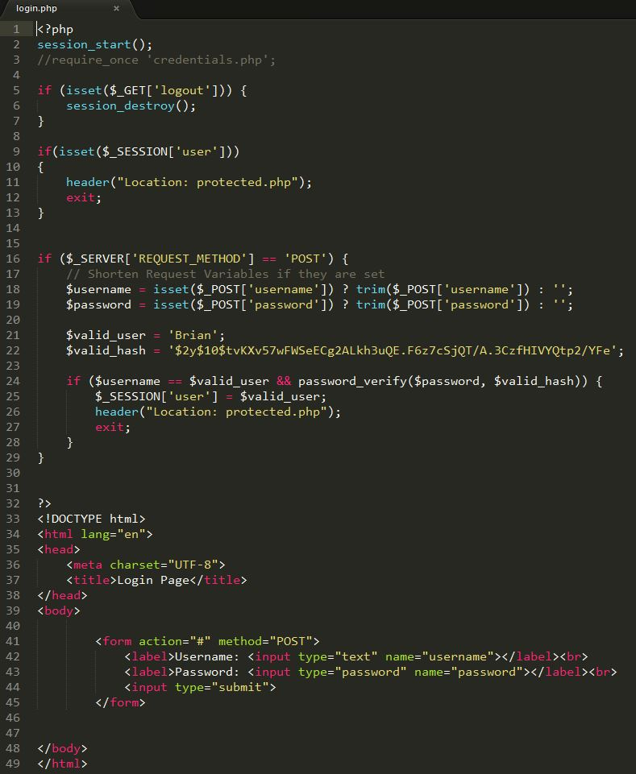

Credentials.php

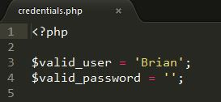

Protected.php (in this case, username=Brian, password=password) if you have multi users, should use array for valid_user[].

